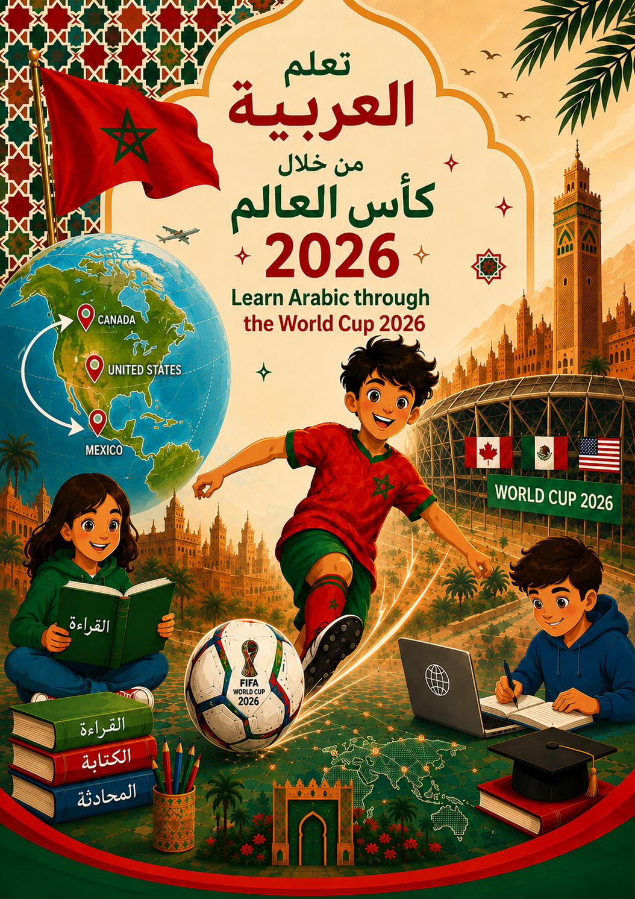

Introduction
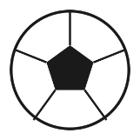

These lessons on the 2026 FIFA World Cup invite students to learn more about and engage with the Arabic language through the tournament’s biggest storyline for Arabic learners everywhere: the Moroccan national team’s historic run through the expanded, 48-team competition hosted across the United States, Mexico, and Canada.
This is a new 2026 edition of the World Cup Lesson Plans series for the Arabic classroom. It follows the same structure, methodology, and workbook style as the original collection, but places Morocco—the Atlas Lions (أُسود الأطلس)—at the center of every lesson. Students will follow Morocco’s actual, real 2026 World Cup journey match by match: from the group stage draw against Brazil, Scotland, and Haiti, through a penalty-shootout win over the Netherlands, a commanding Round of 16 victory over co-host Canada, and a hard-fought quarterfinal against France.
The lesson plans were created for students at the novice-mid to intermediate level and can be adapted for elementary, middle, and high school students. They can be taught together as a full unit or used as individual lessons. Every lesson includes a Teacher Procedure (Lesson Plan) and a separate, printable Student Handout.
A note on real 2026 results
All match results, dates, scores, and player names used in this workbook reflect the actual, verified outcomes of the 2026 FIFA World Cup. Where a detail could not be verified, it has been left general rather than invented.

Modern Standard Arabic and Moroccan Darija
Most vocabulary and structures in this workbook are presented in Modern Standard Arabic (MSA — الفصحى), which is used in the news reports, match commentary, and formal writing that students will encounter. Where a fan chant, greeting, or everyday expression is distinctly Moroccan Darija (المغربية الدارجة), it is clearly labeled “Darija” so students understand the difference between the formal language of the press and the spoken language of the stands.

2026 WORLD CUP LESSON PLANS
CONTENTS
LESSON 1 | كأس العالم 2026: المنتخبات والمجموعات والمغرب  The 2026 World Cup : Teams, Groups, and Morocco
LESSON 2 | ثقافة كأس العالم ورموزه وكرة القدم المغربية  World Cup Culture, Symbols, and Moroccan Football
LESSON 3 | مسيرة المنتخب المغربي في كأس العالم 2026  The Moroccan Journey at the 2026 World Cup
LESSON 4 | تريد أن تشاهد مباراة المغرب معي؟  Do You Want to Watch Morocco’s Game with Me?
LESSON 5 | في المباراة: نشجع المغرب  At the Match: Supporting Morocco

Lesson 1: The 2026 World Cup — Teams, Groups, and Morocco
الدرس 1: كأس العالم 2026 — المنتخبات والمجموعات والمغرب
TEACHER PROCEDURE LESSON 1
Prior Knowledge
- Sports vocabulary; the verb “to love/like”
- Countries and continents; colors; shapes (star, circle, cross)
Lesson Goals
Students will be able to:
- Identify the 48 countries that qualified for the expanded 2026 World Cup, hosted by the United States, Mexico, and Canada
- Categorize teams by FIFA continental zone
- Identify and describe the flags of Morocco and its Group C opponents: Brazil, Scotland, and Haiti
- Explain why Morocco’s 2026 campaign is historic — the Atlas Lions reached the semifinals in 2022, the first African nation ever to do so
Vocabulary
English | Arabic
World Cup | كأس العالم
Team / national team | فريق / منتخب
Host country | الدولة المستضيفة
Group / group stage | مجموعة / الدور الأول
Flag | علم
Continent | قارة
I root for / cheer for | أشجّع
Atlas Lions (Morocco’s nickname) | أُسود الأطلس
Important Structures
Structure
ألوان علم هذا البلد هي ___.
The colors of this country’s flag are ___.

Structure
أشجّع فريق المغرب.
I cheer for the Moroccan team.
Sources & Materials
- 2026 FIFA World Cup Final Draw results (fifa.com)
- World Cup Groups Handout (below)
- Blank FIFA Continental Zone Chart (Student Handout)
Teacher Procedure
1. Ask students which sports teams and countries they cheer for: ما هي الرياضات التي تحبونها؟,
ما هو الفريق الذي تشجعونه؟
2. Introduce the 2026 FIFA World Cup as a soccer competition taking place every four years, and explain that this edition is the first ever hosted by three countries together (the United States, Mexico, and Canada) and the first to include 48 national teams instead of 32.
3. Before Reading: Show students a world map or globe. Ask them to name any of the 48 qualified nations they already recognize. Introduce the six FIFA continental zones and have students sort a few well-known teams into zones as a warm-up.
4. Reading: Direct students to the “World Cup Groups” handout. Focus attention on Group C, which includes Morocco, Brazil, Scotland, and Haiti. Explain that this was called a “group of death” by sports commentators because all three of Morocco’s opponents were considered dangerous opponents.
5. Have students read the flag descriptions for Group C and match each description to the correct flag, writing the country name in Arabic.
6. Speaking: In pairs, students describe the colors and symbols of Morocco’s flag (red field, green five-pointed star) using the Important Structures above, then do the same for Brazil, Scotland, and Haiti.
7. Discuss as a class: why is Morocco’s presence in this tournament exciting for Arabic-speaking audiences? Introduce the fact that Morocco reached the World Cup semifinals in 2022, becoming the first African and first Arab nation ever to do so.
8. After Reading: Have students choose which of the four Group C teams they will cheer for (encourage Morocco!) and explain why in one or two Arabic sentences using vocabulary from this lesson.
Teacher Answer Key : Groupe C
GROUP C — المجموعة C
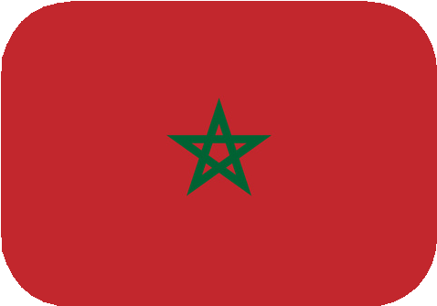  Morocco  المغرب | 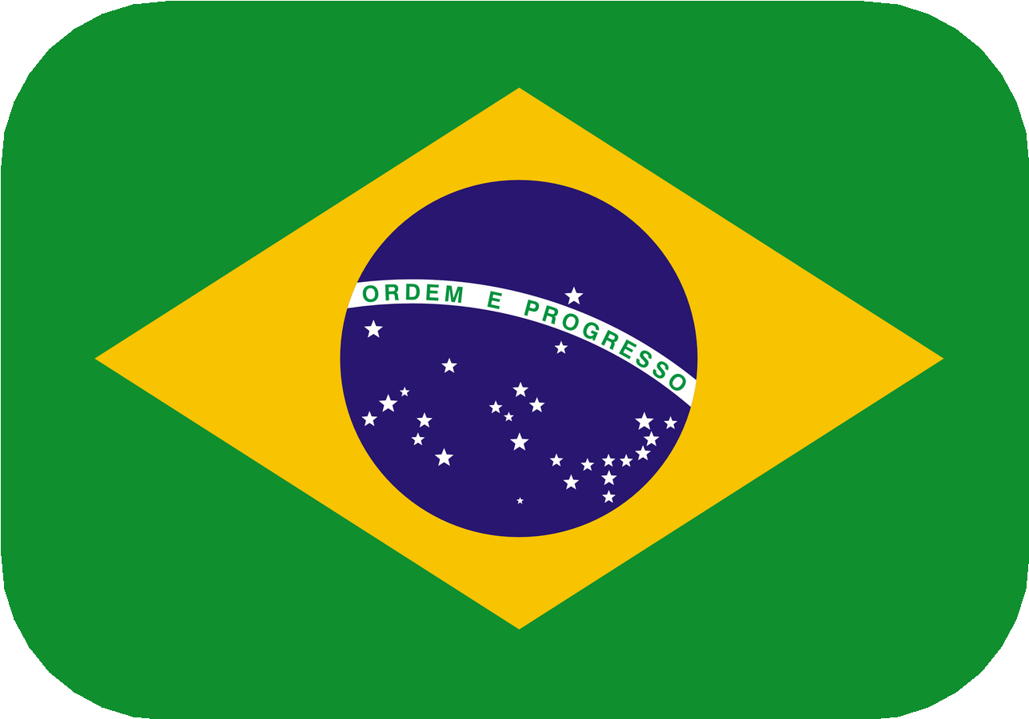  Brazil  البرازيل | 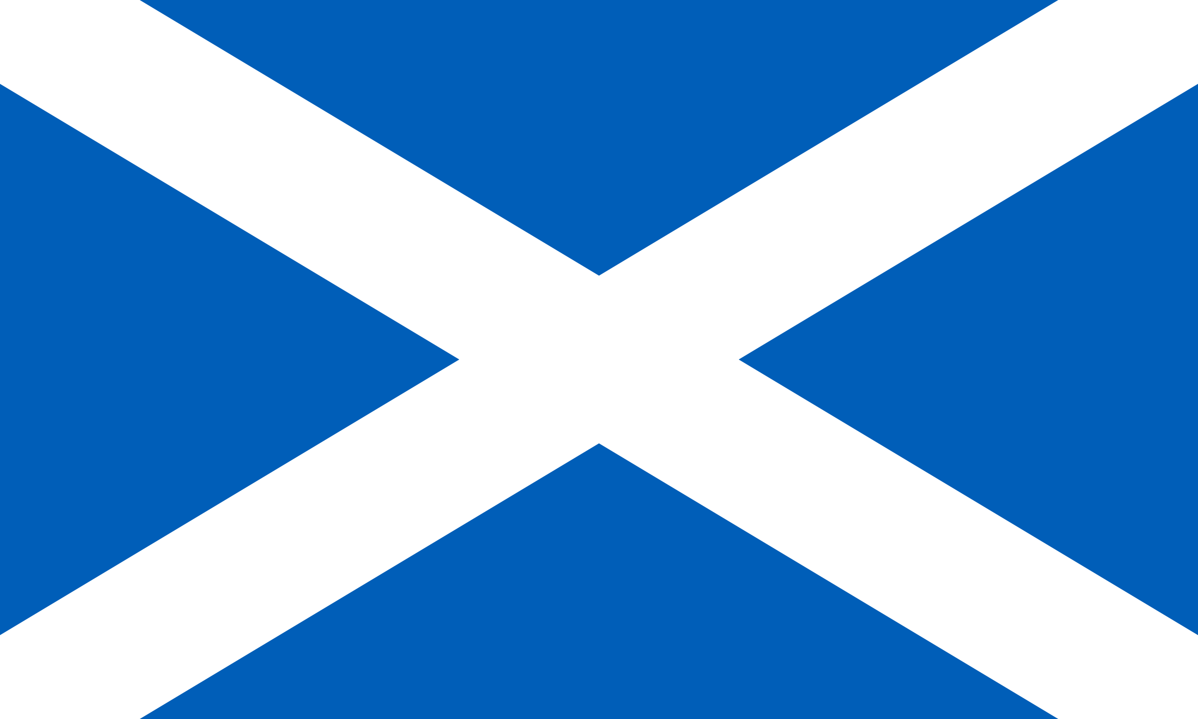  Scotland  اسكتلندا | 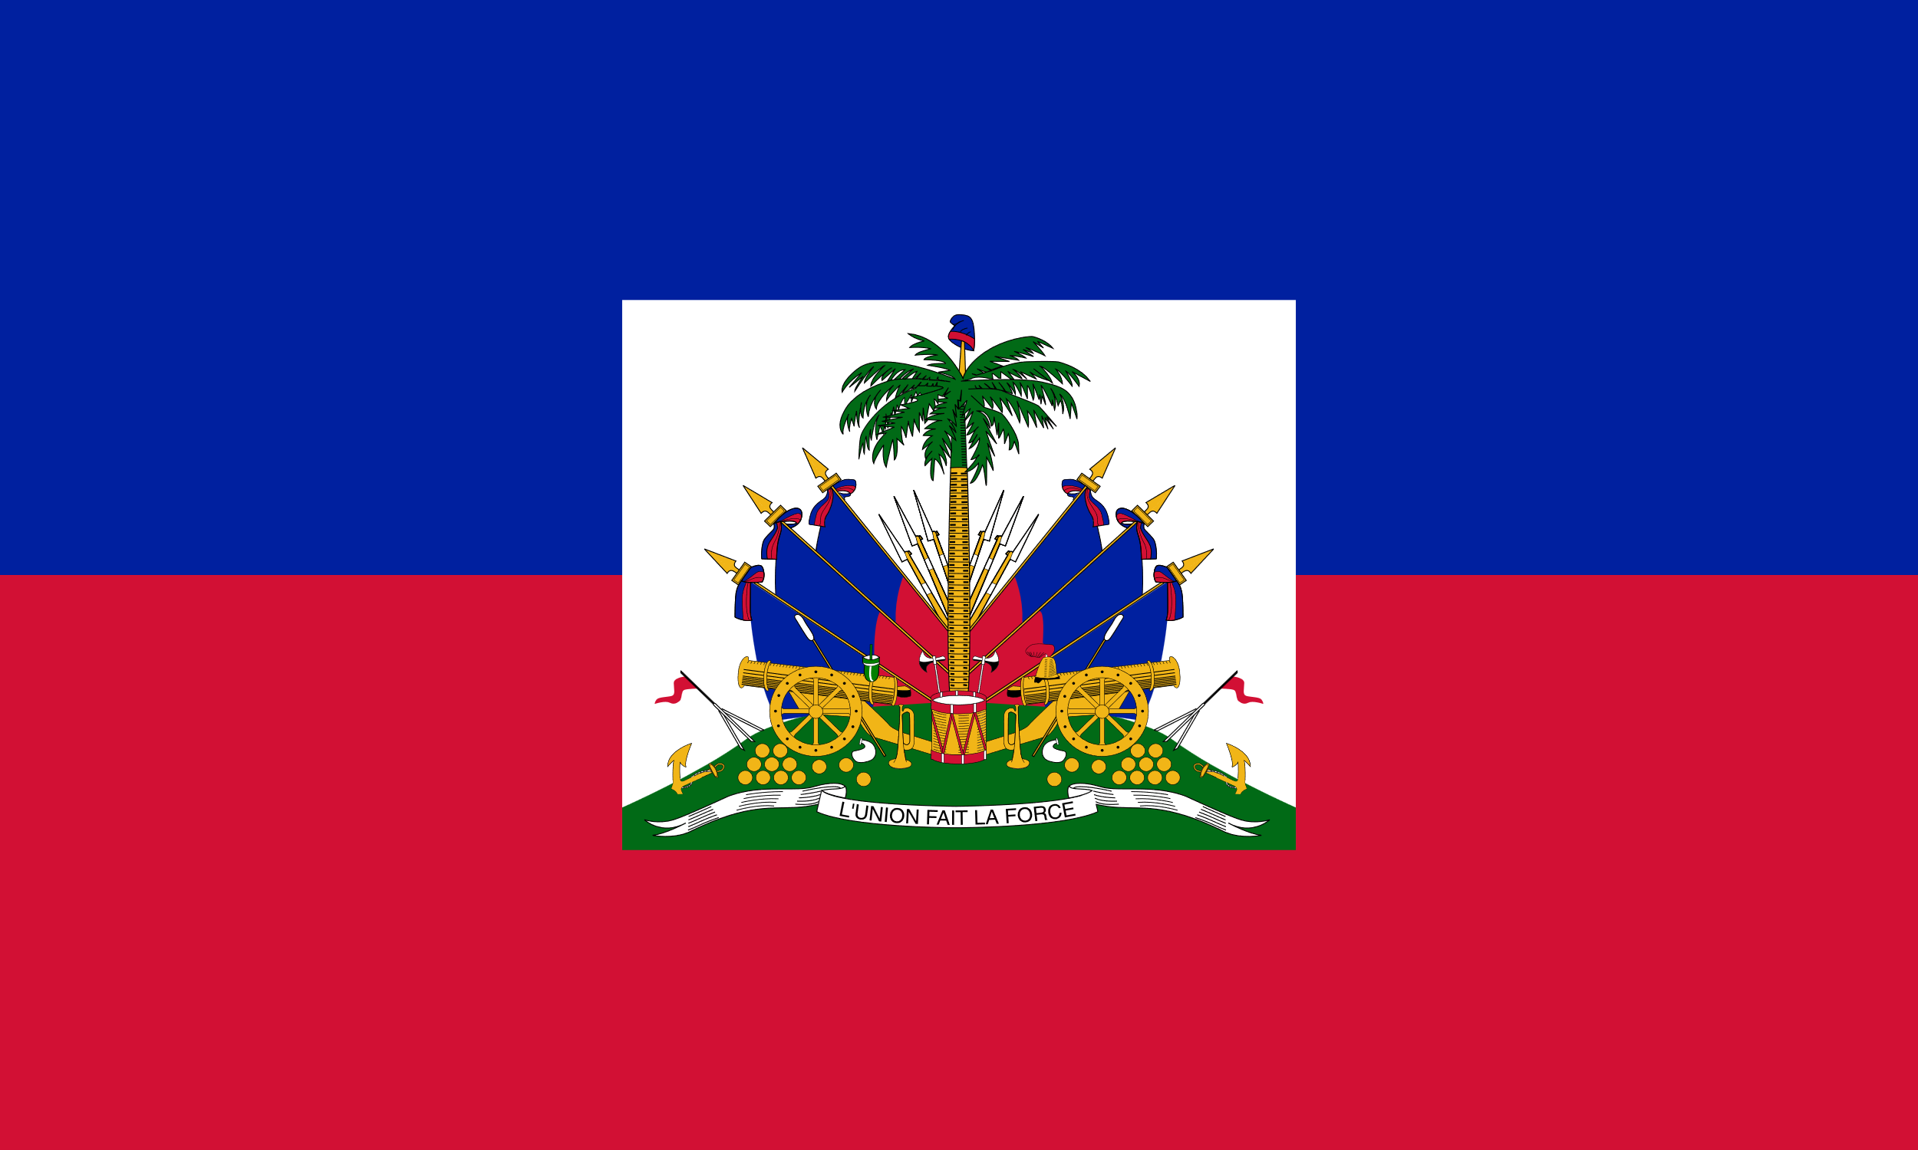  Haiti  هايتي

STUDENT HANDOUT LESSON 1
In this lesson, you will become familiar with the countries competing in the 2026 World Cup, with special attention to Morocco and its group.
Vocabulary
English | Arabic
World Cup | كأس العالم
Team / national team | فريق / منتخب
Host country | الدولة المستضيفة
Group / group stage | مجموعة / الدور الأول
Flag | علم
Continent | قارة
I root for / cheer for | أشجّع
Atlas Lions (Morocco’s nickname) | أُسود الأطلس
Important Structures
ألوان علم هذا البلد هي ___. (. ___ The colors of this country’s flag)
أشجّع فريق ___. (I cheer for the ___ team.)
Before Reading
1. What sport or team do you usually cheer for? Which countries or teams do you know that are competing in the 2026 World Cup? Write down a few notes to share in class.
Reading 1
2. The 2026 World Cup expanded from 32 to 48 teams for the first time. Below is Morocco’s group, Group C. Read the flag colors and match each description to a country.
GROUP C — المجموعة C
  Morocco  المغرب |   Brazil  البرازيل |   Scotland  اسكتلندا |   Haiti  هايتي

Speaking
3. With a partner, describe the flag of each Group C team using the Important Structures above. Then say which team you will cheer for and why.
After Reading
4. Look at a full FIFA Continental Zone chart. Sort Morocco, Brazil, Scotland, and Haiti by continent. How many Arabic-speaking countries qualified for the 2026 World Cup that you can name? (Hint: look for Morocco, Tunisia, Egypt, Saudi Arabia, Qatar, and Jordan.)
5. Bonus: Morocco’s Group C was called a “group of death” in the sports media. In your own words (in English), explain what that phrase means and why it applied to this group.

Lesson 2: World Cup Culture, Symbols, and Moroccan Football
الدرس 2: ثقافة كأس العالم ورموزه وكرة القدم المغربية
TEACHER PROCEDURE LESSON 2
Prior Knowledge
- Basic sports vocabulary; clothing and color vocabulary; numbers
Lesson Goals
Students will be able to:
- Describe the symbols and traditions associated with the World Cup, including mascots and the trophy
- Explain the importance of football (كرة القدم) in Moroccan culture
- Name Morocco’s nickname and describe the team’s colors and crest
Vocabulary
English | Arabic
Mascot | تميمة / تعويذة
Trophy | كأس
Fans / supporters | الجماهير / المشجّعون
Stadium | الملعب
Jersey / uniform | القميص الرياضي
Crest / emblem | الشعار
Passion / enthusiasm | الحماس
Pride | الفخر
Sources & Materials
- Images of previous World Cup mascots and trophies
- Images or descriptions of the Moroccan national team crest (a red shield bearing a green five-pointed star, topped with a golden crown)
Teacher Procedure
1. Before Speaking: Ask students what a mascot is and why major sporting events use them. Familiarize them with the Arabic word: تعويذة / تميمة.
2. Show images of a few historic World Cup mascots. Ask students to describe the colors and clothing of each mascot using vocabulary they already know.
THE OFFICIAL 2026 FIFA WORLD CUP MASCOTS
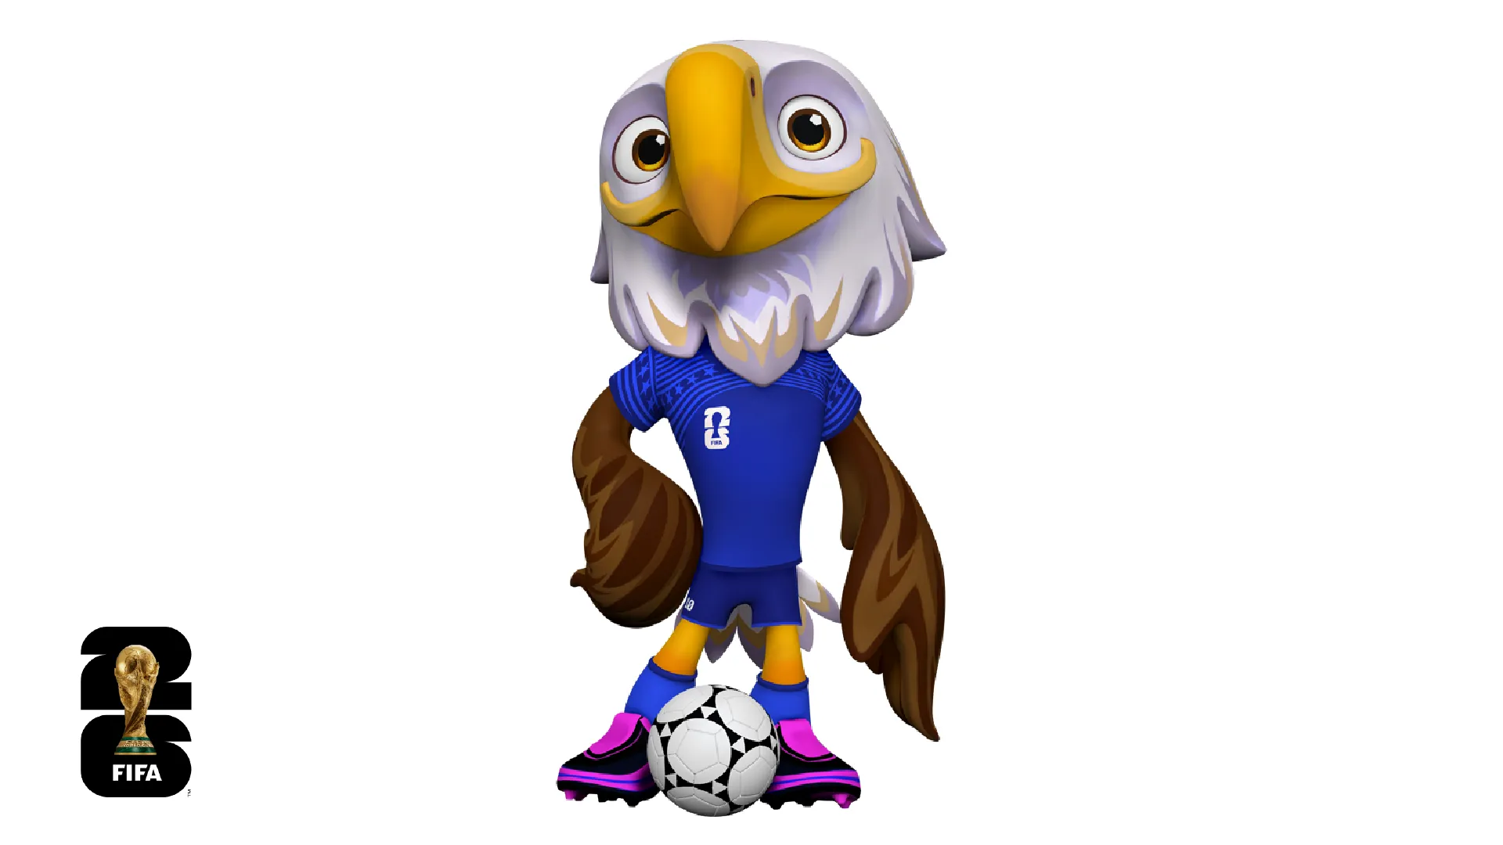  Clutch (USA) | 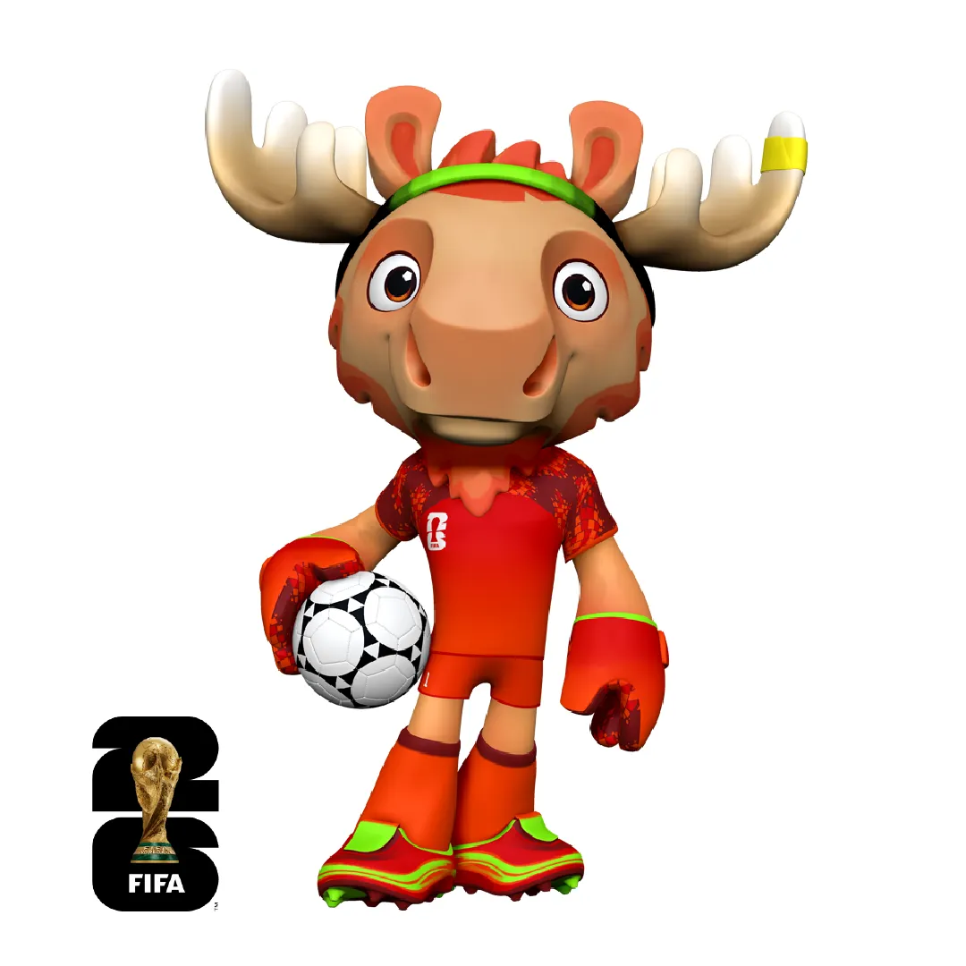  Maple (Canada) | 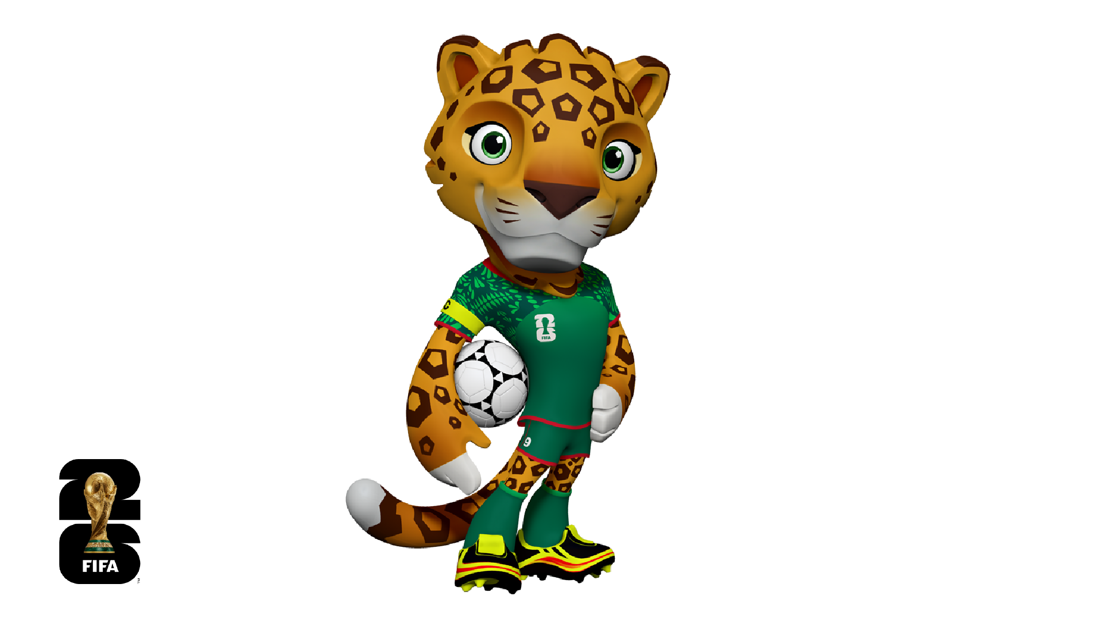  Zayu (Mexico)

3. Shift focus to football culture in Morocco. Explain that football is the most popular sport in Morocco, that Moroccan clubs such as Wydad Casablanca and Raja Casablanca have passionate, historic rivalries, and that the national team is affectionately known as أسود الأطلس (“the Atlas Lions”), named for the Atlas Mountains and the Barbary lion once native to Morocco.
4. Describe the Moroccan national crest: a red shield with a green five-pointed star, crowned in gold. Have students compare it with the flag they learned in Lesson 1.
5. Speaking: In small groups, students imagine and describe a mascot for the Moroccan national team for the 2026 World Cup, choosing an animal or symbol connected to Morocco (for example, the Atlas lion, a Barbary macaque, or a zellige-tile pattern) and describing its colors and clothing in Arabic.
6. After Speaking: Share mascot ideas as a class and vote on a favorite.

STUDENT HANDOUT LESSON 2
In this lesson, you will explore the traditions of the World Cup and learn about the deep connection between football and Moroccan culture.
Vocabulary
English | Arabic
Mascot | تميمة / تعويذة
Trophy | كأس
Fans / supporters | الجماهير / المشجّعون
Stadium | الملعب
Jersey / uniform | القميص الرياضي
Crest / emblem | الشعار
Passion / enthusiasm | الحماس
Pride | الفخر
Before Speaking
1. What is a mascot, and why do major events use them? Can you name a mascot from a sports team, school, or event you know?
THE OFFICIAL 2026 FIFA WORLD CUP MASCOTS
  Clutch (USA) |   Maple (Canada) |   Zayu (Mexico)

Reading
Morocco and Football: المغرب وكرة القدم
كرة القدم هي الرياضة الأكثر شعبية في المغرب.
اسم المنتخب المغربي هو أُسود الأطلس.
ألوان القميص المغربي هي الأحمر والأخضر.
2. Read the short passage above. What is Morocco’s national team called? What colors does the jersey have?
Speaking
3. In your group, invent a mascot for Morocco’s 2026 World Cup team. Choose an animal or symbol connected to Morocco (the Atlas lion is a strong choice!) and describe its colors and clothing in Arabic. Draw your mascot below.

After Speaking
4. Present your mascot to the class in Arabic. Which mascot did the class like best?

Lesson 3: The Moroccan Journey at the 2026 World Cup
الدرس 3: مسيرة المنتخب المغربي في كأس العالم 2026
This is the central lesson of the workbook
This lesson follows Morocco’s real, complete 2026 World Cup journey — from the group stage through elimination in the quarterfinals — using verified results, dates, and scorers.

TEACHER PROCEDURE LESSON 3
Prior Knowledge
- Numbers; past-tense verbs; basic sports vocabulary from Lessons 1–2
Lesson Goals
Students will be able to:
- Narrate Morocco’s 2026 World Cup run in chronological order, from the group stage to elimination
- Read short Arabic match reports and answer comprehension questions about scores, scorers, and outcomes
- Describe Morocco’s journey orally and in writing using past-tense structures
Vocabulary
English | Arabic
Match | مباراة
Team / national team | فريق / منتخب
Player | لاعب
Coach | مدرّب
Goal | هدف
Win | فوز
Lose | خسارة
Draw / tie | تعادل
Score / result | نتيجة
Group | مجموعة
Round | دور
Qualification | تأهّل
Elimination | إقصاء
Supporters / fans | المشجّعون / الجماهير
Stadium | الملعب
Final | النهائي
Semifinal | نصف النهائي
Quarterfinal | ربع النهائي
Round of 16 | دور الـ 16
Journey | مسيرة
Achievement | إنجاز
Victory | انتصار
Penalty shootout | ركلات الترجيح
Extra time | الوقت الإضافي
Important Structures
في المباراة بين المغرب و___، فاز ___ والنتيجة كانت ___.
(In the match between Morocco and ___, ___ won and the final score was ___.)
تأهّل المغرب إلى ___.
(Morocco qualified for ___.)
Sources & Materials
- Morocco’s 2026 World Cup Journey Tracker (below)
- Six short original match reports (below), written in simplified Modern Standard Arabic
Teacher Procedure
1. Before Reading: Ask students what they already know about Morocco’s 2022 World Cup run (semifinal finish, first African team to reach that stage). Explain that Morocco returned to the 2026 tournament aiming to go even further.
2. Present the Journey Tracker as a chronological overview. Read each row aloud with the class, modeling the Important Structures.
3. Reading: Distribute the six match reports. Depending on level, assign one report per pair/group or have the whole class read all six together.
4. Comprehension: After reading, groups answer the comprehension questions for their assigned match, then report back to the class in order, reconstructing Morocco’s full journey chronologically.
5. Speaking: In pairs, students take turns explaining Morocco’s journey to a partner from memory, using the tracker as a prompt if needed.
6. Writing: Students write a short paragraph titled “2026 مسيرة المغرب في كأس العالم” (“Describe Morocco’s journey at the 2026 World Cup”), using past-tense verbs and at least four of the vocabulary words above.
7. Sequencing: Give students the six key events out of order (see Student Handout) and have them number the events 1–6 in the correct chronological sequence.
8. Prediction/Reflection: Ask students to recall what they might have expected before the tournament (based on Morocco’s 2022 run) and compare it with what actually happened in 2026. Discuss as a class: was Morocco’s 2026 result a success, considering they became the first African team to reach back-to-back quarterfinals?
Morocco’s 2026 World Cup Journey Tracker — Teacher Answer Key
Stage | Opponent | Date | Score | Result | Key Moment
Group Stage | Brazil البرازيل | June 13, 2026 | 1–1 | Draw تعادل | Morocco holds five-time champions Brazil to a draw
Group Stage | Scotland اسكتلندا | June 19, 2026 | 1–0 | Win فوز | A single goal is enough for three crucial points
Group Stage | Haiti هايتي | June 24, 2026 | 4–2 | Win فوز | Rahimi’s 78′ goal seals top-eight finish in the group
Round of 32 | Netherlands هولندا | June 29, 2026 | 1–1 (a.e.t.) — won 3–2 on penalties | Win (PK) فوز بالترجيح | Diop’s 91′ equalizer forces extra time; Saibari seals it on penalties
Round of 16 | Canada كندا | July 4, 2026 | 3–0 | Win فوز | Ounahi scores twice in Houston
Quarterfinal | France فرنسا | July 9, 2026 | 0–2 | Loss خسارة | Mbappé and Dembélé end Morocco’s run in Boston

STUDENT HANDOUT LESSON 3
In this lesson, you will follow Morocco’s real 2026 World Cup journey, match by match, from the group stage to the quarterfinal.
Vocabulary
English | Arabic
Match | مباراة
Team / national team | فريق / منتخب
Player | لاعب
Coach | مدرّب
Goal | هدف
Win | فوز
Lose | خسارة
Draw / tie | تعادل
Score / result | نتيجة
Group | مجموعة
Round | دور
Journey | مسيرة
Achievement | إنجاز
Penalty shootout | ركلات الترجيح
Elimination | إقصاء
Quarterfinal | ربع النهائي
Important Structures
في المباراة بين المغرب و___، فاز ___ والنتيجة كانت ___.
Before Reading
1. What do you already know about Morocco’s 2022 World Cup run? Write one sentence about it.
Reading — Morocco’s Match Reports
2. Read your assigned match report(s) below and answer the comprehension questions that follow.
Match 1 — Morocco vs. Brazil (Group Stage)
في 13 يونيو 2026، لعب المنتخب المغربي ضد البرازيل في الدور الأول. انتهت المباراة بالتعادل 1‑1. كانت مباراة قوية بين فريقين كبيرين.

Match 2 — Scotland vs. Morocco (Group Stage)
في 19 يونيو 2026، فاز المنتخب المغربي على اسكتلندا بهدف واحد مقابل لا شيء (1‑0). فرحت الجماهير المغربية كثيرا بهذا الفوز.

Match 3 — Morocco vs. Haiti (Group Stage)
في 24 يونيو 2026، فاز المغرب على هايتي بأربعة أهداف مقابل هدفين (4‑2). سجّل اللاعب سفيان الرحيمي هدف الفوز في الدقيقة 78. تأهل المغرب إلى الدور الثاني في المركز الثاني بعد البرازيل.

Match 4 — Morocco vs. Netherlands (Round of 32)
في 29 يونيو 2026، لعب المغرب ضد هولندا في دور الـ 32. سجّلت هولندا هدفا في الدقيقة 72، ثم تعادل المغرب في الدقيقة 91. بعد الوقت الإضافي، فاز المغرب بركلات الترجيح 3‑2. صنع اللاعب إسماعيل الصيباري لحظة الفوز.

Match 5 — Morocco vs. Canada (Round of 16)
في 4 يوليو 2026، فاز المغرب على كندا 3‑0 في مدينة هيوستن. سجّل عز الدين أوناحي هدفين، وأضاف سفيان الرحيمي الهدف الثالث. تأهل المغرب إلى ربع النهائي للمرة الثانية على التوالي.

Match 6 — France vs. Morocco (Quarterfinal)
في 9 يوليو 2026، خسر المغرب أمام فرنسا 0‑2 في بوسطن. سجّل كيليان مبابي وعثمان ديمبيلي هدفي فرنسا. ودّع المغرب البطولة، لكنه أصبح أول منتخب أفريقي يصل إلى ربع النهائي في بطولتين متتاليتين (2022 و2026).

Comprehension Questions
من لعب ضد المغرب في المباراة الأولى؟ (Who did Morocco play first?)
(What was the result against the Netherlands?) ماذا كانت النتيجة ضد هولندا؟
من سجّل هدفين ضد كندا؟ (Who scored two goals against Canada?)
ما الدور الذي ودّع فيه المغرب البطولة؟ (?What round did Morocco leave the tournament in)
3. In your own words (English or Arabic), describe the most important moment of Morocco’s tournament.
Speaking
4. With a partner, take turns explaining Morocco’s journey from memory, from the first match to the last.
Writing
Writing Prompt
صف مسيرة المغرب في كأس العالم 2026.
(Describe Morocco’s journey at the 2026 World Cup.) Use at least four vocabulary words from this lesson and past-tense verbs.

Sequencing Activity
Number these events 1–6 in the order they happened:
- ……Morocco loses to France in the quarterfinal.
- ……Morocco draws 1–1 with Brazil in its opening match.
- ……Morocco defeats Canada 3–0 in the Round of 16.
- ……Morocco beats the Netherlands on penalties in the Round of 32.
- ……Morocco defeats Haiti 4–2 to close out the group stage.
- ……Morocco defeats Scotland 1–0.
Journey Tracker — Fill It In
Use the match reports above to complete the Score and Result columns.
Stage | Opponent | Date | Score | Result | Key Moment
Group Stage | Brazil البرازيل | June 13, 2026
Group Stage | Scotland اسكتلندا | June 19, 2026
Group Stage | Haiti هايتي | June 24, 2026
Round of 32 | Netherlands هولندا | June 29, 2026
Round of 16 | Canada كندا | July 4, 2026
Quarterfinal | France فرنسا | July 9, 2026
Prediction / Reflection
5. Before the tournament, what did you expect from Morocco, based on their 2022 semifinal run? Write one or two sentences.
6. Now that you know what actually happened, do you think Morocco’s 2026 World Cup was a success? Why or why not?

Lesson 4: Do You Want to Watch Morocco’s Game with Me?
الدرس 4: تريد أن تشاهد مباراة المغرب معي؟
TEACHER PROCEDURE LESSON 4
Prior Knowledge
- Telling time; talking about a weekly schedule (busy, free, studying, work, sports, eating)
- The verb “to watch”; days of the week
Lesson Goals
Students will be able to:
- State whether they are busy or free at a given time
- Invite a classmate to watch a Morocco match, and accept or decline an invitation
- Use the real dates of Morocco’s six 2026 World Cup matches to plan a viewing schedule
Vocabulary
English | Arabic
I watch | أشاهد
Busy | مشغول
Free | متفرغ
Because | لأن
Do you want to… ? | هل تريد أن…؟
Let’s watch together | لنشاهد معا
Schedule | جدول
I’m sorry, I can’t | آسف، لا أستطيع
Sources & Materials
- Morocco’s confirmed 2026 World Cup match dates (below)
- Student weekly schedule handout
Teacher Procedure
1. Review expressing being busy or free, and talking about daily commitments. Review vocabulary:
. أشاهد، مشغول، متفرغ، لأن
2. Present Morocco’s six confirmed 2026 World Cup match dates. Have students fill out a personal weekly schedule for the days these matches took place.
3. Speaking: Students walk around the room, inviting classmates in Arabic to watch a specific Morocco match with them. If a classmate is busy, they must give a reason. Model the exchange for the class first.
4. After Speaking: Each student reports back on who they found to watch a match with, and why others were busy.
5. Extension: Have students design a short poster in Arabic inviting the whole class to a viewing party for the France quarterfinal match on July 9.

STUDENT HANDOUT LESSON 4
In this lesson, you will find a time to watch one of Morocco’s World Cup matches with a friend.
Vocabulary
English | Arabic
I watch | أشاهد
Busy | مشغول
Free | متفرغ
Because | لأن
Do you want to… ? | هل تريد أن…؟
Let’s watch together | لنشاهد معا
Before Speaking: Morocco’s Match Schedule
1. Below are the confirmed dates of all six of Morocco’s 2026 World Cup matches. Circle the match you would most want to watch live.
المباراة | Date
المغرب ضد البرازيل | Saturday, June 13, 2026
اسكتلندا ضد المغرب | Friday, June 19, 2026
المغرب ضد هايتي | Wednesday, June 24, 2026
المغرب ضد هولندا (دور الـ 32) | Monday, June 29, 2026
المغرب ضد كندا (دور الـ 16) | Saturday, July 4, 2026
فرنسا ضد المغرب (ربع النهائي) | Thursday, July 9, 2026
Speaking
2. Walk around the classroom and ask at least three classmates: هل تريد أن تشاهد مباراة المغرب معي؟ If they are busy, ask them to explain why in Arabic and write their name and reason below.
Student name | متفرغ/ مشغول | Reason if busy
After Speaking
3. Who did you find to watch a Morocco match with? Report back to the class in Arabic.

Lesson 5: At the Match — Supporting Morocco
الدرس 5: في المباراة — نشجّع المغرب
TEACHER PROCEDURE LESSON 5
Prior Knowledge
- Basic sports vocabulary: player, ball, sport, team
Lesson Goals
Students will be able to:
- Cheer appropriately in Arabic when a goal is scored
- Name the positions of players on a soccer team
- Understand and discuss the lyrics of an Arabic World Cup anthem, “Tahayya”
- Describe the atmosphere of Moroccan football fandom and create their own supporter chant for Morocco
Vocabulary
English | Arabic
Goal ! | هدف!
Amazing! | مذهل !
Dangerous (move, kick) | خطيرة
Impossible ! | مستحيل
Player(s) | لاعب(ون)
Coach | مدرّب
Goalkeeper | حارس(ة) مرمى
Forward / attacker | مهاجم(ة)
Defender | مدافع(ة)
Midfielder | لاعب(ة) وسط
Position | مركز
Sources & Materials
- Player Positions Word Wall Cards
- Video clips of Morocco’s 2026 World Cup goals (on mute), for cheer practice
Song: Tahayya — Maher Zain & Humood
https://www.youtube.com/watch?v=1iWTl8DM7Rg
Teacher Procedure
1. Before Listening: Tell students they are going to مباراة كرة القدم today. Show muted clips of Morocco’s 2026 goals (for example, Rahimi’s winner against Haiti or Ounahi’s brace against Canada) and have students brainstorm cheers or reactions.
2. Teach the goal-scoring vocabulary above. Watch more clips and have students react using the new words.
3. Post player-position vocabulary around the room. Build a soccer field on the floor using position names, then call out positions for students to run to (e.g., أنت حارس مرمى). Repeat with different students acting as مدرّب.
4. Before Listening 2: Ask students what World Cup songs and football chants they know, and how music builds excitement around a tournament.
5. Listening Activity: Play “Tahayya” by Maher Zain and Humood. As students listen, have them jot down any Arabic words they recognize.
6. Vocabulary Activity: Guide students to identify words connected to welcome, world, unity, stadium, flags, dreams, victory, peace, and celebration as they occur in the song.
7. Speaking Activity: In groups, discuss: What is the main message of the song? Which words did you recognize? How does the song create a World Cup atmosphere?
8. Morocco Connection: Discuss how songs like “Tahayya” connect to Arab football culture and to the way Moroccan supporters created a joyful, musical atmosphere around the team throughout the 2026 tournament, from the group stage in Atlanta and Boston through the quarterfinal in Boston.
9. Writing: In groups, students write their own 2026 World Cup cheer or chant for Morocco (at least four lines, with a one- or two-line chorus).
10. Speaking Activity 2: Groups perform their chants for the class.

STUDENT HANDOUT LESSON 5
In this lesson, you will learn player positions, practice football cheers, listen to an Arabic World Cup anthem, and create your own chant to support Morocco.
Vocabulary
English | Arabic
Goal ! | هدف!
Amazing ! | مذهل !
Player(s) | لاعب(ون)
Goalkeeper | حارس(ة) مرمى
Forward / attacker | مهاجم(ة)
Defender | مدافع(ة)
Midfielder | لاعب(ة) وسط
Before Listening
1. You are finally ready to watch a real! مباراة كرة القدم Brainstorm cheers or reactions you might use when Morocco scores.
Listening: Player Positions
2. Your teacher will assign positions to your classmates on a classroom “field.” Write each classmate’s name and position (in Arabic) in the correct spot below.

Before Listening 2: Tahayya
Music has always been part of World Cup culture. You will listen to “Tahayya” by Maher Zain and Humood.
https://www.youtube.com/watch?v=1iWTl8DM7Rg
Listening Activity
3. As you listen, write down any Arabic words you recognize. Look especially for words connected to welcome, world, unity, stadium, flags, dreams, victory, peace, and celebration.

Speaking
4. Discuss with a partner: What is the main message of the song? Which part did you like best? How does the song create a World Cup atmosphere?
5. Morocco Connection: How does a song like this connect to the way Moroccan fans supported the Atlas Lions throughout the 2026 tournament?
Writing: Create Your Own Chant
6. In your group, write a cheer or chant for Morocco’s 2026 World Cup team. It must be at least 4 lines long and include a 1–2-line chorus.

Speaking Activity 2
7. Perform your chant for the class!

🎵 2026 World Cup Song — An Anthem of Enthusiasm and Learning
🎵 أغنية كأس العالم 2026 — نشيد الحماس والتعلم
An original song written for Arabic learners, celebrating the excitement of the 2026 World Cup and Morocco's journey. Read the Arabic lyrics aloud, use the pronunciation guide underneath each line, then review the new vocabulary below.
Song Lyrics — كلمات الأغنية
في المَلعَبِ الكَبيرِ نَلعَبْ
Fil-mal‘abil-kabīri nal‘ab
والفَريقُ بِقُوَّةٍ يَتَقَدَّمْ
Wal-farīqu bi-quwwatin yataqaddam
كُلُّ هَدَفٍ يَزيدُ فَرحَتَنا
Kullu hadafin yazīdu farḥatanā
وَصَوتُ التَشجيعِ يَعلو صَوتَنا
Wa ṣawtut-tashjī‘i ya‘lū ṣawtanā
(Chorus)
هَيّا هَيّا يا مُنتَخَبْ
Hayyā hayyā yā muntakhab
كُلَّ يَومٍ نَلعَبُ وَنُشَجِّعْ
Kulla yawmin nal‘abu wa nushajji‘
كُرَةُ القَدَمِ تَجمَعُنا
Kuratul-qadami tajma‘unā
وَالفَرَحُ دائِماً مَعَنا
Wal-faraḥu dā’iman ma‘anā
أُسودُ الأَطلَسِ تَسيرُ بِثِقَةْ
Usūdul-Aṭlasi tasīru bi-thiqah
في كَأسِ العالَمِ بِشَجاعَةٍ وَقُوَّةْ
Fī ka’sil-‘ālami bi-shajā‘atin wa quwwah
كُلُّ خُطوَةٍ نَحوَ الفَوزِ جَميلَةْ
Kullu khuṭwatin naḥwal-fawzi jamīlah
نَتَعَلَّمُ العَرَبِيَّةَ بِابتِسامَةٍ أَصيلَةْ
Nata‘allamul-‘arabiyyata bi-ibtisāmatin aṣīlah
(Chorus repeats)
هَيّا هَيّا يا مُنتَخَبْ
Hayyā hayyā yā muntakhab
كُلَّ يَومٍ نَلعَبُ وَنُشَجِّعْ
Kulla yawmin nal‘abu wa nushajji‘
كُرَةُ القَدَمِ تَجمَعُنا
Kuratul-qadami tajma‘unā
وَالفَرَحُ دائِماً مَعَنا
Wal-faraḥu dā’iman ma‘anā
تَحيا الرِياضَةُ، تَحيا اللُغَةْ
Taḥyar-riyāḍatu, taḥyal-lughah
مَعاً نَحلُمُ، مَعاً نَبتَسِمْ
Ma‘an naḥlumu, ma‘an nabtasim

📚 كلمات جديدة — New Vocabulary
Français | Arabic
Équipe nationale | مُنتَخَب
But (au football) | هَدَف
Football | كُرَةُ القَدَم
Stade / terrain | مَلعَب
Victoire | فَوز
Encouragement / soutien | تَشجيع
Joie | فَرَح
Les Lions de l'Atlas (surnom du Maroc) | أُسودُ الأَطلَس

Prepared by
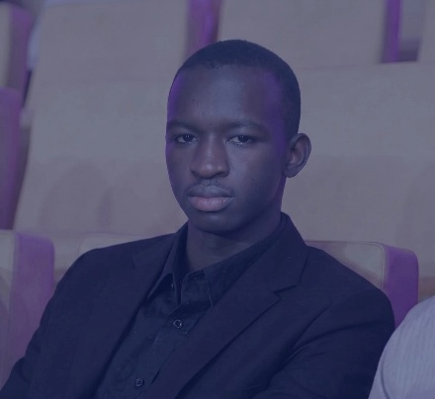
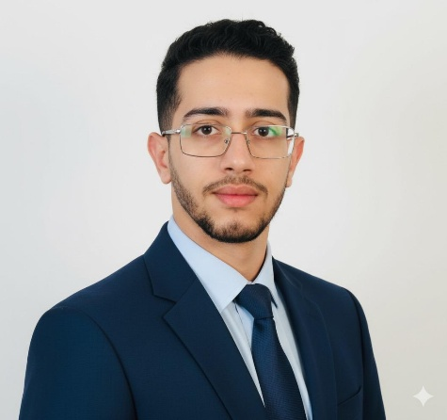
This document was prepared by:
Noura LATIFI | Kouma LASSANA | Othman LAAFAR
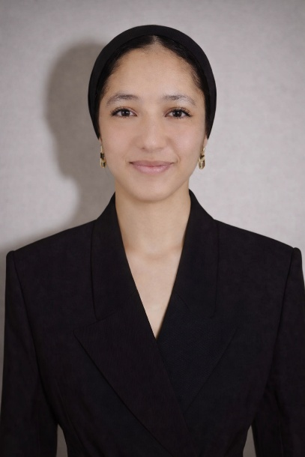
Supervised by:
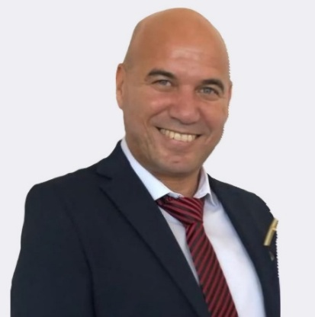
Mr. Nabil El Moutawakil El Alami
In partnership with:
M2N Link Solutions

