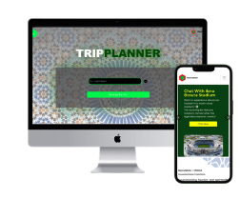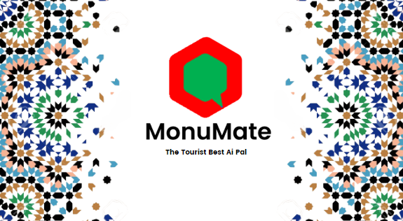

At MonuMate, we're dedicated to revolutionizing travel with AI, catering to football events like CAN 2025 and the World Cup. Combining technology and cultural immersion, we craft personalized journeys that redefine tourism.

At MonuMate, we're dedicated to revolutionizing travel with AI, catering to football events like CAN 2025 and the World Cup. Combining technology and cultural immersion, we craft personalized journeys that redefine tourism.

