**Gulliver Travels Hotel Website -**[**link**](http://www.gulliverstravelhotelgh.com/)

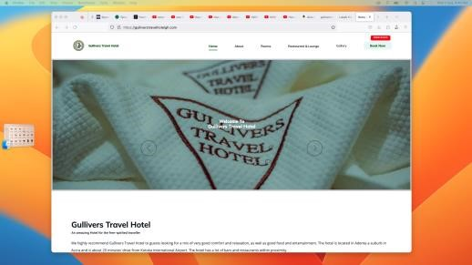

* Designed and developed a comprehensive school website using HTML, CSS, and PHP.
* Created a user-friendly interface to showcase school programs, events, and enrollment information.
* Implemented interactive features to engage

students, parents, and teachers.

# Lobab Kids School Website - [link](https://lobab-kids.netlify.app/)

* Designed and developed a comprehensive school website using HTML, CSS, and PHP.
* Created a user-friendly interface to showcase school programs, events, and enrollment information.
* Implemented interactive features to engage students, parents, and teachers.

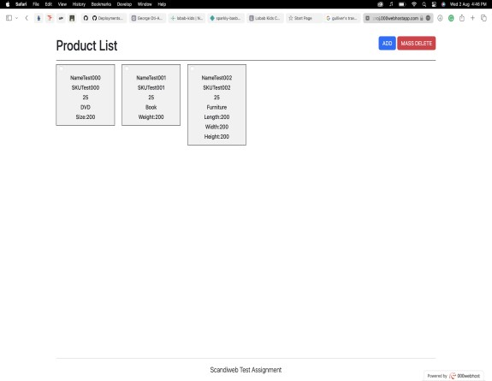

*Add a caption for your picture.*

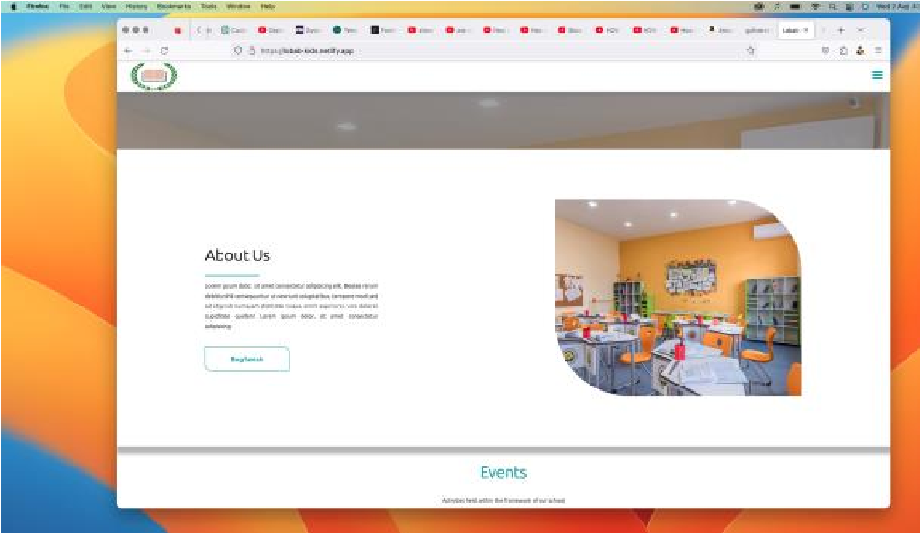

*Add a caption for your picture.*

## TheProduct(CRUD Product List Page) - n ni [link](http://scwproj.000webhostapp.com/)

* Built a dynamic product list page using PHP for Create, Read, Update, and Delete (CRUD) operations.
* Created a RESTful API with PHP to handle data interactions.
* Interfaced the API with HTML, CSS, and

JavaScript using AJAX and Fetch for seamless user experience.

* Developed a React version of the front end for enhanced user interaction and responsiveness.
* Developed a secure OTP (One-Time Password) generator using PHP and an exact replica in Nodejs.

**Urban Condos Website**

**-**

[**k**](http://www.urbancondosgh.com/)

[**lin**](http://www.urbancondosgh.com/)

**COVID**

**-**

**19**

**Mobile App**

•

Developed a mobile app using Flutter to provide

real

-

time COVID

-

statistics.

19

•

Integrated APIs to fetch and display accurate

data on infection rates, recoveries, and

fatalities.

•

Designed an intuitive user interface for easy

navigation and information access

**GESA App**

**-**

**Student App for the College of**

**Engineering**

•

Developed the official mobile app for

the

College of Engineering using Flutter.

•

Enabled students to access important

announcements, schedules, and resources.

•

Collaborated with a team to ensure seamless

functionality and user experience.

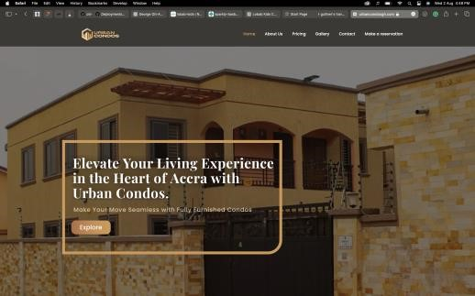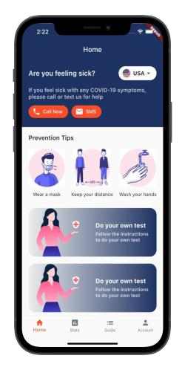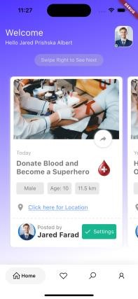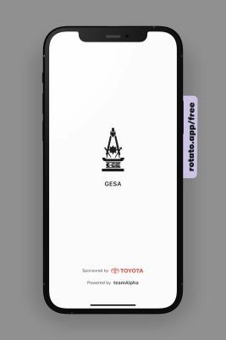

* Implemented OTP verification in Node.js for enhanced user authentication.
* Used cryptography principles to ensure data integrity and security.

# Blood Donation UI App

* Designed and built a mobile app UI prototype for a blood donation platform.
* Utilized Flutter to create an appealing and user-friendly interface.
* Focused on user experience to encourage blood donation and community engagement.

|  |
| --- |
| **Skills**     * Languages: Golang, C, PHP, Dart * Frameworks: Flutter, Wails * Web Development: HTML, CSS, PHP, React * Mobile Development: Flutter * Version Control: Git * Problem Solving: Algorithmic thinking, debugging, optimization * Project Management: Agile methodologies, teamwork, communication     **Contact Information**  Feel free to reach out to me via email at jrgeorge991@gmail or connect with me on [+233500052067]. |