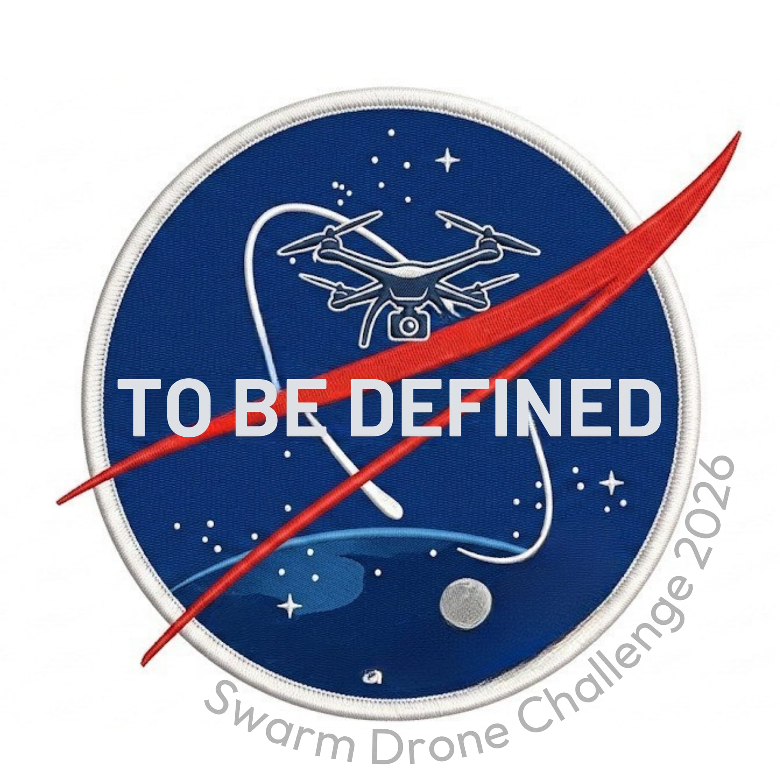
SWARM DRONE CHALLENGE 2026
Technical Report
Team To Be Defined
René (Electronics) • Thomas (Software) • Sascha (IT)
Oliver (AI) • Vicki (Project Management)
April 2026
Submitted to brigkAIR / MBDA

1. Introduction
This report describes the design, implementation, and functionality of the autonomous drone swarm system developed by Team To Be Defined for the Swarm Drone Challenge 2026 (SDC26). Our system enables 2–5 Parrot Anafi drones to operate as a coordinated swarm in the Capture the Flag arena, executing real-time perception, autonomous navigation, and collaborative strategy through a centralized Command and Control (C2) architecture.
Our design philosophy rests on three pillars:
- Device-agnostic architecture: A unified REST API abstracts all drone hardware, allowing the intelligence layer to operate independently of the underlying platform.
- AI-first development: The entire codebase was developed using agentic AI (Claude Code), enabling rapid iteration on complex subsystems like PD controllers, FSM-based missions, and neural network integration.
- Centralized C2 with per-drone autonomy: A single C2 server coordinates fleet strategy while each flight controller runs its own vision pipeline and flight control loop at minimal latency.
The system is implemented entirely in Python 3, using Flask for web services, OpenCV for computer vision, and standard scientific Python libraries (NumPy, SciPy). No proprietary middleware or commercial autopilot software is used.

2. System Architecture

2.1 Hardware Configuration
The swarm consists of the following hardware components:
- 5 × Parrot Anafi drones: Competition-grade quadcopters equipped with 4K gimbal cameras, GPS, barometer, and IMU. Controlled via the Olympe SDK over Wi-Fi. Each drone streams MJPEG video and telemetry in real time.
- 5 × Flight controllers: x86_64 Linux-based computers, each paired 1:1 with a drone over a dedicated Wi-Fi link. Each controller runs the unified API server, the ArUco vision pipeline, and the local flight control loop.
- 1 × C2 server: A central x86_64 Linux machine connected to all flight controllers over a wired LAN. Runs the web-based C2 dashboard, strategy engine, mission orchestrator, and collision avoidance logic.

2.2 Software Stack
Each flight controller exposes a unified REST API that abstracts the Parrot Olympe SDK behind standardized HTTP endpoints. This device-agnostic design means the entire intelligence layer—from ArUco positioning to mission orchestration—communicates through the same API regardless of the underlying drone hardware. The API provides endpoints for:
- Takeoff, landing, and emergency stop commands
- RC-style continuous control (forward/back, left/right, up/down, yaw)
- Real-time telemetry polling (attitude, velocity, battery, GPS)
- MJPEG video stream access for both the downward and forward cameras
- State management and flight mode switching
Communication protocols: The C2 server sends target coordinates to flight controllers via HTTP (REST). Flight controllers report their estimated position and telemetry back to C2 via UDP for low-latency state updates. Each flight controller communicates with its paired Anafi drone over Wi-Fi, carrying control commands, telemetry, and the MJPEG video stream.

2.3 C2 Web Controller
The C2 server hosts a Flask-based web dashboard (remote_web_controller.py) that provides a single-pane-of-glass view of the entire fleet. The dashboard supports:
- Live per-drone video feeds with ArUco marker overlay
- A 2D top-down arena map showing all drone positions and detected markers
- Per-drone telemetry (battery, altitude, attitude, velocity, signal strength)
- Manual OBSERVE and LIVE mode control for the ArUco seek module
- 21 live-tunable PD + IMU-D controller parameters per drone
- Special mission launch and monitoring with per-drone FSM phase badges
- Fleet-wide emergency stop, kill switch, and individual drone commands

3. Perception & Positioning

3.1 ArUco Marker-Based Positioning
The arena contains 24 ArUco markers from the DICT_4X4_50 dictionary, each 0.5 m × 0.5 m, mounted on pillars at heights of 2 m and 4 m around the perimeter. An additional origin marker (ID 0) is placed at the back wall center and serves as the local coordinate frame reference.
Each flight controller runs a real-time ArUco detection pipeline using OpenCV’s ArUco module. The pipeline operates at approximately 5 Hz and performs:
- Marker detection and pose estimation: cv2.aruco.detectMarkers identifies visible markers in each MJPEG frame. The known marker size (0.5 m) enables single-marker distance estimation via a calibrated power-law model: distance = A × pixel_size^(−B).
- EMA-filtered error signals: Raw pixel errors (horizontal offset, vertical offset, perspective skew, distance) are passed through exponential moving average filters (α = 0.30) with configurable soft deadbands to suppress micro-jitter.
- PD control with IMU damping: The proportional term (camera-based visual servoing) provides the command signal, while the derivative term uses IMU velocity data (vgx, vgy, vgz from the Anafi telemetry at body-frame cm/s) to actively damp oscillations. Yaw rate damping uses differentiated heading samples. All 21 gain and threshold parameters are live-tunable from the C2 dashboard.
The controller supports two operational modes: OBSERVE (detection only, no actuation) and LIVE (closed-loop flight control). Mode switching is gated by the C2 dashboard and can be disabled fleet-wide via environment variable.

3.2 YOLO Drone Detection
To detect opposing team drones in the arena, we trained a YOLO11n (nano) single-class detector on the Seraphim drone detection dataset (83,483 images, 640×640 resolution, CC BY 4.0 license from HuggingFace).
Platform | Format | Inference | FPS
x86_64 (CPU) | ONNX | ~50 ms | 20
RPi 5 | NCNN | ~67 ms | 15
Jetson Orin Nano | TensorRT FP16 | ~27 ms | 37
Table 1: YOLO11n inference performance across deployment targets.
The DroneDetector module runs as a background thread consuming the same MJPEG stream as the ArUco pipeline. It uses OpenCV DNN (cv2.dnn.readNetFromONNX) for inference—no PyTorch required at runtime. Detections are exposed as normalized relative coordinates (rel_x, rel_y ∈ [−1, +1]) and bounding box area (proxy for distance). The module is rate-limited to 10 FPS to coexist with ArUco detection without saturating the CPU.
The intended consumer is an evasion module using artificial potential fields with altitude-layer separation for inter-team collision avoidance.

4. Swarm Coordination

4.1 Fleet Management
The ObserverFleet module (aruco_seek_multi.py) manages a dictionary of per-drone DroneObserver instances. Each observer is fully self-contained with its own HTTP session, API base URL, parameter set, target marker, EMA filter state, and background threads. This design avoids module-level globals, enabling N observers to run in parallel without interference.
When the C2 operator modifies the fleet configuration (add/remove drones, change API endpoints), the fleet automatically synchronizes by creating or destroying observer instances.

4.2 Mission Orchestration
Missions are implemented as finite state machines (FSMs) running on dedicated daemon threads. The first implemented mission—Scan All Markers—demonstrates the coordination framework:
FSM State | Behavior
SEARCH | Drone rotates to find an unclaimed visible ArUco marker. Claims it via a shared map.
APPROACH | Drone flies toward the claimed marker using PD control until within the approach tolerance.
HOVER | Drone holds position in front of the marker for a configurable duration (default: 2 seconds).
DONE | Marker is added to the scanned set. Drone returns to SEARCH for the next unclaimed marker.
ERROR | Recovery state for lost sight, timeout, or communication failure.
Table 2: FSM states for the Scan All Markers mission.

4.3 Collision Avoidance
The mission orchestrator maintains a shared claim map (claimed: dict[drone_id → marker_id]) that prevents two drones from targeting the same marker simultaneously. When a drone in SEARCH state identifies a candidate marker, it checks the claim map before committing. If another drone has already claimed that marker, the second drone either selects an alternative or hovers in place until the first drone completes its scan.
If a drone loses sight of its claimed marker mid-hover, it releases the claim and transitions back to SEARCH, freeing the marker for other drones. The mission tick rate is 0.5 seconds, balancing responsiveness against computational overhead.

4.4 Arena Configuration
A regulation-faithful JSON configuration file (arena_config_default.json) encodes the complete SDC26 arena: 20 m × 10 m × 6 m field dimensions, equal-thirds zone partitioning (red / neutral / blue at 6.667 m intervals), all 25 marker positions per Figure 3 of the regulations, and the full scoring/timing ruleset (5 s color hold, 2 s hover-to-revert, 5 s home-zone validation, 600 s match duration). This configuration drives the arena visualization, mission planning, and spatial reasoning across all modules.

5. Development Methodology & Outlook

5.1 Agentic AI Development
A distinctive aspect of our approach is the systematic use of agentic AI (Anthropic’s Claude Code) as a development partner throughout the project. Rather than using AI as an occasional coding assistant, Claude Code operates as a full team member: writing production modules, reviewing code, debugging integration issues, and iterating on controller tuning.
Key examples include:
- The entire aruco_seek_multi.py module (430+ lines)—including the per-drone observer architecture, FSM mission logic, and claim-based collision avoidance—was designed and implemented through agentic AI collaboration.
- The C2 web controller received 900+ lines of additions (ArUco panel, mission panel, 16 new API routes) in a single iterative session.
- The arena_config_default.json was derived directly from the SDC26 regulations PDF, with every marker position, scoring rule, and timing constraint extracted and validated programmatically.
- Live PD tuning parameters were designed as hot-reloadable dataclasses, enabling rapid in-flight tuning without code changes.
This methodology has proven highly effective for rapid prototyping of complex real-time systems, reducing the time from concept to working code by an estimated factor of 5–10× compared to traditional development.

5.2 Testing & Validation
The system supports a dry-run mode that skips takeoff, landing, and PCMD commands while logging all RC outputs for offline analysis. This enables full mission rehearsal without risking drone hardware. The unified API’s device-agnostic design also allows testing against a software-in-the-loop simulator before deploying to physical drones.

5.3 Future Work
Before the competition, we plan to:
- Implement the evasion module consuming YOLO detections via artificial potential fields with altitude-layer separation for inter-team collision avoidance.
- Develop the full Capture the Flag strategy engine on the C2 server, including target assignment, scoring optimization, and defensive positioning.
- Fine-tune the YOLO model on images of drones with spherical protection cases, matching the actual competition appearance.
- Integrate UDP-based low-latency position reporting from flight controllers to C2 for tighter coordination loops.
- Conduct multi-drone integration testing in progressively larger arena configurations.

— End of Report —

