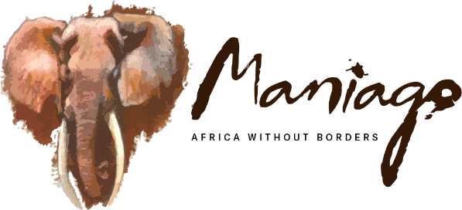

25TH ANNIVERSARY AND THE FUTURE

Prepared for

JASON BELL

15TH TO 26TH SEPTEMBER 2025

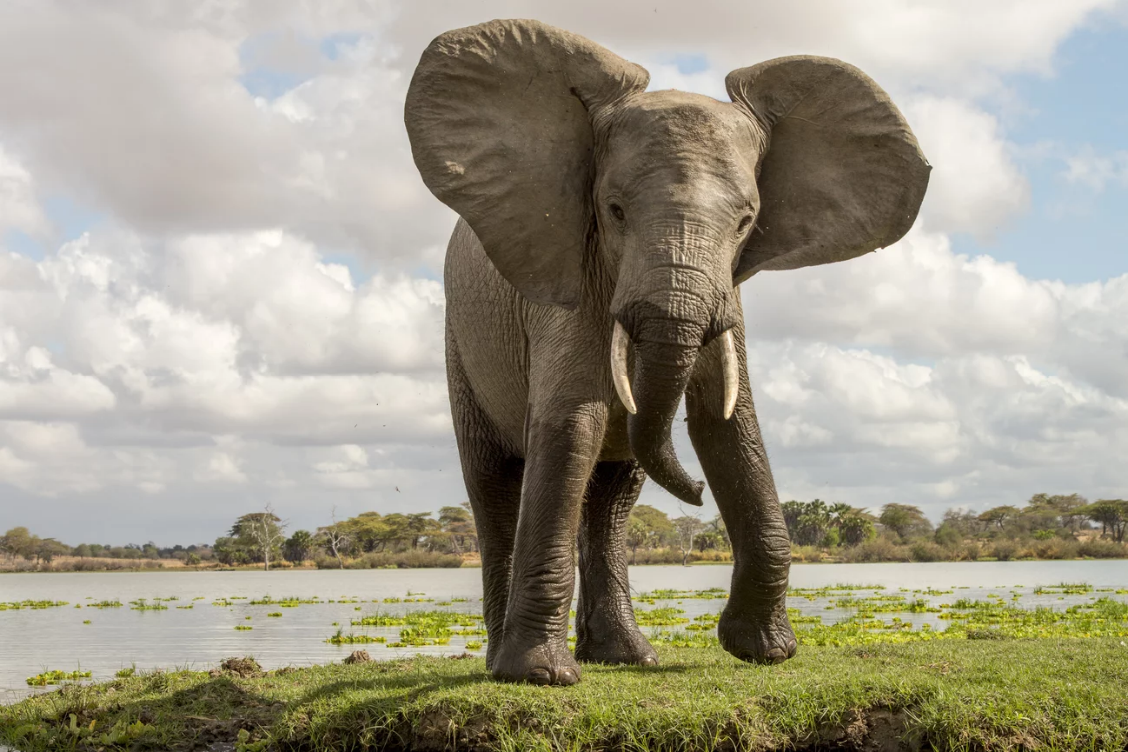

|  |  |
| --- | --- |
| 15TH SEPTEMBER: NAIROBI | |
|  | 22:20hrs. Arrive at Jomo Kenyatta International Airport on flight KQ793, where you will be met and transferred to the Nairobi Serena Hotel.  Overnight at Nairobi Serena Hotel – Deluxe Rooms (Breakfast, lunch and Dinner) |
| 16TH SEPTEMBER: NAIROBI | |
| Breakfast at the hotel.  0800Hrs: Early morning game drive in the Nairobi National Park. |  |
| Meeting and Lunch with IFAW Staff  Dinner hosted by Maniago at Nairobi Serena. | |
| 17TH SEPTEMBER: NAIROBI / SAMBURU NATIONAL RESERVE | |
|  | Breakfast at the hotel.  0700Hrs: Check out of the hotel and transfer to Wilson Airport.  0800Hrs: Depart on a Scenic Air charter flight to Samburu National Park. |
| Met at Buffalo Springs airstrip by Maniago Safaris driver guides and transferred to Samburu Lodge with a game drive en route.  Lunch at the lodge.  Afternoon meeting with the Traditional Leaders at the lodge  Late this afternoon, your driver guides will drive empty to Meru so that they can meet you at the airstrip the next morning.  Overnight at Soroi Samburu Lodge – (Meals: Breakfast, Lunch and Dinner) | |
| ACCOMMODATION: SOROI SAMBURU LODGE | |
| Discover the epitome of wilderness adventure paired with comfort at the Soroi Samburu Lodge. Opened in July 2025, this extraordinary lodge is nestled in the heart of the rugged Samburu landscape, offering a blend of authentic safari experiences and modern conveniences. |  |
| The lodge caters to diverse preferences with a total of 50.  Rooms (comprised of standard rooms, superior rooms, and family units), making it an ideal choice for corporate getaways, conferences, and incentive trips.  In Samburu, search for rare game only found north of the equator, such as the reticulated giraffe, gerenuk, Grevy’s zebra, Beisa Oryx, and Somali ostrich. Samburu lies in the vast, hot, and arid northern region of Kenya and is adjacent to Buffalo Springs and Shaba National Reserves. | |

|  |  |
| --- | --- |
| 18TH SEPTEMBER: SAMBURU NATIONAL RESERVE / MERU/ SAMBURU | |
|  | Breakfast at the hotel.  0700Hrs Transfer back to Buffalo Springs airstrip by Lodge vehicles for a Tropic Air charter flight to Meru National Park.  0800Hrs Fly to Meru – Murera airstrip |
| 0830Hrs Met on arrival at Murera airstrip by Maniago driver guides and will be transferred to the conservation projects in Meru.  Visit Conservation projects supported by IFAW.  Visit the Park Headquarters and the Rhino Sanctuary.  Lunch at Elsa’s Kopje.  1500Hrs Late in the afternoon, you will be transferred to Kinna airstrip for your Tropic Air Charter.  1600Hrs: Fly back to Buffalo Springs airstrip.  1630Hrs: Met by your lodge driver guides and transferred to Samburu Lodge with a short game drive en route.  Overnight at Soroi Samburu Lodge – (Meals: Breakfast, Lunch and Dinner) | |

|  |  |
| --- | --- |
| 19TH SEPTEMBER: SAMBURU NATIONAL RESERVE | |
| Breakfast at the lodge.  Visit Conservation Projects in Samburu and talk with Samburu Traditional Leaders. Itinerary led by Tom Lesarge.  Lunch at the lodge. |  |
| Overnight at Soroi Samburu Lodge – (Meals: Breakfast, Lunch and Dinner) | |
| 20TH SEPTEMBER: SAMBURU NATIONAL RESERVE/ LEWA / SAMBURU  ( Approx. 2hrs each way) | |
| Breakfast at the lodge.  Drive to Lewa Conservancy and attend the World Ranger Challenge.  Lunch at Ngiri House  Return to your lodge in the late evening.  Overnight at Soroi Samburu Lodge – (Meals: Breakfast, Lunch and Dinner) | |
| 21ST SEPTEMBER: SAMBURU/RETETI/SAMBURU | |
|  | Breakfast at the lodge.  Drive to Reteti Elephant Orphanage for a public visit taking place between 1130Hrs to 1230Hrs.  Lunch at Reteti House. |
| More activities at Namunyak Conservancy before returning to Soroi Samburu Lodge in the late evening.  Overnight at Soroi Samburu Lodge – (Meals: Breakfast, Lunch and Dinner) | |

|  |  |
| --- | --- |
| 22ND SEPTEMBER: SAMBURU NATIONAL RESERVE / LAMU | |
|  | Early breakfast at the lodge and check out  08:00Hrs: Transfer to Buffalo Springs airstrip  08:30Hrs: Depart on a Scenic Air Charter flight to Manda airstrip in Lamu |
| 09:55Hrs: Arrive at Manda airstrip.  Met by a representative of Manda Bay and transferred to Manda Bay Lodge.  Lunch and dinner are included  Afternoon briefing by IFAW Marine co-ordinator FlipFlopi/IFAW  Overnight at Manda Bay Lodge - Beach Front, Palm and Garden Rooms (Breakfast, Lunch and Dinner) | |
| 23RD TO 26TH SEPTEMBER: LAMU | |
| Spend three more days in Lamu, attending meetings and visiting the local conservation projects.  On 23rd September, visit FlipFlopi with PRATI (Pate Community group). |  |
| On 24th September, Whale watching / Marine activity for filming/footage.  On 25th September, Tour of Lamu and sunset dhow trip  Game drive in Manda Island and sundowners  16:45hrs Transfer to Manda Bay airport for a flight to Nairobi.  Met on arrival at Wilson Airport and transferred to Four Points by Sheraton Nairobi Airport.  Lunch at the hotel.  Overnight at Four Points by Sheraton Nairobi Hotel – Standard Room (Breakfast, Lunch and Dinner) | |
| 26TH SEPTEMBER: NAIROBI / DEPART | |
| Early morning breakfast at the hotel.  Transfer to the departure terminal for your KQ782 Flight departing at 07:30Hrs. | |

|  |
| --- |
| INCLUSIONS & EXCLUSIONS  Included in the programme:   * Meet and greet services on arrival at Jomo Kenyatta International Airport, as well as on departure * Private airport transfers in Nairobi * Services of our professional English-speaking driver guide/s for various movements * Transport and game drives in Two Maniago Safaris six-seater 4x4 safari land cruisers on exclusive use in Samburu National Park, Meru, to Reteti Elephant Orphanage visit, Lewa Conservancy, Tsavo West National Park and Amboseli National Park * One Alphard at disposal in Nairobi with an English-speaking guide * Accommodation at Nairobi Serena Hotel on Full board basis in Deluxe rooms * Accommodation at Samburu Lodge on Full board basis in Standard rooms * Accommodation at The Manda Bay on full board basis in Beach Front, Palm and Garden rooms and includes: drinking water, airstrip transfers from Manda airport, kayaking, sailing, windsurfing and laundry. * Accommodation at Kilaguni Serena Safari lodge on full board basis in Deluxe rooms * Accommodation at Elephant Gorge Camp on Full board basis * Park Entrance Fees for Samburu Game Reserve, Meru, Tsavo West and Amboseli National Parks * Lunch at Elsa’s Kopje, Ngiri House and Reteti House * Public Visit to Reteti Elephant Orphanage at 1130Hrs to 1230Hrs. * Refillable water bottles for refilling your drinking water * Flying Doctors temporary membership cover for emergency evacuation only. * Day rooms and lunch at Nairobi Serena Hotel on the last day. * Scenic Air Charter flights Nairobi/Samburu; Samburu/Manda; Manda/Kilaguni * Tropic Air Charter flight Samburu (Buffalo Springs)/Meru (Murera airstrip); Kinna airstrip/Buffalo Springs airstrip * All government taxes and levies.   Excluded:   * International airfare inclusive of taxes * Kenya - To be applied and paid for online <http://evisa.go.ke/evisa.html/> * Dhow Trip in Ras Kitau * All drinks of choice * Laundry except at Manda Bay * Items of a personal nature, i.e., telecommunication bills, etc. * Travel, baggage and medical insurance – highly recommended * Tips and gratuities * Any other item(s) not specifically mentioned under the inclusions above. |