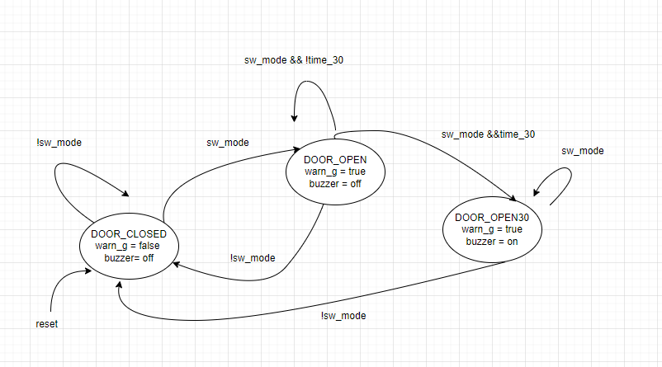

Figure ALRMFSM state transition diagram

1. If the microcontroller is in BOOTSEL idle mode and it’s not driving any pins – then it typically draws 9.0 µA per Mhz. This is according to Table 677 on the Pico data sheet. The operating frequency at 40 MHz.

40 × 0.000009= 3=0.36 mA

REF: PICO DATA SHEET, TABLE 637, PAGE 626

1. Maximum current from IO pin = 35.5 µA in popcorn mode

Maximum current from all Pico IO pins = 40 pins * 35.5

= 1.42 mA

REF: PICO PINOUT DIAGRAM HANDED IN CLASS

REF: PICO DATA SHEET, TABLE 637, PAGE 626

1. <https://learn.adafruit.com/adafruit-2-4-tft-touchscreen-breakout>

Alarm_intf.h

#ifndef ALARM_INTF_H

#define ALARM_INTF_H

#include <inttypes.h>

#include "pico/stdlib.h"

//connect buzzer to pin 25

#define BUZZER 25

//connect door sensor to pin 11

#define SENSOR 11

//connect LED  tp pin 25

#define LED    26

// Initialize the alarm interfaces

void initAlarm(){}

//read door sensor

uint8_t readDoor ();

// turn warning LED OFF

void ledoff();

// turn warning LED ON

void ledon ();

// turn alarm buzzer OFF

 void alarmOff();

// turn alarm buzzer ON

 void alarmon ();

#endif

#include "alarm_intf.h"

#include "stdbool.h"

#include "pico/stdlib.h"

// Initialize the alarm interfaces

void initAlarm(){}

// Initialize the alarm interfaces void initAlarm();

uint8_t readDoor (){

}

// turn warning LED OFF

void ledoff(){

}

// turn warning LED ON

void ledon (){

}

// turn alarm buzzer OFF

 void alarmOff(){

 }

// turn alarm buzzer ON

 void alarmon (){

 }