Website-Ready Brand Profile
OPULENCE • SIMPLICITY • CLASS
Custom Tailoring • Bespoke Menswear • Kenyan Craftsmanship
COMPANY PROFILE
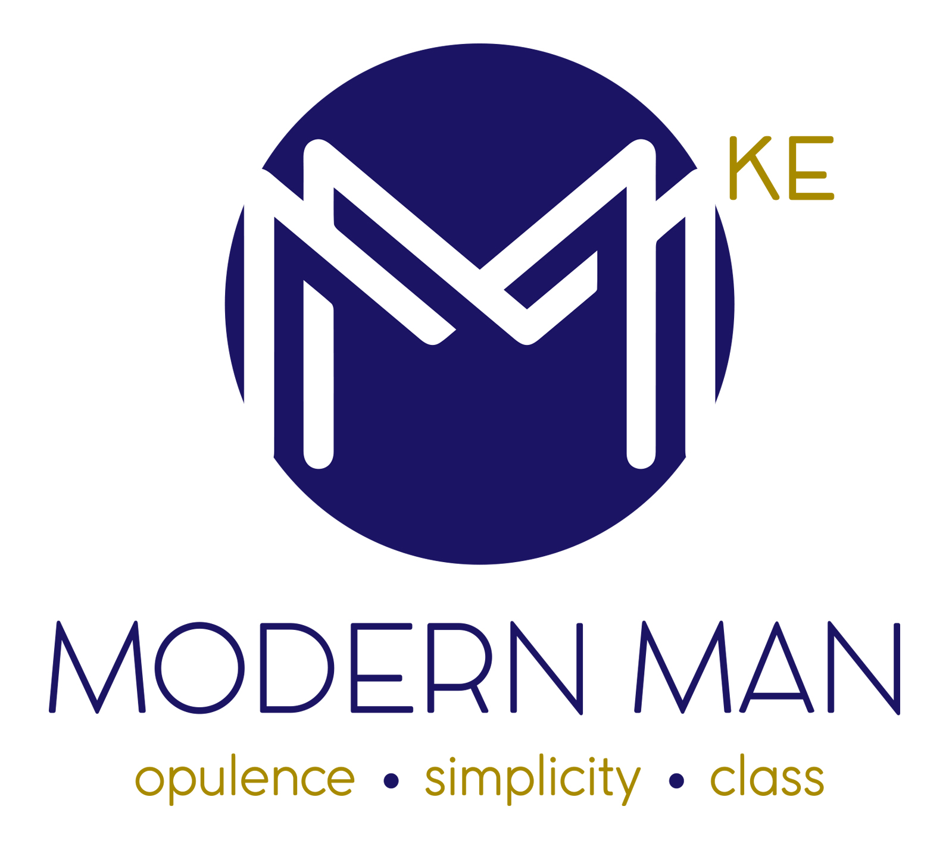

Brand Overview
Modern Man Kenya is a contemporary custom tailoring house based in Kenya, dedicated to creating refined menswear that combines impeccable fit, timeless style and modern sophistication. We specialise in made-to-measure and bespoke garments designed around the individual—his proportions, personality, lifestyle and occasion.
From boardroom tailoring and elevated business attire to wedding suits, formalwear and statement pieces, Modern Man Kenya brings together thoughtful design, premium fabric selection and meticulous craftsmanship to create garments that look distinctive and feel personal.

Our Brand Philosophy
Opulence • Simplicity • Class
We believe great style begins with the right fit. A well-tailored garment should not simply follow fashion; it should express character, enhance confidence and remain relevant beyond a single season.
Our approach is rooted in the balance between classic tailoring codes and contemporary menswear. Clean silhouettes, considered proportions, refined detailing and fabric-led design come together to create clothing that is polished without being predictable.

Our Positioning
Modern Man Kenya positions itself as a premium Kenyan custom tailoring brand for men who value individuality, craftsmanship and understated luxury. Our garments are made with intention—from the first consultation and style direction through pattern development, fittings, finishing and final presentation.

What We Create
- Bespoke and made-to-measure suits
- Two-piece and three-piece suits
- Tuxedos and black-tie formalwear
- Wedding suits and groom's tailoring
- Corporate and executive wardrobes
- Custom shirts and coordinated separates
- Traditional and contemporary occasion wear
- Statement jackets and special-event tailoring
- Personalised wardrobe and styling solutions

The Modern Man Experience
Every client begins with a personal consultation where we understand his preferred aesthetic, intended occasion, lifestyle and fit requirements. We then guide the client through fabric, colour, construction, silhouette and detailing choices to develop a garment that is distinctly his.
Our fitting process is central to the experience. Measurements and proportions are carefully considered, the garment is assessed through fittings, and refinements are made to achieve a clean, balanced silhouette. The result is clothing designed around the wearer rather than a generic size chart.

Craftsmanship & Tailoring
Our tailoring philosophy places equal importance on structure, comfort and finish. We pay close attention to the elements that define a well-made garment: proportion, shoulder line, chest balance, sleeve length, trouser break, collar placement, lapel shape and finishing details.
Depending on the garment and design direction, clients can personalise details such as lapel style, buttons, pocket configuration, lining, stitching, monograms, cuffs and trouser finishing. These details allow a classic garment to become a personal signature.

Fabric & Design
Fabric is the foundation of every tailored garment. We help clients select cloth according to season, climate, occasion, drape, texture, durability and desired aesthetic. From sophisticated solids and subtle textures to expressive checks, stripes and statement cloths, the fabric choice sets the tone for the finished piece.
Our design language favours versatility and longevity: garments should perform in real life while maintaining a sharp, contemporary presence. We embrace colour and individuality where appropriate, while retaining the discipline of classic menswear.

Tailoring for Every Occasion

Business & Executive
Sharp, confident tailoring for boardrooms, leadership settings, client meetings and everyday professional wardrobes. Our approach focuses on clean lines, versatile colour palettes and refined details that communicate professionalism without sacrificing personal style.

Wedding & Groom
Personalised wedding tailoring created around the groom, the ceremony and the overall wedding aesthetic. From timeless black-tie elegance to contemporary colour, texture and cultural influences, we create looks designed to make the occasion memorable.

Formal & Eveningwear
Tuxedos, dinner suits and elevated evening pieces with considered lapels, refined shirting, polished accessories and sophisticated finishing. Designed for black-tie events, galas, celebrations and milestone occasions.

Signature & Occasion Pieces
For clients who want something more distinctive, we develop statement garments through expressive fabrics, bold colour combinations, unique trims, contrasting textures and personalised design details.

Why Modern Man Kenya
- Personalised tailoring rather than off-the-rack sizing
- Design guidance from consultation through final fitting
- Attention to proportion, silhouette and finishing
- A balance of classic tailoring and contemporary style
- Garments designed around the individual client
- A distinctly Kenyan luxury fashion perspective
- Tailoring suitable for professional, formal and special occasions

Our Vision
To establish Modern Man Kenya as a leading African custom tailoring house recognised for exceptional fit, contemporary menswear design, craftsmanship and a distinctive approach to personal style.

Our Mission
To create exceptional tailored clothing that enables every client to look refined, feel confident and express his individuality—through personalised service, considered design and uncompromising attention to detail.

Our Values
- Craftsmanship — We respect the discipline and detail behind exceptional tailoring.
- Individuality — Every client has a distinct identity, and every garment should reflect it.
- Precision — Fit, proportion and finishing are treated as essential, not optional.
- Elegance — We pursue sophistication that feels confident, contemporary and enduring.
- Service — We build lasting relationships through personal attention and professional guidance.
- Innovation — We continually explore new fabrics, silhouettes, styling ideas and techniques while respecting the foundations of menswear.

Our Brand Promise
At Modern Man Kenya, we do more than make suits. We create tailored expressions of identity. Every garment is considered, fitted and finished to help the modern gentleman present himself with confidence, sophistication and authenticity.

Website Brand Statement
Modern Man Kenya is a premium custom tailoring house creating bespoke and made-to-measure menswear for the modern gentleman. Based in Kenya, we combine contemporary design, refined tailoring and personalised service to create suits, tuxedos, shirts, wedding attire and statement pieces defined by exceptional fit and individual character.

Website Tagline
- Where Fit Meets Character.

