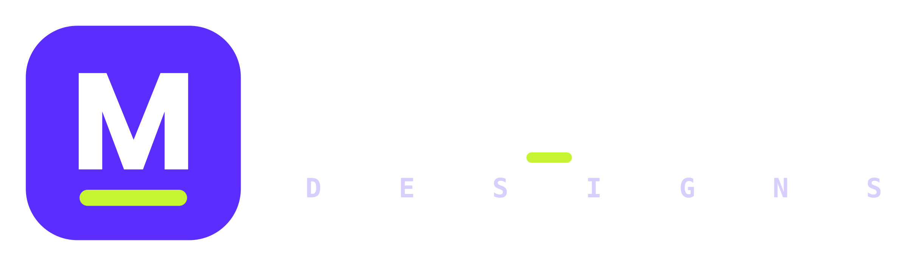
Company
Profile
Graphic design for Kenyan small businesses,
startups and creators.
Design to the max_
+254 112 816 303 | maxthompson786@gmail.com | Nairobi, Kenya | 2026
otienoryan786-lab.github.io/Max_imum-Designs

01 ABOUT US

Who we are
Behind every small business is an idea that deserves to look as good as it is. Max_imum Designs is a graphic design studio based in Nairobi that gives founders a clear, confident brand without agency prices or freelancer guesswork.
We design logos, brand kits, social media, print and pitch decks. Every project has a written quotation, a clear timeline and a fixed number of revisions, so you always know what you will get and what it will cost.
AT A GLANCE
STUDIO  Max_imum Designs | FOUNDER  Ryan Otieno
BASED IN  Nairobi, Kenya | ESTABLISHED  2026
LANGUAGES  English and Kiswahili | FOCUS  Branding, social, print, decks

MISSION  Give every Kenyan small business a brand it is proud of, at a fair and clear price. | VISION  A Kenya where good ideas are never held back by bad design.
OUR VALUES
Max effort  Every job gets our best. | Clear first  Plain words, clear prices. | Rooted in Kenya  Designed for local life. | Craft  Details matter. | Respect  Your idea is the hero.
02 WHAT WE DO

Our services
01  Logo and identity  A mark and a system that people remember.  Logo concepts, colours, fonts, mini brand guide | 02  Social media design  One look across every post.  Post templates, covers, profile pictures
03  Print design  From flyer to shop sign.  Flyers, menus, posters, business cards | 04  Pitch decks  Clear slides that win trust.  Investor and client decks with speaker notes
05  Packaging and labels  Make your product look ready for the shelf.  Product labels, stickers, bags | 06  Web graphics  Banners and simple landing pages.  Web banners and HTML and CSS pages
03 HOW WE WORK

Process and pricing
1  Brief  A 5-minute creative brief form | 2  Concepts  Two directions to choose from | 3  Refine  Two rounds of changes included | 4  Deliver  PNG, PDF and source files | 5  Support  Help for 30 days after
PACKAGES
STARTER  KES 3,500  - Logo, 2 concepts  - 2 rounds of changes  - PNG, PDF and SVG files | BRAND  KES 12,000  - Logo and colour palette  - Fonts and mini guidelines  - 3 social media templates  - Business card design | MAX  KES 25,000  - Everything in Brand  - Stationery set  - Pitch deck or 10 social posts  - 30 days of support
Proposed launch prices. Final prices are confirmed in your written quotation.

How projects run
- A written quotation first, valid for a stated period.
- 50% deposit to start; balance on delivery.
- Pay by M-Pesa, with an invoice and a receipt for every payment.
- Final files are released once paid in full.
04 THE TEAM AND OUR WORK

Founder and projects
 | Ryan Otieno  Founder & Graphic Designer  23 years old and a full-stack software engineering student at Moringa School. Ryan designs brands and builds with HTML, CSS and JavaScript, which will let Max_imum Designs grow into design-to-code landing pages.
SELECTED WORK
CONCEPT PROJECT  DukaPay  A complete brand system for a stock-tracking and micro-credit idea for Kenyan dukas: logo family, colour palette, a 19-page guidelines book, 16 print-ready stationery items and a social media kit. | OUR OWN BRAND  Max_imum Designs  Built to the same standard we offer clients: logos in 5 colourways, 16 stationery items, social templates, a 13-page guidelines book and layered PSD files.
WHO WE SERVE
Small shops and food businesses  Menus, signage, labels | Startups and founders  Logo, brand kit, pitch deck
Churches, NGOs and events  Posters, programmes, banners | Creators and musicians  Cover art, social packs, merch
05 GET IN TOUCH

Karibu, let's talk
PHONE / WHATSAPP
+254 112 816 303
EMAIL
maxthompson786@gmail.com
LOCATION
Nairobi, Kenya
WEBSITE
otienoryan786-lab.github.io/Max_imum-Designs
BRAND AT A GLANCE
Midnight Ink  #0E0B24 | Max Violet  #5B2EFF | Volt Lime  #C6F432 | Cloud  #F3F1FF
Typeface: Poppins (Arial in Office files) | Accent: spaced mono | Tagline: Design to the max_

Business details
Registered business name | [REGISTERED BUSINESS NAME]
Business registration no. | [BUSINESS REGISTRATION NO.]
KRA PIN | [KRA PIN]
M-Pesa Till / Paybill | [M-PESA TILL]
Fill in before sharing with clients.
Design to the max_

