ConstructIQ
AI-Powered Construction Field Intelligence & Smart Material Optimization Platform
Full System Prototype Document

1. Introduction
ConstructIQ is an intelligent construction platform that assists engineers with field analysis,
material optimization, machine integration, and offline-first operation. It integrates AI, IoT, mobile computing, and cloud services.

2. System Architecture
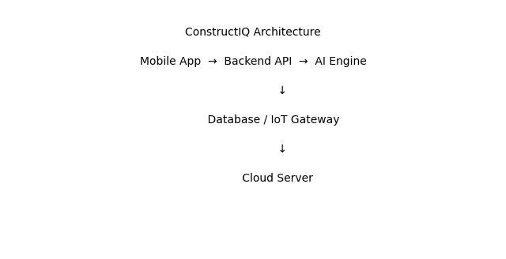

3. Core Modules
• Site Intelligence (GPS, maps, photos, soil AI)
• Material Calculator & Mixing Engine
• Construction Procedure Guide
• IoT Machine Integration
• Chatbot Assistant
• Offline Mode
• Admin Dashboard

4. Materials Database (All Categories)
Civil: cement, sand, ballast, gravel, blocks, bricks, stones, steel, timber
Roads: subgrade, sub-base, asphalt, bitumen, aggregates
Finishing: paint, tiles, glass, insulation, plaster
Plumbing: pipes, fittings, tanks, pumps
Electrical: cables, conduits, switches, panels
Structural: beams, trusses, meshes, prefabricated parts

5. Use Case Diagram
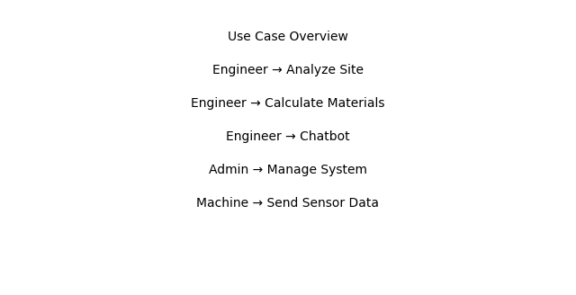

6. Workflow Diagram
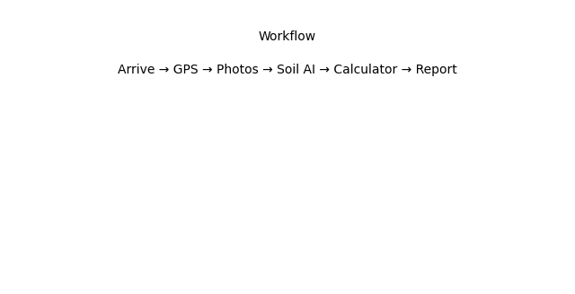

7. Database Schema (Sample)
Users(id, name, email, role)
Projects(id, type, location, soil, slope)
Materials(id, name, unit, price)
Machines(id, type, status)
SensorLogs(machine_id, value, time)

8. API Endpoints
POST /api/login
POST /api/projects
GET /api/materials
POST /api/calculate/concrete
POST /api/chat

9. Algorithms
Concrete Volume = L × W × H
Slope = rise/run × 100
Cost = quantity × price

10. Security
JWT authentication, HTTPS, encrypted local storage, role-based access control

11. Deployment
Docker containers for backend, AI engine, databases. Deploy to VPS/AWS with Nginx and CI/CD pipeline.

12. Starter Code Repository Structure
ConstructIQ/
mobile-app-kotlin/
backend-laravel-api/
ai-engine-python/
iot-gateway/
docker/
docs/

13. Sample Code Snippets
Laravel Route:
Route::post('/calculate', [CalculatorController::class, 'compute']);

Kotlin API Call:
api.calculateConcrete(data)

Python FastAPI:
@app.post('/soil')

14. User Manual
Install app → Login → Start Project → Capture Site → Calculate → Chatbot → Generate Report

15. Conclusion
ConstructIQ provides a complete ecosystem for smart construction decision-making, suitable for roads, houses, and infrastructure projects, even in offline environments.

