ConstructIQ – Smart Construction Intelligence Platform
Updated Comprehensive Prototype with Full Material Manufacturer Support, IoT Automation, and Cross-Platform Functionality

1. Introduction
ConstructIQ is an intelligent construction system designed for engineers, contractors, and construction material manufacturers.
It automates site analysis, material estimation, machine operation, and reporting, while supporting offline use in remote areas.

2. Objectives
• Analyze construction sites before building
• Identify soil type, groundwater level, and slope
• Estimate quantities of all construction materials including cement, bitumen, aggregates, steel, and prefabricated materials
• Automate concrete and bitumen mixing, batching, and pumping operations
• Provide dashboards for material manufacturers (production planning, mix optimization, plant monitoring)
• Offer AI-based guidance and a chatbot assistant
• Operate both online and offline

3. Supported Platforms
• Mobile: Android (Play Store), iOS (App Store)
• Web: Progressive Web App (PWA)
• Desktop: Windows, macOS, Linux
• Cross-platform framework: Flutter
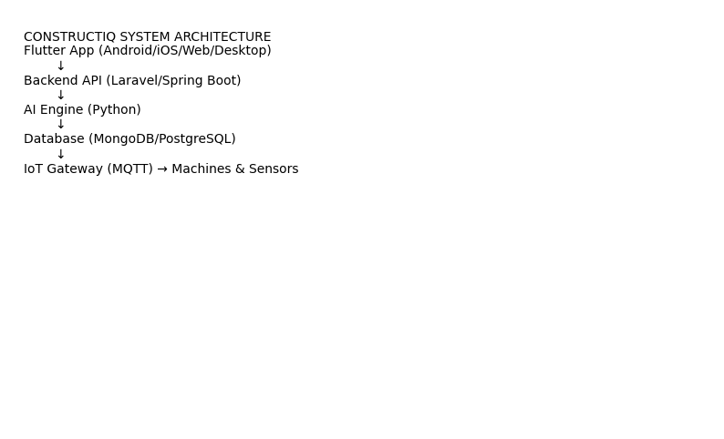

4. Core Modules
• User Authentication & Role Management
• GPS & Google Maps Integration
• Camera Capture & Photo Analysis
• Soil Type Detection & Water Level Analysis
• Slope Measurement
• Material Calculator & Mix Design Engine
• Machine Control & IoT Integration
• Manufacturer Dashboard for Production & Supply Chain
• AI Chatbot Assistance
• Offline Data Storage & Sync

5. Sensors Required
• GPS Module
• Camera
• Accelerometer & Gyroscope (slope)
• Soil Moisture Sensor
• Soil pH Sensor
• Penetrometer / Density Probe
• Ultrasonic Water Level Sensor
• Flow Meters
• Load Cells
• Temperature Sensors
• Vibration Sensors

6. Machines Required
• Concrete Batching Plant
• Cement Mixer Trucks
• Bitumen/Asphalt Plant
• Crushers & Screeners
• Excavators
• Compactors / Rollers
• Water Pumps
• Weighbridges
• PLC Controllers
• Robotic Mixers / Automated Equipment
• Machines can be remotely started/stopped and monitored from the app

7. Materials Coverage
• Cement, sand, gravel, ballast, steel, bricks, blocks, timber, glass, gypsum
• Bitumen, asphalt, geotextiles, plastics, pipes, insulation, paints, tiles
• Prefabricated blocks, admixtures, stabilizers, recycled materials
• Quantities calculated automatically and optimized based on site analysis and AI recommendations

8. Machine Automation
• Machines communicate via MQTT or PLC
• Engineers can start, pause, or stop mixers, batching plants, pumps, and other machinery from the app
• Real-time sensor feedback ensures correct operation and safety

9. Manufacturer Dashboard
• Production Planning & Scheduling
• Raw Material Tracking
• Mix Optimization & Testing
• Plant Status & Machine Health Monitoring
• Sales & Supply Forecasting
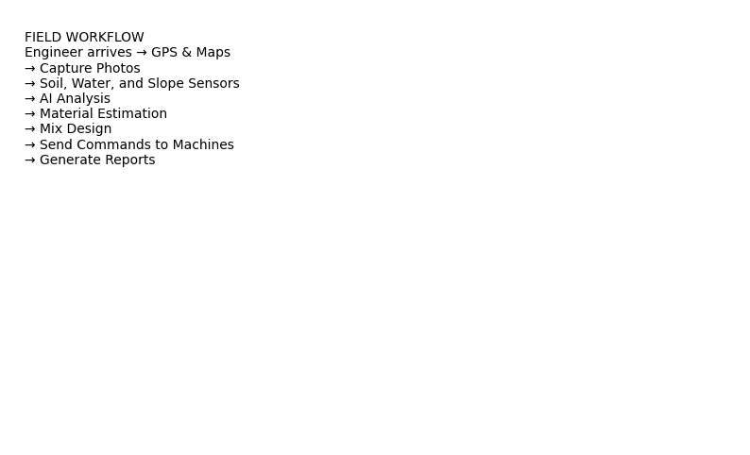

10. Offline Capability
• SQLite local database stores all site and calculation data
• Full app functionality available offline
• Automatic sync with cloud when internet is available

11. API Endpoints
POST /analyze-soil
POST /calculate-materials
POST /start-machine
POST /machine-status
POST /chatbot
GET /reports
GET /manufacturing-dashboard

12. Database Tables
Users, Projects, Sensors, Materials, Machines, MixDesigns, Commands, Reports, ManufacturerLogs


13. Deployment Strategy
• Docker containers for backend, AI engine, databases
• Cloud hosting
• Mobile apps on Play Store & App Store
• Web app PWA hosting
• Desktop installers for Windows/macOS/Linux

14. Future Enhancements
• Drone mapping and terrain scanning
• Satellite imagery analysis
• AR/VR construction guidance
• Predictive maintenance for machines
• BIM integration
• Supplier marketplace & material ordering

