
MAKERERE UNIVERSITY

COLLEGE OF COMPUTING AND INFORMATION SCIENCES
EMBEDDED SYSTEMS

An ESP32-Based RFID Access Control, Occupancy Monitoring and Automated Lecture Room Lighting System for CoCIS

Report

Embedded Systems, Department of Networks, Makerere University

Name | Registration number
Kavuma Mustafa Kasirye | 24/U/05533/PS
Otimong Jonathan | 24/U/10833/PS
Nakabuubi Hilda Joyce | 24/U/08182/EVE
Okoth Victor | 23/U/1315
Nyonyozi Maria Lisa Loyce | 23/U/16424/EVE

Lecturer / Supervisor: DR. MARY NSABAGWA
Group number: Group 13
WOKWI SIMULATION LINK:https://wokwi.com/projects/479582612769517569
FIRMWARE LINK:https://raw.githubusercontent.com/otimongjonathan/firmware/main/merged-firmware.bin

TASKS COMPLETED BY EACH MEMBER

Member | Role | Link to video
Kavuma Mustafa Kasirye | Lighting system | room lighting presentation
Otimong Jonathan | RFID readers
Nakabuubi Hilda | diagram.json | https://youtu.be/EF6LE0LP7RI
Nyonyozi Maria Lisa Loyce | Backend (MQTT bridge, REST API, database) and management dashboard
Okoth Victor | LCD monitor

TABLE OF CONTENTS
TASKS COMPLETED BY EACH MEMBER 2
LIST OF TABLES 5
LIST OF FIGURES 5
ABSTRACT 6
1. INTRODUCTION 7
1.1 Background and Problem Statement 7
1.2 Objectives 7
1.3 Scope 7
1.4 Definitions and Acronyms 8
2. SYSTEM REQUIREMENTS 8
2.1 Functional Requirements 8
2.2 Non-Functional Requirements 9
3. USE CASE ANALYSIS 10
3.1 Actors 10
3.2 System Use Case Diagram 10
3.3 Controller, Bridge and API Use Case Diagram 11
3.4 Use Case Summary 12
3.5 Use Case Specifications 13
4. SYSTEM ARCHITECTURE 13
4.1 Overview 14
4.2 End-to-End System Architecture 14
4.3 Network Design 15
4.4 Architectural Modules 15
4.5 Concurrency Model 16
4.6 Data Flow for an Access Request 16
4.7 Communication Interfaces 17
4.8 Server-Side Components 18
5. HARDWARE COMPONENTS 19
5.1 Component List 19
5.2 Pin Assignment 20
5.3 Hardware Design Notes 21
6. SOFTWARE DESIGN 21
6.1 Development Environment 21
6.2 Start-up Sequence 21
6.3 Access Decision Logic 22
6.4 RFID Driver 23
6.5 Door Control 23
6.6 Storage and Persistence 23
6.7 Communication 24
6.8 Room Automation 25
6.9 Serial Console 25
6.10 LCD Driver 26
6.11 Time Synchronisation 26
7. DATABASE DESIGN 26
7.1 Choice of Database Engine 26
7.2 Entity-Relationship Diagram 27
7.3 Tables 27
8. REST API AND HOW TO ACCESS IT 28
8.1 General Conventions 28
8.2 Security Model 29
8.3 Endpoint Summary 29
8.4 Accessing the API with Swagger UI 30
9. MANAGEMENT DASHBOARD 31
9.1 Accessing the Dashboard and Logging In 32
9.2 Roles and Permissions 32
9.3 Overview Tab 32
9.4 Schedule, Users and Audit Log Tabs 33
9.5 Reports Tab 33
9.6 Database Tab 34
10. IMPLEMENTED FEATURES 34
11. SYSTEM OPERATION 35
11.1 Normal Operation 35
11.2 Administrator Operation 36
11.3 Monitoring 36
11.4 Dashboard Operation 36
12. TESTING AND RESULTS 36
12.1 Automated Database, API and Bridge Tests 37
12.2 End-to-End Test over the MQTT Broker 37
13. LIMITATIONS AND FUTURE WORK 38
13.1 Known Limitations 38
13.2 Future Work 39
14. CONCLUSION 39
REFERENCES 40

LIST OF TABLES
TABLE I FUNCTIONAL REQUIREMENTS 9
TABLE II ACTORS OF THE SYSTEM 10
TABLE III SUMMARY OF USE CASES 12
TABLE IV USE CASE SPECIFICATION: UC01 ENTER BUILDING 13
TABLE V SOFTWARE MODULES AND RESPONSIBILITIES 15
TABLE VI FREERTOS TASKS 16
TABLE VII INTERNAL AND EXTERNAL INTERFACES 18
TABLE VIII WHAT THE MQTT BRIDGE DOES WITH EACH MESSAGE 19
TABLE IX COMPONENT LIST 19
TABLE X GPIO ASSIGNMENT 20
TABLE XI ACCESS DECISION RULES 22
TABLE XII MQTT TOPICS 24
TABLE XIII CONSOLE COMMANDS 25
TABLE XIV TABLES OF THE CENTRAL DATABASE 28
TABLE XV GENERAL API CONVENTIONS 29
TABLE XVI SUMMARY OF API ENDPOINTS 29
TABLE XVII DASHBOARD AND API ROLES 32
TABLE XVIII AUTOMATED TEST RESULTS 37
TABLE XIX END-TO-END TEST OVER THE MQTT BROKER 38

LIST OF FIGURES
Fig. 1. System use case diagram of the CoCIS Smart Control and Monitoring System. 11
Fig. 2. Use case diagram of the entrance ESP32, the MQTT bridge and the REST API. 12
Fig. 3. End-to-end architecture of the CoCIS Smart Control and Monitoring System. 14
Fig. 4. Sequence of a card scan, from the reader to the database and the dashboard. 17
Fig. 5. Entity-relationship diagram of the cocis.db database. 27
Fig. 6. Executing POST /device/access/check in Swagger UI: the request, the curl command and the GRANTED response. 31
Fig. 7. Dashboard Overview tab: occupancy, lecture rooms, controller status and recent access events. 33
Fig. 8. Dashboard Reports tab: daily totals, peak occupancy and lighting energy. 34
Fig. 9. Database tab: access events stored from the entrance ESP32 over MQTT. 34
Fig. 10. MQTT bridge window: messages from the entrance ESP32 stored in the database. 38

ABSTRACT
This report describes the design, implementation and operation of the CoCIS Entrance Node, an embedded access-control system built around an ESP32 microcontroller. The system reads RFID cards at separate entry and exit readers, checks the validity of the card and decides whether to open each door using a card whitelist, an opening-hours schedule and an anti-passback rule. It then drives servo-actuated doors with LED, buzzer and LCD feedback. It tracks building occupancy, keeps a persistent audit log on an SD card, stores configuration in non-volatile memory, and publishes events and state to an MQTT broker as JSON. Two PIR motion sensors automate the lighting of two rooms. An administrator can inspect and configure the device through a serial console. The firmware is written in C on ESP-IDF using FreeRTOS and is demonstrated in the Wokwi simulator. A management dashboard, fed by an MQTT bridge, a REST API and an SQLite database, lets staff monitor occupancy, lecture rooms and the access history from a web browser.
Index Terms: Access control, ESP32, ESP-IDF, FreeRTOS, MQTT, MFRC522, RFID, Internet of Things, REST API, dashboard, Wokwi.

INTRODUCTION

Background and Problem Statement
CoCIS at Makerere University houses valuable equipment, such as the laboratory computers, that requires reliable security measures to prevent unauthorised access and protect institutional resources. In addition to security concerns, the college faces high electricity costs, partly because lights are left on in unoccupied rooms. Traditional key-based systems also provide no record of who entered and when. We therefore proposed using low-cost ESP32 microcontrollers with integrated Wi-Fi to build networked access-control nodes that authenticate users with RFID cards and log every attempt. This provides controlled entry to the building, protects people and equipment by showing the occupancy at any given moment, supports evacuation planning, and saves electricity by switching lights off when a room is unoccupied.

Objectives
- Authenticate users at entry and exit readers using RFID tags.
- Enable actuation of the entry and exit doors and give immediate visual, audible and textual feedback on the LCD screen.
- Enforce an opening-hours schedule and an anti-passback rule.
- Automate room lighting with PIR motion sensors and report room status to the entrance node via MQTT.
- Maintain a live occupancy count and store state in non-volatile memory to survive power interruptions.
- Keep a timestamped audit log on an SD card for persistence and publish events to an MQTT broker.
- Provide a secured serial console for inspection and configuration.
- Demonstrate the complete system using the Wokwi simulator.

Scope
This pilot project initially covers one entrance node with two doors (entry and exit) and two monitored lecture rooms. It covers the embedded firmware and the simulated hardware, together with a management dashboard and the supporting backend (an MQTT bridge, a REST API and an SQLite database) that consume the node's MQTT messages.

Definitions and Acronyms

Acronym | Definition
MQTT | Message Queuing Telemetry Transport
RFID tag | Radio Frequency Identification tag
ESP32 | The microcontroller used in the system
ESP-IDF | Espressif IoT Development Framework used to build the firmware
FreeRTOS | Free Real-Time Operating System
LED | Light Emitting Diode
LCD Screen | Liquid Crystal Display
PIR sensor | Passive Infrared motion sensor
API | Application Programming Interface
REST | Representational State Transfer
JSON | JavaScript Object Notation
NVS | Non-Volatile Storage (flash memory of the ESP32)
UML | Unified Modeling Language

SYSTEM REQUIREMENTS

Functional Requirements
TABLE I
FUNCTIONAL REQUIREMENTS
ID | Requirement
FR1 | The system shall read the unique identifier (UID) of an RFID card presented to either entry or exit reader.
FR2 | The system shall grant access only to UIDs on the authorised list.
FR3 | The system shall deny entry outside the configured opening hours; exit shall always be permitted if the person is inside.
FR4 | The system shall deny a second entry by a card already inside and deny exit by a card not inside.
FR5 | The system shall open the corresponding door for a fixed time after a granted request.
FR6 | The system shall give feedback through a green or red LED, a buzzer and a 16x2 LCD.
FR7 | The system shall maintain an occupancy count and the list of cards inside.
FR8 | The system shall persist the schedule and the inside list in non-volatile memory.
FR9 | The system shall append every access attempt to a CSV log on an SD card.
FR10 | The system shall publish occupancy, access events, schedule and room status to an MQTT broker.
FR11 | The system shall switch each room light on when motion is detected and off after five seconds without motion.
FR12 | The system shall provide a serial console in which schedule changes require an authenticated administrator session that expires automatically.
FR13 | The system shall obtain the current time from a network time server.

Non-Functional Requirements
- Responsiveness: a card presented to a reader shall be processed within a fraction of a second (readers are polled every 150 ms).
- Reliability: failure of the SD card or the MQTT connection shall not prevent doors from operating.
- Thread safety: all shared data shall be protected against concurrent access by multiple tasks.
- Maintainability: pins, network settings, topics, authorised cards and limits shall be centralised in one configuration header.
- Testability: the whole system shall run unmodified in the Wokwi simulator.

USE CASE ANALYSIS
Before designing the hardware and software, the group identified who uses the system and what each user needs it to do. These needs are captured below as UML use cases. Each use case is traced to the firmware module or backend component that implements it, so every part of the design can be explained by the need it serves.

Actors
Table II lists the actors. People interact with the system directly; the timer and the two external systems take part in use cases without a person being involved.
TABLE II
ACTORS OF THE SYSTEM
Actor | Type | Description
Building User | Person | Any student, staff member, lecturer or visitor who holds an RFID card and passes through the main entrance.
Room Occupant | Person | Anyone in Lecture Room 1 or 2. Detected by the room's PIR motion sensor; needs no card.
Management Viewer | Person (role VIEWER) | College management or reception staff who monitor occupancy, logs and reports on the dashboard.
Security Officer | Person (role SECURITY) | Everything a Viewer can do, plus emergency mode, lockdown of the entrance and light overrides.
System Administrator | Person (role SUPER_ADMIN; admin PIN on the ESP32) | Everything a Security Officer can do, plus managing authorised cards, the access schedule and settings.
Time | Timer | The five-second motion timeout that switches a room's lights off.
Entrance ESP32 | External system | The controller: decides every scan and publishes events over MQTT.
MQTT Bridge | External system | Program on the server that relays the ESP32's messages to the REST API and forwards lockdown commands back.

System Use Case Diagram
Fig. 1 shows the use cases of the whole system. Use cases on the left are carried out by people in the building; those on the right are management functions. Dashed arrows show «include» relationships (a step that is always performed, such as verifying a card) and «extend» relationships (optional behaviour, such as a manual lighting override). The hollow-headed arrows between the staff actors show that each role inherits the abilities of the one below it.
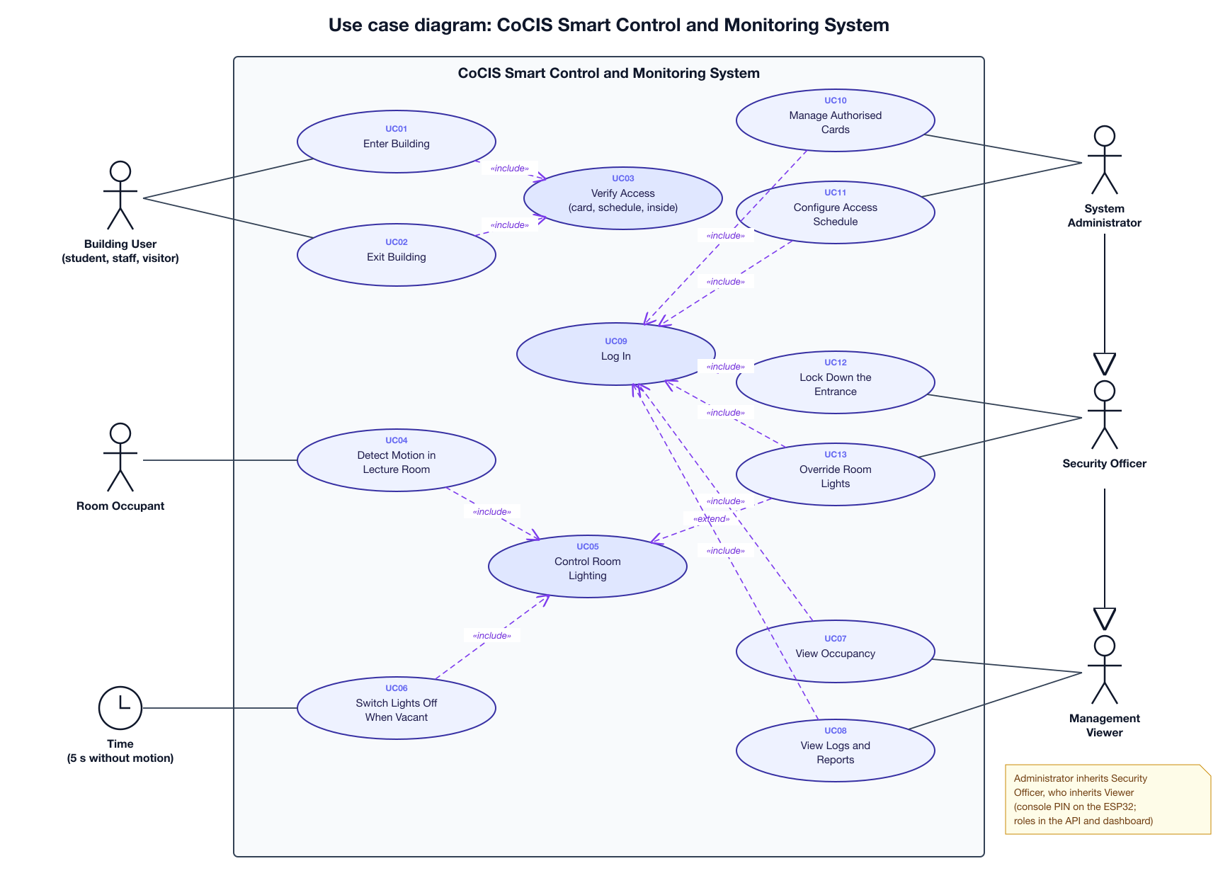
Fig. 1. System use case diagram of the CoCIS Smart Control and Monitoring System.

Controller, Bridge and API Use Case Diagram
Fig. 2 shows how the controller's data reaches the database. The ESP32 never calls the API itself: it publishes to the MQTT broker, and the bridge makes the API requests. Every request the bridge makes is authenticated with the device key, and every event is stored exactly once, however many times it is delivered.
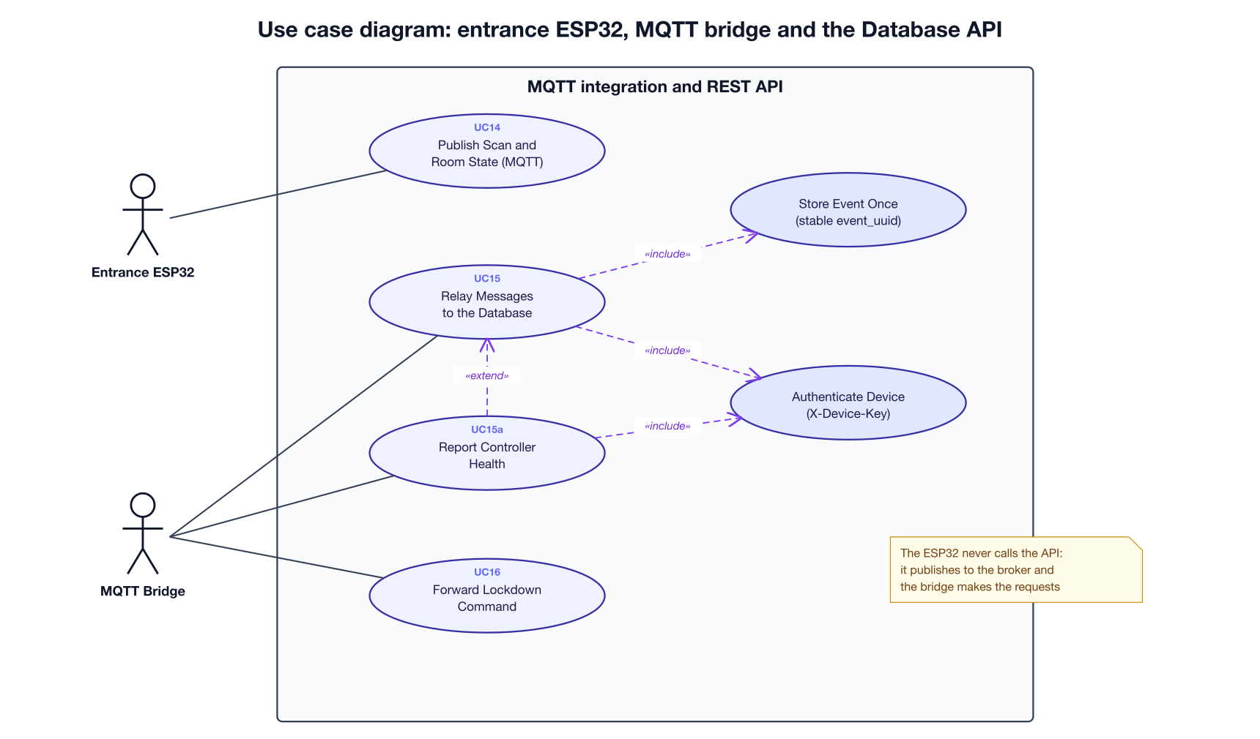
Fig. 2. Use case diagram of the entrance ESP32, the MQTT bridge and the REST API.

Use Case Summary
Table III summarises every use case with its primary actor and the part of the system that implements it.
TABLE III
SUMMARY OF USE CASES
ID | Use case | Primary actor | Implemented by
UC01 | Enter Building | Building User | rfid.c, state.c, door.c; bridge; access_events, building_visits
UC02 | Exit Building | Building User | rfid.c, state.c, door.c; bridge; access_events, building_visits
UC03 | Verify Access (card, schedule, inside) | Included by UC01, UC02 | state_evaluate() in state.c
UC04 | Detect Motion in Lecture Room | Room Occupant | rooms.c (room_lights task)
UC05 | Control Room Lighting | Included by UC04, UC06 | rooms.c, comms.c; bridge; room_status_logs
UC06 | Switch Lights Off When Vacant | Time | HOLD_TICKS in rooms.c
UC07 | View Occupancy | Management Viewer | Dashboard Overview; GET /occupancy; console status, who
UC08 | View Logs and Reports | Management Viewer | Dashboard Reports, Audit log and Database tabs
UC09 | Log In | Any staff actor | POST /auth/login; console login
UC10 | Manage Authorised Cards | System Administrator | Console user add/remove; dashboard Users tab
UC11 | Configure Access Schedule | System Administrator | Console schedule set; dashboard Schedule tab
UC12 | Lock Down the Entrance | Security Officer | PUT /settings/lockdown; bridge; comms.c
UC13 | Override Room Lights | Security Officer | Console lights command; dashboard light mode
UC14 | Publish Scan and Room State | Entrance ESP32 | comms.c (MQTT topics)
UC15 | Relay Messages to the Database | MQTT Bridge | bridge/mqtt_bridge.py; POST /device/relay
UC15a | Report Controller Health | MQTT Bridge | POST /device/heartbeat; devices table
UC16 | Forward Lockdown Command | MQTT Bridge | Bridge publishes to cocis/cmd/entrance

Use Case Specifications
The most important use case, entering the building, is specified in detail below. The main flow is the normal sequence of steps; the alternative flows cover errors and exceptions (step 3a is an alternative to step 3).
TABLE IV
USE CASE SPECIFICATION: UC01 ENTER BUILDING
Primary actor | Building User
Goal | Enter CoCIS through the entry lane of the main entrance.
Preconditions | The user holds an RFID card. The ESP32 is running.
Main flow | 1. The user taps the card on the entry reader (MFRC522).  2. The RFID task reads the four-byte UID and the time.  3. The ESP32 verifies access (UC03).  4. The ESP32 opens the entry door servo for three seconds, lights the green LED, beeps briefly and shows ACCESS GRANTED and the UID on the LCD.  5. The ESP32 adds the card to its inside list, appends the scan to access.csv on the SD card and publishes it over MQTT (UC14).  6. The bridge stores the scan and opens a visit in the database (UC15).
Alternative flows | 3a. Access is denied: the door stays shut, the red LED lights, the buzzer sounds for 0.5 s and the LCD shows ACCESS DENIED. The refused scan is still logged and published.  5a. The broker cannot be reached: the scan is still decided, logged on the SD card and shown on the LCD, but it does not reach the database.
Postconditions | A row exists in access_events. If access was granted, the user has an open row in building_visits.
Implemented by | rfid.c, state.c, door.c; bridge POST /device/relay; tables access_events and building_visits

SYSTEM ARCHITECTURE

Overview
The system follows a layered, task-based architecture running on a single ESP32. At the lowest layer, hardware drivers (RFID, servo, LCD, SD card, GPIO) interact with the peripherals. Above them sit the shared-state and storage services, and at the top an orchestration layer (the RFID workflow, the room task and the console) implements behaviour and publishes information through the communications module. Each module exposes a small header interface, and only the state module owns shared data, which it protects with a mutex.
The sections that follow describe the end-to-end architecture of the complete system and its network design, the firmware architecture on the ESP32 (Sections 4.4 to 4.7) and the server-side components that carry the controller's data to the management dashboard (Section 4.8).

End-to-End System Architecture
Fig. 3 shows the final architecture in four layers, read from left to right:
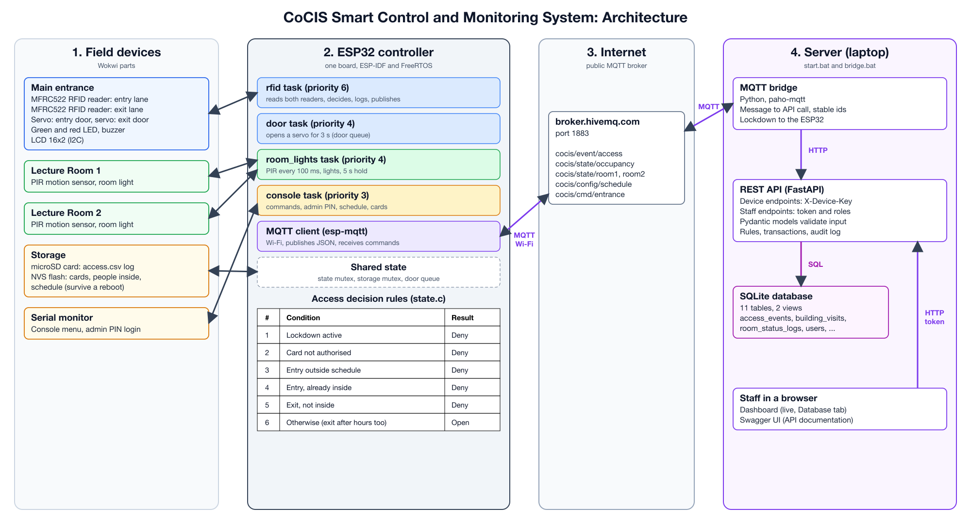
Fig. 3. End-to-end architecture of the CoCIS Smart Control and Monitoring System.
- Layer 1, field devices: at the main entrance, an MFRC522 RFID reader and a door servo for each lane, a green and a red LED, a buzzer and a 16x2 LCD; in each lecture room, a PIR motion sensor and the room light; for storage and administration, a microSD card, the ESP32's NVS flash and the serial monitor.
- Layer 2, the ESP32 controller: one board running the FreeRTOS tasks described in Section 4.5. Every access decision is made here, so the doors keep working without a network.
- Layer 3, the MQTT broker: the public broker broker.hivemq.com on port 1883 passes messages between the ESP32 and the server. Neither side connects to the other directly.
- Layer 4, the server: the MQTT bridge, the REST API and the SQLite database run on a laptop or college server, and staff use the management dashboard and Swagger UI in a web browser.

Network Design
The ESP32 does not need to be on the same network as the database. The ESP32 (in Wokwi, on the Wokwi-GUEST Wi-Fi) and the server each open an outgoing connection to the MQTT broker on the internet, and the broker passes the messages between them. No router settings or port forwarding are needed, and the database is never exposed to the internet. On the server, the bridge calls the REST API over HTTP on the same computer, and staff reach the API and the dashboard from a web browser.

Architectural Modules
TABLE V
SOFTWARE MODULES AND RESPONSIBILITIES
Module | Files | Responsibility
Entry point | main.c | Creates the SPI bus, initialises all modules in order, starts the tasks, sets the time zone and starts SNTP.
Configuration | config.h | Pin numbers, Wi-Fi and MQTT settings, topic names, authorised card list, limits and timings.
Shared state | state.c, state.h | Owns occupancy, inside list, schedule, admin session and room flags; evaluates access requests.
RFID | rfid.c, rfid.h | Register-level MFRC522 driver for two readers and the complete card-tap workflow.
Door | door.c, door.h | PWM servo control through a request queue and a dedicated task.
Storage | storage.c, storage.h | NVS storage for schedule and inside list; SD-card CSV audit log.
Communications | comms.c, comms.h | Wi-Fi station setup, MQTT client, JSON publishing and subscription handling.
Rooms | rooms.c, rooms.h | PIR polling, light control, room status updates and publishing.
Console | console.c, console.h | UART command-line interface with admin authentication.
Display | lcd.c, lcd.h | HD44780 16x2 LCD driver over I2C and the idle and result screens.

Concurrency Model
The firmware uses FreeRTOS tasks so that slow actions, such as holding a door open for three seconds, never block card reading or room monitoring. Table VI lists the tasks. Producers communicate with the door task through a queue, and all access to the shared state goes through mutex-protected functions.

TABLE VI
FREERTOS TASKS
Task | Priority | Stack (bytes) | Function
main (app_main) | Default | 8192 | Initialisation, then returns; other tasks continue.
rfid | 6 | 8192 | Polls the entry and exit readers every 150 ms and runs the access workflow.
door | 4 | 2048 | Blocks on a queue; moves a servo to the open position, waits, and closes.
room_lights | 4 | 4096 | Reads both PIR sensors every 100 ms and controls the lights.
console | 3 | 4096 | Reads typed characters from UART0 and executes commands.
Library tasks | Library-defined | Internal | Wi-Fi, TCP/IP, MQTT client and SNTP operate in tasks created by ESP-IDF.

Data Flow for an Access Request
- The RFID task reads a card UID from a reader and converts it to a 32-bit number.
- Repeated reads of the same card within 1.5 seconds are ignored.
- The state module evaluates the request and returns one of six results.
- If the result is a grant, a request is placed on the door queue and the door task moves the servo.
- LEDs, the buzzer and the LCD show the result.
- The event is appended to the SD log, published to MQTT, and the occupancy is published.
- The inside list and schedule are saved to non-volatile memory.
- After three seconds the LCD returns to the idle screen.
Fig. 4 follows the same scan beyond the controller. After the door has opened, the event travels through the MQTT broker and the bridge to the REST API, which stores it in the database in one transaction, and the dashboard shows it within three seconds.
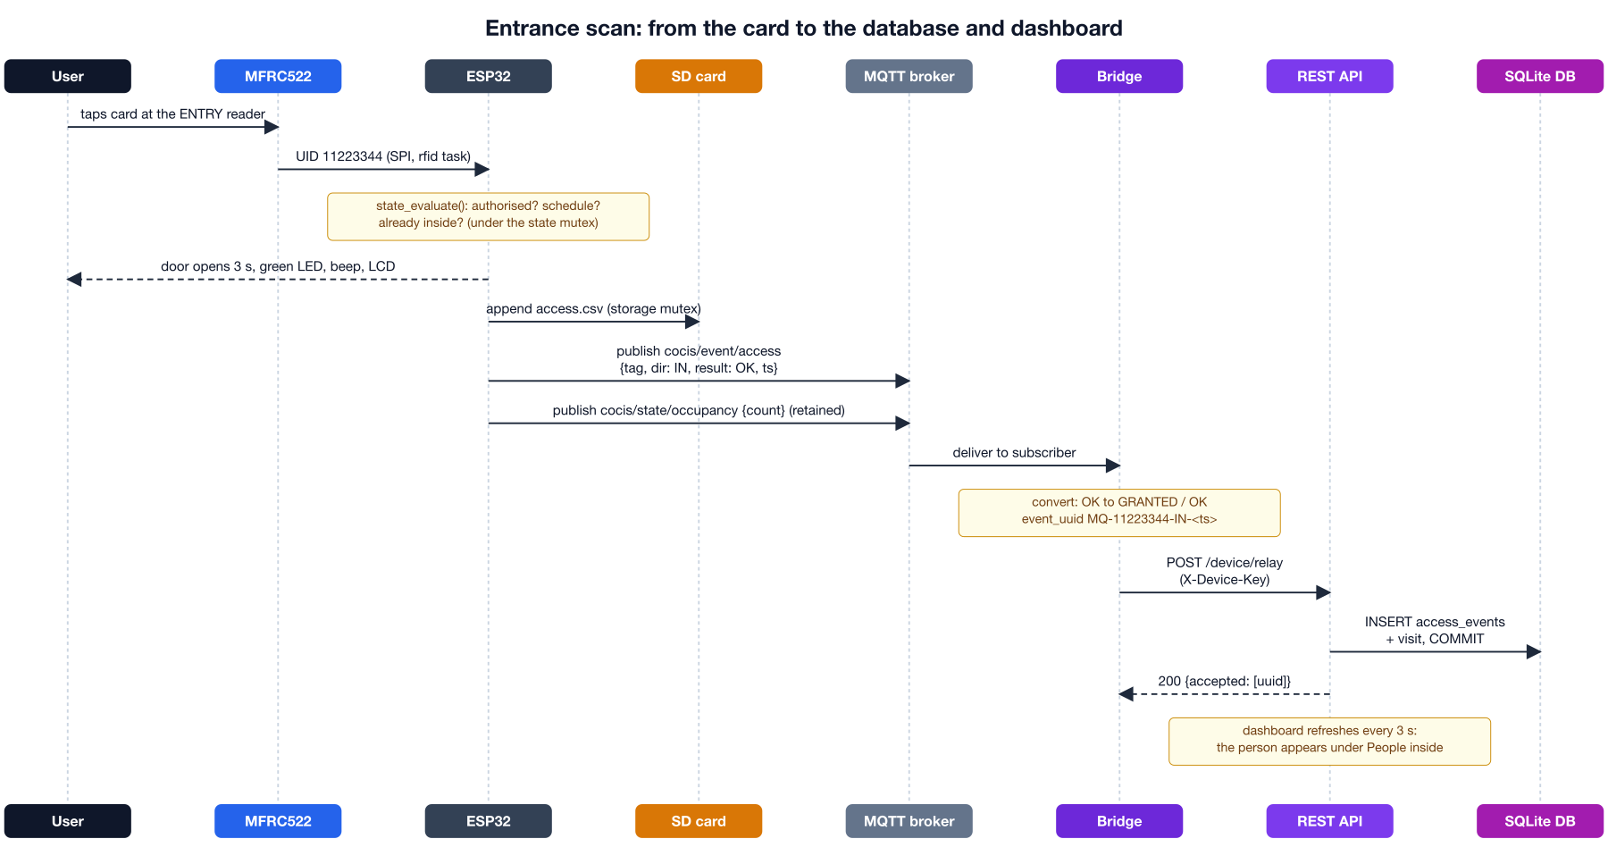
Fig. 4. Sequence of a card scan, from the reader to the database and the dashboard.

Communication Interfaces
TABLE VII
INTERNAL AND EXTERNAL INTERFACES
Interface | Used for | Settings
SPI (SPI2 host) | Two MFRC522 readers and the microSD card on one shared bus | SCK 18, MISO 19, MOSI 23; separate chip-select per device; readers at 1 MHz, mode 0
I2C (port 0) | 16x2 LCD through a PCF8574 backpack | SDA 21, SCL 22, address 0x27, 100 kHz
LEDC PWM | Two servo motors | 50 Hz, 16-bit resolution
UART0 | Serial console | 115200 baud, 8N1
Wi-Fi (station mode) | Network access | SSID Wokwi-GUEST, open network
MQTT over TCP | Publishing and subscribing | Broker broker.hivemq.com, port 1883, keep-alive 30 s

Server-Side Components
The server side gives management a permanent, searchable record of everything the controller does. It consists of four parts:
- MQTT bridge (bridge/mqtt_bridge.py): subscribes to the controller's topics with the Eclipse Paho client, converts each message and calls the REST API with a device key. It needs no change to the firmware.
- REST API (FastAPI): device endpoints authenticated with the X-Device-Key header, and staff endpoints authenticated with a login token and three roles (VIEWER, SECURITY and SUPER_ADMIN). Every request body is validated, every write runs in a database transaction, and every change is recorded in an audit log. Swagger UI at /docs documents and tests every endpoint.
- SQLite database: eleven tables and two views, including users, rooms, access_events, building_visits, room_status_logs, access_schedule, devices and audit_log.
- Management dashboard: the web interface for staff, described in Section 9.
Table VIII shows what the bridge does with each message from the controller. Three safeguards keep the database correct: a stable event_uuid means that a message delivered twice is stored once; retained messages older than ten minutes, left over from earlier runs, are ignored; and before SNTP has set the ESP32's clock, the bridge uses its own time.
TABLE VIII
WHAT THE MQTT BRIDGE DOES WITH EACH MESSAGE
ESP32 message | Bridge action | API request | Stored in
Scan on cocis/event/access | Convert the result code and build a stable event_uuid | POST /device/relay | access_events, building_visits
Room state on cocis/state/roomN | Occupied becomes count 1 and trigger MOTION; vacant becomes 0 and NO_MOTION | POST /device/relay | rooms, room_status_logs
Count on cocis/state/occupancy | Compare with the database | GET /occupancy | Shown in the bridge window
Window on cocis/config/schedule | Copy to all seven days if different | PUT /schedule | access_schedule
First granted scan of a new card | Register the card | POST /users | users
Any message | Mark the controller as online | POST /device/heartbeat | devices
Lockdown changed on the server | Publish LOCKDOWN or UNLOCK (retained) | GET /occupancy every 2 s | Reaches the ESP32

HARDWARE COMPONENTS

Component List
TABLE IX
COMPONENT LIST
Component | Qty | Role in the system
ESP32 DevKit-C v4 (4 MB flash) | 1 | Runs all firmware.
MFRC522 RFID reader (13.56 MHz) | 2 | Reads the card UID at the entry door or the exit door over SPI.
RFID tag | As required | Uniquely identifies a user. The simulation uses UID 11:22:33:44.
microSD card | 1 | Stores the access.csv audit log (SPI).
Servo motor | 2 | Opens and closes the entry door and exit door according to the PWM signal it receives.
Green LED | 1 | Access granted indicator.
Red LED | 1 | Access denied indicator.
Buzzer | 1 | Provides audible feedback.
PIR motion sensor | 2 | Detects presence in Rooms 1 and 2.
Yellow LED | 2 | Represent the lights for Rooms 1 and 2.
LCD 1602 with I2C backpack | 1 | Displays the welcome screen, occupancy number and access results.

Pin Assignment
TABLE X
GPIO ASSIGNMENT
GPIO | Signal | Connected device
18 | SPI SCK | Both RFID readers and SD card
19 | SPI MISO | Both RFID readers and SD card
23 | SPI MOSI | Both RFID readers and SD card
5 | Chip select | Entry RFID reader
4 | Reset | Entry RFID reader
15 | Chip select | Exit RFID reader
2 | Reset | Exit RFID reader
16 | Chip select | SD card
13 | PWM | Entry door servo
33 | PWM | Exit door servo
12 | Output | Green LED
14 | Output | Red LED
27 | Output | Buzzer
34 | Input | PIR sensor, Room 1
26 | Output | Light LED, Room 1
35 | Input | PIR sensor, Room 2
25 | Output | Light LED, Room 2
21 | I2C SDA | LCD
22 | I2C SCL | LCD

Hardware Design Notes
All three SPI devices share one bus and are distinguished by their chip-select lines, so only one is active at a time. GPIO34 and GPIO35 are input-only pins on the ESP32 and are therefore well suited to the PIR sensors. In the simulation all modules and servos are powered from the 3.3 V rail. A physical build should power the servos from a separate 5 V supply with a common ground, and should review the use of the ESP32 boot-strapping pins GPIO2, GPIO12 and GPIO15, which are used here for the exit reader reset, the green LED and the exit reader chip select.

SOFTWARE DESIGN

Development Environment
The firmware is written in C using the ESP-IDF 5.x framework with the CMake and Ninja build system. The project is named “entrance”, and the build produces entrance.elf and entrance.bin which the Wokwi simulator loads. The MQTT client is the Espressif esp-mqtt component (version 1.1.0), obtained through the IDF Component Manager. Other components used are FreeRTOS, the SPI, GPIO, LEDC and UART drivers, the new I2C master driver, NVS flash, the FAT file system with SD-SPI, the Wi-Fi and network interface stack, SNTP and cJSON. Project-specific build settings are in sdkconfig.defaults: an 8 KB main-task stack, a 1000 Hz FreeRTOS tick, warning-level logging, a 4 MB flash with the single-application large partition table, and long file name support for FAT.

Start-up Sequence
The function app_main in main.c performs the following steps in order. It creates the shared SPI2 bus with the SCK, MISO and MOSI pins and a maximum transfer size of 4096 bytes. It initialises the LCD and shows the welcome screen. It then initialises the state, storage, door, RFID, rooms and communications modules and the console. Next it starts the RFID and room tasks, waits three seconds for Wi-Fi to associate, starts the MQTT client and the console task, sets the time zone to EAT-3 (UTC+3), and starts SNTP polling of pool.ntp.org. Finally it prints a banner inviting the user to type help.

Access Decision Logic
The function state_evaluate in state.c is the core of the system. It receives the card identifier, the reader direction and the current time. The time is first converted to minutes after midnight:
m = 60 × hour + minute (1)
The schedule is stored as a start minute s and an end minute e. A time m is inside the allowed window when the following holds. If s equals e, access is always allowed. If s is less than e, the window is s ≤ m < e. Otherwise the window wraps midnight and is m ≥ s or m < e. The decision is then made while holding the state mutex, according to Table XI.
TABLE XI
ACCESS DECISION RULES
Reader | Condition | Result | Effect on state
Either | Card not on the authorised list | DENIED_UNKNOWN | None
Entry | Outside the allowed window | DENIED_SCHEDULE | None
Entry | Card already inside | DENIED_ALREADY_IN | None
Entry | Otherwise | OK | Card added to inside list; occupancy increases by one
Exit | Card not inside | DENIED_NOT_IN | None
Exit | Inside, within window | OK | Card removed; occupancy decreases by one
Exit | Inside, outside window | OK_AFTER_HOURS | Card removed; occupancy decreases by one

Allowing exit at any time is a deliberate safety decision: nobody can be locked inside after hours.

RFID Driver
The MFRC522 driver is written directly against the chip’s registers. A register write is a two-byte SPI frame whose first byte is the address shifted left by one bit, and a read sets the most significant bit of the address byte. Initialisation pulses the hardware reset line, issues a soft reset, configures the internal timer, forces 100% ASK modulation, sets the CRC preset, and switches the antenna on through the TX control register.
A generic transceive routine clears the interrupt flags, flushes the FIFO, loads the bytes to send, starts the transmit-and-receive command and polls the interrupt register until a receive or idle flag is set or a timeout expires. It returns an error if the error register reports buffer overflow, collision, parity or protocol errors. Reading a UID follows the ISO/IEC 14443-A procedure: a request command (REQA, 0x26, sent with 7-bit framing) must return a two-byte answer, and then an anti-collision command (0x93, 0x20) must return five bytes, namely four UID bytes and a check byte. The check byte must equal the exclusive-OR of the four UID bytes. The four UID bytes are combined into a 32-bit number in big-endian order, so that the UID 11:22:33:44 becomes 0x11223344.
A repeated scan of the same card within SCAN_COOLDOWN_MS (1500 ms) is ignored so a card resting on the reader is not counted repeatedly. Protocol errors are logged at most once every three seconds.

Door Control
Each servo expects a pulse every 20 ms whose width sets the angle. The LEDC timer runs at 50 Hz with 16-bit resolution, so the duty value for a pulse of width t is:
duty = (t / 20 ms) × 65536 (2)
A 1.0 ms pulse gives a duty of 3277 (closed position, about 0 degrees) and a 1.5 ms pulse gives 4915 (open position, about 90 degrees in the simulator). The function door_open places a request on a queue of four entries without waiting, so the caller is never blocked. The door task receives the request, moves the servo to the open duty, waits DOOR_OPEN_MS (3000 ms) and returns it to the closed duty.

Storage and Persistence
Non-volatile storage (NVS) holds the schedule start and end as two integers and the inside list as a single binary blob consisting of a count followed by up to sixteen 32-bit card identifiers. The loader validates the count before copying, which protects against a corrupted blob. The state module copies its data into local variables while holding the mutex and writes to flash after releasing it, so slow flash operations never block other tasks.
The SD card is mounted through the SD-SPI driver at /sdcard on the shared SPI2 bus with its own chip select. If the card has no valid file system it is formatted. The file access.csv is opened in append mode, and a header line is written when the file is empty. Each access attempt adds one row with the Unix epoch, an ISO 8601 local time, the tag in eight hexadecimal digits, the direction (IN or OUT) and the result text. The file is flushed after every row so that a power loss costs at most one record. If the card cannot be mounted the system logs a warning and continues without file logging.

Communication
The Wi-Fi module configures the station interface for an open network and connects. The MQTT client is created with a client identifier made from a fixed prefix and the six bytes of the device’s MAC address, which keeps identifiers unique when several nodes share a broker. Table XII lists the topics. State topics are published as retained messages with quality of service 1, so a dashboard that connects later immediately receives the latest values. Access events are published with quality of service 0 and are not retained, because each event is a one-time fact.
TABLE XII
MQTT TOPICS
Topic | Direction | Flags | Payload (JSON)
cocis/state/occupancy | Publish | Retained, QoS 1 | {"count":N,"ts":epoch}
cocis/event/access | Publish | Not retained, QoS 0 | {"tag":"11223344","dir":"IN","result":"OK","ts":epoch}
cocis/config/schedule | Publish | Retained, QoS 1 | {"start":"07:00","end":"21:00","version":epoch}
cocis/state/room1, cocis/state/room2 | Publish and subscribe | Retained, QoS 1 | {"occupied":true,"lights":true,"ts":epoch}

On every (re)connection the node subscribes to the two room topics and publishes its current occupancy and schedule. When a message arrives on a room topic, the JSON is parsed with cJSON and, if both fields are valid booleans, the room state is updated.

Room Automation
The room task reads both PIR sensors every 100 ms. Motion resets a hold counter and turns the room light on. When there is no motion, the counter runs for five seconds, after which the light is switched off. The room state is stored and published only when it changes. The five-second grace period prevents flicker from brief gaps in the sensor output. An administrator can also force a room's lights on or off, or return them to automatic control, with the lights command.

Serial Console
The console task reads UART0 one byte at a time, echoes characters, supports backspace, and executes the command when Enter is pressed. A 128-byte line buffer prevents overflow. An administrator session starts with the login command and expires automatically after ADMIN_TTL_S (300 seconds). Table XIII lists the working commands.
TABLE XIII
CONSOLE COMMANDS
Command | Access | Description
help | Open | Prints the command list.
status | Open | Prints time, schedule, occupancy, admin state and both rooms.
occupancy | Open | Prints the current occupancy.
who | Open | Lists the card identifiers currently inside.
schedule show | Open | Prints the schedule window.
schedule set HH:MM HH:MM | Admin | Sets, saves and publishes a new schedule; times are validated.
login <user> <pin> | Open | Starts a five-minute admin session if the PIN is correct.
logout | Open | Ends the admin session.
reboot | Open | Restarts the device.
scan <in|out> <HEX> | Open | Simulates a card tap at the entry or exit reader.
user list | Open | Lists the authorised cards.
user add <HEX> | user remove <HEX> | Admin | Authorises or removes a card; the list is saved in NVS.
lights <room1|room2> <on|off|auto> | Admin | Forces a room's lights on or off, or returns them to automatic control.

LCD Driver
The 16x2 LCD uses an HD44780 controller connected through a PCF8574 I2C expander in 4-bit mode. Every byte is sent as two nibbles. Each nibble is placed in the upper four bits of an expander byte together with the register-select, enable and backlight bits, and the enable line is pulsed high then low to latch the data. The initialisation follows the datasheet reset sequence of three function-set nibbles followed by the switch to 4-bit mode, then sets two lines with a 5x8 font, clears the display, selects left-to-right entry and turns the display on. The idle screen shows “CoCIS Security” and the occupancy. The result screen shows ACCESS GRANTED or ACCESS DENIED and the direction and tag.

Time Synchronisation
Schedule decisions and log timestamps depend on the real time, which the firmware obtains with SNTP from pool.ntp.org and presents in the time zone EAT-3. Until the first synchronisation completes, the clock reports a time near the Unix epoch.

DATABASE DESIGN
The central database is the system's long-term memory. It answers the questions management cares about: who is in the building now, who came in yesterday and when they left, whether the lecture-room lights were left on, and who changed the schedule. The ESP32 keeps only what it needs to work on its own (NVS flash and the SD-card log); the database on the server is the official record.

Choice of Database Engine
SQLite 3 was chosen for the central database. It stores the whole database in one file (data/cocis.db), needs no separate database server, is built into Python, and fully supports transactions, foreign keys, unique and partial indexes, generated columns and views, all of which the design relies on. Write-Ahead Logging (WAL) mode is enabled so that read requests, such as the dashboard refreshing every three seconds, never wait for a write. Because the API uses only standard SQL, the same schema can move to PostgreSQL or MySQL if CoCIS rolls the system out to the whole college.

Entity-Relationship Diagram
Fig. 5 shows the eleven tables and how they are related. People and their movements are held in users, access_events and building_visits; rooms and lighting in rooms and room_status_logs; staff accounts in admins and admin_sessions; configuration in access_schedule and system_settings; and device health and the audit trail in devices and audit_log.
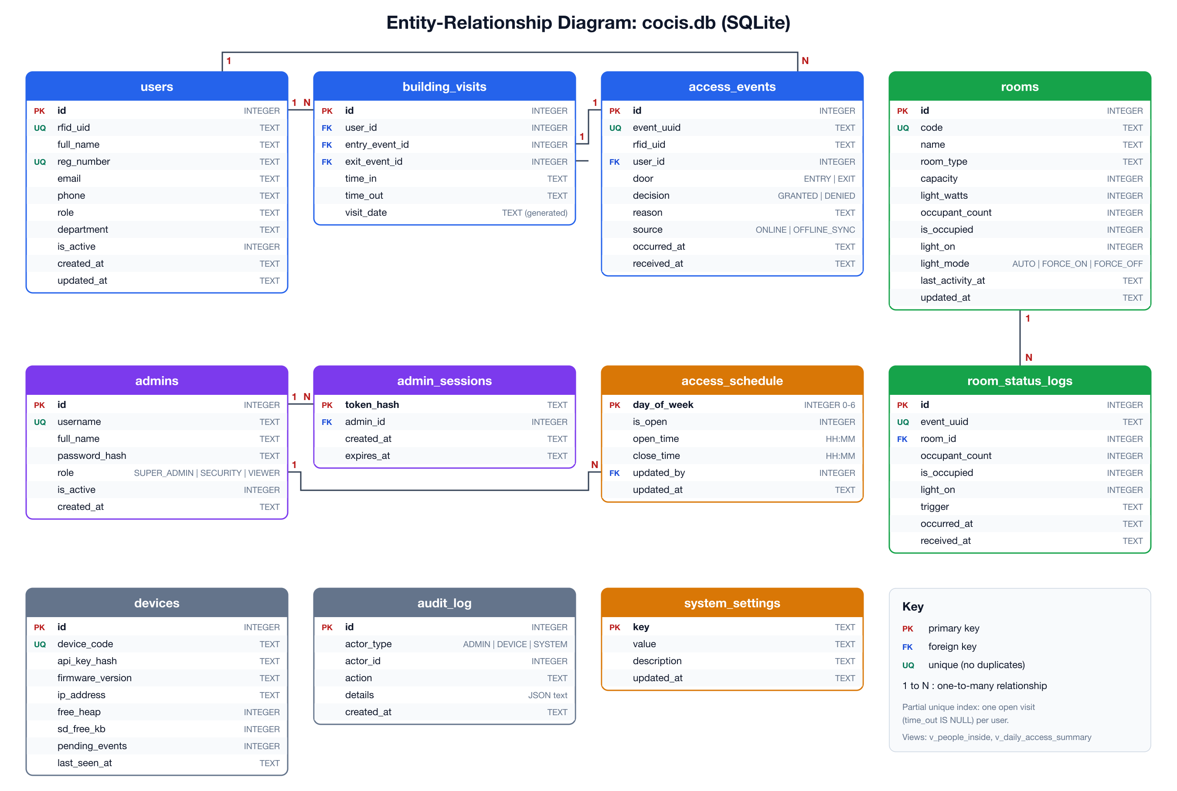
Fig. 5. Entity-relationship diagram of the cocis.db database.
The main relationships are one to many: a user has many access events and many visits, each visit points at the scans that opened and closed it, and each room has many status changes, which give the lighting energy report.

Tables
Table XIV describes each table. All times are stored as ISO 8601 text in East Africa Time (for example 2026-10-30T08:15:02), which sorts correctly and is easy to produce on the ESP32.
TABLE XIV
TABLES OF THE CENTRAL DATABASE
Table | Holds | Key columns
users | Every person issued an RFID card | rfid_uid (unique), full_name, reg_number, role, is_active
rooms | The entrance and the two lecture rooms, with each room's live state | code (MAIN, LR1, LR2), occupant_count, light_on, light_mode, light_watts
access_events | Every RFID scan, granted or denied | event_uuid (unique), rfid_uid, user_id, door, decision, reason, source, occurred_at
building_visits | One row per stay in the building | user_id, entry_event_id, exit_event_id, time_in, time_out, visit_date
room_status_logs | History of occupancy and lighting changes | event_uuid, room_id, occupant_count, light_on, trigger, occurred_at
access_schedule | Opening hours for each day of the week | day_of_week, is_open, open_time, close_time, updated_by
system_settings | Key and value settings | emergency_mode, lockdown_mode, light_off_delay_s, config_version
admins | Staff accounts | username, password_hash (PBKDF2-SHA256), role, is_active
admin_sessions | Login tokens currently issued | token_hash (SHA-256 of the token), admin_id, expires_at
devices | Controllers allowed to send data, with their health | device_code, api_key_hash, firmware_version, last_seen_at
audit_log | Every configuration change and login attempt | actor_type, actor_id, action, details (JSON), created_at

REST API AND HOW TO ACCESS IT
The REST API is the only way into the database. The MQTT bridge uses it to store the controller's events, and staff use it, through the dashboard, Swagger UI or any HTTP client, to monitor the building and change settings. It is written in Python with FastAPI, validates every request with Pydantic models, and is served by Uvicorn on port 8000.

General Conventions
TABLE XV
GENERAL API CONVENTIONS
Item | Value
Base URL | http://127.0.0.1:8000/api/v1 on the server itself (http://<server-ip>:8000/api/v1 from the college network)
Format | JSON request and response bodies (Content-Type: application/json)
Time format | ISO 8601 local time (EAT), for example 2026-10-30T08:15:02
Device authentication | Header X-Device-Key: <device key>
Staff authentication | Header Authorization: Bearer <token>, using the token returned by POST /auth/login
Documentation | Swagger UI at http://127.0.0.1:8000/docs, ReDoc at /redoc, and the machine-readable specification at /openapi.json
Dashboard | http://127.0.0.1:8000/dashboard/

Security Model
There are two kinds of client, each with its own credential. Devices (the MQTT bridge on behalf of the entrance ESP32, or an HTTP controller) send a secret device key on every request; the server stores only its SHA-256 hash. Staff log in with a username and password, which is stored as a salted PBKDF2 hash, and receive a random bearer token that is valid for eight hours; only a hash of the token is stored. Every management endpoint checks the token and the role (Table XVII), and all configuration changes, logins and failed logins are written to the audit log.

Endpoint Summary
Table XVI lists every endpoint. The paths are relative to the base URL.
TABLE XVI
SUMMARY OF API ENDPOINTS
Method | Path | Access | Purpose
GET | /health | None | Check that the API is running
POST | /device/relay | Device key | Store events decided by the MQTT controller, relayed by the bridge
POST | /device/heartbeat | Device key | Report controller health; learn config_version and lockdown_mode
POST/GET | /device/access/check, /rooms/status, /events/batch, /config | Device key | Decisions, room reports, offline uploads and configuration for an HTTP controller
POST | /auth/login, /auth/token | None | Log in and receive a bearer token (the form version is used by Swagger UI)
POST/GET | /auth/logout, /auth/me | Any role | End the session, or return the logged-in account
GET | /users, /users/{id} | VIEWER | List, search or read card holders
POST/PATCH/DELETE | /users, /users/{id} | SUPER_ADMIN | Register, change or deactivate a card holder (history is kept)
GET | /occupancy | VIEWER | People inside now and the state of each lecture room
GET | /access-events, /visits | VIEWER | Search the access log; time in and time out per person per day
GET | /rooms, /rooms/{code}/history | VIEWER | Rooms with their live state, and a room's changes on a given day
PUT | /rooms/{code}/light-mode | SECURITY | AUTO, FORCE_ON or FORCE_OFF light override
GET / PUT | /schedule | VIEWER / SUPER_ADMIN | Read or change the weekly opening hours
GET / PATCH | /settings | VIEWER / SUPER_ADMIN | Read or change the system settings
PUT | /settings/emergency, /settings/lockdown | SECURITY | Emergency mode; lockdown, forwarded to the ESP32 by the bridge
GET | /reports/daily, /devices | VIEWER | Daily totals, peak occupancy, lighting energy and controller status
GET | /audit-log, /db/tables, /db/{table} | SUPER_ADMIN | Audit trail and read-only view of the database tables

The API answers with standard HTTP status codes: 200 for success, 201 when a user is created, 401 for a missing or wrong device key, password or token, 403 when the role is not allowed, 404 when a user or room does not exist, 409 when a card or registration number is already registered, and 422 when validation fails. Errors always have the same shape, for example {"detail": "Requires role SUPER_ADMIN or higher"}.

Accessing the API with Swagger UI
Swagger UI is the easiest way to explore and test the API: it lists every endpoint with its request and response format and lets a tester call it from the browser. Any other HTTP client, such as curl or Postman, works the same way: staff log in with POST /auth/login and send the returned token in the Authorization header, and devices send their X-Device-Key header. The demonstration accounts and keys are listed in the backend README.
- In the backend folder run setup.bat once, then start.bat, which starts the API, the database and the dashboard and opens http://127.0.0.1:8000/docs.
- Click Authorize. Under AdminLogin enter the administrator username and password and click Authorize; under DeviceKey enter the device key and click Authorize. Close the dialog.
- Open an endpoint, for example POST /device/access/check, click Try it out, edit the example body if needed and click Execute.
- Read the response below the request (Fig. 6). Swagger UI also shows the equivalent curl command, which can be copied into a terminal.
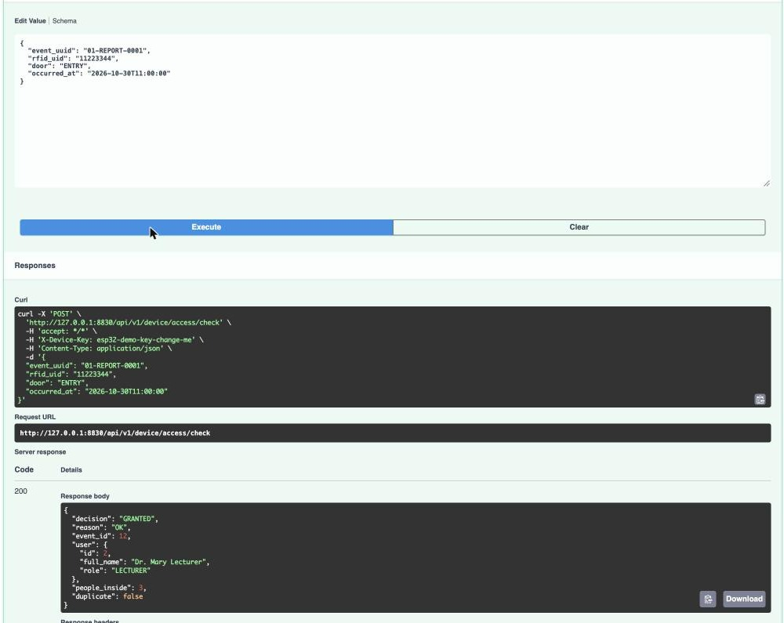
Fig. 6. Executing POST /device/access/check in Swagger UI: the request, the curl command and the GRANTED response.

MANAGEMENT DASHBOARD
The management dashboard is the web application through which college management and security staff monitor and manage the system without using the serial console. It is written in plain HTML, CSS and JavaScript (dashboard/index.html, app.js and style.css), is served by the REST API at /dashboard/, and needs no installation: staff open it in any web browser, including on a phone. The dashboard calls only the REST API, with the same login and role checks as Swagger UI, and refreshes its live views every three seconds, so a card scanned at the ESP32 appears on screen within about three seconds.

Accessing the Dashboard and Logging In
With the API running (start.bat), staff open http://127.0.0.1:8000/dashboard/ on the server, or http://<server-ip>:8000/dashboard/ from another computer on the college network, and log in with a username and password. The API checks the password hash and issues a token that is valid for eight hours, and every login is recorded in the audit log.

Roles and Permissions
The role on each staff account decides what that person may see and change (Table XVII). The same roles protect the REST API, so a user cannot bypass them by calling the API directly.
TABLE XVII
DASHBOARD AND API ROLES
Role | Can view | Can change
VIEWER | Occupancy, lecture rooms, access events, visits, schedule, reports and controller status | Nothing
SECURITY | Everything a VIEWER can see | Emergency mode, lockdown and room light modes
SUPER_ADMIN | Everything, including the audit log and the Database tab | Everything above, plus card holders, the schedule and system settings

Overview Tab
The Overview tab is the live view for security staff (Fig. 7). It shows the number of people inside, the emergency switch, a card for each lecture room with its occupancy, light state and light mode buttons (AUTO, FORCE_ON and FORCE_OFF), the controller's status (online, last seen, pending events and firmware), the people inside the building, and the latest access events with their decision and reason. Denied scans are highlighted, so an unknown card stands out at once.
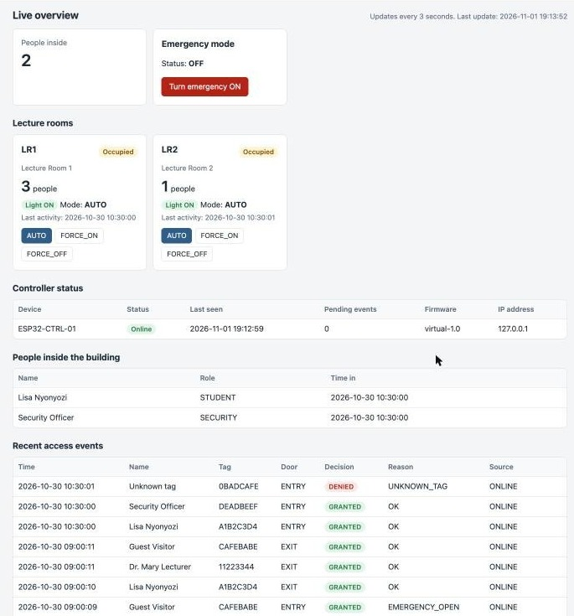
Fig. 7. Dashboard Overview tab: occupancy, lecture rooms, controller status and recent access events.

Schedule, Users and Audit Log Tabs
The Schedule tab sets the opening hours for each day of the week; only a SUPER_ADMIN can save, and a closing time before the opening time is refused. The Users tab registers new card holders and deactivates lost or expired cards; a deactivated card is refused at once and its history is kept. The Audit log tab lists every login and change with the staff member who made it and the reason given, so every configuration change can be traced.

Reports Tab
The Reports tab gives the daily totals of entries, exits and refusals, refusals by reason, the number of unique visitors, the busiest moment of the day, and the hours and energy (kWh) used by each room's lights, with a bar chart (Fig. 8). The lighting figures support the project's aim of reducing the college's electricity costs.
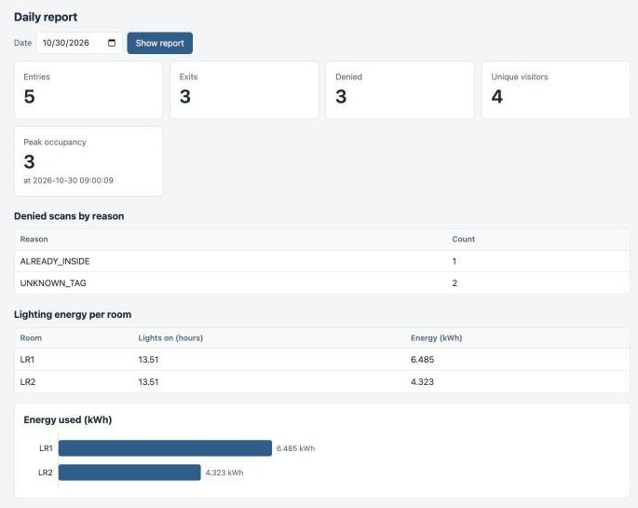
Fig. 8. Dashboard Reports tab: daily totals, peak occupancy and lighting energy.

Database Tab
The Database tab shows the real rows of any table, newest first, with a Refresh button and an optional three-second auto-refresh; new rows are highlighted. It proves that every scan and room change from the ESP32 reaches the database: Fig. 9 shows access events stored from the entrance controller over MQTT. Only a SUPER_ADMIN can open this tab, and password and key hashes are never shown.
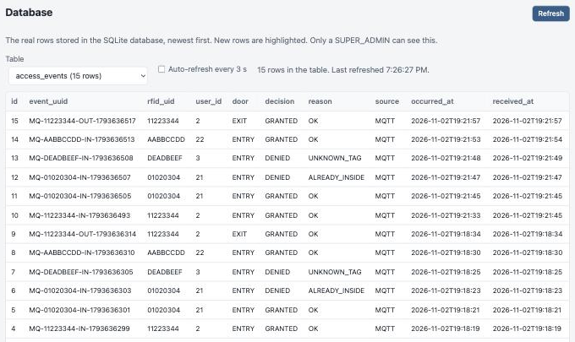
Fig. 9. Database tab: access events stored from the entrance ESP32 over MQTT.

IMPLEMENTED FEATURES
- Dual-reader RFID access control with an authorised card list.
- Configurable opening-hours schedule with support for windows that cross midnight.
- Anti-passback enforcement (no double entry, no exit without entry).
- Always-permitted exit, with an OK_AFTER_HOURS result for exits outside the schedule.
- Servo-driven entry and exit doors operated through a queue.
- Multi-channel feedback: green and red LEDs, buzzer patterns, and LCD messages.
- Live occupancy tracking and an inside-list of card identifiers.
- Persistent storage of schedule and inside list in NVS.
- CSV audit log on an SD card with graceful fallback if the card is absent.
- MQTT publishing of occupancy, events, schedule and room status as JSON, with retained state messages.
- MQTT subscription for room-state messages.
- Motion-controlled lighting for two rooms with a five-second grace period.
- Serial command console with PIN-protected administrative actions and automatic session expiry.
- Network time synchronisation with an East Africa Time zone setting.
- Mutex-protected shared state and a queue-based door task for safe concurrency.
- Web management dashboard with live occupancy, lecture room status, opening hours, card holders, daily reports, an audit log and a live database view.
- MQTT bridge, REST API and SQLite database that store every scan and room change exactly once.
- Role-based staff access (VIEWER, SECURITY, SUPER_ADMIN) with token login and an audit trail of every change.
- Card management (user add and user remove) and manual light overrides from the serial console.

SYSTEM OPERATION

Normal Operation
After power-up the LCD shows the welcome screen with the occupancy. The system waits for cards. When an authorised card is presented to the entry reader within the opening hours, the green LED lights, the buzzer gives a short beep, the entry servo opens the door for three seconds, the LCD shows ACCESS GRANTED with the direction and tag, and the occupancy increases. Presenting the same card at the exit reader opens the exit door, removes the card from the inside list and decreases the occupancy. An unknown card, a second entry, an exit without entry, or an entry outside the schedule produces the red LED, a half-second buzzer tone, no door movement and an ACCESS DENIED message. Every attempt is written to the SD log, printed on the console and published to MQTT.

Administrator Operation
The administrator opens the serial monitor and types help. After logging in with the login command, the schedule can be changed with schedule set, for example schedule set 07:00 21:00. The new schedule is stored in flash and published to MQTT. The status command shows the full system state at any time.

Monitoring
A remote client subscribes to the cocis topics on the same broker to display occupancy, a live feed of access events, the active schedule and each room’s occupied and light state. Because state topics are retained, the client sees current values immediately on connecting.
In this project that client is the MQTT bridge, which stores the messages in the database so that the management dashboard (Section 9) can display them.

Dashboard Operation
To run the backend and the dashboard, run setup.bat once in the backend folder, then start.bat (REST API, database and dashboard) and bridge.bat (MQTT bridge), and start the firmware in Wokwi or run entrance_sim.bat. Open http://127.0.0.1:8000/dashboard/ and log in; a card tapped in Wokwi appears in the Overview and Database tabs within three seconds. On macOS or Linux the equivalent scripts are setup.sh, start.sh and bridge.sh.

TESTING AND RESULTS
The system was tested at two levels: automated tests of the database, API and bridge, and an end-to-end test of the complete path over the public MQTT broker.

Automated Database, API and Bridge Tests
The backend has an automated test suite (tests/test_api.py, tests/test_bridge.py and tests/test_simulator.py, run with pytest through test.bat) that starts the API on a fresh, empty database and exercises it exactly as the bridge, a controller and a staff member would. All 22 tests pass (Table XVIII).
TABLE XVIII
AUTOMATED TEST RESULTS
# | Test | What it proves | Result
1-2 | Start-up and device keys | The API starts and creates the database; unknown device keys are refused (401). | Pass
3-5 | Access rules | Entry, exit and anti-passback work; unknown cards and entries outside the schedule are refused. | Pass
6-7 | Duplicates and concurrency | A repeated event is stored once; eight simultaneous scans of one card give exactly one grant and one visit. | Pass
8 | Offline batch upload | Out-of-order offline events are stored correctly and lighting energy is computed. | Pass
9-11 | Schedule, roles and cards | Schedule changes are validated; role checks give 403; duplicate cards give 409; deactivated cards are refused. | Pass
12-14 | Emergency, heartbeat and rooms | Emergency mode is audited; controller health is stored; room counts and lights are tracked. | Pass
15-17 | Swagger UI, dashboard and database viewer | Swagger login works; the dashboard is served; the database view is read-only and hides secrets. | Pass
18-21 | MQTT bridge | Firmware result codes and PIR rooms are stored faithfully, a relayed event is stored once, and lockdown reaches the bridge. | Pass
22 | Virtual ESP32 end to end | Online and offline decisions and repeated uploads leave exactly the right people inside, with no duplicates. | Pass

End-to-End Test over the MQTT Broker
The complete path was tested over the internet on 2 November 2026. The entrance controller's messages were published to broker.hivemq.com, the bridge relayed them to the API (Fig. 10), and the database and the dashboard were checked (Fig. 9). Table XIX lists the results.
TABLE XIX
END-TO-END TEST OVER THE MQTT BROKER
# | Message published | Expected in the database | Result
M1 | scan in 11223344 (result OK) | GRANTED entry, source MQTT, visit opened | Pass
M2 | scan in 01020304 twice | First GRANTED, second DENIED ALREADY_INSIDE | Pass
M3 | scan in DEADBEEF (not authorised on the ESP32) | DENIED UNKNOWN_TAG | Pass
M4 | Room 1 motion, then vacant | room_status_logs MOTION then NO_MOTION; LR1 light on then off | Pass
M5 | user add AABBCCDD, then scan in AABBCCDD | Card registered in users, then GRANTED entry | Pass
M6 | scan out 11223344 | GRANTED exit, visit closed | Pass
M7 | Retained messages from an earlier run | Ignored, nothing stored | Pass
M8 | Controller status | ESP32-MQTT-ENTRANCE shown online on the dashboard | Pass

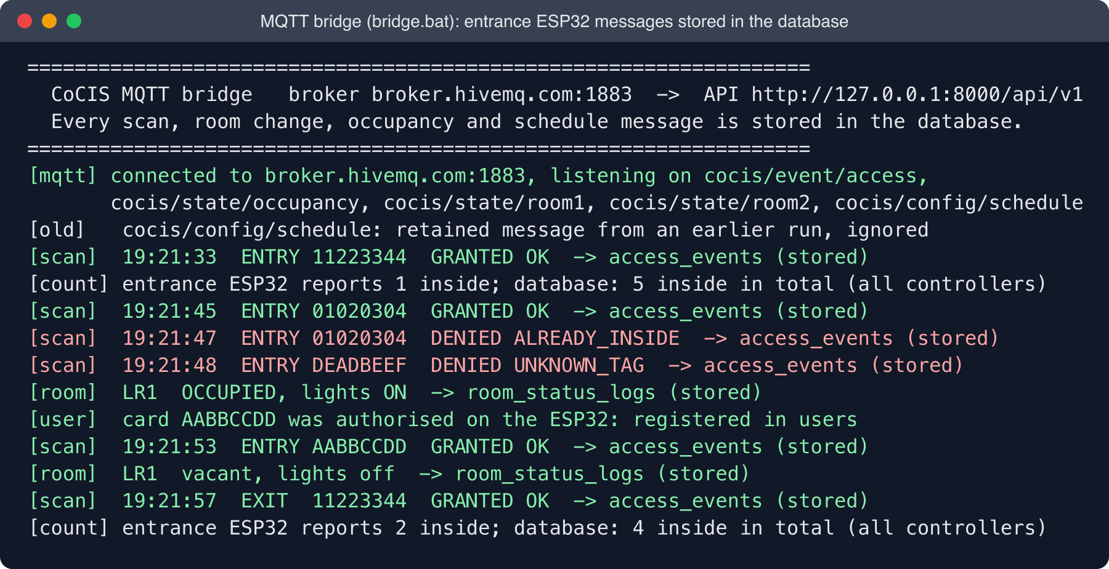
Fig. 10. MQTT bridge window: messages from the entrance ESP32 stored in the database.

LIMITATIONS AND FUTURE WORK

Known Limitations
- Initialisation order: the state module loads the saved schedule and inside list before the storage module initialises NVS, so on a normal start these values may not be restored. Calling the storage initialisation first resolves this.
- If no schedule has ever been saved, the system starts with the schedule 00:00 to 00:00, which means access is always allowed, rather than the intended 07:00 to 21:00.
- The administrator PIN is fixed in the source code, so changing it requires re-flashing.
- The Wi-Fi start-up uses a fixed three-second wait and has no reconnect handler.
- The RFID task pauses for three seconds after each scan to keep the LCD message visible, during which the other reader is not polled.
- The lockdown handler compares 19 characters of the topic, but cocis/cmd/entrance has 18, so LOCKDOWN and UNLOCK commands from the server are ignored until this value is corrected.
- The MQTT broker is public and unauthenticated, so the topics are readable and writable by anyone.
- Some commands listed by the help text (logs, sd dump, config save) are not implemented.
- The OLED driver files (oled.c, oled.h) are present but not part of the build.

Future Work
- Store the administrator PIN as a hash in NVS instead of in the source code.
- Use TLS and broker authentication for MQTT.
- Replace fixed delays with event-driven Wi-Fi handling and non-blocking display timers.
- Correct the lockdown topic check so that a lockdown set by security staff reaches the controller.
- Extend the management dashboard with push notifications and weekly occupancy trends.
- Add over-the-air firmware updates and a larger authorised card database.

CONCLUSION
The CoCIS Entrance Node integrates RFID authentication, schedule and anti-passback rules, door actuation, multi-channel feedback, occupancy monitoring, persistent storage, audit logging, MQTT reporting, automated motion-based room lighting and a serial administration console in a single ESP32 firmware. The modular design with a mutex-protected state module, a queue-driven door task and a central configuration header keeps the code understandable and safe under concurrency. The system is demonstrated in the Wokwi simulator, and the limitations identified in this report provide a clear path for improvement toward a production-ready deployment. The management dashboard, supported by the MQTT bridge, the REST API and the SQLite database, turns the node's messages into a permanent record that staff can monitor and manage from a web browser.

REFERENCES
- Espressif Systems, “ESP-IDF Programming Guide.” [Online]. Available: ESP-IDF framework documentation
- Espressif Systems, “ESP-MQTT component (espressif/mqtt).” [Online]. Available: mqtt documentation
- R. Barry, “Mastering the FreeRTOS Real Time Kernel: A Hands-On Tutorial Guide.” Real Time Engineers Ltd.
- Wokwi, “Wokwi Simulator Documentation.” [Online]. Available: https://docs.wokwi.com/
- FreeRTOS, “FreeRTOS Documentation.” [Online]. Available: freertos documentation
- S. Ramírez, “FastAPI Documentation.” [Online]. Available: https://fastapi.tiangolo.com/
- SQLite Consortium, “SQLite Documentation.” [Online]. Available: https://www.sqlite.org/docs.html
- Eclipse Foundation, “Eclipse Paho MQTT Python Client.” [Online]. Available: https://eclipse.dev/paho/
- Object Management Group, “OMG Unified Modeling Language (UML), Version 2.5.1,” 2017.

