MAKERERE UNIVERSITY
College of Computing and Information Sciences (CoCIS)
Embedded Systems Coursework | BSE III and CS II | Academic Year 2026/2027
Smart Control and Monitoring System
RFID Access Control, Occupancy Monitoring and Automated Lighting using an ESP32, an SD Card and a Central Database API
System Operation Report
Group: ____________
Course Lecturer: ____________________
Submission date: 2nd November 2026

Group Member Details
The table below lists all members of the group, as required by Deliverable 5 of the coursework brief.
Table 1: Group member details
# | Full name | Registration No. | Student No. | Programme | Main responsibility
1 | Lisa Nyonyozi |  |  |  | Use cases, architecture, database, REST API
2
3
4
5

Table of Contents

Group Member Details i
1. Introduction 1
1.1 Background 1
1.2 Problem Statement 1
1.3 Objectives 1
1.3.1 Main Objective 1
1.3.2 Specific Objectives 1
1.4 Scope of the Pilot 1
2. Requirements and Use Case Analysis 3
2.1 Actors 3
2.2 System Use Case Diagram 3
2.3 Controller, Bridge and API Use Case Diagram 4
2.4 Use Case Specifications 5
3. System Architecture 12
3.1 Design Decision: One ESP32 Controller 12
3.2 From the Initial Draft to the Final Architecture 12
3.3 Final System Architecture 13
3.3.1 Layer 1: Field devices 14
3.3.2 Layer 2: The ESP32 controller 14
3.3.3 Layer 3: The MQTT broker 14
3.3.4 Layer 4: The server 15
3.4 Network Design: How the Controller Reaches the Database 15
3.5 Design Decision: Room Occupancy Sensing 16
3.5.1 The known weakness of motion sensing 16
3.5.2 Options considered 16
3.5.3 How the weakness is managed 17
3.6 Design Decision: What to Store on the Memory Card 17
3.6.1 How the controller stores data 17
3.6.2 Why not a full SQLite database on the SD card? 18
3.7 How Data Flows Through the System 18
3.7.1 A card scan 18
3.7.2 Room lighting and lockdown 19
3.8 Access Decision Rules 20
3.9 Synchronisation and Reliability 21
3.10 How the Architecture Meets the Requirements 21
4. Hardware Design 23
4.1 Components Used 23
4.2 Pin Assignment 23
4.3 Circuit Diagram 24
5. Firmware and Software Design 25
5.1 Task Structure and Start-up Sequence 25
5.2 RFID Access Control Module 26
5.3 PIR Occupancy and Lighting Module 26
5.4 Storage Module 26
5.5 Communication Module (Wi-Fi and MQTT) 26
5.6 Serial Interface and Management Menus 27
5.7 Synchronisation in the Firmware 27
5.8 MQTT Bridge 27
5.9 Management Dashboard 28
5.10 Testing Tools Without Hardware 28
6. Database Design 29
6.1 Choice of Database Engine 29
6.2 Entity-Relationship Diagram 29
6.2.1 Relationships 30
6.3 Data Dictionary 30
6.3.1 users 30
6.3.2 rooms 31
6.3.3 access_events 32
6.3.4 building_visits 32
6.3.5 room_status_logs 33
6.3.6 access_schedule 33
6.3.7 system_settings 34
6.3.8 admins 34
6.3.9 admin_sessions 34
6.3.10 devices 35
6.3.11 audit_log 35
6.4 Integrity Rules, Indexes and Views 35
6.5 Local Storage on the ESP32 36
6.6 Initial (Seed) Data 36
7. REST API Design and Documentation 38
7.1 General Conventions 38
7.2 Security Model 39
7.3 Endpoint Summary 39
7.4 Device Endpoints 41
7.5 Management Endpoints 43
7.6 Access Decision Reason Codes 46
7.7 Running the API 46
7.7.1 Testing the API in Swagger UI 47
7.8 Connecting the Entrance Controller to the API 47
7.9 Demonstration Credentials 47
7.10 Example: How a Scan Is Sent and Saved 48
8. Implemented Features and Innovations 49
8.1 Core Features 49
8.2 Innovations 49
9. System Operation and User Guide 51
9.1 A Typical Day 51
9.2 Entrance Controller in Wokwi 51
9.2.1 Reading the LCD 52
9.3 MQTT Bridge 52
9.4 Management Dashboard 53
9.4.1 Overview 54
9.4.2 Schedule 55
9.4.3 Users 55
9.4.4 Reports 55
9.4.5 Audit Log 56
9.5 Swagger UI (API Documentation) 56
9.6 Testing Without Wokwi 58
10. Testing and Results 61
10.1 Database and API Tests 61
10.2 End-to-end Test Over the MQTT Broker 62
10.3 End-to-end Tests with the Virtual HTTP Controller 62
11. Wokwi Simulation Link 64
12. Individual Contributions 65
13. Individual Video Demonstrations 66
14. Conclusion and Recommendations 67
14.1 Conclusion 67
14.2 Limitations and Future Work 67
References 68
Appendix A: Project Files 70
Appendix B: Explaining the System (Likely Questions) 71
Appendix C: Reference HTTP Controller 73

List of Figures

Figure 1: System use case diagram 4
Figure 2: Use case diagram of the entrance ESP32, the MQTT bridge and the Database API 5
Figure 3: Initial hand-drawn architecture draft prepared by the group 13
Figure 4: Final system architecture of the CoCIS Smart Control and Monitoring System 14
Figure 5: Network view: where each part runs and how it connects 15
Figure 6: Recommended upgrade: infrared break-beam people counter at a lecture-room door 17
Figure 7: Sequence of a card scan, from the reader to the database 19
Figure 8: Room lighting messages and the lockdown command 20
Figure 9: Every part and the ESP32 pin it uses 24
Figure 10: Entity-relationship diagram of the cocis.db database 30
Figure 11: MQTT bridge: entrance ESP32 messages stored in the database 52
Figure 12: Database tab: access_events rows stored from MQTT 53
Figure 13: Database tab: room_status_logs rows from the PIR rooms 53
Figure 14: Dashboard login 54
Figure 15: Dashboard Overview tab: occupancy, lecture rooms, controller status and recent scans 54
Figure 16: Dashboard Schedule tab: opening hours per day 55
Figure 17: Dashboard Users tab: registering and deactivating card holders 55
Figure 18: Dashboard Reports tab: daily totals, peak occupancy and lighting energy 56
Figure 19: Dashboard Audit log tab 56
Figure 20: Swagger UI: instructions, demo data and the device endpoints 57
Figure 21: Swagger UI: logging in with the Authorize dialog 57
Figure 22: Swagger UI: an access check executed, with the server's answer 58
Figure 23: Virtual HTTP controller demonstration, steps 2 to 7 59
Figure 24: Virtual HTTP controller demonstration, steps 8 to 10 60
Figure 25: Reference controller running in Wokwi 73
Figure 26: Reference controller serial monitor: offline decisions and status 74
Figure 27: Reference controller: online access request over HTTP 74
Figure 28: Reference controller: offline operation and store-and-forward 75

List of Tables

Table 1: Group member details i
Table 2: Actors of the system 3
Table 3: Use case specification UC01: Enter Building 5
Table 4: Use case specification UC02: Exit Building 6
Table 5: Use case specification UC03: Verify Access 6
Table 6: Use case specification UC04: Detect Motion in Lecture Room 7
Table 7: Use case specification UC05: Control Room Lighting 7
Table 8: Use case specification UC06: Switch Lights Off When Vacant 7
Table 9: Use case specification UC07: View Occupancy 8
Table 10: Use case specification UC08: View Logs and Reports 8
Table 11: Use case specification UC09: Log In 8
Table 12: Use case specification UC10: Manage Authorised Cards 9
Table 13: Use case specification UC11: Configure Access Schedule 9
Table 14: Use case specification UC12: Lock Down the Entrance 10
Table 15: Use case specification UC13: Override Room Lights 10
Table 16: Use case specification UC14: Publish Scan and Room State 11
Table 17: Use case specification UC15: Relay Messages to the Database 11
Table 18: Connections between the parts of the system 15
Table 19: Comparison of occupancy sensors for the lecture rooms 16
Table 20: Findings on running a database on the ESP32 memory card 18
Table 21: Storage options compared 18
Table 22: Access decision rules on the ESP32, in the order they are evaluated 20
Table 23: Synchronisation mechanisms and the problem each one solves 21
Table 24: Traceability from coursework requirements to use cases and design 21
Table 25: Wokwi parts used 23
Table 26: ESP32 pin assignment (from main/config.h) 23
Table 27: Source files of the entrance firmware 25
Table 28: FreeRTOS tasks in the entrance firmware 25
Table 29: MQTT topics and messages 26
Table 30: Serial menu commands of the entrance firmware 27
Table 31: What the bridge does with each message 28
Table 32: Data dictionary: users 31
Table 33: Data dictionary: rooms 31
Table 34: Data dictionary: access_events 32
Table 35: Data dictionary: building_visits 32
Table 36: Data dictionary: room_status_logs 33
Table 37: Data dictionary: access_schedule 33
Table 38: Data dictionary: system_settings 34
Table 39: Data dictionary: admins 34
Table 40: Data dictionary: admin_sessions 34
Table 41: Data dictionary: devices 35
Table 42: Data dictionary: audit_log 35
Table 43: Integrity constraints, indexes and views 35
Table 44: Storage on the ESP32 36
Table 45: General API conventions 38
Table 46: HTTP status codes returned by the API 38
Table 47: Staff roles and permissions 39
Table 48: Summary of all API endpoints 39
Table 49: Scripts for installing, starting and testing the API 46
Table 50: Running the complete system 47
Table 51: Demonstration credentials (change before real deployment) 47
Table 52: Core features and how to show them 49
Table 53: Parts of the system and how each is started 51
Table 54: What the 16x2 LCD shows 52
Table 55: Automated database and API test results 61
Table 56: End-to-end test over the MQTT broker 62
Table 57: Individual contributions of group members 65
Table 58: Links to individual video demonstrations 66
Table 59: Database and API project files 70

Note: if a list above is empty, click inside it and press F9 (Mac: Fn + F9), or right-click and choose Update Field, then Update entire table.

1. Introduction

1.1 Background
The College of Computing and Information Sciences (CoCIS) at Makerere University houses computers, networking equipment and laboratory hardware that must be protected from unauthorised access. The college also pays high electricity bills, partly because lights are left on in lecture rooms that nobody is using. At a management meeting in October 2026 it was agreed to build an automated system that controls who enters the building and switches lecture-room lights according to whether the rooms are occupied. The system starts as a pilot covering the main entrance and two lecture rooms.

1.2 Problem Statement
Access to the CoCIS building is not recorded, so management cannot tell who is inside at any moment, and the building cannot be closed reliably outside working hours. Lecture-room lights depend on people remembering to switch them off, which wastes energy. A solution is needed that identifies every person at the entrance, enforces a configurable schedule, knows how many people are in each lecture room, and keeps working when the network fails.

1.3 Objectives

1.3.1 Main Objective
To design and implement, on the Wokwi simulator with ESP-IDF, a smart control and monitoring system for the CoCIS main entrance and two lecture rooms.

1.3.2 Specific Objectives
- Identify every person with an RFID tag at separate entry and exit doors, and open the right door only for valid tags.
- Keep a record of every entry and exit so that management can see who is inside at any time.
- Detect whether each lecture room is occupied and switch its lights automatically.
- Store logs, configuration and unsent records on a memory card.
- Provide serial-monitor menus for monitoring and configuration.
- Enforce a configurable access schedule that only authenticated, authorised staff can change, and that also stops people leaving outside the permitted period.
- Prevent conflicts and race conditions where tasks or requests share data.

1.4 Scope of the Pilot
The pilot covers the main entrance (one entry lane and one exit lane) and Lecture Rooms 1 and 2. Following the lecturer's guidance that the free Wokwi plan simulates one microcontroller, a single ESP32 runs all three terminals as separate FreeRTOS tasks (Section 3). The firmware is written in C with ESP-IDF: two MFRC522 RFID readers control the entry and exit doors, and a PIR motion sensor switches the lights in each lecture room. The ESP32 publishes every event over MQTT. On the server side, an MQTT bridge, a REST API, a SQLite database and a web dashboard store the records and let management monitor and configure the building (Section 3.4).

2. Requirements and Use Case Analysis
Before designing the hardware, database and API, we identified who uses the system and what each of them needs it to do. These are captured as UML use cases. Each use case is traced to the tables and API endpoints that implement it, so every part of the design can be explained by the need it serves.

2.1 Actors
Table 2: Actors of the system
Actor | Type | Description
Building User | Person | Any student, staff member, lecturer or visitor who holds an RFID card and passes through the main entrance.
Room Occupant | Person | Anyone in Lecture Room 1 or 2. Detected by the room's PIR motion sensor; needs no card.
Management Viewer | Person (role VIEWER) | College management or reception staff who monitor occupancy, logs and reports on the dashboard.
Security Officer | Person (role SECURITY) | Everything a Viewer can do, plus lockdown of the entrance and light overrides.
System Administrator | Person (role SUPER_ADMIN; admin PIN on the ESP32) | Everything a Security Officer can do, plus managing authorised cards, the access schedule and settings.
Time | Timer | The 5 second motion timeout that switches a room's lights off.
Entrance ESP32 | External system | The controller: decides every scan and publishes events over MQTT.
MQTT Bridge | External system | Program on the server that relays the ESP32's messages to the REST API and forwards lockdown commands back.

2.2 System Use Case Diagram
Figure 1 shows the use cases of the whole system. Use cases on the left are carried out by people in the building; those on the right are management functions. Dashed arrows show «include» relationships (a step that is always performed, such as verifying a card) and «extend» relationships (optional behaviour, such as a manual lighting override). The hollow-headed arrows between the staff actors show that their roles build on each other.
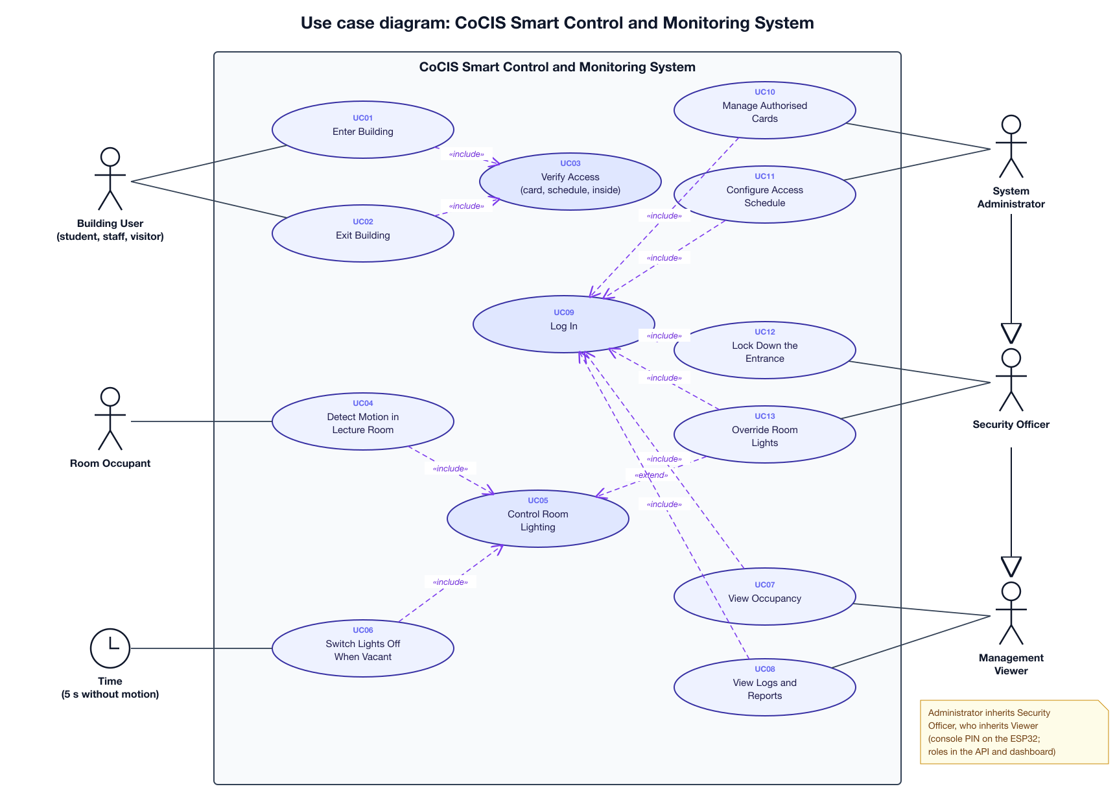
Figure 1: System use case diagram

2.3 Controller, Bridge and API Use Case Diagram
Figure 2 shows how the controller's data reaches the database. The ESP32 never calls the API itself: it publishes to the MQTT broker, and the bridge makes the API requests. Every request the bridge makes includes device authentication, and every event is stored exactly once, however many times it is delivered.
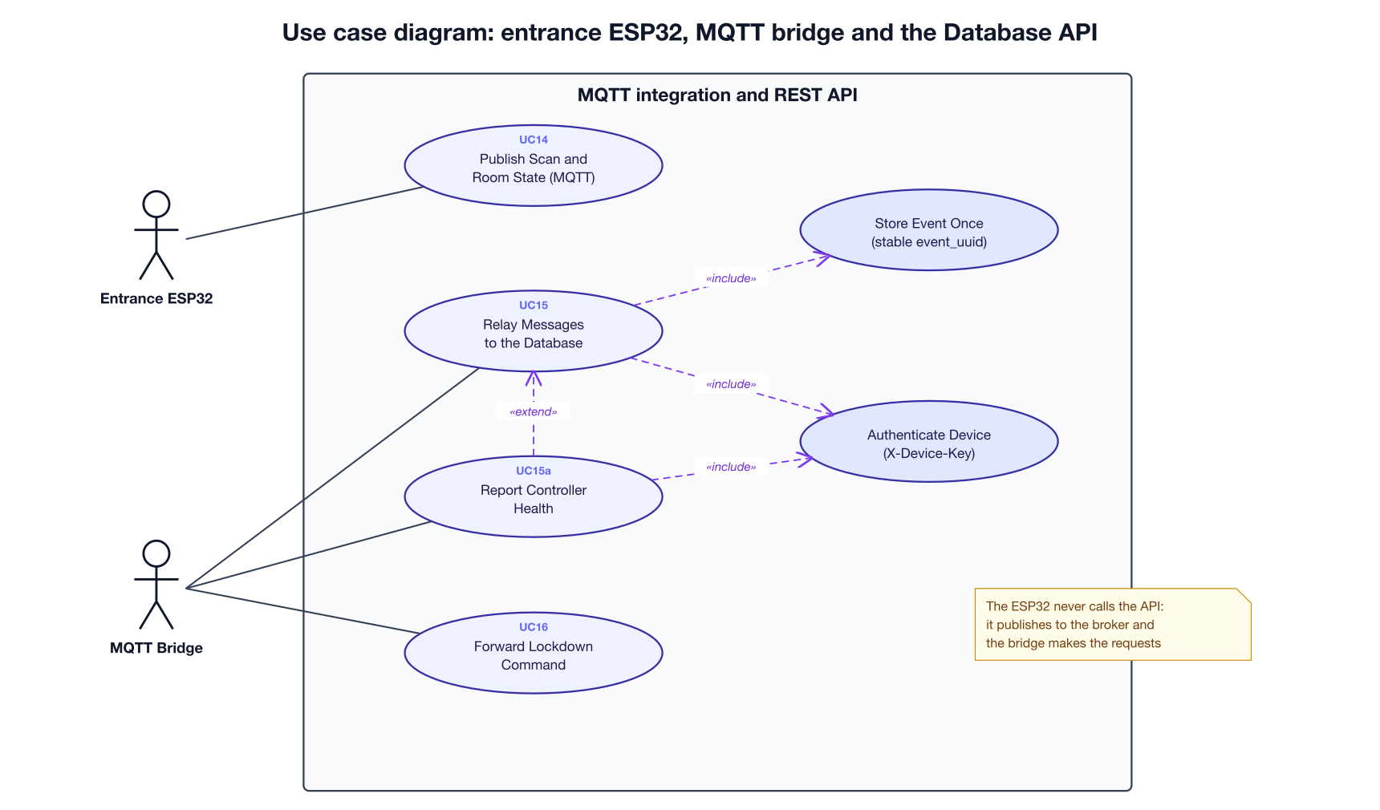
Figure 2: Use case diagram of the entrance ESP32, the MQTT bridge and the Database API

2.4 Use Case Specifications
Each use case is specified below. Main flow is the normal sequence of steps; Alternative flows cover errors and exceptions (step 3a means an alternative to step 3).
Table 3: Use case specification UC01: Enter Building
UC01: Enter Building
Primary actor | Building User
Goal | Enter CoCIS through the ENTRY lane of the main entrance.
Preconditions | The user holds an RFID card. The ESP32 is running.
Main flow | 1. The user taps the card on the ENTRY reader (MFRC522).  2. The rfid task reads the 4-byte UID and the time.  3. The ESP32 verifies access (UC03).  4. The ESP32 opens the ENTRY door servo for 3 seconds, lights the green LED, beeps briefly and shows ACCESS GRANTED and the UID on the LCD.  5. The ESP32 adds the person to its people-inside list, appends the scan to access.csv on the SD card and publishes it over MQTT (UC14).  6. The bridge stores the scan and opens a visit in the database (UC15).
Alternative flows | 3a. Access is DENIED: the door stays shut, the red LED lights, the buzzer sounds for 0.5 s and the LCD shows ACCESS DENIED. The refused scan is still logged and published.  5a. The broker cannot be reached: the scan is still decided, logged on the SD card and shown on the LCD; it does not reach the database.
Postconditions | A row exists in access_events (source MQTT). If granted, the user has an open row in building_visits.
Implemented by | rfid.c (rfid_trigger_scan), state.c; bridge POST /device/relay; tables access_events, building_visits

Table 4: Use case specification UC02: Exit Building
UC02: Exit Building
Primary actor | Building User
Goal | Leave CoCIS through the EXIT lane.
Preconditions | The user is recorded as inside the building.
Main flow | 1. The user taps the card on the EXIT reader.  2. The ESP32 verifies access (UC03).  3. The ESP32 opens the EXIT door for 3 seconds and removes the person from the people-inside list.  4. The scan is logged, published and stored; the visit gets its time out.
Alternative flows | 2a. The person is not recorded as inside: refused (DENIED_NOT_IN).  2b. Outside the opening hours: the exit door still opens, so nobody is trapped inside, but the result is OK_AFTER_HOURS with a longer beep, and it is stored as such so security can follow up.
Postconditions | The visit has a time_out; the person no longer appears in v_people_inside.
Implemented by | state_evaluate(); bridge POST /device/relay; tables access_events, building_visits

Table 5: Use case specification UC03: Verify Access
UC03: Verify Access
Primary actor | None (included by UC01 and UC02)
Goal | Decide on the ESP32 whether a scanned card may pass, and give a result code.
Preconditions | A card UID, door and time have been read.
Main flow | 1. Take the state mutex.  2. If lockdown is active, refuse.  3. Check that the card is in the authorised list.  4. For ENTRY: check the time is inside the daily window and the person is not already inside.  5. For EXIT: check the person is inside.  6. Return the result code (Table 22) and update the people-inside list; release the mutex.
Alternative flows | 1a. Any check fails: return the matching DENIED code; nothing else changes.
Postconditions | The decision is made locally, so doors work even without a network.
Implemented by | state_evaluate() in state.c

Table 6: Use case specification UC04: Detect Motion in Lecture Room
UC04: Detect Motion in Lecture Room
Primary actor | Room Occupant
Goal | Have the room marked occupied when someone is moving in it.
Preconditions | The room's PIR sensor is connected (GPIO 34 for Room 1, GPIO 35 for Room 2).
Main flow | 1. The room_lights task reads both PIR outputs every 100 ms.  2. Motion resets the room's hold timer.  3. The room is occupied while there was motion in the last 5 seconds.  4. The lights are updated (UC05).
Alternative flows | 2a. A light override is active: the sensor is still read but the override decides the light (UC13).
Postconditions | The room's state is current on the ESP32.
Implemented by | rooms.c (room_lighting_task)

Table 7: Use case specification UC05: Control Room Lighting
UC05: Control Room Lighting
Primary actor | None (included by UC04 and UC06; extended by UC13)
Goal | Keep the lights on only while a lecture room is in use.
Preconditions | The room's motion state and override are known.
Main flow | 1. If an override is set (ON or OFF), use it; otherwise use the motion state.  2. When the state changes, switch the light output.  3. Publish the new state to cocis/state/roomN (retained).  4. The bridge stores it in rooms and room_status_logs with trigger MOTION or NO_MOTION.
Alternative flows | 3a. No broker: the light still switches; only the database is not updated.
Postconditions | The light matches the room's use; the change is logged for the energy report.
Implemented by | rooms.c, comms_publish_room(); bridge; room_status_logs, GET /reports/daily

Table 8: Use case specification UC06: Switch Lights Off When Vacant
UC06: Switch Lights Off When Vacant
Primary actor | Time
Goal | Save energy when a room is no longer in use.
Preconditions | The room is in automatic mode and its light is on.
Main flow | 1. Five seconds pass with no motion.  2. The room becomes vacant and the light switches off (UC05).  3. The change is published and stored with trigger NO_MOTION.
Alternative flows | 1a. Motion returns before the 5 s end: the timer restarts and the light stays on.
Postconditions | The light is off and the room shows as vacant on the dashboard.
Implemented by | HOLD_TICKS in rooms.c

Table 9: Use case specification UC07: View Occupancy
UC07: View Occupancy
Primary actor | Management Viewer (and, by inheritance, Security Officer and System Administrator)
Goal | See who is in the building now and the state of each lecture room.
Preconditions | Logged in to the dashboard (UC09), or at the ESP32 console.
Main flow | 1. The viewer opens the dashboard Overview (or types status, who or occupancy at the console).  2. The system shows everyone inside with their time in, the total, and each room's state and light.
Alternative flows | 1a. The token has expired: 401, and the viewer logs in again.
Postconditions | None (read only).
Implemented by | GET /occupancy; view v_people_inside; table rooms; console cmd_status()

Table 10: Use case specification UC08: View Logs and Reports
UC08: View Logs and Reports
Primary actor | Management Viewer
Goal | Review access history, visits, room history and daily summaries.
Preconditions | Logged in (UC09).
Main flow | 1. The viewer opens Reports, the Database tab or the access log, and chooses a date or filter.  2. The system returns the matching records, newest first.  3. For a daily report it calculates entries, exits, refusals by reason, unique visitors, peak occupancy and lighting energy.
Alternative flows | 2a. No records match: an empty list. 2b. At the ESP32, logs <n> and sd dump <n> read the SD card log.
Postconditions | None (read only).
Implemented by | GET /access-events, /visits, /rooms/{code}/history, /reports/daily, /db/{table}

Table 11: Use case specification UC09: Log In
UC09: Log In
Primary actor | Any staff actor
Goal | Prove identity before viewing or changing anything.
Preconditions | The person has a staff account (dashboard) or the admin PIN (ESP32 console).
Main flow | 1. Dashboard: the person enters a username and password; the API checks the PBKDF2 hash and issues a token valid for 8 hours, recorded in the audit log.  2. ESP32 console: login <user> <pin> starts an admin session that expires after 5 minutes.
Alternative flows | 1a. Wrong password: 401 and LOGIN_FAILED is audited. 2a. Wrong PIN: ERR: bad pin.
Postconditions | A row in admin_sessions, or an active admin session on the ESP32.
Implemented by | POST /auth/login; state_admin_login()

Table 12: Use case specification UC10: Manage Authorised Cards
UC10: Manage Authorised Cards
Primary actor | System Administrator
Goal | Authorise new cards and remove lost ones.
Preconditions | Admin session on the ESP32 (UC09).
Main flow | 1. The administrator types user add <HEX> or user remove <HEX> at the console.  2. The ESP32 updates its list and saves it to NVS flash, so it survives a reboot.  3. The first granted scan of a new card makes the bridge register it in users (POST /users), so it appears on the dashboard.
Alternative flows | 1a. No admin session: ERR: admin required. 2a. The list is full (64 cards) or the card exists: refused.
Postconditions | The card list on the ESP32 and the users table agree.
Implemented by | state_user_add(), storage_save_users(); bridge register()

Table 13: Use case specification UC11: Configure Access Schedule
UC11: Configure Access Schedule
Primary actor | System Administrator
Goal | Set the daily hours during which the building may be entered.
Preconditions | Admin session on the ESP32.
Main flow | 1. The administrator types schedule set HH:MM HH:MM.  2. The ESP32 saves the window to NVS and enforces it from the next scan.  3. It publishes the schedule (retained); the bridge copies it to access_schedule (PUT /schedule), so the dashboard shows the hours in use.
Alternative flows | 1a. No admin session: refused. 3a. A window that crosses midnight is enforced on the ESP32 but not copied, because the database stores one window per day.
Postconditions | The ESP32 and the database show the same hours.
Implemented by | console.c, state_set_schedule(), comms_publish_schedule(); bridge on_schedule()

Table 14: Use case specification UC12: Lock Down the Entrance
UC12: Lock Down the Entrance
Primary actor | Security Officer
Goal | Refuse every card at once during a security threat.
Preconditions | Logged in as SECURITY or SUPER_ADMIN.
Main flow | 1. The officer sets lockdown on (PUT /settings/lockdown) with a reason; it is audited.  2. Within 2 seconds the bridge publishes LOCKDOWN to cocis/cmd/entrance (retained).  3. The ESP32 sets its lockdown flag and refuses every scan.  4. UNLOCK ends it the same way.
Alternative flows | 3a. In the current firmware the topic check compares 19 characters instead of 18, so the command is ignored until that one value is corrected (Section 14.2).
Postconditions | Doors follow the lockdown state; every change is audited.
Implemented by | PUT /settings/lockdown; bridge watch_lockdown(); mqtt_cb() in comms.c

Table 15: Use case specification UC13: Override Room Lights
UC13: Override Room Lights
Primary actor | Security Officer or System Administrator
Goal | Force a lecture room's lights on (for example for cleaning) or off, or return them to automatic.
Preconditions | Admin session on the ESP32.
Main flow | 1. The administrator types lights room1 on, off or auto.  2. The room_lights task applies the override at its next 100 ms cycle (extends UC05).
Alternative flows | 1a. No admin session: refused.
Postconditions | The override stays until set back to auto.
Implemented by | rooms_set_override() in rooms.c

Table 16: Use case specification UC14: Publish Scan and Room State
UC14: Publish Scan and Room State
Primary actor | Entrance ESP32
Goal | Make every event available to the rest of the system.
Preconditions | Wi-Fi connected and the MQTT client started.
Main flow | 1. After each scan, publish {tag, dir, result, ts} to cocis/event/access and the occupancy count to cocis/state/occupancy.  2. After each room change, publish {occupied, lights, ts} to cocis/state/roomN.  3. After a schedule change, publish it to cocis/config/schedule.  4. State topics are retained, so a new subscriber immediately receives the latest values.
Alternative flows | 1a. Not connected: the publish is skipped; the SD log keeps the local record.
Postconditions | Messages are on the broker for every subscriber.
Implemented by | comms.c

Table 17: Use case specification UC15: Relay Messages to the Database
UC15: Relay Messages to the Database
Primary actor | MQTT Bridge
Goal | Store every ESP32 message in the database exactly once.
Preconditions | The API is running; the bridge is subscribed.
Main flow | 1. The bridge receives a message and converts it (Table 31).  2. It gives the event a stable event_uuid built from the card, direction and ESP32 time.  3. It sends POST /api/v1/device/relay with its device key.  4. The API stores it in one transaction and reports it as accepted (or as a duplicate).  5. The bridge also sends a heartbeat (UC15a), so the dashboard shows the controller online.
Alternative flows | 1a. A retained message older than 10 minutes is ignored. 3a. The API is down: the error is shown and the message is lost; the ESP32's SD log still has it.
Postconditions | The database matches the ESP32's events; the dashboard updates within 3 seconds.
Implemented by | bridge/mqtt_bridge.py; POST /device/relay, POST /device/heartbeat

3. System Architecture
This chapter explains how the whole system fits together: the devices in the building, the single ESP32 controller that runs them, the MQTT broker that carries its messages, and the server side (bridge, REST API, database and dashboard) that keeps the official records. It also records the main design decisions and the reasons for them.

3.1 Design Decision: One ESP32 Controller
The coursework brief (Section 2.3) describes three control terminals (Lecture Room 1, Lecture Room 2 and the main entrance), each of which may use its own ESP32. The free version of the Wokwi simulator only supports one microcontroller per project, and the course lecturer confirmed by email that groups should use one. Our design therefore uses one ESP32 that serves all three terminals.
The terminals still exist logically: the entrance is handled by the rfid and door tasks and each lecture room by the room_lights task (Section 3.3.2). If CoCIS later moves to one ESP32 per terminal, each board can publish to the same MQTT topics, and the bridge, API and database stay exactly the same.

3.2 From the Initial Draft to the Final Architecture
Figure 3 is the group's first hand-drawn sketch. It identified the main ideas that the final design keeps: users carrying RFID tags, a main entrance split into an Entrance lane and an Exit lane, a scanner that opens the door, a server, a memory card, and database tables for users, events (RFID, time in, time out, date), rooms and room status.
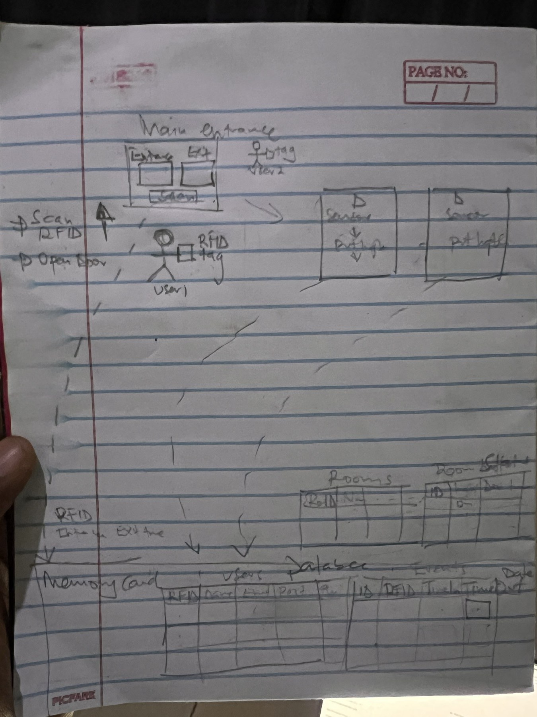
Figure 3: Initial hand-drawn architecture draft prepared by the group
While refining the sketch we made the following changes:
- The ESP32 talks MQTT, not directly to the server. It publishes small JSON messages to a broker; a bridge on the server turns them into API requests. The controller stays simple and never waits for the server.
- Two separate server boxes became one REST API. A single API with clear endpoints is easier to secure, test and explain.
- The memory card and the database have distinct jobs. The ESP32 keeps its settings in NVS flash and a log on the SD card; the SQLite database behind the API is the central record (Section 3.6).
- The Events table was split into access_events and building_visits. Every scan is an access event; a visit pairs an entry with its exit, giving the time in, time out and date columns from the sketch.
- New tables were added for the schedule, staff accounts and sessions, devices, settings and an audit log, so that configuration is authenticated and every change is traceable.

3.3 Final System Architecture
Figure 4 shows the final architecture in four layers, read from left to right.
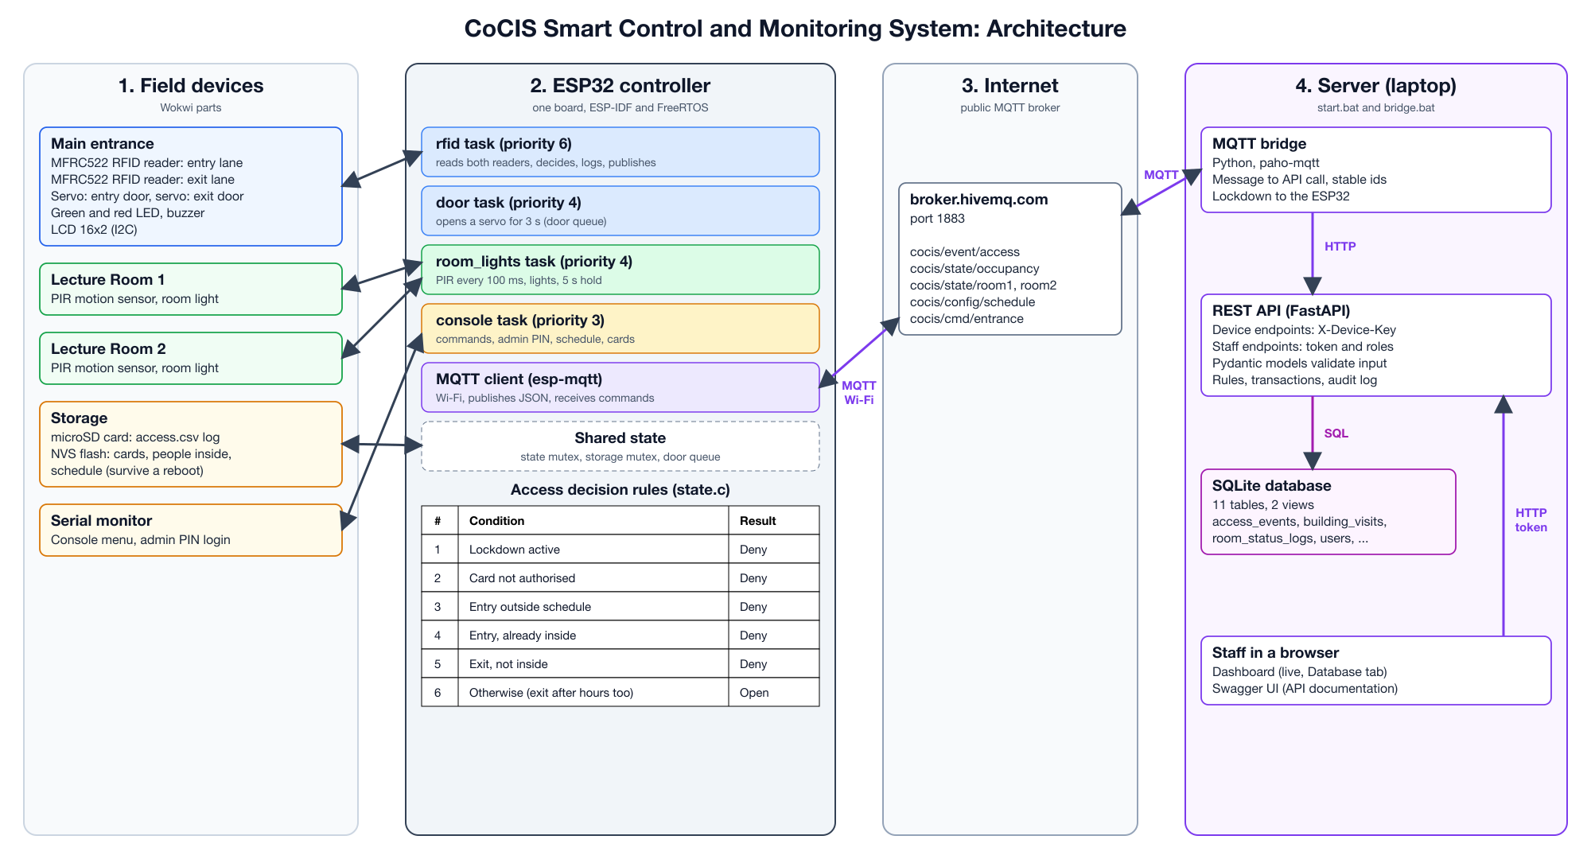
Figure 4: Final system architecture of the CoCIS Smart Control and Monitoring System

3.3.1 Layer 1: Field devices
- Main entrance: an MFRC522 RFID reader and a door servo for each lane, a green and a red LED, a buzzer and a 16x2 LCD.
- Lecture Rooms 1 and 2: a PIR motion sensor and the room light.
- Storage and console: a microSD card for the access log, the ESP32's NVS flash for settings, and the serial monitor.

3.3.2 Layer 2: The ESP32 controller
One ESP32 runs these FreeRTOS tasks at the same time (details in Chapter 5):
- rfid (priority 6): polls both readers, decides, logs and publishes each scan.
- door (priority 4): opens a servo for 3 seconds when asked through the door queue.
- room_lights (priority 4): reads the PIR sensors every 100 ms and switches the lights.
- console (priority 3): the serial menu for staff.
- MQTT client: the ESP-IDF esp-mqtt component, which runs its own task for the network.
Shared data is protected by a state mutex and a storage mutex (Section 3.9), and every door follows the same six rules (Table 22).

3.3.3 Layer 3: The MQTT broker
The public broker broker.hivemq.com on port 1883 passes messages between the ESP32 and the server. Neither side connects to the other directly.

3.3.4 Layer 4: The server
The MQTT bridge, the FastAPI REST API and the SQLite database run on a laptop or college server, with the dashboard and Swagger UI in a browser. Details are in Section 3.4 and Chapters 6 and 7.

3.4 Network Design: How the Controller Reaches the Database
Figure 5 answers a common question: does the ESP32 need to be on the same network as the database? No. The ESP32 (in Wokwi, on the Wokwi-GUEST Wi-Fi) and the server each open an outgoing connection to the MQTT broker on the internet. The broker passes the messages between them. Because nobody needs to connect into the laptop, no router settings, port forwarding or tunnel are needed for MQTT, and the database never has to be exposed to the internet.
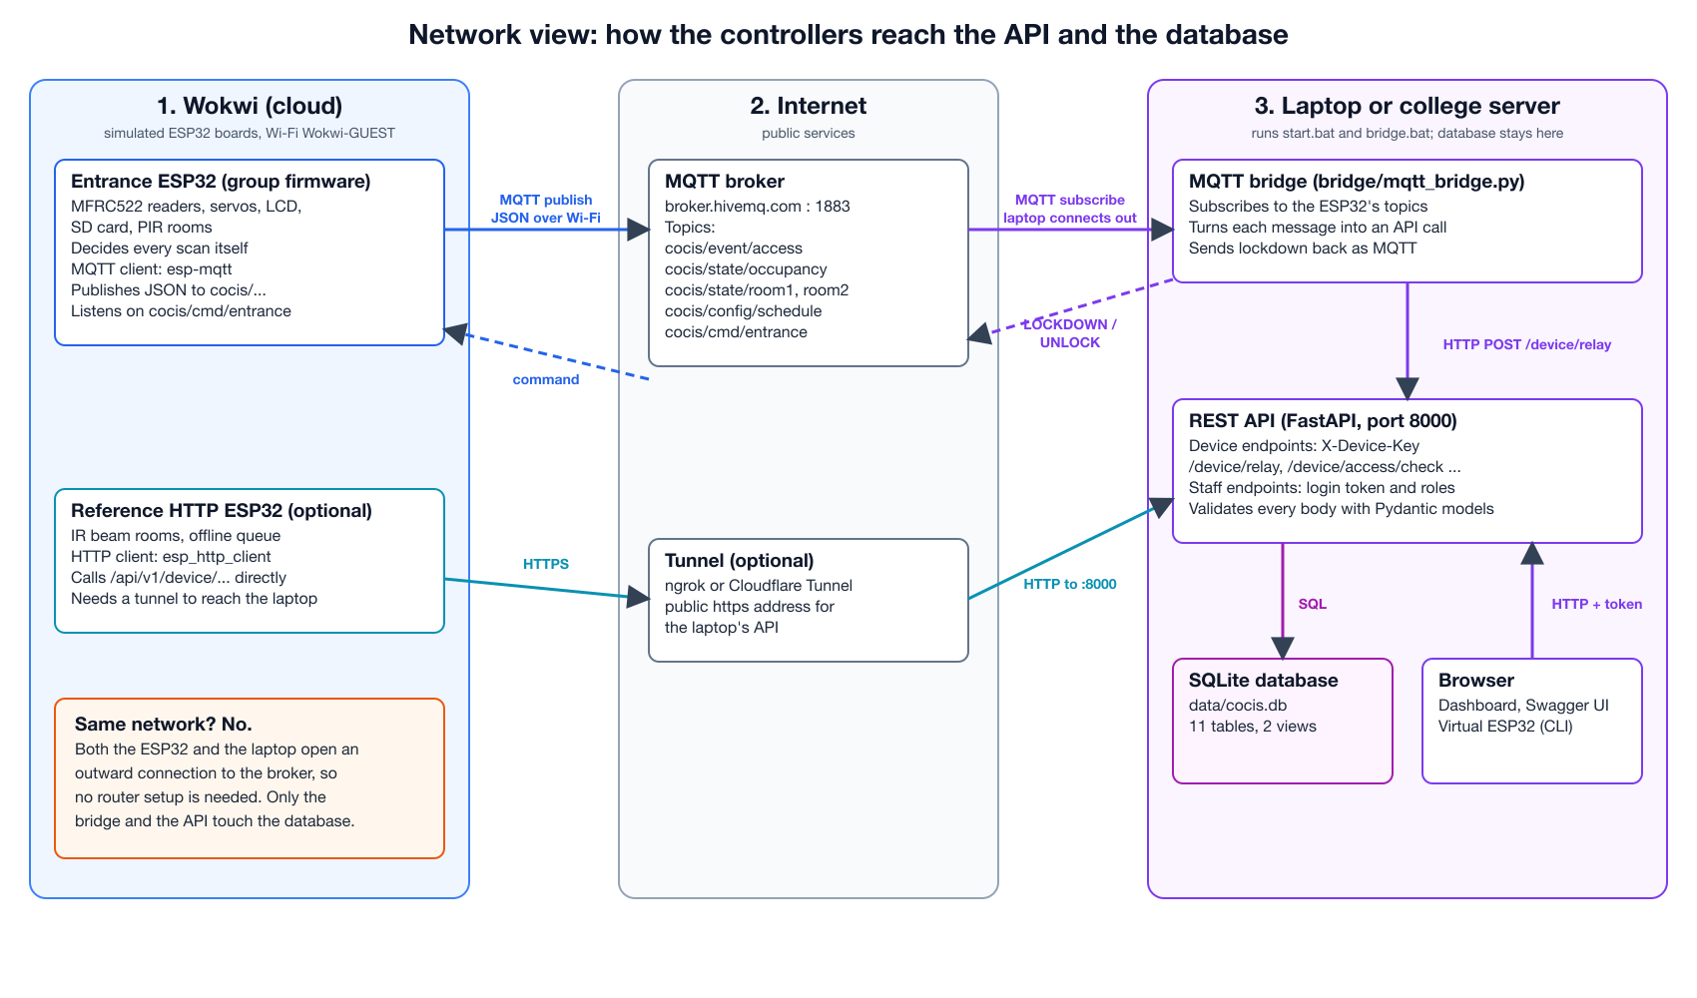
Figure 5: Network view: where each part runs and how it connects
Table 18: Connections between the parts of the system
Link | Protocol | Who connects | Network needed
ESP32 to broker | MQTT 3.1.1 over TCP, port 1883, JSON payloads | ESP32 connects out | Internet (Wi-Fi Wokwi-GUEST in the simulator)
Broker to bridge | MQTT subscription | Bridge connects out | Internet on the server
Bridge to REST API | HTTP, JSON, header X-Device-Key | Bridge calls 127.0.0.1:8000 | Same computer
API to database | SQL through Python sqlite3 | Inside the API process | Same computer (one file)
Dashboard to API | HTTP, JSON, bearer token | The browser | Same computer, or the college network with start.bat --lan
Bridge to ESP32 (lockdown) | MQTT publish to cocis/cmd/entrance | Bridge publishes, ESP32 subscribed | Internet

For a real deployment the broker would be a private one (for example Mosquitto on the college server, with a username, password and TLS on port 8883). Only the broker address in the firmware's config.h and the bridge's --broker option would change.

3.5 Design Decision: Room Occupancy Sensing
Each lecture room has a PIR (passive infrared) motion sensor. The room is treated as occupied while there has been motion in the last 5 seconds; then the lights switch off. PIR sensors are cheap, simple and available in Wokwi, and they meet the brief's requirement that lights follow occupancy.

3.5.1 The known weakness of motion sensing
A PIR sensor does not detect people; it detects changes in infrared heat as warm bodies move. A person who sits still produces no change, so a room full of students writing an exam can look empty. Occupancy-sensor company Butlr notes that a student taking an exam may barely move for 60 to 75 minutes, and a 1996 ACEEE study of classroom lighting controls reported early occupancy sensors turning lights off in occupied rooms. With a 5 second hold, this happens quickly.

3.5.2 Options considered
Table 19: Comparison of occupancy sensors for the lecture rooms
Sensor | How it detects people | Still occupants | Counts people | Wokwi | Use
PIR motion sensor | Changes in infrared heat as people move | Missed after the hold time | No | Yes | Implemented (with a hold timer)
Active IR break-beam pair at the door | Two beams at the door; the order they break gives the direction | Not affected: people are counted in and out | Yes | Simulated with pushbuttons | Recommended upgrade (demonstrated by the reference controller)
Thermopile IR array (e.g. AMG8833) | Absolute heat per pixel, so still bodies are seen | Detected | Roughly | No part | Future option
Ultrasonic or mmWave radar | Reflections of small movements | Detected | No | Ultrasonic only | Not chosen

3.5.3 How the weakness is managed
- Hold time. Commercial classroom sensors use 15 to 30 minutes; the 5 seconds used here (HOLD_TICKS) keeps the Wokwi demonstration quick and is one constant to change.
- Manual override. Staff can force a room's lights on with lights room1 on (UC13), for example during an exam.
- Recorded for review. Every switch is stored with trigger MOTION or NO_MOTION, so the energy report shows how long lights were on, and management can tune the hold time from real data.
- Upgrade path. Counting people with two infrared beams at the door (Figure 6) keeps lights on for still occupants. The database and API already support counts (PERSON_IN and PERSON_OUT), and our reference controller demonstrates it (Appendix C).
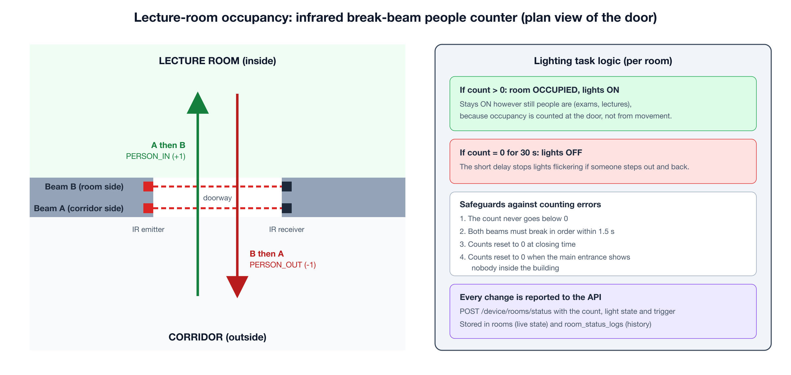
Figure 6: Recommended upgrade: infrared break-beam people counter at a lecture-room door

3.6 Design Decision: What to Store on the Memory Card
Section 2.4 of the brief proposes an SD card to hold the large volume of data the system produces. We investigated whether the SD card should hold a full database, and how it fits into the architecture.

3.6.1 How the controller stores data
- NVS flash (non-volatile storage inside the ESP32): the authorised card list, the people-inside list and the schedule. They are small, read on every scan and must survive a reboot. NVS writes are atomic, so a power cut never leaves half a value.
- microSD card: access.csv, an append-only log of every scan (time, card, direction, result). It can be opened in a spreadsheet straight from the card and read with sd dump <n>.
- Central SQLite database on the server: the authoritative record with relationships, constraints, reports and the audit trail (Chapter 6).

3.6.2 Why not a full SQLite database on the SD card?
Table 20: Findings on running a database on the ESP32 memory card
Concern | What we found | Effect on the design
Concurrency | The ESP32 SQLite port does not implement file locking, so it is only reliable from one thread. | Several tasks write data; a shared database would need its own locking layer.
Memory | About 320 KB of usable RAM; SQLite's page cache competes with Wi-Fi, TLS and FreeRTOS. | Risk of running out of memory in Wokwi.
Power loss | FAT file systems are commonly corrupted when power is cut mid-write; a database rewrites pages in place. | Append-only logs are far safer.
Remote access | Management cannot query an SD card from the office. | The official record must be on the server.

Table 21: Storage options compared
Option | Works offline | Safe on power loss | Fits ESP32 memory | Central reports | Decision
No local storage (server only) | No | n/a | Yes | Yes | Rejected
Full SQLite database on the SD card | Yes | Weak | Tight | No | Rejected
NVS for state + CSV log on SD + SQLite on the server | Yes | Good | Yes | Yes | Chosen

3.7 How Data Flows Through the System

3.7.1 A card scan
Figure 7 follows one scan from the card to the dashboard. The ESP32 decides and opens the door at once, then logs and publishes; the bridge stores the event through the API in one database transaction.
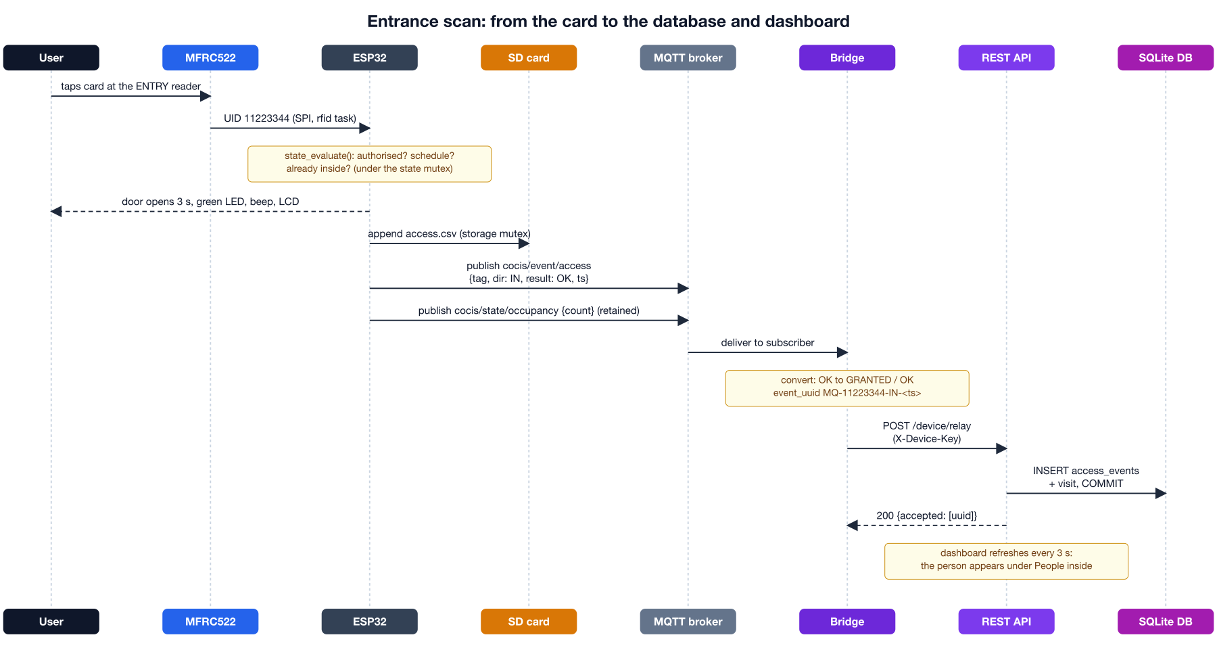
Figure 7: Sequence of a card scan, from the reader to the database
- The user taps a card; the rfid task reads the UID over SPI.
- state_evaluate() applies the rules (Table 22) under the state mutex.
- The door task opens the servo for 3 seconds; LEDs, buzzer and LCD give feedback.
- The scan is appended to access.csv and published to cocis/event/access as {"tag":"11223344","dir":"IN","result":"OK","ts":1793636493}.
- The bridge receives it, converts it and calls POST /api/v1/device/relay with its device key.
- The API stores the event and opens the visit in one transaction; the dashboard shows the change within 3 seconds.

3.7.2 Room lighting and lockdown
Figure 8 shows the room messages and the one command that travels the other way: a lockdown set on the dashboard reaches the ESP32 through the bridge and the broker.
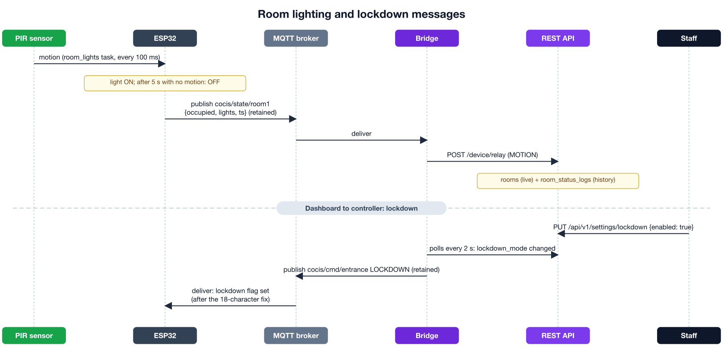
Figure 8: Room lighting messages and the lockdown command

3.8 Access Decision Rules
The ESP32 applies the rules below, in this order, in state_evaluate(). The first rule that matches decides. The result code is shown on the LCD, written to the SD log, published and stored in the database.
Table 22: Access decision rules on the ESP32, in the order they are evaluated
# | Condition | Result code | Stored as
1 | Lockdown is active | DENIED_SCHEDULE | DENIED, OUTSIDE_SCHEDULE
2 | Card is not in the authorised list | DENIED_UNKNOWN | DENIED, UNKNOWN_TAG
3 | ENTRY outside the daily window | DENIED_SCHEDULE | DENIED, OUTSIDE_SCHEDULE
4 | ENTRY but already inside (anti-passback) | DENIED_ALREADY_IN | DENIED, ALREADY_INSIDE
5 | EXIT but not recorded as inside | DENIED_NOT_IN | DENIED, NOT_INSIDE
6a | EXIT outside the daily window | OK_AFTER_HOURS | GRANTED, OK_AFTER_HOURS
6 | Otherwise | OK | GRANTED, OK

Rule 6a is a deliberate safety choice: Section 2.6 of the brief says people should not leave outside the authorised period, but locking someone inside is dangerous, so the exit door opens and the event is recorded as OK_AFTER_HOURS (with a different beep) for security to follow up. Entry outside the window is always refused.

3.9 Synchronisation and Reliability
Section 2.7 of the brief asks for mechanisms that prevent conflicts, inconsistent records and race conditions. Table 23 lists each shared resource and how it is protected, on the ESP32 and on the server.
Table 23: Synchronisation mechanisms and the problem each one solves
Where | Shared resource or risk | Mechanism used
ESP32 | Card list, people-inside list, schedule and room states, used by the rfid, room_lights, console and MQTT tasks | State mutex (s.mtx in state.c): every read or change takes it
ESP32 | The SD log, written after each scan | Storage mutex (s_mtx in storage.c)
ESP32 | Opening a door without blocking the reader | Door queue: the rfid task sends a request and the door task holds the servo for 3 s
ESP32 | One card held over a reader | 1.5 s cooldown for the same card (SCAN_COOLDOWN_MS)
ESP32 flash | Power cut while saving state | NVS commits are atomic
Bridge | A message delivered twice, or retained messages replayed on reconnect | Stable event_uuid from card, direction and ESP32 time; stale retained messages ignored
API / DB | Two requests at the same moment (e.g. the bridge and a dashboard change) | BEGIN IMMEDIATE transactions: one writer at a time
API / DB | A person recorded inside twice | Partial unique index uq_one_open_visit
API / DB | The same event stored twice | event_uuid is UNIQUE; duplicates are reported, not stored

The server-side protection was tested by firing eight simultaneous ENTRY requests for the same card at the API: exactly one was granted and only one visit was created (Section 10.1).

3.10 How the Architecture Meets the Requirements
Table 24: Traceability from coursework requirements to use cases and design
Brief section | Requirement | Use cases | Where it is handled
2.1 | RFID access at entry and exit; know who is inside | UC01 to UC03, UC07 | Two MFRC522 readers and servos; people-inside list on the ESP32; access_events, building_visits, v_people_inside
2.2 | Lights follow room occupancy | UC04 to UC06, UC13 | PIR sensors and the room_lights task; overrides; room_status_logs and the energy report
2.3 | Three terminals working as one system | All | One ESP32 (per the lecturer's email) with tasks per terminal; MQTT topics per terminal
2.4 | Store large volumes of data | UC01, UC15 | SD card access.csv, NVS, and the central SQLite database
2.5 | Serial menus and useful information | UC07 to UC11 | Console task with status, who, logs, user, schedule and lights commands; dashboard as an additional interface
2.6 | Configurable schedule, changed only by authorised staff | UC09, UC11 | schedule set needs the admin PIN; copied to access_schedule; entry refused outside the window
2.7 | Synchronisation and reliability | UC14, UC15 | Mutexes and a queue on the ESP32; transactions, unique keys and idempotent relay on the server (Table 23)

4. Hardware Design
The whole circuit is built in the Wokwi simulator (diagram.json of the entrance firmware), so no physical parts are needed. Wokwi provides working models of the MFRC522 RFID reader, servo, PIR sensor, LCD and microSD card, so the firmware drives them exactly as it would drive real hardware.

4.1 Components Used
Table 25: Wokwi parts used
Wokwi part | Quantity | Role in the system
ESP32 DevKitC V4 | 1 | Runs every task for the entrance and both lecture rooms
MFRC522 RFID reader (board-mfrc522) | 2 | Entry lane and exit lane readers on the shared SPI bus
Servo motor | 2 | Entry door and exit door: opened for 3 seconds on GRANTED
Green and red LED | 2 | Access granted or refused
Buzzer | 1 | 80 ms beep when granted, 200 ms after hours, 500 ms when refused
LCD 16x2 with I2C backpack | 1 | Idle: CoCIS Security and the occupancy; after a scan: ACCESS GRANTED or DENIED and the card
PIR motion sensor | 2 | One per lecture room
LED (room light) | 2 | The lights of Lecture Rooms 1 and 2
microSD card | 1 | access.csv log of every scan

4.2 Pin Assignment
Table 26: ESP32 pin assignment (from main/config.h)
Component | ESP32 pin | Signal type
SPI bus (both readers and the SD card) | SCK 18, MISO 19, MOSI 23 | SPI2, 1 MHz for the readers
Entry reader: chip select, reset | GPIO 5, GPIO 4 | SPI chip select, digital output
Exit reader: chip select, reset | GPIO 15, GPIO 2 | SPI chip select, digital output
microSD card: chip select | GPIO 16 | SPI chip select
Entry servo, exit servo | GPIO 13, GPIO 33 | PWM 50 Hz, 16-bit (LEDC channels 0 and 1)
Green LED, red LED, buzzer | GPIO 12, GPIO 14, GPIO 27 | Digital output
LCD (I2C address 0x27) | SDA GPIO 21, SCL GPIO 22 | I2C at 100 kHz (new ESP-IDF I2C master driver)
PIR Room 1, light Room 1 | GPIO 34, GPIO 26 | Digital input (input-only pin), digital output
PIR Room 2, light Room 2 | GPIO 35, GPIO 25 | Digital input (input-only pin), digital output
Serial monitor | UART0 | 115200 baud

Sharing one SPI bus between three devices saves pins; each device has its own chip-select line, and only one transaction runs at a time. GPIO 34 and 35 are input-only pins, which suits the PIR outputs.

4.3 Circuit Diagram
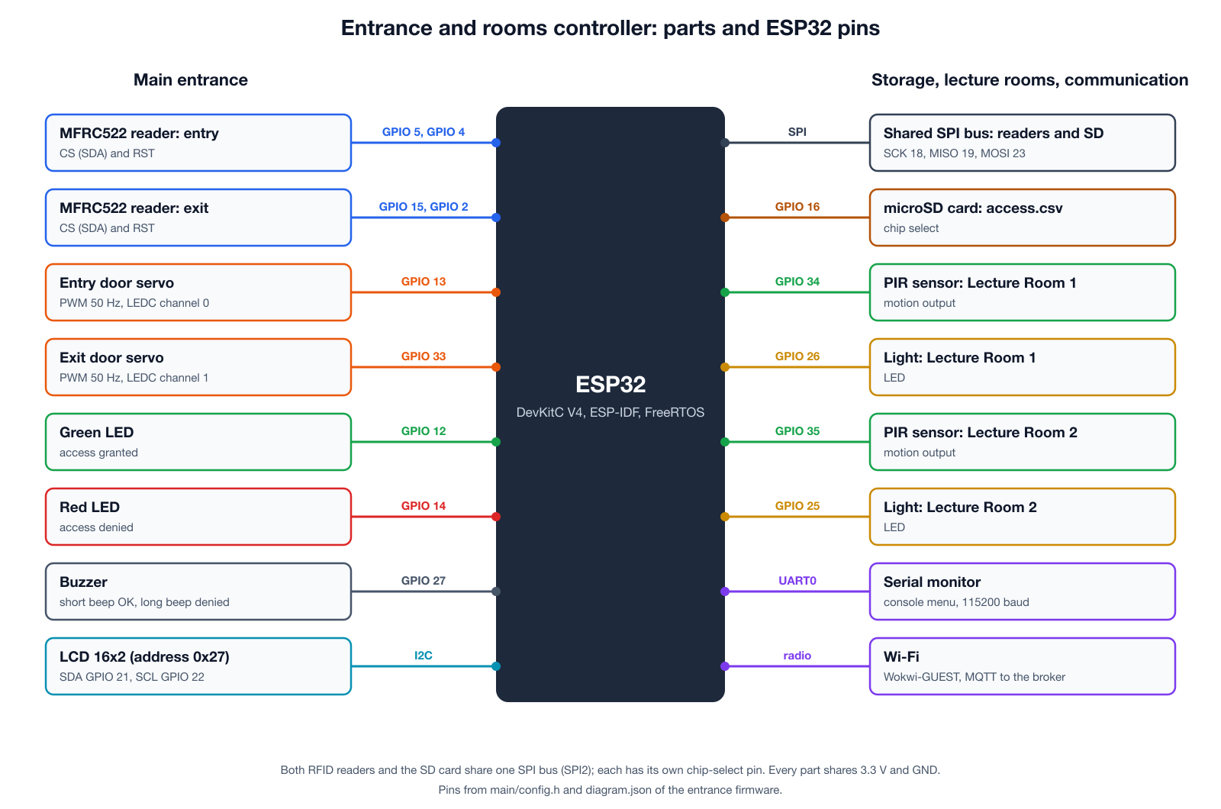
Figure 9: Every part and the ESP32 pin it uses
[To be completed by: ______________________] Insert a screenshot of the entrance circuit running in Wokwi (the diagram.json of the group's firmware), showing the LCD after a scan.

5. Firmware and Software Design
The firmware is an ESP-IDF project in C (main/ of the entrance firmware), built with idf.py and run in Wokwi through wokwi.toml. It uses two managed components, espressif/mqtt and espressif/cjson. Each concern is in its own source file.
Table 27: Source files of the entrance firmware
File | Responsibility
main.c | Start-up: SPI bus, LCD, state, storage, door, RFID, rooms, Wi-Fi, console; then the tasks, MQTT and NTP
config.h | Pins, Wi-Fi and broker settings, topics, default cards, limits
rfid.c | MFRC522 driver over SPI, the rfid task, the feedback and logging after each scan
state.c | The rules (state_evaluate), people inside, cards, schedule, admin session, room states, under one mutex
door.c | Servo PWM and the door task fed by a queue
rooms.c | PIR sensing, 5 s hold timer, light outputs and overrides
storage.c | NVS for cards, people inside and schedule; SD card log access.csv
comms.c | Wi-Fi, the MQTT client, topics and JSON messages, the lockdown command
console.c | Serial menu and admin commands
lcd.c | 16x2 LCD driver over I2C

5.1 Task Structure and Start-up Sequence
app_main() initialises the SPI bus and the LCD (which shows the welcome screen at once), then the state (restored from NVS), storage (NVS and SD card), doors, RFID readers, rooms, Wi-Fi and console. It starts the rfid and room tasks, waits 3 seconds for Wi-Fi, starts MQTT and the console, and finally starts NTP with the time zone EAT-3.
Table 28: FreeRTOS tasks in the entrance firmware
Task | Priority | Stack | What it does
rfid | 6 (highest) | 8 KB | Polls both readers every 150 ms, applies the rules, drives feedback, logs and publishes
door | 4 | 2 KB | Waits on the door queue; opens the requested servo for 3 s
room_lights | 4 | 4 KB | Reads the PIR sensors every 100 ms; switches and publishes the lights
console | 3 | 4 KB | Reads the serial monitor and runs commands
MQTT (esp-mqtt) | set by the component | own | Keeps the broker connection, publishes and receives

Card reading has the highest priority because a person is waiting at the door; the console has the lowest because a person typing can wait a few milliseconds.

5.2 RFID Access Control Module
Both MFRC522 readers share the SPI bus at 1 MHz (chosen for stable simulation). The rfid task polls each reader in turn: it sends REQA, runs anticollision to read the 4-byte UID and checks its XOR checksum. A card held on a reader is only processed once every 1.5 seconds. rfid_trigger_scan() then calls state_evaluate(), opens the door through the door queue, gives LED and buzzer feedback, shows the result on the LCD, appends to the SD log, publishes the event and the occupancy, and saves the state to NVS.

5.3 PIR Occupancy and Lighting Module
The room_lights task reads both PIR outputs every 100 ms. Motion resets a hold counter; the room is occupied while the counter is below 50 cycles (5 seconds). An override from the console (lights roomN on|off|auto) takes priority. Only when a room's light state changes does the task switch the output, update the shared state and publish cocis/state/roomN, so the broker and database are not flooded.

5.4 Storage Module
storage.c keeps three small values in NVS under the namespace cocis: sched_start and sched_end (minutes since midnight), and the blobs inside and users (count plus card UIDs). At start-up the default schedule is 07:00 to 21:00 and the default cards are 11223344 and 01020304. The SD card is mounted at /sdcard and access.csv is opened in append mode with the header epoch,iso8601,tag_hex,dir,result; each scan adds one line under the storage mutex and is flushed immediately.

5.5 Communication Module (Wi-Fi and MQTT)
comms.c joins the Wokwi-GUEST network and starts the esp-mqtt client with the broker in config.h. It publishes JSON built with snprintf or cJSON (Table 29). On connecting it subscribes to the command topic and republishes the occupancy and schedule, so a new subscriber has the current values.
Table 29: MQTT topics and messages
Topic | Direction | Payload example | Retained | QoS
cocis/event/access | ESP32 to server | {"tag":"11223344","dir":"IN","result":"OK","ts":1793636493} | No | 0
cocis/state/occupancy | ESP32 to server | {"count":2,"ts":1793636493} | Yes | 1
cocis/state/room1, room2 | ESP32 to server | {"occupied":true,"lights":true,"ts":...} | Yes | 1
cocis/config/schedule | ESP32 to server | {"start":"07:00","end":"21:00","version":...} | Yes | 1
cocis/cmd/entrance | Server to ESP32 | LOCKDOWN or UNLOCK | Yes (bridge) | 1

5.6 Serial Interface and Management Menus
Table 30: Serial menu commands of the entrance firmware
Command | Purpose
help, status | Menu; time, schedule, occupancy, admin session, card count, both rooms with their mode
occupancy, who | Number of people inside; list of cards inside
logs <n>, sd dump <n> | Recent scans from the SD card log
scan in|out <HEX> | Simulate a card at the entry or exit reader
login <user> <pin>, logout | Admin session (5 minutes)
user list | add <HEX> | remove <HEX> | Authorised cards (admin)
schedule show | set HH:MM HH:MM | Access window (admin)
lights room1|room2 on|off|auto | Light override (admin)
config save, reboot | Save state; restart

5.7 Synchronisation in the Firmware
All shared state lives in one structure in state.c protected by a FreeRTOS mutex; every function that reads or writes it takes the mutex first, and slow work (SD and NVS writes, MQTT) is done after releasing it. The SD log has its own mutex. The door queue lets the rfid task carry on scanning while a door is open. Table 23 summarises these mechanisms with the server-side ones.

5.8 MQTT Bridge
The bridge (bridge/mqtt_bridge.py, started with bridge.bat) connects the firmware to the database without any change to the firmware. It uses the Python paho-mqtt library to subscribe to the ESP32's topics and the standard library to call the API. Messages are handled one at a time by a worker thread, so the database receives them in order. Table 31 shows what it does with each message.
Table 31: What the bridge does with each message
ESP32 message | Bridge action | API request | Stored in
Scan on cocis/event/access | Convert the result code, build a stable event_uuid (MQ-11223344-IN-1793636493) | POST /device/relay | access_events (source MQTT), building_visits
Room on cocis/state/roomN | Occupied becomes count 1 and trigger MOTION; vacant becomes 0 and NO_MOTION | POST /device/relay | rooms, room_status_logs
Count on cocis/state/occupancy | Compare with the database | GET /occupancy | Shown in the bridge window
Window on cocis/config/schedule | Copy to all seven days if different | PUT /schedule | access_schedule
First granted scan of a new card | Register the card | POST /users | users
Any message | Mark the controller online | POST /device/heartbeat | devices
Lockdown changed on the server | Publish LOCKDOWN or UNLOCK (retained) | GET /occupancy every 2 s | Reaches the ESP32

Three safeguards keep the database correct: the stable event_uuid means a message delivered twice is stored once; retained messages older than 10 minutes (left over from earlier runs) are ignored; and before NTP has set the ESP32's clock (a timestamp from 1970) the bridge uses its own time.

5.9 Management Dashboard
Management use a web dashboard served by the API itself at /dashboard/ (plain HTML, CSS and JavaScript, no installation). It calls only the API, with the same login and role checks as Swagger UI. Its Database tab shows the real rows of each table with a Refresh button and auto-refresh, which makes it easy to show that every event reaches the database. The screens are shown in Section 9.4.

5.10 Testing Tools Without Hardware
Two tools let anyone test the server side on a laptop. entrance_sim.bat publishes exactly the messages the entrance firmware publishes (same topics, same JSON, same rules), so the bridge, database and dashboard can be tested without running Wokwi. simulate.bat and demo.bat run a virtual HTTP controller that calls the API directly (Appendix C).

6. Database Design
The database is the system's long-term memory. It answers the questions management cares about: who is in the building now?, who came in yesterday and when did they leave?, were the lecture-room lights left on?, who changed the schedule? It also holds the configuration that the ESP32 downloads.

6.1 Choice of Database Engine
We chose SQLite 3 for the central database. It stores the whole database in one file, needs no separate database server, is built into Python, and fully supports transactions, foreign keys, unique and partial indexes, generated columns and views, all of which this design relies on. Its single-writer locking model makes the concurrency guarantees in Section 3.9 simple to reason about. Write-Ahead Logging (WAL) mode is enabled so that read requests (for example, a dashboard showing occupancy) never wait for a write. Because the API only uses standard SQL, the same schema can move to PostgreSQL or MySQL if CoCIS rolls the system out to the whole college.
On the ESP32 itself, data is kept in CSV files on the SD card rather than in a database, for the reasons given in Section 3.6.

6.2 Entity-Relationship Diagram
Figure 10 shows the eleven tables and how they are related. Blue tables hold people and their movements, green tables hold rooms and lighting, purple tables hold staff accounts, orange tables hold configuration and grey tables hold device health and the audit trail.
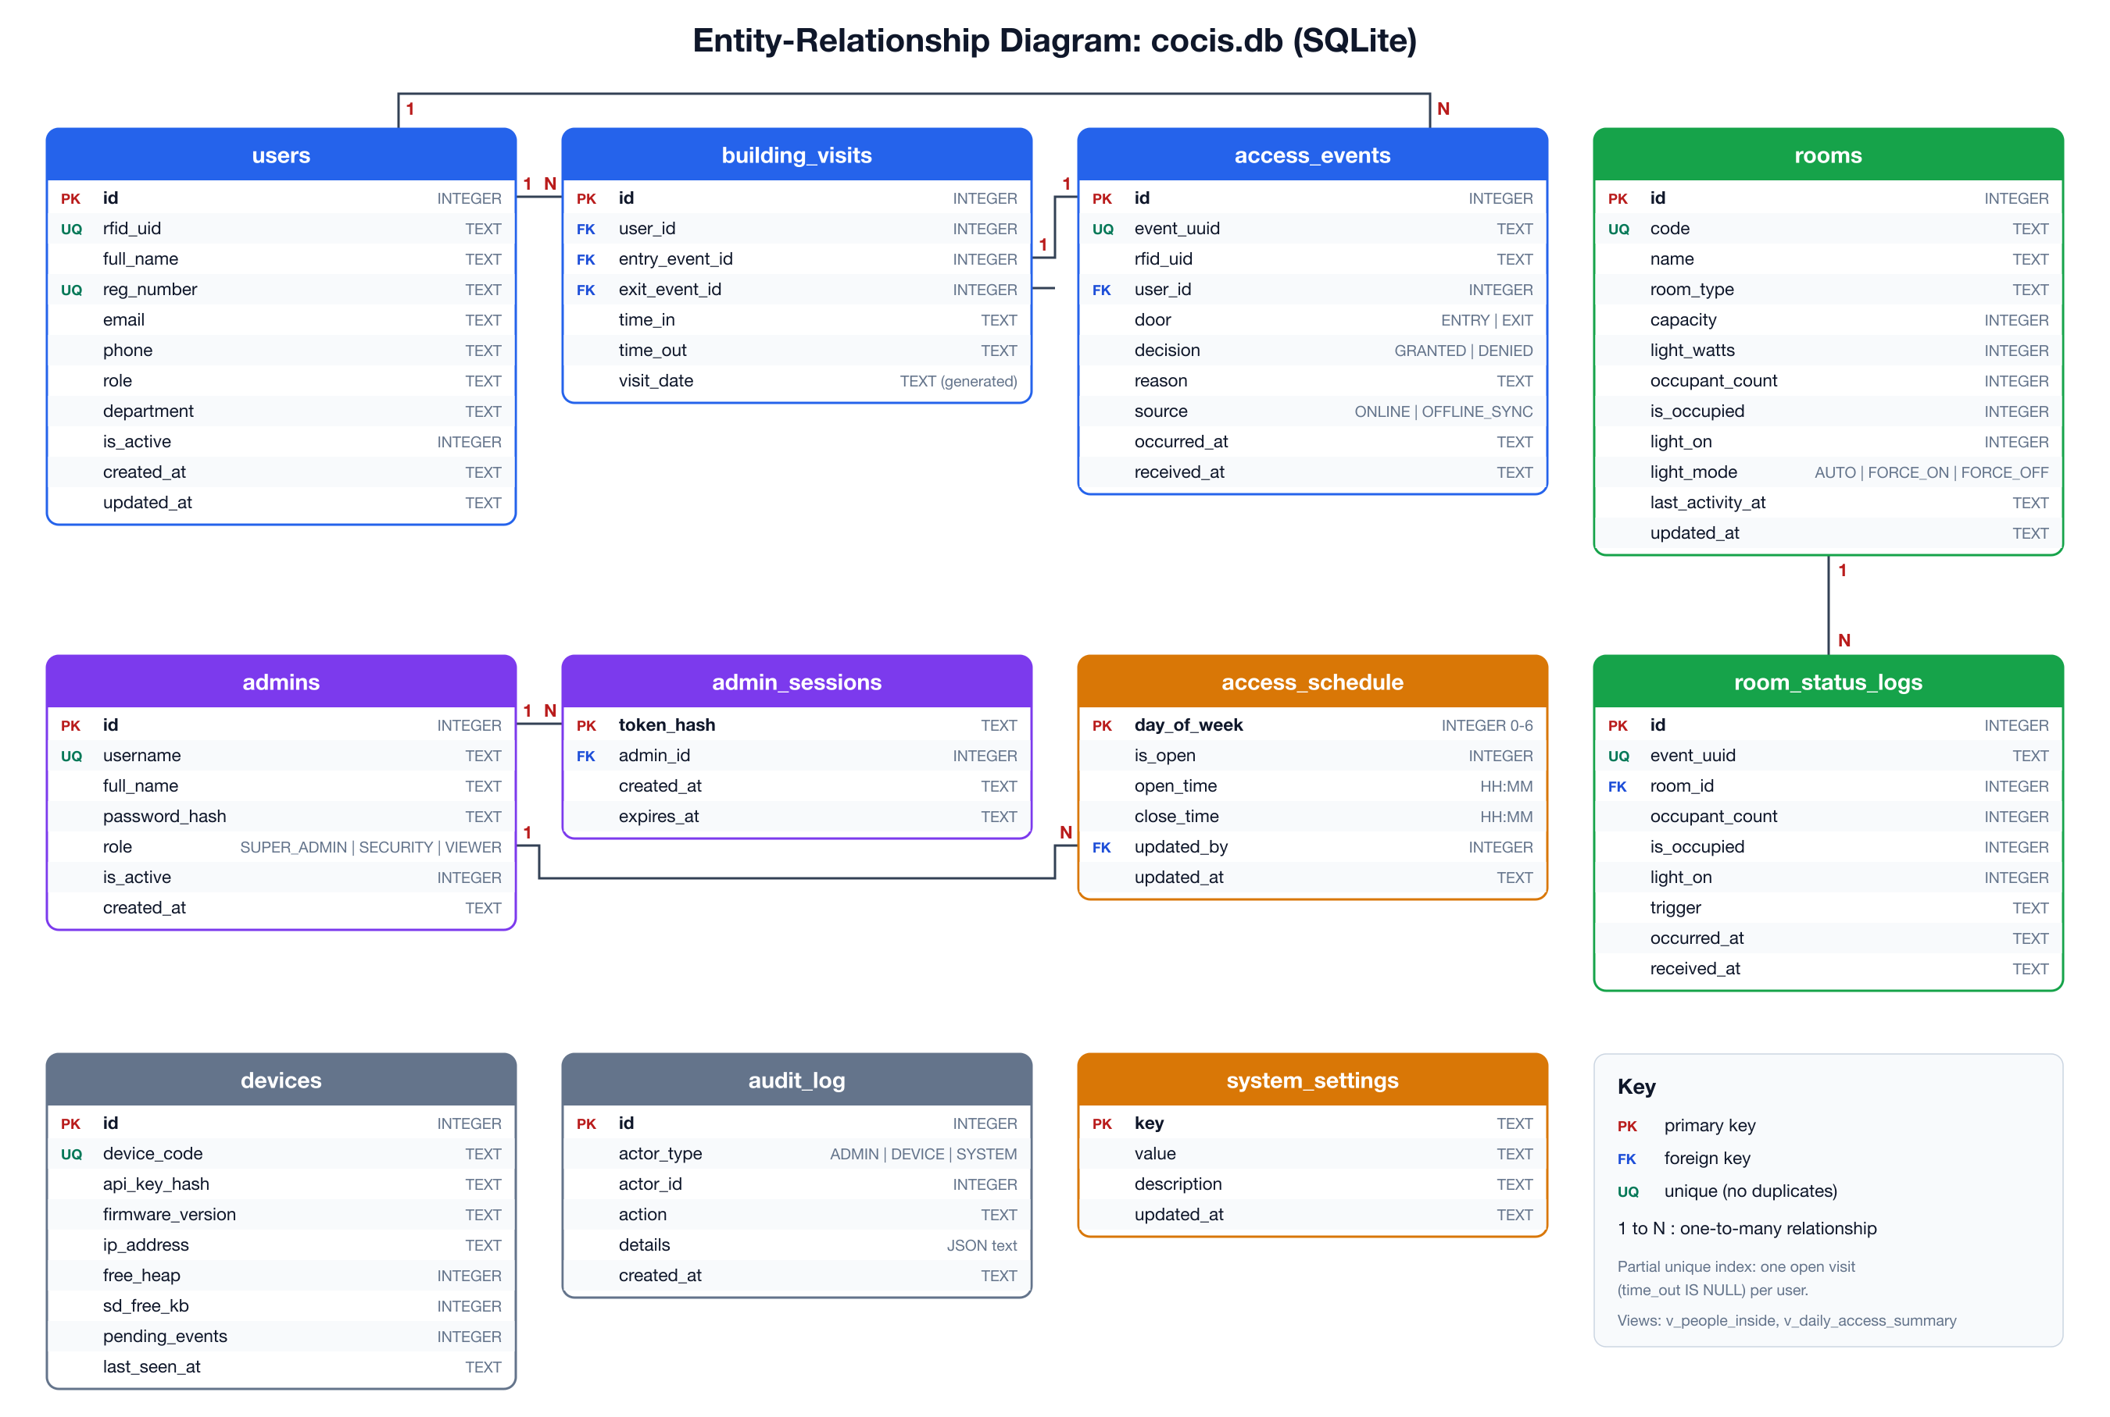
Figure 10: Entity-relationship diagram of the cocis.db database

6.2.1 Relationships
- users to access_events (one to many): one person can scan many times. user_id is NULL for unknown tags, but the raw rfid_uid is always stored so intruder attempts are still logged.
- users to building_visits (one to many): one row per stay in the building.
- access_events to building_visits (one to one): each visit points at the event that opened it (entry_event_id) and the event that closed it (exit_event_id).
- rooms to room_status_logs (one to many): every change of occupant count or light state is logged.
- admins to admin_sessions (one to many) and admins to access_schedule (one to many, via updated_by): who is logged in and who last changed each day's schedule.

6.3 Data Dictionary
This section describes every table and column. Time values are stored as ISO-8601 text in East Africa Time, for example 2026-10-30T08:15:02, which sorts correctly as text and is easy to produce on the ESP32 with strftime.

6.3.1 users
Every person who has been issued an RFID tag.
Table 32: Data dictionary: users
Column | Type | Constraints | Description
id | INTEGER | PK, auto-increment | Internal identifier
rfid_uid | TEXT | NOT NULL, UNIQUE | Tag UID in upper-case hex, e.g. A1B2C3D4
full_name | TEXT | NOT NULL | Name shown on the LCD and in reports
reg_number | TEXT | UNIQUE | Student or staff number
email, phone | TEXT |  | Contact details
role | TEXT | STUDENT, STAFF, LECTURER, SECURITY or VISITOR | Category of user
department | TEXT |  | Department
is_active | INTEGER | 0 or 1, default 1 | 0 = tag disabled (lost card, left the college); history is kept
created_at, updated_at | TEXT | default now | Record timestamps

6.3.2 rooms
The three controlled zones, with each lecture room's live state.
Table 33: Data dictionary: rooms
Column | Type | Constraints | Description
id | INTEGER | PK | Internal identifier
code | TEXT | NOT NULL, UNIQUE | MAIN, LR1 or LR2
name | TEXT | NOT NULL | Display name
room_type | TEXT | ENTRANCE or LECTURE_ROOM | Kind of zone
capacity | INTEGER |  | Seats
light_watts | INTEGER | default 0 | Total lamp power, used to estimate energy
occupant_count | INTEGER | NOT NULL, >= 0 | People in the room (beam counter), or 1 and 0 for occupied and vacant (PIR room)
is_occupied | INTEGER | 0 or 1 | 1 when occupant_count > 0
light_on | INTEGER | 0 or 1 | Current light state
light_mode | TEXT | AUTO, FORCE_ON or FORCE_OFF | AUTO = the counter decides; otherwise a manual override
last_activity_at | TEXT |  | Last time someone crossed the doorway
updated_at | TEXT | NULL until first report | Device time of the last reported change

6.3.3 access_events
Every RFID scan at the main entrance, whether granted or denied.
Table 34: Data dictionary: access_events
Column | Type | Constraints | Description
id | INTEGER | PK | Internal identifier
event_uuid | TEXT | NOT NULL, UNIQUE | Id generated by the ESP32; stops duplicates
rfid_uid | TEXT | NOT NULL | UID that was scanned (even if unknown)
user_id | INTEGER | FK to users.id, nullable | The matching user, if any
door | TEXT | ENTRY or EXIT | Which lane was used
decision | TEXT | GRANTED or DENIED | Outcome
reason | TEXT | OK, OK_AFTER_HOURS, UNKNOWN_TAG, INACTIVE_USER, OUTSIDE_SCHEDULE, ALREADY_INSIDE, NOT_INSIDE or EMERGENCY_OPEN (Table 22) | Why
source | TEXT | ONLINE, OFFLINE_SYNC or MQTT | Decided by the API; by an HTTP controller while offline; or by the MQTT entrance controller and relayed by the bridge
occurred_at | TEXT | NOT NULL, indexed | Time of the scan (ESP32 clock)
received_at | TEXT | default now | Time the server stored it

6.3.4 building_visits
One row for each stay in the building. If time_out is empty, the person is inside now.
Table 35: Data dictionary: building_visits
Column | Type | Constraints | Description
id | INTEGER | PK | Internal identifier
user_id | INTEGER | FK to users.id | Who
entry_event_id | INTEGER | FK to access_events.id | The scan that opened the visit
exit_event_id | INTEGER | FK to access_events.id, nullable | The scan that closed it
time_in | TEXT | NOT NULL | Entry time
time_out | TEXT | nullable | Exit time; NULL = still inside
visit_date | TEXT | generated from time_in | Date part, indexed for daily reports

6.3.5 room_status_logs
History of occupancy and lighting changes in each lecture room.
Table 36: Data dictionary: room_status_logs
Column | Type | Constraints | Description
id | INTEGER | PK | Internal identifier
event_uuid | TEXT | NOT NULL, UNIQUE | Id generated by the ESP32
room_id | INTEGER | FK to rooms.id | Which room
occupant_count | INTEGER | >= 0 | Count after this change
is_occupied, light_on | INTEGER | 0 or 1 | New state
trigger | TEXT | MOTION, NO_MOTION (PIR rooms), PERSON_IN, PERSON_OUT, COUNT_RESET (beam counters), MANUAL_OVERRIDE, SCHEDULE or EMERGENCY | What caused the change
occurred_at, received_at | TEXT |  | Device time and server time

6.3.6 access_schedule
The permitted access window for each day of the week (seven rows).
Table 37: Data dictionary: access_schedule
Column | Type | Constraints | Description
day_of_week | INTEGER | PK, 0 to 6 | 0 = Sunday ... 6 = Saturday (same as C's tm_wday)
is_open | INTEGER | 0 or 1 | 0 = building closed all day
open_time, close_time | TEXT | HH:MM, open < close | Access allowed from open_time up to (not including) close_time
updated_by | INTEGER | FK to admins.id | Who last changed it
updated_at | TEXT |  | When

6.3.7 system_settings
Small key/value settings that are sent to the ESP32.
Table 38: Data dictionary: system_settings
Column | Type | Constraints | Description
key | TEXT | PK | emergency_mode, lockdown_mode, light_off_delay_s, timezone, config_version, heartbeat_interval_s
value | TEXT | NOT NULL | Value as text
description | TEXT |  | What it means
updated_at | TEXT |  | Last change

6.3.8 admins
Staff who can log in to manage the system.
Table 39: Data dictionary: admins
Column | Type | Constraints | Description
id | INTEGER | PK | Internal identifier
username | TEXT | NOT NULL, UNIQUE | Login name
full_name | TEXT | NOT NULL | Display name
password_hash | TEXT | NOT NULL | PBKDF2-SHA256, 200,000 iterations, random salt; never the plain password
role | TEXT | SUPER_ADMIN, SECURITY or VIEWER | Permission level (Table 47)
is_active | INTEGER | 0 or 1 | Disabled accounts cannot log in
created_at | TEXT |  | When the account was created

6.3.9 admin_sessions
Login tokens currently issued. Only a SHA-256 hash of each token is stored.
Table 40: Data dictionary: admin_sessions
Column | Type | Constraints | Description
token_hash | TEXT | PK | SHA-256 of the bearer token
admin_id | INTEGER | FK to admins.id | Owner
created_at, expires_at | TEXT |  | Tokens expire after 8 hours

6.3.10 devices
The ESP32 controller(s) allowed to send data, and their latest health report.
Table 41: Data dictionary: devices
Column | Type | Constraints | Description
id | INTEGER | PK | Internal identifier
device_code | TEXT | NOT NULL, UNIQUE | ESP32-MQTT-ENTRANCE (through the bridge) or ESP32-CTRL-01 (HTTP controller)
api_key_hash | TEXT | NOT NULL | SHA-256 of the device key
firmware_version, ip_address | TEXT |  | From the heartbeat
free_heap, sd_free_kb | INTEGER |  | Memory and SD space left
pending_events | INTEGER |  | Records waiting to be uploaded (0 for the MQTT controller)
last_seen_at | TEXT |  | Used to show the device as online or offline

6.3.11 audit_log
A permanent record of every configuration change and login attempt.
Table 42: Data dictionary: audit_log
Column | Type | Constraints | Description
id | INTEGER | PK | Internal identifier
actor_type | TEXT | ADMIN, DEVICE or SYSTEM | Who acted
actor_id | INTEGER |  | admins.id or devices.id
action | TEXT | NOT NULL | e.g. SCHEDULE_UPDATE, EMERGENCY_ON, LOGIN_FAILED
details | TEXT (JSON) |  | What exactly changed
created_at | TEXT | indexed | When

6.4 Integrity Rules, Indexes and Views
Table 43: Integrity constraints, indexes and views
Object | Type | Why it exists
Foreign keys (PRAGMA foreign_keys = ON) | Constraint | A visit cannot point at a user or event that does not exist
CHECK constraints on role, door, decision, reason, light_mode, trigger, counts and 0/1 flags | Constraint | Invalid values are rejected by the database itself, not only by the API
CHECK (open_time < close_time) | Constraint | A schedule cannot close before it opens
uq_one_open_visit on building_visits(user_id) WHERE time_out IS NULL | Partial unique index | A person can only be inside once: the final safeguard against race conditions
idx_access_events_time, idx_access_events_user | Index | Fast log searches by date and by person
idx_visits_date, idx_room_logs, idx_audit_time | Index | Fast daily reports and history
v_people_inside | View | Everyone with an open visit: answers "who is inside now?"
v_daily_access_summary | View | Entries, exits and refusals per day

6.5 Local Storage on the ESP32
The controller keeps only what it needs to work on its own (design in Section 3.6).
Table 44: Storage on the ESP32
Where | Name | Contents | Written when
NVS flash | sched_start, sched_end | Access window in minutes since midnight | schedule set
NVS flash | users (blob) | Number of cards, then up to 64 UIDs | user add, user remove
NVS flash | inside (blob) | Number of people inside, then up to 16 UIDs | After every scan
microSD card | /sdcard/access.csv | epoch, iso8601, tag_hex, dir, result | Every scan (append only)

A migration in api/db.py upgrades databases made before the bridge existed: the tables whose allowed values were widened (access_events, room_status_logs) are rebuilt from the current schema, keeping every row, with foreign keys switched off during the copy.

6.6 Initial (Seed) Data
When the API starts for the first time it creates the database from database/schema.sql and loads database/seed.sql: the three rooms, a default schedule (Monday to Friday 07:00 to 22:00, Saturday 08:00 to 17:00, Sunday closed), the default settings, four demonstration users whose tag UIDs match the Wokwi simulation, one administrator account and one device key. The demonstration credentials are listed in Section 7.9 and must be changed before any real deployment.

7. REST API Design and Documentation
The API is the only way into the database. The ESP32 uses it to ask for access decisions and to report events; staff use it to monitor the building and to change settings. Interactive documentation, generated automatically from the code, is available at /docs (Swagger UI) whenever the API is running; this chapter is the written reference.

7.1 General Conventions
Table 45: General API conventions
Item | Value
Base URL | http://<server>:8000/api/v1
Format | JSON request and response bodies (Content-Type: application/json)
Time format | ISO-8601 local time (EAT), e.g. 2026-10-30T08:15:02
Device authentication | Header X-Device-Key: <device key>
Staff authentication | Header Authorization: Bearer <token> (token from POST /auth/login, or from POST /auth/token when logging in through the Authorize button in Swagger UI)
Interactive docs | /docs (Swagger UI), /redoc; machine-readable spec at /openapi.json (also saved as docs/openapi.json)
Technology | Python 3, FastAPI, Pydantic (validation), Uvicorn (server), SQLite 3

Table 46: HTTP status codes returned by the API
Status | Meaning in this API
200 OK | Request succeeded
201 Created | A new user was registered
400 Bad Request | Request understood but nothing to do (e.g. empty update)
401 Unauthorized | Missing or wrong device key, wrong password, or expired token
403 Forbidden | Logged in, but the role is not allowed to do this
404 Not Found | User or room does not exist
409 Conflict | RFID tag or registration number is already registered
422 Unprocessable Entity | Validation failed (wrong field type, bad time format, negative count, opening after closing, ...)

Errors always have the same shape, so the ESP32 and any dashboard can handle them in one place:
{ "detail": "Requires role SUPER_ADMIN or higher" }

7.2 Security Model
There are two kinds of client, each with its own credential. The ESP32 sends a secret device key on every request; the server stores only its SHA-256 hash. Staff log in with a username and password (stored as a salted PBKDF2 hash) and receive a random bearer token valid for 8 hours. Every management endpoint checks the token and the role in Table 47. All configuration changes, logins and failed logins are written to the audit log.
Table 47: Staff roles and permissions
Role | Intended for | Allowed to
VIEWER | Management, reception | Read everything except the audit log: users, occupancy, logs, rooms, schedule, settings, reports
SECURITY | Security officers | Everything VIEWER can, plus switch emergency mode and override room lights
SUPER_ADMIN | System administrator | Everything, including registering and deactivating users, changing the schedule and settings, and reading the audit log

7.3 Endpoint Summary
Table 48: Summary of all API endpoints
Method | Path (after /api/v1) | Auth | Use case | Purpose
GET | /health | none |  | Check that the API is running
POST | /device/access/check | Device |  | Decide and record a scan (HTTP controller)
POST | /device/rooms/status | Device |  | Report a room change (HTTP controller)
POST | /device/events/batch | Device |  | Upload records stored while offline (HTTP controller)
POST | /device/relay | Device | UC15 | Store events decided by the MQTT controller, relayed by the bridge
GET | /device/config | Device |  | Download schedule, tags and settings (HTTP controller)
POST | /device/heartbeat | Device | UC15a | Report health; learn config_version and lockdown_mode
POST | /auth/login | none | UC09 | Log in, receive a bearer token
POST | /auth/token | none | UC09 | Same login as a form, used by the Authorize button in Swagger UI
POST | /auth/logout | any role | UC09 | Invalidate the token
GET | /auth/me | any role | UC09 | Who am I?
GET | /users | VIEWER | UC10 | List or search tag holders
GET | /users/{id} | VIEWER | UC10 | One user, including whether they are inside
POST | /users | SUPER_ADMIN | UC10 | Register a new tag holder
PATCH | /users/{id} | SUPER_ADMIN | UC10 | Change details, re-issue a tag, activate or deactivate
DELETE | /users/{id} | SUPER_ADMIN | UC10 | Deactivate (soft delete; history kept)
GET | /occupancy | VIEWER | UC07 | People inside now, and lecture-room status
GET | /access-events | VIEWER | UC08 | Search the access log (filters and paging)
GET | /visits | VIEWER | UC08 | Time in and time out per person per day
GET | /rooms | VIEWER | UC07 | All rooms with live state
GET | /rooms/{code}/history | VIEWER | UC08 | A room's changes on a given day
PUT | /rooms/{code}/light-mode | SECURITY | UC13 | AUTO, FORCE_ON or FORCE_OFF override
GET | /schedule | VIEWER | UC11 | Weekly access schedule
PUT | /schedule | SUPER_ADMIN | UC11 | Change one or more days of the schedule
GET | /settings | VIEWER |  | All system settings
PATCH | /settings | SUPER_ADMIN |  | Change light-off delay or heartbeat interval
PUT | /settings/emergency | SECURITY |  | Emergency mode (all doors open) for the HTTP controller
PUT | /settings/lockdown | SECURITY | UC12 | Lockdown on or off; forwarded to the ESP32 by the bridge
GET | /reports/daily | VIEWER | UC08 | Daily totals, peak occupancy and lighting energy
GET | /devices | VIEWER |  | ESP32 health and online status
GET | /audit-log | SUPER_ADMIN |  | Recent configuration changes and logins
GET | /db/tables | SUPER_ADMIN | UC08 | Tables and views with their row counts
GET | /db/{table} | SUPER_ADMIN | UC08 | Latest rows of one table (read-only, secrets hidden)

7.4 Device Endpoints
Device endpoints are authenticated with the X-Device-Key header. The MQTT bridge uses /device/relay and /device/heartbeat on behalf of the entrance ESP32 (Section 7.8). The other device endpoints serve controllers that call the API directly, such as the reference HTTP controller and the virtual ESP32 (Appendix C).
POST /api/v1/device/access/check
Authentication: X-Device-Key
Purpose: Called by the Access Control task every time a tag is scanned while online (UC01 to UC03). The API decides, records the event and updates the visit in one transaction, and returns the decision. If the same event_uuid is sent again (e.g. the ESP32 retried after a timeout), the original answer is returned with duplicate: true and nothing new is stored.
Request body
{
"event_uuid": "01-000123",
"rfid_uid": "A1B2C3D4",
"door": "ENTRY",
"occurred_at": "2026-10-30T08:15:02"
}
Response 200
{
"decision": "GRANTED",
"reason": "OK",
"event_id": 812,
"user": { "id": 1, "full_name": "Lisa Nyonyozi", "role": "STUDENT" },
"people_inside": 37,
"duplicate": false
}
Notes
rfid_uid must be 8 to 20 hex characters (lower case is accepted and converted). door is ENTRY or EXIT. The ESP32 opens the door only when decision is GRANTED; it can show user.full_name and people_inside on the LCD. When people_inside is 0 the ESP32 resets both room counts (UC06).
POST /api/v1/device/rooms/status
Authentication: X-Device-Key
Purpose: Called by the Lighting task whenever someone crosses a lecture-room doorway, a count is reset, or the lights change (UC04 to UC06).
Request body
{
"event_uuid": "01-000124",
"room_code": "LR1",
"occupant_count": 14,
"light_on": true,
"trigger": "PERSON_IN",
"occurred_at": "2026-10-30T08:16:40"
}
Response 200
{ "stored": true, "duplicate": false }
Notes
room_code is LR1 or LR2. occupant_count must be 0 or more; the server sets is_occupied from it. trigger is one of PERSON_IN, PERSON_OUT, COUNT_RESET, MANUAL_OVERRIDE, SCHEDULE, EMERGENCY. The room's live state is only replaced if this report is newer than the one already held.
POST /api/v1/device/events/batch
Authentication: X-Device-Key
Purpose: Uploads up to 200 access events and 200 room events saved in outbox.csv while the ESP32 was offline (UC14). All of them are stored in one transaction, in time order. For access events the ESP32 includes the decision it made offline, which the server records as-is with source = OFFLINE_SYNC.
Request body
{
"access_events": [
{ "event_uuid": "01-000130", "rfid_uid": "A1B2C3D4", "door": "EXIT",
"occurred_at": "2026-10-30T16:00:00", "decision": "GRANTED", "reason": "OK" }
],
"room_events": [
{ "event_uuid": "01-000131", "room_code": "LR1", "occupant_count": 0,
"light_on": false, "trigger": "PERSON_OUT", "occurred_at": "2026-10-30T16:05:00" }
]
}
Response 200
{ "accepted": ["01-000130", "01-000131"], "duplicates": [] }
Notes
The ESP32 deletes every uuid in accepted and duplicates from outbox.csv. Sending the same batch twice is safe.
GET /api/v1/device/config
Authentication: X-Device-Key
Purpose: Returns everything the ESP32 needs to make decisions on its own (UC15). The ESP32 saves it to the SD card (users.csv, schedule.csv, config.csv, inside.csv).
Response 200
{
"config_version": 9,
"server_time": "2026-10-30T08:00:00",
"timezone": "EAT-3",
"emergency_mode": false,
"light_off_delay_s": 30,
"heartbeat_interval_s": 60,
"schedule": [ { "day_of_week": 1, "is_open": 1, "open_time": "07:00", "close_time": "22:00" } ],
"room_light_modes": { "LR1": "AUTO", "LR2": "AUTO" },
"authorised_tags": [ { "rfid_uid": "A1B2C3D4", "full_name": "Lisa Nyonyozi", "role": "STUDENT" } ],
"currently_inside": [ "A1B2C3D4" ]
}
Notes
Only active users are listed. schedule always contains all seven days (shortened above).
POST /api/v1/device/heartbeat
Authentication: X-Device-Key
Purpose: Sent every heartbeat_interval_s seconds (UC15a). Lets management see that the controller is alive, and tells the ESP32 whether its cached configuration is out of date.
Request body
{ "firmware_version": "1.0.0", "ip_address": "10.10.0.2",
"free_heap": 120000, "sd_free_kb": 31000, "pending_events": 0 }
Response 200
{ "server_time": "2026-10-30T08:01:00", "config_version": 9, "emergency_mode": false }
Notes
If config_version differs from the version on the SD card, the ESP32 calls GET /device/config. emergency_mode is included so that an emergency reaches the doors within one heartbeat.
POST /api/v1/device/relay
Authentication: X-Device-Key
Purpose: Called by the MQTT bridge for every message from the entrance controller (UC15). The controller has already decided, so the events are stored as they are, with source MQTT. The body has the same shape as a batch.
Request body
{ "access_events": [ { "event_uuid": "MQ-11223344-IN-1793636493", "rfid_uid": "11223344",
"door": "ENTRY", "decision": "GRANTED", "reason": "OK", "occurred_at": "2026-11-02T19:21:33" } ],
"room_events": [ { "event_uuid": "MQ-room1-1-1-1793636510", "room_code": "LR1",
"occupant_count": 1, "light_on": true, "trigger": "MOTION", "occurred_at": "2026-11-02T19:21:50" } ] }
Response 200
{ "accepted": ["MQ-11223344-IN-1793636493", "MQ-room1-1-1-1793636510"], "duplicates": [] }
Notes
Events are sorted by time and stored in one transaction. An event_uuid that is already stored is listed under duplicates and not stored again, so a message delivered twice is harmless. A granted entry opens a visit; a granted exit closes it.

7.5 Management Endpoints
POST /api/v1/auth/login
Authentication: none
Purpose: Exchange a username and password for a bearer token (UC09). Failed attempts are written to the audit log.
Request body
{ "username": "admin", "password": "********" }
Response 200
{ "access_token": "q5k...Zt0", "token_type": "bearer",
"expires_at": "2026-10-30T16:15:00", "role": "SUPER_ADMIN",
"full_name": "System Administrator" }
Errors
401: wrong username or password, or account disabled.
POST /api/v1/users
Authentication: Bearer, SUPER_ADMIN
Purpose: Register a new tag holder (UC10). The configuration version is increased so the ESP32 learns about the new tag.
Request body
{ "rfid_uid": "0BADF00D", "full_name": "New Student", "reg_number": "24/U/0099",
"email": "new@students.mak.ac.ug", "role": "STUDENT", "department": "Computer Science" }
Response 201
The stored user, plus is_inside: false.
Errors
409: tag or registration number already registered. 422: invalid UID or role.
GET /api/v1/occupancy
Authentication: Bearer, any role
Purpose: Who is in the building right now, and the state of each lecture room (UC07).
Response 200
{
"people_inside_count": 2,
"people_inside": [
{ "user_id": 1, "rfid_uid": "A1B2C3D4", "full_name": "Lisa Nyonyozi",
"role": "STUDENT", "time_in": "2026-10-30T08:15:02" }
],
"rooms": [
{ "code": "LR1", "name": "Lecture Room 1", "occupant_count": 14, "is_occupied": 1,
"light_on": 1, "light_mode": "AUTO", "last_activity_at": "2026-10-30T09:02:11",
"updated_at": "2026-10-30T09:02:11" }
],
"emergency_mode": false,
"as_of": "2026-10-30T09:05:00"
}
GET /api/v1/access-events
Authentication: Bearer, any role
Purpose: Search the access log, newest first (UC08).
Query parameters
from, to (dates, YYYY-MM-DD), door (ENTRY or EXIT), decision (GRANTED or DENIED), user_id, limit (default 50, max 500), offset. Example: /access-events?from=2026-10-30&decision=DENIED
Response 200
{ "total": 3, "limit": 50, "offset": 0,
"items": [ { "id": 815, "event_uuid": "01-000140", "rfid_uid": "00000000",
"user_id": null, "full_name": null, "door": "ENTRY", "decision": "DENIED",
"reason": "UNKNOWN_TAG", "source": "ONLINE",
"occurred_at": "2026-10-30T10:44:51", "received_at": "2026-10-30T10:44:51" } ] }
GET /api/v1/visits
Authentication: Bearer, any role
Purpose: Time in and time out for each stay (UC08): the Events table from the original sketch.
Query parameters
date (YYYY-MM-DD), user_id
Response 200
[ { "id": 51, "user_id": 1, "full_name": "Lisa Nyonyozi", "rfid_uid": "A1B2C3D4",
"visit_date": "2026-10-30", "time_in": "2026-10-30T08:15:02",
"time_out": "2026-10-30T12:40:18" } ]
PUT /api/v1/schedule
Authentication: Bearer, SUPER_ADMIN
Purpose: Change the access window for one or more days (UC11). The change is audited and the new config_version is returned; the ESP32 picks it up at its next heartbeat.
Request body
{ "days": [
{ "day_of_week": 6, "is_open": true, "open_time": "08:00", "close_time": "14:00" },
{ "day_of_week": 0, "is_open": false, "open_time": "08:00", "close_time": "17:00" }
] }
Response 200
{ "schedule": [ ...all seven days... ], "config_version": 10 }
Errors
403: role below SUPER_ADMIN. 422: time not HH:MM, or open_time not before close_time.
PUT /api/v1/settings/emergency
Authentication: Bearer, SECURITY or above
Purpose: Emergency evacuation (UC12): every door opens for every tag (and unknown tags) until it is switched off. A reason is required and is saved in the audit log.
Request body
{ "enabled": true, "reason": "Fire alarm in Block B" }
Response 200
{ "emergency_mode": true, "config_version": 11 }
PUT /api/v1/rooms/{code}/light-mode
Authentication: Bearer, SECURITY or above
Purpose: Override automatic lighting (UC13), e.g. force LR1's lights on for cleaning staff, or off during a power-saving period. AUTO gives control back to the infrared counter.
Request body
{ "mode": "FORCE_ON" }
Response 200
{ "room": "LR1", "light_mode": "FORCE_ON", "config_version": 12 }
GET /api/v1/reports/daily
Authentication: Bearer, any role
Purpose: A one-day management summary (UC08): traffic, refusals by reason, unique visitors, the busiest moment, and how long each room's lights were on with the energy used (hours multiplied by light_watts).
Query parameters
date (YYYY-MM-DD, default today)
Response 200
{
"date": "2026-10-30", "entries": 142, "exits": 139, "denied": 6,
"denied_by_reason": { "UNKNOWN_TAG": 2, "OUTSIDE_SCHEDULE": 3, "ALREADY_INSIDE": 1 },
"unique_visitors": 118,
"peak_occupancy": { "count": 64, "at": "2026-10-30T10:58:40" },
"lighting": [ { "room": "LR1", "lights_on_hours": 6.25, "energy_kwh": 3.0 },
{ "room": "LR2", "lights_on_hours": 3.5, "energy_kwh": 1.12 } ]
}
The remaining endpoints in Table 48 follow the same pattern; their full request and response schemas can be explored and tried in Swagger UI at /docs.
PUT /api/v1/settings/lockdown
Authentication: Bearer, SECURITY or higher
Purpose: Lock or unlock the entrance (UC12). The change is audited and raises the configuration version; the bridge sees it within 2 seconds and publishes LOCKDOWN or UNLOCK to the ESP32.
Request body
{ "enabled": true, "reason": "Security threat at the gate" }
Response 200
{ "lockdown_mode": true, "config_version": 14 }

7.6 Access Decision Reason Codes
The reason field returned by /device/access/check and stored in access_events takes the values in Table 22. The firmware can map each code to an LCD message, for example OUTSIDE_SCHEDULE shows "Building closed" and ALREADY_INSIDE shows "Already checked in".

7.7 Running the API
The project needs only Python 3.10 or newer. Ready-made scripts in the project folder do the setup and start-up on each operating system:
Table 49: Scripts for installing, starting and testing the API
Step | Windows | macOS or Linux
Install the packages (once) | double-click setup.bat | ./setup.sh
Start the API and open the docs | double-click start.bat | ./start.sh
Run the automated tests | double-click test.bat | ./test.sh
Start again with a fresh database | double-click reset_db.bat | delete data/cocis.db

The database file data/cocis.db is created automatically on first start, and the browser opens the interactive documentation at http://127.0.0.1:8000/docs. The README file gives the full installation steps, including installing Python on Windows.

7.7.1 Testing the API in Swagger UI
- Click Authorize at the top of the page.
- Under AdminLogin enter admin and Admin@CoCIS2026, and click Authorize. Under DeviceKey enter esp32-demo-key-change-me, and click Authorize. Close the dialog.
- Open POST /device/access/check, click Try it out, then Execute. The prefilled example is a scan of Lisa Nyonyozi's tag on a weekday at 09:00, so the answer is GRANTED.
- Open GET /occupancy and execute it: Lisa is listed as inside. Every other endpoint can be tried the same way.

7.8 Connecting the Entrance Controller to the API
The entrance ESP32 is connected through the MQTT bridge. To run the complete system:
Table 50: Running the complete system
Step | Windows | macOS or Linux | What happens
1 | start.bat | ./start.sh | API, database and dashboard on port 8000
2 | bridge.bat | ./bridge.sh | Bridge connects to broker.hivemq.com and to the API
3 | Run the entrance firmware in Wokwi | same | ESP32 publishes to the same broker
4 | Open /dashboard/ | same | Scans, people inside and rooms update within 3 s

Without Wokwi, step 3 can be replaced by entrance_sim.bat, which publishes the same messages. The laptop needs internet access for the bridge; it does not need to be on the same network as the ESP32 (Section 3.4).

7.9 Demonstration Credentials
Table 51: Demonstration credentials (change before real deployment)
Credential | Value | Used by
Administrator | username admin, password Admin@CoCIS2026 (SUPER_ADMIN) | Swagger UI, Postman, serial menu
Device key (bridge) | mqtt-bridge-key-change-me for device ESP32-MQTT-ENTRANCE | MQTT bridge (X-Device-Key)
Device key (HTTP) | esp32-demo-key-change-me for device ESP32-CTRL-01 | HTTP controller and virtual ESP32
ESP32 admin PIN | login admin 1234 | Entrance firmware console
Demo cards | 11223344 lecturer and 01020304 student (authorised on the ESP32); A1B2C3D4, DEADBEEF, CAFEBABE in the database | Wokwi simulation, dashboard

7.10 Example: How a Scan Is Sent and Saved
1. The ESP32 publishes the scan (comms_publish_event() in comms.c, unchanged):
cJSON *o = cJSON_CreateObject();
char t[16]; snprintf(t, sizeof(t), "%08lX", (unsigned long)tag);
cJSON_AddStringToObject(o, "tag", t);
cJSON_AddStringToObject(o, "dir", is_in ? "IN" : "OUT");
cJSON_AddStringToObject(o, "result", result); // e.g. "OK", "DENIED_UNKNOWN"
cJSON_AddNumberToObject(o, "ts", (double)time(NULL));
char *s = cJSON_PrintUnformatted(o);
esp_mqtt_client_publish(s_mqtt, TOPIC_EVENT, s, 0, 0, 0); // cocis/event/access
2. The bridge converts it and calls the API (bridge/mqtt_bridge.py):
decision, reason = RESULTS[msg["result"]] # "OK" -> ("GRANTED", "OK")
event = {"event_uuid": f"MQ-{tag}-{direction}-{int(msg['ts'])}", # stable: stored once
"rfid_uid": tag, "door": "ENTRY" if direction == "IN" else "EXIT",
"decision": decision, "reason": reason, "occurred_at": local_time(msg["ts"])}
POST http://127.0.0.1:8000/api/v1/device/relay
X-Device-Key: mqtt-bridge-key-change-me
{"access_events": [event], "room_events": []}
3. The API validates and saves it. FastAPI checks the body against the Pydantic model EventBatch (each event must have a known door, decision and reason, and a valid time), checks the device key, then stores it in one transaction:
with write_tx(conn): # BEGIN IMMEDIATE ... COMMIT
for ev in sorted(body.access_events, key=lambda e: e.occurred_at):
if existing_event(conn, ev.event_uuid): # already stored: skip
duplicates.append(ev.event_uuid); continue
record_access(conn, ..., source="MQTT") # INSERT access_events, open/close visit
accepted.append(ev.event_uuid)
The HTTP reference controller (Appendix C) skips steps 1 and 2: it calls POST /device/access/check directly with esp_http_client and lets the API decide.

8. Implemented Features and Innovations

8.1 Core Features
Table 52: Core features and how to show them
Brief requirement | How it is implemented and demonstrated
RFID entry and exit (2.1) | Two MFRC522 readers; tap a card (or scan in 11223344): the entry servo opens, the green LED lights and the LCD shows ACCESS GRANTED
Who is inside (2.1) | People-inside list on the ESP32 (who), and v_people_inside on the dashboard
Automatic lighting (2.2) | PIR motion turns a room light on; 5 s without motion turns it off; lights room1 on|off|auto overrides
Data storage (2.4) | access.csv on the SD card, NVS for state, and the central database through the bridge
Serial menus (2.5) | help, status, who, logs, user, schedule, lights (Table 30)
Configurable schedule (2.6) | login, then schedule set 07:00 21:00; entries outside the window are refused
Synchronisation (2.7) | Mutexes and a door queue on the ESP32; transactions and unique keys on the server (Table 23)

8.2 Innovations
- Live database and dashboard without changing the firmware. The MQTT bridge stores every scan and room change within a second; the dashboard updates every 3 seconds.
- No network setup. The ESP32 and the server only connect out to the broker, so the database stays private and no tunnel is needed.
- Exactly-once storage. Stable event ids, transactions and a unique key mean a repeated message never creates a duplicate record.
- Safe after-hours exit. People are never locked inside; exits after hours are recorded separately for security.
- Two-way control. Lockdown set on the dashboard is sent to the ESP32 as an MQTT command.
- Database tab. The dashboard shows the real rows of every table, with new rows highlighted, so stored data can be checked live.
- Energy and occupancy reports. Lights-on hours and kWh per room, entries, refusals by reason and peak occupancy per day.
- Role-based access and audit trail. Three staff roles, hashed passwords, expiring tokens and a record of every change and failed login.
- Self-documenting API. Swagger UI lets anyone explore and test every endpoint, with ready examples.
- Testing without hardware. entrance_sim.bat reproduces the controller's messages; 22 automated tests cover the API, bridge and database.

9. System Operation and User Guide
This chapter shows each part of the finished system in use, with screenshots taken from the running software. Table 53 lists the parts, who uses each one and how it is started.
Table 53: Parts of the system and how each is started
Part | Used by | How to start it | Section
Wokwi simulation (entrance firmware) | Everyone: it is the controller at the doors and rooms | Run the entrance project in Wokwi | 9.2
MQTT bridge | Runs in the background on the server | bridge.bat (Windows) or ./bridge.sh | 9.3
REST API and database | The ESP32, the dashboard, Swagger UI | start.bat (Windows) or ./start.sh | 9.5
Management dashboard | Security staff and administrators | http://127.0.0.1:8000/dashboard/ after start.bat | 9.4
Swagger UI | Developers and testers | http://127.0.0.1:8000/docs after start.bat | 9.5
Entrance stand-in, virtual ESP32 | Testers, with no Wokwi or hardware | entrance_sim.bat, demo.bat | 9.6

9.1 A Typical Day
- In the morning the server runs start.bat and bridge.bat; the ESP32 joins Wi-Fi and the broker, and republishes its occupancy and schedule.
- A student taps a card at the entry reader. The ESP32 checks the rules, opens the door and publishes the scan; the bridge stores it and opens a visit.
- The student walks into Lecture Room 1. The PIR sensor detects motion and the light switches on; the change is stored.
- Security staff watch the dashboard: who is inside, both rooms, and the latest scans, refreshed every 3 seconds.
- If the network fails, the ESP32 keeps deciding and logging to its SD card; the database catches up from new messages when the link returns.
- The room empties; 5 seconds after the last motion the light switches off.
- Management read the daily report: entries, refusals, peak occupancy and the energy used by the lights.

9.2 Entrance Controller in Wokwi
The entrance firmware is built with idf.py build and run in Wokwi (wokwi.toml). In the simulation, a card is presented to a reader by clicking the MFRC522 part, or typed at the console with scan in <HEX>; the PIR sensors are triggered by clicking them.
[To be completed by: ______________________] Insert screenshots of the entrance firmware in Wokwi: (1) the circuit after a granted scan, with the LCD showing ACCESS GRANTED; (2) the serial monitor after `help` and `status`; (3) a room light on after the PIR is triggered.

9.2.1 Reading the LCD
Table 54: What the 16x2 LCD shows
When | Line 1 | Line 2
Idle | CoCIS Security | Occupancy: 2
After a granted scan (3 s) | ACCESS GRANTED | IN 11223344
After a refused scan (3 s) | ACCESS DENIED | IN DEADBEEF

9.3 MQTT Bridge
Figure 11 shows the bridge window while the entrance controller is used. Each line is one message: scans and room changes are stored, a new card authorised on the ESP32 is registered, and old retained messages from earlier runs are ignored.
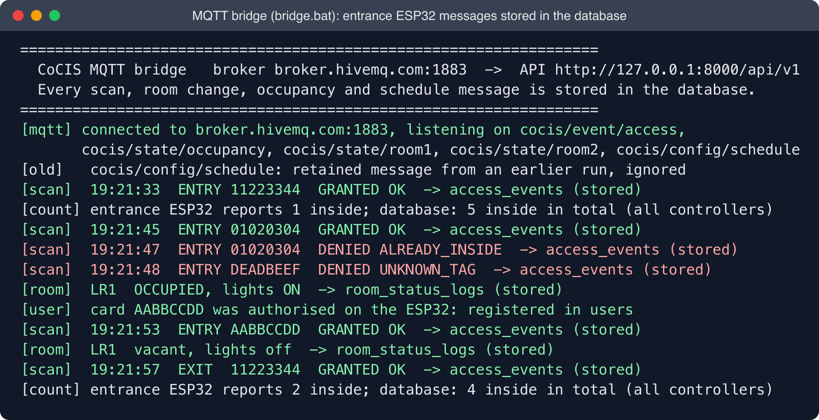
Figure 11: MQTT bridge: entrance ESP32 messages stored in the database
The dashboard's Database tab proves that each message reached the database (Figures 12 and 13): every scan has source MQTT and the bridge's stable event id, and each room change has trigger MOTION or NO_MOTION.
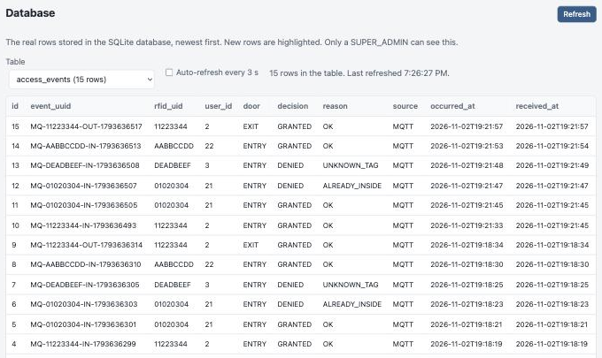
Figure 12: Database tab: access_events rows stored from MQTT
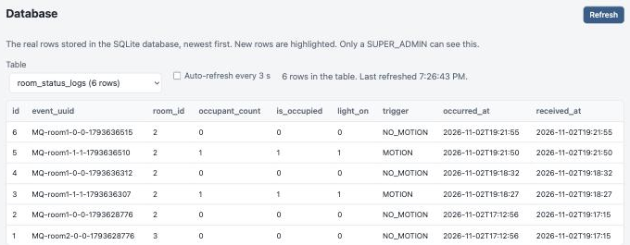
Figure 13: Database tab: room_status_logs rows from the PIR rooms

9.4 Management Dashboard
The dashboard is a web page served by the API. Staff log in (Figure 14) with an administrator account; the role decides what they may change (Table 47).
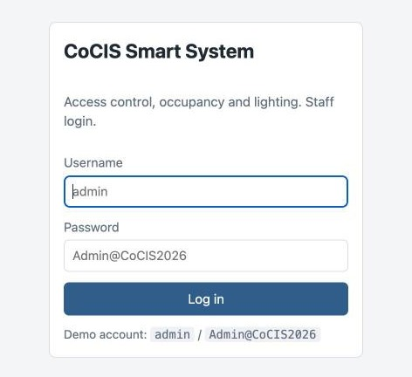
Figure 14: Dashboard login

9.4.1 Overview
The Overview tab (Figure 15) is the live view for security staff. It shows the number of people inside, the emergency switch, a card for each lecture room with its count, light state and light mode buttons, the controller's health (online, last seen, events waiting, firmware) and, below, the people inside and the latest scans with their decision and reason.
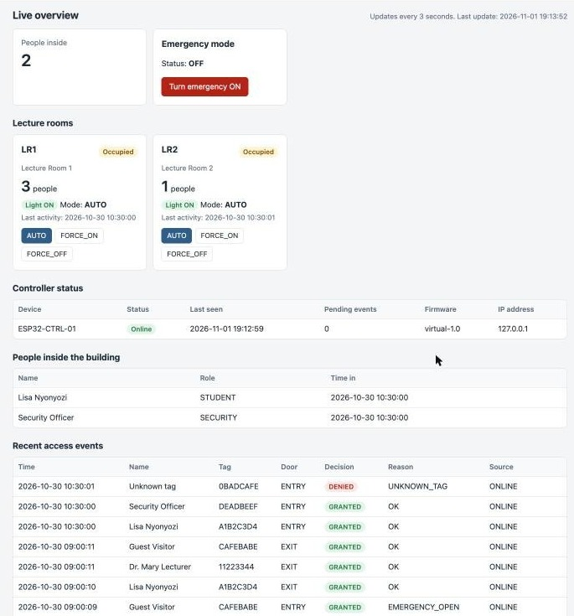
Figure 15: Dashboard Overview tab: occupancy, lecture rooms, controller status and recent scans

9.4.2 Schedule
The Schedule tab (Figure 16) sets the opening hours for each day. Only a SUPER_ADMIN can save; the change raises the configuration version, so the ESP32 downloads it at its next heartbeat. A closing time before the opening time is refused with a clear message.
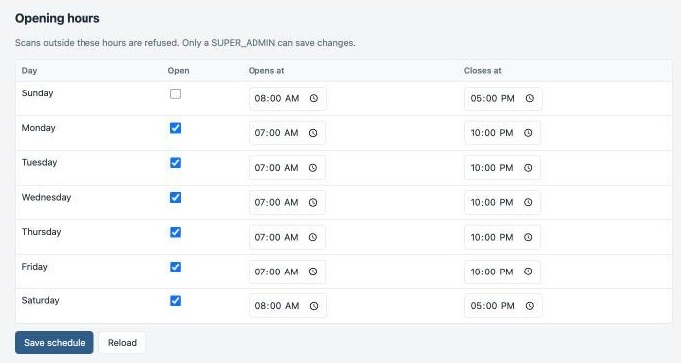
Figure 16: Dashboard Schedule tab: opening hours per day

9.4.3 Users
The Users tab (Figure 17) registers new card holders and deactivates lost or expired cards. A deactivated card is refused at the door at once, and its history is kept.
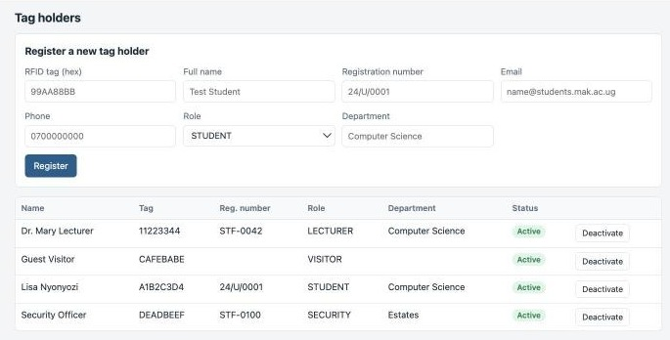
Figure 17: Dashboard Users tab: registering and deactivating card holders

9.4.4 Reports
The Reports tab (Figure 18) gives the daily totals, the busiest moment of the day, refusals by reason and the hours and energy (kWh) used by each room's lights, with a bar chart. In the example the rooms were still occupied at the end of the demonstration, so their lights count as on until the end of the day.
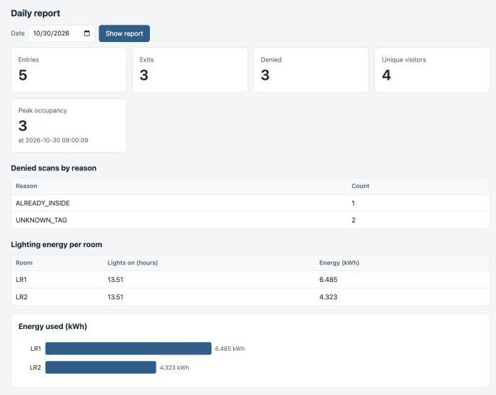
Figure 18: Dashboard Reports tab: daily totals, peak occupancy and lighting energy

9.4.5 Audit Log
The Audit log tab (Figure 19) lists every login and change with the staff member and the reason, for example the emergency drill switched on and off from the serial menu.
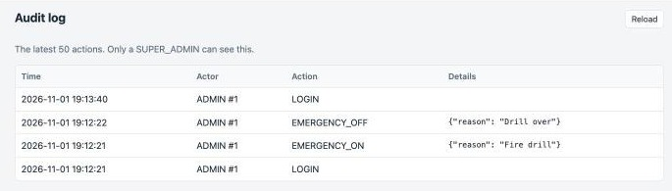
Figure 19: Dashboard Audit log tab

9.5 Swagger UI (API Documentation)
Swagger UI at /docs lists every endpoint and lets testers call them from the browser (Figure 20). The page starts with the steps and the demo logins.
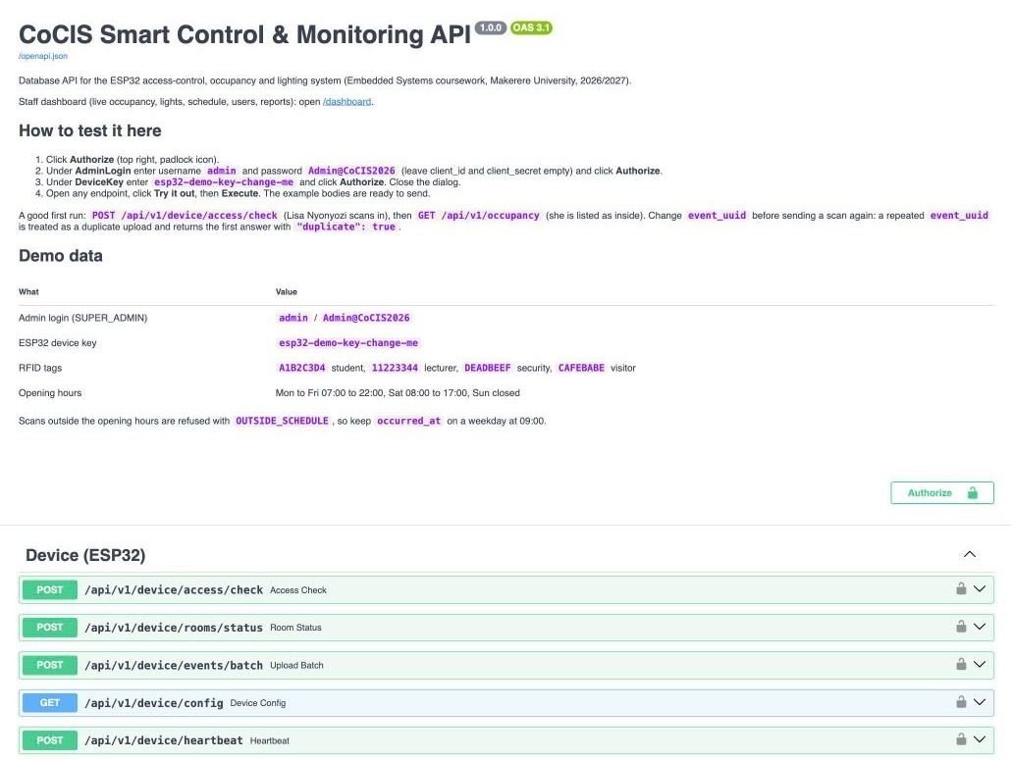
Figure 20: Swagger UI: instructions, demo data and the device endpoints
The Authorize button opens the dialog in Figure 21: the device key for the ESP32 endpoints and the administrator login for staff endpoints.
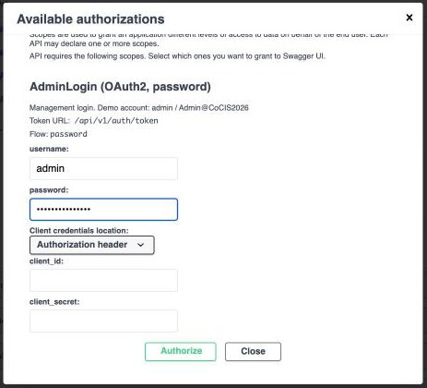
Figure 21: Swagger UI: logging in with the Authorize dialog
Figure 22 shows a scan sent as the ESP32 would send it: the lecturer's card at the entry door. The response says GRANTED, with the person's name and the new number of people inside.
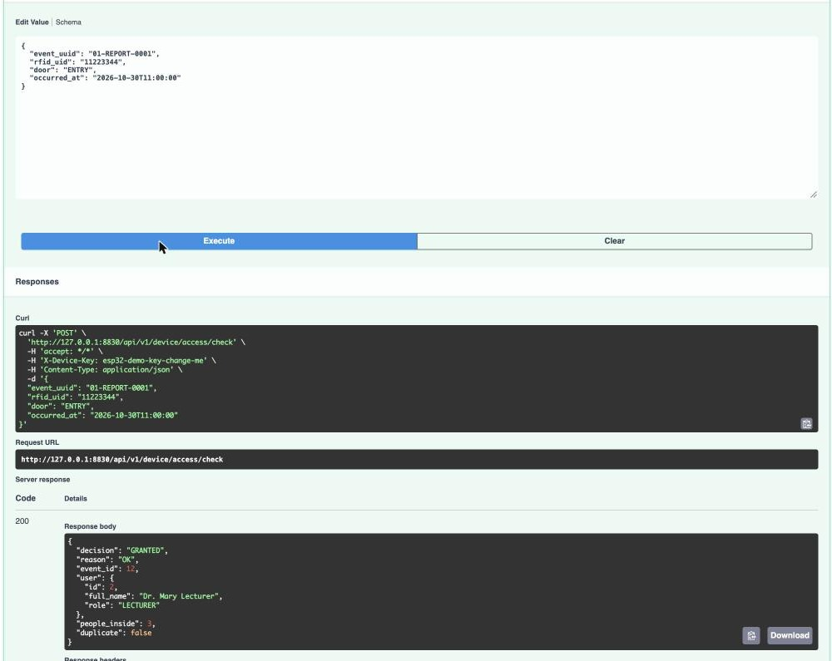
Figure 22: Swagger UI: an access check executed, with the server's answer

9.6 Testing Without Wokwi
entrance_sim.bat publishes the entrance controller's exact messages to the broker, so the bridge, database and dashboard behave as they do with Wokwi. Its --demo mode runs: a lecturer and a student enter, anti-passback, an unknown card, motion in Room 1, a new card authorised and used, the room emptying and the lecturer leaving.
The virtual HTTP controller (demo.bat, simulate.bat) tests the API's own decision path (Figures 23 and 24).
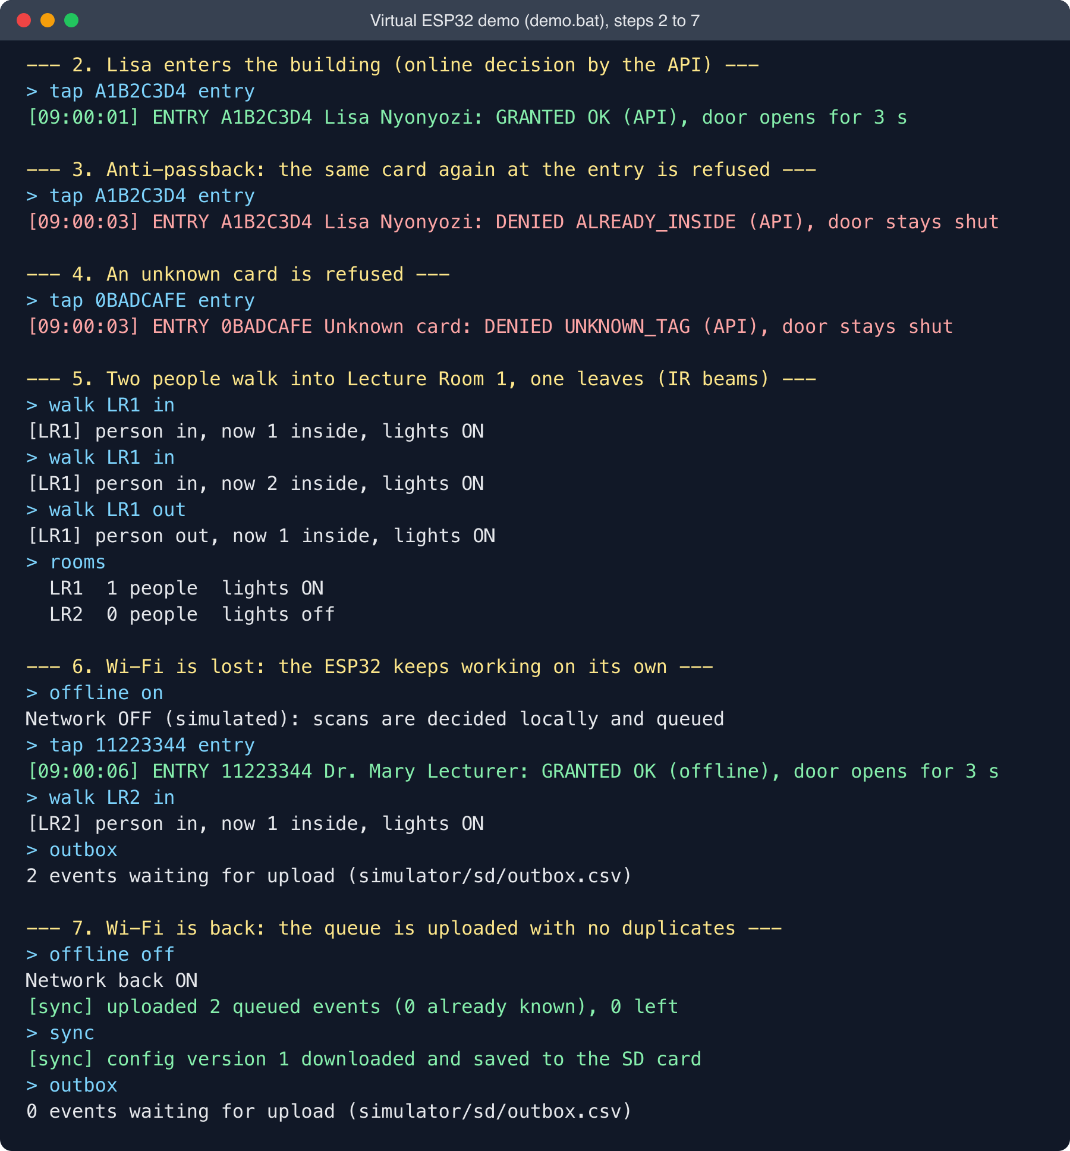
Figure 23: Virtual HTTP controller demonstration, steps 2 to 7
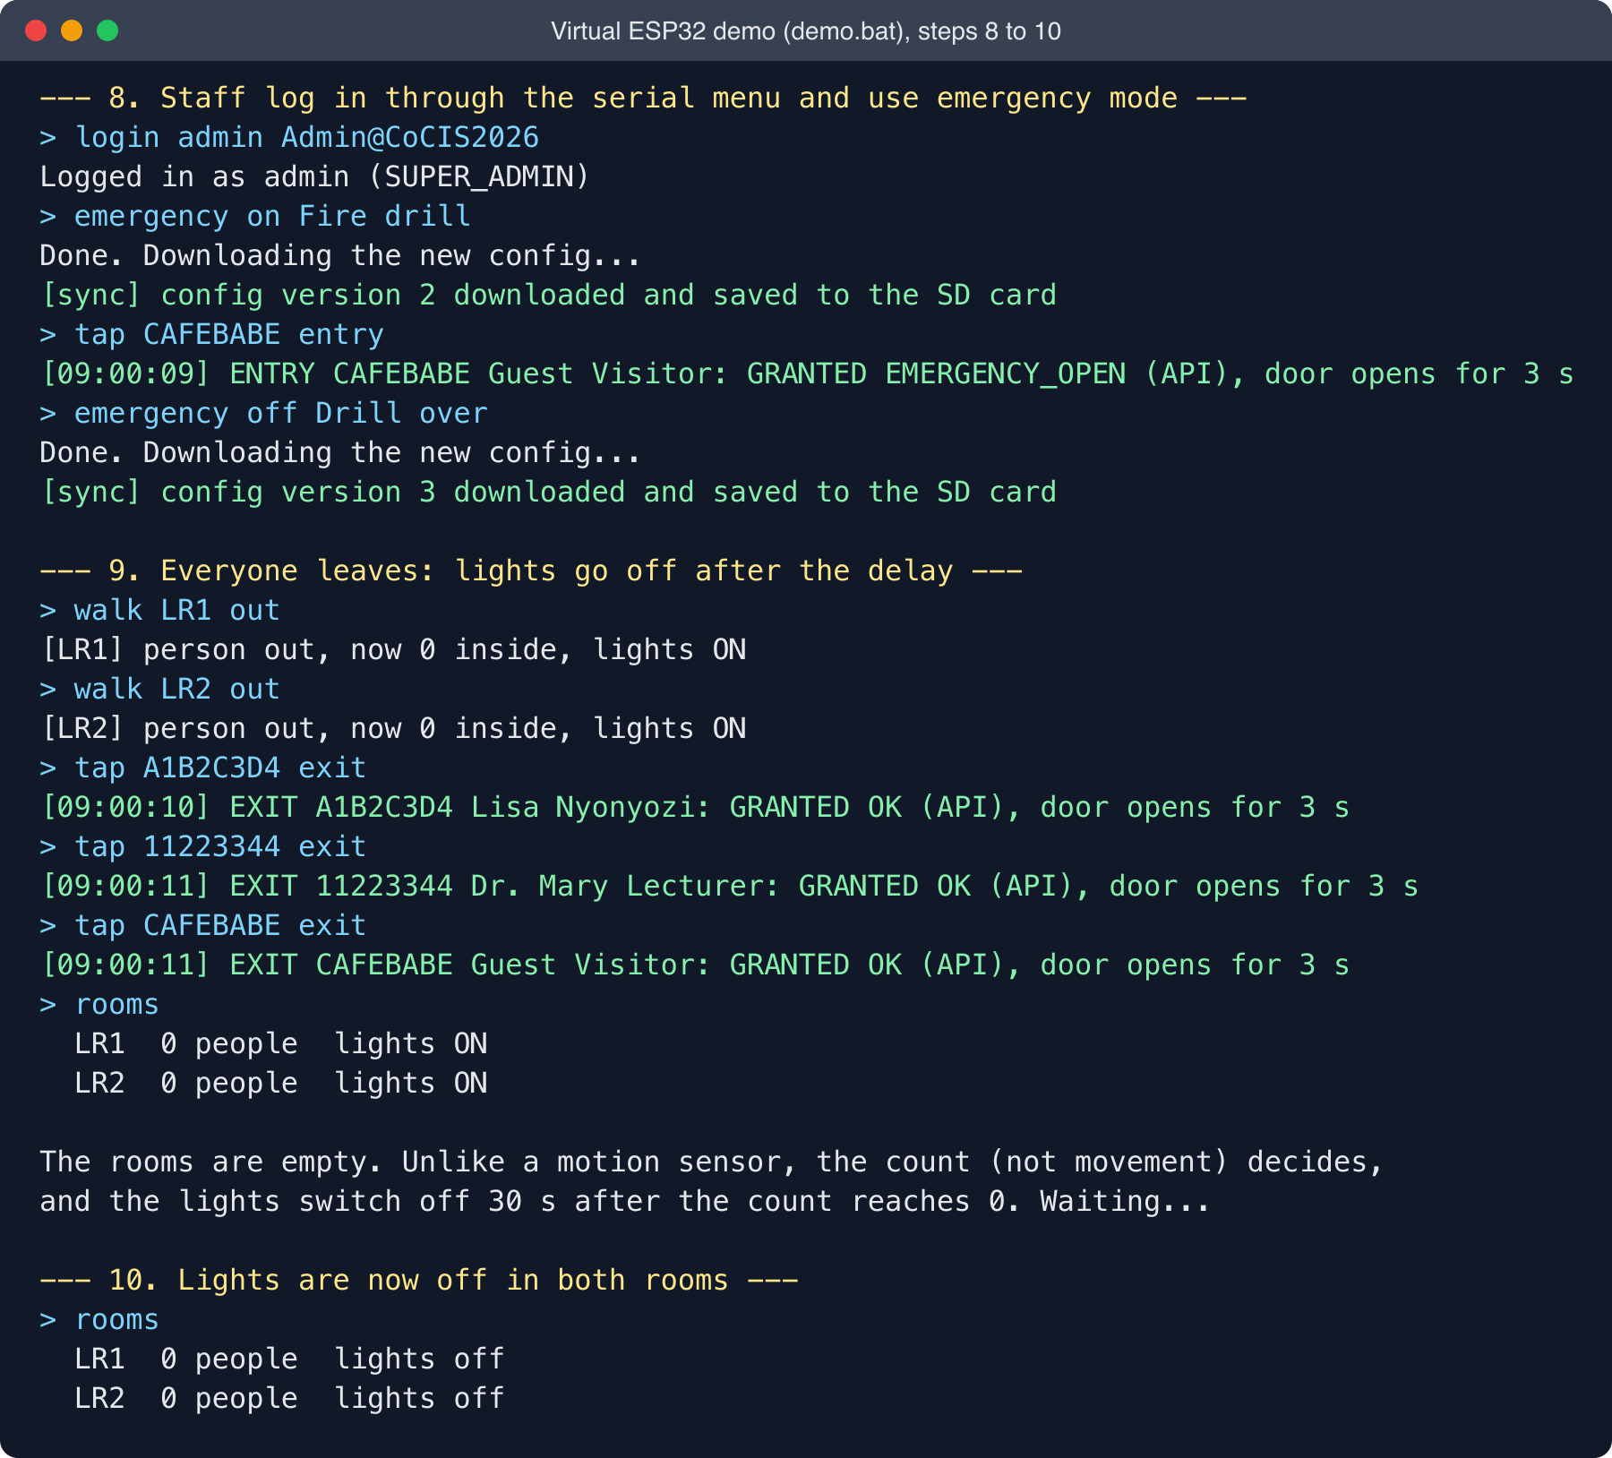
Figure 24: Virtual HTTP controller demonstration, steps 8 to 10

10. Testing and Results

10.1 Database and API Tests
The API is covered by an automated test suite (tests/test_api.py, run with pytest) that starts the API on a fresh, empty database and exercises it exactly as the bridge, the ESP32 and a staff member would. All 21 tests pass.
Table 55: Automated database and API test results
# | Test | Use case | What it proves | Result
1 | Health check |  | API starts and creates the database | Pass
2 | Wrong device key |  | Device endpoints reject unknown devices (401) | Pass
3 | Entry, exit and anti-passback | UC01 to UC03 | Entry opens a visit; second entry refused; exit closes it; second exit refused | Pass
4 | Unknown tag and schedule | UC03 | Unknown tags refused; access refused at 23:00 and on Sunday | Pass
5 | No exit outside schedule | UC02 | A person inside cannot leave after closing time (brief Section 2.6) | Pass
6 | Retry is idempotent | UC01 | Re-sending the same event_uuid returns the original decision, no duplicate | Pass
7 | Concurrent entries | UC03 | 8 simultaneous scans of one tag give exactly 1 granted and 1 visit | Pass
8 | Offline batch upload | UC14 | Out-of-order offline events stored correctly; re-upload gives only duplicates; lighting energy computed (2 h, 0.96 kWh) | Pass
9 | Schedule change | UC11, UC15 | Change raises config_version and reaches /device/config; opening after closing rejected (422) | Pass
10 | Viewer cannot change schedule | UC09, UC11 | Role check (403); wrong password (401) | Pass
11 | User registration and deactivation | UC10 | Duplicate tag rejected (409); deactivated tag refused | Pass
12 | Emergency mode | UC12 | All doors open, even for unknown tags after hours; ON and OFF audited | Pass
13 | Heartbeat | UC15 | Device health stored; controller shown online | Pass
14 | Still occupants keep lights on | UC04, UC05 | Room stays occupied with lights on while the IR count is above 0, however long; goes empty at 0; negative counts rejected (422) | Pass
15 | Swagger UI login | UC09 | The Authorize button's form login returns a working token; wrong password refused (401); both security schemes are published | Pass
16 | Dashboard served |  | The dashboard page, script and style sheet are served by the API | Pass
17 | Database viewer | UC08 | Rows are read-only, password and key hashes are never returned, unknown tables are refused | Pass
18 | Firmware results mapped | UC15 | All six result codes of state.c are stored faithfully; a 1970 timestamp is replaced | Pass
19 | PIR rooms stored | UC05 | Occupied and vacant become counts 1 and 0 with triggers MOTION and NO_MOTION | Pass
20 | Relay stores once | UC15 | Events through /device/relay have source MQTT, open a visit, and a second delivery is a duplicate | Pass
21 | Lockdown reaches the bridge | UC12 | Lockdown appears in the heartbeat reply and the occupancy view, and can be turned off | Pass

10.2 End-to-end Test Over the MQTT Broker
The complete path was tested over the internet on 2 November 2026: the entrance stand-in published the firmware's messages to broker.hivemq.com, the bridge relayed them, and the database and dashboard were checked (Figures 11 to 13).
Table 56: End-to-end test over the MQTT broker
# | Message published | Expected in the database | Result
M1 | scan in 11223344 (result OK) | GRANTED entry, source MQTT, visit opened | Pass
M2 | scan in 01020304 twice | First GRANTED, second DENIED ALREADY_INSIDE | Pass
M3 | scan in DEADBEEF (not authorised on the ESP32) | DENIED UNKNOWN_TAG | Pass
M4 | Room 1 motion, then vacant | room_status_logs MOTION then NO_MOTION; LR1 light on then off | Pass
M5 | user add AABBCCDD, then scan in AABBCCDD | Card registered in users, then GRANTED entry | Pass
M6 | scan out 11223344 | GRANTED exit, visit closed | Pass
M7 | Retained messages from an earlier run | Ignored, nothing stored | Pass
M8 | Controller status | ESP32-MQTT-ENTRANCE online on the dashboard | Pass

[To be completed by: ______________________] Add the tests the group ran on the entrance firmware in Wokwi, with screenshots of the LCD and serial monitor.

10.3 End-to-end Tests with the Virtual HTTP Controller
An automated end-to-end test (tests/test_simulator.py) starts a real API server and drives the virtual ESP32 against it: online decisions, anti-passback, offline decisions while the network is down, an IR crossing, upload of the queue, and a second upload of the same queue plus a damaged line. The test checks that the server ends with exactly the right people inside and the right room count, with no duplicates. Together with the API and bridge tests this gives 22 automated tests, all passing. The scripted demonstration (demo.bat) runs the same story step by step for the presentation.

11. Wokwi Simulation Link
Entrance controller (group firmware): ____________________________________________
Reference HTTP controller (Appendix C): https://wokwi.com/projects/479503784454238209
To run either project, open the link and press the green play button. The entrance controller connects to the broker by itself; start start.bat and bridge.bat on a laptop to see its events in the database and dashboard.

12. Individual Contributions
Each member's tasks and responsibilities (Deliverable 4).
Table 57: Individual contributions of group members
Member | Tasks and responsibilities
Lisa Nyonyozi | Carried out the use case analysis and wrote the use case specifications (Chapter 2); designed the overall system architecture and redrew it from the group's draft, including the infrared occupancy and memory-card design decisions (Chapter 3); designed and implemented the SQLite database: schema, constraints, indexes, views and seed data (Chapter 6); designed, implemented and tested the REST API that connects the ESP32 to the database, including authentication, roles, offline synchronisation and reports (Chapter 7); wrote the API documentation and the automated test suite (Section 10.1); designed and built the MQTT bridge that connects the group's entrance firmware to the database and dashboard without changing the firmware, and the network design (Section 3.4); built the management dashboard.

13. Individual Video Demonstrations
Table 58: Links to individual video demonstrations
Member | Feature(s) demonstrated | Video link
Lisa Nyonyozi | Use cases, architecture and network; database; REST API in Swagger UI; MQTT bridge with a live scan reaching the dashboard

14. Conclusion and Recommendations

14.1 Conclusion
The system meets the brief on one simulated ESP32. Two RFID readers control separate entry and exit doors under a configurable schedule with anti-passback; PIR sensors switch the lecture-room lights; the SD card and NVS keep logs and state; the serial menu supports monitoring and authenticated configuration; and mutexes, a queue, transactions and unique keys keep the records consistent. Through MQTT and a bridge, every event reaches a central database and a live dashboard without changing the controller, and without the controller and the database sharing a network.

14.2 Limitations and Future Work
- Lockdown command ignored. In comms.c line 75 the command topic is compared with 19 characters, but cocis/cmd/entrance has 18, so LOCKDOWN and UNLOCK never match. Changing both 19s to 18 makes the dashboard's lockdown work.
- Public broker. Anyone using the same topics on broker.hivemq.com is also received. A private broker with a password and TLS should be used for real deployment.
- Still occupants. PIR sensors miss people who sit still; a longer hold time, a manual override, or infrared beam counting at the door (Section 3.5) solve this.
- One-way configuration. Cards and schedule are changed on the ESP32 and copied to the database; changes made on the dashboard do not yet reach the ESP32.
- Lost messages while offline. Events are published with QoS 0 and not queued, so the database misses scans made while the ESP32 is disconnected (they remain in access.csv). Uploading the SD log on reconnect, or QoS 1 with the client's outbox, would close this gap.
- Real hardware and one board per terminal are the next steps; the topics, bridge, API and database already support them.

References
ACEEE (1996) Occupancy sensors in classrooms: field experience. ACEEE Summer Study on Energy Efficiency in Buildings, Panel 4, Paper 10. Available at: https://www.aceee.org/files/proceedings/1996/data/papers/SS96_Panel4_Paper10.pdf
Butlr (2025) Common problems with PIR sensors and Occupancy sensors for classrooms. Available at: https://www.butlr.com/blog/common-problems-pir-sensors and https://www.butlr.com/blog/occupancy-sensors-classrooms
Espressif Systems (2026) ESP-IDF Programming Guide: FAT Filesystem Support, SD SPI Host Driver, ESP HTTP Client, FreeRTOS. Available at: https://docs.espressif.com/projects/esp-idf/en/latest/esp32/api-reference/storage/fatfs.html
FastAPI (2026) FastAPI documentation. Available at: https://fastapi.tiangolo.com/
Hackster.io (n.d.) DIY bidirectional counter using Arduino and IR sensors. Available at: https://www.hackster.io/its_me_yogesh/diy-bidirectional-counter-using-arduino-and-ir-sensors-36ba45
Siara, A. (2019) SQLite3 library for ESP32 (forum announcement and README, including notes on locking and flash wear). Available at: https://esp32.com/viewtopic.php?p=38285
SQLite Consortium (2026) SQLite documentation: transactions, WAL mode, partial indexes, generated columns. Available at: https://www.sqlite.org/docs.html
University Politehnica of Bucharest (2025) ESP32 Smart Access Monitor (IoT course project using two IR sensors for entry and exit counting). Available at: https://ocw.cs.pub.ro/courses/iothings/proiecte/2025sric/esp32-smart-access-monitor
Wokwi (2026) wokwi-microsd-card reference. Available at: https://docs.wokwi.com/parts/wokwi-microsd-card
Human occupancy monitoring and positioning with a speed-responsive adaptive sliding window using an infrared thermal array sensor (2024). Sensors, PMC11722904. Available at: https://www.ncbi.nlm.nih.gov/pmc/articles/PMC11722904/
Makerere University, CoCIS (2026) Smart Control and Monitoring System for CoCIS: Embedded Systems coursework brief, BSE III and CS II.
OASIS (2014) MQTT Version 3.1.1, OASIS Standard. Available at: https://docs.oasis-open.org/mqtt/mqtt/v3.1.1/mqtt-v3.1.1.html
Espressif Systems (2026) ESP-MQTT component documentation. Available at: https://docs.espressif.com/projects/esp-idf/en/latest/esp32/api-reference/protocols/mqtt.html
HiveMQ (2026) Public MQTT broker (broker.hivemq.com). Available at: https://www.hivemq.com/mqtt/public-mqtt-broker/
Eclipse Foundation (2026) Eclipse Paho MQTT Python client. Available at: https://eclipse.dev/paho/
Espressif Systems (2026) Arduino ESP32 core documentation. Available at: https://docs.espressif.com/projects/arduino-esp32/
Wokwi (2026) ESP32 simulation guide and ESP32 WiFi networking. Available at: https://docs.wokwi.com/guides/esp32

Appendix A: Project Files
Table 59: Database and API project files
Path | Contents
database/schema.sql | All CREATE TABLE, INDEX and VIEW statements
database/seed.sql | Rooms, default schedule, settings and demo users
api/main.py | Application entry point; creates the database on start-up
api/db.py | Connections, write_tx() transactions, password hashing, settings, audit helper
api/security.py | Device-key and bearer-token checks; role enforcement
api/access_logic.py | The access rules, visit tracking, room-state updates
api/schemas.py | Request validation models (Pydantic)
api/routes_device.py | Endpoints used by the ESP32
api/routes_admin.py | Endpoints used by staff, including reports
tests/test_api.py, tests/test_simulator.py | 16 API tests and 1 end-to-end test with the virtual ESP32
reference-firmware/main/main.c | Reference HTTP controller firmware (Appendix C)
reference-firmware/diagram.json | Wokwi circuit; reference-firmware/wokwi.toml and CMakeLists.txt for Wokwi in VS Code and idf.py
dashboard/ | Management web dashboard (HTML, CSS, JavaScript), served at /dashboard/
simulator/virtual_esp32.py | Virtual ESP32 for testing without hardware; simulate.bat and demo.bat start it
setup.bat, start.bat, test.bat, reset_db.bat | Windows scripts: install, start (opens the docs), test, reset the database
setup.sh, start.sh, test.sh | The same scripts for macOS and Linux
run.py | Starts the API and opens the docs; used by both start scripts
bridge/mqtt_bridge.py | MQTT bridge between the entrance ESP32 and the API; started by bridge.bat
bridge/entrance_sim.py | Publishes the entrance ESP32's messages for testing; started by entrance_sim.bat
README.md (in each folder) | Short guide for each app: firmware, api, database, dashboard, simulator, docs
docs/screenshots/ | Screenshots used in Chapter 9, and the generator for the terminal images
docs/openapi.json | Machine-readable API specification (importable into Postman)
docs/diagrams/ | Use case, architecture, infrared counter, ER and sequence diagrams (SVG and PNG)

Appendix B: Explaining the System (Likely Questions)
Short answers prepared so that every member can explain the use cases, architecture, database and API during the presentation.
Q: Why only one ESP32 when the brief mentions three terminals?
A: The free Wokwi plan supports one microcontroller and the lecturer confirmed one should be used. Each terminal is handled by its own task, so the design stays modular.
Q: Does the ESP32 need to be on the same network as the database?
A: No. The ESP32 and the server each connect out to the MQTT broker on the internet, and the broker passes messages between them. The database stays private on the server; no tunnel or port forwarding is needed.
Q: How does a scan get into the database?
A: The ESP32 decides, opens the door and publishes {tag, dir, result, ts} to cocis/event/access. The bridge receives it, converts the result code and calls POST /api/v1/device/relay with its device key. The API validates it with a Pydantic model and stores it in one transaction.
Q: Why MQTT and not HTTP from the ESP32?
A: Publishing is fast and does not wait for the server, so the door never waits. Many subscribers can read the same messages, retained messages give the latest state to anyone who connects, and the ESP32 does not need to know where the server is.
Q: Why do you need a bridge?
A: MQTT and HTTP are different protocols. The bridge subscribes to the broker and makes the REST calls, so the firmware did not have to change at all, and the API keeps one way of storing events.
Q: What stops a message being stored twice?
A: The bridge builds a stable event_uuid from the card, the direction and the ESP32's time. The event_uuid column is UNIQUE, so a second delivery is reported as a duplicate and not stored.
Q: Why a PIR sensor, and what is its weakness?
A: PIR sensors are cheap and available in Wokwi. They detect movement, not people, so a still class can look empty. A longer hold time, the manual override, or counting people with infrared beams at the door (Section 3.5) handle this.
Q: Is the memory card the database?
A: No. The ESP32 keeps its card list, people inside and schedule in NVS flash and logs every scan to access.csv on the SD card. The official database is SQLite on the server, reached through the bridge and API.
Q: What happens when Wi-Fi goes down?
A: Doors keep working: the ESP32 decides on its own and logs to the SD card. Messages are not queued, so those scans reach the database only if the SD log is uploaded later; this is listed as future work.
Q: How do you prevent race conditions?
A: On the ESP32, one mutex protects the shared state and another the SD log, and a queue hands door requests to the door task. On the server, each write is a BEGIN IMMEDIATE transaction and a unique index allows only one open visit per person.
Q: How does the system know who is inside?
A: On the ESP32, the people-inside list. In the database, each granted entry opens a row in building_visits and each granted exit closes it; open visits are the view v_people_inside.
Q: Why can people leave after hours?
A: Locking someone inside is dangerous, so the exit door opens but the event is recorded as OK_AFTER_HOURS for security to follow up. Entry outside the hours is refused.
Q: How is the schedule protected?
A: On the ESP32, schedule set needs the admin PIN. On the dashboard, only a SUPER_ADMIN can change it, with hashed passwords, expiring tokens and an audit log.
Q: What are the API's models?
A: Pydantic classes in api/schemas.py, for example AccessCheck, EventBatch, RoomStatus and Login. FastAPI checks every request against them, so a wrong door, unknown reason or bad time is refused with 422 before any database code runs.
Q: How can we test without Wokwi?
A: Run start.bat, bridge.bat and entrance_sim.bat. The stand-in publishes the same messages as the firmware, so the database and dashboard update exactly as with the real controller.
Q: How is energy saving measured?
A: Every light change is stored with its time. The daily report adds up the hours each room's lights were on and multiplies by the room's lamp power.

Appendix C: Reference HTTP Controller
Before the group's firmware was integrated, a reference controller was built to develop and test the API (reference-firmware/main/main.c, Wokwi project https://wokwi.com/projects/479503784454238209). It calls the REST API directly over HTTP instead of MQTT, counts people with two infrared beams per room door (the recommended upgrade in Section 3.5), and keeps an offline queue on the SD card that it uploads when the network returns. It is kept as a working demonstration of these features and of the API's own decision path.
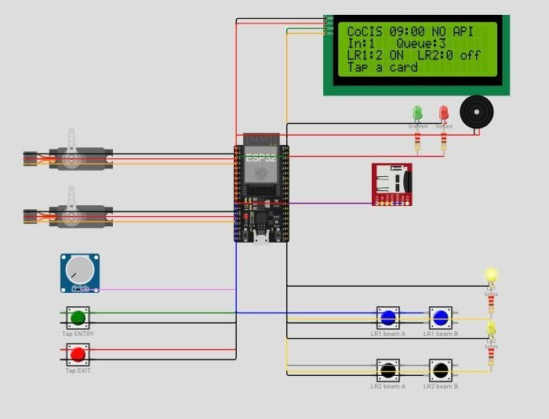
Figure 25: Reference controller running in Wokwi
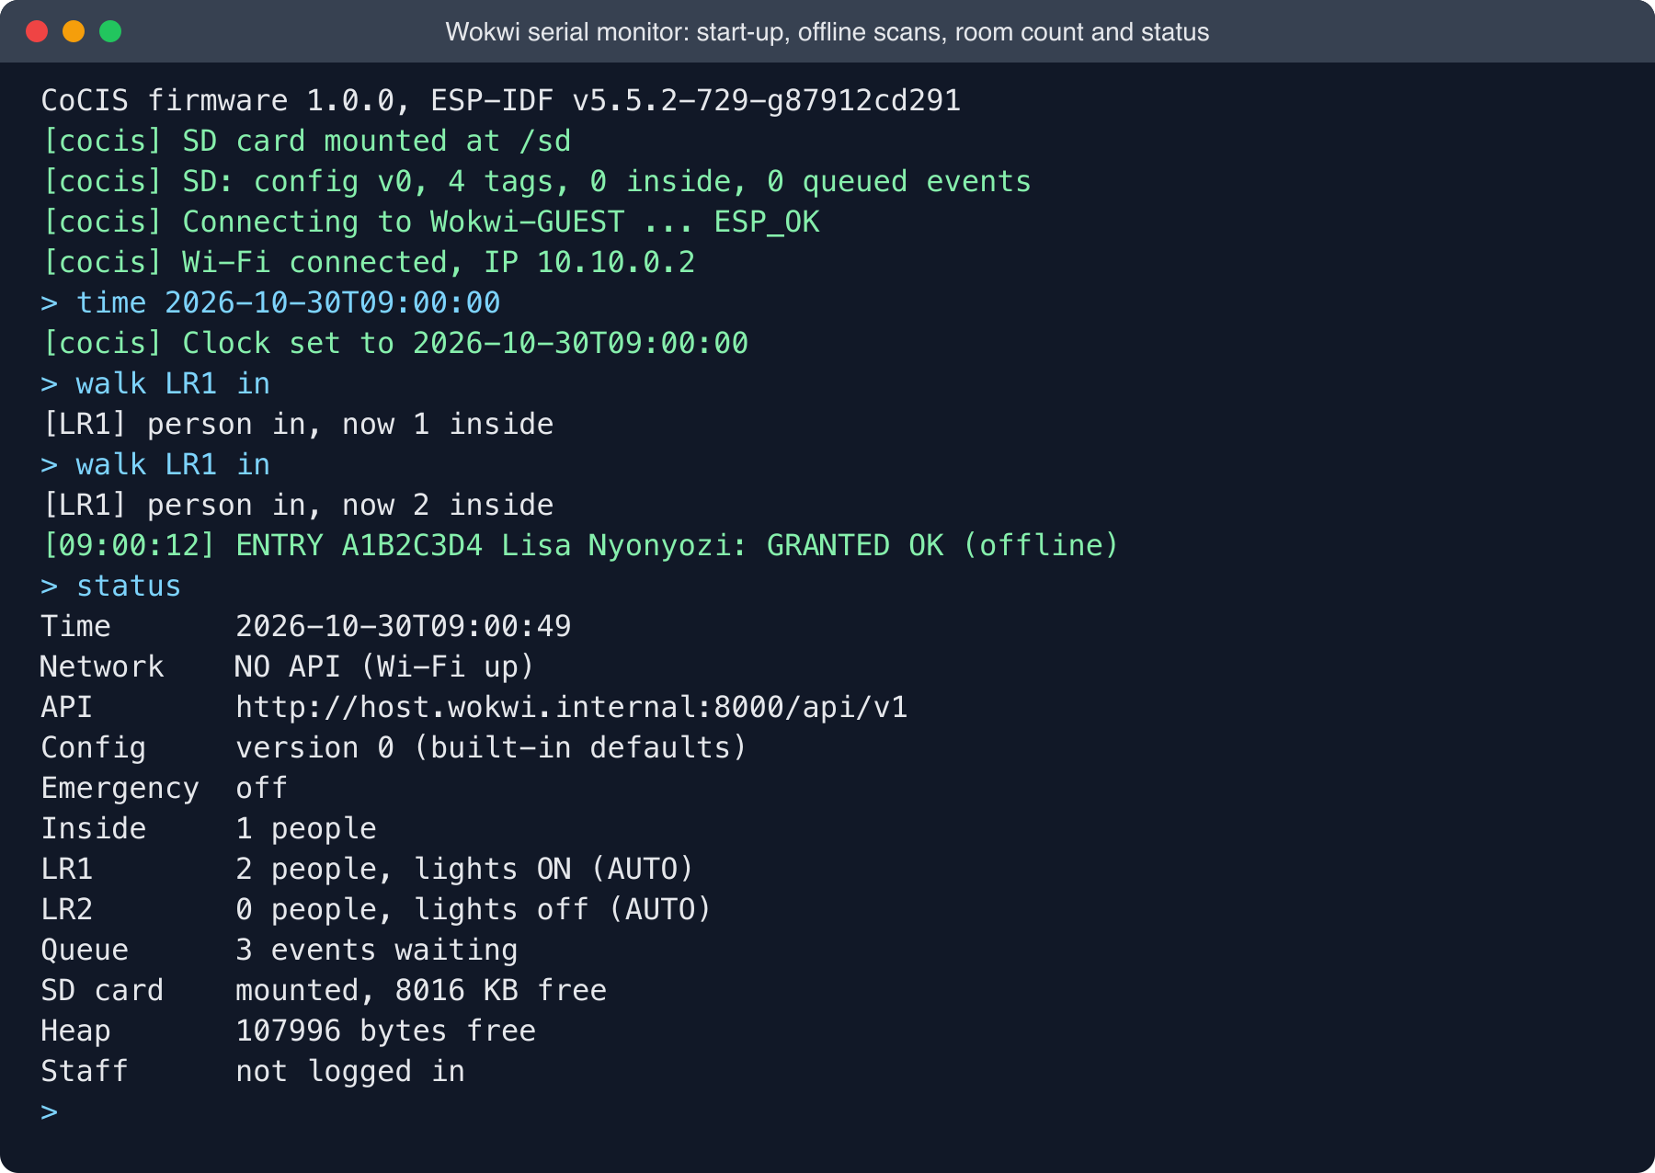
Figure 26: Reference controller serial monitor: offline decisions and status
Its online and offline paths are shown in Figures 27 and 28.
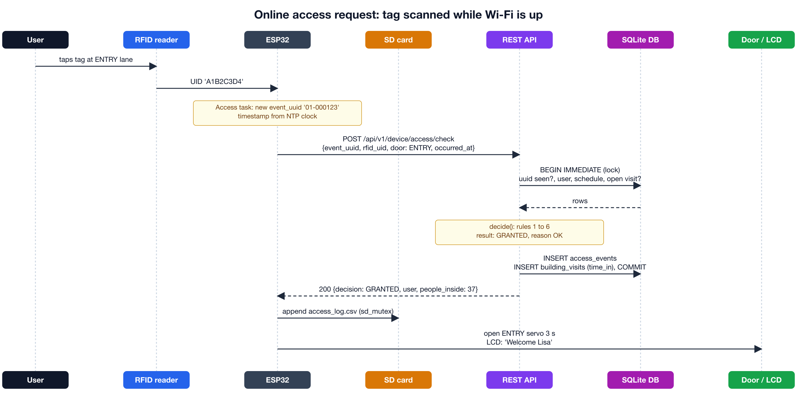
Figure 27: Reference controller: online access request over HTTP
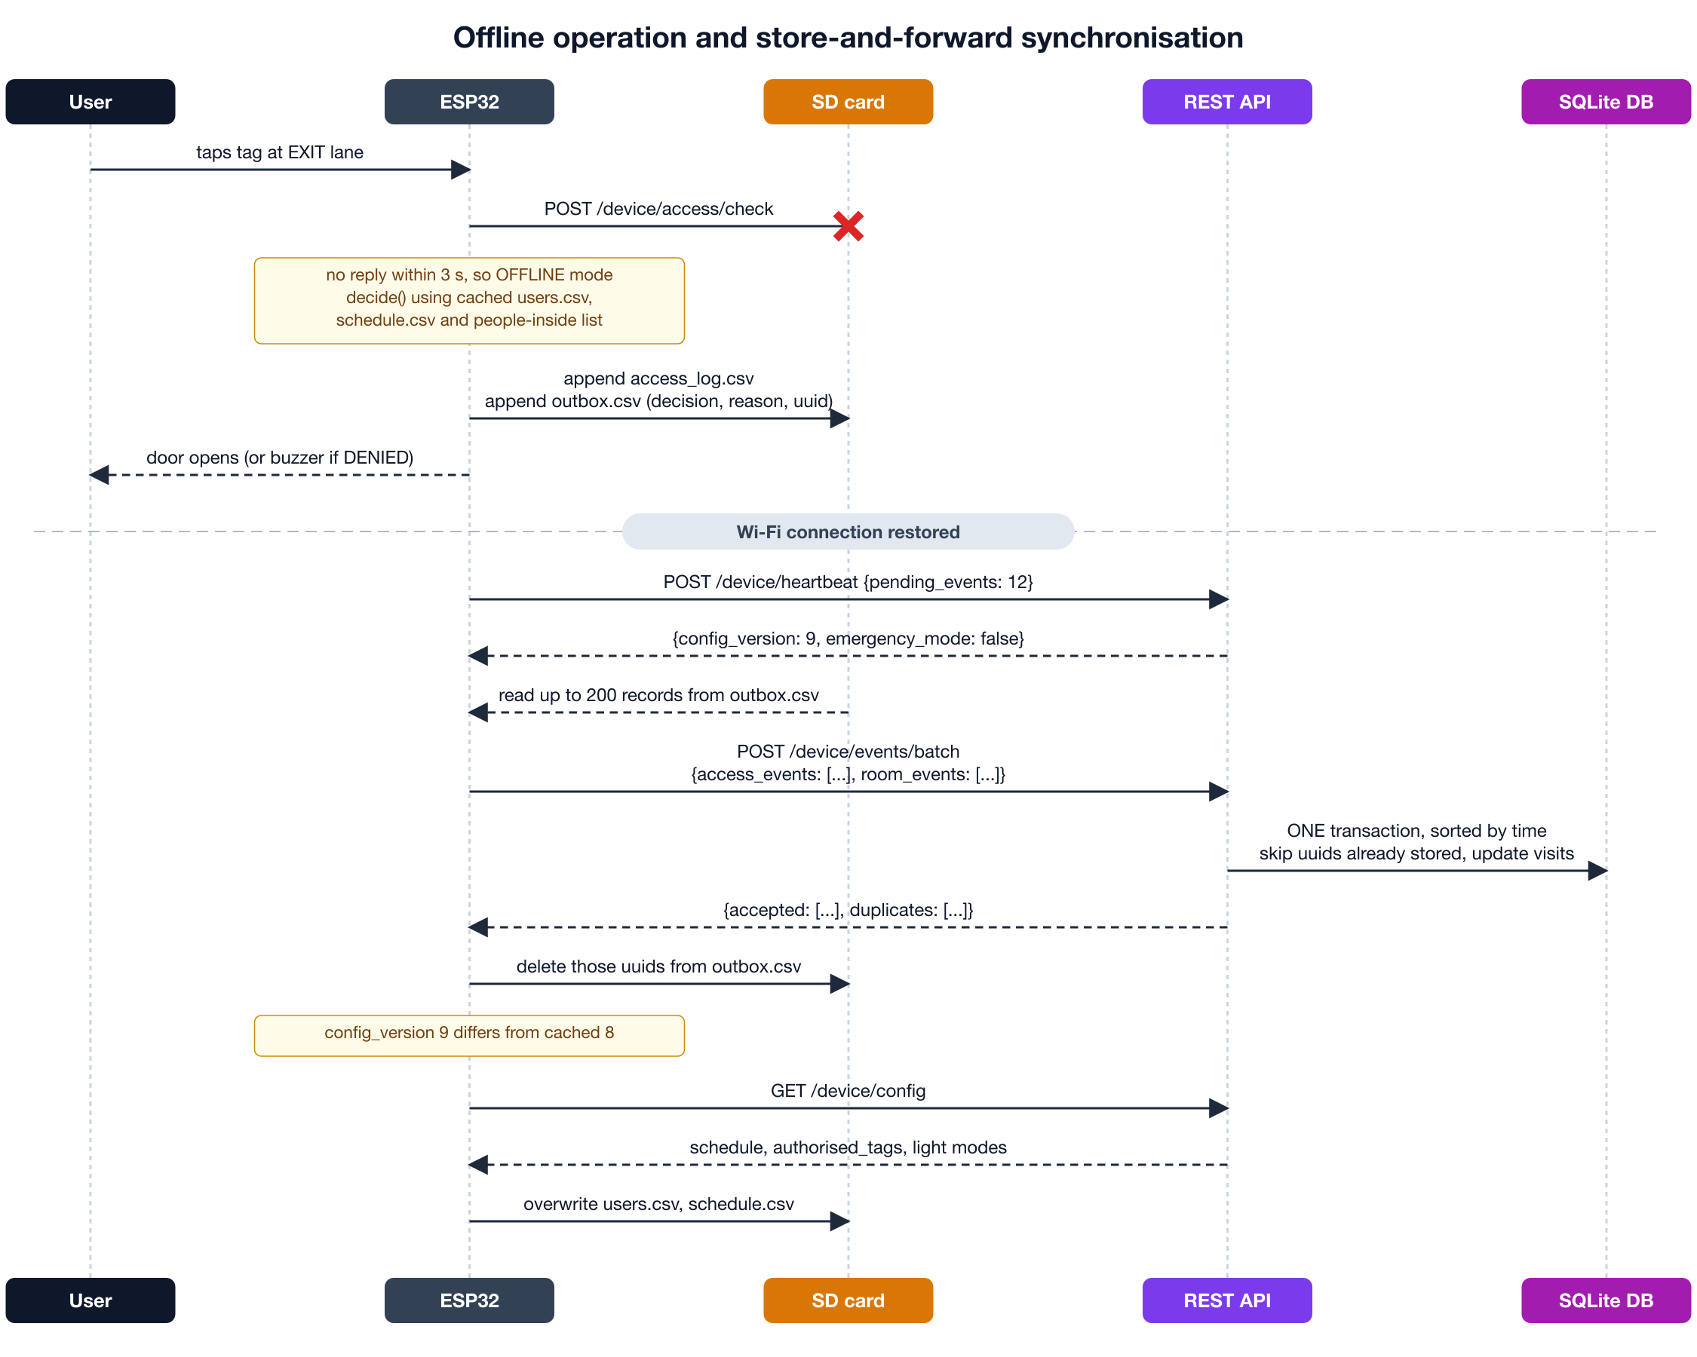
Figure 28: Reference controller: offline operation and store-and-forward

