Task 3:

We are creating an MVP for a twitter clone, assuming the MVP will allow users to:

* Log in and out
* Write TweetClones
* View a chronologically ordered timeline of other user’s TweetClones
* Like Tweetclones

Please answer the following questions

1. How would you structure the data, what data structures are required?

Initially via SQL tables, with a structure similar to:   
(see diagram below for ease)

* User
  + user_id
  + username
  + email
  + password
  + tweet_id
  + follower_id
  + like_id
* Tweets
  + tweet_id
  + tweet_time
  + tweet_body
  + user_id
  + like_id
* Followers
  + follower_id (foreign_key → user_id)
  + user_id
  + follow_time
* Likes
  + like_id
  + tweet_id
  + user_id
  + like_time

Relationships  
User → 1 to many → Tweets  
User → many to many → Followers  
User → 1 to many → Likes  
Tweets → 1 to many → Likes

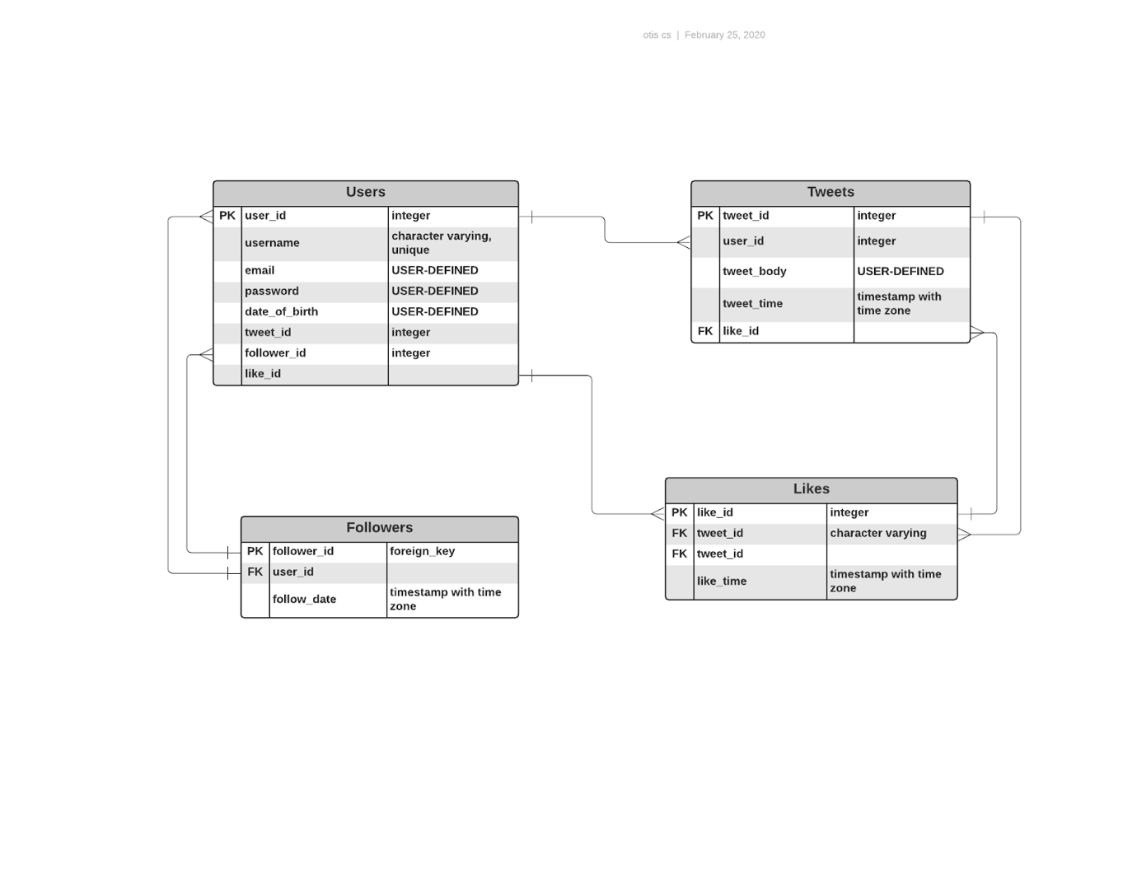

1. How would you feed the data to a frontend application?

Using the following or something similar.

users_followed = []

for follower in followers:

   if follower.user_id == user_id:

        users_followed.append(follower.follower_id)

returned_tweets = []

for tweet in tweets:

  if tweet.user_id in users_followed:

      returned_tweets.append({"tweet_id": tweet.tweet_id,

                            "tweet_time": tweet.tweet})

# Then sort the dict object:

for key, value in returned_tweets.items():

  if tweet.user_id in user.users_followed:

    returned_tweets.items()

    sorted_returned_tweets = returned_tweets.sort(tweets.tweet_time)

1. What endpoints would you define?

For part 3:

Aside from repeating my answer from part 1, I’m unsure.