Analysis Proposal
Prepared for Drinking Excess Alcohol is Dangerous (DEAD) • Team Joe Abercrombie
DEAD has asked us to help identify what drives higher or lower alcohol purchasing across Iowa, so that campaigns that seek to make alcohol culture in the state can be times to have the most impact. Our proposal focuses to analyze alcohol purchases on major holidays and state events, such as the Iowa State Fair and home football games.

Data & Wrangling Plan
We decided to focus on alcohol purchases between 2022 through 2026. The raw dataset records wholesale liquor orders indicating when stores order for restocks, it does not indicate the individual point of sale for liquor orders by customer. To account for this, we decided to aggregate liquor orders by the week (Monday-Sunday) rather than daily. We also chose to track Iowa City and Ames separately, as the state's two largest college towns, since events like home football games can drive localized spikes in liquor sales that might otherwise be diluted in a statewide total.
We are also building a calendar events table, which includes major holidays, as well as the dates for Super Bowl Sunday, Iowa State Fair dates, and home game schedules pulled from additional sources. Each of these events are included as a weekly indicator in our model (whether these events occurred).

Dataset | Grain | Source | Role in analysis
Iowa liquor wholesale orders | Transaction-level, 2022–2026 (~13.2M rows) | State of Iowa liquor distribution records | Aggregated to weekly ordering volume, statewide and by city
Calendar events | Daily, 2022–2026 | Computed (fixed & rule-based holidays); Super Bowl / Iowa State Fair dates and Hawkeyes / Cyclones home-game schedules from public sources | Converted to weekly “event occurred this week” indicators

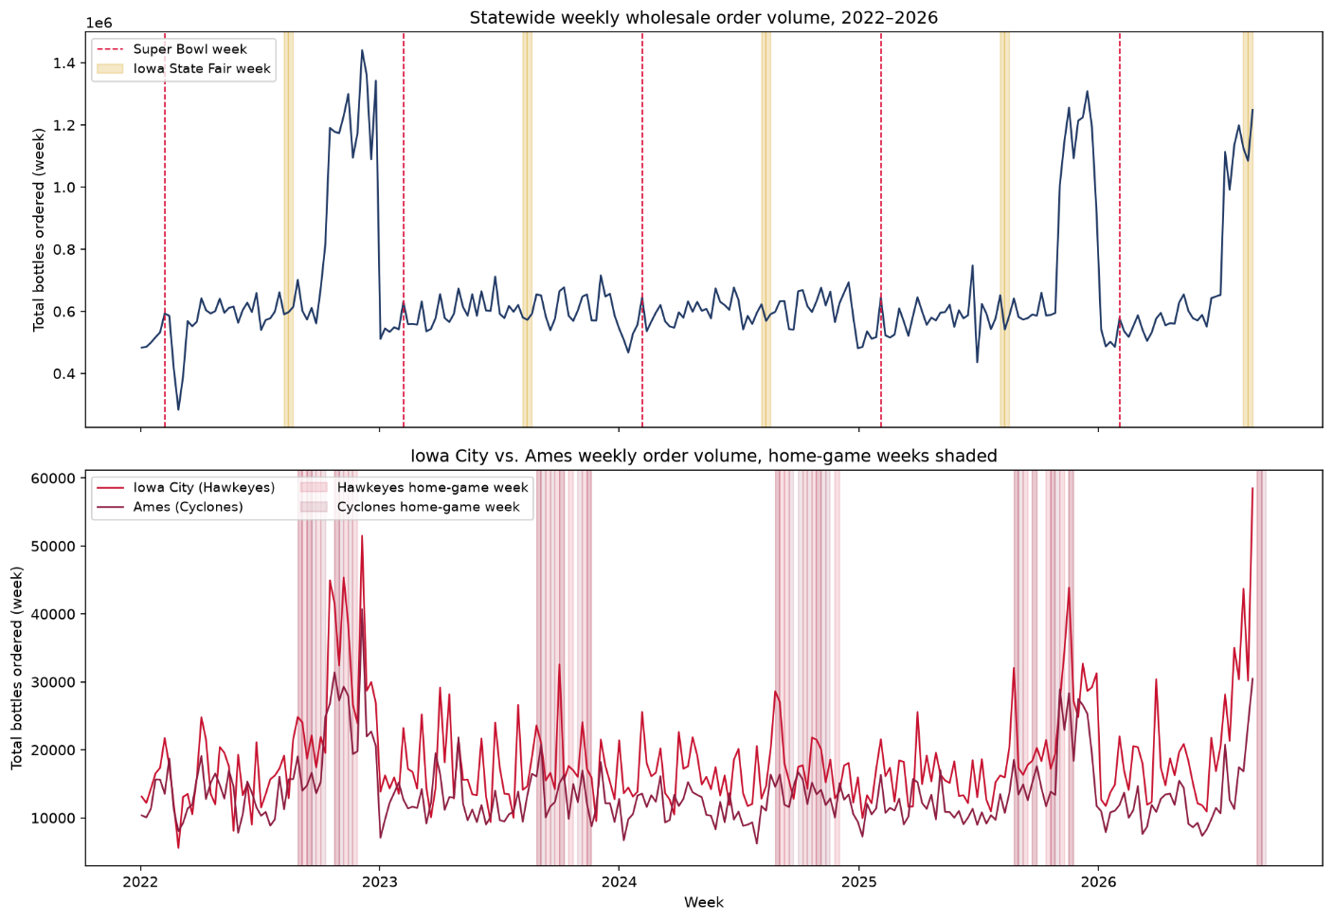

Modeling Approach & Validation
The observational unit we chose is one week. The target variable is the log of total bottles ordered that week. We decided to log-transform sales since volume is right skewed. We plan to only use linear regression, where each model contains the log weekly volume, calendar month fixed effects, and weekly/event game indicators.
To decide on which model to use, we will check whether adding calendar events improve predictions. We will be comparing models using F-test and AIC/BIC. Since our data is ordered by time, we will also test the model by training it on older weeks and checking how well it predicts more recent months.
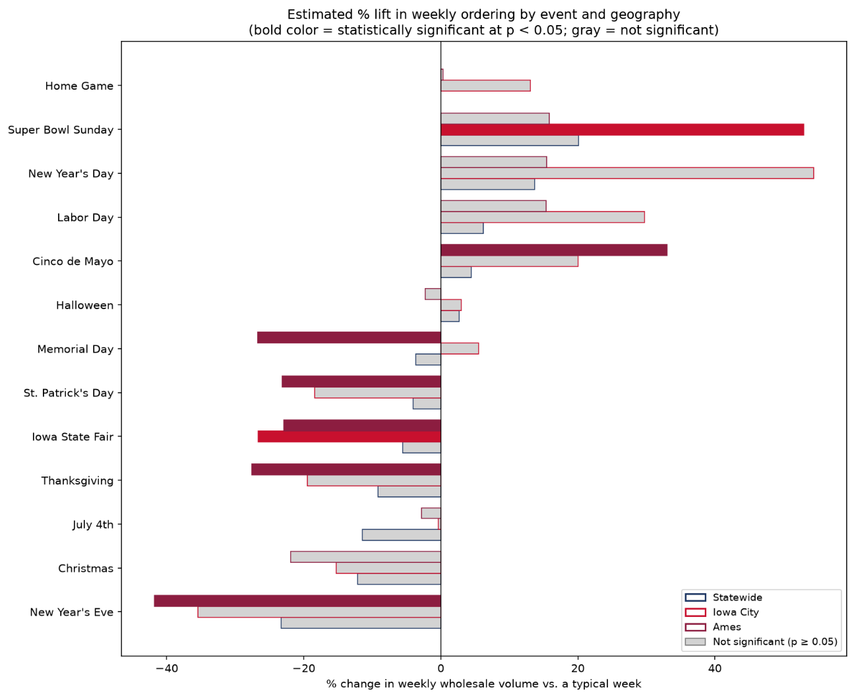

What DEAD Can Expect
Our final analysis will identify which specific calendar occasions are associated with a meaningful and statistically significant increase in alcohol ordering. Our goal is to prioritize a ranked list of whether and when DEAD can run a safe alcohol campaign.

