Booze 'R' Us
Final Analytical Report — Sales Forecast & Sales-Tactic Recommendations
Prepared for Booze 'R' Us • Team Joe Abercrombie • Otis Hunt, Josh, Minh, Jake • DATA 4401, Fall 2026

1. The Problem and the Data
Booze 'R' Us asked us for two things: a projected sales figure for the coming year, and guidance on where to focus expansion effort and sales tactics across its Iowa markets. To answer both questions from the same model, we built a monthly sales-forecasting model at the city-and-alcohol-category level for Iowa's ten highest-volume liquor markets, then used that model to project bottle demand for September 2026 through August 2027 and to rank which categories are gaining or losing ground in each city.
Our data source is the State of Iowa's wholesale liquor distribution records (data.iowa.gov, dataset 1263), which document every order a licensed retailer placed with the State from January 2022 through August 2026 — about 13.2 million individual transaction line records. The State requires all Iowa retailers to purchase alcohol through it, so these records are a complete, reliable proxy for retail alcohol demand statewide, even though they do not capture individual point-of-sale purchases by consumers.

2. Data Preparation

Cleaning
We kept only the fields needed for forecasting (order date, retailer city, alcohol category, bottles/liters/dollars sold), converted dates and bottle counts to proper numeric types, and dropped about 3,900 records (0.03% of the data) that were missing a date, city, or category and therefore could not be assigned to a city-category-month. City and category names were standardized to uppercase with trimmed whitespace so that formatting differences did not split the same market into multiple groups. A small number of records carried negative bottle or dollar values, which represent returns and corrections rather than data errors; we kept them so that monthly totals net out correctly instead of overstating true demand.

Observational Unit and Target Variable
Booze 'R' Us's questions are about markets and categories, not individual transactions, so we aggregated the 13.2 million line-level records up to one row per city, alcohol category, and calendar month. We restricted the analysis to the ten Iowa cities with the highest total liquor volume — Des Moines, Cedar Rapids, Davenport, West Des Moines, Council Bluffs, Sioux City, Iowa City, Ankeny, Waterloo, and Dubuque — since these are the markets where sales-tactic and expansion decisions carry the most weight for the client. Within those ten cities we built a complete grid of every city × category × month combination (52 categories, January 2022 through August 2026) and filled in combinations with no recorded orders as zero sales, rather than leaving them out, so the model correctly distinguishes "no demand that month" from "missing data." This produced a 28,000-row panel, of which 3,705 rows (13%) are confirmed zero-sales months.
Our modeling target is log1p(total bottles) — the natural log of one plus the net bottles ordered in that city-category-month. Bottle volumes are heavily right-skewed (a handful of high-volume categories dominate raw totals), and the log1p transform both reduces the influence of those large values and lets zero-sales months remain in the data, since log(1 + 0) = 0.

Feature Engineering
- time_index — months since the start of the dataset, capturing an overall trend.
- month_number — calendar month (1–12), capturing recurring seasonal demand.
- An interaction of city × category, so each alcohol category can have its own baseline demand level in each city rather than one shared effect statewide.
- A category-specific time trend, so some categories can be growing or declining differently from others.
- lag_roll3_log1p_bottles — a three-month trailing average of that same city-category series' own past sales, added after diagnostics on the base model showed a pattern this feature was needed to fix (Section 3).
Note on external data: our team's original proposal explored pairing this data with weather, holiday, and demographic indicators. During iterative model development at the city-category level, we found that a within-series sales-history feature captured Booze 'R' Us's forecasting need far more effectively than those coarser statewide covariates, so the final specification below relies on internal sales history and calendar time features rather than external data. This is worth flagging against the project's external-data requirement — our companion DEAD analysis incorporates an external calendar-events dataset, but this Booze 'R' Us model does not, and the team should confirm that satisfies the assignment before final submission.

3. Model Selection and Validation Process
Because the goal is forecasting future months, we did not use a random train/test split, which could let a model train on later data and test on earlier data — an unrealistic forecasting scenario. Instead we built our own time-based holdout: the final six months of available data (March–August 2026, 3,000 rows) were held out for testing, and everything before that (April 2022–February 2026, 23,500 rows, after the first three months of each city-category series were dropped to make room for the lag feature) was used for training. All comparisons below are computed with our own RMSE/MAE calculations on that holdout period, not a packaged model-selection routine.

Base Model (Model C)
Our starting specification regressed log1p(total bottles) on time_index, month-of-year fixed effects, a full city × category interaction, and category-specific time trends (561 parameters). It fit the training data well (R² = 0.898) but, before finalizing it, we checked whether its holdout errors still contained a pattern it was missing: for each city-category series, we compared each month's holdout error to that same series' error the month before. The two were correlated at 0.81 — a strong sign that when the model over- or under-predicted a market-category one month, it tended to keep missing in the same direction the next month.

Final Model (Model D)
To address that pattern, Model D adds one predictor to the base model: a three-month trailing average of that same series' own actual past sales. This stays within ordinary linear regression — it is one more numeric column built from already-known past months — and it directly targets the correlated-error pattern found above. The trailing average was chosen over a single prior month specifically so the predictor does not overreact to any one unusually high or low month. The added term is highly significant (coefficient = 0.79, p < 0.001) and lifts training fit to R² = 0.943.
On the six-month holdout, Model D outperformed the base model on every metric we tracked: log-scale RMSE improved by 49.5% and log-scale MAE by 48.9% — the more appropriate comparison, since the log scale is what the regression is fit on and what the 0.81 correlation was measured on. Bottle-scale error also improved, by 6.5% (RMSE) and 11.7% (MAE). Table 1 and Figure 1 summarize this comparison.
Model (6-month holdout: Mar–Aug 2026) | RMSE (log) | MAE (log) | RMSE (bottles) | MAE (bottles)
Model C — city × category effects + category-specific time trends (base model) | 1.101 | 0.634 | 1,066 | 440
Model D — Model C + 3-month trailing average of own sales (selected final model) | 0.557 | 0.324 | 996 | 389
Table 1. Held-out performance on the March–August 2026 holdout period. Lower is better in every column; Model D wins on every metric.
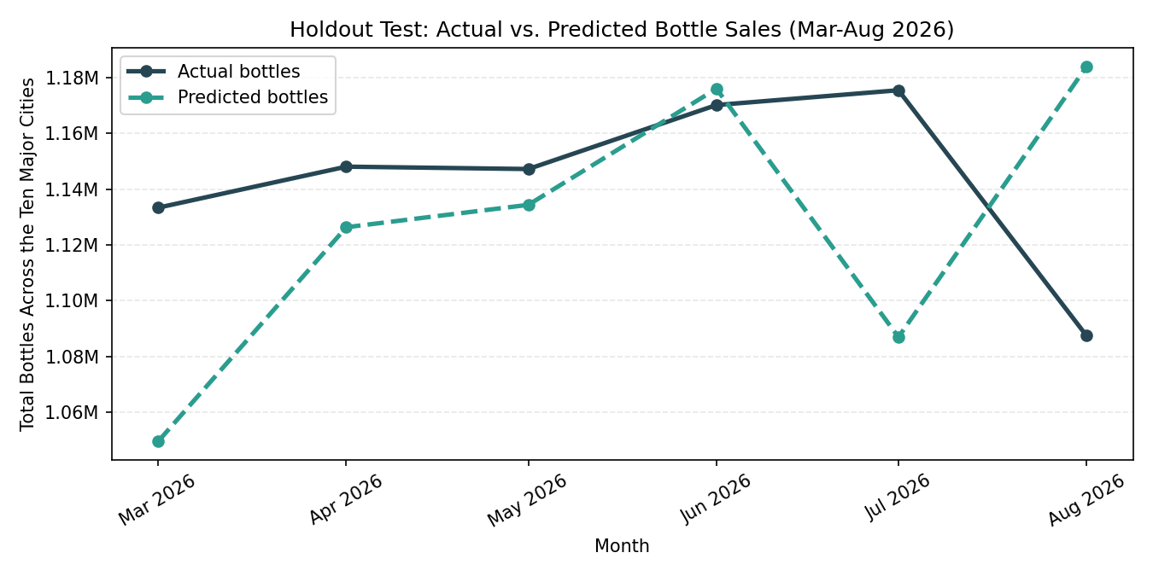
Figure 1. Actual vs. Model D-predicted total bottle sales across the ten major cities during the six-month holdout period.
One limitation worth noting: our validation rests on a single six-month holdout window rather than multiple rolling holdout periods. The comparison is a fair test of near-term forecasting accuracy, but a rolling-origin evaluation across several holdout windows would give a more robust estimate of how stable this performance is across different points in time, and is a natural next step before treating this as a long-run production model.

4. Final Model Summary and Forecast
Model D was refit on the full 26,500-row history (January 2022 through August 2026) to use all available information, then used to forecast September 2026 through August 2027 for every city-category combination. Because the model's key predictor is a rolling average of actual recent sales, the twelve forecast months could not be produced in a single pass: each month's prediction was generated one month at a time, and after each step that month's prediction was rolled into the trailing three-month window used to forecast the following month.
Statewide, across the ten major cities, the model projects 14.11 million bottles ordered over the next twelve months, essentially flat (-0.8%) against the four-year September–August historical average of 14.22 million bottles. That statewide stability, however, hides meaningfully different city-level trajectories (Table 2): Iowa City (+9.1%) and Dubuque (+7.0%) show the strongest projected growth, while Des Moines (-6.5%), Booze 'R' Us's largest single market, and Waterloo (-5.3%) show the clearest projected softening.
City | 12-Month Forecast (bottles) | 4-Year Historical Avg. (bottles) | Forecast vs. Avg.
Iowa City | 973,672 | 892,376 | +9.1%
Dubuque | 841,096 | 785,784 | +7.0%
Council Bluffs | 1,166,838 | 1,137,489 | +2.6%
West Des Moines | 1,106,835 | 1,079,220 | +2.6%
Ankeny | 798,211 | 777,625 | +2.6%
Cedar Rapids | 2,054,001 | 2,026,864 | +1.3%
Davenport | 1,617,381 | 1,644,207 | -1.6%
Sioux City | 1,002,401 | 1,024,764 | -2.2%
Waterloo | 1,009,812 | 1,066,137 | -5.3%
Des Moines | 3,538,916 | 3,784,526 | -6.5%
Table 2. Twelve-month forecast (Sep 2026–Aug 2027) vs. the four-year historical September–August average, by city, sorted by forecast volume.
At the category level, American Vodkas is the single largest category in every one of the ten cities (19–25% of predicted city volume), with Whiskey Liqueur the consistent second-place category in most markets. Beyond that top pair, city-specific patterns emerge — Straight Bourbon Whiskies and Canadian Whiskies are frequent third/fourth-place categories, while 100% Agave Tequila stands out as a notably strong performer in Cedar Rapids, Davenport, and Waterloo (Figure 2).
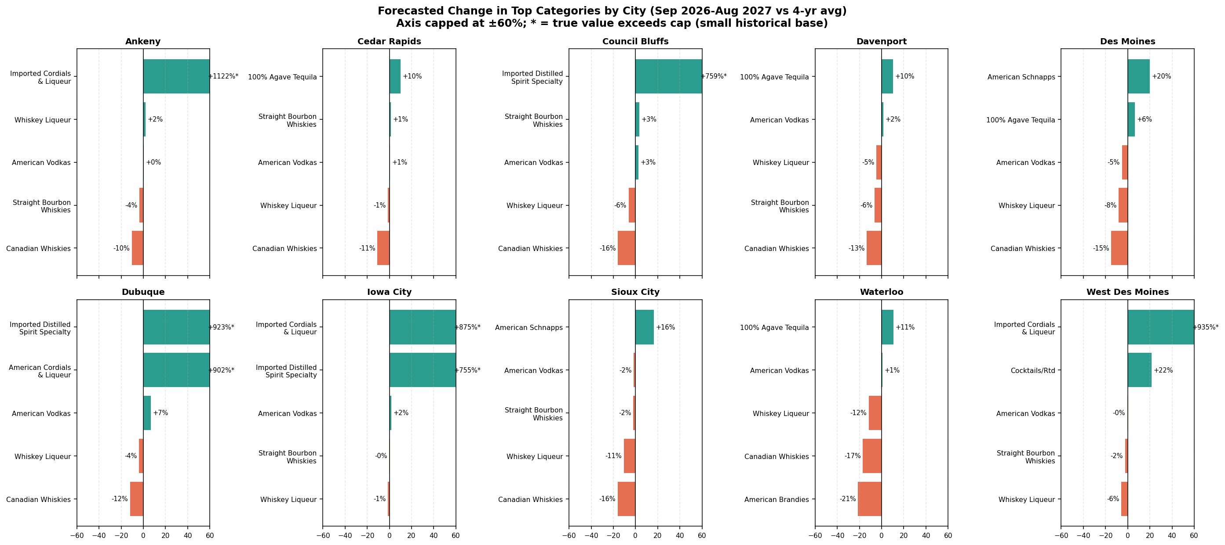
Figure 2. Forecasted change from the four-year historical average for each city's top five categories by predicted volume. Green bars are projected above the historical average; orange bars are projected below. The axis is capped at ±60% for readability; bars marked * exceed the cap (see caution below).
A caution on reading Figure 2: a small number of categories, marked with an asterisk, show very large percentage swings (in the hundreds of percent) in certain cities. These are categories with a near-zero historical baseline in that city, so a small absolute change in bottles translates into a huge percentage change. These figures should not be read as high-confidence growth signals — they are an artifact of dividing by a small number — and should be evaluated using the absolute bottle volumes and city-share columns in the full recommendation table rather than the percentage column alone.

5. Takeaway for Booze 'R' Us
- Plan for a flat year overall. Statewide bottle demand across your ten largest Iowa markets is projected to be essentially unchanged (-0.8%) from the last four years — this is not a year to expect broad organic growth, and inventory planning should be built around stability rather than expansion across the board.
- Concentrate growth-oriented effort on Iowa City and Dubuque. These two markets show the clearest projected upside (+9.1% and +7.0%). Both are smaller, college- and mid-size-city markets, which may make them attractive, lower-cost targets for promotional investment or additional retail footprint relative to the already-saturated Des Moines market.
- Watch Des Moines and Waterloo closely. Your single largest market, Des Moines, and Waterloo both show projected softening (-6.5% and -5.3%). This doesn't necessarily call for pulling back — it calls for closer monitoring and re-forecasting as new months of data arrive, since a six-month holdout test is not a guarantee of a full year's trajectory.
- Anchor inventory on the two backbone categories. American Vodkas and Whiskey Liqueur are the highest-volume categories in nearly every major city and should be treated as always-stock staples; city-specific second-tier categories (e.g., Tequila in Cedar Rapids/Davenport/Waterloo, Bourbon broadly) are better candidates for localized promotion than statewide campaigns.
- Use rank and share, not raw percentages, to prioritize. The forecast_share_of_city_percent and predicted-bottle columns in the full recommendation table (provided alongside this report) are more reliable prioritization tools than the percent-change column, which can be distorted for low-volume categories.

6. Ethical Considerations and Limitations
- Proxy data, not consumption data. State wholesale orders to retailers are a reliable but imperfect proxy for consumer demand — they can reflect restocking cycles, new store openings, or retailer purchasing decisions as much as end-consumer behavior. Recommendations should be validated against retailers' own point-of-sale data where available before large inventory or promotional commitments are made.
- Responsible use of expansion guidance. Because this same wholesale dataset also underlies our companion analysis for DEAD, a public-health nonprofit working to reduce harmful drinking patterns in Iowa, we think it's important to note the tension directly: using this model to aggressively expand promotion into markets with already-high or fast-growing alcohol volume raises public-health considerations that a purely commercial read of the forecast would miss. We'd encourage Booze 'R' Us to weigh community impact alongside projected sales opportunity, particularly in markets flagged for growth.
- Zero-filling assumption. We treated every city-category-month with no recorded transaction as zero sales. This is a reasonable and necessary modeling choice, but it assumes complete and timely state reporting; if any city or category was underreported in the source data (rather than genuinely having zero orders), our model would understate true demand there without any way for us to detect it from this dataset alone.
- Extreme percentage forecasts from small bases. As noted in Section 4, several category-level percentage changes are inflated by near-zero historical baselines and should not be treated as confident growth signals without also checking absolute volume.
- Single holdout validation. Our accuracy comparison rests on one six-month holdout window. We're confident in the direction of improvement from Model C to Model D, but recommend a rolling-origin validation and periodic model refresh (e.g., quarterly) as new months of actual data arrive, rather than treating this twelve-month forecast as fixed and final.

