Criterion C: Development

My first step was to start testing the two API wrappers I would be using to get data from the two exchanges. Later on in the project, for the sake of simplicity, I moved from the two APIs to one unified wrapper called CCXT, but for now I will discuss the two API wrappers I initially used.
In an effort to avoid writing my own wrappers which would have wasted my limited time, I found two existing wrappers on GitHub for my two exchanges.
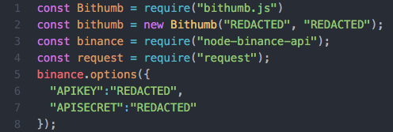
bithumb.js is the wrapper for the Korean side, node-binance-api is the wrapper for the Hong Kong side

The one for the exchange on the Hong Kong side was extremely well documented and was written by one of the main maintainers of Node.js. On the other hand, the wrapper for the Korean exchange was not well documented, but I successfully got it working for the initial steps.
My first step was simply getting my data collection function for the two exchanges working. This was my first introduction to something I had never seen before, the async/await structure from the new ECMA standards. Initially I did not understand it, but I eventually grew to love it since it would allow me to wait for a trade to be fully executed before the next function in the loop ran. The entire data gathering function was an async with the promises being the data from the Korean exchange.

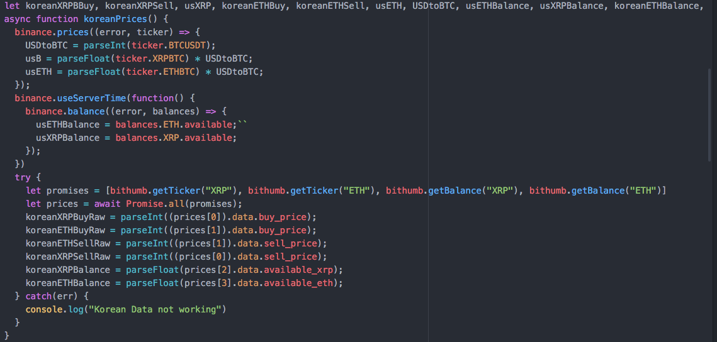
This screenshot shows the structure of my data collection function, along with the majority of my variables declared above it. When the async ran, it would wait for the promises to be fulfilled by the Korean data before running the whole function.

After finalizing my data collection, I move on to making a ready function that would convert the Korean prices to USD before supplying them to the spread checker as inputs.

