TECHNICAL UNIVERSITY OF DUBLIN – BLANCHARDSTOWN CAMPUS



Investigating Low Level Rootkit Obfuscation and Persistence Techniques Against Modern Detection Mechanisms

Tytus Kopera B00140074
2025

Declaration

Abstract
Table of Contents
Declaration 3
Abstract 4
Overview 6
Background 6
Topic of research 6
Objective of research 6
Scope and limitations 6
Literature Review 8
Introduction 8
Malware Development and Rootkits 8
Resource usage 11
x86_64 Architecture & Assembly 12
Operating System Inernals 12
AV/EDR evasion 12
Anti-debugging and anti-sandboxing techniques 12
Cryptomining and Exfiltration 15
Summary 16
Methodology 17
Development Environment 17
Malware Design & Development 17
Technical Requirements 18
Hardware 18
Software 18
Miscellaneous 18
Design & Implementation 19
Rootkit 19
getdents64 19
kill 19
Ftrace 19
Loader Script 20
Payload Script 20
Testing, Optimisation & Experimentation 22
Hooking Mechanisms 22
Automated Control over XMRig configuration file 22
Dynamic Source Code Re-Compilation 22
File encryption and the bootstrap script 22
Analysis 24
Critical Evaluation of the Implementation 24
Synthesis of Findings and Analysis 24
Conclusion 25

Overview

Background
Cyber criminals and cyber security researchers are locked in a constant game of cat and mouse. Although malware isn’t always used by cyber criminals due to the difficulty of use relative to non malware techniques, it remains a critical issue in the world of cyber security. Both exploits and payloads, as well as associated evasion, obfuscation and other miscellaneous techniques, evolve daily and so must be recognised and dealt with promptly by security researchers, administrators and analysts. Hackers can ,with the use of malware, can most importantly take remote control of the victim’s machine. In such cases, this machine ends up being part of a botnet for distributed denial of service attacks or cryptocurrency mining. Eg case of such things. Generally it is in the best interest of the adversary to remain in control of the victim machine for as long as possible, to generate as much profit or accumulate as many machines as possible. Once the malware is first detected, the entire “blue” side of the IT world rallies to understand and exterminate the malware. However there are also ways for the hacker to buy time for his malware, using code obfuscation and anti-debugging techniques. As a rule of thumb, unseen is better.

Topic of research
This project will be focusing on both the processes of rootkit development and malware detection. It will cover the creation of a kernel land rootkit with advanced anti-debugging and obfuscation features. Additionally, the research will be then delving into malware detection and removal techniques, and will be exploring all venues necessary to allow for the discovery and disposal of the malware

Objective of research
To find out what are the most up to date evasion methods in malware, how to circumvent and detect the malware using these methods and in turn circumvent the circumvention method. This will be achieved through writing a kernel land rootkit with up to date anti measures and techniques, analyzing the rootkit to break it with modern anti malware techs and then redesigning parts of the rootkit to keep the cycle cycling.

Scope and limitations
Malware development specifically but also malware detection are highly technical topics with high degrees of depth and complexity. Theses can be written about either one of these subjects at an extremely granular level, therefore the scope that can be allowed for this topic will have to be quite shallow at this bachelor level. Malware development, especially kernel land rootkit development, is a low level concept, therefore a low level programming language is necessary. The chosen language, C, is a very simple language by design but this simplicity can lead to overt project complexity. This can prove to be a hurdle during the implementation and may lead to delays and compromises in the implementation. There is a possibility that despite the amount of research put into the project prior to the implementation, a facet of the required design may force the implementation to be fundamentally redesigned during the process of implementation.

Literature Review

Introduction
Development and use of malware by threat actors costs organizations and individuals untold amounts of money, time, effort and are on the forefront of the public view. The most severe of which would be rootkits, due to their longevity and ability to hide itself and other malicious software. It is prudent to research first all relevant information regarding modern malware techniques and modern malware detection to subsequently identify any gaps in information regarding the latest of what modern malware has to offer, or rather take away. Fundamentally, one must understand malware development, modern rootkits and how we can identify this software. One must understand what a rootkit exploits in regards to the function of various instruments of the operating system, such as stack/heap operations, environment variables and the CPU itself. Malware researchers will use reverse engineering methods to understand how malware operates to get a better idea of what to fix/patch to prevent this malware from operating effectively or at all. However, in recent years some malware such as the ransomware used by the Bayrob malware gang have begun to be developed, treated and used in such a way that it became almost impossible to reverse engineer them. Such a hurdle must be acknowledged in the literature and research, since it will be very likely adopted en masse, possible as part of a framework for cybercriminals to follow.

Malware Development and Rootkits
Due to the increasing adoption rates of Linux operating systems for personal use, the overwhelming presence of Linux in corporate use in the shape of servers and IoT devices, the creation of malware made specifically to target Linux based systems grows in potential. It will challenge the long held belief that Linux based system users should not fear malware since Linux holds too small a market share for malware developers to develop malware for Linux based machines. Linux machines don’t ship with any anti-malware software, nor is there much market demand for such software. Partially thanks to this, malware in Linux tends to be simpler, according to the paper Characterizing Linux-based malware:Findings and recent trends by Carrillo-Mondéjar et al. Trends show that Linux based malware is in its relative infancy, the code is not obfuscated and generally more simple making it easier for static analysis. However, a lot of the malware is designed to work on specific platforms and the right environment because they are built for IoT devices, impeding the use of dynamic analysis. Many IoT devices run Linux making them ample targets for malware developers, which are usually targeted by C&C based malware, usually for the purposes of cryptomining and botnet inclusion. Malware has been seen employing some techniques such as the periodic switching of the C&C server. Despite its simplicity, Linux malware does vary in complexity and crucially can be found on the internet for malicious use. Exploits, payloads and kits can be found in repositories, forums and marketplaces, allowing for even the most unskilled threat actor to use complicated/advanced tools, though sometimes for a price.

Carrillo-Mondéjar, J., Martínez, J. L., & Suarez-Tangil, G. (2020). Characterizing Linux-based malware:Findings and recent trends. Carrillo-Mondéjar , J , Martínez , J L & Suarez-Tangil , G 2020 , ’ Characterizing Linux-Based Malware : Findings and Recent Trends ’ , FUTURE GENERATION COMPUTER SYSTEMS , Vol. 110 , Pp. 267-281 . Https://Doi.Org/10.1016/j.Future.2020.04.031. https://kclpure.kcl.ac.uk/portal/en/publications/5bbfb8b7-9061-43a9-acf8-880ff7aa5b0f
Rootkits have also been following this trend of gradually increasing complexity over the years, though somewhat more sharply. Userland rootkits, such as Jynx1.0 and other rootkits utilizing LD_PRELOAD as their conduit for malicious library injection are all but obsolete, owing to existing in userspace (RING 3). The current generation of rootkits are written to exist in RING 0, which is the kernel space. The next generation of rootkits will operate below the kernel. Researchers and developers should have the prerequisite understanding of operations and infrastructure which rootkits target and exploit in order to understand the rootkit itself and subsequently how to counteract it. The CPU operates on a Fetch-Execute cycle ie. data is fetched from memory and executes it. The CPU decodes the instruction frame to obtain the instructions and the program counter, the latter of which is a memory location which points to the next instruction frame. There is a data bus which connects data from the CPU to the RAM. Memory on this bus is called physical memory and has a 2^36 – 1 byte range. A compiled program’s memory is divided into 5 portions: .text, .data, .bss, heap and stack. Instructions in the text segment are non linear dyue to high level control features and procedures ie. branch, jump and call ASM instructions. As the program executes, the instruction pointer ie. $EIP, which points to the next/current instruction, starts from the first function in the text segment. This register cannot be directly accessed by software and can only be controlled by control-transfer instructions such as JMP, CALL, and RET. $EIP can only be read by executing a CALL instruction and reading the value of the return instruction pointer from the procedure stack. These are fundamental concepts of execution flow and is exploitable by malware in the form of execution path manipulation. Other methods include memory overflow, kernel code and kernel code injection. On the topic of memory overflow, perhaps the most well known exploit known as the stack overflow is dependent on the stack/heap architecture. The stack is an abstract data structure with a FILO , ie. First In Last Out, structure and cannot be directly controlled by the programmer in contrast to the heap. The heap is a segment where blocks of memory are allocated by the programmer. The allocated memory in stack grows in address, whereas the memory addresses in stack go down. This structure, as well as the fact that the heap can overwrite variables on the stack, makes stack overflows possible. The heap can be overwritten in such a way that the value on the stack gets overwritten with a return address pointing somewhere else, such as further in memory in order to skip certain functions, variables assignments or otherwise.

From the perspective of an OS’s data storage, rootkits come in two flavours: Kernel Object Hooking and Dynamic Kernel Object Manipulation. KOH rootkits hijack kernel control flow whereas DKOM rootkits subvert the kernel by directly modifying dynamic data objects.
Syscalls invoke kernel routines from within user apps. Processes have a set of interfaces to interact with different hardware devices. Syscalls jump to an assembly function called the system call handler. System call number gets passed to identify the required system call, for which the %eax register is used for. The system call handler is responsible for:
- saving the contents of most registers in the kernel mode stack
- handling syscalls by invoking a corresponding C function called the system call service routines
- exiting from handlers→registers get loaded with the values saved in the kernel mode stack and the CPU gets switched to user mode
The aforementioned service routine function does not interact with the platform specific assembly parts of the system when switching to and from kernel/user space
Kernel uses system call dispatch table in sys_call_table array and has __NR_syscall entries. In order to hook syscalls, the address of the sys_call_table is required, but finding this value is difficult. One method borne from a Black Hat Conference in 2009 describes the use of the contents of the IDTR register to help find the address of the sys_call_table.
Rootkits utilize system call hooks and alter kernel data structures to hide. For example if the PID of a command’s output matches the PID of rootkit, the hooked function will discard the return value of the desired PID and continue as normal. The same can be done network information, altering eg. tcp4_seq_show which populates /proc/net/tcp and is used by network information tools such as netstat.
The next generation of rootkit will run the operating system as a virtualized operating system, drawing inspiration from blue pill subvirt.

Vlad, M. (2011). Rootkits and Malicious Code Injection. Journal of Mobile, Embedded and Distributed Systems; Vol. 3 No. 2 (2011): Mobile and Embedded Security; 91-99 ; 2067-4074. http://www.jmeds.eu/index.php/jmeds/article/view/Rootkits-and-Malicious-Code-Injection
Stühn, J., Hilgert, J.-N., & Lambertz, M. (2024). The Hidden Threat: Analysis of Linux Rootkit Techniques and Limitations of Current Detection Tools. Digital Threats: Research and Practice, 5(3), 1–24. https://doi.org/10.1145/3688808
Hogan, P. (2021). Warping Reality: Creating and Countering the Next Generation of Linux Rootkits. https://doi.org/10.5446/54225
J. Ericson, Hacking: The art of exploitation

Resource usage
Luigi Catuogno, Clemente Galdi, & Nicola Pasquino. (2018). An Effective Methodology for Measuring Software Resource Usage. http://hdl.handle.net/11588/710581
The most prolific Cybercriminal activity usually involves Cryptomining to some degree, given how profitable it is on a large scale when regardless of the machine themselves. Detecting active cryptominers on a machine is a trivial task, since most cryptominers tend to run on all cylinders. What can be observed is an increased strain on the CPU and/or GPU as well as increased network activity. Catuogno et al. have discovered in their paper An Effective Methodology for Measuring Software Resource Usage that malicious software can be ran inside a docker instance to limit network and CPU usage on the host machine to the malicious actor’s desired amount.

Linux Kernel

AV/EDR evasion

Anti-debugging and anti-sandboxing techniques
If met with an unknown binary, a reverse engineer will attempt to use a plethora of techniques/tools to understand the binary more. Tools such as ghidra, IDA, gnu debugger, objdump, strings and radare2 are likely to be used and so we must investigate how a piece of malware can be designed and implemented to make analysis with the aforementioned tools as difficult as possible. Possible techniques include: executable bit flipping, static library linking, and code obfuscation
Book called “Programming Linux Anti-Reversing Techinques” by Jacob Baines, anti reversing important.
Self healing code is an anti-debugging measure which detects any modification of its own code and reverts it back to its original state before executing, trouncing debuggers. Self healing code can be found in licensed software to prevent cracking. These are rough groupings of anti debugging techniques:
- timing/latency analysis – given the implied additional time overhead that a software run on a debugger will have over being run on bare metal, there will be a time discrepancy between the expected runtime of the program and the actual runtime when run inside a debugger
- process detection – detecting presence of known debugging and related tools
- memory analysis – detecting if parts of code are being loaded into different locations
- patching detection – detecting arbitrary patching(machine code modification) in process memory
- break-point detection – break points alter machine code in memory→ program scans its own memory to search machine code for software break points eg. 0xCC on x86 an AMD64
- monitoring debugger APIs – only one process can act as debugger for another process at a time. Debugger APIs that are exposed are hooked and monitored globally
- monitoring exception handlers – when a debugger is attached to a process, exceptions are handled by the debugger without passing it back to the program. This can result in crashes and terminations, discrepancies which can be used to detect debugging attempts
- blocking debuggers – either blocking debugger APIs or removing debugger related artifacts eg. break points or in-memory patching
Anti debugging codes oft used . Some require special hardware eg. High bandwidth Digital content protection which encrypts signals between the monitor and computer. Most protection measures are limited to CPU implementations, which can be defeated using custom tools.
There are two main types of breakpoints: hardware and software breakpoints. Software breakpoints are most common – the debugger overwrites the target address with INT 03H(0xCC) and gets control after execution to inspect its state. To resume, the break point gets removed. Such a breakpoint cannot be set on non-code addresses such as data sections(eg. .bss and .text)I/o Mapped Memory, and Read-Only Memory Regions. Hardware breakpoints are much more flexible than software breakpoints: they can be set on I/O ports, memory access as well as regular execution memory. They are set by writing in debug registers which are platform specific.
Most trivial way of checking for software breakpoints is to look for 0xCC at every offset where an instruction would normally begin, however if this measure is found by a reverse engineer, the reverse engineer could easily bypass this measure by modifying it directly to always return false on the 0xCC check. A counter measure for this sort of source code manipulation or any sort of source code manipulation would involve the use of checksum comparison, wherein the program checks its hash checksum against some desired value. This measure would work best if the hash is not hardcoded as this too can be used by the reverse engineer to exploit the program.
To evade software breakpoints one would find the offset where a break point is applied, disable memory protection on the memory block containing the target code and restore both the original bytes and original memory protection.
To evade memory debugging, one could allocate a dynamic buffer, write machine code for RET in the beginning of buffer, push a return address on the stack, make an unconditional jump to the buffer. If the return address is different from the specified one, that means that program is being debugged.
As suggested by Mishra & Hanawa in their paper: Thwarting Piracy: Anti-Debugging Using GPU-assisted Self-healing Codes. GPUs could instead be used to do this instead. Running such code on the GPU provides us with several advantages over the traditional method: GPU-run anti debugging code is not visible to the CPU and so breakpoints are not visible to the CPU, DMA(Direct Memory Access) can be configured between the GPU and RAM which makes related data transfer invisible to the CPU. Tools to debug GPU codes are not as common, adding to the difficulty of debugging GPU-run code. In contrast to this programming with the GPU has been made simpler and more convenient thanks to toolkits like CUDA/OPENCL. GPUs also have advanced error detection and reporting and I/O virtualization. The aforementioned Direct memory address can be set up between RAM and GPU to not involve the CPU in memory allocation and use, which would bypass some hardware based monitoring features.
Thwarting Piracy: Anti-debugging Using GPU-assisted Self-healing Codes (2022)
Adhokshaj Mishra, Manjesh Kumar Hanawal
[doi]: https://dx.doi.org/10.48550/arxiv.2210.11047

As outlined by Park et al. in: A practical approach for finding anti-debugging routines in the Arm-Linux using hardware tracing the following is a list of common debugger detection techniques for for Linux-based machines:
- debugger detection ptrace() - invoking ptrace(PTRACE_TRACEME,0) and getting a return value of less than zero would indicate that debugging is in progress
- using SIGILL – used by tools such as Pangu, if a SIGILL-invoking illegal instruction is used but the original handler does not handle SIGILL, it would suggest that a debugger instead has handled the signal eg. udf instructions on ARM systems invoke SIGILL
- using SIGSEV – SIGSEV occurs upon segmentation faults. Similar to SIGILL, one would check if the SIGSEV signal is handled by the original handler and not by a debugger
- using SIGTRAP – SIGTRAP signal is used for debugging. If it is present, the debugger will intercept it
- using environment variables – debuggers may set certain environment variables such as ‘COLUMNS’, ‘LINES’ and ‘_=gdb_path’ in the case of the GNU Debugger
- using file descriptors – When a program is executed, file descriptors of 0-2 are assigned. When a file is opened for the first time it gets the number 3 assigned to it. In a debugger like gdb, a numer greater than 3 would be assigned to it because file descriptors before that of the opened file would have been given to gdb-related internal programs
- using /proc/$PPID/cmdline - /proc/$PPID/cmdline contains the content of the commandline when executing a process. This file can be checked against a list of debugging programs
- using /proc/$PPID/status - /proc/$PPID/status contains inforamtion on the execution status of the parent process. Mentions of gdb or other debugging software will suggest that a debugger is running
- detecting breakpoints – if a breakpoint is detected by any means (some measures are architecture specific) then that would suggest that a debugger is running
- using LD_PRELOAD – Sometimes the use of custom libraries loaded in through LD_PRELOAD can be used to suggest that a debugger is running
- checking /proc/self/status - /proc/self/status is a file with the status of a program. The TracerPid entry changing from a zero to a non-zero value would suggest that debugging is underway
- checking /proc/self/fd – gdb forks processes for debugging and /proc/self/fd contains information regarding the file descriptors owned by a given program. Generally, more than six lines in this file would suggest that debugging is underway
- detection before main – A debugger detection routine can be hidden and called before main
- checking execution speed – as stated before in this review, programs run through a debugger will not execute as fast as it would under normal conditions. This discrepancy can be used to detect debugging
Different systems and hardwares may have their own debugging features. Park et al mention ARM which has CoreSight, has invasive and non-invasive hardware based debugging features

Yeongung Park, Seokwoo Choi, Un Yeong Choi, Haimin Jin, Nurul Harzira Mohamad Nor, & Yongsu Park. (2024). A practical approach for finding anti-debugging routines in the Arm-Linux using hardware tracing. Scientific Reports, 14(1), 1–19. https://doi.org/10.1038/s41598-024-65374-w
Find something with encryption of code
obfuscation techniques include: insertion of dead code, reordering of instructions, reordering of basic blocks, reordering of functions within a module, substitution of instructions with equivalent ones, and encryption of constant data buffers
A. R. Nurmukhametov. (2018). The Application of Compiler-based Obfuscation and Diversification for Program Signature Modification. Труды Института Системного Программирования РАН, 28(5), 93–104. https://doi.org/10.15514/ISPRAS-2016-28(5)-5

Cryptomining and Exfiltration
Due to how profitable cryptomining is to criminals, it must be looked at it detail. Idle mining and execution stalling code are some techniques seen in software packages for eg. mining monero that can be bought. Through static and dynamic analysis, information can be obtained from the mining malware: request-for-work packets with the id of the miner can be extracted from the command line options passed to the mining tool or from network traffic. Through the same method the type of wallet and crypto can also be ascertained. In a similar manner, domains and IPs of mining pools and proxies can be extracted. If a proxy is used then if the data can be correlated to known pools it can be ascertained that a proxy is used. With cryptomining malware, the wallet can be extracted. Monero is very difficult to track, making it an obvious choice for cybercriminals.
Suarez-Tangil, G., & Pastrana, S. (2019). A First Look at the Crypto-Mining Malware Ecosystem:A Decade of Unrestricted Wealth. Suarez-Tangil , G & Pastrana , S 2019 , A First Look at the Crypto-Mining Malware Ecosystem : A Decade of Unrestricted Wealth . in IMC ’19: Proceedings of the Internet Measurement Conference . Pp. 73-86 . Https://Doi.Org/10.1145/3355369.3355576. https://kclpure.kcl.ac.uk/portal/en/publications/ae326208-a2a3-401c-aaff-103b732437c2
XMR whitepaper

Summary
Trends and current literature suggest that the modern Rootkit is a xyz LKM rootkit as outlined by cyz. If built for the Linux Kernel, then the hooking of file reading syscalls would be paramount to the functionality of the rootkit. XMRig, partly due to its Free and Open Source nature as well as the benefit of using XMR as the cryptocurrency of choice from the perspective of Operational Security.

Methodology
The approach was linear and fundamental at first, due to the nature and inherent complexities of kernel level programming. The development for 75% of the project hinged around the creation of the rootkit so that it had the essential hooking components. However, the rootkit itself was merely a passive component in the malware and the shell scripts written accounted for the active duties of the malware.

Development Environment
The rootkit was designed for the GNU/Linux operating system running Linux kernel version 6.12.21_1 and using GRUB as the bootloader. The rootkit module was written in C, due to C’s innate acting vicinity to the kernel and due to it being native in the Linux Kernel. Bash was the language of choice for the shell scripts, due to it being POSIX friendly, powerful and simple. The malware was developed and tested in a Virtual Machine in QEMU with KVM support, for granular control, optimisation and it working well with the Linux machine that was the Host Operating System. Modern malware is seen increasingly frequently to be designed for Linux machines, therefore a stripped down approach that requires as little non-standard or niche components would be most fitting.

Malware Design & Development
The rootkit was developed as a loadable kernel module, hence the name LKM rootkit. It’s job was to hook system calls to prevent the user from being aware of the malware’s presence. Affected CLI tools included netstat, ls and ps. It was rendered reboot persistent via the GRUB configuration file found in /etc/default/, into which the payload script was injected and facilitated the continuous insertion of the rootkit upon booting. The two auxiliary sections of the malware included the payload script which acquired, configured and ran XMRig as well as inserting the rootkit, and the loader script which was the initial point contact which made the necessary changes to the victim’s machine to allow the payload to be run on boot. LKM rootkits are the popular choice for modern rootkits due to how well documented they are relative to more niche methods, such as sub-kernel rootkits.

Technical Requirements

Hardware
- X86_64 CPU with 5 threads minimum– The rootkit only hooks 64 bit versions of syscalls. Additionally, mining only begins if there are at least 5 threads in the CPU
- 2GB RAM – Enough to run the operating system and the mining software
- 10GB Storage – To store the OS and XMRig, with 3GB to spare.

Software
- XMRig – XMR being the most OPSEC friendly cryptocurrency, the XMRig mining software is the only smart way to mine cryptocurrency as an APT
- Bash – The POSIX compliant scripting language which most Linux distros use by default
- GNU/Linux OS – Rootkit is designed specifically for the Linux kernel and GNU utilities are frequently used in the scripts
- Ftrace – The hooking mechanism which allows the rootkit to intercept and modify syscalls and their return values
- wget – Used for downloading XMRig
- GRUB – Bootloader for which the payload is designed to exploit

Miscellaneous
- Root access – root is required to run the loader script successfully

Design & Implementation

Rootkit
The rootkit is written in C compiled via a Makefile and the make command. Its functions are to hook getdents64 and kill. The former of which can be found in the backend of commands that gather lists of files, such as ls, git and ps. This is what allows the rootkit to be invisible in the terminal; it cannot be found as a file and the active part of the malware, ie. XMRig, is also not caught thanks to ps not seeing it. The kill hook is used for capturing the PID of the process to hide. Due to the rootkit not being a binary file and thus not technically running, there is only one process that needs to be hidden, which is XMRig. This fact made the implementation of the PID hiding significantly easier.

getdents64
The function takes in and modifies the data passed in from the %rsi register. This variable is a struct called linux_dirent64 which is a Linux struct defined in the GNU C library, with d_name and d_reclen being the two crucial struct attributes which define the filename and size of the directory entry, respectively. A kernel buffer is allocated into which the data is copied to from the userspace, using the copy_from_user function. The resulting buffer is then iterated through by d_reclen bytes. The function compares the d_name variable to both the PREFIX variable and the hidden_pid variable. If either returns a positive result then the directory entry is skipped. If the directory entry is the first one in the buffer, the directory entry is shifted back by its d_reclen, skipping it entirely. The resulting buffer is then copied back into userspace via copy_to_user and the data is returned to the command calling it.

kill
The kill hook is responsible for specifying which process to hide. It does so by extracting the pid and signal from the %rdi and %rsi registers respectively. If the signal is 64, then the pid is copied to the hidden_pid variable via sprintf. If this requirement is not met, the kill syscall returns with regs as the argument.

Ftrace
The hooks are registered with ftrace thanks to the ftrace_helper.h file and the kernel module is installed inside the basic_init function with the fh_install_hooks function, which uses the hooks struct and size of the hooks struct as defined in the ftrace_helper.h header file. For debugging purposes, the kernel prints “rootkit loaded” which can be seen in dmesg. However this can be removed. Similarly, the fh_remove_hooks removes the kernel module inside the basic_exit function. The kernel also prints “rootkit unloaded” for debugging purposes.

Loader Script
The loader script is responsible for facilitating the payload script to run on boot. It does so by copying the payload script to /sbin/ and appending “init=/sbin/script_rootkit.sh” inside the quotation marks on the line containing “GRUB_CMDLINE_LINUX_DEFAULT=”. This causes GRUB to execute /sbin/script_rootkit.sh as if it were a normal init script. The GRUB config file is then updated with update-grub, with the stdout and stderr being redirected to /dev/null, making it not visible. Next, the script generates a 32 byte hexadecimal keyfile in /boot/ which is then used as the password for encrypting the rootkit kernel module. Openssl is used to encrypt the file using AES-256-CBC. Lastly, the script executes a normal programme, such as vim, to act like a trojan.

Payload Script
This script runs every time the machine boots. It firstly attempts to remount the root directory in read and write mode to allow for the acquiring and configuration of XMRig. It checks if /opt/.xmrig/ exists and creates it if it doesn’t. Next it checks is /opt/.xmrig/xmrig and /opt/.xmrig/config.json exists. If either one doesn’t exist then everything inside the /opt/.xmrig directory is deleted and the script waits until internet connectivity is achieved. It then downloads XMRig via wget and extracts the tarball and copies the required files into their respective URIs. It then cleans up the /opt/.xmrig directory by removing the tarballs and the XMRig folder generated by the extraction. It then uses sed to change the “url” and “user” values in the config.json file to the url of the specified pool and address of the specified XMR wallet respectively. If both the encrypted rootkit module and the keyfile exist, the module is decrypted and the output file becomes /dev/shm/rootkit.ko, which is a directory in memory. The kernel module is then inserted and immediately deleted. Next, the script checks if the machine has enough threads and if it does, it then loops to checks if both /opt/.xmrig/xmrig and /opt/.xmrig/config.json exist. If they don’t exist then wait for 5 seconds and reset the loop. When both files exist, the XMRig binary is executed and immediately “kill -64 $!” is called to copy the PID of the XMRig process to the hidden_pid variable. Lastly, ‘/sbin/init “$@”’ is called, in order to resume the regular boot process.
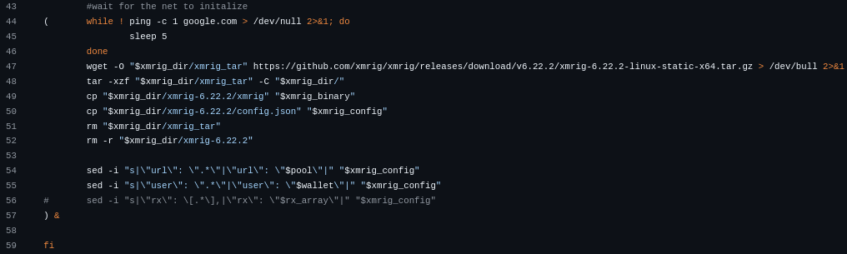
Note that both snippets of the script that wait for some files to exist before running are sent to the background to avoid stalling or even deadlocking the boot process. This was achieved by enveloping the locking snippets inside parentheses and the parentheses were appended with the “&” symbol. Additionally XMRig was also sent to the background via appending with the “&” symbol due to how the “$!” works. This variable holds the PID of the last backgrounded process, which made it trivial to capture the PID of the XMRig process.
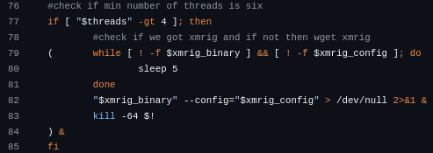

Testing, Optimisation & Experimentation
The development of the rootkit was subject to some experimentation in regards to the hooking technique use, the automated control over the XMRig configuration file, the implementation of a separate bootstrap script and the dynamic re-compilation of the source code.

Hooking Mechanisms
In the initial research phase there were three candidates for the hooking mechanism: ftrace, kprobe and eBPF. The extended Berkeley Packet Filter method was the most powerful of the three but was found to be somewhat limited and the most complex option. The kprobe method was employed at first due to its flexibility and versatility but this too was too complex. The implemented mechanism was the ftrace method, which was not as stealthy as the kprobe method, due to it leaving traces in the /sys/kernel/tracing directory. It required more configuration out-of-the-box than the kprobe method but open-source ftrace configuration were acquired.

Automated Control over XMRig configuration file
It was intended for the XMRig configuration file to also specify the number of threads to use. It the payload script would divide the number of threads 5 and the result was the amount of threads that would be used with the affinity of -1. However, due to time constraints and the implementation not working in a reasonable amount of time, this idea was scrapped.

Dynamic Source Code Re-Compilation
For the kernel module to work, it had to be compiled for the exact same kernel version as the intended insertion environment’s kernel version. Therefore it would have made sense for the kernel module to be recompiled if the current kernel version was not the same as the last known kernel version. This however posed a new problem, namely of how store the source code. It wouldn’t be desirable for the source code to be stored on the machine because that would then defeat the purpose of encrypting the kernel module. In such a case, the source code would have to also be encrypted, but additional complications with the make command and time constraints forced the dynamic source code re-compilation feature to be scrapped.

File encryption and the bootstrap script
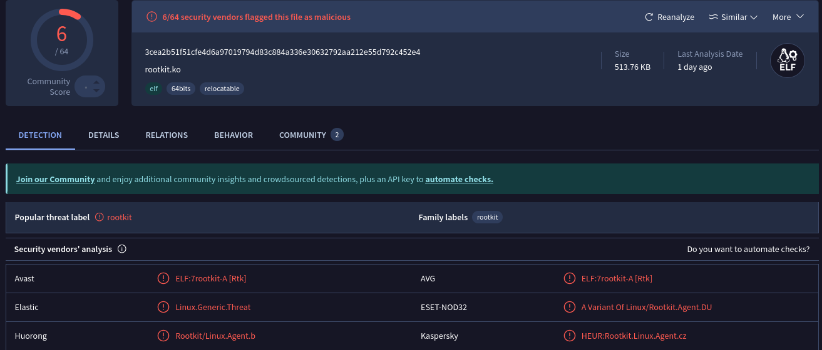
By uploading the malware files to VirusTotal, it was found that the kernel module was flagged by multiple vendors as malicious, and correctly categorised as a rootkit. Similarly, the payload script was also flagged as malicious for containing reference to XMRig. The kernel module was trivial to decrypt at boot time and was the more pressing file to encrypt, given that it left traces in dmesg. The encryption of the payload script, however, created the need for a separate bootstrap script. This bootstrap script would have been injected into the GRUB configuration file instead of the payload script and would be responsible for decrypting the payload script and loading it into memory before executing it. This caused the system to hang for reasons not fully understood andso due to time constraints was scrapped. The payload script remains un-obfuscated.

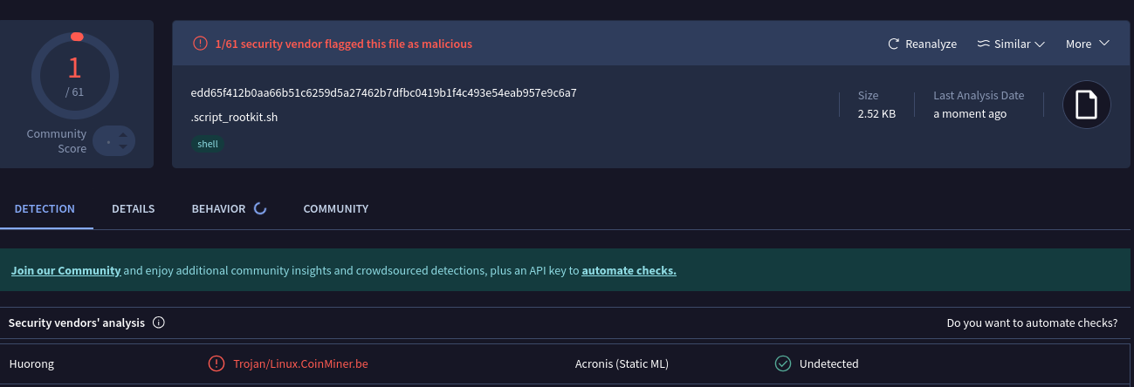

Analysis

Critical Evaluation of the Implementation

Synthesis of Findings and Analysis

Conclusion

