uRProgramming
By

Zekai Otles
Created on \Sexpr{date()}

Table of Contents
1 .Introduction 3
2 .Environment Setup for R programming Developers 4
2.1 Environment setup 4
2.2 Using Version Control System 4
2.3 Using IDE to develop R scripts 4
2.4 Writing functions 4
2.5 Create R package System 4
3 .Simple Data Types and Objects 5
4 .Control Structures 6
4.1 If statements 6
4.2 If then Else statements 7
4.3 Switch statements 8
5 .Loop Structures 9
5.1 For loop 9
5.2 While loop 9
6 .Data Structures 11
6.1 Vector 11
6.2 Matrix 11
6.3 DataFrame 11
6.4 List 11
7 .Simple Statistical Analysis 12
8 .Simple Statistical Analysis 13
9 .Simple Table Outputs 14

Introduction

Environment Setup for R programming Developers

Environment setup

<<environment, echo=FALSE, results=xml>>=

odfTable(pkgVersions("data frame"))
@

<<environmentl>>=
environment("ls")
cat("Current Working Dir \n",getwd())
@

Using Version Control System
Talk about version control system, why we use git system. Briefly explains the benefits of git.
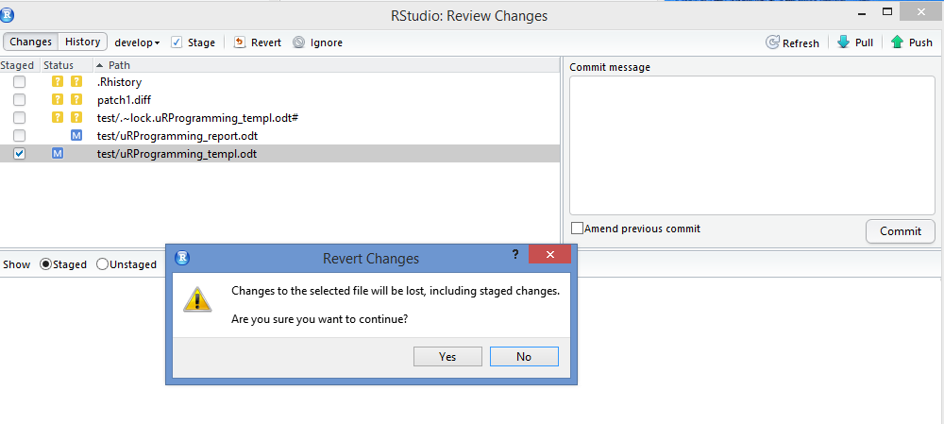

Using IDE to develop R scripts
Rstudio is our choice of integrated development environment (IDE). It allows to use modern software tools like git version control system. The Rstudio is also integrated with rapid build tools for the packages. Use figures from open office

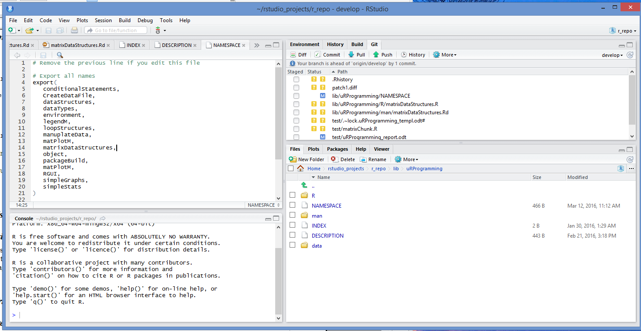
Writing Functions

Create R package System

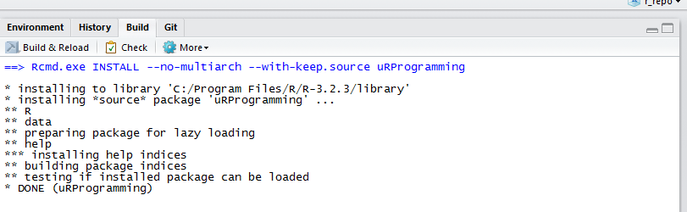

Open Office as an Integrator

Simple Data Types and Objects

Control Structures

Control structures are used to change a flow or follow a logic. The control structures are easily could make any program more followable for maintenance and understanding, they could also turn the most unfollowable code. Control structures are very straight forward when used in a modular way in a less number of statements or calling other reusable functions.oo
In the following sections, the usage of if block will be explained with examples. The samples should help reader to solidify the understandif of te control structures.

If statements
Let's use simple vector which contains only numbers, check if numbers is equal to specific value assign iFound as True.
If ( Statements) { Assignment}
<<ifStatement1, echo=FALSE>>=
cat(“x<-c(0,3,6,9,12,15,18,21,24)\n”)
cat(“if(x[which(x==6)]==6){iFound<-TRUE}\n”)
cat(“print(iFound)\n”)
#print(iFound)
@

In the above example, which finds the index number for the value. The usage of which in vector is pretty powerful as shown in the example. The which statement is pretty handy determining the index of vector or array. When the vector with right index with exact value found, iFound assigned to be true.
Logical operators in R are
Operator | Description
== | Equal to
!= | Not equal to
< | Less than
<= | Less or equal to
> | Greater than
>= | Greater or equal to
& | And
| | Or

Following code snippet is simple example of how to use logical operators. The first example is the exacty equal to operator. The second example demonstrates less than or equal to operator and assigning the value based on the result. The third example shows greater than comparison.The last example is combination greater than, and, less then or equal to.
<<ifStatement2, echo=FALSE>>=
cat(“Ex. 1”)
cat(“if(demDat[indx,1] ==1 ) {demDat[indx,1]<-'M'}\n”)

cat(“\nEx.2\n”)
cat(“if(demDat[indx,2] <=25 )demDat[indx,2]<-'Y' \n“)

cat(“\nEx.3”)
cat(“ if(demDat[indx,2] > 50 ) {demDat[indx,2]<-'O'} \n“)

cat(“\nEx.4”)
cat(“if(demDat[indx,2] > 25 & demDat[indx,2] <=50 )demDat[indx,2]<-'M' \n“)

@

If then Else statements

If then else block is used when comparison expected to result in a choice either true or false. It gives the programmer, the power to control logical flow. In R programming, if then else blocks are in the following format
If ( Statements) { Assignment}
else (statements) { Assignment}

<<conditionalStatements>>=
#cat(conditionalStatements())
@

Switch statements

Loop Structures
The loop structures are needed to access elements of vectors, matrix, list and data frame. The access of the data is important to reach or manipulate the elements. The for and while loop are used to iterate elements.

For loop
The for loop is used for sequentially access the data elements. Each element of data stuctures can be reached, used or manipulated within the for loop. The for loop is in the following format.
for (values in sequence) {
statement
}
The following code snippets how for loop is used. In the following example, 100 number with specified seed assign to vector. This vector has only integers for demonstration pupose.

<<forLoop1, echo=FALSE>>=
cat(“set.seed(312)\n”)
set.seed(312)
cat(“#create 100 random number between 0 and 1000\n”)
cat(“xInt<-floor(runif(100,0,1000))\n”)
xInt<-floor(runif(100,0,1000))
cat(“for(indx in 0:length(xInt) ){\n”)
cat(“if(indx %%10 ==0){print(xInt[indx])}\n”)
cat(“}\n”)
for(indx in 0:length(xInt) ){

if(indx %%10 ==0){print(xInt[indx])}
}

@

While loop
The access of certain elements could be controlled by using while loop, the expression determines executing statements or not.
while(expression){
statement
}

In the following example, the elements between two indices are assigned as either even or odd. Execution will stop when expression is false, otherwise statements within the block is executed.
<<whileLoop1, echo=FALSE>>=
cat(“set.seed(312)\n”)
set.seed(312)
cat(“#create 100 random number between 0 and 1000\n”)
cat(“xInt<-floor(runif(100,0,1000))\n”)
xInt<-floor(runif(100,0,1000))
cat(“index<-80”)
cat(“while(index<=length(xInt)){\n”)
cat('xInt[index]<-ifelse(as.integer(xInt[index]) %%2==0,"Even","Odd")\n')
cat(“if(index %%4 ==0){print(xInt[index])}\n”)
cat(“index<-index+1\n”)
cat(“}\n”)

index<-80
while(index<=length(xInt)){
xInt[index]<-ifelse(as.integer(xInt[index]) %%2==0,"Even","Odd")
if(index %%4 ==0){print(xInt[index])}
index<-index+1

}

@

Data Structures
The main R structures are either vector (array), matrix, data frame and list. The usage and examples how to use data stuctures will help reader to access data to manipulate and display.

Vector
The vector or one dimensional array is extremely useful data structure in R. We can easily store continous and categorical data in a vector. In general, the iterator method is used to reach elements of vector to manipulate or use. The R has built in methods in base-package such as c, which, sum, append, rev and sort are some of the functions. Here, we will explain and the usage of some of the function with vector data structures. The first example shows how to store strings into a vector, use sort function to alphebatically store into the same vector and print out the vector. The second example is creating random number generated vector elements. Select only subset of elements (every 10th element ), asssign the values to new vector and find the sum of it. The loop structure is also used to demonstrate how to reach elements of the vector.

<<vector1, echo=FALSE>>=
cat(“Ex. 1 \n”)
cat(“Assign a vector with text fields \n”)
xText<-c('Elma','Portakal','Armut','Erik','Seftali','Kaysi')
cat(“print(xText)\n”)
print(xText)
cat(“sort the vector and reassign to itself\n”)
cat(“xText<-sort(XText)\n”)
xText<-sort(xText)
print(xText)
cat(“print(xText)\n\n”)

cat(“Ex. 2 \n”)
cat(“set.seed(312)\n”)
set.seed(312)
cat(“#create 100 random number between 0 and 1000\n”)
cat(“xInt<-floor(runif(100,0,1000))\n”)
xInt<-floor(runif(100,0,1000))
cat(“Find the vector elements has modulus of 10 \n”)
cat(“indicies<-which(xInt%%10 ==0)\n”)
indicies<-which(xInt%%10 ==0)
cat(“print(indicies)\n”)
print(indicies)

cat(“The usage of for loop is shown previously.\n”)
cat(“ xNewInt<-array('',dim=length(indicies))\n”)
xNewInt<-array('',dim=length(indicies))
cat(“ xNewInt<-as.numeric(xNewInt) \n”)
xNewInt<-as.numeric(xNewInt)
cat(“for(indx in 1:length(indicies) ){\n”)
cat(“xNewInt[indx]<-xInt[indicies[indx]]\n”)
cat(“}\n”)
for(indx in 1:length(indicies) ){
xNewInt[indx]<-xInt[indicies[indx]]
}
cat(“sum(xNewInt)\n”)
sum(xNewInt)
@

Matrix
Matrix is two dimensional array. Matrix is used to store rectangular and table data. Any time, one has a data in a spreadsheet, table or regular form of data, the matrix data sructure should be one of the choices. In order to reach elements of matrix, the indices of matrix is used.
In following examples will show how to use matrix data structure to reach and manipulate the data. In the first example, we created simple one dimensional array and parse elements and created matrix to print in a table format. In the second example, we read a simple gridded data and reach each of the elements using loop structures for the demonstration purposes. In third same example, some of basic functions like which, sum from base R library is used.

<<matrix0,echo=FALSE >>=
matr<-matrixDataStructures(chunk=1)
@
<<matrix1,echo=FALSE ,results=xml>>=
odfTable(matr)
@

<<matrix2,echo=FALSE >>=
matr2<-matrixDataStructures(chunk=1)
@
<<matrix3,echo=FALSE >>=
matr3<-matrixDataStructures(chunk=3)
@

DataFrame

List

Simple Statistical Analysis

Simple Statistical Analysis

Simple Table Outputs

References

