uRProgramming
By

Zekai Otles
Created on \Sexpr{date()}

Table of Contents
1 Introduction 4
2 Environment Setup for R programming Developers 4
2.1 Environment setup 4
2.2 Using Version Control System 4
2.3 Using IDE to develop R scripts 4
2.4 Writing functions 4
2.5 Create R package System 4
3 Simple Data Types and Objects 5
4 Control Structures 7
4.1 If statements 7
4.2 If then Else statements 9
4.3 Switch statements 9
5 Loop Structures 11
5.1 For loop 11
5.2 While loop 11
6 Data Structures 13
6.1 Data Frame 15
6.2 Vector 16
6.3 Matrix 17
6.4 List 17
7 Simple Statistical Analysis 18
8 Graphic Outputs 20
9 Simple Table Outputs 20
10 Reference 20

Acknowledgements
I would love thank my wife Sevtap Otles putting up with me while I was working on this book. I would not meet with R programming, if I was not hired by Dr. Paul Carbone who has shown how to be dedicated and sincere for his colleagues.
It would have been impossible to reach wherever I am at without my mom's trust and support. She (Zulfinaz Otles) influenced me and others to reach our education goals to be successful in life. She constantly worries the lack of educational opportunities for the people and children of Turkey, she is so concerned about education cost which is financially stressing the families.
My grand father (Ethem Demirkol) has taught me to work hard, be honest and treat all the people equal.
Finally, I would love thank to both of my sons (Erkin and Arel) for their sincerity, honesty, life choices and support to my wife and myself.
Thanks to all supporters, readers of this book and contributors to society.

Introduction
The idea is to create simple book, it will flow well and also easy to understand. Many people don't have much time to start a R programming and don't have experience other software engineering tools. Here in this book my aim is to start simple and built on using some software technologies.

Environment Setup for R programming Developers

Environment setup

<<environment, echo=FALSE, results=xml>>=

odfTable(pkgVersions("data frame"))
@

<<environmentl>>=
environment("ls")
cat("Current Working Dir \n",getwd())
@

Using Version Control System
Talk about the version control, and why it is so important.
Explain why you decide to use git and demonstrate the git.
Talk about git, demonstrate add, commit checkout the difference in the files. Binary files in the git,
how to branch.

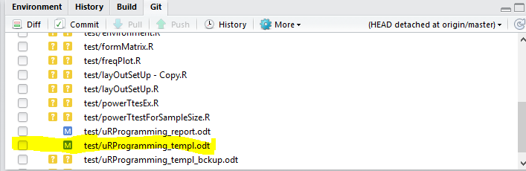

<<git0,echo=FALSE,results=xml,fig=TRUE>>=
odfFigureCaption(“Git from Rstudio shows which files are modified recently”,label=”Figure”)
@

The git commit example from Rstudio, after committed with following message “Modified after adding bar plot example to the document.” we also push our code to the repository.

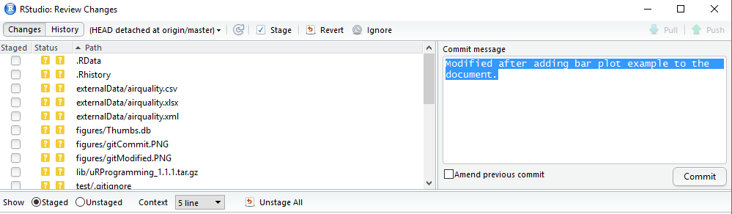
<<git1,echo=FALSE,results=xml,fig=TRUE>>=
odfFigureCaption(“Git from Rstudio shows how to commit the modified file”,label=”Figure”)
@

Git branching, create either using command line or git GUI like source tree can be used for creating branch and other git functionality.
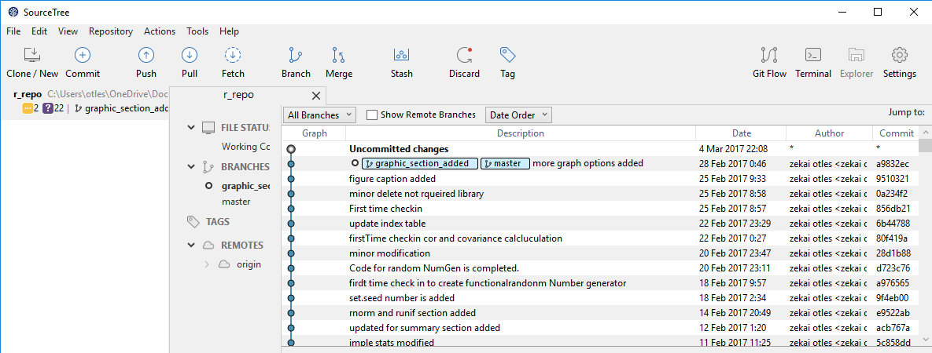
<<git2,echo=FALSE,results=xml,fig=TRUE>>=
odfFigureCaption(“Source tree Git shows the created branches”,label=”Figure”)
@

When another braches checked out from R studio, it shows what files are checkout from the branch.
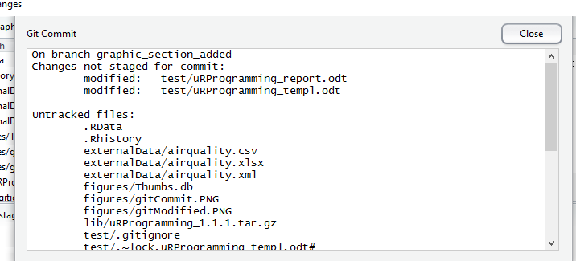
<<git3,echo=FALSE,results=xml,fig=TRUE>>=
odfFigureCaption(“Git from Rstudio shows the file from the branch”,label=”Figure”)
@

Using IDE to develop R scripts
R studio or other tools to develop application,

Writing functions
Simple example

Create R package System
Build R package Rtools needs to be installed (Refence) for windows and Linux.
Windows insallation and linux instalation. Windows installation is requires downloading Rtools.exe for the R version. Version of R can be found by version to the R shell window.

R CMD build uRProgramming

Show them how to build pacjkage from GUI
R CMD BATCH odfWeave.R

Simple Data Types and Objects
R language has following defined data types, Double, Character, Logical and Complex. Numeric variable as a default defined as double,simple text string defined as Character, single character [T and F] is defined as Logical,and complex numbers are defined as Complex.
Integer objects are created with integer, as.integer keywords. Similarly numeric objects are created with numeric and as.numeric keywords. Boolean, Double, Character, Logical, Complex objects are created by their types [boolean, double,character,..] and as.types [boolean.double,..], The variables or vector also can be casted from one type to another type using similar keywords.

<<dataType1,echo=FALSE>>=
cat(“library(uRProgramming)”)
cat(“dataTypes(24)”)
cat(“dataTypes('ali')”)
cat(“dataTypes(T)”)
cat(“a<-as.integer(24)”)
cat(“dataTypes(a)”)

cat(“standard output from above lines”)
library(uRProgramming)
dataTypes(24)
dataTypes("ali")
dataTypes(T)
a<-as.integer(24)
dataTypes(a)

@

In the following examples show how casting works. Following snippet it, can be copied and saved as testDataTypes.R. This R script should be sourced in the R shell in order to have function testDataTypes(), and run the program. The x vector created as sequence of variables between 1 and 100 increment by 10.011. The x is created as default double variable. The x vector is casted to integer y vector. The later part of the example demonstrates, casting x vector into z character vector.

<<dataType2,echo=FALSE>>=
cat( “testDataTypes<-function(){ “)
cat( “#create logical variable ”)
cat(“ iTest<-T ”)
cat( “is.logical(iTest) \n”)
cat(“if(iTest == is.logical(iTest)) cat('Logical ')”)

cat(“#create simple double vector ”)
cat(“ x<-seq(1,100,by=10.011)”)
cat(“ is.double(x)”)
cat(“ if(iTest == is.double(x)) cat('x is double Vector ')”)

cat(“ #cast double vector to integer”)
cat(“y<-as.integer(x)”)
cat(“is.integer(y)”)
cat(“if(iTest == is.integer(y)) cat('y is integer Vector ')”)

cat(“#cast to character vector”)

cat(“z<-as.character(x)”)
cat(“is.character(z)”)
cat(“ if(iTest == is.character(z)) cat('z is character Vector ')”)
cat(“}”)
@

<<dataType2x,echo=FALSE>>=
testDataTypes<-function(){
#create logical variable
iTest<-T
is.logical(iTest)
if(iTest == is.logical(iTest)) print("Logical \n")

#create simple double vector
x<-seq(1,100,by=10.011)
is.double(x)
if(iTest == is.double(x)) cat("x is double Vector \n")

#cast double vector to integer
y<-as.integer(x)
is.integer(y)
if(iTest == is.integer(y)) cat("y is integer Vector \n")

#cast to character vector

z<-as.character(x)
is.character(z)
if(iTest == is.character(z)) cat("z is character Vector \n")
}
source('~/r_repo/test/testDataTypes.R')
@

Source this above program, and run the program (testDataTypes())
<<dataType3,echo=FALSE>>=
#use readr package
myString<-read_file('~/r_repo/test/testDataTypes.R')

#readLines('~/r_repo/test/testDataTypes.R')
#this works, please uncomment following line
#cat(myString)
testDataTypes()
@

Control Structures

Control structures are used to change a flow or follow a logic. The control structures are easily could make any program more followable for maintenance and understanding, they could also turn the most unfollowable code. Control structures are very straight forward when used in a modular way in a less number of statements or calling other reusable functions.oo
In the following sections, the usage of if block will be explained with examples. The samples should help reader to solidify the understandif of te control structures.

If statements
Let's use simple vector which contains only numbers, check if numbers is equal to specific value assign iFound as True.
If ( Statements) { Assignment}
<<ifStatement1, echo=FALSE>>=

cat(“x<-c(0,3,6,9,12,15,18,21,24)”)
x<-c(0,3,6,9,12,15,18,21,24)
cat(“if(x[which(x==6)]==6){iFound<-TRUE}”)
if(x[which(x==6)]==6){iFound<-TRUE}
cat(“print(iFound)”)
print(iFound)
@

In the above example, which finds the index number for the value. The usage of which in vector is pretty powerful as shown in the example. The which statement is pretty handy determining the index of vector or array. When the vector with right index with exact value found, iFound assigned to be true.
Logical operators in R are
Operator | Description
== | Equal to
!= | Not equal to
< | Less than
<= | Less or equal to
> | Greater than
>= | Greater or equal to
& | And
| | Or

Following code snippet is simple example of how to use logical operators. The first example is the exacty equal to operator. The second example demonstrates less than or equal to operator and assigning the value based on the result. The third example shows greater than comparison.The last example is combination greater than, and, less then or equal to.
<<ifStatement2, echo=FALSE>>=
cat(“Ex. 1”)
cat(“if(demDat[indx,1] ==1 ) {demDat[indx,1]<-'M'}”)

cat(“\nEx.2”)
cat(“if(demDat[indx,2] <=25 )demDat[indx,2]<-'Y' “)

cat(“\nEx.3”)
cat(“ if(demDat[indx,2] > 50 ) {demDat[indx,2]<-'O'} “)

cat(“\nEx.4”)
cat(“if(demDat[indx,2] > 25 & demDat[indx,2] <=50 )demDat[indx,2]<-'M' “)

@

If then Else statements

If then else block is used when comparison expected to yield result either true or false. It gives the programmer, the power to control logical flow. In R programming, if then else blocks are in the following format
If ( Statements) { Assignment}
else (statements) { Assignment}

<<conditionalStatements>>=
#cat(conditionalStatements())
@

Switch statements

One can use switch statement to modular conditional statements. The switch statement evaluates according the to the first argument.
switch(Expression,List)
The first argument determines how the results will be evaluated. The first line shows a number in the first argument will select the corresponding list element, in the second line of code snippet shows the the corresponding character strings of list element.

<<switch1, echo=TRUE>>=
switch(3,1.5,2,300,4)
switch("iki", "bir"="bir", "iki"="Two", "uc"="uc")
@
Following function demonstrates how simple if then else block could be replaced by modular switch statements, this type of example can be extended to more modular functionality.
<<switch2, echo=FALSE>>=
myString<-read_file('~/r_repo/test/usingSwitch.R')
cat(myString)
source('~/r_repo/test/usingSwitch.R')

@
<<switch3,echo=TRUE>>=

x<-seq(1,100,by=10.011)
x
xC<-usingSwitch(x,"character")
xC
xI<-usingSwitch(x,"integer")
xI

@

Loop Structures
The loop structures are needed to access elements of vectors, matrix, list and data frame. The access of the data is important to reach or manipulate the elements. The for and while loop are used to iterate elements.

For loop
The for loop is used for sequentially access the data elements. Each element of data stuctures can be reached, used or manipulated within the for loop. The for loop is in the following format.
for (values in sequence) {
statement
}
The following code snippets how for loop is used. In the following example, 100 number with specified seed assign to vector. This vector has only integers for demonstration pupose.

<<forLoop1, echo=FALSE>>=
cat(“set.seed(312)”)
set.seed(312)
cat(“#create 100 random number between 0 and 1000”)
cat(“xInt<-floor(runif(100,0,1000))”)
xInt<-floor(runif(100,0,1000))
cat(“for(indx in 0:length(xInt) ){”)
cat(“if(indx %%10 ==0){print(xInt[indx])}”)
cat(“}”)
for(indx in 0:length(xInt) ){

if(indx %%10 ==0){print(xInt[indx])}
}

@

While loop
The access of certain elements could be controlled by using while loop, the expression determines executing statements or not.
while(expression){
statement
}

In the following example, the elements between two indices are assigned as either even or odd. Execution will stop when expression is false, otherwise statements within the block is executed.
<<whileLoop1, echo=FALSE>>=
cat(“set.seed(312)”)
set.seed(312)
cat(“#create 100 random number between 0 and 1000”)
cat(“xInt<-floor(runif(100,0,1000))”)
xInt<-floor(runif(100,0,1000))
cat(“index<-80”)
cat(“while(index<=length(xInt)){”)
cat('xInt[index]<-ifelse(as.integer(xInt[index]) %%2==0,"Even","Odd")')
cat(“if(index %% 4 == 0 ){print(xInt[index])}”)
cat(“index<-index+1”)
cat(“}”)

index<-80
while(index<=length(xInt)){
xInt[index]<-ifelse(as.integer(xInt[index]) %%2==0,"Even","Odd")
if(index %% 4 == 0 ){print(xInt[index])}
index<-index+1

}

@

Data Structures
In my experience as software engineer and data analyst, introduction to database and utilizing with the data structures would be valuable experience in terms of programming, Specifically storing and retrieving data from database is a great experience for the structured programming. Thus, we introduce the database in this section. The MySQL was chosen because of of simplicity to installation and free to use. The community version is freely avaliable to use, it can be downloaded from oracle. The RMYSQL package allows us utilize some of database functionality within R scripts. Avaliable datasets from basic R installation will be loaded to the urprogramming schema into MySql database. Later those dataset tables will be used to demonstrate to basic data structues like vector, list and matrix.
Insert air quality data from R datasets into airquality table into the schema. Later on selected data from mysql table will be converted into vector and list, etc.

<<dataStruc1,echo=FALSE>>=
myString<-read_file('~/r_repo/test/insertData.R')
cat(myString)
source('~/r_repo/test/insertData.R')

@

In order to load airquality data to the table in MySql database, connection to database will open with folowing statement.

con <- dbConnect(RMySQL::MySQL(), dbname = "urprogramming",password="urprogramming")

The dbConnect statement in RMySQL library requires name of database, schema, username and password. Once the connection is established, the connection object is used to populate the rows in table using the statements starting with
"INSERT INTO airquality VALUES(,,,,)”.

<<dataStruc2,echo=TRUE>>=
insertData()
results<-dbSendQuery(con, "SELECT * FROM airquality")
dataFrm<-dbFetch(results,)

print(dim(dataFrm))
print(dataFrm[1:5,])

@

The following statement will select each row and form a result set.
results<-dbSendQuery(con, "SELECT * FROM airquality")

The result set will be loaded to dataframe using dbFetch(results,) function from the RMySQL library. The insertData function is configured so the records will only inserted when there is no data in the table. Here, we introduced the basic functionality of database in R. Similar to insert and select , update, truncate could be used to manipulate data in tables. There are many options for SQL statements to create complex joins or selecting the subsets of the data . This kind of SQL statements can be found in MySQL documentations, that's why we did not want to go beyond the basic of SQL statements.
The following figure shows the instance from MySQL Workbench. The tool can be used to execute SQL statements.

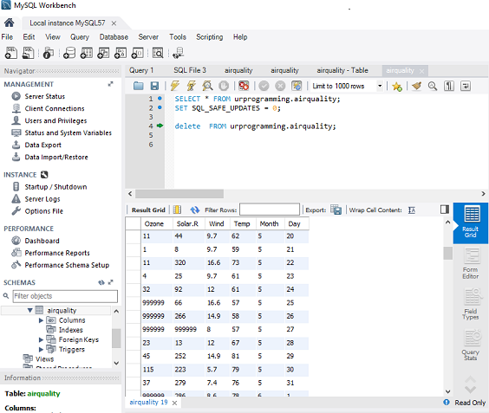
<<pict1,echo=FALSE,results=xml,fig=TRUE>>=
odfFigureCaption(“MySQL screen shot showing the table and querries”,label=”Figure”)
@

Similar data stored in in data bases, one could easily have data stored so called as flat data asci files. Those are created from either either simple editor or spread sheet programs. R has very easy interfaces to read flat files or spreadsheet data. The flat file stored in "~/r_repo/externalData/airquality.csv" can be read with following statement

read.csv(file="~/r_repo/externalData/airquality.csv",header=TRUE,sep=",")

If data is in spreadsheet, it can be saved as flat file from spreadsheet then read data from flat file using similar staement. The data file could be read using read.csv funtion from R util pacakage. There are other packages avaliable for reading spreadsheet data to R.

Data Frame
Data frame is one of the available data structures. The data frame is similar to the spreadsheet data, one can easily see the structure of the data. Once the data saved in data frame structure, the structure of data, dimensions and contents of data is readily available in R. The structure of data is determined from str( name of data frame object) as shown in the the following example
str(dataFrm).
The statement gives the structure of data, name of data variables and also type of variable stored. As seen in the example, air quality data store Ozone, Solar.R, Temp, Month, Day variables as int and wind as num. These variables can be changed using casting as we shown earlier in Simple Data Type section. We can figure out the data stored in a data frame using existing function dim in R base functions, colnames (again from R base functions) refers the variable names stored in data structures. The View function R util functions can display the data frame contents so we can have some idea about the data. The following section
View(dataFrm[1:4,])
is displaying the data from the first through fourth row in dataFrm.
results<-dbSendQuery(con, "SELECT * FROM airquality")
dataFrm<-dbFetch(results)
the results from select assigned to dataFrm. The dataFrm has following structure
<<dataFrm,echo=FALSE>>=
cat(“str(dataFrm)”)
str(dataFrm)
cat(“dim(dataFrm)”)
print(dim(dataFrm))
cat(“colnames(dataFrm)”)
colnames(dataFrm)
#View(dataFrm[1:4,])
cat(“View(dataFrm[1:4,])”)
print(dataFrm[1:4,])
@

Vector
Vector is used for atomic data types (integer,numeric, complex, and character) and list storage. It is a powerful way to store data and it usage in the computations is extremely simplifies the programming. The examples will demonstrate the power of vector calculations. Temperature from Fahrenheit is easily converted to Celsius with following statement.
tempAsCels<-5*(dataFrm$Temp-32)/9.0
<<vector,1echo=FALSE>>=
tempAsCels<-5*(dataFrm$Temp-32)/9.0

cat(“is.vector(tempAsCels)”)
print(is.vector(tempAsCels))

cat(“View(tempAsCels(1:5)”)
print(tempAsCels[1:5])
@
It is also easy to dissect and examine data stored in vector format. The following simple snippet will demonstate how to retrive the month data from the dataFrm object. We have determined the months which days are 80 degree Fahrenheit . It also shown number of 80 degree days for our data.
<<vector2,echo=FALSE>>=
cat(“dataFrm$Month[dataFrm$Temp==80]”)
cat(“length(dataFrm$Month[dataFrm$Temp==80])”)

dataFrm$Month[dataFrm$Temp==80]
length(dataFrm$Month[dataFrm$Temp==80])
@
The which, function is available from the R base package, is used to determine the indices of the vector when the condition meets up the criteria. The following snippets show which element of the temperature vector was exactly 80 degrees Fahrenheit.
<<vector3,echo=FALSE>>=
cat(“which(dataFrm$Temp==80)”)

which(dataFrm$Temp==80)
@

Matrix
The matrix is available in R to store two dimensional array in a matrix format. The discussion of matrix without array will not be complete to understand data structures in R programming. The array can store vector data in one, two or dimensional format. The vector data is stored without array bound information, but array and matrix needs complete information about dimensions.
The array needs the information about data types and dimensions of the array. The array stores one to many dimensional data. In the following example, row_names stored in a one dimensional array .
row_Names<-array("",dim=length(unique(dataFrm$Month)))
Structure of array can be found using str from util package in R. The str function will give data types and dimension of the array. The following demonstrates how to use str function with array.
strr(row_Names)
Another useful function to check whether data stored in array or not. If the data stored in an array, is.array(row_Names) will return TRUE.
The matrix is a special case of array which is a two dimensional data structure. The matrix need data types, row and column dimensions. The tempAsMatrix is defined as matrix in the following example.
tempAsMatrix<-matrix("",nrow=length(unique(dataFrm$Month)),ncol=30)
<<matrix,echo=FALSE>>=
myStringM<-read_file('~/r_repo/test/formTempMatrix.R')
cat(myStringM)
source('~/r_repo/test/formTempMatrix.R')
@
The str function for matrix type will return data types, and bounds of the each dimensions. The base package has a function to determine whether data structure is matrix or not. In the following example,
is.matrix(tempAsMatrix)
the return value will be TRUE.

List
The list is very powerful data structure, heterogeneous data can be stored in a list. The list can contain list, data frame, array and matrix in a structure. The dataFrm, row_Names and tempAsMatrix data structures are all stored in a list called aList. The data structure can be retrieved using the list$name structure, such as aList$dataFrm.
<<list1,echo=FALSE>>=
myStringL<-read_file('~/r_repo/test/useList.R')
cat(myStringL)
source('~/r_repo/test/useList.R')
@

<<list2,echo=FALSE>>=
cat('str(aList)')
str(aList)
@
As seen above, the list data structure is very convenient way to store multiple data structures into a data structure.

Simple Statistical Analysis
This section is simple introduction to statistical analysis. There will be brief explanation about creating normally distributed variables used statistical analysis, creating simple summary mean, standard deviation. The simple statistical functions are available stats, base, time functional packages. The functional examples will show how to use those simple statistics using already defined data structures. Introduction how to use simple statistics against their data will give foundation to extend the readers ability to do further complex statistical analysis. This will also help utilizing the other packages in available by R community.
<<stats1,echo=FALSE>>=
myStringM<-read_file('~/r_repo/test/simpleStats.R')
cat(myStringM)
source('~/r_repo/test/simpleStats.R')
@
In the example, normally distributed random variable created using rnorm function from stats package. Using some of the available functions such as mean, summary and sd from base and stats packages. The mean from base package gives the arithmetic mean of the values. The min and max returns minimum and maximum values for the input values. The sd is standard deviation of the input values. The summary function from base package returns min and max values , the first and third quartiles, median and mean of input values.
<<stats2,echo=FALSE>>=
cat('xStats<-simpleStats(100,273.16,15)')
xStats<-simpleStats(100,273.16,15)
cat('str(xStats)')
str(xStats)

@

Normally distributed random numbers is generated by using rnorm function from stats package. The runif generates uniformly distributed random numbers. The random number generators ran four times in the example, and selected the fifth element of the storage vectors (xTempNorm and xTempUni). Since the script is not using fixed seed number for the random number generators, the storage vectors will consist of different elements as we shown here with the fifth elements of the vectors.

<<stats21,echo=FALSE>>=
myStringM<-read_file('~/r_repo/test/randomNumGen.R')
cat(myStringM)
source('~/r_repo/test/randomNumGen.R')
@
<<stats3,echo=FALSE>>=
xRandGenF<-randomNumGen(FALSE)
@

The same example will be repeated for fixed seed numbers for the random number generation. When we set the seed the numbers the produced random number vectors using rnorm and runif will always contains same elements. The fifth elements for the xTempNorm and xTempUni vectors is always same for the given seed number 6543. The summary of the storage xTempNorm and xTempUni vector will yield same results because of the same seed number.

<<stats4,echo=FALSE>>=
xRandGenT<-randomNumGen(TRUE)
@

The xRandGenT list is used to sample two vector datasets. The sample method from base R package used to select 15 random elements from vector datasets . Once the samples assigned the correlations values computed by using different methods avaliable from stats package. The covariance between xTempNorm and xTempUni vector datasets computed using cov function from stats package. The standard deviations calculated using sd function from he stats package.
<<stats5,echo=FALSE>>=
myStringM<-read_file('~/r_repo/test/corTest.R')
cat(myStringM)
source('~/r_repo/test/corTest.R')
@
<<stats6,echo=FALSE>>=
cat('corTest(xRandGenT$xTempNorm,xRandGenT$xTempUni)')
corTest(xRandGenT$xTempNorm,xRandGenT$xTempUni)
@

Graphic Outputs

This section is designed to be how to represent data output in a graphical formats.
The visual presentation of data will help audience form an opinion much faster in human's brain. This might be very well represented by the common known phrase “A picture is worth a thousand words” (http://www.phrases.org.uk/meanings/a-picture-is-worth-a-thousand-words.html). This is mind, we will show examples of histogram, bar plot, plot, matplot is readily avaliable R graphics pckage.
<<graph0,echo=FALSE>>=
myStringM<-read_file('~/r_repo/test/normalDist.R')
cat(myStringM)
source('~/r_repo/test/normalDist.R')
@
<<graph1,echo=FALSE,results=xml,fig=TRUE>>=
cat('normalDist(numSet=100,mean=c(5,15,50),sd=c(10,5,3,1))')
normalDist(numSet=100,mean=c(5,15,50),sd=c(10,5,3,1))
odfFigureCaption(“Example Histogram”,label=”Figure”)
@
<<graph2,echo=FALSE>>=
myStringM<-read_file('~/r_repo/test/freqPlot.R')
cat(myStringM)
source('~/r_repo/test/freqPlot.R')
source('~/r_repo/test/formTempMatrix.R')
source('~/r_repo/test/layOutSetUp.R')
tempAsMatrix<-formTempMatrix(dataFrm)
source('~/r_repo/test/catTemp.R')
arrayOfBreaks<-c(55,60,65,70,75,80,85,90,95,100,105)
columnNames<-c("55-60","60-65","65-70","70-75","75-80","80-85","85-90","90-95","95-100","100-105")
catTemp(matrix=tempAsMatrix,arrayOfBreaks=arrayOfBreaks,columnNames=columnNames)
@

<<graph3,echo=FALSE,results=xml,fig=TRUE>>=
freqPlot(tempMatrixCat,xlabels="Days",ylabels="Number of days with the range ",besideOrNot=FALSE,titleOfPlot="Temperatures at each Day of")
odfFigureCaption("Example Bar Plot",label="Figure")
@
bar plot
<<graph4,echo=FALSE,results=xml,fig=TRUE>>=
freqPlot(tempMatrixCat,xlabels="Days",ylabels="Number of Days with the range",onePlot=TRUE,besideOrNot=TRUE,isCol=FALSE,titleOfPlot="Temperatures Distribution May-Sep")

odfFigureCaption("Example Bar Plot with combined data",label="Figure")
@
stackbar plot
<<graph5,echo=FALSE,results=xml,fig=TRUE>>=
freqPlot(tempMatrixCat,xlabels="Days",ylabels="Number of Days with the range",onePlot=TRUE,besideOrNot=FALSE,isCol=FALSE,titleOfPlot="Temperatures Distribution May-Sep")

odfFigureCaption("Example Bar Plot with combined data",label="Figure")
@
Multi line plots
<<synDat,echo=FALSE,results=xml,fig=TRUE>>=
# I usually load the libraries first so that any output produced by
source('~/r_repo/test/matPlotM.R')

xlabel<-"Days"
xaxisOpts<-c(1,30,29,"n")
yaxisOpts<-c(55,105,11,"n")
ylabel<-"Temp(F)"

legendNames=row.names(tempAsMatrix)

colnames(tempAsMatrix)<-seq(1:dim(tempAsMatrix)[2])
matPlotDat<-t(tempAsMatrix)

titleOfPlot="Daily Observation"

#out<-matPlotM(matPlotDat,xlab=xlabel,ylab=ylabel,title=titleOfPlot,leg=legendNames)
out<-

matPlotM(matPlotDat,xlab=xlabel,ylab=ylabel,yaxisOpts=yaxisOpts,title=titleOfPlot,leg=legendNames)

print(out)
#matPlotM(matPlotDat,xlab=xlabel,xaxisOpts=xaxisOpts,ylab=ylabel,yaxisOpts=yaxisOpts,title=titleOfPlot,leg=legendNames)

odfFigureCaption(“Observation”,label=”Figure”)
@

<<graph6,echo=FALSE,results=xml,fig=TRUE>>=

titleOfPlot="Daily Temperature"
cntr<-contourplot(matPlotDat,xlab=”Days of Month”,ylab=”Months”)
print(cntr)
odfFigureCaption(”Daily Temperature Values Plotted as Contours”,label=”Figure”)
@

Simple Table Outputs
<<table1,echo=FALSE>>=
colnames(tempAsMatrix)<-seq(1:30)

tablo<-as.table(t(tempAsMatrix))
print(tablo)

@
May be grid table from grid Extra pacakage reference
<<table2,echo=FALSE,results=xml,fig=TRUE >>=
library(gridExtra)

tablo<-grid.table(t(tempAsMatrix))

print(tablo)
@

summary of statiscic in table format
<<dataPair,echo=FALSE>>=
#use readr package
myString<-read_file('~/r_repo/test/paired_tTest.R')

#this works, please uncomment following line
cat(myString)
source('~/r_repo/test/paired_tTest.R')
tTestResults<-paired_tTest()
@

source paired_test and modify heightData input it will be read
<<table3, echo=FALSE, results=xml>>=
odfTable(as.data.frame(tTestResults$xMatr))

@

t -test p-values compare to each other
<<table4, echo=FALSE, results=xml>>=
dff<- as.data.frame(tTestResults$pValues)
colnames(dff)<-colnames(tTestResults$xMatr)
nRow<-length(colnames(dff))-1
rownames(dff)<-colnames(dff)[1:nRow]

odfTable(dff)

@

Please start here

Reference
-MySQL reference
-RMySQL

