Checking the python version
Py --version
For making the environment and installing the django
After that we install colorama
What is colorama:
Install colorama, a Python package that translates ANSI color codes into Windows API calls. Django commands will detect its presence and will make use of its services to color output just like on Unix-based platforms. colorama can be installed via pip:

For making a project in Django
- django-admin –version or python -m django --version
- django-admin startproject mysite
- python manage.py runserver
- python manage.py startapp polls
- python manage.py migrate
- python manage.py makemigration

make your model
example of a model
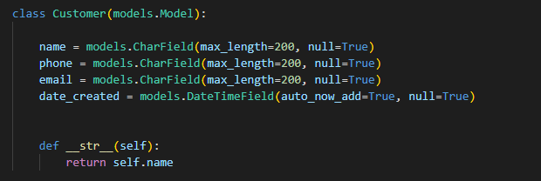
this example of admin registration of a model
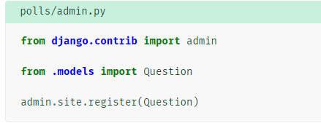

Project of my brother Soufiane laaziz
Installing Django
cdInstalling colorama

Making a folder, project name

We see if we installed Django, we create our project name and we change the directory and we run the server

We create the app and we change to it
Register your app
Add templates
Inside the app
We create a templates folder and we create a an app name folder and inside of it we create html pages.

For static file we create a folder in the app

We add this in setting

We add this url under setting
+ static(settings.STATIC_URL, document_root=settings.STATIC_ROOT)+ static(settings.MEDIA_URL, document_root= settings.MEDIA_ROOT)
In html page
It is better to have a separate folders inside static folder
This is how we do it in the body
Example of nav bar in the html
The result of giving css
The result of this css
Is
The output of this css
Is
The output of this css
Is
The output of this css
The output of this css
Is

For database

Login
Django already has created the app of authentication for us

Add this in url of the project
Just change the accounts with your app name
HTML page for login page
We add this in setting
After that we create a superuser

Inurl
Site
Site:starbucks.com filetype:pdf
Filetype:env”DB_PASSWORD”
Whoisip
Filetype:reg reg HKEY
Registry editor (windows)
Google hacking database

Github
- git init
- git add .
- git commit -m "Add all my files"
- git remote add origin https://github.com/yourusername/your-repo-name.git
Upload of project from scratch require git pull origin master.
- git pull origin master
- git push origin master or
git push --force origin master

for getting your repository to your local machine:
make directory folder
cd to your folder
git clone “your rep link ”

do “dir” for showing your files

how to make changes in your file:
git status to see your files
git add . or specific file
git commit -a -m “title of changes”

for deleting unwanted file
git reset head “name of the file”

for example if you want to get a file from remote repo or last update that someone was working on it you do :
git pull origin

for activate your envirenemts virtual :
source learning_English/Scripts/activate

