G7 Car Bidding Project
Group7_Project1_Phase4

Professor: Wafa Elmannai
Member: Otmane Laaziz, Naveen Kumar Achanta, Ravi Kumar Munagala,
Vamshi Kumar Reddy Amanaganti

In this phase we are going to show our description of our tables and we are going to insert some data in our tables. Also, we will do some queries to retrieve the data we want from different tables. The data that we are going to insert is just an example of the real data the users will be entering in the app.

Account table
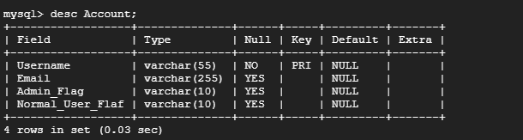
After inserting our data
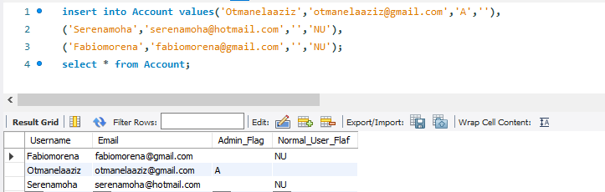

Admin table
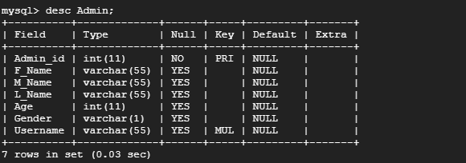
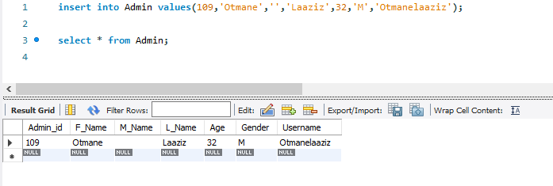

Bids table
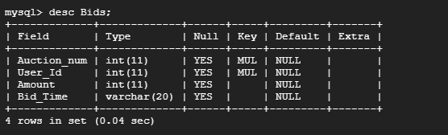
After entering the data
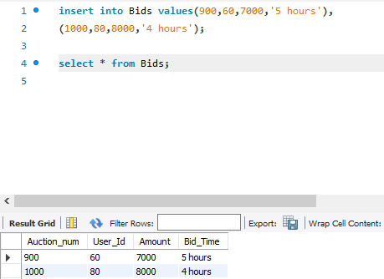

Buyer Feedback table
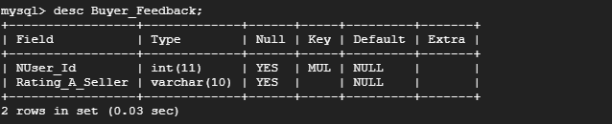
After entering the data
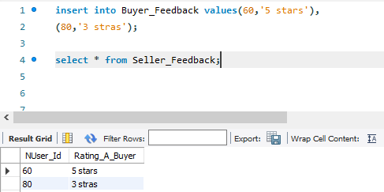

Manage Table
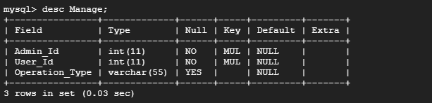
After entering the data
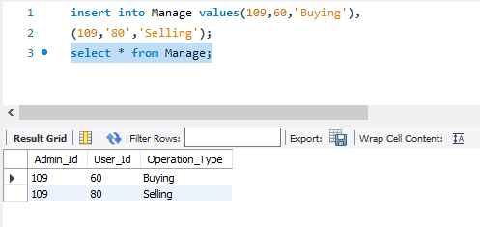

Normal User table
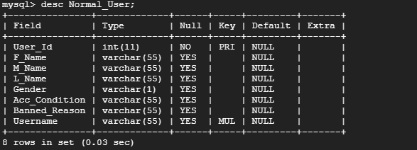
After entering the data
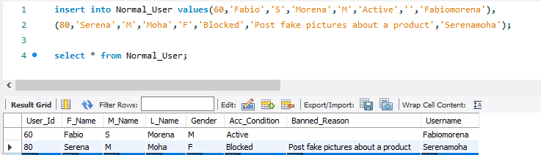
Payment table
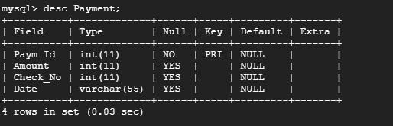
After entering the data
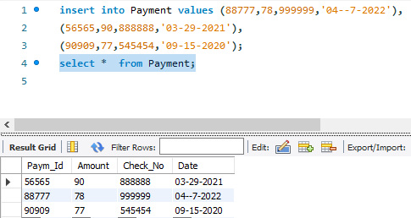

Post table
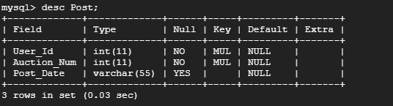
After entering the data
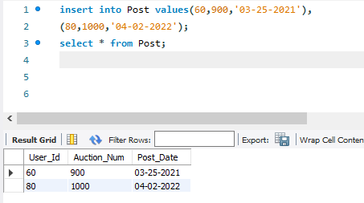
Seller feedback table
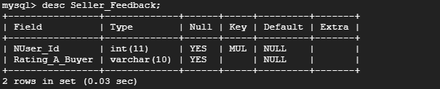
After entering the data
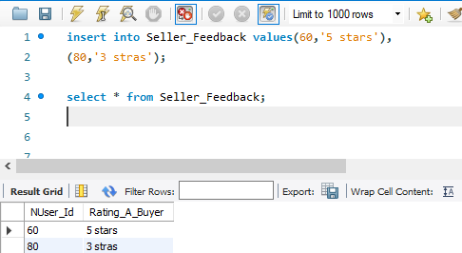
Transaction history table
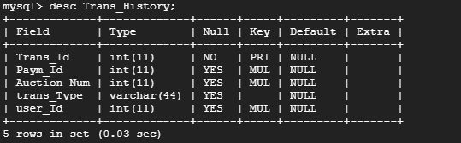
After entering the data
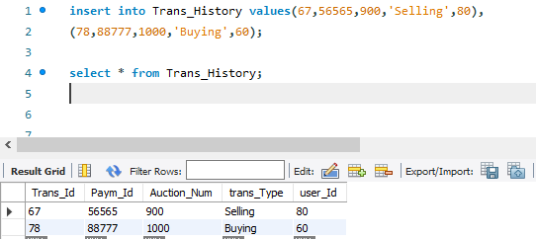

Auction table
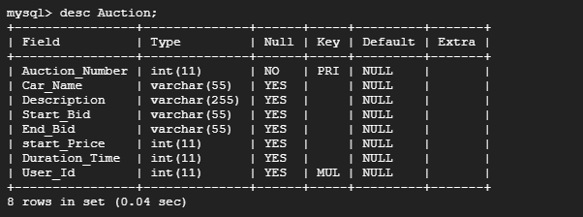
After entering the data
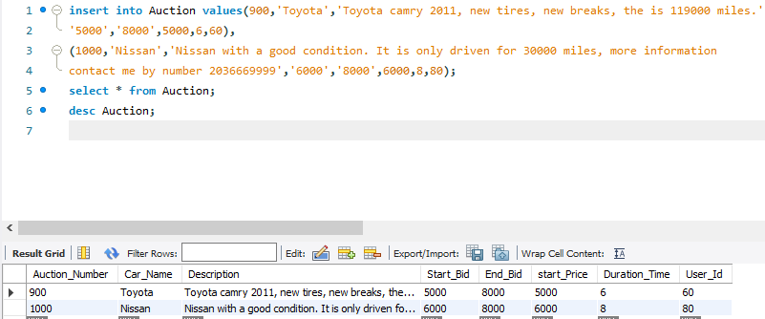

We are going now to use queries and retrieve the data that we need. These queries some of them are basic and some of them are nested.
Query for selecting all the data in a table. Our table of testing are (Auction and Normal_User)

We use : SELECT * FROM table_name
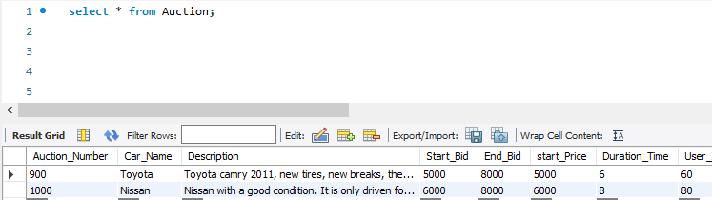

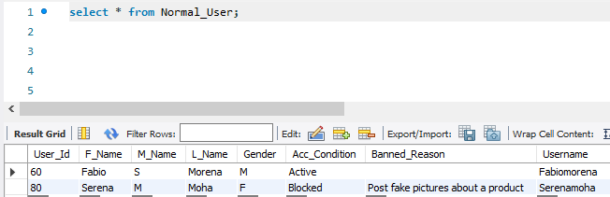

SELECT * FROM table_name WHERE condition
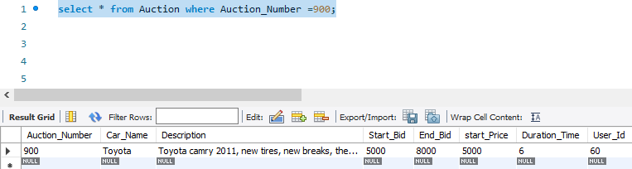

SELECT F_Name,L_Name,Banned_Reason FROM Normal_User WHERE User_Id = 80;
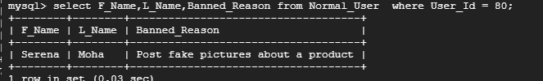
SELECT * FROM Auction WHERE Car_Name = ‘Nissan’;
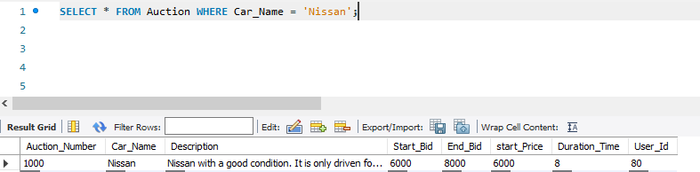

SELECT * FROM Admin WHERE L_Name LIKE ‘%laaziz’;
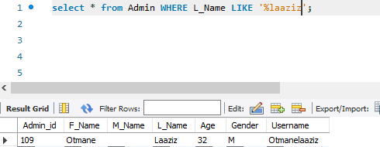
Using order by:
Before
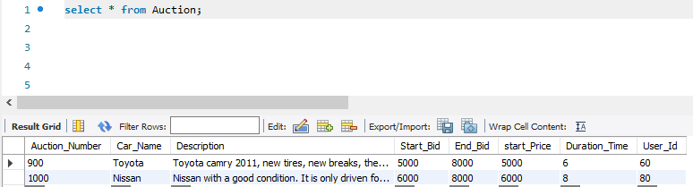
After
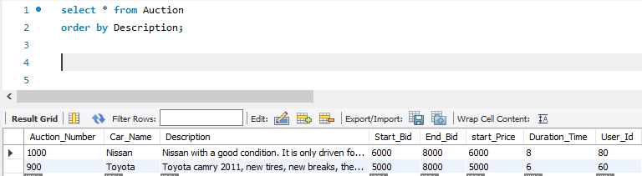
Create a view for a table
Describe the view
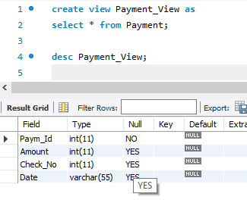
Select * from the view
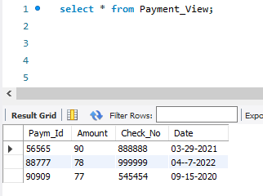

Using join to gather more than one table
Right join
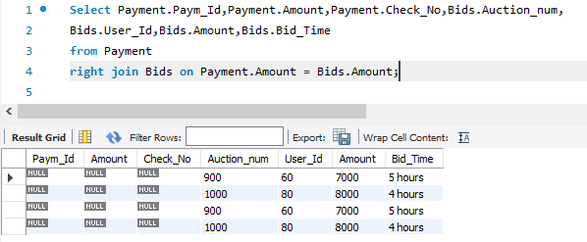
Left join
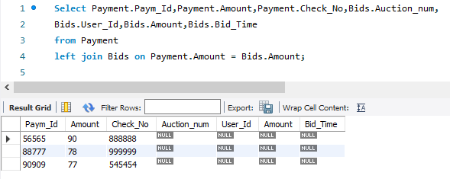
Using union all
We user payment table and Bids table and union amount column
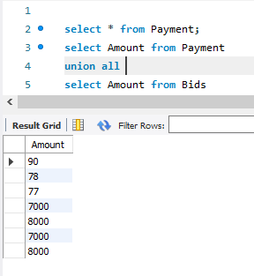
Adding and dropping primary key and foreign key
Adding a primary key (Admin_id)
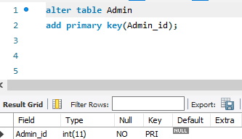
Adding Foreign key
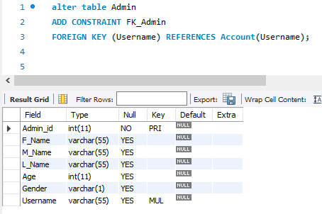
Nested query
Example about Bids table
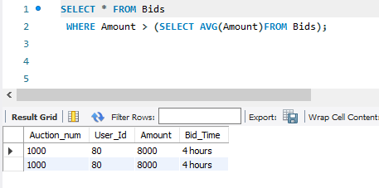

Getting the average of the start bid where the user id of normal user is:
