**G7 Car Bidding Project**

**Group7_Project1_Phase4**

**Professor:** [Wafa Elmannai](https://bridgeport.instructure.com/courses/1854188/users/4087853)

**Member**: Otmane Laaziz, Naveen Kumar Achanta, Ravi Kumar Munagala,

Vamshi Kumar Reddy Amanaganti

In this phase we are going to show our description of our tables and we are going to insert some data in our tables. Also, we will do some queries to retrieve the data we want from different tables. The data that we are going to insert is just an example of the real data the users will be entering in the app.

Account table

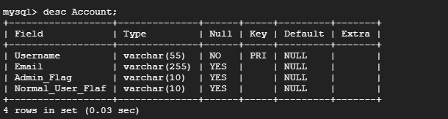

After inserting our data

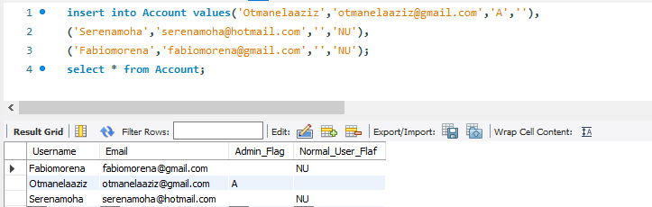

**Admin table**

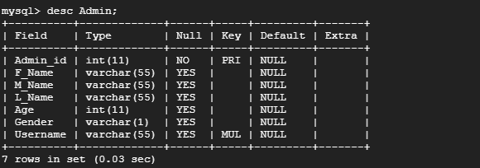

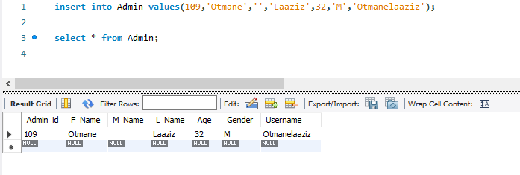

**Bids table**

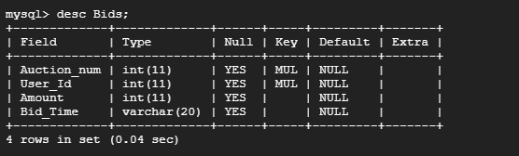

After entering the data

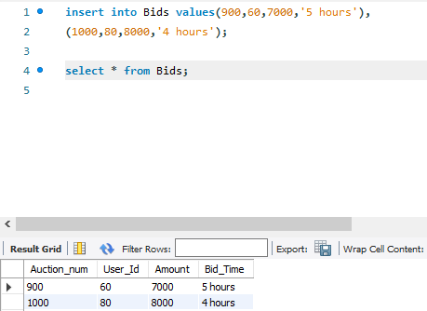

**Buyer Feedback table**

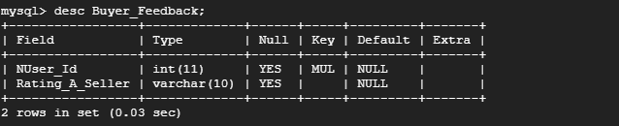

After entering the data

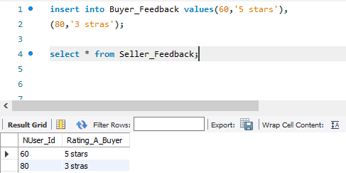

**Manage Table**

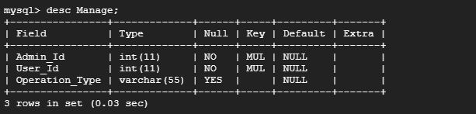

After entering the data

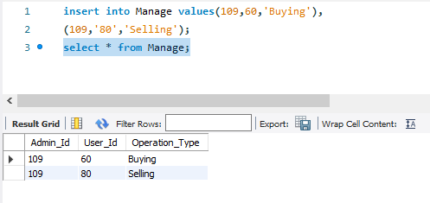

**Normal User table**

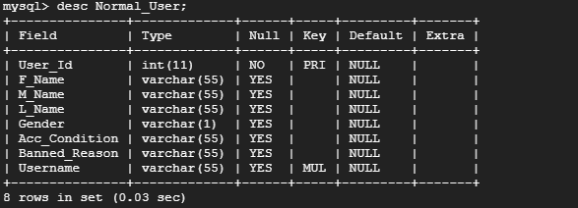

After entering the data

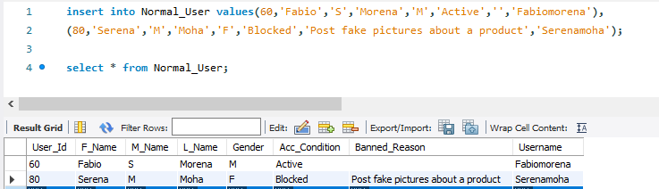

**Payment table**

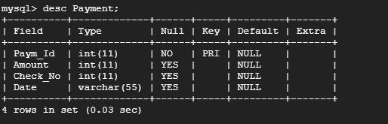

After entering the data

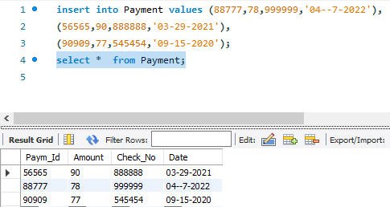

**Post table**

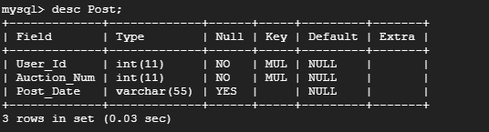

After entering the data

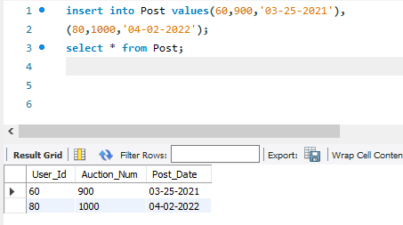

**Seller feedback table**

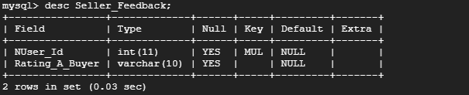

After entering the data

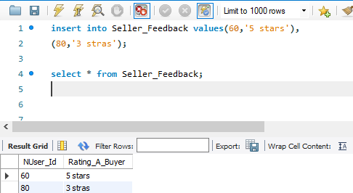

**Transaction history table**

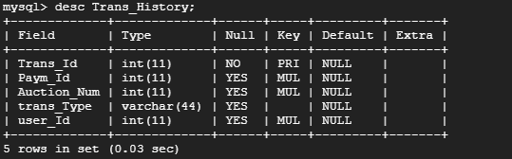

After entering the data

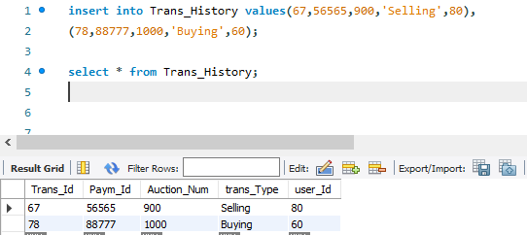

**Auction table**

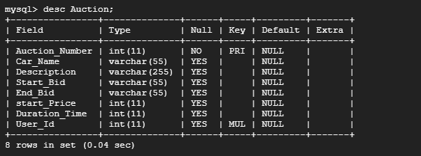

After entering the data

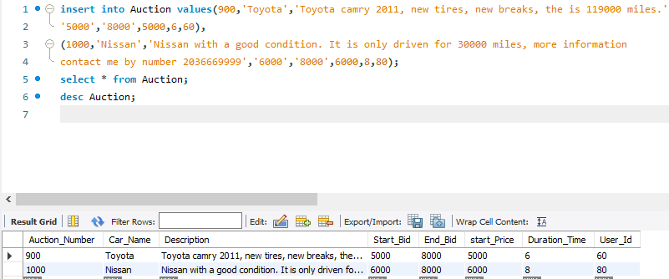

We are going now to use queries and retrieve the data that we need. These queries some of them are basic and some of them are nested.

Query for selecting all the data in a table. Our table of testing are (Auction and Normal_User)

**We use : SELECT * FROM table_name**

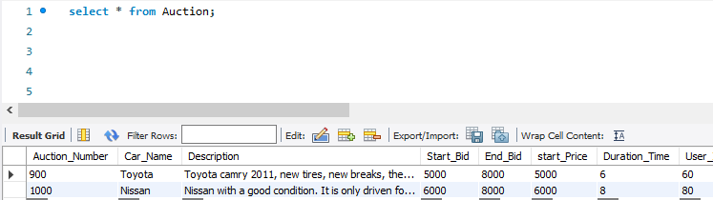

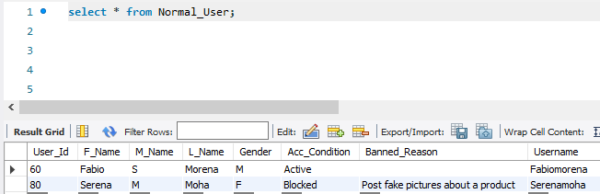

**SELECT * FROM table_name WHERE condition**

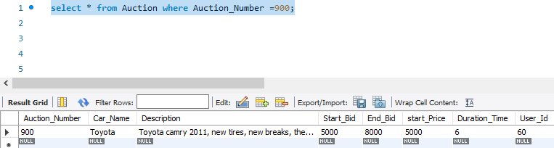

**SELECT F_Name,L_Name,Banned_Reason FROM Normal_User WHERE User_Id = 80;**

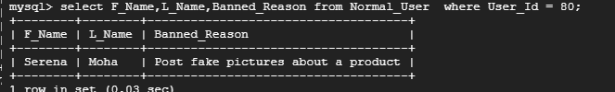

**SELECT * FROM Auction WHERE Car_Name = ‘Nissan’;**

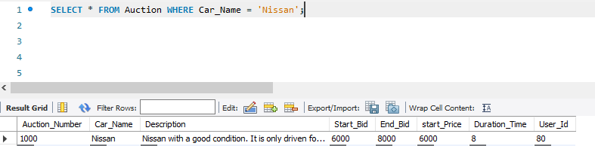

**SELECT * FROM Admin WHERE L_Name LIKE ‘%laaziz’;**

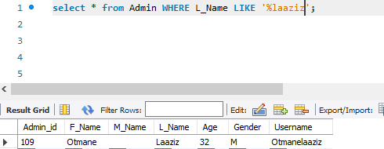

**Using order by:**

**Before**

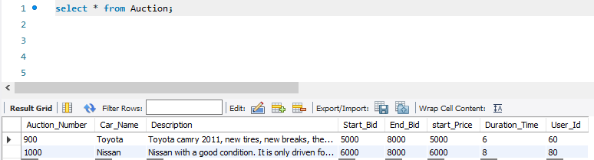

**After**

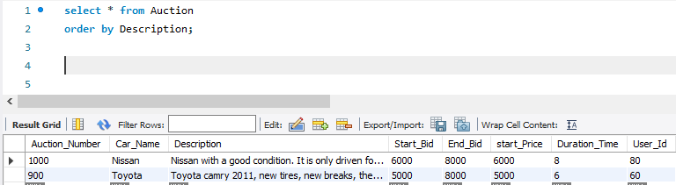

**Create a view for a table**

**Describe the view**

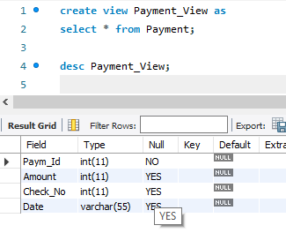

**Select * from the view**

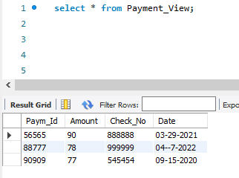

**Using join to gather more than one table**

**Right join**

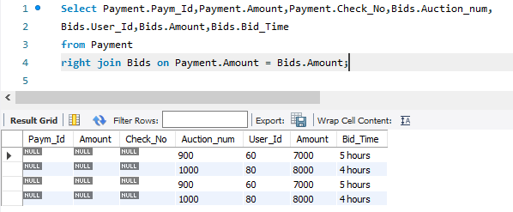

**Left join**

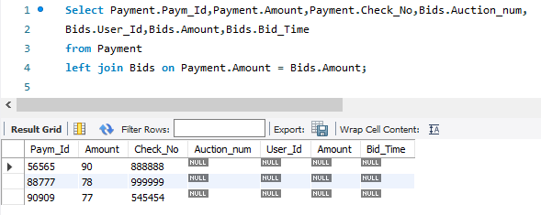

**Using union all**

**We user payment table and Bids table and union amount column**

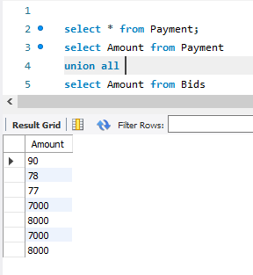

**Adding and dropping primary key and foreign key**

**Adding a primary key (Admin_id)**

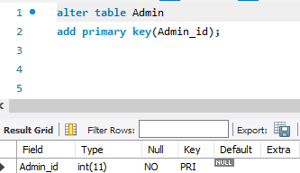

**Adding Foreign key**

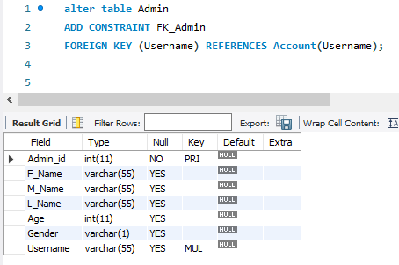

**Nested query**

**Example about Bids table**

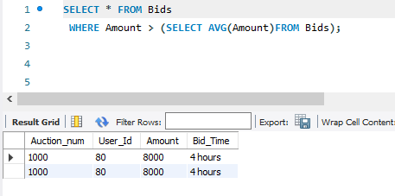

**Getting the average of the start bid where the user id of normal user is:**

