Figures and Tables Apendix
- Research model
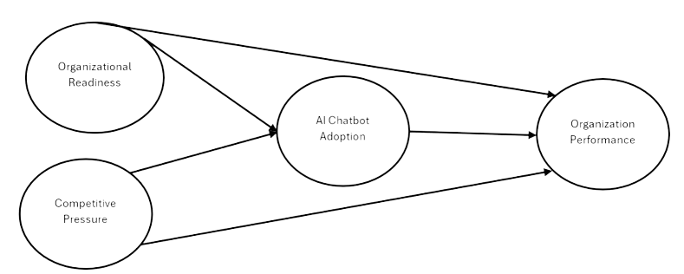
- Sample characteristics
Kategori | Jumlah | %
Posisi
Pemilik | 132 | 52.8%
Manajer | 118 | 47.2%
Bidang usaha
F&B | 77 | 30.8%
Fashion | 97 | 38.8%
Jasa | 16 | 6.4%
Perdagangan | 8 | 3.2%
Kontruksi | 6 | 2.4%
Tourism | 8 | 3.2%
IT | 9 | 3.6%
Desain interior | 13 | 5.2%
Craft | 14 | 5.6%
Other | 2 | 0.8%
Usia usaha
Kurang dari 1 tahun | 35 | 14%
1-3 tahun | 90 | 36%
4-6 tahun | 95 | 38%
Lebih dari 6 tahun | 30 | 12%
Omzet
< 300 juta | 59 | 23.6%
>300 juta – 2,5 miliar | 111 | 44.4%
>2.5 miliar – 50 miliar | 80 | 32%
Jumlah karyawan
1-2 orang | 42 | 16.8%
3-5 orang | 80 | 32%
6-10 orang | 83 | 33.2%
Lebih dari 10 orang | 45 | 18%
Platform pemasaran
Offline store | 110 | 44%
Website pribadi | 139 | 55.6%
Marketplace | 132 | 52.8%
Media sosial | 99 | 39.6%
Whatsapp business | 99 | 39.6%
Other | 25 | 10%

- PLS Algorithm results
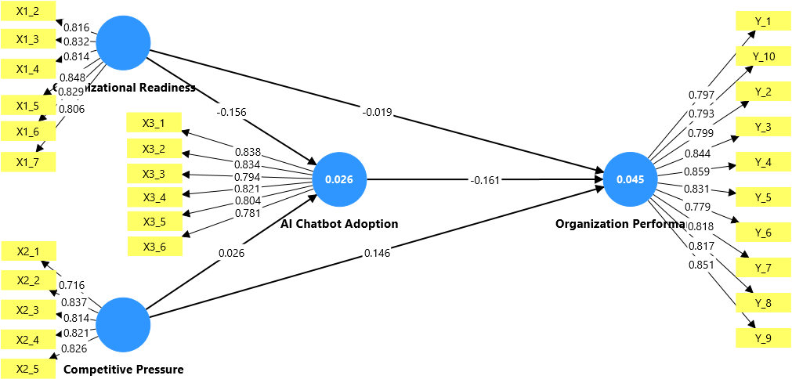

- Construct Reliability and Validity
 | Code/ items | Loadings | Cronbach's alpha | Composite reliability (rho_a) | Composite reliability (rho_c) | Average variance extracted (AVE)
AI Chatbot Adoption (AIA) | AIA 1 | 0.838 | 0.899 | 0.931 | 0.921 | 0.660
 | AIA 2 | 0.834
 | AIA 3 | 0.794
 | AIA 4 | 0.821
 | AIA 5 | 0.804
 | AIA 6 | 0.781
Competitive Pressure (CP) | CP 1 | 0.716 | 0.867 | 0.892 | 0.901 | 0.647
 | CP 2 | 0.837
 | CP 3 | 0.814
 | CP 4 | 0.821
 | CP 5 | 0.826
Organization Performance (OP) | OP 1 | 0.797 | 0.946 | 0.967 | 0.953 | 0.671
 | OP 10 | 0.793
 | OP 2 | 0.799
 | OP 3 | 0.844
 | OP 4 | 0.859
 | OP 5 | 0.831
 | OP 6 | 0.779
 | OP 7 | 0.818
 | OP 8 | 0.817
 | OP 9 | 0.851
Organizational Readiness (OR) | OR 2 | 0.816 | 0.906 | 0.911 | 0.927 | 0.679
 | OR 3 | 0.832
 | OR 4 | 0.814
 | OR 5 | 0.848
 | OR 6 | 0.829
 | OR 7 | 0.806

- Discriminant Validity
 | AI Chatbot Adoption | Competitive Pressure | Organization Performance | Organizational Readiness
AI Chatbot Adoption
Competitive Pressure | 0.089
Organization Performance | 0.139 | 0.133
Organizational Readiness | 0.164 | 0.104 | 0.064

- Path Coefficient
Hypothesis | Path | Koefisien Jalur (β) | T statistik | P values | Result
H1 | Organizational Readiness AI Chatbot Adoption | -0.156 | 2.526 | 0.012 | Supported
H2 | Organizational Readiness Organization Performance | -0.019 | 0.239 | 0.811 | Rejected
H3 | Competitive Pressure AI Chatbot Adoption | 0.026 | 0.237 | 0.813 | Rejected
H4 | Competitive Pressure Organization Performance | 0.146 | 1.854 | 0.064 | Rejected
H5 | AI Chatbot Adoption Organization Performance | -0.161 | 2.332 | 0.020 | Supported

