Study of the Contrast Observed on Carbon by Monte Carlo Simulation on wet-STEM Tomography

Rahmat Firman Septiyanto^{1,a} , and Isriyanti Affifah²
¹Department of Physics Education, Universitas Sultan Ageng Tirtayasa, Serang, Indonesia
²Department of Chemistry Education, Universitas Sultan Ageng Tirtayasa, Serang, Indonesia
ªemail rahmat_firman99@untirta.ac.id

Abstract. Materials science is a field that needs a three-dimensional (3D) structure characterization method. Tomography is an excellent devicel for analyzing the three-dimensional structure of a material. The principle is prominent on the acquisition of a series of projected images at different tilt angles, and on the calculation of the three-dimensional (3D) volume reconstruction (tomogram) using a special algorithm. Various studies have been developed to perform electron tomography in Environmental Scanning Electron Microscopy (ESEM), which provides access to the observation of hydrated samples in an aquatic environment. In this study we present the feasibility of tomography on wet materials, namely Carbon compounds by simulating electron material interactions. From these simulations, we determine the optimum detectable thickness of water in the wet material which is calculated by Monte Carlo simulation.

Keywords: Carbon, Tomography, Monte Carlo Simulation, wet-STEM

Introduction
Several types of materials contain or are dispersed in water during the process, both organic and inorganic materials [1], [2]. For example, biological cells contain a high fraction of water. Latex suspensions, consisting of polymer particles dispersed in water, are used for a variety of applications, including for paints, glues or as a binder for superinsulators [3]. In inorganic materials there are materials which in the process must be dispersed in a liquid, for example in some ceramics, to obtain ceramics with high density, a dispersion process using liquids and surfactants is required [4], [5].
Ceramics involve nanoparticles that are synthesized directly in a liquid, through a chemical or physical process. In all cases, a complete understanding of the dispersion in suspension is useful for understanding the properties of the material. At the nanoscale and mesoscales, electron microscopy is a key technique [5]. Environmental Scanning Electron Microscopy (ESEM) can also be used to study liquid suspensions. With differential pumping, the pressure in the sample chamber can reach several tens of Torr. The use of the Peltier stage in ESEM makes it possible to observe objects in a fully hydrated state [6], [7]. Condensation and evaporation of water can be carried out on the spot by changing the pressure in the sample chamber. Wet material was successfully observed in ESEM using secondary electron or backscattering electron detectors [7], a collection of detectors placed under a liquid droplet has proven to be an efficient mode of observation [8].
Tomography is a prominent characterization device in materials science and biology. The principle of tomography is based on the acquisition of a series of projected images at different angles of inclination, and on the calculation of the volume of a three-dimensional (3D) reconstruction (tomogram) using a special algorithm [9]. Bogner et al [8] have explained the utility of the combined STEM-in-SEM and ESEM, and this idea was behind the development of the wet STEM imaging mode. Reimer et al have characterized certain samples in various modes of transmission and have highlighted beam widening through sample thickness. They have shown that resolution, which is directly related to probe size, is subject to a top-down effect [10]. The use of thin samples thus results in better resolution, avoiding the probe extending through the thickness of the sample.
In previous studies, an analysis of the determination of the minimum water layer on the MCM-41 sample was carried out using wet-STEM [11]. Configuration Scanning Transmission Electron Microscopy (STEM) on Environmental Scanning Electron Microscopy (ESEM) provides a new approach for characterizing the 3D structure of materials and optimizes the compromise between resolution levels of several tens of nm and large tomogram sizes due to the high transparency thickness. In addition, STEM enables the transmission of 2D observations of wet samples in ESEM by controlling the sample temperature and the water pressure of the sample environment [11].
Carbon material is easy to get in the world since it is a vastly abundant material. This material has a symbol C with atomic number 6 and has four electrons to construct covalent chemical bonds. Carbon has density 2,267 g/cm³ in graphite. In this study, we perform a measurement study via simulation of electron-matter interactions for electron tomography in ESEM, which enables the acquisition of image sequences on wet samples. The example used is carbon material which is widely used in ceramic engineering in industry. Then, a Monte Carlo simulation will be used to estimate the optimum amount of water that can be detected in the wet sample.
Theoretical Background
In this simulation, it is necessary to pay attention to the important parameters of the STEM tomography technique.
Tomography-STEM Technique
The tomo-STEM electron tomography technique consists of three main parts, namely: (a) a tilting system, (b) a system for keeping the target area within the field of view, (c) a detection system [12]. The functions of these parts are as follows: (a) the tilting system is a large microscope that allows the introduction of piezoelectric systems for rotation of more than 360° around the horizontal axis; rotation is done accurately. (b) Systems for maintaining areas of interest within the field of view: a translational piezoelectric system is used to place the desired area in the eucentric position before the acquisition of the image series. Then, good positioning of the area of interest during acquisition is ensured by the movement of the ordinary microscope stage. (c) Detection system: for wet STEM imaging conditions, an annular detector is dedicated to backscattering. The collection of electrons is removed from its position and placed under a thin sample; the electrons are scattered (transmitted indirectly) through the sample. Whole device is controlled and customized via the LabView software interface. Schematic of the tomo-STEM tool is displayed in Figure 1.
Each series of micrographs was acquired in STEM-in-SEM mode in circular dark field conditions with the detector placed under the rotating sample. The three-dimensional structure was then reconstructed using traditional software including TomoJ [13].
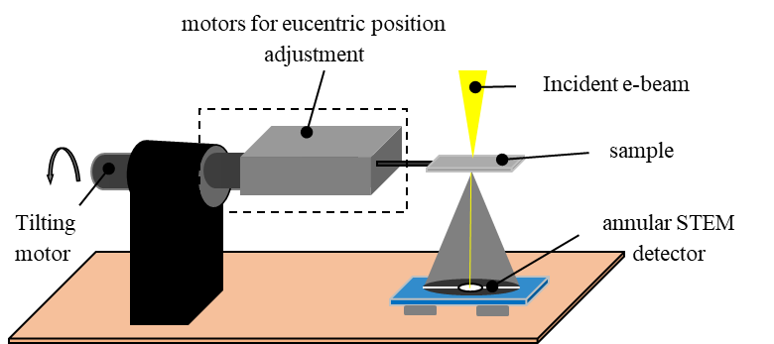
- Schematic of the tomo-STEM tool [12]
Materials and Methods
This research method is a simulation using Hurricane software, which can be installed on a computer or laptop with a minimum of Windows XP or Windows 7 specifications. Carlo decided that this product is free for the public and simply downloads it on the official website, so he doesn't use USB hardware anymore.
Simulation Methods, Conditions and Parameters
In this study, we use the method of collecting electron scattering using software Hurricane from SAMx (http://www.samx.com/index.html.fr) with Monte Carlo simulation. This research has also previously been carried out using a Monte Carlo simulation with Hurricane software with MCM-41 material [9], [11] . Prior to the simulation, the first step is to determine the sample, which can be a pure compound or a mixture. The compound used is alumina (Al₂O₃), with a layer of water and without a layer of water which will be seen through the simulation. We entered the alumina compound by selecting the compound menu that has been provided in the Hurricane software, which contains some information regarding the compound to be used in the simulation. We used an accelerating voltage of 30 keV for the simulation as defined for the experiment. Simulation parameters include the ability to specify the maximum number of passes achieved during the simulation. We selected 100,000 passes for the simulation and usually the higher the number of passes the slower the simulation process. The sample structure used in the simulation meets the following criteria: x = 5000 nm, y = 5000 nm, and for the z-axis, thickness variations from 200 nm to 4000 nm are used.
The batch simulation mode has been specially designed to allow multiple simulations to be carried out sequentially and simultaneously, with or without variations in deposit thickness. This is especially useful when simulations must be performed while changing one of the simulation parameters. For the simulation in this work, a spherical liquid precipitate with a radius of 1000 nm and thickness with variations of the liquid layer at 10 nm, 20 nm, 30 nm, 50 nm, 100 nm was used. To determine the optimum water film thickness, we set the contrast variation to 5%. The stages of the flowchart in this study displays in Figure 2.
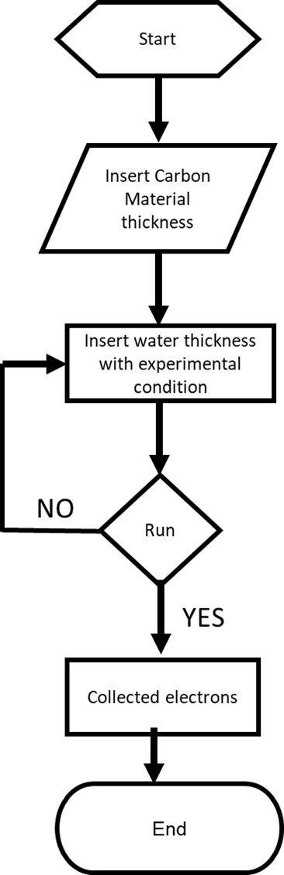
- Flowchat Monte Carlo Simulation Stages
Results and Discussion
Determination of optimum water layer thickness with variation of sample thickness Carbon
Here we discuss the results of the Monte Carlo simulation on a computational box containing Carbon thin films of varying thickness. And coated by water with variations in thickness as well. electrons collected in the Monte Carlo simulation with variations in the thickness of the water layer in the carbon sample can be seen in Figure 3. The number of electrons used is 100,000 and the average number of electrons collected at a predetermined scattering angle is between the angles of 14° - 40° [9].
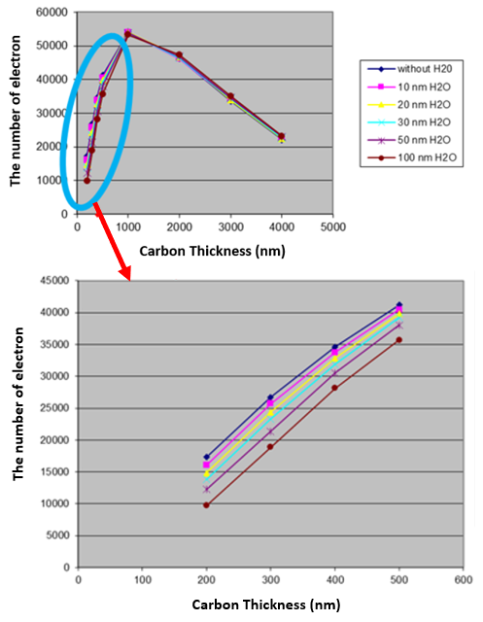
- The average number of electrons collected at scattering angles between 14° - 40° on Carbon material with variations in the thickness of the water layer.
Figure 3 presents the optimum detectable water layer and shows that Carbon with a thickness of 500 nm has a maximum point of the number of electrons collected. This represents that the greater the number of scattering electrons that can enter the dark circular field, the smaller the number of electrons collected at thicknesses above 500 nm. This can happen because the higher the thickness of carbon, the smaller electrons are captured since there are a lot of electrons which are reflected out of the dark circular field. If we maximize the thickness of carbon from 0 to 500 nano meter, the difference for each thickness of water will be known respectively. All of the thicknesses carbon with water layers, the number of electrons relatively elevate between thickness of water 200 nm and 500 nm. From here we can determine the optimal thickness of the water.
Previous studies with different samples (MCM-41) stated that the curves for different thicknesses of water layers all had the same overall shape, with a maximum thickness of MCM-41 (equal to 2 m) [9]. For the thickness of MCM-41 which is thinner than 1 m, the number of electrons increases as the increase in sample thickness causes an increase in the number of scattering events and scattering angles. On the other hand, for MCM-41 which is thicker than 2 m, then increase in the number of scattering events still leads to increase in scattering angle, which will exceed maximum gathering angle [9], [11].
In the case of carbon, the number of electrons collected escalate until the thickness of 500 nm and the scattering angle elevates as the electron scattering increases. For sample thicknesses above 500 nm, the collection angle will be more than 40° so it will induce a decrease in electron collection. The number of electrons leaving the sample is slightly affected by the layer of water above it. Nothing else affects the number of electrons collected by the detector. Therefore, it is likely to calculate the optimal water layer in which electrons can be detected at any material thickness from the Monte Carlo simulation.
Contrast Variation
When the partial pressure of water is increased, water condenses on the sample, which results in variations in contrast. The expected change in contrast between dry and wet conditions is shown in Figure 4. This provides information on the possibility of detecting a water film on carbon. For the determination of the optimal thickness of the water, we have set the contrast variation to be greater than 5% [9], [11]. All the parameter needed has been reported through the data perform in Table 1.
Table 1. Contrast variation of some carbon thickness
Variation of H₂O | Carbon Thickness (nm)
 | 200 | 300 | 400 | 500 | 1000
10 | 0.080 | 0.050 | 0.020 | 0.015 | 0.005
20 | 0.150 | 0.090 | 0.060 | 0.040 | 0.020
30 | 0.200 | 0.140 | 0.080 | 0.070 | 0.025
50 | 0.300 | 0.200 | 0.130 | 0.180 | 0.035
100 | 0.450 | 0.300 | 0.180 | 0.140 | 0.040

By the Figure 4, we can determine the optimum water layer that can be detected by taking the thickness of carbon with a contrast variation of more than or equal to 5% and the results are shown in Figure 4. Optimal contrast variation has been selected at 5% and dry to wet conditions are indicated by the increasing thickness of carbon. Contrast variation of 5% is indicated for each thickness of carbon. The optimum water thickness obtained from the contrast variation has been determined for each sample thickness.
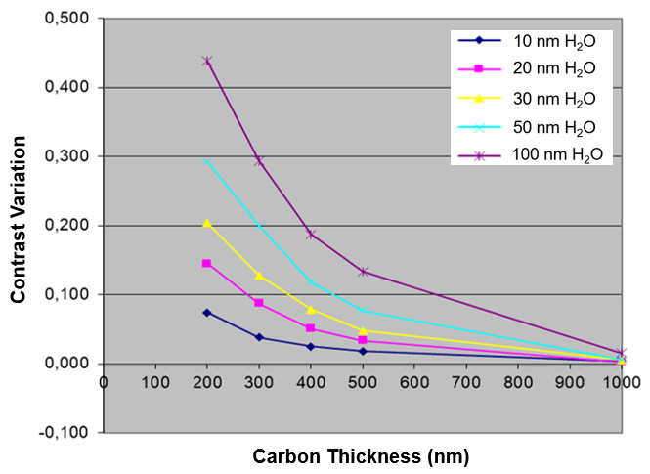
- Expected contrast variation from dry to wet conditions, in a function of matrix thickness carbon
Contrast variation is calculated from the Monte Carlo simulation to explain how a particular area can be distinguished from the water layer. The formula used is:

$$Contrast Variation = \frac{Ndry - Nwet}{Ndry}x100\%$$

where $Ndry$ and $Nwet$ correspond to the number of electrons collected in the desired region with no water layer and in a pure water layer of the same thickness [13].
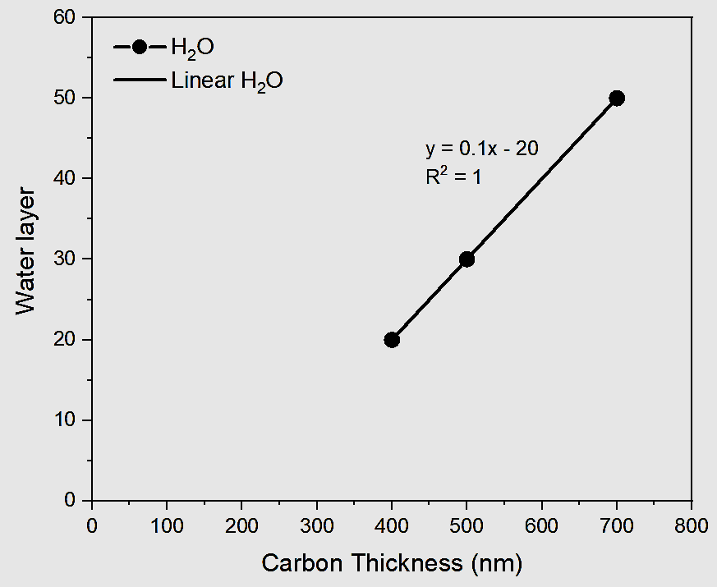
- Contrast variation in Carbon when electrons are collected in the optimum water layer
At a certain thickness of a material, the thicker the material the greater the optimum thickness of the water obtained, it means that the number of electron scattering caught is greater so that the contrast of the image obtained is clearer.
The optimum water layer thickness that can be detected are 20 nm, 30 nm, and 50 nm on carbon with a thickness of 400 nm, 500 nm, and 700 nm, respectively. Interestingly, the relationship between optimum water thickness and carbon sample thickness is linear (as shown in Figure 5). In Figure 5, three of the five water resistance data are taken, the three data taken are data that show perfect linearity. Figure 5 also shows the relationship between the optimum value of water and the thickness of carbon indicating that the higher the thickness of carbon, the higher the optimum value of water required. This represents that the higher the thickness of carbon and water, the higher the number of electrons captured by water in the annular dark field. This is closely related to previous research, on another material (MCM-41) which showed that linearity [11]. However, the optimal thickness of water is only available up to a thickness of 0.5 micrometer carbon and 50 nm of water. If the thickness of carbon and water is added continuously, more and more electrons are reflected from the dark circular field. Thus, the contrast of the image obtained is increasingly unclear.
Monte Carlo electron trajectory simulation of the interaction volume
From the Kanaya-Okayama formula shown in equation (1), we can determine the dimensions of the interaction volume of a simple material, namely Carbon. In parallel, Monte Carlo simulations of “bulk materials” provide electron trajectories, the limiting being of the interaction volume (as shown in Figure 5 for the Al₂O₃ example). We have several material thickness parameters with a computational box sample structure: x = 33,000 nm, y = 33,000 nm, and z = 20,000 nm. This parameter is used to obtain the dimensions of the interaction volume.
On carbon, the interaction volume dimension from the Monte Carlo simulation was found to be equal to 8 microns, which is in agreement with what can be obtained by the Kanaya-Okayama formula (9 microns). This validates the way we draw the interaction volume boundaries from the Monte Carlo results, and it also makes it possible to define the interaction volume dimensions for all studied materials. Obviously, the size of the interaction volume is a strong function of the energy of the incident beam as well as the structure and density of the chemical. Here's Kanaya Okayama's Formula:
$$R=\frac{\left(0.0276 E^{1.67}\right)}{Z^{0.89}}$$
Parameter of R, A, Z, $ρ$ and E is dimension interaction volume, relative atomic mass (g/mol), atomic number, density (g/cm)² and energy of incident light (keV), respectively.
Figure 6 shows the electron trajectories used to calculate the dimensions of the interaction volume or the depth that the electrons can reach as shown in the Monte Carlo simulation. When the incident ray is fired, the electrons will be scattered marked by electron traces, this Monte Carlo simulation explains the existence of traces of electrons fired by the incident light with an energy of 30 kV.
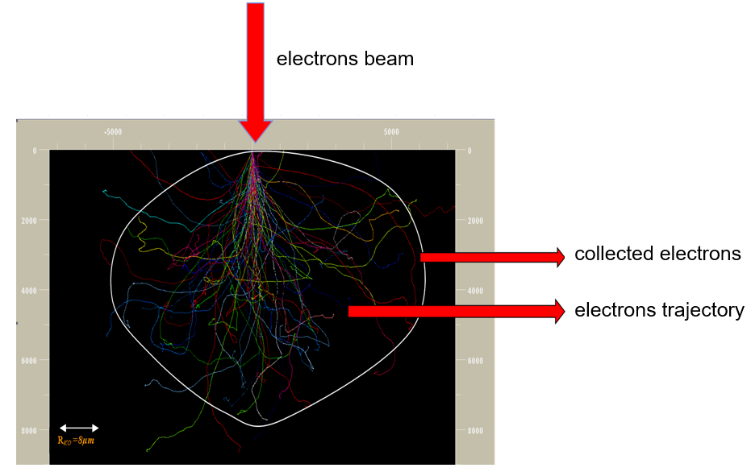
- Monte Carlo electron trajectory simulation of the interaction volume in carbon as a function of the incident radiant energy of 30 keV with a sample thickness of 20,000 nm.
Conclusions
Image contrast simulations in STEM-in-SEM simulating the experimental configuration have been investigated. Special software based on the Monte Carlo method (Hurricane software) has been used to calculate the paths of 100,000 electrons. With the Monte Carlo simulation, we have been able to calculate the optimum thickness of the water layer that can be detected in carbon material. The relationship between optimum water film thickness and sample thickness is considered to be linear, but the equation depends on the chemical structure of the sample and its density. The empirical relationship between the optimum water layer thickness and the sample layer, which also involves a measure of the interaction volume and sample density. In later work, it will be interesting to test the validity of the empirical equations we define, for example by analyzing the behavior of new materials.
Acknowledgements
The author would like to thank all related parties who helped the process of this research, especially to Prof. Karine Masenelli Varlot - MATEIST INSA Lyon France, and Dr. eng. Ferry Iskandar, M. Eng - ITB Bandung.

References
[1] J. Xiao, G. Foray, and K. Masenelli-Varlot, “Analysis of liquid suspensions using scanning electron microscopy in transmission: estimation of the water film thickness using Monte–Carlo simulations,” Journal of Microscopy, vol. 269, no. 2, pp. 151–160, 2018, doi: 10.1111/jmi.12619.
[2] G. Foray, S. Cardinal, A. Malchere, and J. M. Pelletier, “Mechanical spectroscopy, a tool to characterize cement latex composites,” Solid State Phenomena, vol. 184, pp. 399–404, 2012, doi: 10.4028/www.scientific.net/SSP.184.399.
[3] P. Yu, B. Cui, and Q. Shi, “Preparation and characterization of BaTiO3 powders and ceramics by sol-gel process using oleic acid as surfactant,” Materials Science and Engineering: A, vol. 473, no. 1–2, pp. 34–41, 2008, doi: 10.1016/j.msea.2007.03.051.
[4] G. Spina, G. Bonnefont, P. Palmero, G. Fantozzi, J. Chevalier, and L. Montanaro, “Transparent YAG obtained by spark plasma sintering of co-precipitated powder. Influence of dispersion route and sintering parameters on optical and microstructural characteristics,” Journal of the European Ceramic Society, vol. 32, no. 11, pp. 2957–2964, 2012, doi: 10.1016/j.jeurceramsoc.2012.02.052.
[5] H. Stahlberg and T. Walz, “Molecular electron microscopy: State of the art and current challenges,” ACS Chemical Biology, vol. 3, no. 5, pp. 268–281, 2008, doi: 10.1021/cb800037d.
[6] A. M. Donald, “The use of environmental scanning electron microscopy for imaging wet and insulating materials,” Nature Materials, vol. 2, no. 8, pp. 511–516, 2003, doi: 10.1038/nmat898.
[7] D. J. Stokes, B. L. Thiel, and A. M. Donald, “Direct observation of water-oil emulsion systems in the liquid state by environmental scanning electron microscopy,” Langmuir, vol. 14, no. 16, pp. 4402–4408, 1998, doi: 10.1021/la980281c.
[8] A. Bogner, G. Thollet, D. Basset, P. H. Jouneau, and C. Gauthier, “Wet STEM: A new development in environmental SEM for imaging nano-objects included in a liquid phase,” Ultramicroscopy, vol. 104, no. 3–4, pp. 290–301, 2005, doi: 10.1016/j.ultramic.2005.05.005.
[9] K. Masenelli-Varlot et al., “Wet-STEM tomography: principles, potentialities and limitations,” Microscopy and Microanalysis, vol. 20, no. 2, pp. 366–375, 2014.
[10] G. P, H. Gilde, and L. Reimer, “Measurement of the top bottom effect in scanning transmission electron microscopy of thick amorphous specimens,” J. Microsc., vol. 100, no. 1, p. . 81–92, 1974, doi: https://doi.org/10.1111/j.1365-2818.1974.tb03915.x.
[11] R. F. Septiyanto, K. Masenelli-Varlot, and F. Iskandar, “Simulation of electron-matter interaction during wet-STEM electron tomography,” AIP Conference Proceedings, vol. 1586, no. November, pp. 82–85, 2014, doi: 10.1063/1.4866735.
[12] P. Jornsanoh, G. Thollet, J. Ferreira, K. Masenelli-Varlot, C. Gauthier, and A. Bogner, “Electron tomography combining ESEM and STEM: A new 3D imaging technique,” Ultramicroscopy, vol. 111, no. 8, pp. 1247–1254, 2011, doi: 10.1016/j.ultramic.2011.01.041.
[13] J. Xiao, L. Roiban, G. Foray, and K. Masenelli-Varlot, “Characterization of Liquid Suspensions in 3D using Environmental Scanning Electron Microscopy in Transmission,” Microscopy and Microanalysis, vol. 24, no. S1, pp. 350–351, 2018, doi: 10.1017/s1431927618002246.

