Paper Title* (use style: paper title)
*Note: Sub-titles are not captured in Xplore and should not be used
*Note: This paper version is for double blind review. Author should not add any of their information within the paper file.

Abstract—This electronic document is a “live” template and already defines the components of your paper [title, text, heads, etc.] in its style sheet. *CRITICAL: Do Not Use Symbols, Special Characters, Footnotes, or Math in Paper Title or Abstract. (Abstract)
Keywords—component, formatting, style, styling, insert (key words)

Introduction (Heading 1)
This template must be used as a guideline for the format and structure of articles published in the proceedings of the International Conference on Education and Technology (ICET). Authors are required to comply with the prescribed writing rules and structure, including font type, font size, formatting of tables and figures, and citation style. This template adopts a two-column format consisting of left and right columns. The columns are interconnected, so text will automatically flow from the left column to the right column once the left column is filled. Subheadings should be written using the provided styles (e.g., Heading 1) prepared by the committee.
The introduction must include a general background, a review of previous studies (state of the art) to establish the scientific novelty of the article, a clear statement of the novelty, and the research problem (gap) or hypothesis. The final part of the introduction should present the objectives of the study and the limitations of the article. A separate literature review section is not required within the introduction. All manuscript content in each subsection must be written in Times New Roman, 10-point font, using A4 paper size (210 × 297 mm or 8.27” × 11.69”).
All paragraphs, both in the left and right columns, must be justified. The article content must follow the template formatting rules with margins set to: top 1.9 cm, left 1.6 cm, right 1.6 cm, and bottom 2.56 cm. Paragraph spacing should be set as follows: left “0 pt”, right “0 pt”, before “0 pt”, and after “6 pt”.

Method
This section should explain the research in a chronological manner, including the research design, procedures, testing methods, and data collection techniques. The explanation may be supported by diagrams, flowcharts, or tables. The description of the research process must be supported by relevant references to ensure that it is scientifically acceptable.
Since this template uses a two-column format (left and right), any explanation of methods that includes diagrams, flowcharts, or tables must be adjusted to fit within the column layout. Examples of the use of diagrams, flowcharts, and tables in explaining research methods can be seen in Figures 1 and 2 and Table 1. Figure captions should use the style Fig. 1, while tables should use the style TABLE I. Tables must be formatted using Times New Roman, 8-point font.
For embedding images in the paper, authors are requested to follow the guidelines below:
Minimum Resolution: Images (photographs, line drawings, maps) should have a minimum resolution of 300 DPI (dots per inch) for linework and 150-300 DPI for photographs.
- Format: Preferred formats are JPEG, TIFF, or PNG.
- Quality: Figures must be clear, sharp, and not pixelated. Any text within the images must be legible.
- Separation: Original high-resolution files should often be submitted separately from the main manuscript file, especially for complex graphs.
- No Screenshots: Images should not be taken from screenshots or print screens, as these usually lack the necessary resolution.

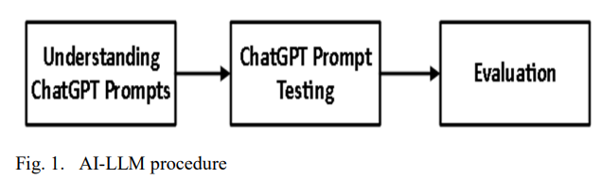
Example of a figure caption. (figure caption)
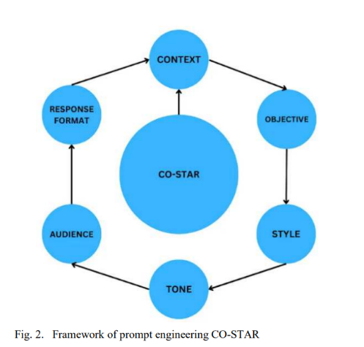
Example of a figure caption. (figure caption)
Table Type Styles
Table Head | Table Column Head
 | Table column subhead | Subhead | Subhead
copy | More table copyª

Result And Discussion
Before you begin to format your paper, first write and save the content as a separate text file. Complete all content and organizational editing before formatting. Please note sections A-D below for more information on proofreading, spelling and grammar.
Keep your text and graphic files separate until after the text has been formatted and styled. Do not use hard tabs, and limit use of hard returns to only one return at the end of a paragraph. Do not add any kind of pagination anywhere in the paper. Do not number text heads-the template will do that for you.

Abbreviations and Acronyms
Define abbreviations and acronyms the first time they are used in the text, even after they have been defined in the abstract. Abbreviations such as IEEE, SI, MKS, CGS, sc, dc, and rms do not have to be defined. Do not use abbreviations in the title or heads unless they are unavoidable.

Units
- Use either SI (MKS) or CGS as primary units. (SI units are encouraged.) English units may be used as secondary units (in parentheses). An exception would be the use of English units as identifiers in trade, such as “3.5-inch disk drive”.
- Avoid combining SI and CGS units, such as current in amperes and magnetic field in oersteds. This often leads to confusion because equations do not balance dimensionally. If you must use mixed units, clearly state the units for each quantity that you use in an equation.
- Do not mix complete spellings and abbreviations of units: “Wb/m2” or “webers per square meter”, not “webers/m2”. Spell out units when they appear in text: “. . . a few henries”, not “. . . a few H”.
Identify applicable funding agency here. If none, delete this text box.
- Use a zero before decimal points: “0.25”, not “.25”. Use “cm3”, not “cc”. (bullet list)

Equations
The equations are an exception to the prescribed specifications of this template. You will need to determine whether or not your equation should be typed using either the Times New Roman or the Symbol font (please no other font). To create multileveled equations, it may be necessary to treat the equation as a graphic and insert it into the text after your paper is styled.
Number equations consecutively. Equation numbers, within parentheses, are to position flush right, as in (1), using a right tab stop. To make your equations more compact, you may use the solidus ( / ), the exp function, or appropriate exponents. Italicize Roman symbols for quantities and variables, but not Greek symbols. Use a long dash rather than a hyphen for a minus sign. Punctuate equations with commas or periods when they are part of a sentence, as in:
a  b    
Note that the equation is centered using a center tab stop. Be sure that the symbols in your equation have been defined before or immediately following the equation. Use “(1)”, not “Eq. (1)” or “equation (1)”, except at the beginning of a sentence: “Equation (1) is . . .”

Some Common Mistakes
- The word “data” is plural, not singular.
- The subscript for the permeability of vacuum μ₀, and other common scientific constants, is zero with subscript formatting, not a lowercase letter “o”.
- In American English, commas, semicolons, periods, question and exclamation marks are located within quotation marks only when a complete thought or name is cited, such as a title or full quotation. When quotation marks are used, instead of a bold or italic typeface, to highlight a word or phrase, punctuation should appear outside of the quotation marks. A parenthetical phrase or statement at the end of a sentence is punctuated outside of the closing parenthesis (like this). (A parenthetical sentence is punctuated within the parentheses.)
- A graph within a graph is an “inset”, not an “insert”. The word alternatively is preferred to the word “alternately” (unless you really mean something that alternates).
- Do not use the word “essentially” to mean “approximately” or “effectively”.
- In your paper title, if the words “that uses” can accurately replace the word “using”, capitalize the “u”; if not, keep using lower-cased.
- Be aware of the different meanings of the homophones “affect” and “effect”, “complement” and “compliment”, “discreet” and “discrete”, “principal” and “principle”.
- Do not confuse “imply” and “infer”.
- The prefix “non” is not a word; it should be joined to the word it modifies, usually without a hyphen.
- There is no period after the “et” in the Latin abbreviation “et al.”.
- The abbreviation “i.e.” means “that is”, and the abbreviation “e.g.” means “for example”.
An excellent style manual for science writers is [7].
Considering that this template uses a two-column layout (left and right columns), if authors include images or tables of relatively large size, they should be formatted according to the following guidelines, as illustrated in Figure 3 and Table II.

Table Type Styles
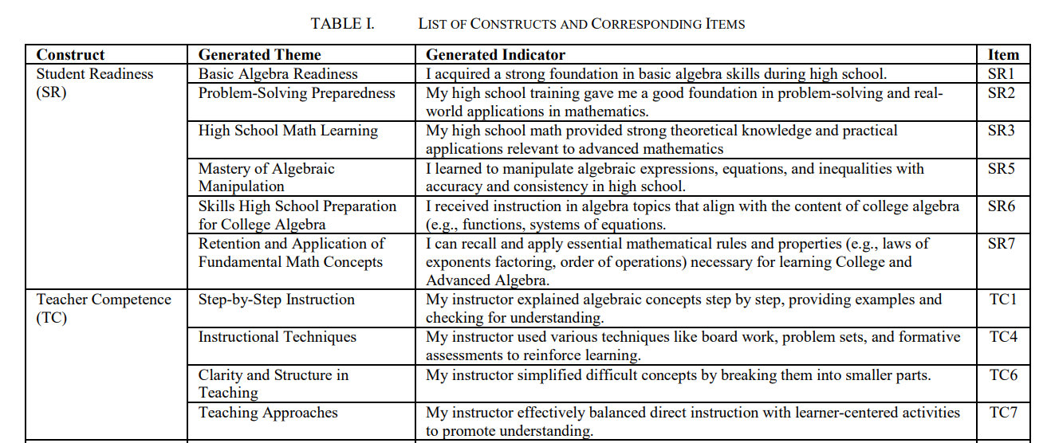

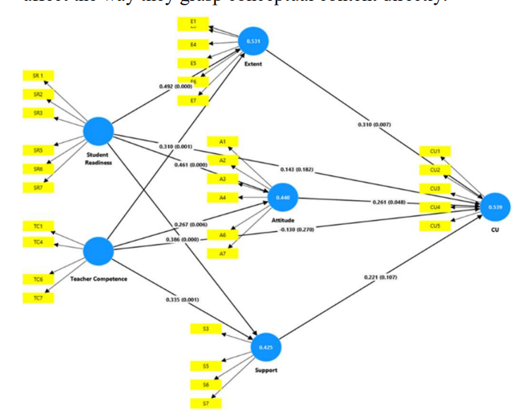
Example of a figure caption. (figure caption)
Sumber: ICET 11th 2025

Conclusion
After the text edit has been completed, the paper is ready for the template. Duplicate the template file by using the Save As command, and use the naming convention prescribed by your conference for the name of your paper. In this newly created file, highlight all of the contents and import your prepared text file. You are now ready to style your paper; use the scroll down window on the left of the MS Word Formatting toolbar.

Acknowledgment (Heading 5)
The preferred spelling of the word “acknowledgment” in America is without an “e” after the “g”. Avoid the stilted expression “one of us (R. B. G.) thanks ...”. Instead, try “R. B. G. thanks...”. Put sponsor acknowledgments in the unnumbered footnote on the first page.

References
The template will number citations consecutively within brackets [1]. The sentence punctuation follows the bracket [2]. Refer simply to the reference number, as in [3]—do not use “Ref. [3]” or “reference [3]” except at the beginning of a sentence: “Reference [3] was the first ...”
Number footnotes separately in superscripts. Place the actual footnote at the bottom of the column in which it was cited. Do not put footnotes in the abstract or reference list. Use letters for table footnotes.
Unless there are six authors or more give all authors’ names; do not use “et al.”. Papers that have not been published, even if they have been submitted for publication,

should be cited as “unpublished” [4]. Papers that have been accepted for publication should be cited as “in press” [5]. Capitalize only the first word in a paper title, except for proper nouns and element symbols.
For papers published in translation journals, please give the English citation first, followed by the original foreign-language citation [6].

- G. Eason, B. Noble, and I. N. Sneddon, “On certain integrals of Lipschitz-Hankel type involving products of Bessel functions,” Phil. Trans. Roy. Soc. London, vol. A247, pp. 529–551, April 1955. (references)
- J. Clerk Maxwell, A Treatise on Electricity and Magnetism, 3rd ed., vol. 2. Oxford: Clarendon, 1892, pp.68–73.
- I. S. Jacobs and C. P. Bean, “Fine particles, thin films and exchange anisotropy,” in Magnetism, vol. III, G. T. Rado and H. Suhl, Eds. New York: Academic, 1963, pp. 271–350.
- K. Elissa, “Title of paper if known,” unpublished.
- R. Nicole, “Title of paper with only first word capitalized,” J. Name Stand. Abbrev., in press.
- Y. Yorozu, M. Hirano, K. Oka, and Y. Tagawa, “Electron spectroscopy studies on magneto-optical media and plastic substrate interface,” IEEE Transl. J. Magn. Japan, vol. 2, pp. 740–741, August 1987 [Digests 9th Annual Conf. Magnetics Japan, p. 301, 1982].
- M. Young, The Technical Writer’s Handbook. Mill Valley, CA: University Science, 1989.

IEEE conference templates contain guidance text for composing and formatting conference papers. Please ensure that all template text is removed from your conference paper prior to submission to the conference. Failure to remove template text from your paper may result in your paper not being published.
We suggest that you use a text box to insert a graphic (which is ideally a 300 dpi TIFF or EPS file, with all fonts embedded) because, in an MSW document, this method is somewhat more stable than directly inserting a picture.
To have non-visible rules on your frame, use the MSWord “Format” pull-down menu, select Text Box > Colors and Lines to choose No Fill and No Line.

