 | Contents list available at CBIORE journal website  International Journal of Renewable Energy Development  Journal homepage: https://ijred.cbiore.id | 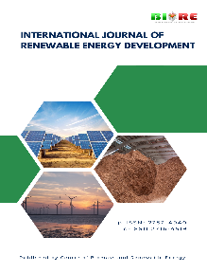
Review/Research Article

Title of manuscript submitted to int. journal of renewable energy development (Amasis MT Pro, 17 pt)

Full Name1ª, Full Name of Author2ª, Full Name of Author3^{b}, Author^{a,c} (12pt)
ªAffiliation, Country (8 pt)
^{b}Afilliation,, Country
^{c}Affiliation, Country
List of ORCID of each author
ORCID author 1: https://orcid.org/0000-000-xxx-xxx
ORCID author 2: https://orcid.org/0000-000-xxx-xxx
..etc
Abstract. The abstract should be clear, concise, descriptive and should provide a brief introduction to the problem. This should generally be followed by a statement regarding the methodology and a brief summary of results. The abstract should end with a comment on the significance of the results or a brief conclusion. Abstracts are written in 8 pt Amasis MT Pro, preferably 250-300 words.

Keywords: Provide keywords, at least 5 words (8 pt)
@ The author(s). Published by CBIORE. This is an open access article under the CC BY-SA license
(http://creativecommons.org/licenses/by-sa/4.0/).
Received: xxx; Revised: xxxx; Accepted: xxx; Available online: xxx

- Introduction
By using this template will enable you to prepare your manuscript in accordance with the instructions for authors for International Journal of Renewable Energy Development (IJRED) papers with a minimal amount of manual styling and formatting. Font 9 pt.
Where appropriate you should overtype the different fields with your own text. Make sure that as you do this the correct style for the current paragraph is still displayed in the style box on the menu bar. Please read through the following sections for more information on preparing your paper. However, if you use the template you do not have to worry about setting margins, page size, and column size etc. as the template already has the correct dimensions.
The style of citation of references follows the journal template (Achankeng 2003). This can be done with following example (Sira et al. 2001).
2. Format
2.1 Format
Text should be produced within the dimensions shown on these pages. Make use of the maximum stipulated length apart from the following two exceptions: (i) do not begin a new section directly at the bottom of a page, but transfer the heading to the top of the next column; (ii) you may exceed the length of the text area by one line only in order to complete a section of text or a paragraph. You must use 1.0 (single) line spacing and Amasis MT Pro font. However, when typing complicated mathematical text it is important to increase the space between the text lines in order to prevent sub- and superscript fonts overlapping one another and making your printed matter illegible. If you are using a desktop publishing program ensure that your auto adjust for interline spacing is suitably set to prevent overlapping but without leaving too much space.
2.2 Authors
Author names should be in 13 pt Century Schoolbook with 6 pts above and 6 pts below. Author addresses are superscripted by numerals and centered over both columns of manuscripts. Professional positions/ titles such as Professor, Dr., Production Manager etc., are to be avoided.
3. Table
Tables should have a title which makes the general meaning understandable without reference to the text. Tables should be presented in the form shown in Table 1, with all text, including title 8pt. Their layout should be consistent throughout.
Horizontal lines should be placed above and below table headings, above the subheadings and at the end of the table above any notes. Vertical lines should be avoided.
If a Table is too long to fit onto one page, the table number and headings should be repeated on the next page before the table is continued. Alternatively, the table can be spread over two consecutive pages (first on even-numbered, then on odd-numbered page). For Figure must be clear and high resolution with min 300 dpi

4. Figure
All illustrations should be clearly displayed by leaving at least a single line of spacing above and below them. When placing a figure at the top of a page, the top of the figure should be at the same level as the first text line of the other column. Legends to illustrations should be centered if on one line or aligned left if on two or more lines and should be 8 pt.
Photographs must always be sharp originals (not screened versions) and rich in contrast. A copy or scan of the photograph should be pasted on the page and the original photograph (labelled) should accompany your paper.
Sharp originals (not transparencies or slides) should be submitted close to the size expected in the publication. All notations and lettering should be no less than 2 mm high. The use of heavy black, bold lettering should be avoided as this will look unpleasantly dark when printed.

Figure 1
5. Equation
Equations should be placed flush-left with the text margin and should be precede and followed by one line of white.
$NPV=-I_{0}+\sum_{1}^{n}{\frac{B-C}{1+r^{2}}}$ (1)

where: NPV is the net present value, t_{PB} is dynamic payback period, IRR is the internal rate of return, I₀ is the initial investment, B represents the benefits in the project life, r is the interest rate (assumed to be 10%), and C represents the costs.

6. Conclusion
Papers not prepared in accordance with these guide lines and manuscripts with number of mistakes will have to be pre-rejected by Editor. Submission of full-text paper can be done through Online Electronic Submissions Interface at the following URL address:
https://ijred.cbiore.id
Currently, online version of IJRED articles in PDF format can be opened for free open access at IJRED website https://ijred.cbiore.id
Acknowledgments
You can put your acknowledgements here

Author Contributions: A.A.: Conceptualization, methodology, formal analysis, writing—original draft, B.B.; supervision, resources, project administration, C.C.; writing—review and editing, project administration, validation, DD.; writing—review and editing, project administration, validation. All authors have read and agreed to the published version of the manuscript.
Funding: This research was funded by xxxxx, or …The author(s) received no financial support for the research, authorship, and/or publication of this article.
Conflicts of Interest: (state the conflicts of interest, if any) or if not: The authors declare no conflict of interest.
References (min 40 references)
Alwis, A. (2001) Study on the potential for biogas in Sri Lanka. ITDG South Asia.
Nazemzadegan, M., & Ghasempour, R. (2019). Evaluating the materials used for hydrogen production based on photoelectrochemical technology. International Journal of Renewable Energy Development, 8(2), 169-178; https://doi.org/10.14710/ijred.8.2.169-178
Government of Zimbabwe (2004) Census 2002. National Report, Central Statistical Office, Harare
McInerney J. (2011) Biogas Technology on Uzi Island. A Feasibility Study Zanzibar.
Rajorhia, U., Kumar, A., & Sharma, R. (2012) Utilisation of Farm Waste in Biogas Production. http://www.landmarkgoc.com/biogas_project.html. Accessed on 3 March 2012

© 202x. The Author(s). This article is an open access article distributed under the terms and conditions of the Creative Commons Attribution-ShareAlike 4.0 (CC BY-SA) International License (http://creativecommons.org/licenses/by-sa/4.0/)

List of Table
Table 1…..
Table 2….

Put your Tables here
Table 1
Provide the caption of your legend
Suburb | Energy source (number of respondents; multiple responses allowed
 | Electricity | Wood | Paraffin
Par 1 | 2 | 13 | 8
Par 2 | 3 | 17 | 13
Par 3 | 1 | 5 | 9
Source: Reference(Year)

List of Figure

Figure 1……
Figure 2…

Put your Figures here

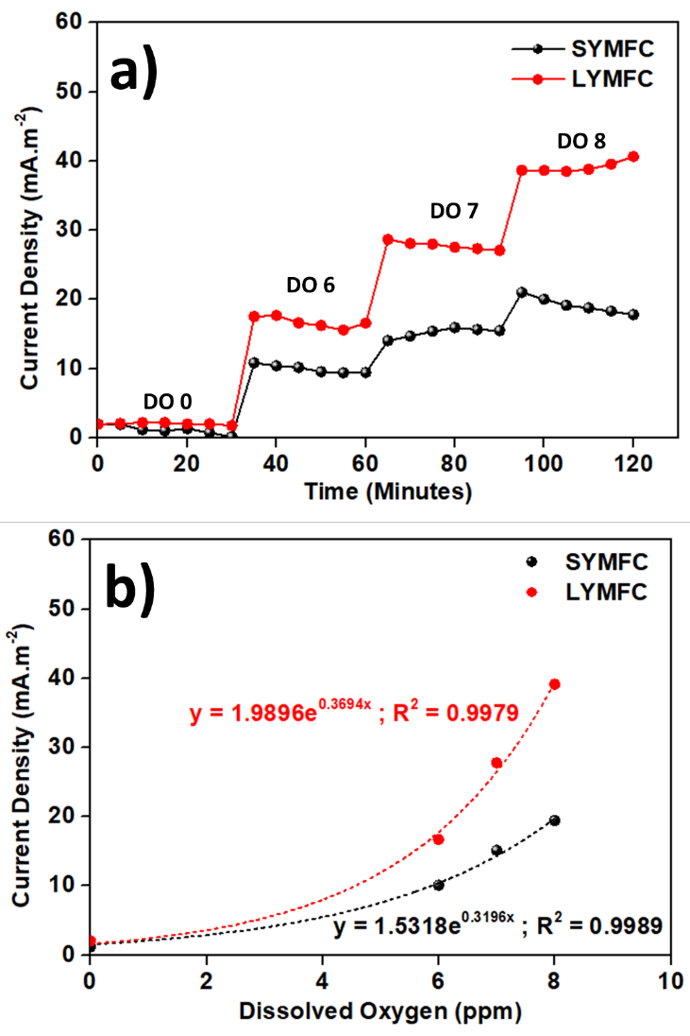
Fig. 1 Provide the caption for your Figures

Corresponding author Email: youremail@mail.com (Name)

