[Please DOWNLOAD this template and edit your manuscript according to this template.]
Your Manuscript’s Title
(Your Manuscript’s Title in English, if the manuscript is in Malay)

Author 1,* Author 2** & Author 3***

Abstract

Please put your abstract here, not more than 250 words. Please put your abstract here, not more than 250 words. Please put your abstract here, not more than 250 words. Please put your abstract here, not more than 250 words. Please put your abstract here, not more than 250 words. Please put your abstract here, not more than 250 words. Please put your abstract here, not more than 250 words. Please put your abstract here, not more than 250 words. Please put your abstract here, not more than 250 words. Please put your abstract here, not more than 250 words. Please put your abstract here, not more than 250 words. Please put your abstract here, not more than 250 words. Please put your abstract here, not more than 250 words. Please put your abstract here, not more than 250 words. Please put your abstract here, not more than 250 words. Please put your abstract here, not more than 250 words. Please put your abstract here, not more than 250 words. Please put your abstract here, not more than 250 words. Please put your abstract here, not more than 250 words. Please put your abstract here, not more than 250 words. Please put your abstract here, not more than 250 words. Please put your abstract here, not more than 250 words. Please put your abstract here, not more than 250 words.

Keywords: 5 keywords, separated by commas

Introduction

Times New Roman, size 12, single spacing, justified. Times New Roman, size 12, single spacing, justified. Times New Roman, size 12, single spacing, justified. Times New Roman, size 12, single spacing, justified. Times New Roman, size 12, single spacing, justified. Times New Roman, size 12, single spacing, justified. Times New Roman, size 12, single spacing, justified. Times New Roman, size 12, single spacing, justified.

First Layer Topic

According to XXX, …

Frist Layer Topic

Second Layer Topic
By referring to…

Third Layer Topic
Generally, many authors argued that…

Photo 1: Description of the Photo
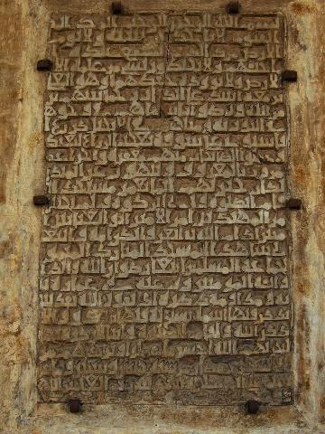
Source: XXX

Figure 1: Description of the Figure

Theoretical framework of...

C

B

A

Source: YYY

Table 1: Description of the Table
XXX | YYY | ZZZ
Source: The Authors’

Remember Abraham said: “O my Lord! Make this city [i.e., Mecca] one of peace and security; and preserve me and my sons from worshipping idols. O my Lord! They have indeed led astray many among mankind […].”

Conclusion

Times New Roman, size 12, single spacing, justified. Times New Roman, size 12, single spacing, justified. Times New Roman, size 12, single spacing, justified. Times New Roman, size 12, single spacing, justified. Times New Roman, size 12, single spacing, justified. Times New Roman, size 12, single spacing, justified. Times New Roman, size 12, single spacing, justified. Times New Roman, size 12, single spacing, justified.

Acknowledgement

Please provide your acknowledgement here. For example: The authors would like to thank the University of xxxxx for providing a research grant to carry out this research. The grant number is xxxxxx.

References

Starting from Volume 20, Issue 1, Journal of Al-Tamaddun fully uses the 18th Edition of the Chicago Style for both footnotes and references. Manuscripts that do not comply with the format will be immediately rejected. Please refer to the journal’s submission guidelines. (Please refer to the journal’s guidelines: https://ejournal.um.edu.my/index.php/JAT/Guidelines)

∗ Author 1 (corresponding author) (PhD), Designation, Affiliation. Email. Please refer to the example below.
** Ahmad (PhD), Senior Lecturer, Department of XXX, Faculty of YYY, Universiti Malaya, Kuala Lumpur, Malaysia. Email: ahmad987@um.edu.my.
*** Siti (PhD), Associate Professor, Institute of AAA, Universiti Kebangsaan Malaysia, Selangor, Malaysia. Email: siti456@ukm.edu.my. For manuscript in Malay, author(s) affiliation must be IN ENGLISH.
Starting from Volume 20 Issue 1, Journal of Al-Tamaddun fully uses the 18th Edition of Chicago Style for both footnotes and references. Manuscripts which do not comply with the format will be immediately rejected. Please refer to the journal’s submission guideline.
Source of the phrase.

