Guidelines for Preparing Paper Manuscript for the Journal of the Civil

Engineering Forum

Ali Awaludin ^{1,*} , Masaharu Fujita ²

¹ Department of Civil and Environmental Engineering, Universitas Gadjah Mada, Yogyakarta, INDONESIA

² Disaster Prevention Research Institute, Kyoto University, Kyoto, JAPAN

* Corresponding authors: ali_hokkaido@yahoo.com

 | Journal of Civil Engineering Forum, January 20XX, X(X): xx-xx  DOI 10.22146/jcef.XXXXX  Available Online at: https://journal.ugm.ac.id/v3/JCEF/issue/archive

Guidelines for Preparing Paper Manuscript for the Journal of the Civil

Engineering Forum
SUBMITTED 1 Agustus 2025 REVISED xxxxx ACCEPTED xxxx
ABSTRACT Contains a short description of the paper. The abstract shall be at least 250 words but not exceed 300 words. Use Abstract style to write all abstract text. The abstract should briefly summarise the essence of the paper and include background, objective, method, results, and conclusions. Avoid using abbreviations and citations.
KEYWORDS Three; to; six; Words; 3-6 words.
© The Author(s) 2020. This article is distributed under a Creative Commons Attribution-ShareAlike 4.0 International license.

GENERAL INFORMATION

The Manuscript
Authors have to type their papers in a form suitable for proceedings publication. Authors shall closely follow the instruction set below in preparing their paper. Use of MSWord document processor is preferable, but not mandatory, for preparing the manuscript.
This document was prepared by MSWord and should be used as the template when using the same document processor. Every paragraph has a specific style definition. Apply the style that has been defined to corresponding paragraph. Do not modify locally any paragraph or text except for mathematical variables in text or Latin words. Always click the style name available on this document that corresponds to each paragraph. See the Styles bar on the top or on the right side of your screen to find the correct style. The paper layout should look like this document.
The paper must contain several chapters coherently: 1) Introduction, 2) Methods, 3) Result, 4) Discussion, and 5) Conclusion. The paper must be written in 6 to 12 pages, including appendices and references. Total words of the Research Paper is 5000 – 6000 words, excluding references. Insert line number beside text for the whole manuscript.

Page Layout
Use an A4 (210×297 mm) size paper for preparing the paper. Set the left and right margins at 15 mm, top and bottom margins at 25 mm. Use one-column page layout for all section of the paper. Set the centre margin at 10 mm (the column width is 85 mm). The page has different odd and even footers, but their headers remain the same.

Font Type, Font Size, and Line Spacing
Use PT Serif 11 point and single line spacing for body text (Normal style). Use Noto Sans 8 point for the abstract (Abstract style), the keywords (Keyword style), Heading (Heading style), the table captions (Table Caption style), the figure captions (Figure Caption style), and the references (Reference style). Use italics for titles of journals or books, parameters in mathematics except for functions (log, ln, sin, cos, max., d in dx, etc.). Never use the bold typeface, except to denote vectors in mathematics. Never underline any text.
Never letter spacing and never use more than one space after each word except those added automatically by the document processor. Refrain from leaving the blank line between paragraphs.

Header and Footer
The header and footer are placed at 125 mm from the top and bottom margins, respectively. The header and footer are written in 10 points Noto sans type font, center aligned, single line spacing, zero spacing before and after the paragraph.

Online Submission
Authors shall submit their papers through the Online Submission System in Journal of the Civil Engineering Forum portal. Please visit https://journal.ugm.ac.id/v3/JCEF/about/submissions for further information.

Title
Apply Title style to the paper’s title. This style has everything needed to define the title layout (font type and size, paragraph alignment, spacing). The title shall be 14 point Noto Sans type font, title case (capitalize the first character of each text, except for preposition), Center aligned, single line spacing, 20 point spacing before and after the paragraph.

Authors and Their Affiliation
Type the name of the authors followed by their last name. Group the authors by their affiliation. If there is only one co-author and he/she has the same affiliation with that of the first author, put the word “and” to separate their names.
Apply Author style to the author paragraph. The authors are written in 11 points Noto Sans type font, center-aligned, single line spacing, 20 point spacing before and after the paragraph.
Apply Author Affiliation style to the affiliation paragraph. The paragraph should be 8 points Noto Sans type, center aligned, single line spacing, zero spacing before and after the paragraph. Author(s) affiliation should contain the following: company/institute/university, city, country (all capital character).

Abstract
The abstract must consist of 250-300 words. Apply Abstract style to the paragraph. It defines the abstract paragraph as 8 points Noto Sans type, justified alignment, single line spacing, 6 point spacing before and 6 point spacing after the paragraph.

Keywords
Write 5 keywords separated by a semicolon (;). Apply Keyword style to the paragraph. It defines the keywords paragraph as 8 points Noto Sans type, left aligned, single line spacing, zero spacing before and after the paragraph.

Headings
Use of two ranks of heading is preferable for the chapter and section. Apply Heading 1 and Heading 2 styles for the chapter and section headings, respectively. You may add a sub-section to have three ranks of heading and apply Heading 3 for this sub-section. Headings shall be kept with the paragraph that immediately follows.
The chapter heading is written in 10 points Noto Sans, 12 point spacing before and 4 point spacing after the paragraph. By applying Heading 1 style, an all capital character and an automatic numbering will be given to the chapter heading. The chapter heading is automatically kept with the paragraph that immediately follows.
The section heading is written in 10 point Noto Sans type font, single line spacing, 12 point spacing before and 4 point spacing after the paragraph. By applying Heading 2 style, an automatic numbering will be given to the section heading. The section heading is automatically kept with the paragraph that immediately follows.
It is strongly recommended to organize the paper in chapters and sections. In rare cases, the paper may have sub-section. However, the author should try to avoid having sub-section in his/her paper. The paragraph below is an example of a sub-section heading.

This is a sub-section heading
The sub-section heading is written in 10 points roman type font, single line spacing, 10 point spacing before and 0 point spacing after the paragraph. An automatic numbering will be given when Heading 3 style is applied to the sub-section heading.

Text
Apply Normal style to paragraphs of the text. It defines the paragraphs to be 11 points PT Serif type font, justified alignment, single line spacing, zero-point spacing before and 10 point spacing after the paragraph. Do not use blank paragraphs to get spacing between consecutive paragraphs.
You may activate line hyphenation. This gives a better paragraph format, but you will have to be careful that the sentence is hyphenated correctly.
Do not locally modify paragraph except to write mathematical parameters or symbols, Latin words, titles of journals or books.
- Use numbering format to write lists.
- Use this type of numbering.
- It is done by applying paragraph numbering format that is available in MSWord.
- Do not indent the list.
Numerals of five or more digits are grouped in three-digit blocks by spaces or commas, e.g. 10,000. Do not do that for numerals of four or fewer digits, e.g. 9000. Decimals are expressed by point, e.g. 3.141592654 or 3.141 592 654. Pay attention not to line break numerals. To keep space-separated words on the same line, use non-hyphenated space. Press SPACEBAR while pressing CONTROL+SHIFT keys, i.e. press together the spacebar, control, and shift keys, to insert this non-hyphenated space.
Use SI unit or its derivatives to denote units.

Equations
Use equation editor for special high-quality fonts for all mathematical equations in the text. Italic type font shall be used as variable except for Greek symbols. Type f but Ф for variables. Roman type font shall be used as a function, e.g. sin, exp, log, d in dx, ∂ in ∂x. Do not type d when you mean differential. You may have dd/dx to express differential of d with respect to x. Do not use italic type font for the unit. Type s instead of s for time unit in second. Type s for variable s, which you may define for distance. Type C for degree unit in Celsius, but type C for a variable that you may define for concentration for example.
Use bold characters to denote matrix or vector variables.
Use an appropriate symbol for degree, which you may get by inserting degree sign from Symbol toolbar available in MSWord, for example 28°C. Do not use superscripted o for degree sign. Use multiplication sign × instead of x for multiplication.
Give the definition of variables below the equation where they appear for the first time.
The equation paragraph is left-aligned, single line spacing, zero-point spacing before and 10 point spacing after the paragraph, do not add space between equation paragraphs. Apply Equation style to define the equation paragraph.
Number consecutively the equations according to their order of appearance. Place the number in parentheses; flush it to the right margin using the tab key. Refer equations by these numbers. Equation (1) and Equation (2) are examples of putting equations in the text.
(1)
where A is the cross-sectional area of flow, Q is the discharge, q_{ℓ} is the lateral flow per unit length of the channel, t is the time, and x is the distance along the channel.
(2)
where u is the flow velocity, Ф is a scalar variable, Γ is the diffusion coefficient, R is the source, and x is the distance along the flow.

Tables
Tables should be located close to the first reference to them in the text and number them consecutively. Explanations should be given at the foot of the table, not within the table itself. Use only horizontal rules: One above and one below the column headings and one at the foot of the table. Tables are written in 10 point PT Serif type font. You may use a smaller font size (9 points) in tables. The table should fit within a column width of 85 mm.
Apply Table Text style to all table texts and column headings. Align column headings to the left of their column and start these headings with an initial capital. Column headings are vertically centered, single line spacing. Align all table texts to the left of their column and to the top of their row. Table texts are single line spacing, zero-point spacing before and after the paragraph.
Type table’s caption above the table. Use 9 point Noto Sans type font, left aligned, single line spacing, 15 points spacing before and 4 points spacing after the paragraph, keep together with the table. Do not put a full stop (“.”) at the end of the caption. Apply Table Caption style to the table caption. See for example Table 1.
You may have two-column wide tables. For such cases, place the tables in a one-column page layout. Try to place a two-column wide table on top or bottom of a page. Place a column break before and after the tables and set the page layout accordingly. The table should fit within the type area width of 180 mm. Table 2 shows an example of wide table placement.

Figures
Figures should be located close to the first reference to them in the text and number them consecutively. Do not make a distinction between photographs and diagrams. Figures should fit within one column width of 85 mm or within the type area width of 180 mm. Figures should have the minimum resolution of 300 dpi. The maximum number of Figures is limited to eight figures.
It is preferable to format figures as a picture. When figures are edited directly in the text, place them in a drawing canvas. Do not place drawing objects on spaces created by inserting blank lines.
Set the wrapping style of figures to “in line with text”. You find this option by right-clicking the drawing canvas or the figure, select format figures or drawing canvas, and select the appropriate wrapping style on the window that appears.
Table 1. Names of styles used in the paper manuscript
Styles | Uses
Abstract | Abstract
Author | Authors
Author Affiliation | Authors’ affiliation
Equation | Equations
Figure | Figures
Figure Caption | Caption of figures
Footer | Footer
Header | Header
Heading 1 | Chapter heading
Heading 2 | Section heading
Heading 3 | Sub-section heading
Heading Not-numbered | Heading for acknowledgment, references, appendices
Keyword | Keywords
List Paragraph | Numbered lists
Normal | Text
Strong | Heading of the abstract and of the Keywords
Table Caption | Caption of tables
Table Text | Texts in tables
Title | Title of the paper
Apply Figure style to the figure paragraph. This ensures that figures will have correct spacing between paragraphs. Place the figure caption underneath the figure. Apply Figure Caption style to the figure caption. The caption is written in 9 point Noto Sans type font, left aligned, single line spacing, 0 point spacing before and 15 point spacing after the paragraph. Put a full stop (“.”) at the end of the caption. Figure 1 gives an example of figure pasted from a jpg file, whereas Figure 2 is an example of figure made by inserting shapes directly on a drawing canvas.
Place wide figures in a one-column page layout. Try to place them on top or bottom of the page. Place a column break before and after the figures and set the page layout accordingly. The figures should fit within the type area width of 180 mm. Apply Figure style to the paragraph. Add caption underneath the figure and apply Figure Caption style. Example of this type is given in Figure 3.
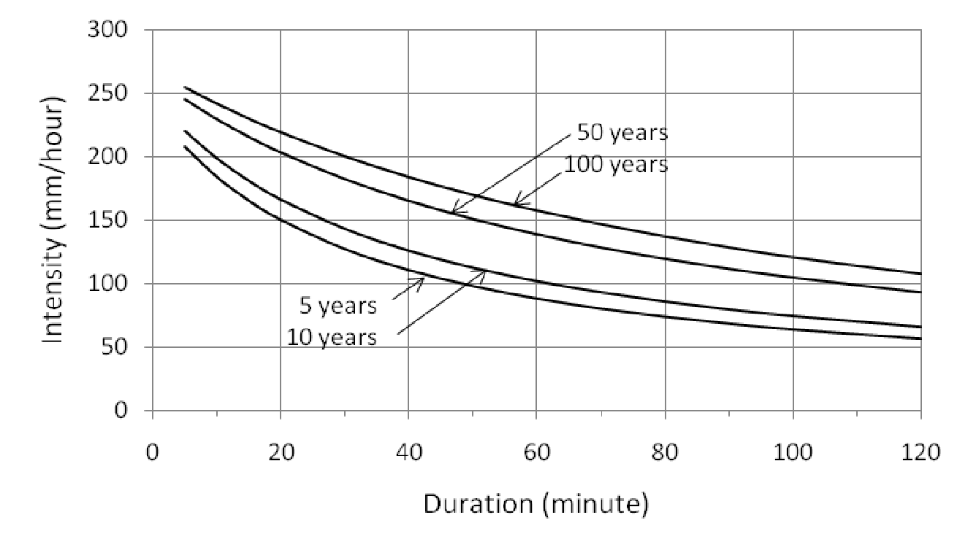
Figure 1. Example of figure pasted into the paper from a jpg file. Set the wrapping style as in line with text.

a
b
c
d

Figure 2. Example of figure edited directly on a drawing canvas.
Table 2. The maximum concentration of NO_{x} for the simple terrain scenario
 | Maximum concentration  (μg/m³) | Indonesian NAAQS*  (μg/m³) | Distance to maximum  (μg/m³)
1-hour concentration | 15.090 | 400 | 951
24-hour concentration | 6.036 | 150 | 951
Annual concentration | 1.207 | 100 | 951
* The Government De5000cree No. 41, May 26, 1999 concerning the National Ambient Level Standard of Air Pollutant.
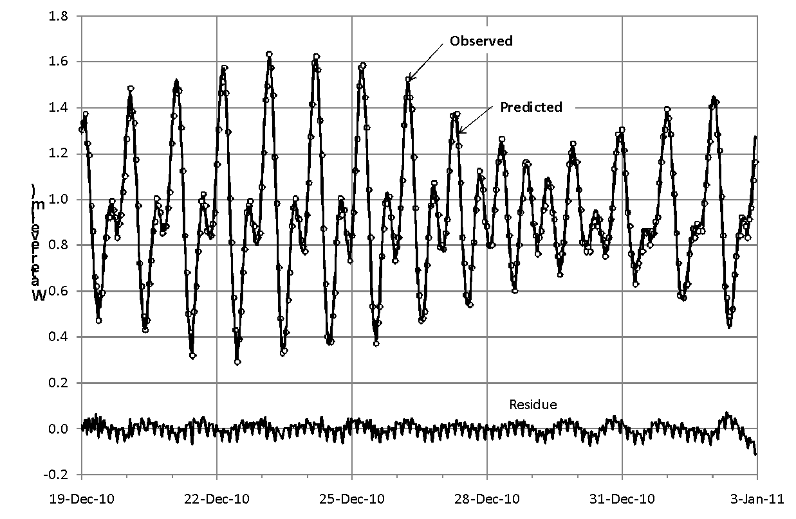
Figure 3. Example of wide figure. It has to fit within type area width of 180 mm.

INTRODUCTION
The introduction must consist of the background of the study, state of the art, gap analysis and aim of the study. The background is one or two paragraph explains the reason why this study is conducted. State of the art consists of literature studies which lead to a knowledge gap among the existing studies. The state of the art should be a guide to find a novelty of the study. Gap analysis is a statement to describe finding from the state of the art and the emergence reason for a study is important to be conducted. The gap analysis must state that the study is never conducted elsewhere before. The last paragraph should contain the aim of study which is generated from gap analysis. The last sentences in The Introduction should state the possible contribution of the study to the existing literature or the existing situation. Adding a new sub-section in The Introduction section is not allowed.

METHODS
The methods section should describe what was done to answer the research question, describe how it was done, justify the experimental design, and explain how the results were analyzed. Scientific writing is direct and orderly. In the methods section it is customary to use a form of the simple past tense to describe what the author did in his/her study. Passive voice is often used. Examples: Total phosphorous (TP) and total nitrogen (TN) were measured in the laboratory using standard procedures.
In the method, it is important to describe the type of research; what kind of data and how data is collected and/or selected your data; how data is analyzed; any tools or materials used in the research; the rationale for choosing these methods. The reason for selecting a method should be supported by references.

RESULTS
The results section should include the findings of the study and ONLY the findings of the study. The findings include data presented in tables, charts, graphs, and other figures (maybe placed among research text or on a separate page) A contextual analysis of this data explaining its meaning in sentence form. The results section should simply state the findings, without bias or interpretation, and arranged in a logical sequence. Typically most of the sentences in the results section will be in the past tense, some will be in the present tense, and very few, if any, will be in the future tense.

DISCUSSION
The purpose of the discussion is to interpret and describe the significance of the study’s findings in light of what was already known about the research problem being investigated, and to explain any new understanding or fresh insights about the problem after study has taken the findings into consideration. To do this, follow three important suggestions: answer those questions posed in the introduction (central research questions); show how the answers are supported by the results and explain how the answers fit relative to the existing body of knowledge about the subject.
In the discussion section, the past tense is generally used to summarize the findings. But when interpreting the results or describing the significance of the findings, the present tense should be used.

CONCLUSION
The conclusion should be written in one paragraph. The conclusion must summarize the whole paper and explain its main purpose. Important things to write in conclusion: Restate hypothesis or research question; restate major findings; the contribution of the study to the existing literature, highlight any limitations in the study and state future directions for research/recommendations.
DISCLAIMER
The authors declare no conflict of interest.
ACKNOWLEDGMENTS
You may place your acknowledgments here. Write only essential acknowledgments.
Apply Heading Not-numbered style to the heading of this acknowledgment.
REFERENCES
Every text citation must be listed under the heading “References” at the end of the text. All the references (minimum 20 references) used in the article must be listed in this part. In this part, all the used references must be taken from primary sources (scientific journals articles). The numbers of journal articles at least 50% of all the references and published in the last ten years. Apply Heading Not-numbered style to the heading of this reference. The reference must be in Harvard-Anglia style and listed in alphabetical order, by surname of the first author followed by initials. All the cited references in the article taken from the other author articles should attach the reference sources. The references should use reference application management such as Mendeley, EndNote, or Zotero. Reference application management enables you to deposit any research data (including raw and processed data, video, code, software, algorithms, protocols, and methods) associated with your manuscript in a free-to-use, open access repository. Please include the DOI of the deposited dataset(s) in your main manuscript file.
References by the same single author are ordered by date, from oldest to most recent. References by more than one author with the same first author are ordered after all references by the first author alone, by surname of the second author, or if they are the same, the third author, and so on. References by the same author with the same date are arranged alphabetically by title excluding 'A' or 'The', unless they are parts of a series, in which case order them by part number. Put a lower-case letter after the year: Dawn, J. (2012a). Dawn, J. (2012b). Below are examples of how to write references:
Website
Asian Development Bank, 2012. Funds. [Online] Available at: http://www.adb.org/site/funds/funds [Accessed 28 June 2013].
Book
Chow, V. T., Maidment, D. R. & Mays, 1988. Applied Hydrology. New York: Mc. Graw-Hill Book Company.
Proceeding
Matsumoto, H., Veldhuis, J., de Wit, J. & Burgh, G., 2008. Network Performance, Hub Connectivity Potential, and Competitive Position of Primary Airports in Asia/Pacific Region. Athens, Air Transport Research Society Conference.
Doctoral Dissertation or Master’s Thesis
Pamungkas, T. Y. D., 2015. The Issues of Track Maintenance Management In Indonesia (based on Study of the British Railways), Yogyakarta: Master Thesis Report. Department of Civil and Environmental Engineering. Universitas Gadjah Mada.
Journal
Adrian, Ronald J., Closing In on Models of Wall Turbulence. Science. 329 (5988), pp. 155-156. URL: https://doi.org/10.1126/science.1192013
Schmidt O.T., Towne A., Rigas G., Colonius T., & Brès G.A., 2018. Spectral analysis of jet turbulence. Journal of Fluid Mechanics. 855, pp. 953-982. URL: https://doi.org/10.1017/jfm.2018.675
Report
Transportation Research Board, 2010. ACRP Report 37 - Guidebook for Planning and Implementing Automated People Mover Systems at Airports, Washington, D.C: FAA
APPENDICES
Appendix (es) can be included here if necessary. If there are two or more appendices, use the headings as Appendix 1, Appendix 2.
Apply Heading Not-numbered style to the heading of this chapter.

