Title of Your Paper, Capitalize Each Word (ARIAL, 14/13)
Author¹, Author¹♣ and Author²
¹ Faculty/School, University, City/State, Country
²Faculty/School, University, City/State, Country

ABSTRACT
Abstract must be between 150-200 words only. The abstract must state the purpose, procedures and conclusions of the study. Example: Although individual lending is not unusual in microfinance, group lending however is considered as more common in this field. Through group lending, all group members are made responsible for the repayment of their loans. The group-based model financing is also viewed as effective in transferring the risk from the providers to the borrowers by imposing the social cost on the borrowers. Despite the high repayment rate recorded by the group-based microfinance institutions, there are arguments that this method of financing may lead to “social loafing”. As there is limited research in this area, this study aims to explore the existence of such scenario in the largest and oldest microfinance instution in Malaysia, Amanah Ikhtiar Malaysia. Based on the observation and interviews with the members of the organization, this study found that to some extent “social loafing” does exist in Amanah Ikhtiar Malaysia. Although the situation is not common, “social loafing” is a serious issue that needs to be controlled in the organization as it is believed that it is contagious and may affect the whole organization in a long run.

Keywords: maximum 5 keywords, Capitalize Each Word; xxx, xxx, xxx, xxx, xxx, xxx

*Notes:
Authors from multiple affiliations are encouraged.
The manuscript should be in 12pt size Times New Roman on page size B5

INTRODUCTION (HEADING ONE, ALL CAPS) (ALL CAPS, ARIAL, 12)

(12 pt)-use styles Heading One-text. Here introduces the paper, and put a nomenclature if necessary, in a box with the same font size as the rest of the paper. The paragraphs continue from here and are only separated by headings, subheadings, images and formulae using page layout, section break.

LITERATURE REVIEW (ALL CAPS, ARIAL, 12)

Review latest and relevant literatures on the topic.

Sub-Heading One, Capitalize Each First Word (Capitalize Each Word, bold, Arial, 11)
For this journal, the files must be in MS Word format only and should be formatted accordingly. Please do not alter the formatting and style layouts which have been set up in this template document. As indicated in the template, papers should be prepared in single column format.
After sub heading must indent

Only original papers will be accepted, and copyright of the published papers will be vested in the publisher. The submitted manuscripts must be 1.5 spacing and do not exceed 20 pages (including endnotes, references, supporting exhibits and any appendices).
Sub-heading two, capitalize first letter (Sentences case, italic and bold, Arial, 11)
Limit manuscript sections and sub-sections to 2sub-heading levels. Make sure heading levels are clearly indicated in the manuscript text.

METHODOLOGY (ALL CAPS, ARIAL, 12)

Sub-Heading One, Capitalize Each First Word (Capitalize Each Word, bold, Arial, 11)
Bulleted lists (or other options are roman numbers or small alphabets) may be included and should look like this:
- First point (Hanging 0.5”)-Table
All tables should be numbered with Arabic numerals. Headings should be placed above tables, centred. Leave one line space between the heading and the table. Only horizontal lines should be used within a table, to distinguish the column headings from the body of the table, and immediately above and below the table. Tables must be embedded into the text and not supplied separately. Table title (Times New Roman, 9pt, bold, Use styles table caption). Content in the table (Times New Roman, 9pt, use style table content). Please ensure the table is auto-fit to window). Below is an example which authors may find useful.
Table 1: Name of Table (Styles: Table Caption) (Capitalize Each Word, size font (9, arial))

An example of a column heading | Column A (t) | Column B (T)
Style Table Content | 1 | 2
Add entry | 3 | 4
And another entry | 5 | 6

Sub-heading two, capitalize first letter (Sentences case, italic and bold, Arial, 11)
All figures should be numbered with Arabic numerals (1,2,...n). All photographs, schemas, graphs and diagrams are to be referred to as figures. Line drawings should be good quality scans or true electronic output. Low-quality scans are not acceptable. Figures must be embedded into the text and not supplied separately. Lettering and symbols should be clearly defined either in the caption or in a legend provided as part of the figure. Figures should be placed at the top or bottom of a page wherever possible, as close as possible to the first reference to them in the paper. Figure title (Times New Roman, 9pt, styles figure caption). Figure is centred.


Figure 1: Name of Figure (Source: ARI, 2018) (Capitalize Each Word, size font (9, arial))

Equations and formulae should be typed and numbered consecutively with Arabic numerals in parentheses on the right hand side of the page (if referred to explicitly in the text). They should also be separated from the surrounding text by one space (12 pt)

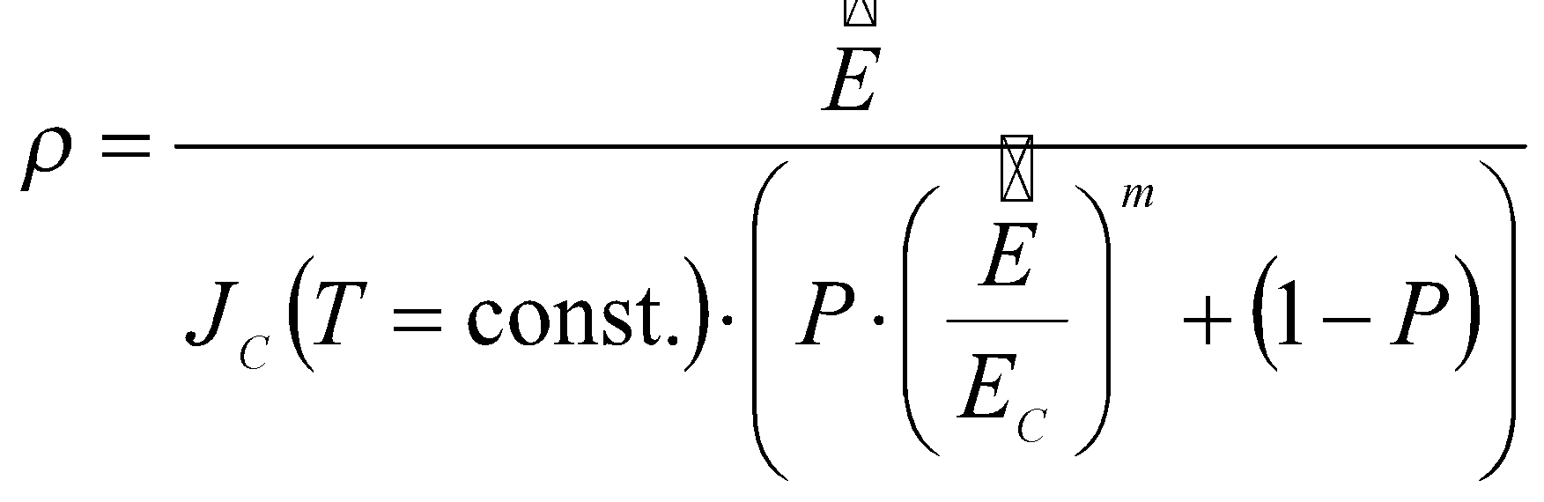 (1)

RESULTS AND DISCUSSION

The results and discussion section should provide details of all findings that are required to support the conclusions of the paper. The discussion should be concise and tightly argued.

Sub-Heading One, Capitalize Each First Word
Result and discussion maybe also separated under two different sections, if desired.

CONCLUSION

Conclude the overall findings of the paper.

ACKNOWLEDGEMENTS (OPTIONAL)

Authors may also include the acknowledgement section.

REFERENCES

Please ensure reference as in the text is listed in the reference part (crosscheck). Reference and citations should be in APA format (leave space between references):

Said, J., Hui, W., Othman, R. & Taylor, D. (2010). The mediating effects of organizational learning orientation on the relationship between strategic management accounting information use and organizational performance. Asia-Pacific Management Accounting Journal, 5(2), 11-29.

Zakaria, N., Mohamed Yunos, R., Che Mahmood, C., Anita, R., & Said, J. (2017). The effect of consumers’ interest, information access and spending willingness on Halal product trustworthiness. Asia-Pacific Management Accounting Journal, 12(2), 183-200.

APPENDIX (OPTIONAL)

Appendix (or appendices) shall start in a new page after the references.

♣ Corresponding Author: Name; Address; Email; Tel:

