**Lab 8. Arithmetic Logic Unit**

Write code for Arithmetic Logic Unit (ALU). ALU performs all arithmetic and logical operations on 32 bit long operands. The result is also 32 bit long.

You are asked to write ALU that performs the following operations:

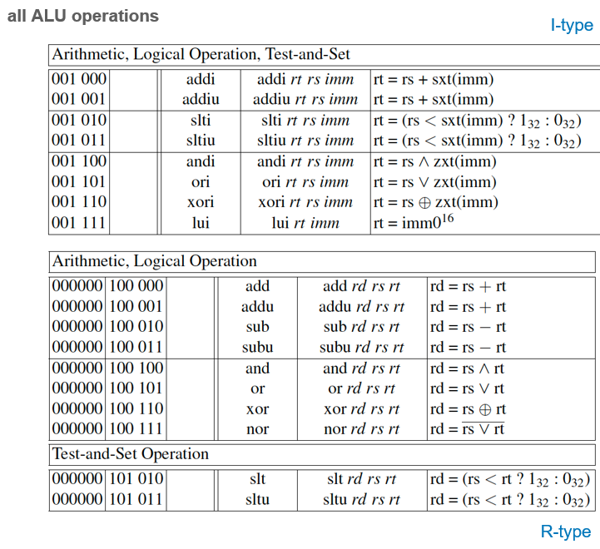

Table 1

For additional Hints see the Lab 8 Hints.ppt file attached, **prof.Wolfgang’s slide 22 from last semester** or read chapter 7 from Pr. Wolfgang’s Book.

Your module should have the following inputs and outputs:

**Inputs**:

i - if it is 1, we have immediate type instruction.

SrcA - 32 bit long. This is the left operand

SrcB - 32 bit long. This is the right operand

af - 4 bit long. This is alu control signals. af decides which arithmetic or logic operation should be performed. Table 2 specifies values of af for corresponding instructions.

**Outputs**:

Alures – 32 bit long. This is the result of the arithmetic/logic operation perfomed on SrcA and SrcB.

Zero – This is zero flag. It is 1 if the alures is 0.

Neg – this is negative flag. It is 1 if alures is 0 and we have signed operation

ovfalu – this is overflow flag. It is 1 if operation caused overflow. And we had signed operation.

1. **I Type Instructions**: Write code that can perform all I type operations from Table 1
2. **R Type Instructions**: Write code that can perform all R type operations from Table 1
3. **Flags**: Write code that evaluates correct values for zero, neg and ovfalu flags.
4. **Simulation & Verification**: Write testbench for your design. Generate Waveforms and explain in your reports why do you think your design works correctly. Write Report in Template

**If you want your module to be ELEGANT and worthy of international standards, I suggest using Figure 39, Lemma 39 and 40 from Pr. Wolfgang's Book (System Architecture An Ordinary Engineering Discipline by Wolfgang J. Paul).**

**Good Luck**

**ALU CONTROL SIGNAL (af) VALUES AND CORRESPONDING OPERATIONS**

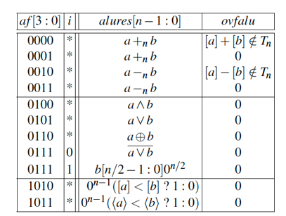

Table 2