Karen Organization of America website content draft
Reviewed from the signed-in KOAmerica Facebook page on 2026-10-02. This is an editorial source and placement draft for the KOA website. It gives the website a dated Updates stream while keeping organizational facts distinct from one-time announcements. The Facebook photo grid exposed about 304 distinct photo links during this pass, but it did not provide a complete, exportable history of captions and dates. No section below claims to cover every historical post or photo.

Source and coverage status
Surface · Reviewed evidence · Coverage
Profile and About · Name, category, founding month/year, purpose, partial street address · Visible profile facts only
Posts · Two coordinator announcements, Washington advocacy trip, July 20 youth-advocacy reel, July 10 volunteer/recent-graduate notice · Selected rendered posts; historical feed incomplete
Photos · Grid traversed through about 304 distinct photo links; five relevant photographs inspected and captured as site candidates · Selective media package, not 304 verified captions or original uploads
Reels · National Youth Advocacy Program reel and a Capitol-stop reel seen in feed · One full reel caption read; other captions unverified
Followers and comments · Not used as website source copy · Excluded
The accessible Facebook feed is virtualized and intermittently remains on “Loading.” A full historical archive requires a Page-owner export or equivalent source package with post IDs, timestamps, captions, and media originals. The page's generated image descriptions are not editorial alt text.

Page identity and standing copy
Draft About opening. The Karen Organization of America supports the wellbeing of Karen people in the United States through advocacy and community connection. The organization's Facebook profile says it was established in August 2018. Confirm the final legal name, founding wording, and current program scope before using this as a permanent About statement.
Source: KOAmerica Facebook profile. The profile calls KOAmerica a nonprofit organization and says it was established in August 2018 to advocate, promote, and advance the wellbeing of Karen people in the United States. The profile currently shows “1407 Hazel Ave,” without enough context to publish a complete address or visitor directions.

Content categories and website placements

Advocacy and civic education
Washington education and advocacy trip. The source post describes more than 35 youth and community leaders visiting Washington, D.C., meeting members of Congress, and discussing humanitarian, security, human-rights, and democracy issues connected to Burma. Treat this as a dated event recap, with the original date and terminology checked against the post before publication. Suggested placement: Updates lead story, then a dated link from Advocacy. Do not turn the event's participant count into an evergreen organization claim.
National Youth Advocacy Program reel. In the July 20 reel, KOAmerica says Saw Ta Nay Tha from California discussed empowering young leaders to advocate for their communities. Suggested placement: a video card in Updates and a “Youth advocacy” section only after KOAmerica confirms the program's current scope, participants, location, and contact path. The reel caption alone does not establish eligibility or an ongoing enrollment offer.
Capitol-stop reel. A second July 20 feed item says “Current stop: The U.S. Capitol.” Its full caption and direct reel link were not verified. Keep it grouped with the Washington trip as an unplaced media candidate.

People and organizational updates
Advocacy Coordinator. The September 11 photo post welcomes Hser Ka Mwee Paw as Advocacy Coordinator. The caption states that she studies Human Development at Cornell University, with an Inequality Studies minor and a Health Equity concentration, and discusses research and community advocacy interests. Suggested placement: dated Updates announcement and, after confirming the current role and preferred bio, a People card. A public Facebook biography is a source for drafting, not proof that every biographical detail should remain on a permanent people page.
Co-Advocacy Coordinator. The later portrait post welcomes Ku Hser Hser Gay as Co-Advocacy Coordinator. The caption says she studies Political Science and Child Development at Vanderbilt University and describes interests in governance, public health, and Karen community advocacy. Suggested placement: dated Updates announcement and, after role and preferred-bio review, a People card. The precise publication date was not captured in this pass.

Participation and external opportunities
Volunteer and graduate interest. A July 10 KOAmerica feed post invites recent graduates and volunteers to complete a form. The photo in that post has ID 1336637585324768. The destination, form owner, and whether the invitation remains open were not verified. Suggested placement: archived Updates item until a working, current sign-up route is confirmed. Do not place an active Home call to action from this excerpt alone.
US Campaign for Burma internship graphics. Three images in the KOAmerica photo grid promote another organization's data, advocacy outreach, and social-media internships: data, advocacy, and communications. The graphics mention Spring 2025. Classify them as past external opportunities. They are not KOAmerica jobs or programs and should not be offered as current openings.

Community life and organizational history
The page cover was posted June 2, 2023. Its caption identifies newly elected committees, department heads, and advisers after KOAmerica's 2nd Congress and general election in Des Moines, Iowa. It is suitable for a dated History entry; it does not show the current board. A separate KYO Day post describes celebration highlights in Des Moines. One soccer image from that post is a Community gallery candidate. Do not infer a recurring sports program from that event.

Choreographed page sequence
Site moment · Content · Editorial rule
Home opening · Organization name and short profile-backed purpose · Keep motion and imagery restrained; a factual introduction must remain readable with reduced motion
Home proof · One dated Washington story card and one current people/update card · Show dates and link to full Updates items; rotate content only when reviewed
Advocacy chapter · Stable description of KOAmerica's advocacy, followed by Washington trip and NYAP reel · Keep event details in dated cards; confirm ongoing program language
Community chapter · Captioned gathering or sports image after event identification · No anonymous full-bleed documentary image without context
People chapter · Two coordinator announcement cards · Confirm continuing titles, preferred short bios, and photo presentation
Get involved · Clear volunteer or contact action · Activate only after the July form or replacement route is verified
Updates archive · Chronological, filterable posts, reels, and external opportunities · External and expired opportunities remain labeled as such

Image records and accessible text
Use the original photo only after retrieving a website-suitable file and checking crop and display quality. Alt text describes what is visible in the selected crop; captions provide names, date, and context. Do not use a person’s refugee history, school, or inferred age as alt text.
Source image · Draft alt text · Draft visible caption · Placement and status
[Ku Hser Hser Gay portrait](https://www.facebook.com/photo.php?fbid=1401168975538295&set=pb.100069356176379.-2207520000&type=3) · “Ku Hser Hser Gay stands outdoors near a low fence with trees behind her.” · “Ku Hser Hser Gay, introduced by KOAmerica as Co-Advocacy Coordinator.” · People/Updates; role and preferred name review
[Hser Ka Mwee Paw portrait](https://www.facebook.com/photo.php?fbid=1390075569980969&set=pb.100069356176379.-2207520000&type=3) · “Hser Ka Mwee Paw stands outdoors against a backdrop of green trees.” · “Hser Ka Mwee Paw, introduced as KOAmerica Advocacy Coordinator on September 11, 2026.” · People/Updates; role review
[Second Congress group](https://www.facebook.com/photo/?fbid=555816113406923&set=a.482729950715540) · “A group poses beneath a Karen Organization of America 2nd Congress and Election banner, with Karen and U.S. flags behind them.” · “KOAmerica committees, department heads, and advisers after the 2nd Congress and general election in Des Moines, Iowa; posted June 2, 2023.” · Dated History entry; no current-board claim
[Washington trip group](https://www.facebook.com/photo.php?fbid=1347042117617648&set=pb.100069356176379.-2207520000&type=3) · “KOAmerica advocacy trip participants pose in a hallway with flags behind them.” · “Participants during KOAmerica's Washington, D.C., education and advocacy trip; photo posted July 23, 2026.” · Dated Advocacy gallery, with full post context
[KYO Day soccer](https://www.facebook.com/photo.php?fbid=2266694160182193&set=pb.100069356176379.-2207520000&type=3) · “Soccer players run toward a ball on a grassy field during KOAmerica's KYO Day celebration.” · “Soccer at KOAmerica's KYO Day celebration in Des Moines, Iowa; photo posted June 1, 2023.” · Dated Community gallery, not an evergreen program claim
The five selected Facebook-rendered JPEGs and their provenance records are in [`media-candidates`](media-candidates/README.md). They are staging assets, not the original uploads or automatically published website media.

Search and answer design
Destination · Suggested title and heading · Answer-focused content · Source/structured-data notes
Home · “Karen Organization of America” · State who KOAmerica serves and link to the dated Updates stream · Use `Organization` data only for verified name, URL, logo, and contact fields
About · “About the Karen Organization of America” · Answer “When was KOAmerica established?” with “The Facebook profile says August 2018,” until the founding record is approved · Link internally to History; do not add a full postal address from “1407 Hazel Ave”
Advocacy · “Karen community advocacy and civic education” · Explain the work, then cite the Washington trip and NYAP reel with dates · `Article` or `VideoObject` data belongs to the specific update, with a verified publication date and thumbnail
People · “KOAmerica people and leadership” · Give current roles only after confirmation; link to dated announcements · No unsupported staff permanence or institutional endorsement
Updates · “KOAmerica news and community updates” · Lead each item with who, what, when, where, and what the visitor can do now · Canonical URLs, visible dates, source links, and `NewsArticle` only when the page is an actual editorial article
Write visible answers in ordinary page text so search engines and AI answer systems can attribute them. Use “Karen Organization of America” near the start of titles and headings to distinguish the organization from unrelated KOA entities. Keep location claims tied to confirmed city/state or event venues; avoid inventing a service area from follower locations. Publish reviewed language versions with correct `lang` and `hreflang`; translated copy and image alternatives need human review. AEO and GEO labels do not justify unsupported claims or stuffed alt text.

Editorial sync queue
For each new Facebook item, record its permalink, publication date, original caption, media IDs, owner, category, current/archive state, website destination, proposed headline, factual checks, image alt, image caption, and approval. Publish a dated Updates item first; change evergreen Home, Programs, People, or Advocacy copy only when the new item changes a confirmed standing fact. Recheck expiring calls to action. Preserve Facebook links as provenance and keep a correction path if the original post changes or is removed.
Next intake step: obtain a Page-owner archive of posts, reels, and original media to reconcile every historical item against this partial browser survey. Keep unverified items in the editorial queue.

Selected photographs

Hser Ka Mwee Paw
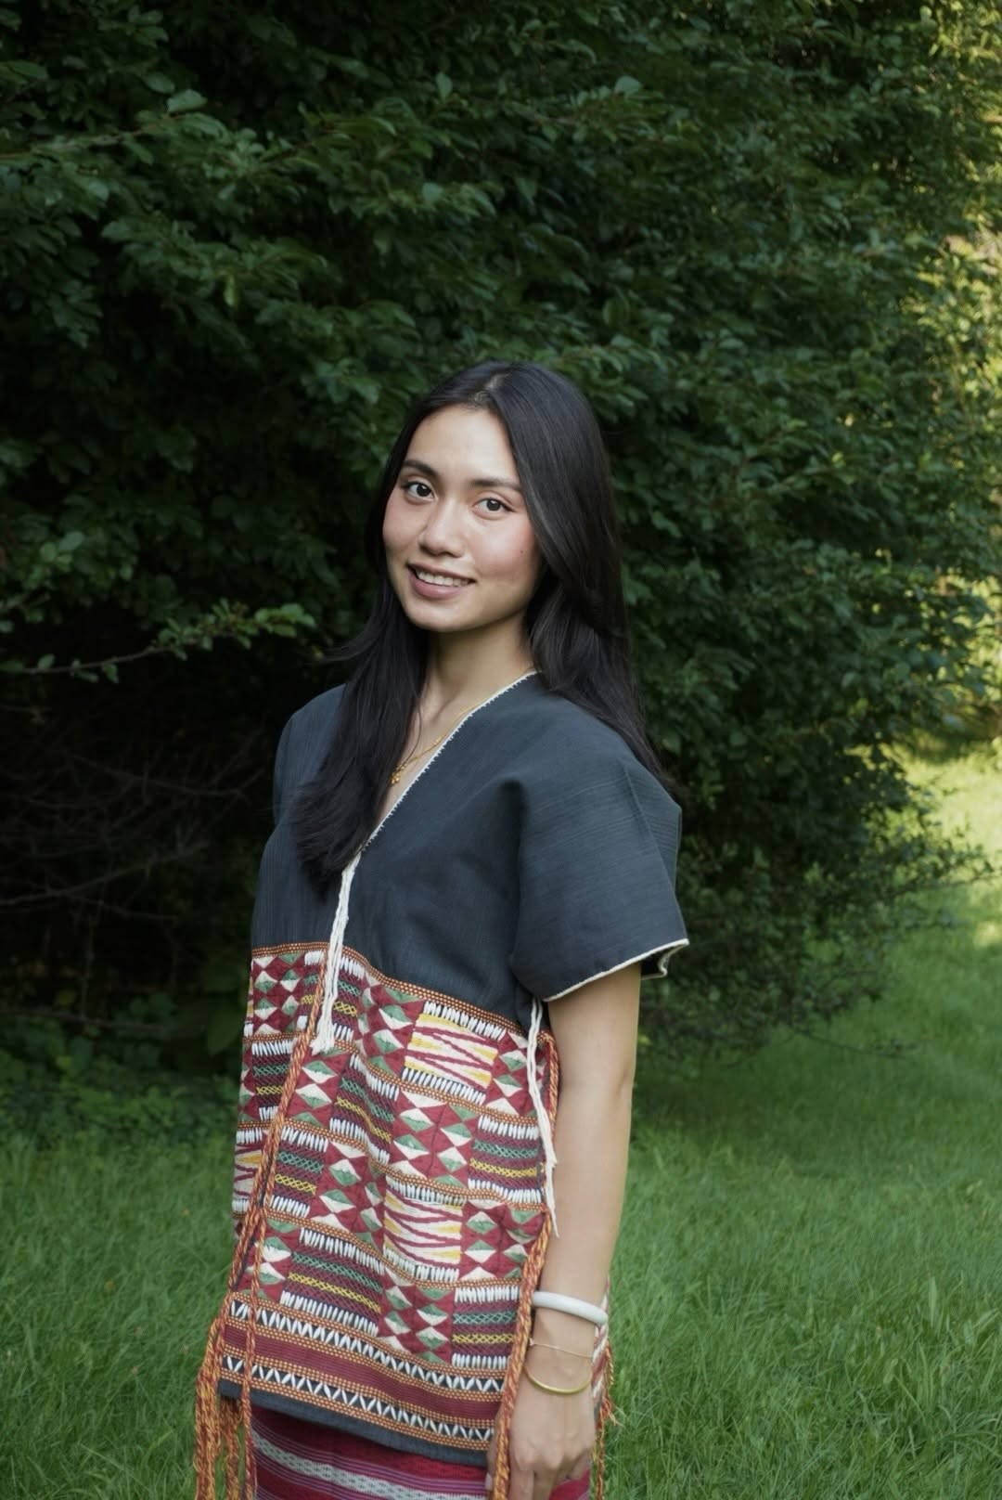
Source and full proposed caption: hser-ka-mwee-paw-facebook.jpg in the media candidate register.

Ku Hser Hser Gay

Source and full proposed caption: ku-hser-hser-gay-facebook.jpg in the media candidate register.

Second Congress and election
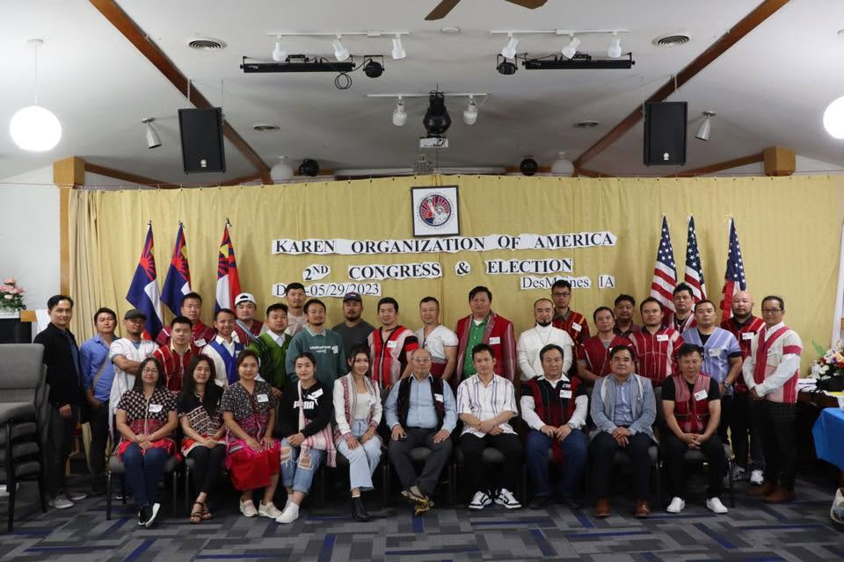
Source and full proposed caption: second-congress-des-moines-facebook.jpg in the media candidate register.

Washington advocacy trip
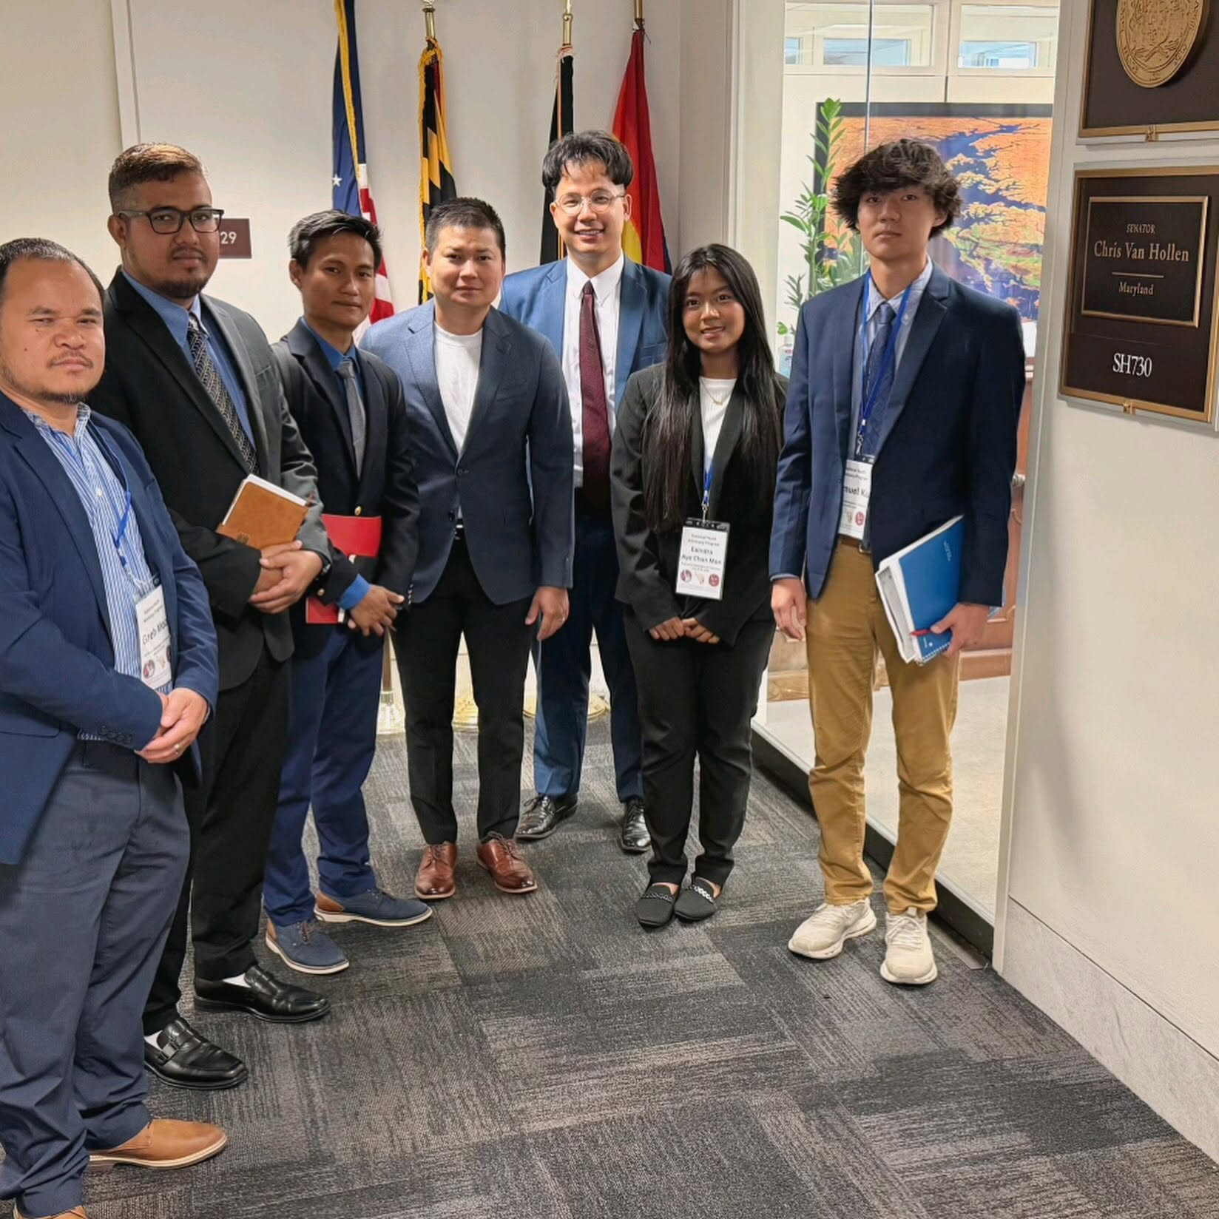
Source and full proposed caption: washington-advocacy-group-facebook.jpg in the media candidate register.

KYO Day soccer
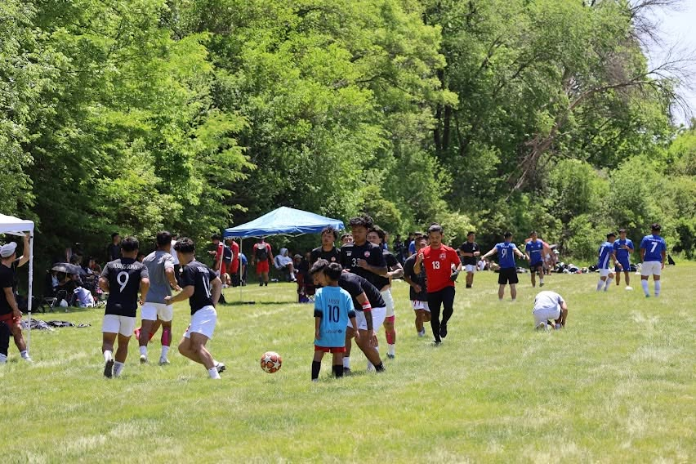
Source and full proposed caption: kyo-day-soccer-facebook.jpg in the media candidate register.
sources: KOAmerica Facebook profile and linked posts, photos, and reel reviewed on 2026-10-02; previously prepared local KOAmerica Facebook content inventory for the Washington post and initial photo clusters.

