**Groupwork_2nd_Submission**

Xing Tao [tao.xing@qq.com](mailto:tao.xing@qq.com)

Tanguy de La Sablieret, tanguy.delasabliere@gmail.com

Abishek Puri, [apuri@connect.ust.hk](mailto:apuri@connect.ust.hk)

Ningxi Wang, [bashu_wnx@163.com](mailto:bashu_wnx@163.com)

**PART　Ｉ：Volatility Analysis**

1. **Data preparing**

Download ten years’ Apple daily stock trading data between 2010-10-1 to 2020-10-1 from Yahoo Finance and calculate daily return, and rescaled the return by multiplying 100.



The rescaled daily return series exhibits only limited autocorrelation, but the squared deviations from the mean do have substantial memory reflected in the slowly-decaying ACF and the PACF high for the first two and cutting off only after the first six lags.

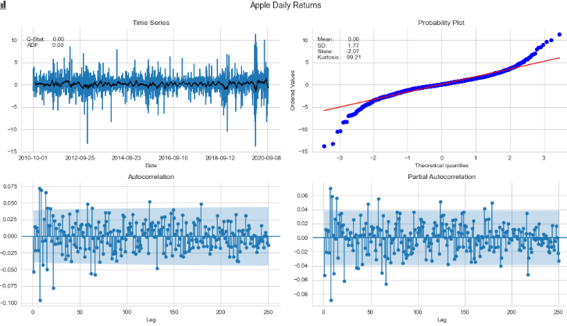

Figure 1. The daily Return of AAPL

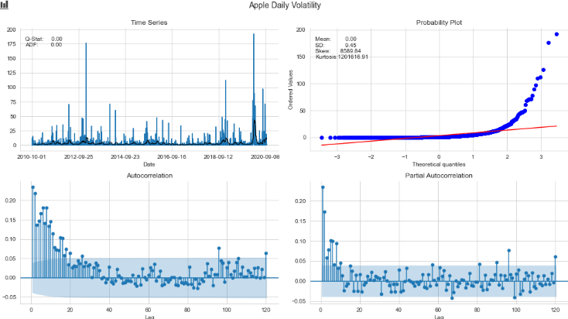

Figure 2. The daily Volatility of AAPL

We run Augmented Dickey-Fuller Test and the p-value is less than the critical value (1%), the series is stationary.

the model residuals and squared residuals for autocorrelation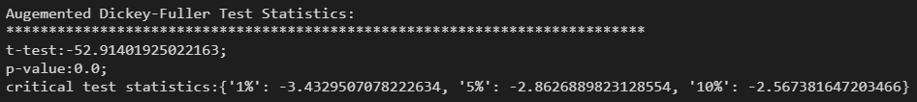

**２． Build a Model to fit the data**

The process of building model include the following components:

* Find an optimal mean model using ARIMA(p,d,q)
* Through grid searching, we fit the residual of ARIMA(p,d,q) with one of the volatility models( ["GARCH","IGARCH","EGARCH","ARCH","TARCH"]) and  **one of** distribution for the standardized residuals (["gaussian","normal", "studentst","skewstudent","generalized error"])
* Then we analyze the residual of the volatility model.

**2.1 find the best choice of (p,d,q) for ARIMA model**

We use the auto_arima function of pmdarima package, and discover the optimal order for an ARIMA model. The optimal order is (p=2, d=0, q=2). The fitting result of ARIMA(2,0,2):

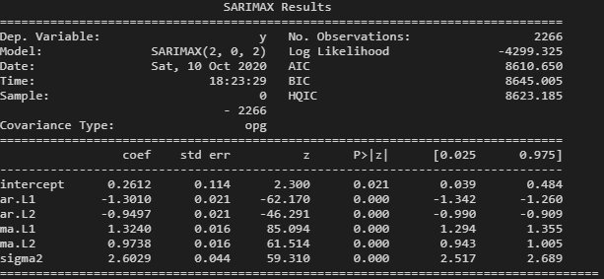

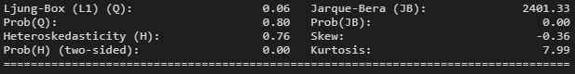

Plot the residual of ARIMA(2,0,2):

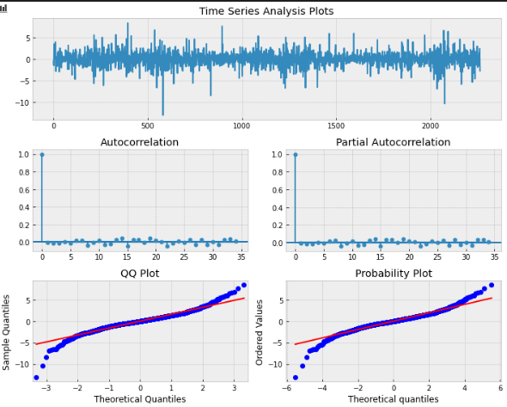

**2.2 Find the best model for volatility process**

We use a grid searching method to find the optimal order for ARCH kind models to fit ARIMA residuals. The searching range for p and q is [0,1,2,3,4,5], and the range for d is [0,1]. The quality of the models is valued by AIC and BIC. The searching result indicates a TARCH(1,1,2).

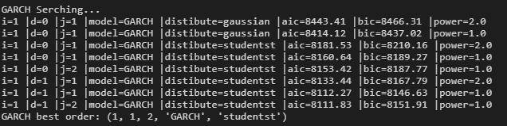

The table table shows different configurations for different volatility models. Due to the limitation of Python packages, we failed to use GARCH-M as an option.

|  |  |  |
| --- | --- | --- |
| **Models** | **Formulas** | **Python code** |
| **ARCH** |  | arch_model(returns, vol=’GARCH’, p=m,o=0,q=0) |
| **GARCH** |  | arch_model(returns, vol=’GARCH’, p=m,o=0,q=s) |
| **IGARCH** |  | arch_model(returns, vol=’GARCH’, p=1,o=1,q=1) |
| **GARCH-M** |  |  |
| **EGARCH** |  | arch_model(data, vol=’EGARCH’, p=m,o=0,q=0) |
| **TARCH/**  **ZARCH** |  | arch_model(returns, p=m, o=0, q=s, power=1.0) |

The fitting results of TARCH(1,1,2):

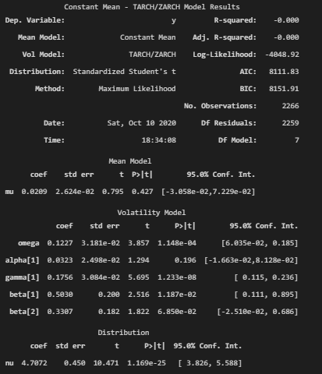

Plot the residual of TARCH(1,1,2):

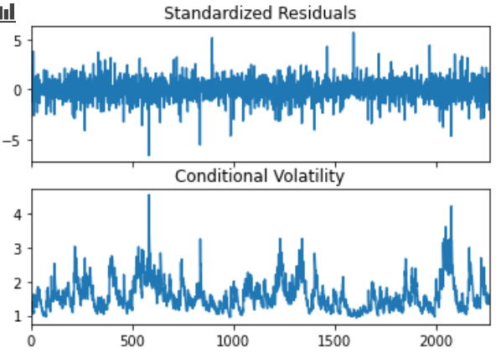

**3. Forecast and Conclusion**

We use Rolling Window Forecasting with a fixed sample length of training data and then produce one-step from the final observation. The workflow is that :

* at the begin of each day of testing data, we run *auto_arima* to discover the optimal ARIMA order;
* then use the residual of ARIMA to find the optimal orders (p,d,q), the optimal Volatility model (one of ["GARCH","IGARCH","EGARCH","ARCH","TARCH"]) and the best distribution for the standardized residuals (one of ["gaussian","normal", "studentst","skewstudent","generalized error"]).
* After that we compute the predicted return using the optimal arima model and Volatility model.

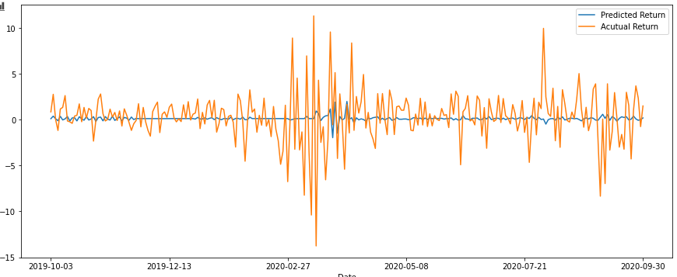

Figure 3. Comparing the actual and predicted returns

Comparing the forecasting return to the actual return, we draw a conclusion: through the model captures the volatility features of the return, it hardly predicts the specific return for the next day.

**Part II. Multivariate Analysis**

1. **Equilibrium FX theories**

A few well known economic theories and models to calculate equilibrium FX are listed below:

**1.1 Kasse’s PPP**

PPP stands for “Purchasing power parity”, which is based on the “law of one price”. It illustrates that if there’s no trade cost, the price of goods should be the same in different regions, thus the exchange rate is the ratio of prices of goods in different currencies.

**1.2 Williamson’s FEER**

FEER stands for “Fundamental Equilibrium Exchange Rate”, which describes that the exchange rate brings the current account into equality with underlying or sustainable capital accounts.

**1.3 Stein’s NATREX**

NATREX stands for “Natural Real Exchange Rate”, which is specified to illustrate the interaction of economies, and therefore build an estimation on the exchange rate.

**1.4 Edwards’s ERER**

ERER stands for “Equilibrium Real Exchange Rate”, is investigated by looking at the reduced forms implying a relationship between exchange rate and a few exogenous “fundamental” variables.

**1.5 McDonald’s BEER**

BEER stands for “Behavioral Equilibrium Exchange Rate”, it considers a measurement of misalignment that is different from the FEER, as it relates the deviation of actual exchange rate from the estimated equilibrium rate. And we will use BEER to estimate the equilibrium in this article.

1. **Indicate macroeconomic variables used to determine the equilibrium FX.**

We follow Wang’s (2007) method to calculate the Equilibrium Exchange Rate of CNY and use the BEER method to determine the rate. The model is as following:

***BEER = f(mon, res, tot, tnt)***

***BEER****:* CNY’s effective exchange rate index from BIS is used as a real effective exchange rate(BEER).

***mon****:* the money supply is indicated by M2 supply.

***res****:* the forgein exchange reserve is indicated by the total stock of net foreign assets.

***tot*** : the terms of trade is indicated by the ratio of the export price index to the import price index.

***tnt***: the relative of untradable to tradable goods is indicated by the ratio of the domestic consumer price index to the domestic wholesale price index.

***BEER***  is accessed from BIS (<https://www.bis.org/statistics>), while ***mon****,* ***res****,* ***tot*** and ***tnt*** are accessed from CEInet Statistics Database(<https://db.cei.cn/>).

1. **The connection between linear regression and Vector Error Correction (VEC)**

Linear regression is a statistics approach to reveal the relationship between dependent variable and independent variables.

Vector Error Correction (VEC) is an approach specifically to analyze multiple time series models, where the underlying variables have a long-term common trend, which is also called cointegrated.

Linear regression is a broader concept of modeling, it is the theory fundamental of the VEC model, which tries to discover a linear combination of one or a few time series data on another time series data set.

1. **Behavioral Equilibrium Exchange Rate (BEER)**

**4.1 VAR process**

We firstly test the unit root and transform the data into stationary series.

|  |  |  |
| --- | --- | --- |
| **Variable** | **Transform Operations\*** | **ADF-Test P-value** |
| *tnt* | diff(1) | 0.00% |
| *mon* | log.diff(1).diff(12) | 0.01% |
| *res* | log.diff(1).diff(12) | 0.29% |
| *tot* | - | 0.15% |
| *beer* | diff(1) | 0.00% |

***\* This process might “throws away” all level information, but VAR approach requires stationary series.***

Plot the transformed data:

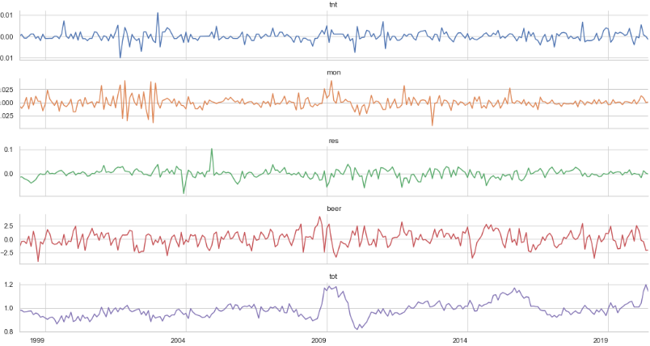

Search for the optimal order for VAR and the result suggests VAR(1).

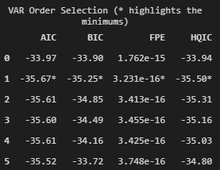

Fit the model, and show the result:

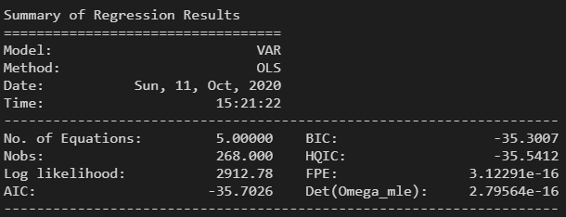

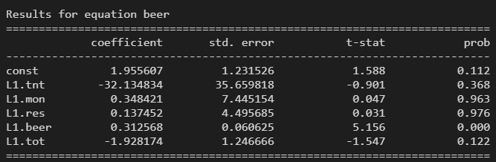

Draw the diagnostics plot for the residual:

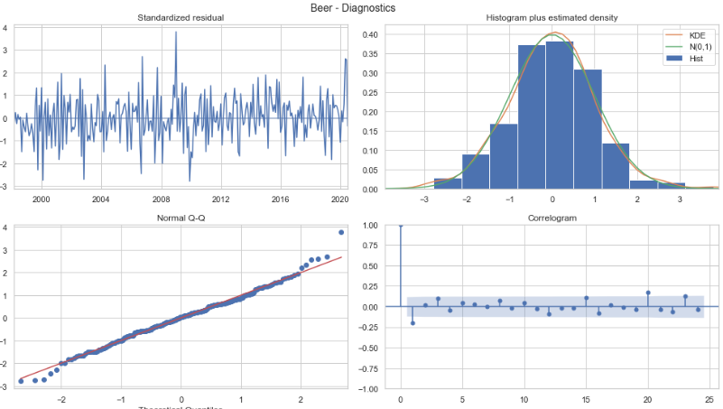

Impulse-Response Analysis with 6 steps:

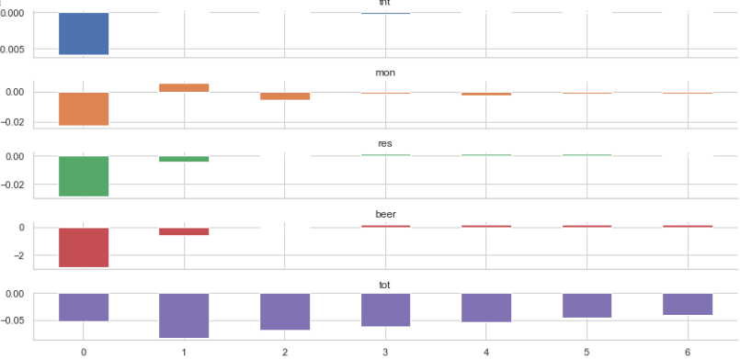

We make a forecast with 12 steps and plot the actual and predicted data in recent 50 month.

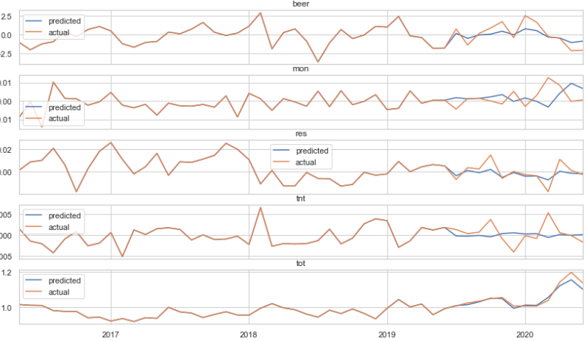

**4.2 Johansen Test and VECM**

In order to fit a VECM model, we need to determine the number of cointegrating relationships using a VEC rank test. The test shows that there is 1 cointegrating vector, which means a VECM (Vector Error Correction Model) is a suitable choice for further analysis. VECM can adjust to both short run changes in variables and deviations from equilibrium.

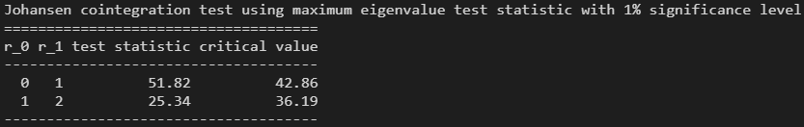

We fit a VECM model and make a forecast plot.

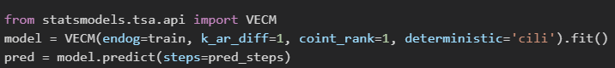

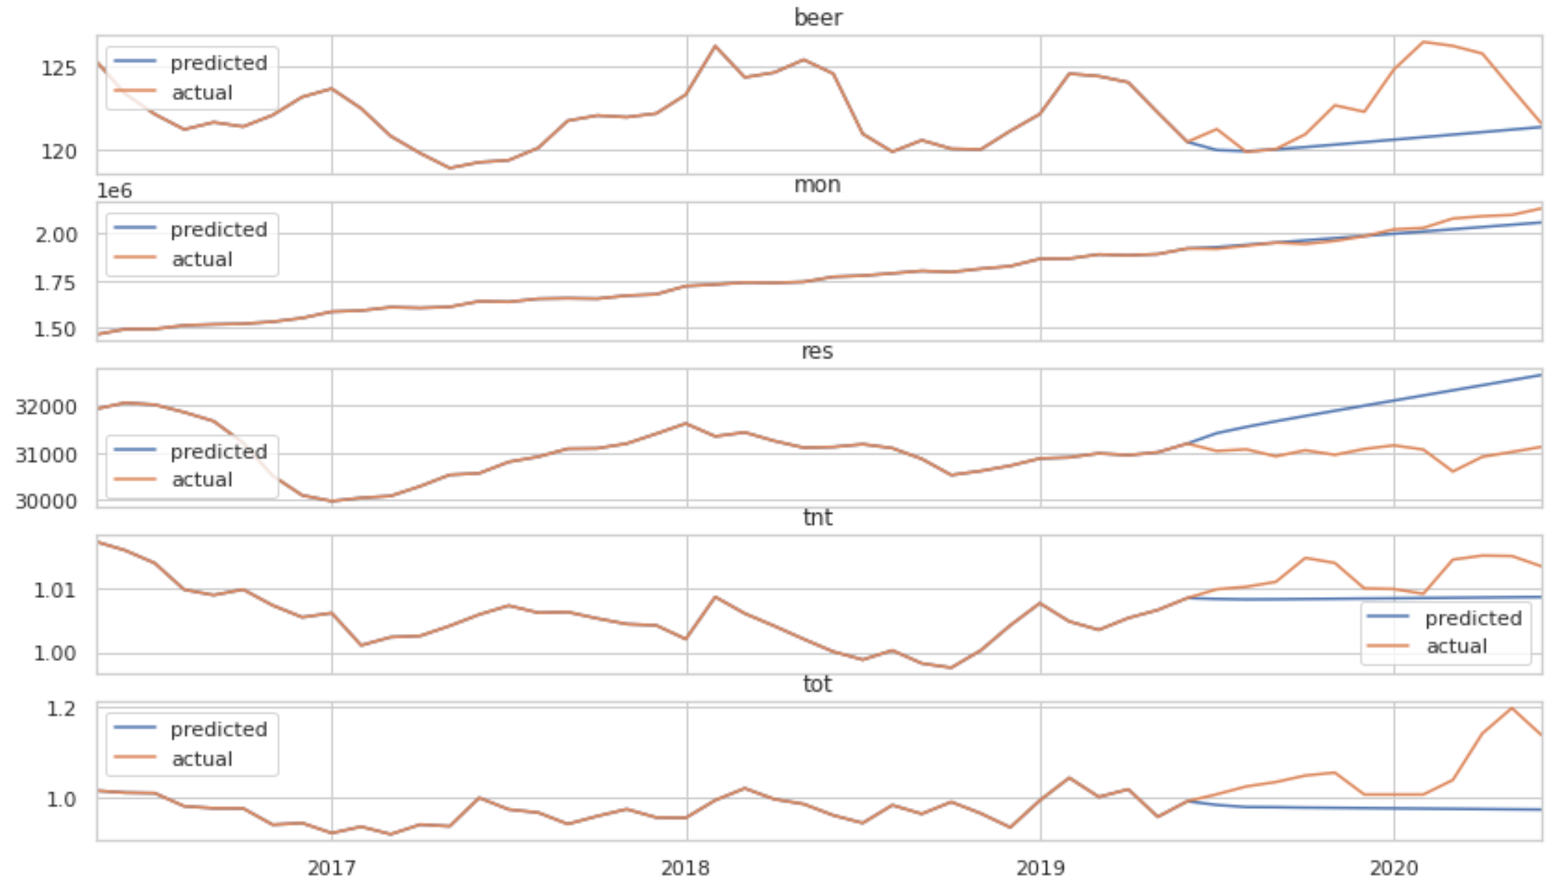

**4.3 Conclusion**

We compared the sum of squared error for VAR and VECM fitted by transformed data and the result shows that VAR performs better in forecasting. However, VECM has a wider range application, because it does not require all series to be stationary.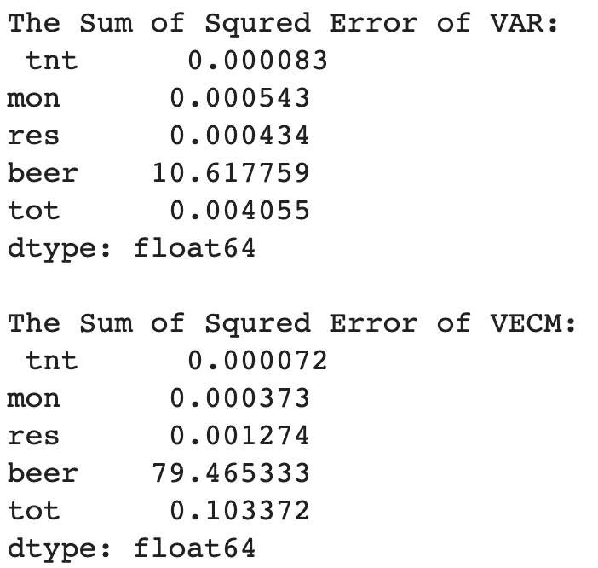

**Reference:**

Clark, P.B., MacDonald, R. Exchange Rates and Economic Fundamentals: A Methodological Comparison of BEERs and FEERs[R]. IMF Working paper. 1998,No.67.

Edwards, S. Real Exchange Rates in Developing Countries: Concepts and Measurement[R]. NBER Working Paper 1989,No. 2950.

L. E. and Montiel, P. J. ( ed. ) , Exchange Rate Misalignment: Concepts and Measurement for Developing Countries [M]. Oxford University Press. 1999.

MacDonald, R. What Determines Real Exchange Rates? The Long and Short of It[R]. IMF Working Paper,1997,No.21.

Montiel. P. J. The Long - Run Equilibrium Real Exchange Rate: Conceptual Issues and Empirical Research, In Hinkle,

Wang, Yajie, etc, Estimating renminbi (RMB) equilibrium exchange rate,[Journal of Policy Modeling](https://www.sciencedirect.com/science/journal/01618938), [Volume 29, Issue 3](https://www.sciencedirect.com/science/journal/01618938/29/3), May–June 2007, Pages 417-429