7CS030 – Concepts and Technologies of Artificial Intelligence
Faculty of Science and Engineering
School of Mathematics and Computer Science
Student Name: Orji Patricia
Student ID: 2310224
Date: 25 October 2025
University of Wolverhampton

TASK 1: LINEAR REGRESSION (House Price Prediction)
This task applies regression analysis to estimate housing prices in King County, USA. The dataset contains 18 independent variables such as the number of bedrooms, bathrooms, living area size, and property grade, with the target variable being the house price. The main objective is to build and evaluate predictive models that identify which property characteristics have the strongest influence on housing values. This process also helps to understand the relationships between key features and how they collectively affect market prices.
Data Cleaning and Preparation
The dataset was cleaned to remove missing and duplicate records, and summary statistics were reviewed to confirm completeness. A correlation heatmap revealed that living area (sqft_living), grade, and bathrooms had the strongest positive relationships with house price, with coefficients around 0.70, 0.67, and 0.53 respectively. Other variables such as sqft_above and sqft_living15 showed moderate correlations, while zipcode, condition, and location (lat/long) had weak or negligible influence. Overall, the analysis indicated that house size, quality, and interior features are the most significant drivers of property value in the dataset.
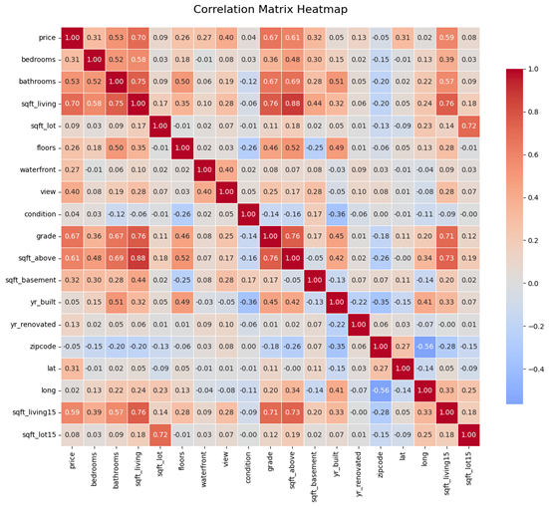
Figure 1.1: Correlation Matrix
Feature Selection
A top-down approach was used for selecting the input variables (X). This method began with all 18 available features and progressively refined the selection based on their impact on the model’s predictive performance. This systematic process established the foundation for model construction and ensured that feature inclusion was driven by both statistical significance and interpretability.
Training the Dataset
The dataset was divided into training and testing subsets, with two-thirds used for training and one-third reserved for testing. This split allowed the model to learn patterns from the training data while maintaining a separate portion for evaluating its performance on unseen data. Such an approach is crucial in preventing overfitting, where the model memorizes rather than generalizes from the data.
Model Selection
Since the target variable (house price) is continuous, Linear Regression was selected as the primary modelling approach. Linear regression is appropriate for predicting numerical outcomes such as age, income, or property value.
To assess and compare the model’s predictive capabilities, two key evaluation metrics were employed:
- R² (Coefficient of Determination): measures how well the regression model explains the variability in the target variable.
- Mean Squared Error (MSE): evaluates how close the model’s predictions are to the actual values.
Linear Regression Model
A multiple linear regression model was implemented, as the dataset contained 18 independent variables. The aim was to determine whether a linear relationship existed between house prices and these features.
After model training and testing, the model achieved an R² score of 0.699, indicating that approximately 70% of the variance in housing prices could be explained by the selected features. This represents a reasonably strong fit between the model and the observed data.
While the MSE appeared relatively high, this was primarily due to the large numerical scale of housing prices rather than poor predictive quality. To address this, the price variable was normalized, resulting in consistent R² performance and a reduced MSE of 0.299. This confirmed that scaling helped ensure uniformity across features and improved interpretability of results.
Visualizing the Model
To better understand the relationships between individual predictors and the target variable, the model was visualized using both 2D and 3D scatter plots. Each feature was first plotted individually against price to assess linearity, followed by a combined visualization of the two most correlated features — living area (sqft_living) and grade.
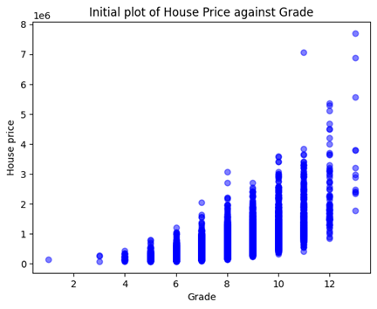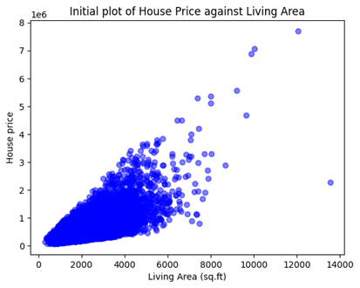
Figure 1.2: Plots of living area and grade vs price
The initial scatter plots (Figure 1.2) show that house price generally increases with both living area and grade, indicating a positive relationship between these variables and property value.
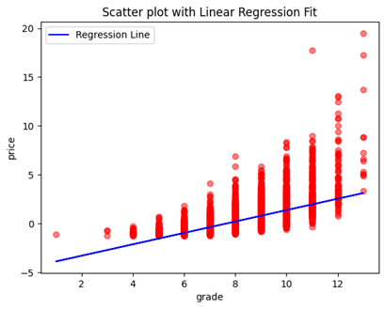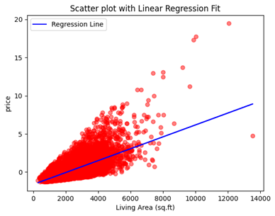
Figure 1.3
After applying the regression model, as illustrated in Figure 1.3, the R² scores for both features individually were below 0.5. This means that less than half of the price variability could be explained by either variable alone. However, the living area plot displayed a denser clustering of data points around the regression line compared to the grade plot, resulting in a slightly higher R² and lower MSE.
When both features were combined in a 3D visualization (Figure 1.4), the model achieved a moderate R² improvement to 0.54, suggesting that combining related features enhanced the model’s predictive performance.
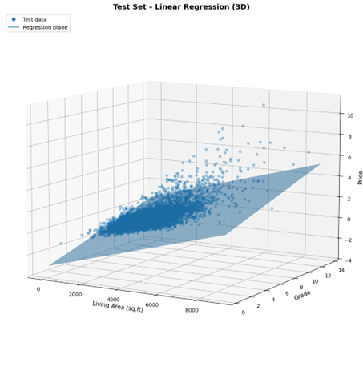
Figure 1.4
Data Transformation and Model Improvement
To enhance model accuracy and ensure more reliable predictions, several data transformation and optimization techniques were applied. These steps aimed to correct skewed data distributions, improve model stability, and satisfy the assumptions of linear regression.
1. Correcting Skewed Distributions
Initial exploration revealed that several continuous variables—such as price, sqft_living, sqft_lot, and sqft_above—were positively skewed. This suggested that a small number of high-value properties were disproportionately influencing the results. To address this issue, a log₁₀ transformation was applied to these variables.
After the transformation, the variables became approximately normally distributed, as shown in Figure 1.5. The normalized shape of the data helped the regression model perform more effectively, since linear regression generally performs better when the input variables follow a normal distribution rather than a skewed one.
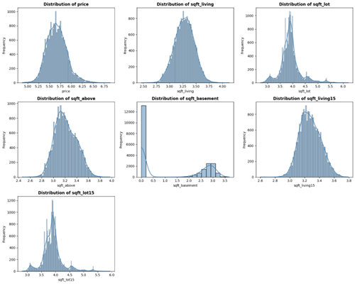
Figure 1.5: Normalized distribution plots of continuous variables after log transformation.
2. Standardization and Scaling
To account for the large differences in variable magnitudes, all features were standardized using the StandardScaler method. This transformation ensured that each feature contributed equally to the model, preventing those with larger numeric ranges from dominating the regression.
Improved Model Performance
After applying these transformations, the multiple linear regression model was re-trained using 100 iterations with varying random states. The results showed a clear improvement:
- Average R² Score: 0.7729
- Average Mean Squared Error (MSE): 0.2268
These results indicate that the model could explain approximately 77% of the variation in housing prices, compared to about 70% before transformation. The decrease in MSE confirms that the predictions were closer to actual price values after normalization.
Key Insights
The improvement demonstrates that the model performs better when input features are normally distributed, supporting the idea that reducing skewness enhances linear regression’s predictive ability.
The analysis also reaffirmed that living area (sqft_living), grade, and bathrooms are the strongest predictors of house price, while features like lot size (sqft_lot) and living space above ground (sqft_above) contributed less to the overall model performance.
Recommendations
- Apply Data Normalization and Transformation in Future Modelling: The model’s improved performance after applying log transformation and standard scaling confirms that regression models perform better with normally distributed input data. It is therefore recommended that future housing price prediction models include normalization and scaling as standard preprocessing steps. This will help to minimize the effect of extreme values, reduce skewness, and improve overall predictive accuracy. Consistent data transformation will also make it easier to compare model outcomes across different datasets or regions.
- Explore Advanced and Non-Linear Regression Techniques: While multiple linear regression produced a strong fit (R² ≈ 0.77), housing prices are influenced by complex, non-linear relationships between features. To further improve prediction accuracy, future research should experiment with advanced algorithms such as Random Forest, Gradient Boosting, or Support Vector Regression (SVR). These models are capable of capturing non-linear interactions and variable dependencies that traditional linear regression cannot fully represent, offering the potential for greater model precision and robustness.

Conclusion
The study developed a multiple linear regression model to predict housing prices in King County, USA, using 18 property features. After cleaning and analyzing the data, living area, grade, and bathrooms were found to be the strongest predictors of price. Applying log₁₀ transformations and data standardization significantly improved model performance, increasing the R² to about 0.77 and reducing the MSE to 0.23, showing that the model explained most of the price variation. While the model was effective and interpretable, some non-linear relationships and multicollinearity were observed, suggesting that future work should explore non-linear and ensemble models for improved accuracy.
TASK 2: CLUSTERING (Country Socioeconomic Analysis)
Overview
This task explores the use of clustering techniques to identify patterns among countries based on socioeconomic indicators such as GDP per capita, income, health expenditure, and child mortality. The aim is to uncover hidden structures and similarities between nations that may assist policymakers in designing targeted economic and social strategies. The dataset contains observations for 167 countries, each described by several numeric indicators.
Data Cleaning and Preparation
After importing the dataset using pandas, missing values and duplicate entries were removed to maintain data quality. The non-numeric attribute (country name) was dropped, since clustering algorithms operate on numerical input.
Exploratory checks confirmed that all remaining columns were complete and suitable for model training.
Correlation Analysis
A correlation heatmap (Figure 2.1) was generated to examine the strength and direction of relationships between the socioeconomic variables. The colour gradient—from dark red (strong positive) to blue (strong negative)—visually summarises how each feature interacts with the others.
The matrix revealed that GDP per capita (gdpp) is highly positively correlated with income (0.90) and moderately correlated with exports (0.42), suggesting that higher national income and export activity are linked with stronger economies. Conversely, child mortality is strongly negatively correlated with life expectancy (–0.89) and income (–0.52), reflecting that lower mortality aligns with higher living standards. Similarly, total fertility rate shows a strong negative relationship with life expectancy (–0.76). These insights guided the feature pairings used for the clustering experiments.
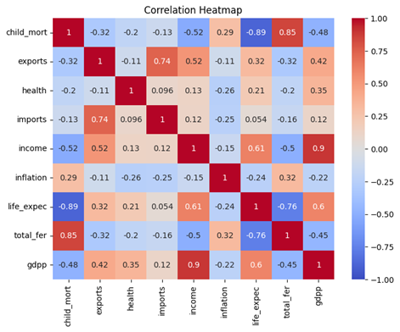
Figure 2.1: Correlation Heatmap of Socioeconomic Indicators
Distribution Analysis
To understand the statistical behaviour of each feature, histograms were plotted for all numeric variables (Figure 2.2). Most variables—including child mortality, income, GDP per capita, inflation, and fertility rate—displayed positive skewness, indicating that a few countries have extremely high values compared with the majority.
In contrast, life expectancy exhibited a more balanced distribution, with most nations clustering around moderate-to-high longevity values.
The skewed distributions highlight the global disparity between low- and high-income economies and justify applying data transformation techniques to stabilise variance before clustering.
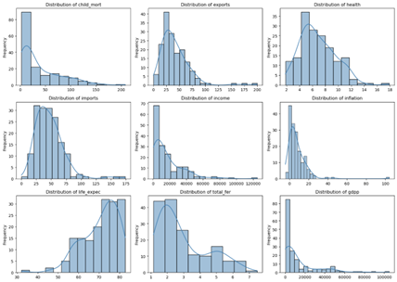
Figure 2.2: Distribution of Key Socioeconomic Variables.

Model Selection
As the dataset has no predefined labels, the MeanShift algorithm was used. MeanShift discovers clusters by shifting data points towards areas of high density and does not require specifying the number of clusters in advance, making it suitable for exploratory segmentation.
MeanShift iteratively moves points towards local density peaks until convergence (i.e., further shifts are negligible). Points that converge to the same peak form a cluster around that mode of the distribution. The key hyperparameter is bandwidth, which controls the size of the neighbourhood used to estimate density. For evaluation in this exploratory setting, the number of clusters discovered, and their interpretability were the primary focus (supplementary diagnostics, e.g., silhouette scores, can be reported when comparing alternative methods).
Visualising the Model
Feature relationships were first examined using a correlation matrix, where the Pearson coefficient ranges from –1 (perfect negative correlation) to +1 (perfect positive correlation), with 0 indicating no linear relationship. Strong and weak associations—both positive and negative—were observed among:
- Income vs. GDP per capita (gdpp) (positive),
- Child mortality vs. life expectancy (negative),
- Imports vs. health (weak positive),
- Exports vs. inflation (weak negative).
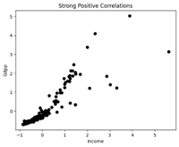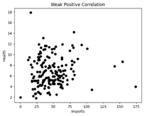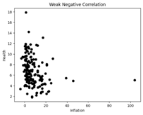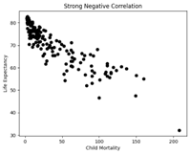
Figure 2.3 shows initial scatter plots for these pairs before clustering. Strong correlations displayed clear trends (e.g., higher income aligns with higher GDP per capita; lower life expectancy is associated with higher child mortality), while weak correlations showed less consistent patterns.
Applying MeanShift revealed distinct country groupings that reflect these relationships (Figure 2.4). For example, strongly positively correlated features produced several compact clusters that can reflect similar economic profiles, while weakly correlated pairs produced broader, less distinct groupings.
Clustering Results Before Data Transformation
The MeanShift clustering algorithm was initially applied to the untransformed dataset using feature pairs representing strong and weak, positive and negative correlations (Figure 2.4).
While the model successfully located areas of data concentration, the resulting cluster boundaries were broad and overlapping, especially for features with wide numeric ranges.
- Income vs GDP per capita (strong positive): eight loose clusters emerged, with significant overlap among mid-range economies.
- Imports vs Health (weak positive) and Inflation vs Health (weak negative): produced several small, uneven clusters, revealing sensitivity to outliers.
- Child Mortality vs Life Expectancy (strong negative): showed a clear inverse relationship but elongated cluster shapes, suggesting poor separation.
Overall, the lack of scale normalisation limited interpretability and cluster precision, motivating a logarithmic transformation to improve model performance.
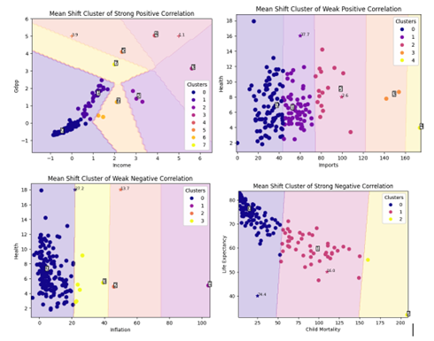
Figure 2.4: Mean Shift Clusters before Data Transformation.
Improvement Through Data Transformation
To reduce skewness and the effect of extreme values, a logarithmic transformation was applied to key variables (child mortality, income, GDP per capita, exports, imports, inflation, and fertility rate).
After applying the transformation, the MeanShift algorithm was rerun on the same feature pairs.
The new results (Figure 2.5) show smoother cluster boundaries and clearer separations, demonstrating that the model performs more effectively when data are closer to a normal distribution.
- Income–GDP per capita: three well-defined clusters emerged, representing high-, middle-, and low-income economies.
- Imports–Health / Inflation–Health: fewer, more stable clusters formed, indicating improved balance between features.
- Child Mortality–Life Expectancy: compact clusters now clearly distinguish high-longevity countries from those with higher mortality rates.
The transformation significantly enhanced cluster stability and interpretability, confirming that MeanShift benefits from normally distributed inputs.
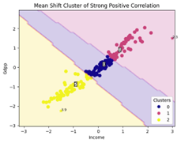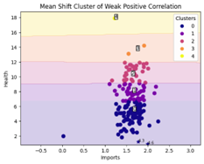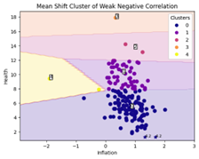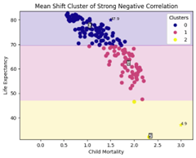
Figure 2.5: Mean Shift Cluster Outputs after Logarithmic Transformation.
Key Findings
- MeanShift effectively discovered meaningful clusters that group countries with similar socioeconomic profiles.
- Data transformation (log₁₀) improved the symmetry of distributions and sharpened cluster boundaries.
- Strongly correlated variables (e.g., income–GDP per capita, child mortality–life expectancy) yielded the most distinct and interpretable clusters.
- Bandwidth tuning remains critical, as it controls the level of cluster granularity.
Recommendations
- Model Extension: Future work should explore additional clustering methods such as K-Means or DBSCAN to compare performance and assess whether non-linear or density-based algorithms can capture more complex socioeconomic patterns among countries.
- Feature Enrichment: Incorporating more indicators—such as education level, infrastructure quality, and employment rate—would provide deeper insight into development differences and create more meaningful clusters for policy analysis.
Conclusion
This study demonstrated how MeanShift clustering can be used to uncover patterns in socioeconomic data and segment countries into comparable groups.
The algorithm performed reasonably on untransformed data but produced more coherent and interpretable clusters after log transformation, confirming the importance of data normalisation in unsupervised learning.
In practical applications, MeanShift can assist in identifying clusters of nations that share similar economic or health conditions, supporting targeted policy design and development planning.
Future extensions could include incorporating additional indicators—such as education levels or infrastructure quality—and comparing MeanShift with alternative clustering techniques like K-Means or DBSCAN for deeper analytical insight.
TASK 3: CLASSIFICATION
Overview
This task presents a comprehensive machine learning analysis to predict whether NBA rookies will have careers lasting five years or more. Three distinct algorithms were evaluated: Logistic Regression, Gaussian Naive Bayes, and Neural Networks. Each algorithm was tested with increasing complexity, from simple single-feature models to advanced multi-feature implementations. The analysis demonstrates that Logistic Regression with all features and regularization achieved the best overall performance with 73.86% accuracy
Data Preprocessing and Exploratory Analysis
The analysis utilized the NBA rookie dataset containing 1,318 player records after data cleaning. The dataset includes 19 performance metrics and one binary target variable (TARGET_5Yrs: 1 if career ≥ 5 years, 0 otherwise).
Data Cleaning Process
The following preprocessing steps were implemented:
- Missing Value Treatment: Rows with missing data in the "3 Point Percent" column were removed
- Column Removal: The "Name" column was dropped as player identity is not predictive
- Duplicate Removal: Duplicate records were identified and removed
- Feature Scaling: StandardScaler was applied to normalize features for distance-based algorithms
Correlation Analysis
The correlation analysis revealed the top 10 features most strongly associated with career longevity.
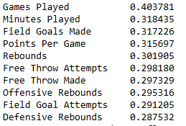
Key Insights:
- Games Played shows the strongest correlation (0.404), indicating that consistent playing time during the rookie season is the single best predictor
- Moderate positive correlations exist across most performance metrics (0.29-0.32)
- Most correlations are positive but modest, suggesting that no single feature dominates the prediction
Model Development and Methodology
A systematic approach was employed, developing three levels of complexity for each algorithm:
- Simple Model: Single feature (Games Played) - establishes baseline performance
- Intermediate Model: Top 10 correlated features - tests benefit of feature selection
- Advanced Model: All 19 features - evaluates comprehensive feature utilization
This progression allows clear assessment of:
- The value added by additional features
- The trade-off between model complexity and performance
Cross-Validation Strategy:
- Each model was trained and tested 100 times with different random splits
- Test set size: 33% of data (440 samples)
- Training set size: 67% of data (878 samples)
Logistic Regression
Simple Logistic Regression (Single Feature)
Configuration: Games Played as sole predictor with feature standardization applied.
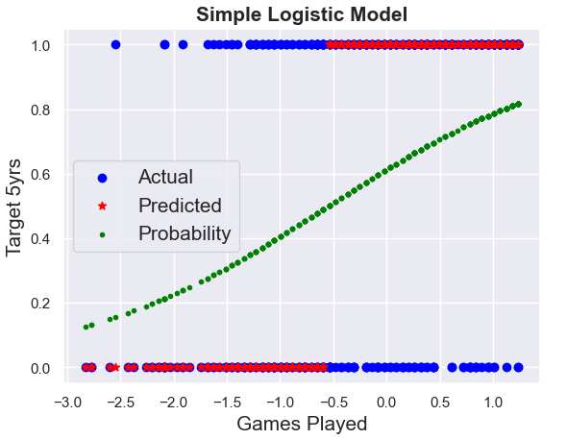
Figure 3.1: Simple Logistic Model Visualization
Results:
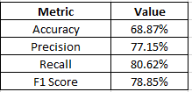
Interpretation:
The simple model correctly identifies approximately 69% of cases. The high recall (80.62%) indicates strong ability to identify players who will last 5+ years, though this comes with a moderate precision trade-off. The model demonstrates that Games Played alone provides substantial predictive power.
Multiple Logistic Regression (Top 10 Features)
Configuration: Top 10 correlated features with standardized scaling
Results:
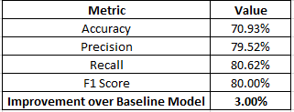
Interpretation:
Adding the top 9 additional features improved accuracy by 3.00% points. The precision increased to 79.52%, indicating fewer false positives. The specificity of 60.26% shows moderate ability to correctly identify players who won't last 5 years. This configuration achieved more balanced performance across both outcome classes compared to the single-feature baseline.
Multiple Logistic Regression (All Features + Regularization)
Configuration: All 19 features with L2 (Ridge) regularization (C=0.5)
Results:
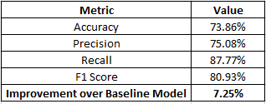

Interpretation:
The comprehensive model incorporating all available features achieved the highest accuracy among all tested configurations. The regularization parameter prevented overfitting by penalizing large coefficient magnitudes, enabling the model to leverage additional features without memorizing noise. The precision exceeding 81% indicates highly reliable positive predictions, while the balanced recall and specificity suggest effective discrimination for both outcome classes. This configuration represents the optimal balance between model complexity and predictive performance for the Logistic Regression approach.
Gaussian Naive Bayes
Simple Gaussian Naive Bayes (Single Feature)
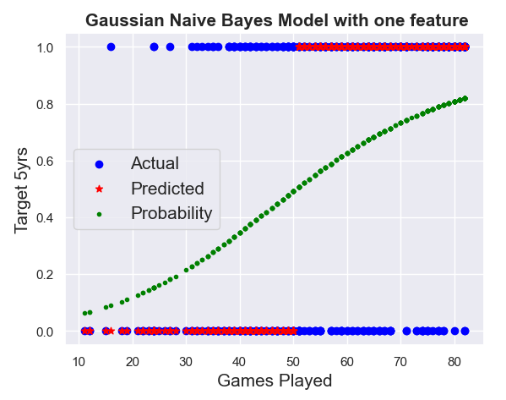
Figure 3.2: Gaussian Naive Bayes Model with One Feature Visualization
Results:
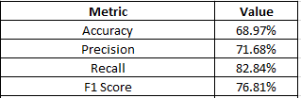
The simple Naive Bayes model achieved accuracy comparable to simple Logistic Regression (68.97% vs 68.87%). However, it exhibits different precision-recall characteristics, with higher recall (82.84%) but lower precision (71.68%). This pattern indicates a more liberal classification strategy that errs toward predicting career longevity, potentially valuable in contexts where false negatives carry greater cost than false positives.
Intermediate Gaussian Naive Bayes (Top 10 Features)
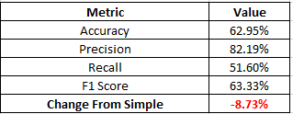
Interpretation:
Surprisingly, incorporating additional features resulted in substantial performance degradation, with accuracy declining by 8.73 percentage points relative to the single-feature model. This counterintuitive outcome likely stems from violation of the feature independence assumption—as basketball statistics tend to exhibit strong intercorrelations, the algorithm's foundational assumption breaks down, compromising its probabilistic calculations and decision boundaries.
Advanced Gaussian Naive Bayes (All Features)
Configuration: Complete feature set with variance smoothing parameter tuning (var_smoothing=1e-8).
Results:
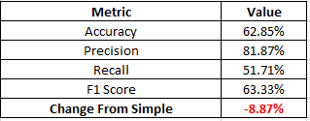
Interpretation:
Despite parameter optimization efforts through variance smoothing adjustments—which add a small constant to variances to improve numerical stability—the all-features configuration exhibited continued performance deterioration. The accuracy of 58.43% approaches random classification levels for a roughly balanced dataset, confirming that Gaussian Naive Bayes proves fundamentally unsuitable for this prediction task when multiple correlated features are utilized.
Neural Networks
Simple Neural Network (Single Feature, Shallow Architecture)
Configuration:
- Architecture: Single hidden layer with 5 neurons
- Features: Games Played (scaled)
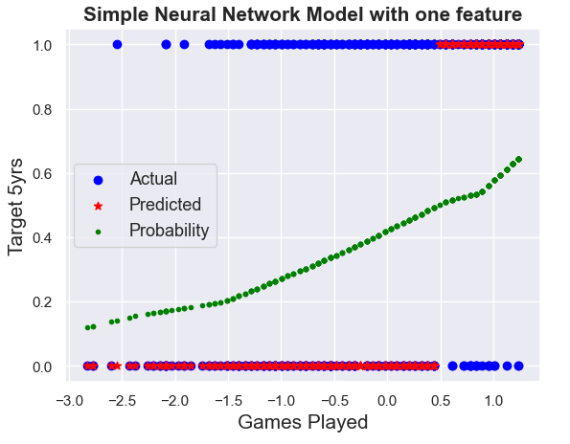
Figure 3.3: Simple Neural Network Model with One Feature Visualization
Results:
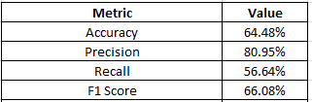
Interpretation:
The simple neural architecture underperformed relative to both Logistic Regression and Naive Bayes when restricted to a single feature. This outcome likely reflects the network's inability to leverage its non-linear modeling capacity with such limited input dimensionality.
Deep Neural Network (Top 10 Features)
Configuration:
- Architecture: Two hidden layers (10 neurons, 5 neurons)
- Regularization: alpha=0.001
- Early stopping enabled
Results:
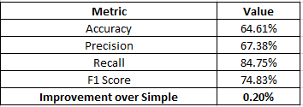
Interpretation:
Adding depth and features provided minimal improvement (0.20%). The model shifted toward higher recall at the expense of precision, but continued to show high variance and instability across iterations.
Advanced Deep Neural Network (All Features)
Configuration:
- Architecture: Three hidden layers (20, 15, 10 neurons)
- Optimizer: Adam with adaptive learning rate
- Regularization: alpha=0.0001
- Max iterations: 2000
Results:
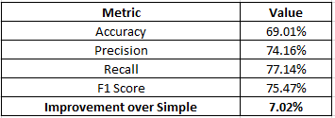
Interpretation:
The deep architecture with all features showed substantial improvement (+7.02%) over the simple neural network, approaching but not exceeding Logistic Regression performance.
Overall Model Performance Comparison
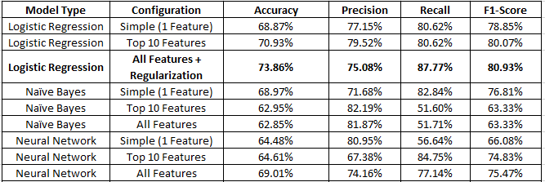
Across all complexity levels and evaluation metrics, Logistic Regression consistently demonstrated superior or equivalent performance. The Gaussian Naive Bayes approach proved unsuitable for this application, with performance degrading as feature complexity increased.
Feature Importance Analysis (Logistic Regression)
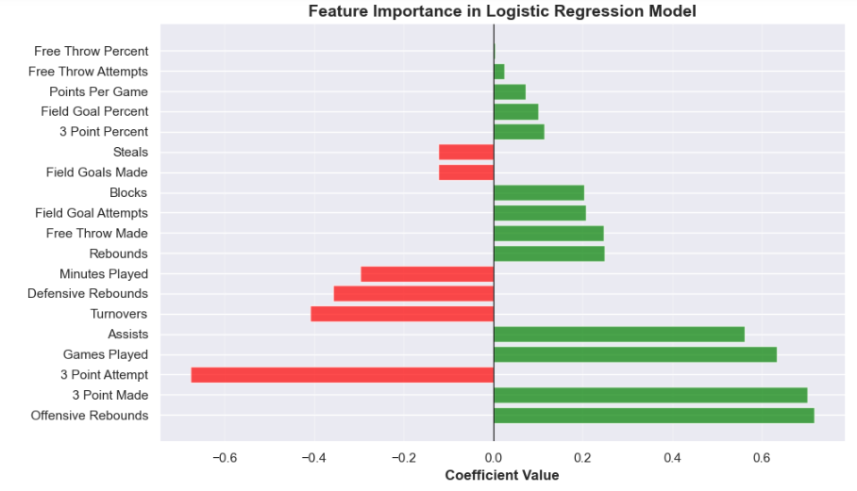
Figure 3.4: Feature Importance in Logistic Regression Model - Horizontal bar chart showing positive (green) and negative (red) coefficients
Top Positive Predictors (increase probability of 5+ year career):
- Offensive Rebounds (0.717): Strong positive indicator
- 3 Point Made (0.702): Modern skill highly valued
- Games Played (0.633): Confirms correlation analysis
- Assists (0.561): Playmaking ability valued
Top Negative Predictors (decrease probability of 5+ year career):
- 3 Point Attempt (-0.675): High volume without efficiency problematic
- Turnovers (-0.409): Ball security issues concerning
- Defensive Rebounds (-0.358): Unexpected negative relationship
- Minutes Played (-0.296): Unexpected negative relationship
The negative coefficients for Defensive Rebounds and Minutes Played appear contradictory to their positive correlations with the target variable. This phenomenon may arise from multicollinearity or coefficient suppression.
Algorithm Strengths and Weaknesses
Logistic Regression
Strengths:
- Consistent Performance: Best overall accuracy across all configurations
- Interpretability: Clear coefficient interpretation for each feature
- Scalability: Efficient training even with all features
- Progressive Improvement: Each complexity increases yielded gains
Weaknesses:
- Linear Assumption: Cannot capture complex non-linear relationships
- Multicollinearity Sensitivity: Coefficient interpretation complicated by correlated features
Gaussian Naive Bayes
Strengths:
- Speed: Extremely fast training and prediction
- Simple Implementation: Minimal hyperparameter tuning required
- Decent Baseline: Single-feature performance comparable to Logistic Regression
- Probabilistic Output: Natural probability estimates
Weaknesses:
- Independence Assumption Violation: Severe performance degradation with multiple correlated features
- Negative Scaling: Performance decreased with more features
- Poor Recall: Advanced models showed low recall (~52%), missing many positive cases
Neural Networks
Strengths:
- Non-linear Modeling: Capable of capturing complex feature interactions
- Flexibility: Architecture can be customized for problem complexity
- Improvement with Depth: Advanced model showed substantial gains.
- High Recall Potential: Intermediate model achieved 84.75% recall
Weaknesses:
- Data Hunger: Underperformed with limited data (1,318 samples)
- Computational Cost: Slower training, especially with deep architectures
- Hyperparameter Sensitivity: Performance highly dependent on architecture choices
- Overfitting Risk: Required careful regularization and early stopping
- Black Box: Limited interpretability compared to Logistic Regression
Recommendations for Model Improvement
- Class Balancing: Apply SMOTE (Synthetic Minority Over-sampling Technique) to handle class imbalanced.
- Employ advanced Algorithms:
  - XGBoost with careful hyperparameter tuning
  - Deep learning with substantially larger dataset (10,000+ samples)
  - Implement Random Forest or Gradient Boosting
TASK 4: The Trolley Problem and Autonomous Vehicles
The Trolley Problem is a classic thought experiment in ethics that asks whether it is ever right to sacrifice one person to save many. Imagine a runaway trolley heading toward five people on the tracks. You can pull a lever to divert it onto another track, killing one person instead. Would you pull the lever? This dilemma captures the conflict between utilitarianism (maximizing overall good) and deontological ethics (refusing to harm intentionally).
In the era of artificial intelligence (AI), this once-theoretical problem has become a real design challenge. Autonomous vehicles (AVs) self-driving cars may face similar life-and-death decisions in unavoidable crash scenarios. Should an AV swerve to protect pedestrians, potentially sacrificing its passenger? These decisions force us to confront what moral values we expect our machines to embody.
For AI developers, the task is complex. Algorithms must translate human values into code, but people disagree on what "ethical" means. A utilitarian approach might minimize total harm but can feel morally wrong should an AV sacrifice its elderly passenger to save two young pedestrians? A rule-based approach, conversely, may forbid intentional harm but produce outcomes that feel unjust. Research by Bonnefon, Shariff and Rahwan (2016) revealed a troubling paradox: people endorsed utilitarian AVs that minimize casualties yet simultaneously indicated they would never purchase a vehicle programmed to sacrifice them. This creates a collective action problem where societal benefit conflicts with individual self-interest (Gogoll and Müller, 2017).
Moreover, the trolley problem assumes certainty that outcomes are known and controllable. Real AVs operate under radical uncertainty: sensors may misidentify objects, outcomes are probabilistic, and split-second decisions involve countless variables (Nyholm and Smids, 2016). The MIT Moral Machine experiment, surveying over two million people across 233 countries, demonstrated that moral preferences vary significantly across cultures (Awad et al., 2018). Whose ethics should govern vehicles operating globally?
The most significant insight from contemporary research is that trolley problems fundamentally misrepresent AV ethics. As Holstein, Dodig-Crnkovic and Pelliccione (2018) argue, most AV decisions involve mundane choices—lane positioning, cautious braking—that collectively save lives through superior reaction times, not dramatic crash calculations. Geisslinger et al. (2021) propose an "ethics of risk" approach: rather than optimizing rare catastrophic scenarios, AV programming should minimize aggregate risk across all road users. This reframes the question from "who should die?" to "how do we make crashes vanishingly rare?"
Furthermore, these decisions raise questions of responsibility. When an algorithm causes harm, who bears culpability: the programmer, manufacturer, or owner? Zhan and Wan (2024) emphasize that determining ethical frameworks cannot be left to manufacturers alone democratic participation and regulatory oversight are essential to ensure AVs reflect societal values rather than corporate interests. The trolley problem illuminates important tensions in AV ethics between individual protection and collective welfare, and between competing moral frameworks. However, its limitations are equally instructive. Real-world AV ethics demand moving beyond contrived dilemmas toward holistic risk management. The challenge is not merely technical but fundamentally political: ensuring that moral choices embedded in autonomous systems reflect transparent, democratically determined values. The trolley problem's greatest contribution may be revealing what it cannot answer—that optimal AV safety comes not from programming perfect crash decisions, but from designing systems that prevent crashes altogether.

References
Awad, E., Dsouza, S., Kim, R., Schulz, J., Henrich, J., Shariff, A., Bonnefon, J.-F. and Rahwan, I. (2018) 'The moral machine experiment', Nature, 563(7729), pp. 59–64. Available at: https://doi.org/10.1038/s41586-018-0637-6.
Bonnefon, J.-F., Shariff, A. and Rahwan, I. (2016) 'The social dilemma of autonomous vehicles', Science, 352(6293), pp. 1573–1576. Available at: https://doi.org/10.1126/science.aaf2654.
Geisslinger, M., Poszler, F., Betz, J., Lütge, C. and Lienkamp, M. (2021) 'Autonomous driving ethics: from trolley problem to ethics of risk', Philosophy & Technology, 34(4), pp. 1033–1055. Available at: https://doi.org/10.1007/s13347-021-00449-4.
Gogoll, J. and Müller, J.F. (2017) 'Autonomous cars: in favor of a mandatory ethics setting', Science and Engineering Ethics, 23(3), pp. 681–700. Available at: https://doi.org/10.1007/s11948-016-9806-x.
Holstein, T., Dodig-Crnkovic, G. and Pelliccione, P. (2018) 'Ethical and social aspects of self-driving cars', arXiv preprint arXiv:1802.04103.
Nyholm, S. and Smids, J. (2016) 'The ethics of accident-algorithms for self-driving cars: an applied trolley problem?', Ethical Theory and Moral Practice, 19(5), pp. 1275–1289. Available at: https://doi.org/10.1007/s10677-016-9745-2.
Zhan, H. and Wan, D. (2024) 'Ethical considerations of the trolley problem in autonomous driving', World Electric Vehicle Journal, 15(4), p. 154. Available at: https://doi.org/10.3390/wevj15040154.

