Issues- CSS File Specifcs:
- CSS has 3 different references for : footer .footer-menu ul, footer .footer-menu ul li, and footer .footer-menu ul li a. Please clean up code See Below.
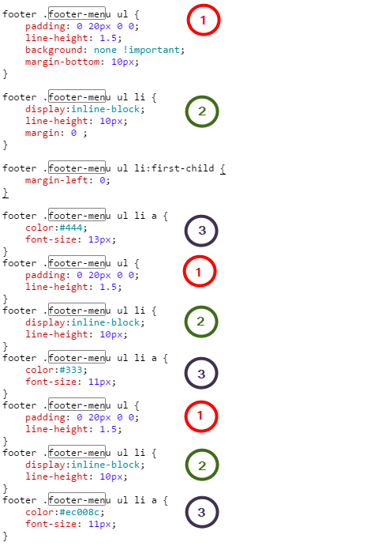

- footer .footer-menu ul li a has 3 different color assignments. The last one #ec008c is the one that is displaying on the site, which is incorrect. Please use only color codes in the Guide attached. This should be using Color #333.
- .toolbar a is currently referencing color code #ec008c. This was to be eliminated from the site, please update to color #333.
- .item .promo-message a is appearing twice in the css. The second one references color ed008c which is what is displaying and we are trying to eliminate. Please remove the second reference as the first one is correct, color #333.
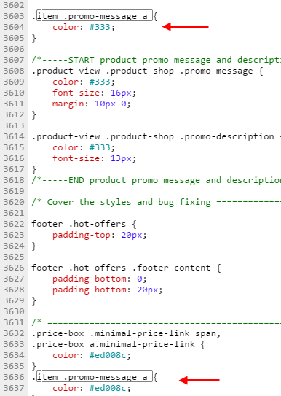
- . product-view .product-shop .promo-description is appearing twice in the css. The second one references color ed008c which is what is displaying and we are trying to eliminate. Please remove the second reference as the first one is correct, color #333.

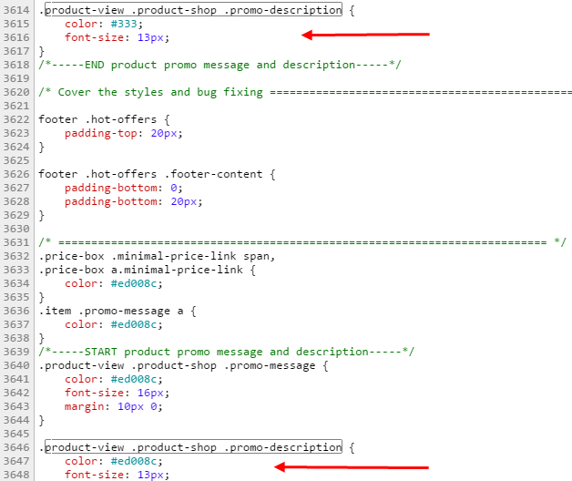
- .price-box .minimal-price-link span, .price-box a.minimal-price-link, .item .promo-message a, .product-view .product-shop .promo-message, .product-view .product-shop .promo-description, all are referencing color #ed008c which is one of the colors we are trying to eliminate from the site. Please only use approved colors from the guide.
Please update all of these to use Color #333
.price-box .minimal-price-link span, .price-box a.minimal-price-link,
.item .promo-message a,
.product-view .product-shop .promo-message,
.product-view .product-shop .promo-description
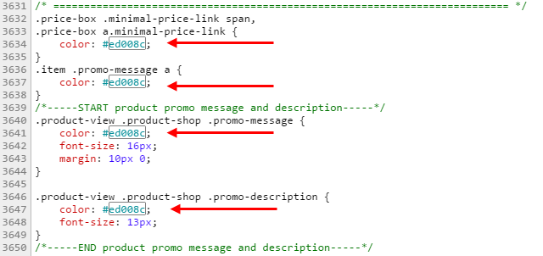
- The tab menu for categories when in an open state is still referencing #ec008c, it should be using color : #d4037f.
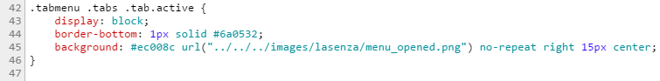
- The tab menu for categories is referencing color #6a0532 as the bottom border color to separate the different tabs. This color should be #000.
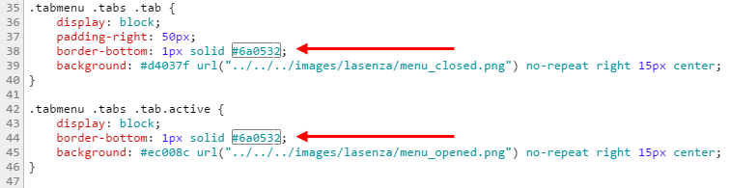
Issues - other formatting:
- The Links for Terms & Conditions, Privacy & Site Map, need to be separated by a “|”. See Below:
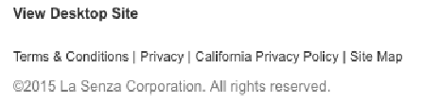

- When selecting a language, it should open an IOS or Android dialog box and not a dropdown box on the page.
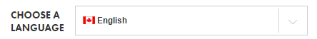

- The tumbler icon needs to be removed and the Snap Chat icon needs to be added with a link to snap chat. See image from Guide below.
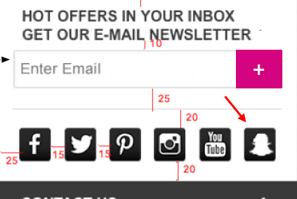

- Get Exclusive CTA –“Join Now” is in pink and should not be. Also the “>” is missing. See below from the Mobile Guide attached.
Current: | 
Should be: | 

- Signup for email – Field name is not updated. Should be “hot offers in your inbox Get our e-mail newsletter. Subscribe button should be the [+] button. See below from the Mobile Guide attached.
Current: | 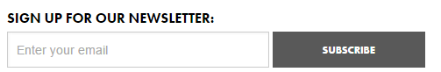
Should be: | 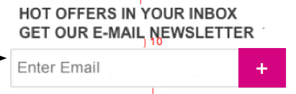

- On Category pages like http://lasenza-stage-ca.lcgosc.com/bras.html the category name is appearing twice on the page. It should only appear once, above the Static block. The one below it should not be displaying.
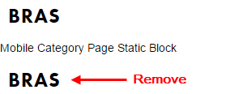

- When you are on a category page 2 or greater and the Prev link is now present, the “<” should also be present on the site, and it is currently missing.
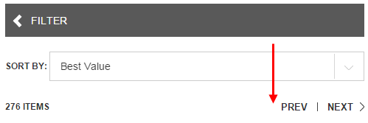

- On the Category page where there are items with Tier Pricing, the “As low as : $x.xx CAD” should appear on a new line.
Current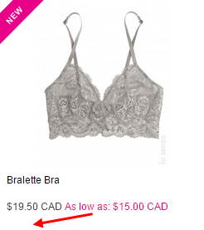 Should be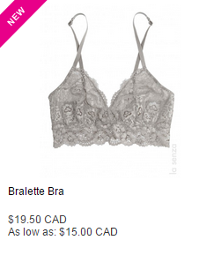

- When you go to a product page and the size selector is disabled because a color has not been selected. The formatting of the Size selector is not correct
Current:
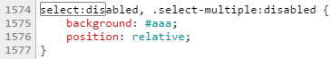
Should be:
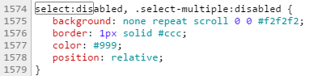

- When you go to a product page and tap on the main image to zoom. The wait loader image never resolves itself, see below.
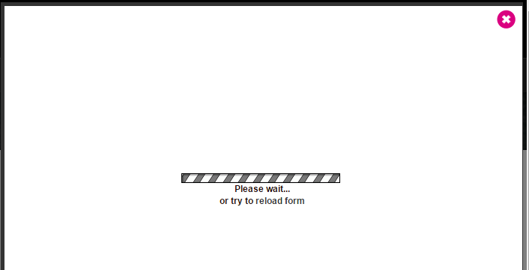

- When you go to a product page and tap on the main image to zoom. Then close it. Then tap to open the nav to go to another category. The category list is not fully displayed. You can only see the first category.
This same scenario occurs when you choose to edit an item in the shopping cart and open the edit overlay.
It also happens if you choose to estimate your shipping & handling costs from the shopping cart page when the overlay opens for that reason as well.
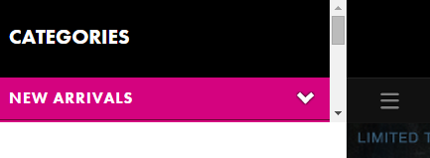

- On product pages, the Share This Item Section is not correct per the Guide provided. See copy from the Guide below.
- The “Share this Item” text is missing.
- The Instagram, Snap Chat & Email icons are missing.
- The Google + Icon should be removed.
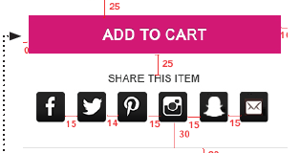

- When you go to the shopping cart page with nothing in the cart. The page is not formatted correctly. See image below.
- Change “Click here to continue shopping” text into button that says “CONTINUE SHOPPING”
- Center “You have no items in your shopping cart.” above the button with a bottom margin of 10px
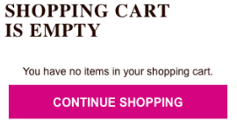

- When you go to a category where there are products with a Promo Message and it comes in multiple colors like on the page: http://lasenza-stage-ca.lcgosc.com/bras/push-up-bras.html. The Swipe to View Text is being cut off. See below.
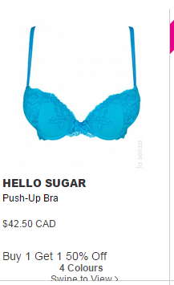

- When you go to the shopping cart page with items in your cart and have not signed in, The links to Estimate the Shipping & Taxes are in color #333, and should be in #fff. See issue below:
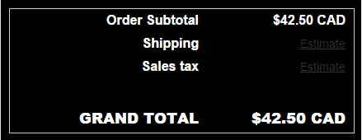

- When you go to the shopping cart page with items in your cart and tap on the edit button and the edit item overlay opens. There is a line under the word quantity that should not be there. See below.
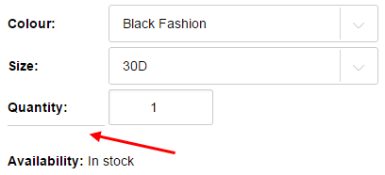

- When you go to the shopping cart page with items in your cart and tap on the edit button and the edit overlay opens. The Close icon needs to be updated from the pink color to Color #333. See Image below.

- With an item in your cart, go to checkout. On the Checkout / One Page tap on the Gift Cards section to expand it and the buttons are not aligned. Expected them to be aligned. See Below.
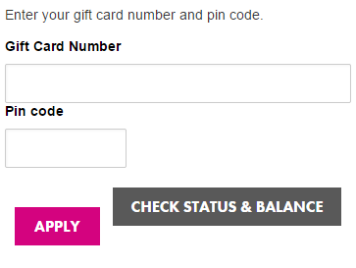

- Go to the Contact Us page : https://lasenza-stage-ca.lcgosc.com/contacts/ The Comment section is filled in Grey. See page below and specifications for this field from the guide below.
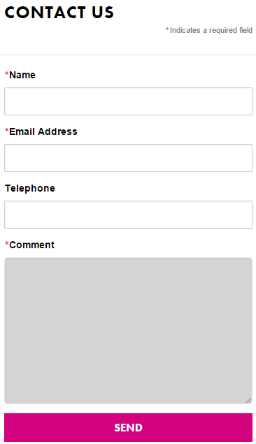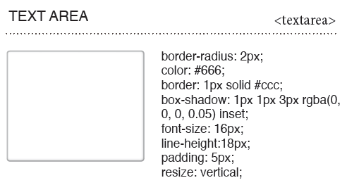

- When you go to the My Orders page. And you have more than 1 page of orders, and tap to go to the next page, the page number should be greyed with a white number and the pink outlines should be grey, along with the “>” Please see page 24 of the guide for more specific details of the layout for this page.
