A test-example program for indirection operator and the paraSolids.scad import file is :
paraSolidExample.scad.

CODE:

include <paraSolids.scad> ///// MUST BE <include>, NOT <use> /////

///A test vector
test = [-1,.5,7,-4,0];

////Some passable functions
function @div72(x) = x/72;
function @square(x) = x*x;
function @xsq_ysq(x,y) = abs(y*y-x*x);
function @add(x,y) = x+y;
function @sinTimes(a,b) = abs(sin(a)*b/5);
function @sinTimesR(r,a) = abs(r-abs(3*cos(a-1)));

echo([div72,square,add,sinTimes])
echo(map(square, test));
echo(map(div72, test));
echo(reduce(add, test));
echo(reduce(sinTimes,test));
echo(filter(div72,test));
echo("DONE WITH TESTS");

////2D examples Uncomment to see.+
//yIsFx(square,xseg=[-3,3],grid=30);
//rIsFa(div72, angle=330, ticks=30);

///3D

//zIsFxy(xsq_ysq, diag=([[1.5,3],[-1.5,-1.5]]), gridx = 20, gridy = 20);
//zIsFxy(add, diag=([[0,2],[3,0]]));
//rIsFza(sinTimes, zseg=[0,5], ticks=30, grid=30);
//zIsFarIsFa(div72,fra=sinTimesR,ticks=40,grid=20);

mandelMax = 150;
function mandel(cons,maxcount=mandelMax,z=[0,0]) =
maxcount==0 ? mandelMax-maxcount
:(norm(z)> 2 ? mandelMax-maxcount
: mandel(cons,
maxcount-1,
[z[0]*z[0]-z[1]*z[1],z[0]*z[1]*2]+cons
)
);
function @testMandel(x,y) = log(mandel([x,y]))/3;
//zIsFxy(testMandel,diag=[[-2,2],[2,-2]],gridx=100, gridy=100);

Removing comments in order:
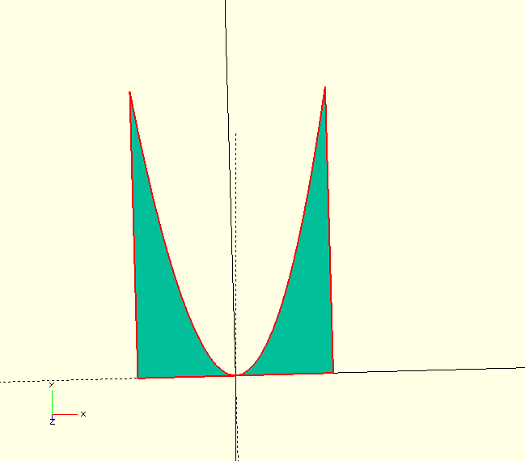
2D examples:
yIsFx(square,xseg=[-3,3],grid=30);

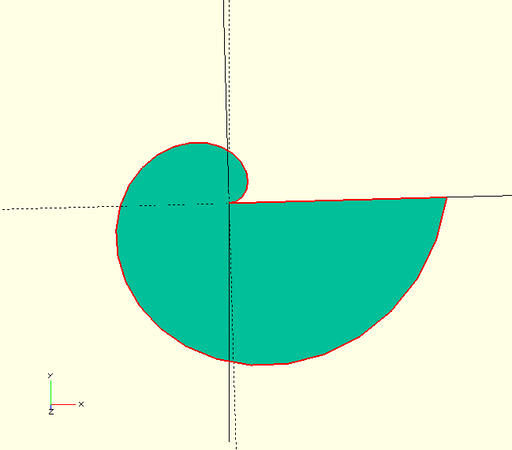
rIsFa(div72, angle=330, ticks=30);

zIsFxy(xsq_ysq, diag=([[1.5,3],[-1.5,-1.5]]),gridx = 20,gridy = 20);
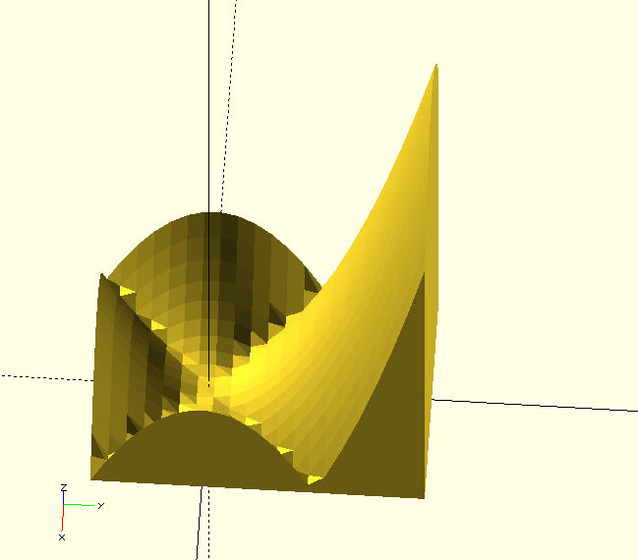

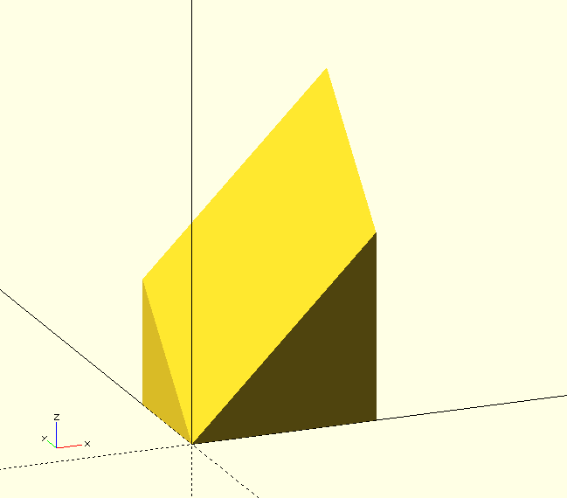
zIsFxy(add, diag=([[0,2],[3,0]]));

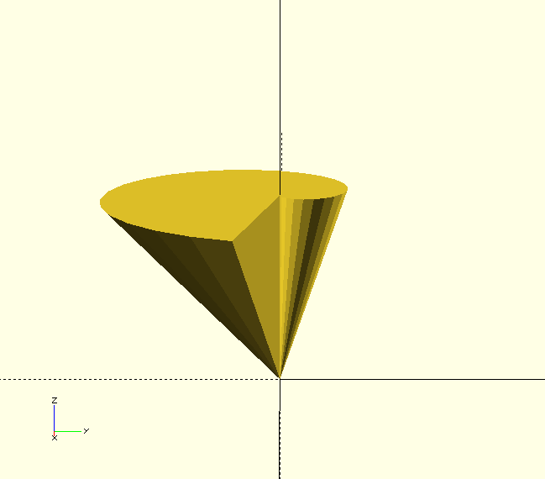
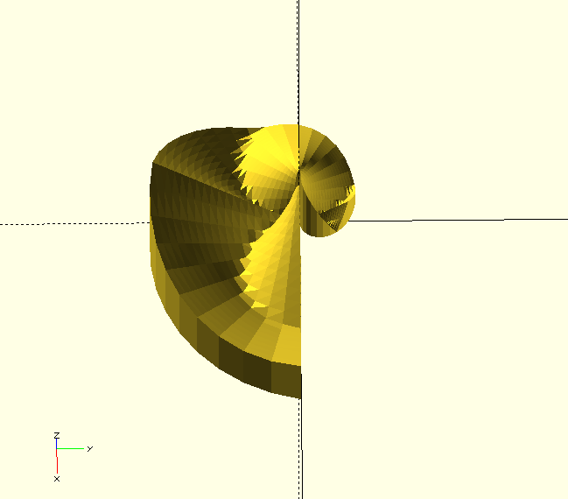
rIsFza(sinTimes, zseg=[0,5], ticks=30, grid=30);

zIsFarIsFa(div72,fra=sinTimesR,ticks=40,grid=20);

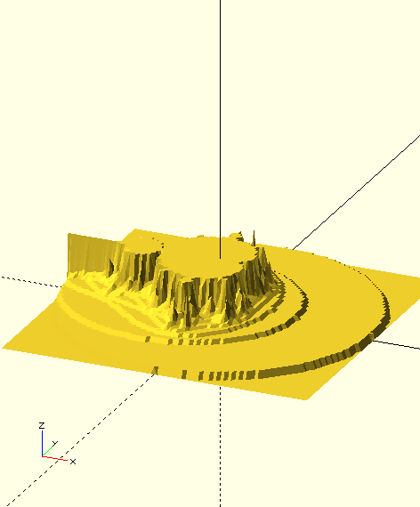
zIsFxy(testMandel,diag=[[-2,2],[2,-2]],gridx=100, gridy=100);

All files needed to alter OpenScad to handle function indirection and run these examples is available at:

https://github.com/ottojas/openscad-affine

FILES FOR ANY VERSION OF OPENSCAD:

affine.scad contains affine transforms and utility functions.
affineExample.scad contains examp[les and test code.

FILES FOR VERSION WITH FUNCTION INDIRECTION.

paraSolids.scad contains functional language constructs reduce and map. Also contains a number of modules to generate shapes parametricly by passing functions.
paraSolidExample.scad contains examples to illustrate and test the code in paraSolids.scad and changes to the openscad program.

THE FOLDER ojasSources contains the five files that have been added to to obtain the functional indirection capabilities. The code that has been altered is marked with "////OS". There are about 30 lines total.

All of these files overwrite files in the src directory.

This file is ParaSolidExamples.pdf in the repository.

