|  |  |
| --- | --- |
| TALLINN UNIVERSITY OF TECHNOLOGY | |
| School of Information Technologies | |
|  | |
|  | |
| Otto Kaarel Altroff  193314IADB | |
| Goal & Habit Tracker Application | |
| Home project in subject Building Distributed System (ICD0021) | |
| Supervisor: | Andres Käver |
|  |  |
|  |  |
|  |  |
|  |  |
|  |  |
|  |  |
|  |  |
|  |  |
|  |  |
|  |  |
|  |  |
|  |  |
|  |  |
|  |  |

Author’s declaration of originality

I hereby certify that I am the sole author of this thesis. All the used materials, references to the literature and the work of others have been referred to. This thesis has not been presented for examination anywhere else.

Author: Otto Kaarel Altroff

Table of contents

Introduction 4

1 Overview 5

2 Analysis 6

2.1 ERD Schema 6

3 Mock Design 7

References 11

Appendix 1 – Non-exclusive licence for reproduction and publication of a graduation thesis 12

# Introduction

The need for productivity apps has increased exponentially in the last few years. More and more people around the world have a desire to set and track their goals and habits associated.

Many goal tracking applications today are too clunky, universal and slow to use. The aim for this project and application is focused towards productivity-orientated people for them to set their goals and keep track of them in a functional and visually pleasing way.

To fulfill this work, the author will create an ERD schema, creates a database and builds application layers respectively to the requirements of the assignement. The course work consists of the documentation (the given document), ERD schema and application source code.

# Overview

The application is aimed for productivity-orientated people for them to set their goals and keep track of them. Anybody can create a user on this platform to start using the platform. A user can set up their profile listing all their goals and habits.

User can keep an eye on the goal progress (displayed visually on reports) and set associated tasks or habits requiered to achieve the goal. Reminders can be set on each task and habit. Goals can be divided into different groups (such as “Personal”, “Work”, “Finances” etc). User can keep a diary and insert entries for each goal or task accordingly.

The application will be created as a hybrid mobile application which will be available on both iOS and Android.

# Analysis

## ERD Schema

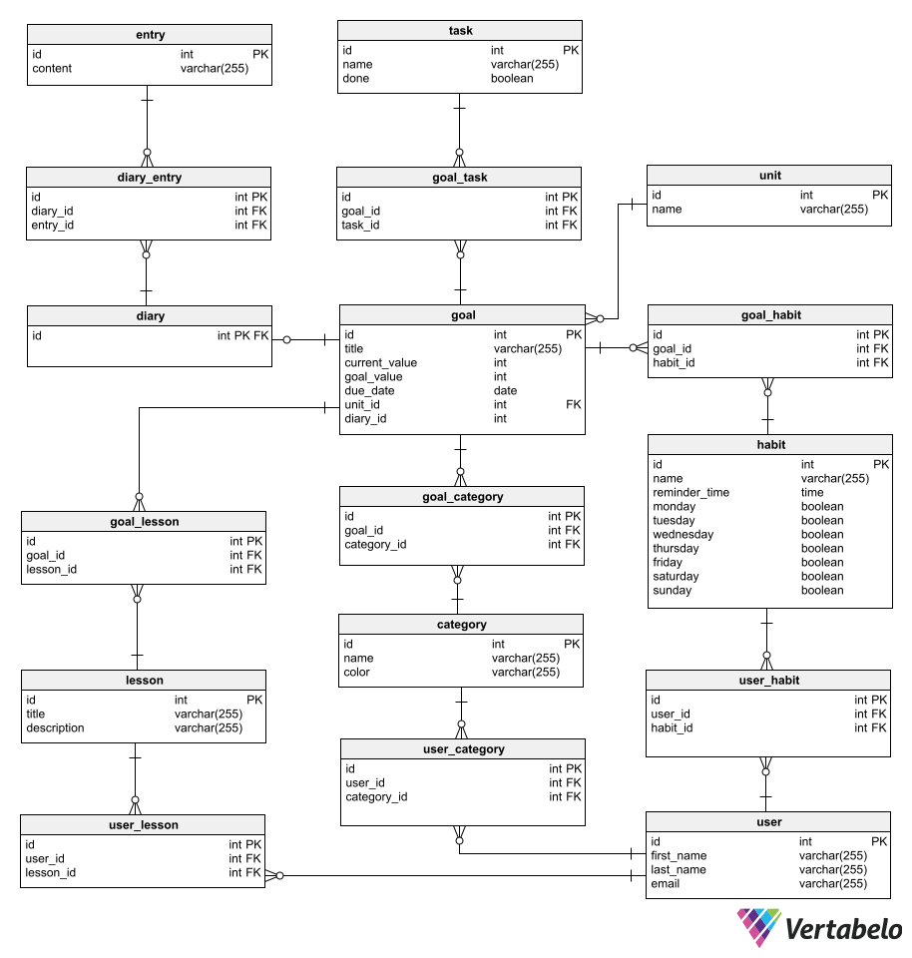

# Mock Design

Created in Canva.com

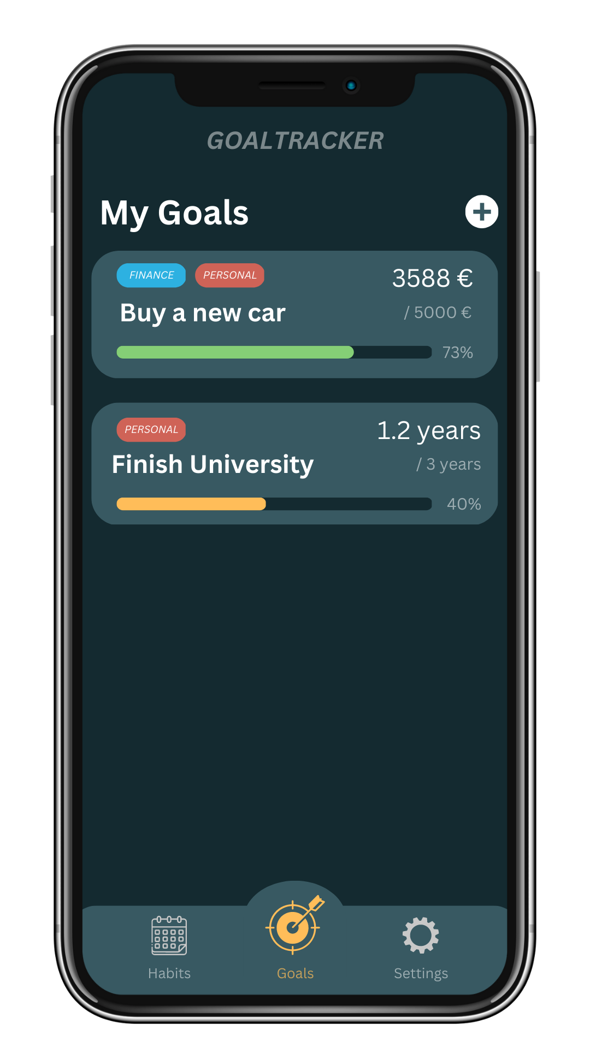

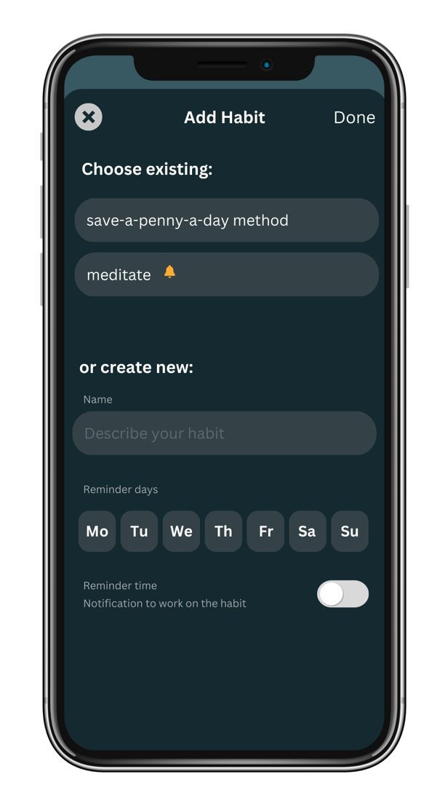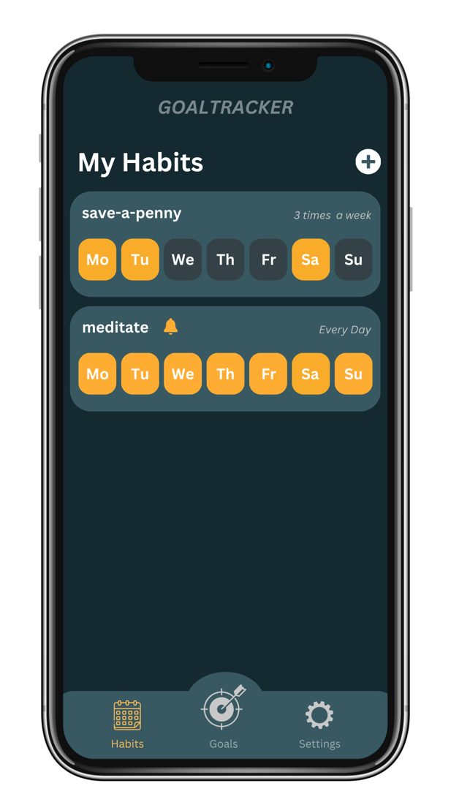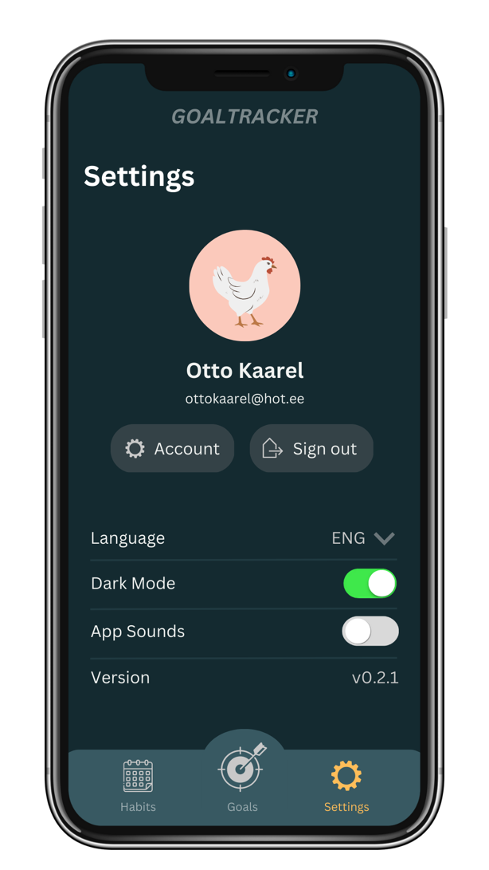

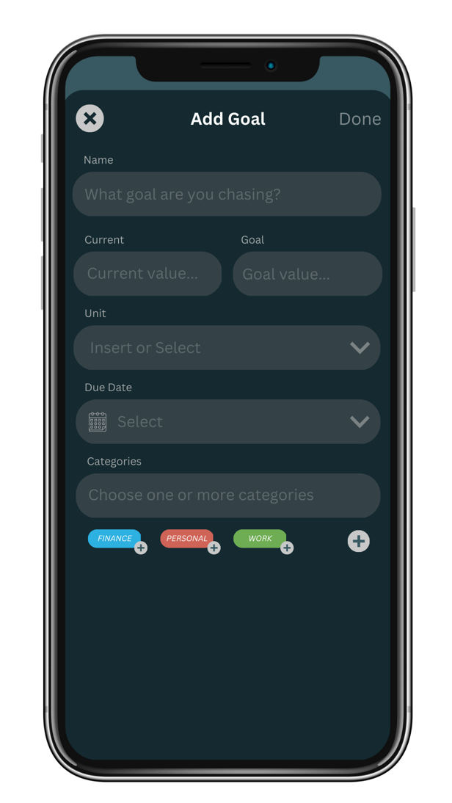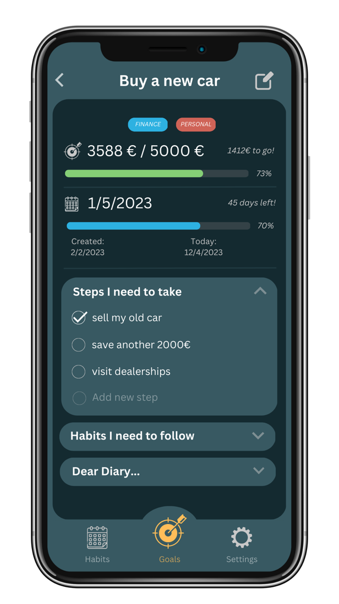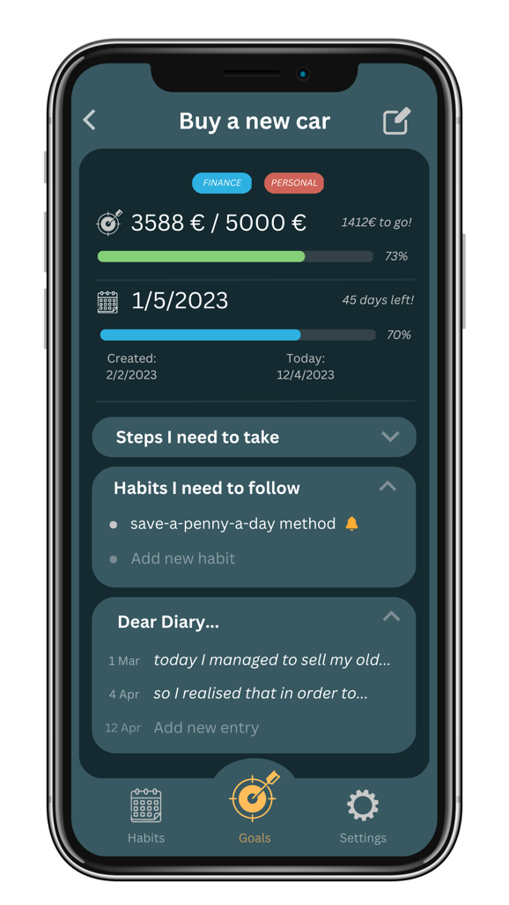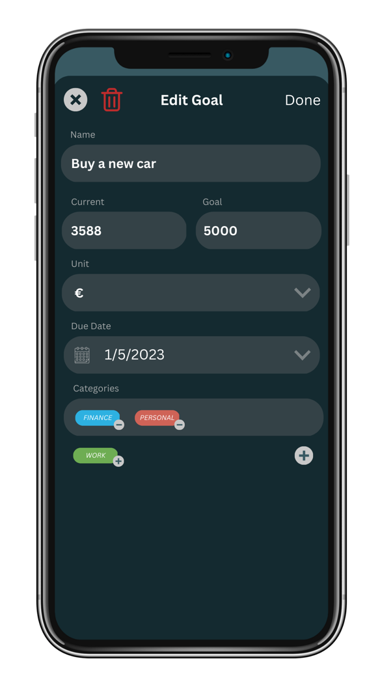

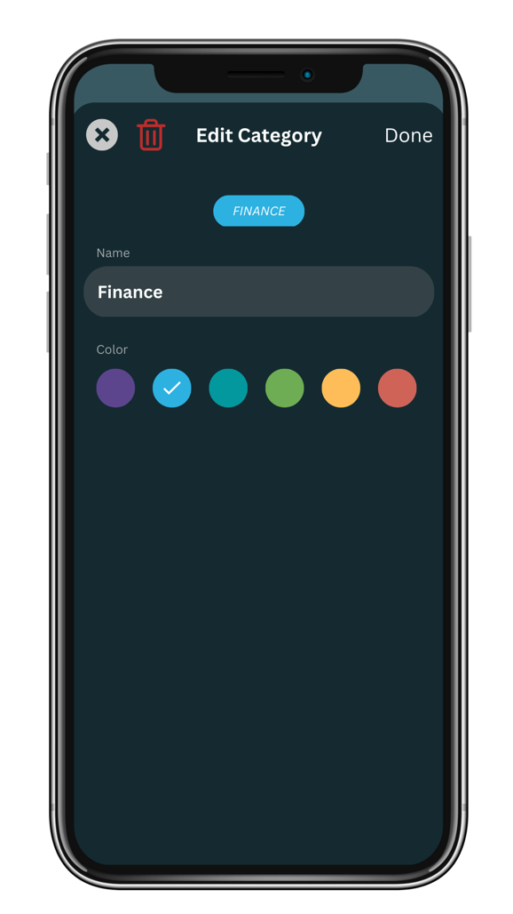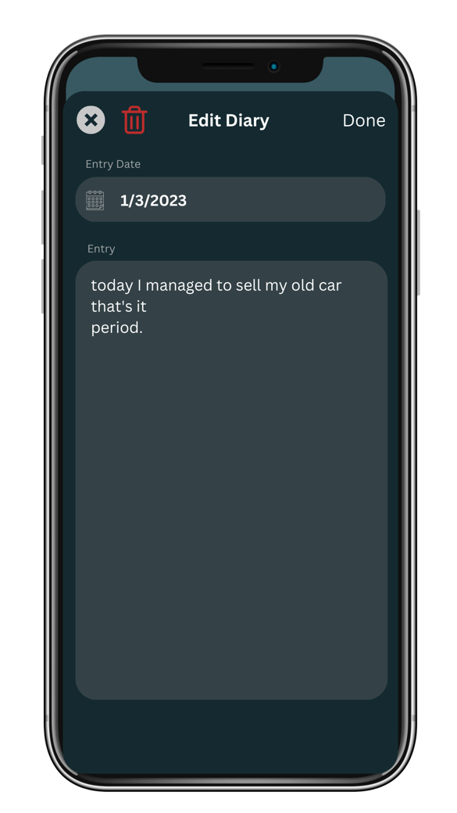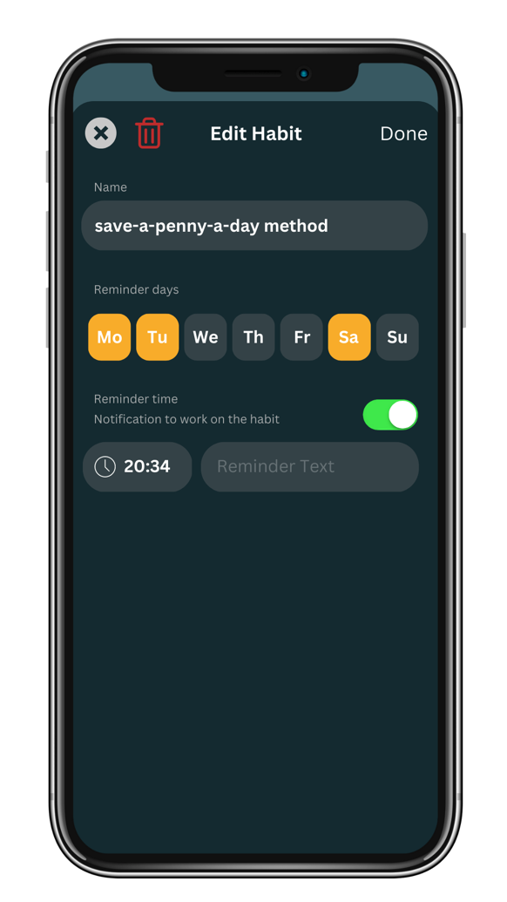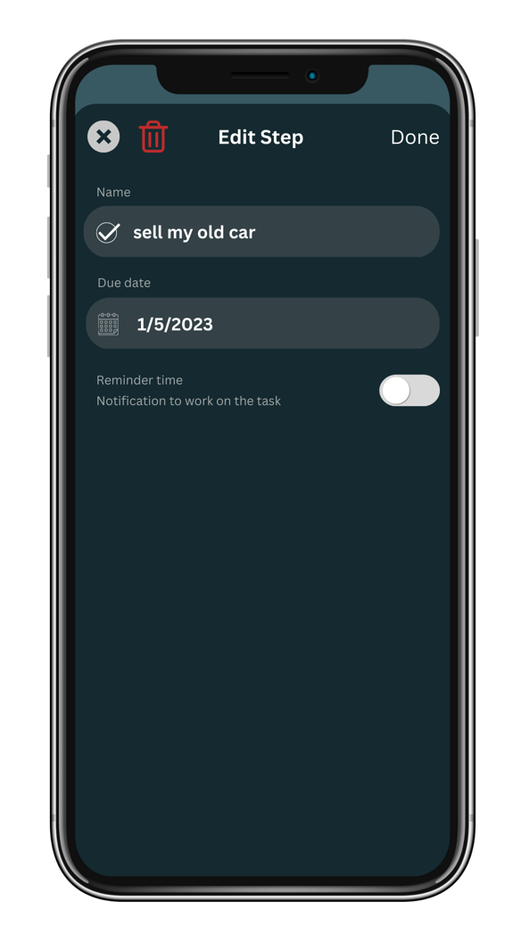

References

1. Käver, A. Building Distributed System (ICD0009) course materials. Read: 13.02.2023 <https://courses.taltech.akaver.com/distributed/home/>

Appendix 1 – Non-exclusive licence for reproduction and publication of a graduation thesis[1]

I

1. Grant Tallinn University of Technology free licence (non-exclusive licence) for my thesis , supervised by
   1. to be reproduced for the purposes of preservation and electronic publication of the graduation thesis, incl. to be entered in the digital collection of the library of Tallinn University of Technology until expiry of the term of copyright;
   2. to be published via the web of Tallinn University of Technology, incl. to be entered in the digital collection of the library of Tallinn University of Technology until expiry of the term of copyright.
2. I am aware that the author also retains the rights specified in clause 1 of the non-exclusive licence.
3. I confirm that granting the non-exclusive licence does not infringe other persons' intellectual property rights, the rights arising from the Personal Data Protection Act or rights arising from other legislation.

1. The non-exclusive licence is not valid during the validity of access restriction indicated in the student's application for restriction on access to the graduation thesis that has been signed by the school's dean, except in case of the university's right to reproduce the thesis for preservation purposes only. If a graduation thesis is based on the joint creative activity of two or more persons and the co-author(s) has/have not granted, by the set deadline, the student defending his/her graduation thesis consent to reproduce and publish the graduation thesis in compliance with clauses 1.1 and 1.2 of the non-exclusive licence, the non-exclusive license shall not be valid for the period.