***MATLAB, Lab 3 – group work***

**Random contest drawing**

Let us imagine that the urn contains 10 balls signed by numbers from 1 to 10 (i.e. the first ball is signed as "1", the second as "2", etc.). We will use the **rand** function to simulate a single drawing of just 1 ball from the urn at the time.

Note that we can easily "convert" the result returned by the **rand** function into a digit from a range [1 ...10], so that the drawing of each of these face values were as likely as 1 / 10 (simple probability statistics).

If 0 <x <1 (as returned by **rand** function), then a whole part of the number represented by y = 1 + 10x is an integer within the required range. You can easily justify that if x has a distribution uniform in [0…1], y takes the values from the set [1, ..., 10] with equal probabilities. So the drawing of a single ball can be coded as follows:

»x = rand  
  
x =  
  
    0.1703  
  
»y = fix (1 + 10 * x)  
  
y =  
  
     2

Of course, the same can be done differently, such as writing a nested **if** statement, etc. However, as described above, the solution is simple. If we want to make 50 draws, we just need to remember the next randomly drawn values in consecutive coordinates of the vector (use cumsum function)

Now imagine that after each drawing the ball from the urn wins a certain amount of money equal to the number written on the ball. Therefore, we can each draw to receive 1 to 10 PLN.

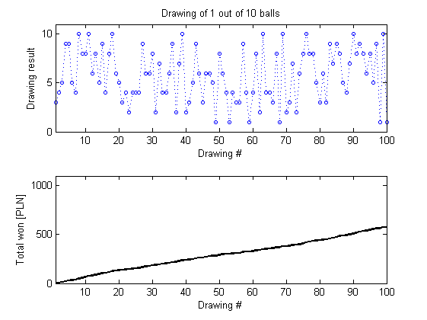

Fig. Chart with results of the lottery

**ASSAIGNMENT:**

1. Prepare the code that simulates 100 drawings with cumulative summation of results. Prepare the chart of simulating 100 drawings. On X axis put the drawing number and on Y axis place the result (number between 1 and 10). On the second plot prepare the cumulative amount of money won in function of drawing number.

|  |
| --- |
| Code:  balls=zeros(100);  for i = 1 : 100  balls(i)=fix(1+10*rand);  total=cumsum(balls);  end    size=get(0,'ScreenSize');  figure('Position', [1 1 size(3) size(4)]);  n =1:100; % n throws  subplot(2,1,1);  h=plot(n,balls);  title('Drawing of 1 out of 10 balls', 'FontSize', 20);  subplot(2,1,2);  s=plot(n,total);  axis([1 100 0 1000])  grid on; |
| Screenshot: |
|  |
| Comments: |
|  |

1. As next part change your code to add the fact that in this lottery you must pay for each drawing. Make up amounts of money to see how this changes the results. The change will be visible in the amount won depending on the price you put on a coupon.

|  |
| --- |
| Code:  tax=5;  balls=zeros(100);  for i = 1 : 100  balls(i)=fix(1+10*rand);  total=cumsum(balls-tax);  end  figure('Position', [1 1 size(3) size(4)]);  n =1:100; % n drawings  subplot(2,1,1);  h=plot(n,balls);  title('Drawing of 1 out of 10 balls with taxes', 'FontSize', 20);  subplot(2,1,2);  s=plot(n,total);  axis([1 100 -1000 1000]);  legend(s,'\ittotal (no taxes)\rm','\ittotal with taxes(5 PLN)\rm');  grid on; |
| Screenshot: |
| Comments: |
|  |