Qualtrics Translator Machine
Turning Qualtrics exports into advisory intelligence. No AI dependency. Full evidence traceability. 30 seconds from upload to insight.

What it is
QTM is a browser-based intelligence engine that takes raw Qualtrics data exports and strategic context documents (annual reports, C-suite interview transcripts, industry benchmarks), cross-references them, and produces prioritised advisory recommendations with three AKT-branded PowerPoint decks tailored to different stakeholder audiences.
It is a single HTML file. No server, no installation, no cloud subscription, no LLM. A consultant opens it in Chrome, drops files in, and gets board-ready deliverables in under 30 seconds.
The interface: upload, analyse, generate
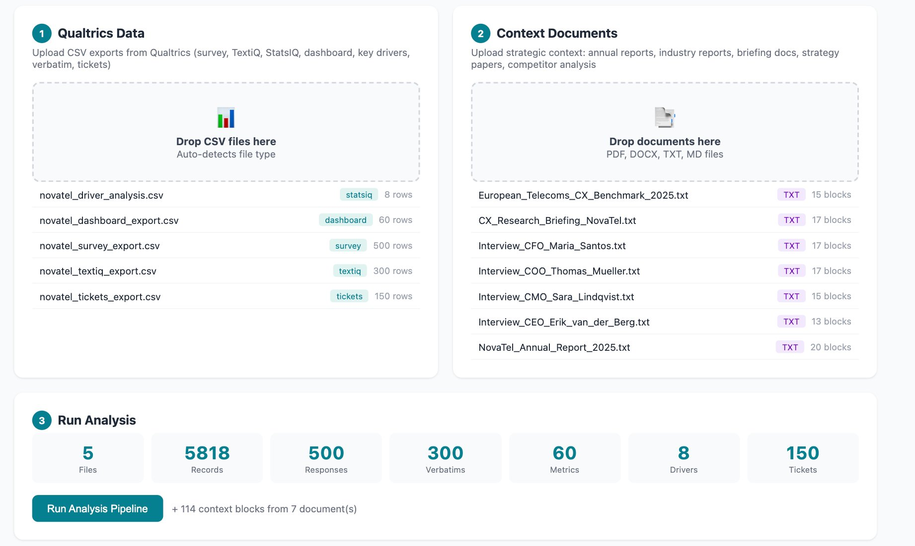
Five Qualtrics CSV exports auto-detected (survey, TextIQ, StatsIQ, dashboard, tickets) alongside seven strategic context documents. The engine classified 5,818 records and 114 context blocks before the consultant touched a button.

How we built it
QTM was designed and built using Claude as a development partner over approximately 150–200 hours of compressed engineering effort. The result is a substantial codebase:
Backend (Python) | Browser app (JS) | Specifications | Test coverage
66 files, 14,100+ lines. FastAPI, SQLAlchemy 2.0, 13-table schema, 7 parsers, 5 analysers, 4 output builders. | 2,500+ lines in a single self-contained file. Full analysis engine, 3 branded PPTX deck builders with charts and tables. | 40+ documents across 9 folders: PRD, user stories, data schema, prioritisation framework, narrative templates, test cases. | 35-assertion E2E test: detection → parsing → ingestion → analysis → scoring → output → lineage → determinism.
Critically, Claude was only the build partner. The product itself has zero AI dependency at runtime. All logic is deterministic and rule-based. Every recommendation traces back to a source file and row. No hallucination, no black box, no variable output quality.

What makes it intelligent
The engine classifies uploads into ten analytical buckets (KPI metrics, trends, target gaps, drivers, tickets, verbatims, benchmarks, stakeholder interviews, strategy context, financial data), then triangulates signals across sources to build confidence-scored priority pockets. Each finding is scored across eight factors:
Factor (weight) | Measures | Factor (weight) | Measures
Customer Impact (20%) | Breadth × severity of customer pain, amplified by verbatim sentiment | Confidence (10%) | Number of independent data sources corroborating the finding
Business Impact (18%) | Driver importance + revenue at risk + strategic alignment | Recurrence (10%) | Consecutive periods the issue has appeared in trend data
Urgency (15%) | Trend velocity + threshold proximity + ticket escalation | Stakeholder Relevance (8%) | Clear organisational ownership from interviews
Strategic Importance (12%) | Match to priorities from annual reports + C-suite interviews | Effort (7%) | Feasibility: process change vs technology rebuild
Transparent scoring: every priority is auditable
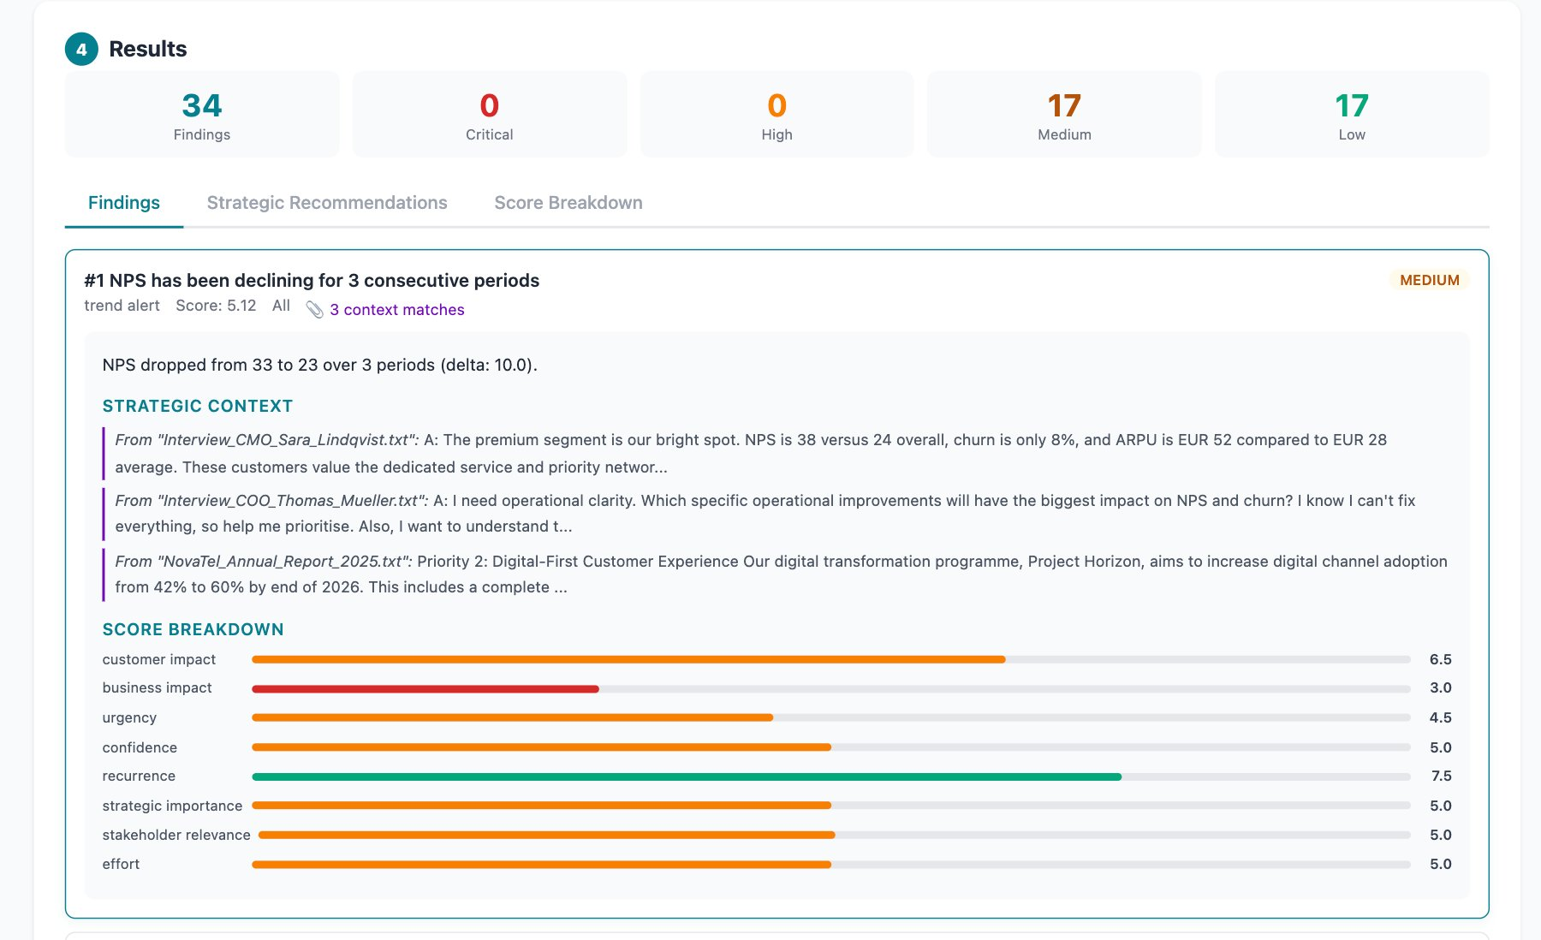
Each finding: composite score, 8-factor bars, strategic context from documents matched automatically. Full audit trail — no hidden judgment.
Output: three AKT-branded decks — C-Level Brief (investment case), Operational Playbook (action plans), Webinar (voiceover scripts). Adapts to available data: no interviews, no stakeholder slides.
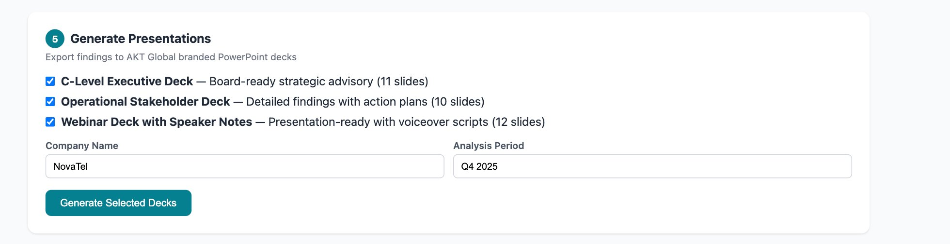
What’s next
Now | Next (40h) | Later
Working prototype. Single HTML file, runs in Chrome. | Brand polish, template library, edge cases, docs, Air Europa pilot. | Multi-user server, Qualtrics API, scheduled runs, named service line.
Zero infrastructure. Zero licences. Zero AI subscription. 150–200 hours already invested. 40 more to make it a team capability. Pilot: Air Europa.

