Game Design Document (GDD)

*Block Breaker*

**CONTENTS**

Description of Game

Sounds

Screen Mockups

Game Play

# Description of Game

A recreation of classic block breaking games like Arkanoid. A bat at the bottom of the screen is used to bounce a ball of blocks above. These blocks disappear after one or more hits, and there will be three block types of different color.

There will be background music, and sound effects for the ball bouncing, and for the blocks breaking. Once all destructible blocks on the level are gone, a “Level Cleared” text will appear which prompts the user to click to load the next level.

Once the player has completed all levels available, they proceed to the win screen and have won the game.

The player has 3 lives which can be used per level. One life is lost if they drop a ball. If a ball drops a message appears to say “Missed” and prompting to click to reload the ball.

Once they drop the 3rd ball, the game is over, they go to the “Game Over” screen and can return to the Main menu to start all over again.

# Sounds

The theme is a retro 8-bit console game so sound samples are to be 8-bit bings and bongs.

Background music plays in the Start Menu only.

Ambient Sound/Music is available for all levels but a default will load if there isn’t a sound explicitly specified.

Bricks explode, indestructible bricks clang, bouncing off bricks causes a hit sound.

Losing a ball triggers a negative ball-loss sound.

Winning the level triggers a positive level-won sound.

# Screen Mockups

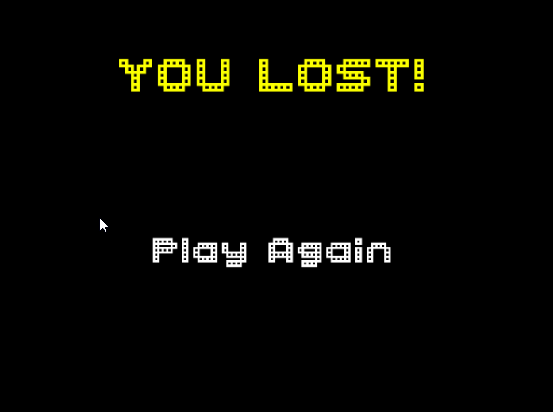

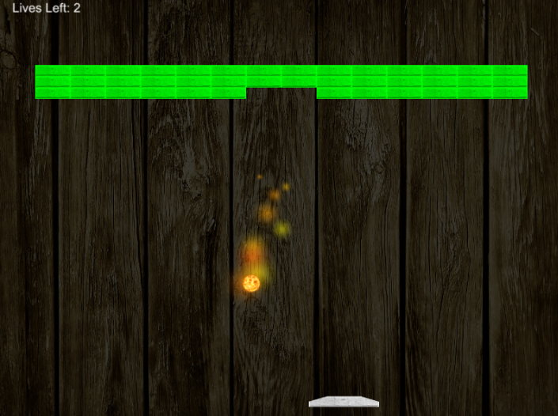

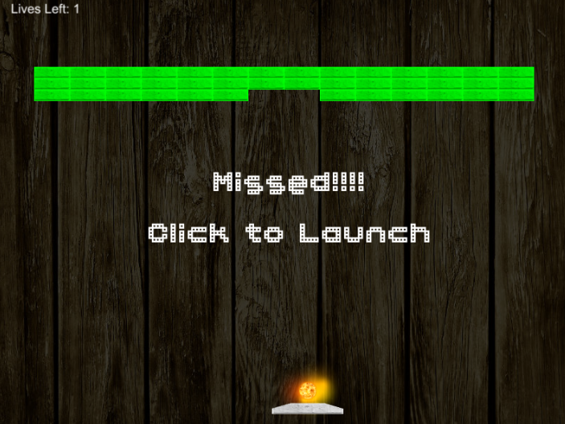

# Game Play

Paddles are equipped with angled edges to assist aiming. Design should allow for future inclusion of power-ups such as:

Multiple Balls

Stretched Paddle

Ball Catch and relaunch

Fireball (pictured) which ignores hit counts and smashes bricks as if 1-hit blocks

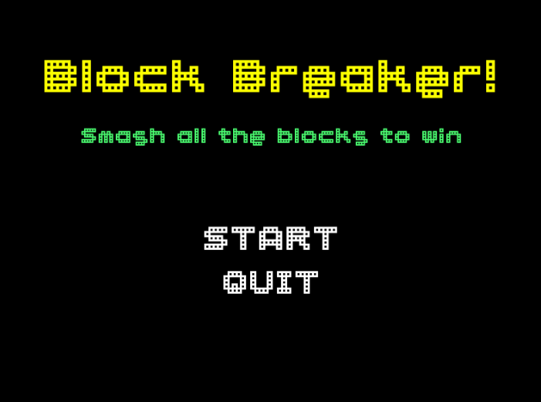Power-ups fall from destructible bricks with random chance of 1 in 10. The type of power-up depends on a second level of randomness.