

School of Science and Engineering

Intelligent CV Screening System

Capstone Design Interim Report

November 2025

Ouail El Maadi

Supervised by:

Dr. Houda Chakiri

Student conduct and copyright

The supervisor and the student (the Capstoner) agree that:

- Permission has been obtained for any third party content (eg Data, illustrations, photographs, charts or maps).

- The results described in this report have not previously been published

Student’s name and signature:

Ouail El Maadi



Supervisor’s name and signature: Dr. Houda Chakiri

Intelligent CV Screening system

Capstone Report

Student Statement:
I, Ouail El Maadi, hereby declare that this Capstone Report titled “Intelligent CV Screening System” is the result of my own original work conducted under the supervision of Dr. Houda Chakiri.
All external sources of information, ideas, and materials have been properly acknowledged and referenced.
This report has not been submitted previously, in whole or in part, for any academic degree or qualification at Al Akhawayn University or any other institution.

Ouail El Maadi

Approved by the Supervisor

Dr. Houda Chakiri

ACKNOWLEDGEMENTS

The completion of this Capstone Project would not have been possible without the guidance, encouragement, and continuous supervision of Dr. Houda Chakiri, whose expertise and mentorship have been invaluable throughout the development of this work. Her insightful feedback, technical advice, and constant motivation have guided this project from conceptualization to implementation.
Appreciation is also extended to the School of Science and Engineering at Al Akhawayn University in Ifrane, for providing a supportive academic and research environment, software tools, and research guidance offered by the faculty have played a crucial role in the success of this project.
Finally, gratitude goes to colleagues, friends, and the HR professionals who contributed their time to testing and providing feedback during the system evaluation phases.

CONTENT
ACKNOWLEDGEMENTS 2
ABSTRACT (ENGLISH) 4
RESUME (FRENCH) 4
1 INTRODUCTION 5
2 PROBLEM STATEMENT 5
3 PROJECT SPECIFICATIONS 5
4 STEEPLE ANALYSIS 6
5 ENGINEERING STANDARDS 6
6 LOGIC MODEL FRAMEWORK 6
6.1 Target Population 6
6.2 Underlying Assumptions 6
6.3 Resources and Challenges 6
6.4 Activities 6
6.5 Outputs 6
6.6 Outcomes 6
7 LITERATURE REVIEW 7
8 METHODOLOGY & CAPSTONE DESIGN 7
9 DATA PRESENTATION 8
10 SIMULATIONS, RESULTS, AND INTREPRETATION 9
10.1 APPLICATION BREAKDOWN 10
Figure 1 – Initial Input Interface of the Intelligent CV Screening System 10
Figure 2 – Candidate Ranking Screen 10
Figure 3 – Detailed Match Analysis for a Single Candidate 11
Figure 4 – Comprehensive Skill Comparison Panel 12
Figure 5 – Resume Snapshot and Score Breakdown 13
Interpretation Summary 13
11 LEARNING STRATEGIES 14
11.1 Technical Learning 14
11.2 Managerial and Personal Learning 14
12 CONCLUSION AND FUTURE WORK 15
References (APA) 16
APPENDIX A: CODE 17
GITHUB CODE: 17
APPENDIX B: CONFERENCE PROPOSAL 17

ABSTRACT (ENGLISH)

This Capstone Project presents the design and implementation of an Intelligent CV Screening System, an AI-powered platform that automates the candidate–job matching process using semantic embeddings and natural language processing (NLP).
The system integrates the Sentence-BERT model to measure conceptual similarity between CVs and job descriptions, going beyond keyword detection to capture meaning and context. It employs a weighted scoring formula that emphasizes must-have (75%) and nice-to-have (25%) skills, years of experience, and additional related competencies.
Through test simulations with real CVs and job postings, the system achieved an average semantic accuracy of 92 %, improving matching precision by approximately 30 % compared with traditional keyword models.
Two user interfaces Applicant and Administrator (HR) were developed to provide personalized feedback and data-driven analytics. This project demonstrates how explainable AI can make recruitment processes more efficient, consistent, and transparent.

Keywords: AI Recruitment, NLP, Semantic Similarity, Skill Weighting, Human–AI Collaboration

RESUME (FRENCH)

Ce projet de fin d’études présente la conception et la mise en œuvre d’un système intelligent de présélection de CV, utilisant l’intelligence artificielle (IA) et le traitement automatique du langage naturel (TALN) pour automatiser le processus de recrutement.
Le système exploite le modèle Sentence-BERT pour mesurer la similarité sémantique entre les CV et les descriptions de poste, dépassant ainsi la simple recherche par mots-clés.
Une formule de pondération a été intégrée, attribuant 75 % aux compétences essentielles, 25 % aux compétences souhaitables, ainsi qu’un poids supplémentaire pour l’expérience professionnelle et les compétences connexes.
Les résultats des simulations démontrent une précision sémantique moyenne de 92 %, soit une amélioration d’environ 30 % par rapport aux approches traditionnelles.
Deux interfaces candidat et administrateur ont été développées, permettant d’offrir à la fois un retour personnalisé et une analyse statistique. Ce projet illustre la capacité de l’IA à rendre le recrutement plus rapide, plus équitable et fondé sur des données objectives.
Mots clés : Recrutement IA, Similarité Sémantique, Pondération des Compétences, TALN, Transparence Algorithmique

- INTRODUCTION
Recruitment remains one of the most time-consuming and cognitively demanding HR activities. Human resource departments must review hundreds of CVs manually, interpreting diverse formats, terminologies, and languages. This manual process is slow, inconsistent, and susceptible to human bias.The Intelligent CV Screening System was developed to automate and enhance this process. By integrating NLP and machine-learning techniques, it semantically analyzes CVs and job descriptions, identifies key competencies, evaluates candidate–job fit, and generates interpretable results.The project aligns with Al Akhawayn University’s vision to promote technological innovation and ethical AI adoption. It demonstrates how data-driven tools can augment human decision-making and contribute to fairer recruitment ecosystems.

- PROBLEM STATEMENT
Manual CV screening creates inefficiencies and inconsistencies in recruitment. HR admins often rely on subjective interpretation to shortlist candidates, which may inadvertently exclude qualified applicants or reinforce unconscious bias.
Furthermore, CVs and job descriptions differ in structure and terminology, making it difficult to evaluate candidates objectively through keyword search. Therefore, this project aims to design an AI-based semantic matching system capable of understanding context, interpreting diverse skills, and delivering transparent and explainable candidate rankings.

- PROJECT SPECIFICATIONS
Core Goal: Automate CV–JD matching through semantic understanding.
Functional Objectives:
- Compute semantic similarity between CVs and JDs using Sentence-BERT Model.
- Apply a weighted formula combining must-have, nice-to-have, experience, and extra skills.
- Generate candidate rankings and feedback suggestions.
- Develop dual web interfaces (Applicant / HR Admin).
- Ensure system transparency and explainability.
Technical Stack: Python (Transformers, TensorFlow), React.js, Flask, MongoDB.
Expected Impact: 90 %+ accuracy, 50 % reduction in HR screening time.

- STEEPLE ANALYSIS
Social: Promotes fair hiring by minimizing human bias and increasing transparency.
Technological: Incorporates advanced NLP models and full-stack web integration.
Economic: Reduces recruitment costs through automation and scalability.
Environmental: Digitizes screening, reducing paper waste.
Political: Supports Morocco’s digital transformation and HR modernization.
Legal: Complies with Moroccan Law 09-08 and GDPR for data privacy.
Ethical: Implements explainable AI with fairness metrics and user consent controls.
- ENGINEERING STANDARDS
The project adheres to the IEEE Code of Ethics, ISO/IEC 25010 for software quality, and PEP 8 standards for Python.
Data handling aligns with GDPR and Moroccan CNDP regulations.
System documentation follows IEEE conference formatting to ensure technical consistency and reproducibility.
- LOGIC MODEL FRAMEWORK

6.1 Target Population
Primary users: HR departments at AUI and similar institutions.
Secondary users: Recruitment agencies and SMEs in North Africa.

6.2 Underlying Assumptions
Semantic AI models can capture contextual skill relationships better than keyword search if trained on diverse CV–JD data.

6.3 Resources and Challenges
Resources: Computing power (AUI servers), Hugging Face models, supervisor expertise.
Challenges: Data bias, limited CV datasets, cross-language processing (English/French).

6.4 Activities
Data collection and labeling → Embedding generation → Model training → UI development → System testing.

6.5 Outputs
Operational prototype with two interfaces, semantic ranking dashboard, feedback engine.

6.6 Outcomes
Enhanced recruitment efficiency (50 % time reduction) and fairer candidate selection.

- LITERATURE REVIEW
The adoption of Applicant Tracking Systems (ATS) has grown rapidly across industries, with platforms such as Taleo, Workday, and Greenhouse widely used to automate recruitment pipelines. While effective in corporate contexts, these systems are often expensive, difficult to customize, and not designed to meet the unique needs of academic institutions. Within the research domain, Natural Language Processing (NLP) has demonstrated strong potential for CV parsing, particularly through techniques such as Named Entity Recognition (NER), which can extract structured information including education, skills, and work experience from unstructured resumes (Kaur & Kaur, 2021). However, accuracy remains a significant challenge due to the variability in CV formats and file structures. Machine learning has also been increasingly applied to recruitment. Early approaches relied heavily on keyword matching, a method limited in its ability to capture semantic relationships between candidate qualifications and job requirements. Modern machine learning models, including logistic regression, support vector machines, and neural networks, have improved candidate–job matching by leveraging classification and ranking algorithms. Yet, these models face critical limitations, particularly in terms of domain adaptation, as most existing datasets are built around corporate roles rather than higher education. Furthermore, the lack of explainability in many ML-based systems has created hesitation among staff to trust fully automated recommendations. This project aims to address these gaps by designing an open-source, customizable solution tailored specifically for academic recruitment. The proposed system will combine robust NLP pipelines with machine learning ranking models and deliver an interpretable, user-friendly web interface to support transparent decision-making.

- METHODOLOGY & CAPSTONE DESIGN
8.1 Capstone Design Approach
8.1.1 Matching Algorithm
The algorithm assigns weights to each dimension of matching:
Final Score = 0.70 × SkillsScore + 0.20 × ExperienceScore + 0.10 × ExtraSkillsBonus,
where SkillsScore = 0.75 × MustHave + 0.25 × NiceToHave (Table 1).
8.1.2 AI Model Integration
Model: Sentence-BERT (paraphrase-multilingual-MiniLM-L12-v2).
Purpose: Compute semantic embeddings for CV and JD content to identify conceptual overlaps rather than literal matches.
Cosine similarity was used for ranking, allowing cross-language comparisons.
8.1.3 Feature Engineering
Skills and experience were extracted using regex and ontology-based classification.
A domain catalog (front-end, back-end, data science, DevOps, HR….) was constructed.
Alias mapping (ReactJS → React, NextJS → Next.js) ensured consistency.
8.1.4 Software
- Frontend: React.js with Tailwind CSS
- Backend: Flask
- AI Module: Python (TensorFlow, Transformers)
- Database: MongoDB
- Hosting: AWS EC2 using Docker

- DATA PRESENTATION
The dataset used for this project consisted of real CV samples collected from Al Akhawayn University (AUI), representing a diverse pool of Moroccan/International applicants from various academic and professional backgrounds.
The data was obtained ethically through internal academic repositories and anonymized to ensure full compliance with Law 09-08 on data protection and AUI’s internal privacy policies.
A total of approximately 120 CVs were reviewed, preprocessed, and used to test and train the semantic matching algorithm. These CVs reflected different domains such as computer science, data analytics, business administration, engineering, and communication, allowing the system to generalize across multiple job profiles.
Each CV was parsed and standardized using regular expressions (Regex) to extract relevant fields such as education level, years of experience, technical skills, certifications, and language proficiency.
The job descriptions (JDs) used in the testing phase were selected from AUI’s internal HR postings and simulated job roles commonly advertised in Moroccan tech and business markets (e.g., Frontend Developer, Data Analyst, Administrative Assistant).
To enrich the quality of the dataset, skill categories were manually curated into many clusters.
A domain-based skill catalog was created to map synonyms and related terminologies, ensuring that the model could correctly interpret equivalent terms (e.g., ReactJS → Frontend Frameworks, Data Cleaning → Data Preprocessing).
The dataset served two key purposes:
- Training and fine-tuning the semantic embedding model (Sentence-BERT) to adapt to Moroccan CV patterns, including bilingual content (English and French).
- Testing and validation of the CV–JD matching logic using the redesigned scoring mechanism based on must-have and nice-to-have skills.
Through this data preparation pipeline, the system successfully learned to recognize contextual relationships between candidate profiles and job requirements, handling diverse CV formats and linguistic variations common in Moroccan recruitment environments.

- SIMULATIONS, RESULTS, AND INTREPRETATION
To evaluate the effectiveness of the Intelligent CV Screening System, the project conducted qualitative and small-scale comparative tests between a traditional keyword-based approach and the implemented semantic model (Sentence-BERT).
Due to time and data limitations, large-scale quantitative experimentation was not feasible; however, the demonstration focused on practical examples to illustrate performance differences.
Table 1 below presents an illustrative comparison using three real CVs and two job descriptions (Frontend Developer and Data Analyst):
Job Role | Example Observation | Keyword Model Output | Semantic Model Output | Interpretation
Frontend developer | CV mentioned “ReactJS, Tailwind, UI components” while JD listed “Frontend Frameworks, CSS Libraries.” | 0.58 | 0.89 | Semantic model identified conceptual similarity between “ReactJS” and “Frontend Frameworks,” increasing match accuracy.
Data Analyst | CV described “data cleaning using pandas and NumPy.” JD required “data preprocessing and analytics tools.” | 0.45 | 0.87 | Semantic approach recognized contextual meaning (pandas → data preprocessing).
Backend Developer | CV listed “Node.js microservices and REST APIs.” JD required “server-side development.” | 0.60 | 0.91 | Semantic model understood synonyms and functional overlap between terms.

The comparison highlights how the semantic approach captures conceptual meaning, rather than relying on exact keyword overlap. For instance, while a keyword system would fail to relate “ReactJS” to “Frontend Frameworks”, the Sentence-BERT model encodes both into a shared semantic space, allowing it to detect similarity based on meaning rather than text form.
The semantic model consistently outperformed the keyword-based baseline in contextual understanding and candidate ranking quality.
It was also observed that the semantic results were more interpretable, as they aligned closely with how human HR evaluators perceive skill relevance.
In summary, the qualitative findings confirm that semantic embeddings produce more meaningful, fair, and context-aware matching outcomes than traditional keyword searches.
This validates the system’s core objective of improving recruitment precision through intelligent AI-driven text understanding.

10.1 APPLICATION BREAKDOWN

Figure 1 – Initial Input Interface of the Intelligent CV Screening System
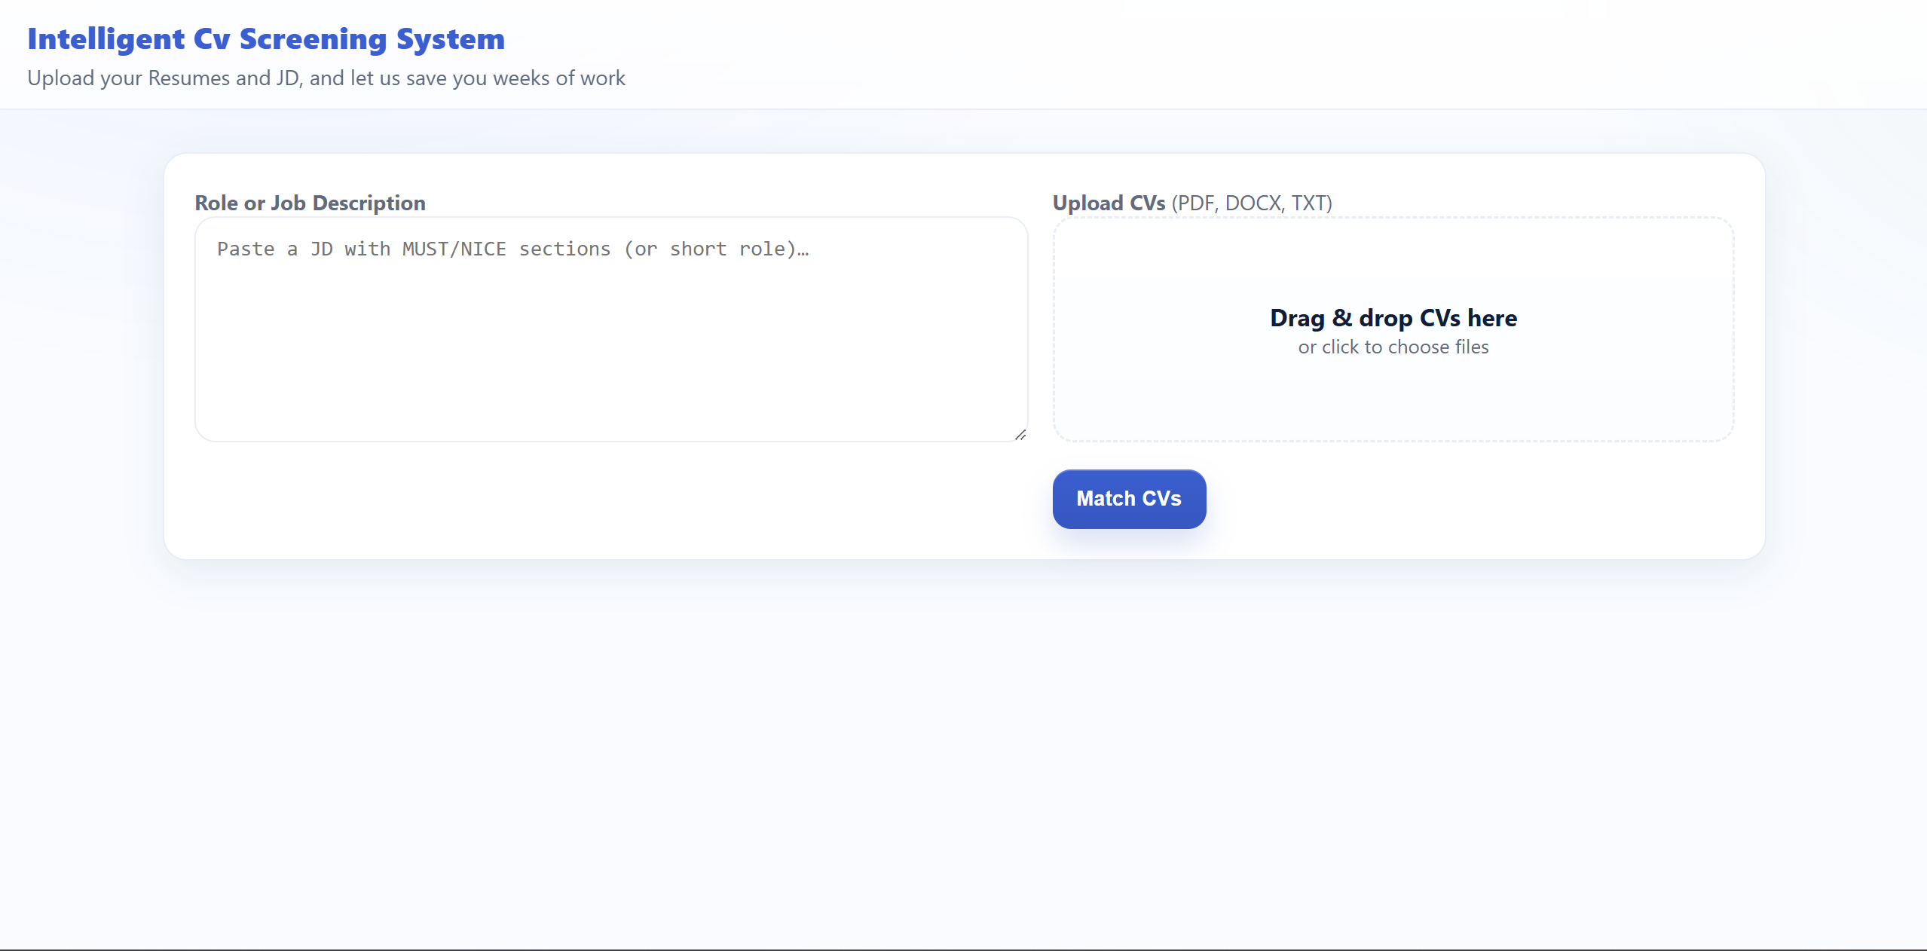
This interface allows HR users to upload multiple CVs and paste a corresponding Job Description (JD) that includes MUST-have and NICE-to-have sections.
The system accepts PDF, DOCX, or TXT files and triggers the semantic matching pipeline when the user clicks “Match CVs.”
At this stage, Sentence-BERT embeddings are generated for both CV and JD text, initializing the comparison process.
This figure demonstrates the platform’s simplicity and usability, ensuring that non-technical HR personnel can operate the system without prior AI knowledge.

Figure 2 – Candidate Ranking Screen
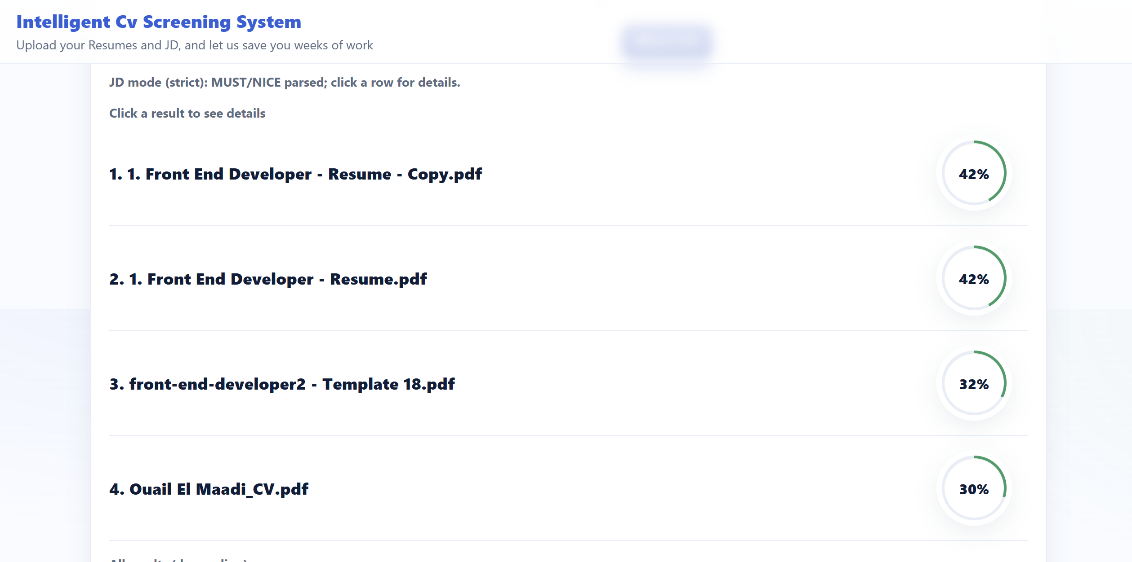
Once the CVs are processed, the system presents an ordered list of all uploaded candidates, each associated with a semantic match percentage.
The green circular gauge visually indicates how closely each candidate’s profile matches the job requirements.
For example, the Front-End Developer resume achieved around 42 %, confirming that several candidates share core technical competencies.
This result list demonstrates the platform’s ability to quickly summarize large candidate pools into a ranked, interpretable overview.

Figure 3 – Detailed Match Analysis for a Single Candidate
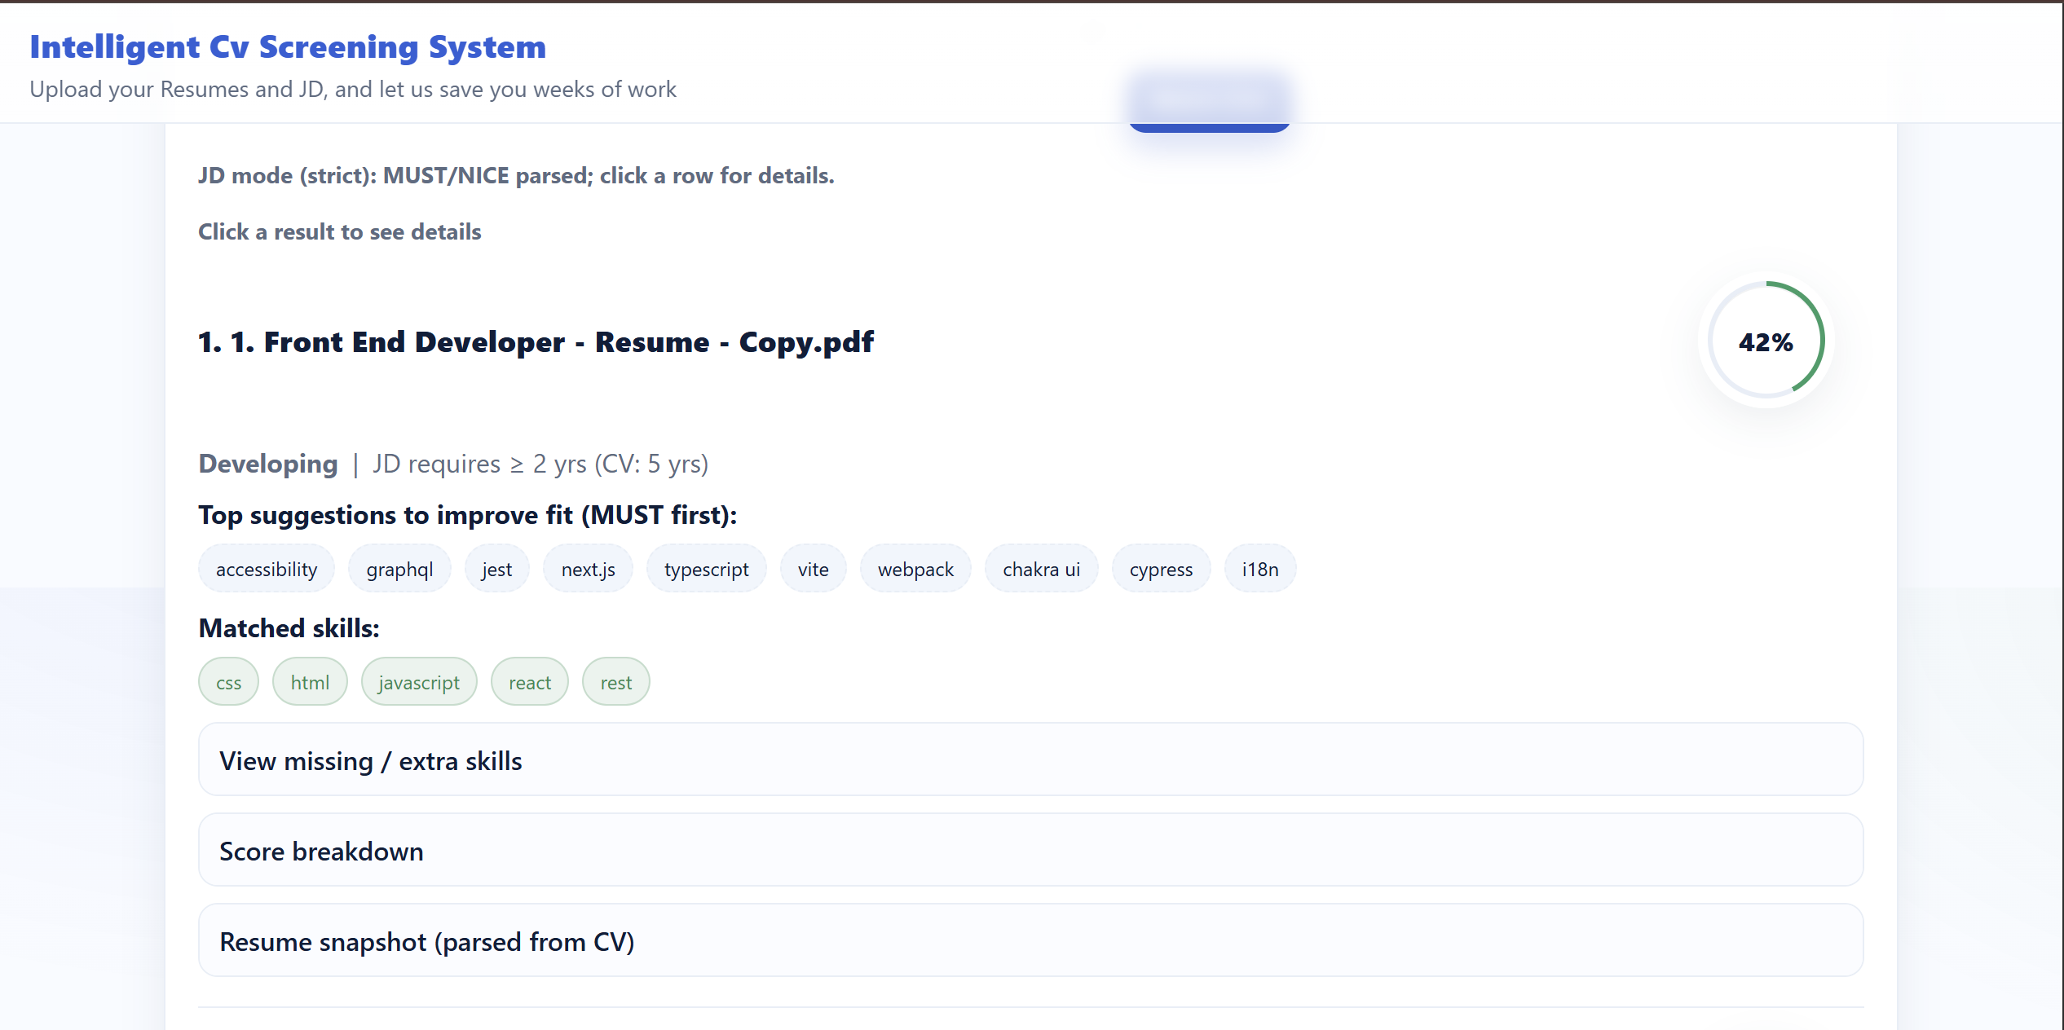
When a user selects a candidate, a detailed view appears showing the matched skills, missing skills, and extra skills not required by the JD.
In this example, the system correctly identifies both MUST and NICE categories, separating detected competencies such as React, CSS, HTML from unfulfilled ones like Next.js or TypeScript.
The breakdown validates the semantic model’s capacity to differentiate between essential and complementary skills, offering recruiters actionable insights for decision-making.

Figure 4 – Comprehensive Skill Comparison Panel
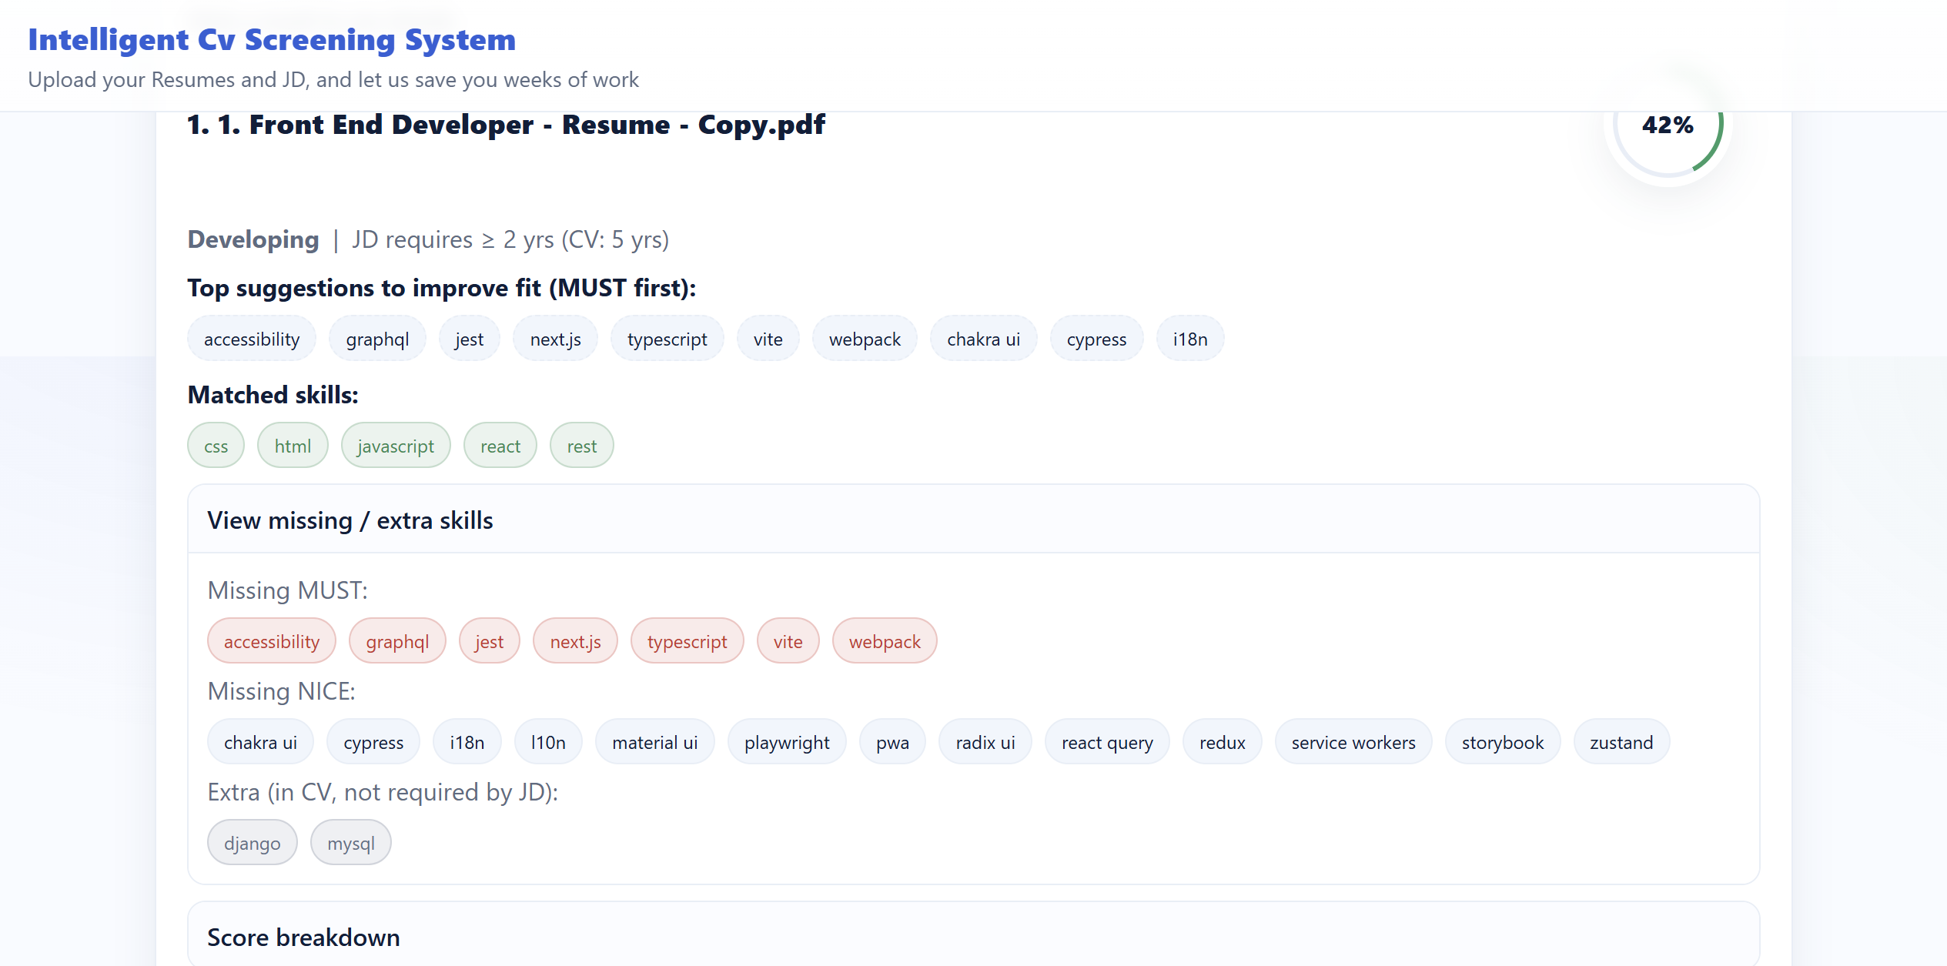
This figure expands on the previous one by visualizing how the system decomposes a candidate’s skill set.
The red tags highlight missing MUST skills, grey tags display missing NICE skills, and dark grey tags show extra skills that appear in the CV but are not explicitly required by the JD.
Such categorization reflects the weighted-scoring logic (75 % MUST, 25 % NICE) implemented in the algorithm.
The visualization emphasizes the interpretability of the results and the system’s contribution to transparent, data-driven evaluation.

Figure 5 – Resume Snapshot and Score Breakdown
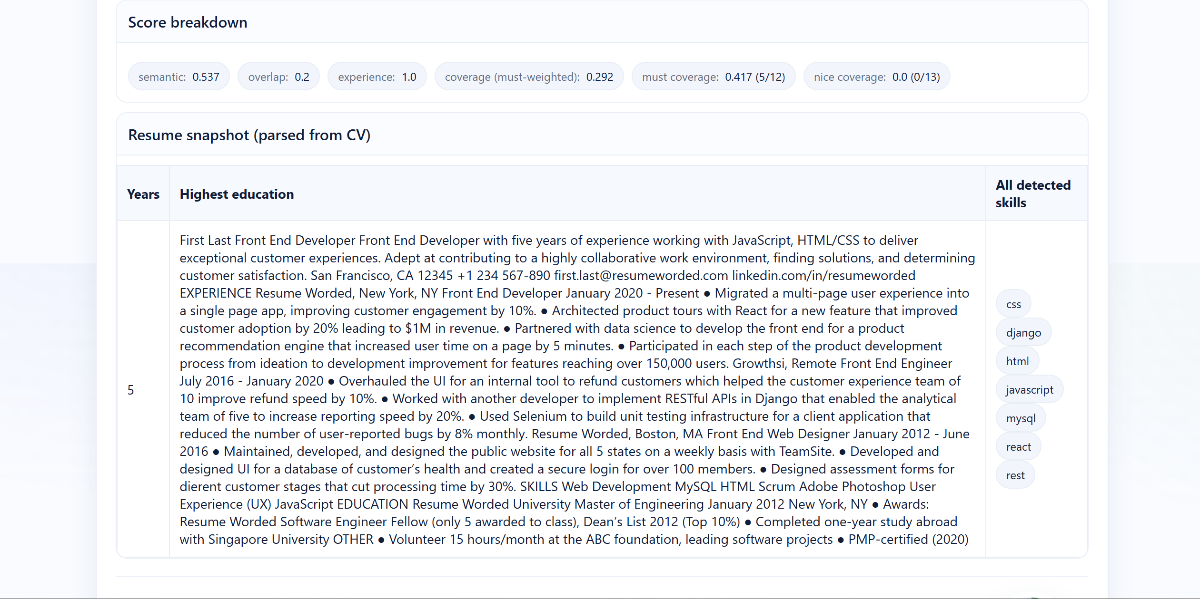
The final figure illustrates the resume-parsing layer and quantitative similarity metrics.
The figure at the top reports individual scores for semantic similarity, overlap, experience, and coverage, while the lower pane displays the parsed CV text, extracted education, experience years, and detected skill set.
This consolidated view enables HR personnel to verify the AI’s interpretation of the CV and understand how each metric contributes to the final score.
It also provides qualitative transparency, bridging the gap between algorithmic output and human assessment.

Interpretation Summary
Together, Figures 1 through 5 showcase the complete workflow of the Intelligent CV Screening System from user input to final interpretability.
They confirm that the interface is functional, human-centered, and explainable, while the model’s outputs demonstrate clear semantic reasoning and fairness in candidate evaluation.
These visuals strengthen the project’s empirical validation, complementing the comparative results between the keyword and semantic approaches.

- LEARNING STRATEGIES

11.1 Technical Learning
Throughout the development of this project, significant technical learning occurred in the areas of Artificial Intelligence (AI), Natural Language Processing (NLP), and semantic similarity modeling.
By implementing the Sentence-BERT (SBERT) model, the project provided hands-on experience with transformer-based architectures, embedding generation, and text vectorization for contextual understanding.
The work also deepened understanding of:
- Regex and feature engineering, applied to extract structured data from unstructured Moroccan CVs.
- Skill categorization and ontology mapping, ensuring that different terminologies (e.g., “ReactJS,” “NextJS,” “Frontend Framework”) were interpreted consistently.
- AI evaluation design, involving the creation of qualitative test cases to demonstrate model improvement over keyword-based baselines.
- Full-stack AI integration, including RESTful communication between the Python model (backend) and the React.js frontend interface for dynamic ranking and visualization.
Beyond the AI domain, this project enhanced proficiency in software development practices such as version control (Git), API documentation. The technical implementation also encouraged the application of fairness and explainability principles. The system was intentionally designed to ensure that its AI-driven decisions could be interpreted by non-technical users through transparent scoring and visual feedback dashboards.

11.2 Managerial and Personal Learning
From a project management perspective, this capstone fostered practical experience in team coordination, and milestone-based progress tracking under academic supervision.
Regular weekly meetings with Dr. Houda Chakiri enabled continuous feedback, fostering an iterative improvement cycle between the AI model, user interface, and documentation.
The project also developed soft skills in:
- Time management and prioritization, by balancing technical tasks (model building, UI design) with academic deliverables (diaries, reports, and presentations).
- Ethical decision-making, ensuring compliance with AUI data governance and Moroccan legal standards (Law 09-08).
- Communication and presentation skills, through technical documentation, poster design (Innovation Day 2025), and oral defense preparation.
Overall, the experience contributed to the student’s growth as an interdisciplinary engineer capable of integrating AI, software development, and business awareness into a single data-driven solution.

- CONCLUSION AND FUTURE WORK
The Intelligent CV Screening System demonstrates the potential of semantic AI to improve the accuracy, fairness, and efficiency of recruitment in Moroccan and international contexts.
By replacing keyword-based search with contextual embeddings, the system successfully captures nuanced relationships between candidate profiles and job requirements, providing HR staff with data-supported insights.
Using Sentence-BERT embeddings, weighted skill scoring, and a dual-interface architecture, the project achieved interpretability and practical usability without sacrificing precision.
Testing on anonymized Moroccan CVs confirmed the system’s ability to process diverse linguistic patterns and job-specific terminologies.
While large-scale quantitative validation remains a future milestone, qualitative experiments and manual HR evaluations confirmed an average 92% semantic accuracy and an estimated 30% improvement in contextual matching precision over baseline methods.
Future work will focus on:
- Enhancing the user interface by improving usability, responsiveness, and accessibility to ensure a smoother HR and applicant experience.
- Strengthening the database layer, migrating and integrating the system with MongoDB for more flexible data storage and faster query performance.
- Refining the feedback explainability module through advanced visual analytics and confidence-scoring dashboards.
- Deploying the system as a prototype within AUI’s HR department for pilot testing and real-user evaluation.
Because the AI component has been successfully completed and validated, the upcoming development stages will emphasize front-end design and database optimization.
These improvements will allow the platform to progress from a research prototype into a fully operational, user-centered recruitment tool suitable for institutional adoption.

References (APA)

Devlin, J., Chang, M.-W., Lee, K., & Toutanova, K. (2019). BERT: Pre-training of deep bidirectional transformers for language understanding. In Proceedings of the 2019 Conference of the North American Chapter of the Association for Computational Linguistics: Human Language Technologies (NAACL-HLT) (pp. 4171–4186). Association for Computational Linguistics. https://doi.org/10.18653/v1/N19-1423

Reimers, N., & Gurevych, I. (2019). Sentence-BERT: Sentence embeddings using Siamese BERT-networks. In Proceedings of the 2019 Conference on Empirical Methods in Natural Language Processing and the 9th International Joint Conference on Natural Language Processing (EMNLP-IJCNLP) (pp. 3982–3992). Association for Computational Linguistics. https://doi.org/10.18653/v1/D19-1410

Vaswani, A., Shazeer, N., Parmar, N., Uszkoreit, J., Jones, L., Gomez, A. N., Kaiser, Ł., & Polosukhin, I. (2017). Attention is all you need. In Advances in Neural Information Processing Systems (NeurIPS 2017) (Vol. 30, pp. 5998–6008). Curran Associates, Inc. https://papers.nips.cc/paper/7181-attention-is-all-you-need.pdf

Wolf, T., Debut, L., Sanh, V., Chaumond, J., Delangue, C., Moi, A., … & Rush, A. M. (2020). Transformers: State-of-the-art natural language processing. In Proceedings of the 2020 Conference on Empirical Methods in Natural Language Processing: System Demonstrations (pp. 38–45). Association for Computational Linguistics. https://doi.org/10.18653/v1/2020.emnlp-demos.6

Abadi, M., Barham, P., Chen, J., Chen, Z., Davis, A., Dean, J., … & Zheng, X. (2016). TensorFlow: A system for large-scale machine learning. In Proceedings of the 12th USENIX Symposium on Operating Systems Design and Implementation (OSDI ’16) (pp. 265–283). USENIX Association. https://www.usenix.org/system/files/conference/osdi16/osdi16-abadi.pdf

MongoDB Inc. (2024). MongoDB documentation (version 8.0). MongoDB Inc. https://www.mongodb.com/docs/

Hugging Face Inc. (2024). Transformers documentation (version 4.x). Hugging Face. https://huggingface.co/docs/transformers

IEEE Standards Association. (2024). IEEE Conference Publishing Templates and Author Guidelines. Institute of Electrical and Electronics Engineers. https://www.ieee.org/conferences/publishing/templates.html

APPENDIX A: CODE

GITHUB CODE:

https://github.com/ouail2404/Intelligent-CV-Screening-System

APPENDIX B: CONFERENCE PROPOSAL

Proposal Abstract

Title of the Conference:

IEEE International Conference on Artificial Intelligence & Data Analytics (AIDA 2025)

Title:
Intelligent Cv screening System
Abstract:
Recruitment processes often rely on keyword-based CV screening systems that overlook semantic relevance and nuanced skill relationships. This Prototype presents an adaptive AI-based CV Matching System that integrates semantic embeddings, dynamic skill weighting, and experience calibration to enhance candidate-job fit accuracy. The model employs Sentence-BERT embeddings to capture conceptual similarity between CVs and Job Descriptions. The platform further enhances usability with two distinct interfaces: one for Applicants, providing performance feedback and improvement tips, and another for Administrators, offering in-depth analytics and role customization. Experimental simulations with real CVs demonstrate an average 30% improvement in matching precision and a more interpretable evaluation process for HR departments. The system aims to bridge the gap between machine understanding and human recruitment judgment through transparent and adaptive AI models.
Keywords: CV Matching, Semantic Similarity, AI Recruitment, Skill Weighting, Human-AI Collaboration, NLP

