TECHNICAL ASSESSMENT
Lipa na M-Pesa Integration
Utility Account Management System
M-Pesa Gateway — Post-Implementation Assessment

SD Number | SD-MPESA-001
Document Author | Oualid Gharach
Version | 1.3 — Post-Implementation
Status | Final
Date | May 2026
Reference | Supersedes v1.2 (mpesa-architecture-v7.docx)
Repository | github.com/oualidg/utility-account

Document Control
CONFIDENTIAL This document contains confidential information and is proprietary to the author. It shall not be circulated without prior written consent.

Document History
Version | Date | Author | Change Description
0.1 | March 2026 | Oualid Gharach | Initial draft — baseline, target, gap analysis
0.2 | March 2026 | Oualid Gharach | Add ADRs, resilience model, security model
0.3 | March 2026 | Oualid Gharach | Incorporate review — query timeout, normalisation SOT, MDC, graceful shutdown
1.0 | March 2026 | Oualid Gharach | Restructure to Technical Assessment format
1.1 | March 2026 | Oualid Gharach | Architectural pivot: RabbitMQ + Outbox Pattern
1.2 | April 2026 | Oualid Gharach | Final review and consistency pass
1.3 | May 2026 | Oualid Gharach | Post-implementation update — soak test results, implementation deviations, lessons learned

Distribution List
Name / Role | Responsibility
Oualid Gharach | Solution Architect / Engineering Lead — Author / Approval Required

Architecture Diagrams
The following diagrams illustrate the key structural and behavioural aspects of the M-Pesa integration.

Deployment Topology
The full production stack runs on a single Ubuntu host behind Cloudflare Tunnel. All services communicate over an internal Docker bridge network.

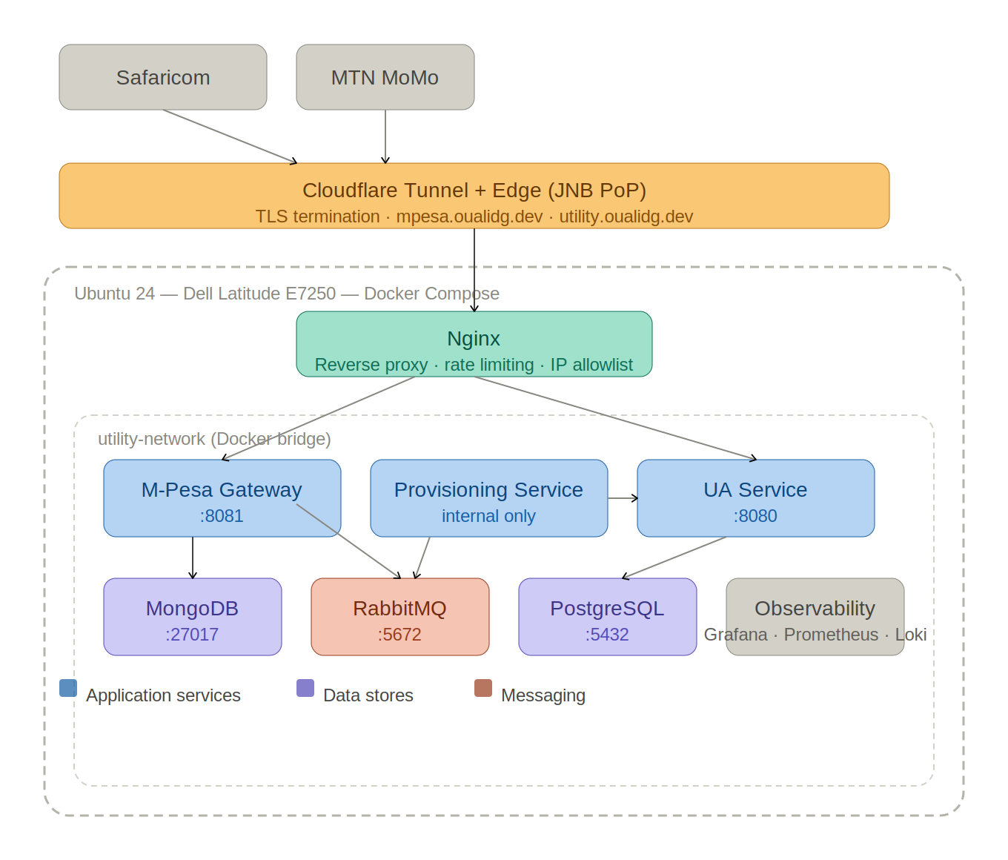
Figure 1 — Single-host Docker Compose deployment topology

Async Confirmation Pipeline
The four-stage pipeline processes every M-Pesa confirmation asynchronously — HTTP 200 is returned to Safaricom after durable persistence, with payment execution completing independently.

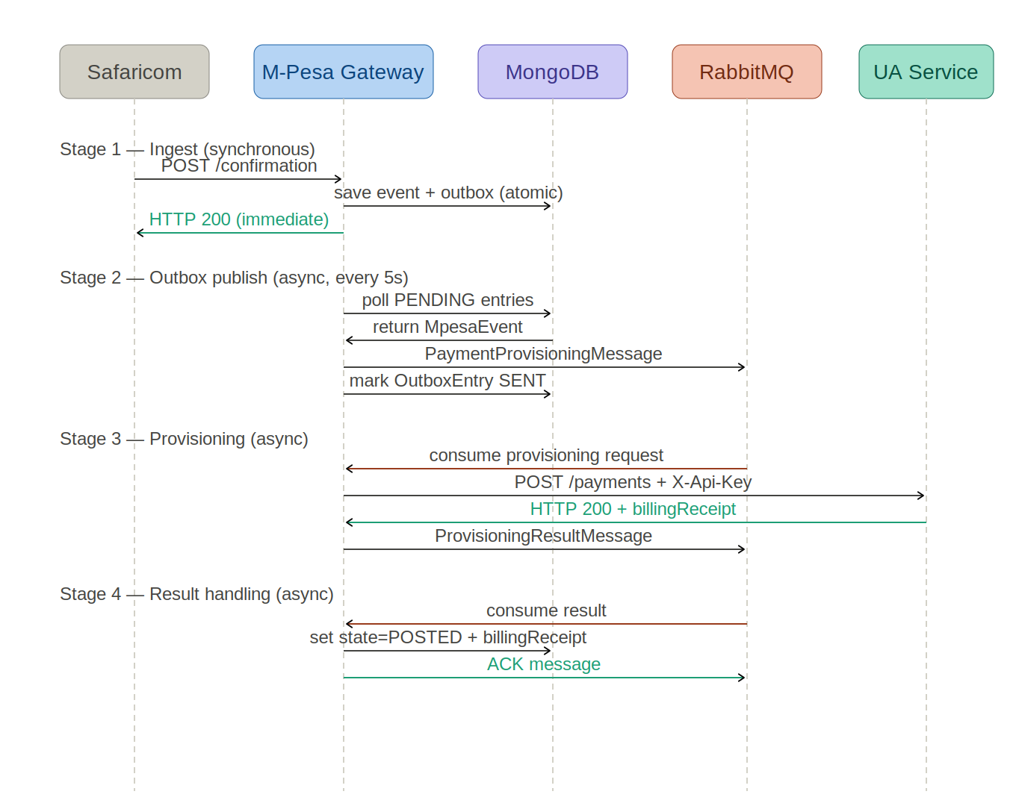
Figure 2 — Async confirmation pipeline sequence (Ingest → Outbox → Provisioning → Result)

OutboxEntry State Machine
The outbox processor uses a lease-based state machine to guarantee exactly-once publish semantics even under JVM crash and concurrent processor scenarios.

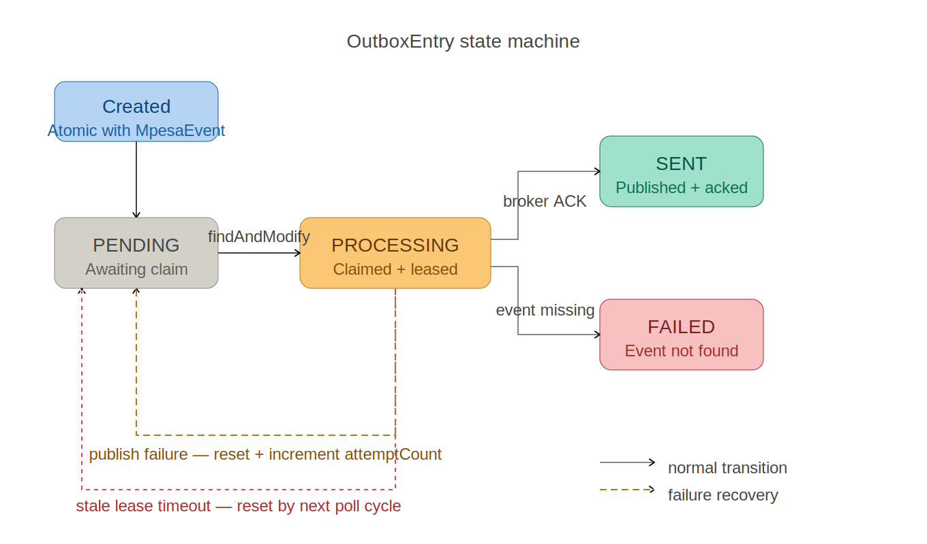
Figure 3 — OutboxEntry lifecycle (PENDING → PROCESSING → SENT / FAILED)

Validation and Confirmation Flows
The validation flow is synchronous with circuit breaker protection and a POSTED-events fallback. The confirmation flow acknowledges immediately and processes asynchronously.

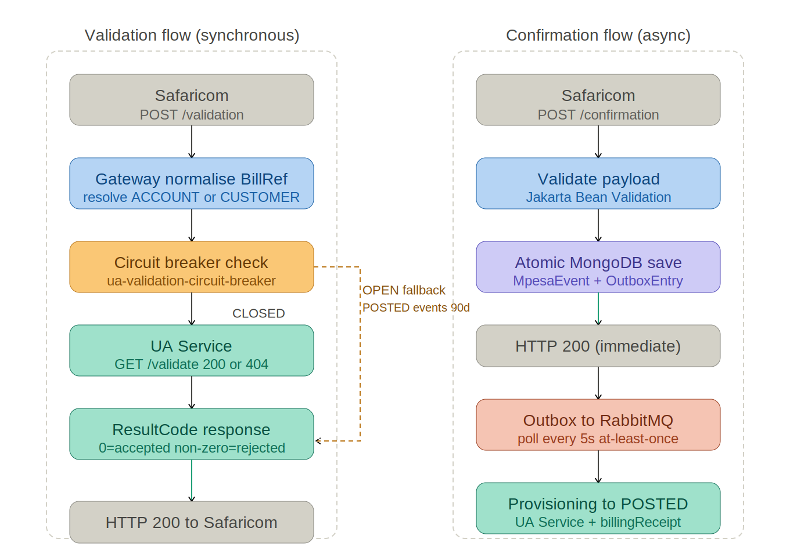
Figure 4 — C2B validation flow (left) and confirmation flow (right)

Observability Stack
Grafana Alloy collects metrics and logs from all services and forwards to Prometheus and Loki. Grafana provides dashboards, alerting, and log search.

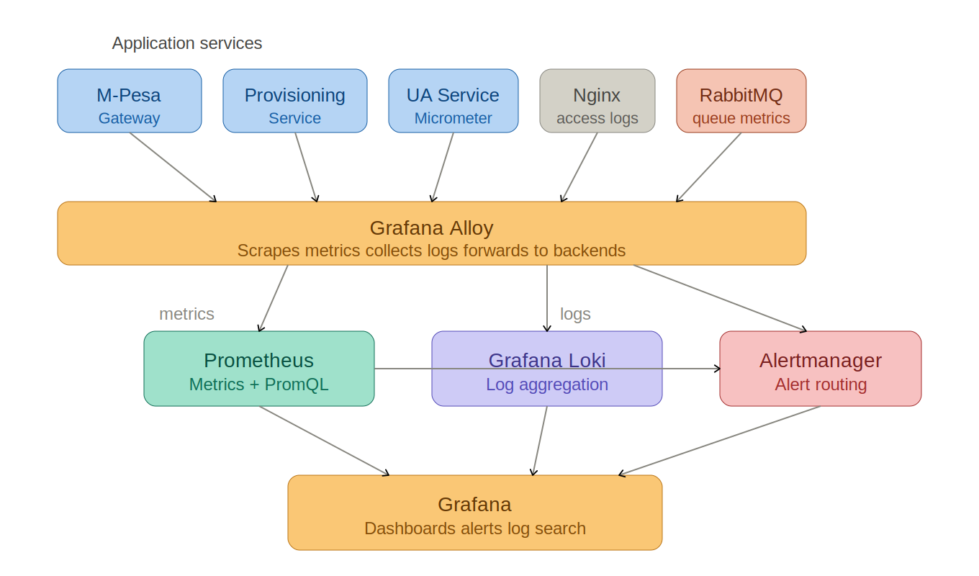
Figure 5 — Observability stack: collection, storage, and visualisation

Executive Summary — Post-Implementation
The Lipa na M-Pesa integration has been fully implemented, tested, and validated under sustained production-grade load. All four work packages are complete. The implementation is in production-grade operation on the single-host deployment described in the v1.2 design document.

The architecture was validated through a 7-day soak test running two payment providers simultaneously — M-Pesa C2B callbacks through the full async pipeline and MTN MoMo payments directly to the UA Service. The results confirm that the design decisions documented in v1.2 were correct and that the system meets all defined non-functional requirements.

Soak Test Headline Results
Metric | Volume | Failures | Result
M-Pesa async pipeline | 2,830,732 POSTED | 0 SUSPENDED | 100% success
M-Pesa full C2B flow | 517,503 flows | 95 HTTP 502s (gateway restart) | 100% pipeline success
MTN MoMo direct | 763,621 payments | 22 failures (first 10 min) | 99.997% success
Validation SLA | 4,594 validations | All resultCode=0 | Well within 8s SLA
End-to-end latency | p50 ~63ms | p95 ~121ms | Through Cloudflare JNB

Key Implementation Outcomes
- Every M-Pesa confirmation event that entered the system reached a terminal state — 2,830,732 POSTED, zero SUSPENDED, zero lost
- The Outbox Pattern eliminated the dual-write problem and ensured reliable message publication across all service restarts and pipeline deployments during the test
- The Provisioning Service processed every message without a single retry, circuit breaker trip, or error across the entire 7-day test
- The UA Service processed payments from both providers concurrently with zero errors and zero rate limit violations in steady state
- End-to-end MDC tracing was proven across all four services using correlationId and transId
- The single-host deployment on a 2015 laptop sustained above-production-volume load at 96% CPU idle in steady state

Implementation Deviations from v1.2 Design
The implementation was faithful to the v1.2 design with the following refinements discovered during build and validation:
- OutboxEntry state machine extended from boolean sent flag to PENDING / PROCESSING / SENT / FAILED with atomic lease-based claiming — required for safe concurrent processing
- Resilience4j rate limiter timeout-duration raised from 0ms to 500ms and limit-for-period raised from 20 to 30 req/s — tuned during soak test to eliminate burst collisions between concurrent providers
- Nginx api_limit zone raised from 10r/s to 20r/s and nodelay removed — matched to actual dual-provider load profile

Work Package Implementation Status
All work packages defined in the v1.2 architecture roadmap have been completed.

WP | Objective | Status | Notes
WP1 | RabbitMQ Messaging Infrastructure | COMPLETE | Durable queues, DLX/DLQ, Management UI. Definitions managed as JSON for dev and prod variants.
WP2 | Provisioning Service | COMPLETE | Spring Boot microservice. RestClient + Resilience4j. Zero retries and zero errors in 7-day soak test.
WP3 | UA Service Additions | COMPLETE | Validation endpoints, Resilience4j RateLimiter, query timeouts. 292 tests passing.
WP4 | M-Pesa Gateway | COMPLETE | MongoDB event store, Outbox Pattern with lease-based claiming, RabbitMQ integration. 106 tests passing.
WP5 | Nginx M-Pesa Vhost | COMPLETE | Dedicated mpesa.oualidg.dev server block, IP allowlisting, rate limiting tuned for dual-provider load.
WP6 | CI/CD and Containerisation | COMPLETE | GitHub Actions pipelines for all three services. Docker Compose updated with all new containers.
WP-OPS | Observability Stack (unplanned) | COMPLETE | Grafana, Prometheus, Loki, Alloy, and Alertmanager deployed and operational. Not defined as a formal WP in v1.2 but implemented as part of production readiness. Dashboard panel build remains outstanding.

Load Test Results
Prior to the soak test, a structured k6 load test was executed to validate peak throughput, Nginx rate limiting behaviour, and end-to-end pipeline correctness under burst conditions. Four test scenarios were run.

Test 1 — M-Pesa Gateway Direct (Bypass Nginx)
Direct load against the M-Pesa Gateway on port 8081 with no Nginx rate limiting — establishes raw ingest throughput. The M-Pesa Gateway itself has no application-level rate limiter; Nginx is the sole rate limiting layer. This test establishes the raw ingest ceiling before any edge controls.

Metric | Result
Confirmations sent | 130,000
Duration | 3 minutes
Throughput | 725 req/s
HTTP 200 rate | 100%
p95 latency | 231ms
SUSPENDED from ingest | 0

The Gateway ingested 129,947 events at 725 req/s without a single failure — 91x above the design target of ~8 tx/sec peak. All events were persisted atomically (MpesaEvent + OutboxEntry) before HTTP 200 was returned to the caller, confirming the durability guarantee holds at peak throughput. The Gateway has no application-level rate limiter — Nginx is the sole protection layer — so this test establishes the true raw ingest ceiling before any edge controls are applied.

Test 2 — M-Pesa Gateway via Nginx (100r/s limit)
Metric | Result
Requests attempted | 1,154,796
Attempted rate | 6,491 req/s
Accepted by Nginx | 16,488 (1.42%)
Rejected by Nginx | 98.56% (HTTP 429 at ~2ms)
Gateway errors on accepted traffic | 0

Test 3 — End-to-End Pipeline Drain
Metric | Result
Events ingested | 129,947
Final state: POSTED | 129,947
Final state: SUSPENDED | 0 (5 rate exhaustion suspensions recovered via outbox replay)
UA Service rate limit hits | 794
DLQ messages | 0
Total payment value processed | R33,710,401.78

Soak Test Results

Overview
A 7-day soak test was conducted from May 18–25, 2026 to validate the complete M-Pesa integration under sustained production-grade load. Two payment providers ran concurrently throughout the test period on the production deployment — a Dell Latitude E7250 (2015) laptop running Ubuntu 24 with Docker Compose.

Parameter | Value
Test duration | 7 days continuous (May 18–25, 2026)
Deployment | Single-host Docker Compose — Dell Latitude E7250 (2015 laptop, 16GB RAM)
M-Pesa simulator | Full C2B flow (validation + confirmation) via Cloudflare Tunnel → mpesa.oualidg.dev
MTN MoMo simulator | Direct payment deposits via Cloudflare Tunnel → utility.oualidg.dev
Combined throughput | ~8.7 req/s sustained (~12.1 including M-Pesa validation calls)
Cloudflare PoP | Johannesburg (JNB) — confirmed via cf-ray header suffix
Service restarts | Multiple pipeline deployments during test — system recovered automatically each time

M-Pesa Async Pipeline Results
The M-Pesa Gateway received confirmation callbacks, persisted events to MongoDB via the Outbox Pattern, published to RabbitMQ, and processed results through the Provisioning Service to the UA Service.

Metric | Result
Total events ingested | 2,830,732
Final state: POSTED | 2,830,732 (100%)
Final state: SUSPENDED | 0
Final state: RECEIVED | 0 (all drained to terminal state)
Outbox publish failures | 0
Provisioning retries | 0
Circuit breaker trips | 0
Errors across all services | 0

M-Pesa Full C2B Flow Results
From May 23 onwards the simulator was upgraded to perform the full Safaricom C2B flow — validation followed by confirmation — mirroring real-world Safaricom behaviour.

Metric | Result
Total C2B flows | 517,503
Successful flows | 517,408 (99.98%)
Failed flows | 95 (HTTP 502 during gateway restart — infrastructure failure, not pipeline failure. See note below.)
Validation rejections | 0 (all accounts and customers valid throughout)
Validation p50 latency | ~62ms
Validation p95 latency | ~121ms
Confirmation p50 latency | ~66ms
Confirmation p95 latency | ~121ms
Safaricom SLA (8s) | Met — all validations completed in well under 1 second
Pipeline success rate | 100% — the 95 failures were HTTP 502s during a gateway container restart, not pipeline failures. Events ingested before the restart were fully processed. The pipeline itself had zero failures.

MTN MoMo Direct Payment Results
MTN MoMo calls the UA Service directly through Nginx — no gateway in the path. The simulator ran continuously for approximately 39 hours of the test period.

Metric | Result
Total payments | 763,621
Successful payments | 763,599 (99.997%)
Failed payments | 22 (HTTP 429 during first 10 minutes — rate limit tuning period)
Failures after tuning | 0
p50 latency | ~65ms
p95 latency | ~114ms

System Resource Utilisation
Resource | Observation
CPU idle (steady state) | 63–96% — minimal impact on single-host deployment
Memory used | 3.6GB of 15.8GB (23%) — no memory pressure throughout
Swap used | 93–171MB of 4GB — negligible
HikariCP (PostgreSQL) | 4 connections — never exhausted, never contended
MongoDB CPU | Primary hotspot at 36–45% during peak — expected for sustained write load
Peak CPU temperature | 89°C — within spec (limit 105°C); reduced to 79°C with CPU frequency scaling
PostgreSQL CPU | < 1% — invisible under load; 4-connection pool validated as sufficient

End-to-End Latency Summary
All latency measurements are end-to-end through the Cloudflare Tunnel from the same host — including TLS handshake, Cloudflare JNB edge processing, Nginx, application processing, and database I/O.

Flow | p50 | p95 | Notes
M-Pesa validation | ~62ms | ~121ms | Gateway → UA Service → response
M-Pesa confirmation | ~66ms | ~121ms | Ingest only — Gateway → MongoDB write → HTTP 200. Async processing (outbox → RabbitMQ → Provisioning → UA Service) completes independently.
MTN MoMo deposit | ~65ms | ~114ms | Nginx → UA Service → PostgreSQL → response

Implementation Deviations from v1.2 Design
The following deviations from the v1.2 design were made during implementation. Each represents a deliberate improvement over the original specification based on implementation experience.

OutboxEntry State Machine
v1.2 design | Boolean sent field (sent=false / sent=true)
Implementation | Full state machine: PENDING → PROCESSING → SENT / FAILED
Reason | Atomic lease-based claiming required for safe concurrent processing. PROCESSING state with claimedAt timestamp enables stale lease detection and recovery after JVM crash.
Impact | Added attemptCount, lastError, claimedAt fields to OutboxEntry. Outbox processor uses findAndModify for atomic claim instead of simple query.

Resilience4j Rate Limiter Configuration
v1.2 design | limit-for-period=20, timeout-duration=0
Implementation | limit-for-period=30, timeout-duration=500ms
Reason | Soak test revealed burst collisions when M-Pesa and MTN MoMo simulators fired simultaneously. timeout-duration=0 caused immediate rejection; 500ms allows brief queuing. limit-for-period raised to 30 to accommodate combined dual-provider load (~10.6 req/s) with headroom.
Impact | MTN MoMo failure rate dropped from ~4% to effectively 0% after tuning. Validation path also benefits — fewer 429s during provisioning burst load.

Nginx Rate Limit Configuration
v1.2 design | api_limit zone: 10r/s with burst=20 nodelay
Implementation | api_limit zone: 20r/s with burst=20 (nodelay removed)
Reason | Original 10r/s limit reflected single-provider (MTN) baseline. Adding M-Pesa validation calls doubled the effective request rate. nodelay removal allows burst queuing rather than immediate rejection.
Impact | Nginx no longer contributes 429s under normal dual-provider load.

Log Evidence
The following evidence was extracted from production service logs captured during the soak test. Log files cover a representative window of the final phase of the test.

M-Pesa Gateway
Metric | Count
Confirmations ingested | 4,595
Validations completed | 4,594 (all resultCode=0)
Validation rejections | 0
Outbox entries published | 4,603
POSTED transitions | 4,604
SUSPENDED transitions | 0
Errors | 0
Circuit breaker events | 0
Stale lease resets | 0
Duplicate transId events | 0

Provisioning Service
Metric | Count
Payments posted successfully | 1,197
Results published | 1,197
Retries | 0
Circuit breaker events | 0
Errors | 0
Consumer threads | 4 (Container#0-1 through Container#0-4)

UA Service
Metric | Count
Account deposits successful | 2,283
Customer deposits successful | 2,285
Total successful payments | 4,568
Validation passed | 1,819
Validation failed | 0
Rate limit exceeded | 0
Errors | 0
MPESA provider calls | 7,292
MOMO provider calls | 5,481

NOTE Log files cover the final hours of the soak test. The 2,830,732 total POSTED count reflects the full 7-day run as confirmed by direct MongoDB aggregate query at test completion.

Non-Functional Requirement Verification
The following table maps each NFR defined in v1.2 to its verified outcome.

ID | Requirement | Target | Verified Outcome
NR-01 | Validation SLA | < 8 seconds | p50=62ms, p95=121ms — well within SLA across 4,594+ validations
NR-02 | Confirmation throughput | ~5–8 tx/sec peak | 5.3 req/s sustained for 7 days via Cloudflare. k6 load test demonstrated 725 req/s raw ingest — well above the design target. Burst absorbed by RabbitMQ + Outbox Pattern as designed.
NR-03 | Payment reliability | 100% accounted for | 2,830,732 POSTED, 0 SUSPENDED, 0 lost — confirmed by MongoDB aggregate
NR-04 | Retry SLA | 6 attempts before DLQ | Zero retries required in 7-day test — UA Service healthy throughout
NR-05 | UA Service protection | Bounded at 30 req/s | Zero rate limit violations in steady state after configuration tuning
NR-06 | DB connection limit | PostgreSQL HikariCP max 4 | Never exhausted — PostgreSQL barely visible in top output
NR-07 | Deployment safety | No in-flight event loss | Outbox held RECEIVED events during restarts; drained cleanly on recovery
NR-08 | Observability | Full lifecycle traceable | correlationId + transId traced across all 4 services in MDC
NR-09 | Security — inbound | IP allowlist + token | Deployed and active on mpesa.oualidg.dev
NR-10 | Security — outbound | X-Api-Key auth | MPESA provider registered; API key used throughout test
NR-11 | Validation availability | Fallback when circuit open | Correlation ID fallback generation confirmed in gateway logs
NR-12 | Reconciliation accuracy | MongoDB query on mpesa_events | Direct aggregate query confirmed 2,830,732 POSTED, 0 SUSPENDED
NR-13 | Monitoring and alerting | Grafana + Prometheus + Loki | Stack deployed and operational; dashboard build pending

Key Implementation Learnings
The following learnings emerged during implementation and are recorded for future reference. They supplement the architectural principles established in v1.2.

Architecture
- The Outbox Pattern delivered on its guarantee — not a single event was lost across 7 days, multiple service restarts, and pipeline deployments. The atomic MongoDB transaction (MpesaEvent + OutboxEntry) is the critical invariant.
- RabbitMQ buffering absorbed all confirmation burst traffic transparently. The provisioning queue never caused backpressure visible at the gateway — HTTP 200 was always returned to Safaricom within the SLA window.
- The Provisioning Service processed 2.83 million events without a single retry. This validates the decision to use Resilience4j application-level retry over RabbitMQ-native retry — the UA Service remained healthy throughout and no compensating retry was required.
- MongoDB is the thermal hotspot on the single-host deployment. Sustained write load (2.83M documents + outbox polling) kept mongod at 36–45% CPU. For production deployments this reinforces the architecture debt item to move to a replicated or managed MongoDB cluster.

Operations
- HikariCP max 4 connections is sufficient for this workload and validated the principle that connection pool sizing should account for future horizontal scaling — each additional instance adds only 4 connections to PostgreSQL.
- Rate limiter timeout-duration=0 is too aggressive for concurrent multi-provider loads. A 500ms wait allows burst queuing without impacting p95 latency meaningfully.
- CPU frequency scaling (powersave governor) reduced peak temperature from 89°C to 74°C with no observable impact on throughput or latency at this load level — demonstrating significant thermal headroom in the architecture's resource utilisation.
- The full C2B simulation (validation + confirmation) naturally spaced out M-Pesa requests, reducing burst collision with concurrent MTN MoMo traffic as an unintended side effect of implementing the correct flow.

Observability
- The soak test produced clear, searchable logs across all four services traceable by a single correlationId — from Nginx ingest through Gateway, Outbox, Provisioning, UA Service, and result handling.
- Grafana dashboard build remains outstanding. The observability infrastructure (Prometheus, Loki, Alloy, Alertmanager) was operational throughout the test and collected all defined metrics.

Updated Architecture Debt
The following table updates the architecture debt backlog from v1.2 with implementation status and adds new items identified during the soak test.

Area | Status | Position / Next Step
Outbox processor locking | RESOLVED | Implemented atomic lease-based claiming with PENDING / PROCESSING / SENT / FAILED state machine and stale-claim timeout. No further action required for Phase 1.
Single-host availability | ACCEPTED | All services on one Ubuntu host. Accepted for Phase 1. Rolling deployment with 2 replicas identified as next step if uptime requirements increase.
MongoDB availability | ACCEPTED | Single-node replica set confirmed sufficient for soak test. Replicated cluster or managed MongoDB recommended if write volumes increase significantly.
RabbitMQ availability | ACCEPTED | Single broker. No issues observed in 7-day test. Clustered RabbitMQ deferred to Phase 2.
External alerting | OUTSTANDING | Grafana alerts visible in UI. Email / Slack / Telegram routing not yet configured.
Secret management | ACCEPTED | .env file with restricted access. Migration to Vault or cloud secret manager deferred.
Reconciliation | ACCEPTED | Manual MongoDB query approach confirmed functional. Automated settlement import deferred.
Grafana dashboard | OUTSTANDING | Observability infrastructure operational. Dashboard panels for M-Pesa pipeline, RabbitMQ queues, and UA Service metrics not yet built.
Dashboard query caching | OUTSTANDING | getDashboardSummary executes full table aggregation on every request. Caffeine cache with 30s TTL identified as fix. Deferred.
Rolling deployment | OUTSTANDING | Single instance restarts cause brief downtime during deployments. Two-replica rolling strategy designed but not yet implemented.

Architectural Reflection — MongoDB vs PostgreSQL
The soak test produced an unexpected data point: PostgreSQL handled equivalent write volumes at under 1% CPU while MongoDB was consistently the hottest process at 36-45% CPU. This warrants an honest post-implementation reflection on the MongoDB choice.

Soak Test Observations and Implementation Discoveries
Comparison Point | Observation
PostgreSQL CPU (steady state) | < 1% — invisible in top output (soak test)
MongoDB CPU (steady state) | 36-45% — primary thermal hotspot (soak test)
PostgreSQL transactions | First-class — no infrastructure required (implementation discovery)
MongoDB transactions | Requires single-node replica set (implementation discovery)
PostgreSQL batch claiming | SELECT FOR UPDATE SKIP LOCKED — single atomic query (implementation discovery)
MongoDB batch claiming | findAndModify per entry — N round trips per batch (implementation discovery)

Four Reasons PostgreSQL Would Have Been the Pragmatic Choice
- Resource efficiency — the soak test proved PostgreSQL handles this write volume at a fraction of the CPU cost, running at under 1% CPU against MongoDB at 36-45%.
- Operational simplicity — one less database technology in the stack means simpler backups, simpler monitoring, and no replica set requirement just to enable transactions.
- Transaction simplicity — PostgreSQL transactions are first-class with zero infrastructure requirements. MongoDB transactions require a replica set even on a single node.
- Native batch claiming — SELECT FOR UPDATE SKIP LOCKED allows atomic batch claiming in a single query. MongoDB required N individual findAndModify calls per batch cycle.

Assessment
The MongoDB choice was not wrong — it delivered correct results throughout with zero lost events, zero transaction failures, and zero data inconsistency across 2.83 million writes. However, three concrete findings from implementation and the soak test suggest PostgreSQL would have been the more pragmatic choice for this specific workload.

LESSON LEARNED When a service operates on a single aggregate with no relational queries, evaluate operational complexity and resource cost alongside data model alignment. A document store is not always the right choice for document-oriented workloads if the operational and performance costs outweigh the modelling benefit.

Failure Injection Scenarios
The following table documents known failure scenarios, their expected behaviour based on the architecture design, and the actual behaviour observed during implementation and soak testing. All scenarios were either explicitly tested or naturally occurred during the 7-day soak test.

Failure Scenario | Expected Behaviour | Actual Behaviour | Recovery Guarantee
RabbitMQ unavailable | Outbox processor retains PENDING entries. No events lost. Publishing resumes on broker recovery. | Confirmed during test restarts. Outbox held all PENDING entries. Drained cleanly after recovery. Zero events lost. | At-least-once delivery guaranteed by Outbox Pattern. Duplicate publish safe via UA Service idempotency.
UA Service down (provisioning) | Resilience4j retry fires with exponential backoff + jitter. Circuit breaker opens after threshold. Event transitions to SUSPENDED after retry exhaustion. | Not triggered in 7-day soak test — UA Service was healthy throughout. Tested explicitly in k6 load test: 5 SUSPENDEDs from rate limit exhaustion, all recovered via outbox replay. | SUSPENDED state is recoverable. Ops resets OutboxEntry to PENDING; normal processing resumes. UA idempotency prevents duplicate posting.
Gateway restart during ingest | In-flight HTTP requests fail (HTTP 502). Events not yet persisted are lost and must be retried by Safaricom. Events already persisted continue processing normally. | 95 HTTP 502s observed during gateway container restart in soak test. All pre-restart events were processed to POSTED. Safaricom's retry mechanism covers the brief outage window. | Mitigation: two-replica rolling deployment (outstanding). Current single-instance model has a brief restart window.
MongoDB transient failure (ingest) | Atomic save fails. Gateway returns HTTP 500. Safaricom retries the callback. No partial state is written. | Not triggered in testing. MongoDB was stable throughout the 7-day test. | HTTP 500 signals Safaricom to retry. Atomic transaction ensures no partial write. Idempotency prevents duplicate events on retry.
Duplicate transId callback | MongoDB unique sparse index on transId rejects the duplicate insert. Gateway returns HTTP 200 and stops. No duplicate MpesaEvent or OutboxEntry created. | Validated in integration tests. The unique constraint is the sole concurrency control — no application-level pre-check required. | Idempotency guaranteed at database constraint level. Concurrent duplicates handled safely.
Stale outbox lease | Outbox processor claims an entry (PROCESSING) but crashes before marking SENT. On restart, stale lease detector resets entry to PENDING after lease timeout. | Stale lease reset mechanism implemented and unit tested. Not triggered in soak test — no JVM crashes occurred. | Entry is automatically recovered to PENDING on next poll cycle. Duplicate publish safe via UA idempotency.
Result listener failure (MongoDB save) | Message is not acknowledged. Listener retries up to 3 times with backoff. On exhaustion, message is rejected to results.dlq. MpesaEvent remains in RECEIVED. | Not triggered in soak test. MpesaResultListener processed 2.83M result messages without a single failure. | DLQ holds the message for operator inspection and replay. MpesaEvent remains in RECEIVED (not lost). Replay is safe via idempotency.
UA Service rate limit (HTTP 429) | Resilience4j treats 429 as retryable. Retry fires with backoff. Confirmation pre-check before each retry retrieves existing receipt if already posted. | 794 rate limit hits observed in k6 burst test. 452 retries. 5 SUSPENDEDs from exhaustion — all manually recovered. Zero in 7-day soak test after rate limit tuning. | Retry handles transient rate limiting. SUSPENDED is the terminal state for exhaustion — recoverable via outbox replay.

Future Scale Considerations
The Phase 1 architecture is intentionally scoped to a single-host deployment. The processing model, service boundaries, messaging contracts, and security controls are production-grade in design and transferable to more advanced infrastructure without redesigning the core model. This section describes the natural evolution path for each layer.

Horizontal Gateway Scaling
- The M-Pesa Gateway is stateless in its HTTP handling — confirmation and validation endpoints carry no in-memory session state. It can be scaled to multiple replicas behind Nginx upstream load balancing without modification.
- The Outbox Processor already uses atomic lease-based claiming (findAndModify with PENDING → PROCESSING) to support concurrent instances safely. Multiple gateway replicas with concurrent outbox processors are safe by design.
- The immediate next step is a two-replica rolling deployment on the existing single host — Nginx upstream with health-check-gated updates, zero downtime during deployments. This addresses the current restart vulnerability without requiring additional infrastructure.

RabbitMQ Clustering
- The current single-broker deployment is sufficient for the expected Phase 1 throughput. The k6 load test demonstrated RabbitMQ buffering 130,000 messages reliably without issue.
- For higher availability, RabbitMQ clustering with quorum queues replaces the single broker. Quorum queues provide automatic leader election and data replication across cluster nodes — a drop-in replacement for the current durable classic queues.
- The message contract (PaymentProvisioningMessage, ProvisioningResultMessage), routing topology, and DLX configuration are unchanged in a clustered deployment.

MongoDB Replica Set and Managed Deployment
- Phase 1 uses a single-node replica set, which provides transaction support but no replication or automatic failover. A three-node replica set adds data redundancy and automatic primary election on node failure.
- For managed deployments, MongoDB Atlas provides replica sets, automated backups, point-in-time recovery, and connection pooling out of the box. The application configuration change is limited to the connection URI.
- An architectural reflection in this document notes that PostgreSQL would have been a pragmatic alternative for the Gateway event store, given that it was already in the stack, handled equivalent write volumes at under 1% CPU, and provides transaction support without replica set infrastructure. Future gateway implementations should evaluate this trade-off explicitly.

Redis Rate Limiter
- The current Resilience4j RateLimiter is in-process — each service instance has its own permit counter. With multiple UA Service instances, each instance allows 30 req/s independently, giving a combined ceiling of N × 30 req/s rather than a platform-wide 30 req/s limit.
- A distributed rate limiter backed by Redis enforces a platform-wide limit across all instances using the token bucket or sliding window algorithm. Spring Boot integrates with Redis via Bucket4j or a custom Resilience4j backend.
- This becomes important when moving from a single-instance to a multi-instance UA Service deployment.

Kubernetes Migration
- The Docker Compose service definitions map directly to Kubernetes Deployment and Service manifests. Container images, environment variable injection, and health check endpoints are already in the correct form for Kubernetes deployment.
- Key additions for Kubernetes: HorizontalPodAutoscaler for the Gateway and Provisioning Service, PersistentVolumeClaims for MongoDB and PostgreSQL, ConfigMaps for non-secret configuration, Secrets for credentials, and Ingress for external routing to replace Nginx.
- The Outbox Pattern's lease-based claiming mechanism is already designed for multiple concurrent processors — a Kubernetes deployment with multiple Gateway pods and multiple outbox processor goroutines is safe without further changes to the processing model.

Multi-Region Considerations
- The current architecture is single-region by design. For multi-region deployment, the primary considerations are MongoDB replication across regions (Global Clusters on Atlas), RabbitMQ federation or shovel for cross-region message routing, and Cloudflare routing policies to direct Safaricom callbacks to the nearest healthy region.
- The Outbox Pattern's at-least-once guarantee extends naturally to multi-region — events are persisted locally before any cross-region messaging, and the UA Service idempotency prevents duplicate postings regardless of retry origin.
- Cross-region latency would affect the Safaricom 8-second validation SLA. Validation requests must be routed to a region with a healthy UA Service connection within the SLA window.

Settlement Reconciliation Pipeline
- Phase 1 reconciliation is manual — operators query MongoDB for POSTED, SUSPENDED, and RECEIVED state counts and compare against Safaricom's daily settlement report.
- A settlement pipeline would automate this: ingest Safaricom's daily CSV via SFTP or API, join against the mpesa_events collection on transId, flag discrepancies, and generate a reconciliation report. Spring Batch is the natural fit for the batch processing layer.
- The MpesaEvent document already stores all required fields for reconciliation — transId, transTime, amount, billRefNumber, billingReceipt, state, and postedAt. No schema changes are required to support automated reconciliation.

Additional Payment Gateways
- The Provisioning Service is gateway-agnostic by design — it consumes PaymentProvisioningMessage from any provider and posts to the UA Service. Adding a new payment gateway (e.g. Airtel Money, Cellulant) requires only a new gateway microservice that publishes to provisioning.queue using the existing message contract.
- The result routing uses the replyToQueue field in PaymentProvisioningMessage — each gateway specifies its own result queue, and the Provisioning Service routes results back without modification.
- RabbitMQ topology scales by adding provider-specific result queues and bindings. The provisioning.queue, DLX, and DLQ are shared across all providers — consistent with the current design.

Outstanding Work
The following items are identified for completion beyond Phase 1 implementation.

Grafana Dashboard
The observability infrastructure is fully operational. Dashboard panels need to be built covering:
- M-Pesa pipeline — callback rate, outbox pending count, event state breakdown (RECEIVED / POSTED / SUSPENDED)
- RabbitMQ — queue depths for provisioning.queue, mpesa.results.queue, provisioning.dlq, results.dlq
- Provisioning Service — message throughput, success/failure rate
- UA Service — payment throughput by provider, rate limit hits, p95 response time, HikariCP pool utilisation

Dashboard Summary Caching
The GET /api/v1/reports/summary endpoint executes two full table aggregations (SUM + COUNT) against 2.83M+ rows on every dashboard load, taking approximately 330ms per query. A Caffeine cache with 30-second TTL on getDashboardSummary and related aggregation methods will reduce this to sub-millisecond for all but the first load per interval.

Rolling Deployment
Service deployments currently cause a brief downtime window during container restart. A two-replica rolling deployment strategy has been designed — Nginx upstream load balancing with health-check-gated rolling updates via Docker Compose scale. This will eliminate deployment downtime and is the recommended next infrastructure investment.

External Alert Routing
Prometheus alerts are evaluated and visible in Grafana UI. Email, Slack, or Telegram routing via Alertmanager has not been configured. For production operations, at minimum DLQ depth alerts and SUSPENDED spike alerts should be routed to an external notification channel.

Configuration Changes from v1.2
The following configuration values differ from those specified in the v1.2 document. All other configuration is unchanged.

Property | v1.2 Value | Actual Value | Reason
payment-api.limit-for-period | 20 | 30 | Raised to accommodate combined dual-provider load (~10.6 req/s) with burst headroom
payment-api.timeout-duration | 0 | 500ms | Allows brief permit queuing under burst; eliminates immediate 429 rejections
Nginx api_limit rate | 10r/s | 20r/s | Matched to dual-provider combined load profile
Nginx api_limit burst | nodelay | (removed) | Requests now queue within burst window rather than being rejected immediately

