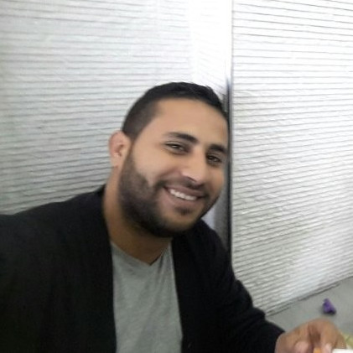

{fullName}
{desc}

Contact Info:


oualidkhial.me

walid.khail@gmail.com

+213550750576

Languages:

{#lang}- {name} {level}
{/lang}

Primary Skills

{#skills}- {name}
{/skills}

About Me:

{AboutMe}

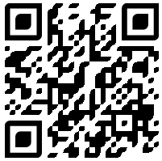
Professional Carrer
please scan the QR code or refer to oualidkhial.me for details

{#carrierDataL}{date}
{title}
@{company}

{/carrierDataL}
{#carrierDataR}{date}
{title}
@{company}

{/carrierDataR}
Educationl Background

{#educationalBackground}
{year}
{degree}
{spec}
{school}
{/}

