Automatic Announcing System

Introduction
The automatic announcing system is a system designed to:
- Play background music
- Play general announcements
- Play time dependent announcements
This guide has been prepared for the following people:
Operators – People who will use the system to make announcements, but will leave the setup to someone else.
Designer – Person who designs schedules and provides audio content.
Expert – Someone who needs to know the extreme details of the system.

Features
The Automatic Announcing System is designed to play background music and announcements. Background music will be played at a reduced volume, announcements are played at full volume.
There are two types of announcements, general and scheduled. A general announcement may be something like, “Grisly Flats is open to the public. Come visit.” It is not time dependent.
A scheduled announcement is one tied to a specific time. For example at 11:55, the announcement, “The 12:00 train will be leaving in 5 minutes”.
Background music will be interrupted for scheduled announcements. General announcements will not be interrupted, so they should be kept short.

Operator Information
This section is for the people who are using the automatic announcer and will not configure it.

To Start
Press -A. The main GUI (Figure 1) will appears.
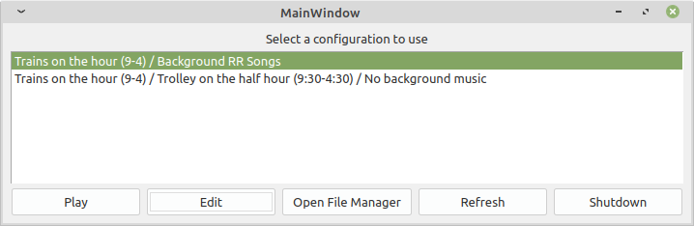
Figure 1: Main window
Click on the predefined configuration you want to use and click “Play”. The announcements will start.

Run time Controls
The following commands are available at any time (Note: All commands require you to press <enter> a the end of the command):
p – Pause system. If in the middle of an announcements, the pause will occur after the announcement. Press <enter> to continue.
v<number>. Set the background volume to <number> percentage of maximum volume. This applies to background only. Foreground will always be played at 100%. To adjust the foreground volume, turn the knob on the amplifier.
v+<number>, v-<number>. Increase or decrease the volume by the indicated number.
s – Suspend. Stop all scheduled announcements. This is for when the schedule gets so screwed up the scheduled announcements are meaningless.
r – Resume. Resume all scheduled announcements.
q – Quit.

Shutdown
Press -X to display the shutdown menu.

Designer
The Designer is the person who designs announcement systems for use by the operators. There is a “friendly” GUI which is designed to help you do this.
A configuration contains the following information:
- A description of the configuration
- The volume for the background music (can be changed while running)
- A list of scheduled announcement
- A list of background songs and general announcements.
When you first start the configuration GUI it displays the main window as shown in Figure 1.
Figure 1: Main Window
The controls on this window are:
Configuration List – Select the configuration to use / edit.
Play – Starts the announcing system using the given configuration.
Edit – Edits the selected configuration. (See next section)
Open File Manager – Opens a file manager window with the directory containing all the configuration files selected. This allows you to delete, copy, and rename configuration files.
Refresh – Reread the list of configuration files. (In case you played around with them in the file manager.)
Shutdown – Exit the program.

Configuration Edit Window
A configuration file contains the following information:
- A one line description of the configuration.
- The volume at which to play background music. (Announcements are played at 100% always.)
- The name of the file holding the scheduled announcements.
- The name of the file holding the background music and announcements.
When you click “Edit” in the main window, the configuration editor window (Figure 2) appears.
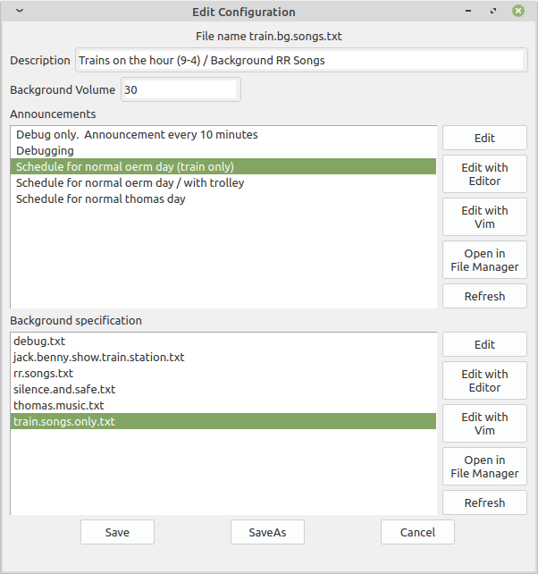
Figure 2: Configuration Edit Window
The configuration edit window let’s you edit a single configuration. The controls on this window are:
Description – The description of the configuration.
Background Volume – Background music volume (0-100%). Note announcements are always at 100%.
Announcements – Which list of scheduled announcements to play.
Background – The list of background music and unscheduled announcements to play.
Save – Save the changes are return to the main window.
Save As – All you to save the configuration under another name.
Cancel – Discard edits and return to the main window.
Both the Announcement and Background panels have the following buttons.
Edit – Edit the list using the GUI
Edit with Editor – Edits the file containing the list with a simple GUI text editor for those familiar with the file format.
Edit with VIM – Edits the file containing the list with a powerful but hard to use editor called Vim.
Open In File Manager – Opens the directory containing the specification files in the file manager.

Editing Announce List Specification
When you select the Edit button next to the list of scheduled announcements, the Edit Announcement window appears. (Figure 3).
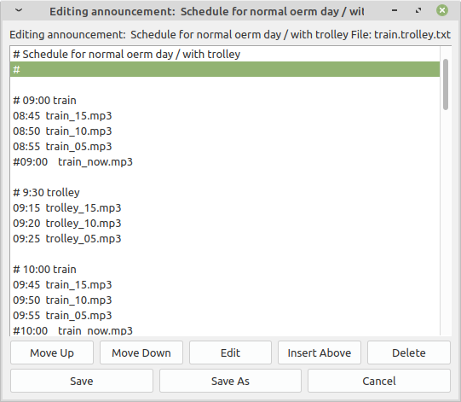
Figure 3: Editing Announcement Specification
Any line that begins with a “#” is a comment. The first line of the file is not only a comment, but used as the description of the file.
The other lines are of the format:
<time> <file>
Where <time> is the time (24 hour clock) of the announcement and <file> is the name of the file containing the announcement.
The controls on this GUI are:
Move Up – Moves the current entry up one slot. For the announcements, the time determines when the announcement plays, not to order in the list.
Move Down – Move the current down one slot.
Edit – Edits the current entry (see below).
Insert Above – Insert an entry before this one. This button uses the current entry for the default values for the new entry.
Delete – Delete the current entry. If you are deleting an announcement from a background list, you will be given the chance to delete all occurrences of this periodic announcement.
Save – Save the current list.
Save As – Save the list under a new name.
Cancel – Terminate the edit and throw away all changes.

Editing an announcement entry
When you edit or insert an announcement, the Edit/Create Announcement popup appears. Figure -4.
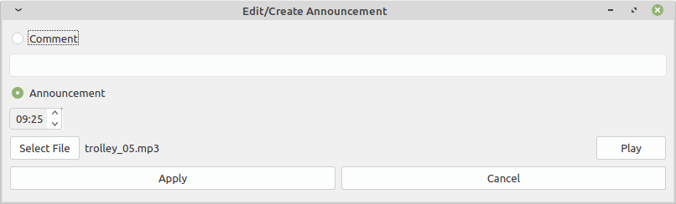
Figure 4: Edit/Create Announcement
The controls on this window are:
Comment / Announcement radio buttons – Selects whether or not this is a comment or announcement.
Comment Blank – Contains the comment if a comment.
Time – Time when the announcement occurs.
Select File – Press this button to select an announcement file to play.
<file-name> – Name of selected file.
Play – Starts a GUI that plays the selected file.
Apply – Apply changes and return the the list editing window.
Cancel – Discard changes and return to the list editing window.

Editing a Background Specification
When you edit a background specification, the GUI in figure 5 appears.
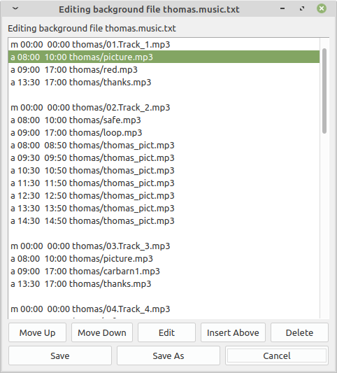
Figure 5: Background Editing Window
Lines beginning with “#” are considered comments.
Lines beginning with “m” specify background music to be played. Lines with “a” specify announcements.
The two times specify the time period during which the audio can be played. A specification of “00:00 00:00” indicates that it can be played any time.
In the sample above, we play an announcement called “thomas/thomas_pict.mp3” from “09:30” to “09:50”. This announcement tells people “It is a good idea to get your picture with Thomas before you board the train.” (Thus avoiding the rush that occurs when everyone leaves the train and goes to get their picture with Thomas. The reason is this is done from 9:30 to 9:50 is that’s when Thomas is in the station. We wouldn’t want to tell people to get their picture with Thomas only to find that he’s out on the main line.
The controls in this window are the same as the Announcement specification editor. It should be noted that position is significant in this specification. The announce-o-matic will go through the entries in this list in order playing each valid one in turn.

Editing an background entry
When you edit or insert background, the Edit/Create Background popup appears. Figure -5.
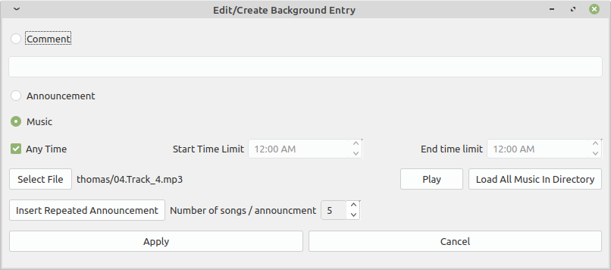
Figure 5: Edit/Create Background
The controls on this window are:
Comment / Announcement / Music – Selects whether or not this is a comment, background or periodic announcement.
Comment Blank – Contains the comment if a comment.
Any Time – If set, the audio can be played at any time.
Start Time Limit, End Time Limit – The time slot during which this audio can be played.
Select File – Press this button to select an announcement file to play.
<file-name> – Name of selected file.
Play – Starts a program that plays the selected file.
Load All Music In Directory – This displays a directory selection dialog and lets you load all the songs in that directory into the specification.
Insert Repeated Announcement – Allows you to insert an announcement multiple time into the specification. For example, if you wanted to insert the announcement “be-save.mp3” every other sing, you would set the Number of Songs / Announcement to 2 and click this button.
Number of Songs / Announcement – Controls how many songs will be between an announcement when using the Insert Repeated Announcement button is clicked.
Apply – Apply changes and return the the list editing window.
Cancel – Discard changes and return to the list editing window.

Importing Songs From a USB Stick
When you insert your usb stick, a file manager window should appear. Select the files you wish to copy to the computer and then on the menu click File → Copy.
On the left side of the File Manager, there’s a places section. Click “user” for the home directory of the user name “user”. Select “announce” then “songs.d”.
Select File → Paste to copy the files into this directory. They are now ready for service.

Importing Announcements From a USB Stick
When you insert your usb stick, a file manager window should appear. Select the files you wish to copy to the computer and then on the menu click File → Copy.
On the left side of the File Manager, there’s a places section. Click “user” for the home directory of the user name “user”. Select “announce” then “announce.d” (scheduled announcement) or “general.d” (General background announcements).
Select File → Paste to copy the files into this directory. They are now ready for service.

Instructions for Linux Geeks
The system is running Crunch Bang Linux a lightweight distribution on a low cost laptop. The account information is:
User name: user
Password: secret
The directory structure in /home/user is:
./announce | Home for all announcement related files
./announce/bin | Announcement executable and libraries
./announce/gui | Source for the announce gui
./announce/config.announce | Scheduled announcement lists
./announce/config.background | Background music lists
./announce/config.master | Master configuration files
./announce/announce.d | Scheduled announcements audio files
./announce/general.d | General (background) announcement audio files
./announce/songs.d | Background music audio files.

Format of master configuration file
Typical file:
Trains on the hour (9-4) / Background RR Songs
train.on.hour.txt
train.songs.only.txt
30

Line 1: Single line description of the configuration
Line 2: Scheduled announcement file (from config.announce)
Line 3: Background music / announcements file (from config.background)
Line 4: Initial background volume

Format of an announcement configuration file
Typical file excerpt:
# Schedule for normal Thomas day
#
8:40 thomas/thomas_15.mp3
8:45 thomas/thomas_10.mp3
8:50 thomas/thomas_05.mp3
8:50 thomas/percy_15.mp3
8:55 thomas/percy_10.mp3
8:55 thomas/hatt_05.mp3
9:00 thomas/hatt_now.mp3
9:00 thomas/percy_05.mp3

If the first line is a comment, it will be used as the description of the file in the GUI.
Comments begin with “#”. Blank lines are allowed.
Scheduled announcement specifications consist of entries like:
hh:mm audio-file.mp3
Where hh:mm is the time of the announcement (24 hour clock).
audio-file.mp3 is the name of the audio file.
Order of entries does not matter. Announcements will be played as close to the time specified as possible.

Background Music and Periodic Announcement File Format
Typical file:
# Background announcements / music for Thomas
m 00:00 00:00 thomas/01.Track_1.mp3
a 08:00 10:00 thomas/picture.mp3
a 09:00 17:00 thomas/red.mp3
a 13:30 17:00 thomas/thanks.mp3

m 00:00 00:00 thomas/02.Track_2.mp3

If the first line is a comment, it will be used as the description of the file in the GUI.
Comments begin with “#”. Blank lines are allowed.
Entries consists of lines like:
<type> <start> <end> <audio-file>
Where:
<type> is “m” for a music file and “a” for a general announcement.
<start>/<end> is the earliest and latest a file can be played. (00:00 00:00) indicates any time.
<audio-file> is the name of the audio to play.
<start>/<end> are used for things like telling the guest to “Get your picture with Thomas early”. This announcement is only valid in the morning so it played between 8 and 10 in the morning.
Order matters. The system will go through each file and if it the time specification permits, play it in turn.

