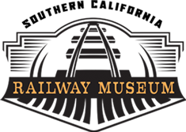

Trolley Simulator Help

Modes
The program has the following modes:
Easy Mode. Designed for children and people who don’t want to learn all the controls. The Deadman must be pressed and then the Controller alone operates the trolley. (See Easy Mode for a tutorial and more information.)
Start/Stop Mode. The Controller, Reverser, and Brake all operate normally. However the program does not check to make sure that the proper starts, stops, and bell calls are made. This is useful when you are getting used to the controls. (See Start/Stop Mode for details.)
Full Mode. All the controls work and you are expected to make all the stops and perform all the safety operations. (See Full Mode for more information.)

Seleting Modes
When you first start, you are promoted to select a mode. If you click the “Tutorial” button next to the mode, you’ll start an interactive tutorial for that mode.
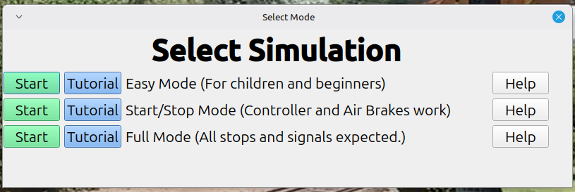

Figure 1: Change Button

Easy Mode
The most important thing when operating a trolley is to operate it safely. In Easy Mode we’ve eliminated a lot of the controls, but you must follow the rules. These are:
- The Deadman must be pressed before anything moves
- The speed limit on the loop line is “Run 3”.
If you go up to the controls and jerk the throttle all the way to Run-8, the simulator will stop you and reset. In real live, you’d damage the trolley. So move things slowly and don’t be a jerk.

Quick Start
- Press the bell button twice. This tells people the trolley is getting ready to move.
- Put your foot on the Deadman.
- Move the controller to Run-1 to start moving.
Run-0 – Slow down and stop
Run-1 – Move slowly
Run-2 – Move faster
Run-3 – Fastest
Run-4 through Run-8. Too fast for our track. This isn’t a main line.

Controls

Bell
The bell tells people what the trolley is doing. If you wish to use proper bell signals they are:
Two dings – go. Sound before you start.
One ding – Stop. Sound after you stop

Deadman
The deadman must be on for the trolley to operate. Put your foot on the deadman switch.
(Click the Deadman button.)
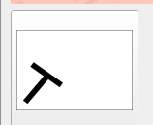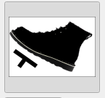

Controller
The controller is used to make the trolley move and make the trolley stop. This is not how a real trolley works. It has been simplified to get you used to the controller,..

Click “+” to move faster. The controller will go into Run-1.
Clicking “+” will advance to Run-2. A third click advances to Run-3.
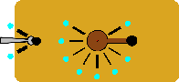  Run-1 Go | 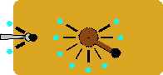  Run-2 Go faster | 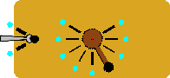  Run-3 Go really fast

To slow down, click “-”. When you reach Run-0 you’ll slow down and stop.
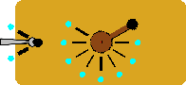

Run-4 and above is too fast for the track and will stop the simulation.

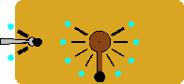

Reset Button
Restarts the simulator.

Air Brakes
In Easy Mode the air brakes are not connected to the brakes. However the brake valve works. It will let air into and out of the brake pipe. The brake gauge will change just like a real trolley.
See Start/Stop mode for an explanation of the air brakes.

Start / Stop Mode
The goal for Start/Stop mode is to safely operate the trolley. All the controls work. We just don’t worry about the bell signals and stopping at right place. All you need to do is get it to move and stop.
Getting a trolley to move is easy. Getting it to stop at the right place is hard.

How a trolley controller works
When the controller is in Run-0, no power is supplied motors under the trolley.
When you move the controller to Run-1 the trolley routes the power through three big resister packs and then through each motor.

Figure 1: Motors and Resister Packs

Figure 2: Run1 wiring
The resister packs consume most of the power and the trolley will move slowly.
When you put a lot of power through a resistor pack it gets hot. If you stay in Run-1 for more than about 10 seconds it will overheat, so you are only allowed to stay in Run-1 for 10 seconds.
Run-2 routes the power through only two resister packs so more power goes to the wheels.

Figure 3: Run 2
Run-3 uses only one resister, so even more power goes to the wheels.
Run-4 is called full series. All the power goes into the first set of wheels and then the second. There is no resister pack involved. You can stay in Run-4 for as long as you want. Unfortunately we have speed limit on the loop line and Run-4 is not allowed. If you tried to use Run-4 the trolley would go too fast and come off the track.

Figure 4: Run-4 – Full series
Run-5 again cuts in the three resister packs. But this time is send power to the motors in parallel. This means that instead of each motor using half the available power, they use it all.

Figure 5: Run-5
Run-6 uses a smaller resister pack and Run-7 uses the smallest. Run-8 is full parallel with full power going to both wheels. It is the fastest the trolley can go. Or could go if we didn’t have bumpy track and sharp curves. Run-3 is our fastest legal controller position. Anything more than that causes the simulator to detect an unsafe condition and stop the simulation.

Slowing Down
When slowing down you must move the controller quickly back to Run-0. If you’re in Run-3 you can’t linger on Run-2 or Run-1. That’s because the motors in the trolley will act as generators and cause problems with the electrical system. If you observe the real trolley the motorman will slam the controller back to Run-0.

Air Brake Basics
The handle on an air brake has the following positions (left to right)
Release – Brakes are released and the trolley can move
Lap – Keep the air pressure constant.
Apply – Let air into the brake pipe.
Emergency – Stop the trolley as fast as possible.
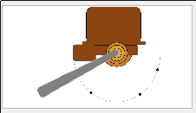 | 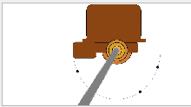 | 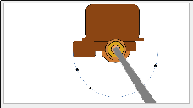 | 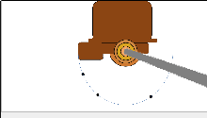
Release | Lap | Apply | Emergency
Figure 6: Brake Handle Positions
In the upper right is the brake gauge. The black arrow shows the pressure in the reservoir. If this gets low the trolley has a problem and will be taken out of service. It never gets that low in the simulator.
The red arrow indicates the pressure in the brake cylinder. “0” indicates the brakes are off and the trolley can move. To make this happen, move the brake handle to the release position and leave it there. Notice the that red arrow goes to zero.
Figure 7: Release brakes
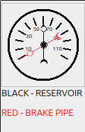
Figure 9: Brakes released – no pressure in the brake pipe.
To slow the trolley gently you need to put about 10 pounds in the brake pipe. This is called a “10 pound set”. To make a 10 pound set, move the brake handle to the “Apply” position for about ½ a second, the move it back to the “Lap” position.
Figure X: Making a set.
Air brakes are a lot different than car brakes. In a car if you want to slow you press the brake and the car slows down.
In a trolley if you do a 10 pound set, the trolley will not slow down. Nothing will happen for a few seconds as the brake cylinder extends, then the brakes will slow down the trolley. So if you want to stop at Broadway, you must do your 10 pound set about 30 feet before the stopping point. Then wait for the cylinder to extend and the trolley to slow down.

Exercise 1: Basic Controls
We are going to move and stop the trolley.
Execute the following steps:
- Place your foot on the Deadman.
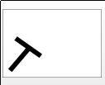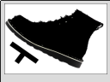
- Put the brake handle in the release position.
- Put the reverser in the forward position. 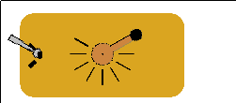
- Move the controller to Run-1, leave it there for five seconds, and return it to Run-0. The trolley will start to move.
- Move the brake handle to “Emergency”.
- The trolley will suddenly stop.
This is a sudden and jarring stop. This is not what you want to do normally, but is the simplest way of stopping.

Exercise 2: Smooth Stop
We are going to try and do a gradual stop.
- Place your foot on the Deadman.
- Put the brake handle in the release position.
- Put the reverser in the forward position.
- Move the controller to Run-1, leave it there for five seconds, and return it to Run-0. The trolley will start to move.
- Move the brake handle to “Apply” for ½ second, then move it back to “Lap”

- The trolley coast for a few seconds then slow down when the brakes kick in.
- Note if you appear to be stopping short, you can move the brake handle to “Release” and the brakes will come off letting you move again.

Exercise 3: Running Faster
We’re now going to move the trolley a little faster.
- Place your foot on the Deadman.
- Put the brake handle in the release position.
- Put the reverser in the forward position.
- Move the controller to Run-1, leave it there for five seconds.
- Move the controller to Run-2, leave it there for five seconds.
- Slam the controller back into Run-0.
- Move the brake handle to “Apply” for ½ second, then move it back to “Lap”
- The trolley coast for a few seconds then slow down when the brakes kick in.
- Note if you appear to be stopping short, you can move the brake handle to “Release” and the brakes will come off letting you coast.

Full Mode
In Full Mode you run the trolley following all the rules. If you break a rule that may damage the trolley, the simulation will stop. If you break a rule involving operations or safety, you’ll receive a warning.

Bell Signals
oo Two dings indicate that the trolley is about to move forward.
o One ding indicates the trolley has stopped.
oooo... Crossing
You must sound the “forward” bell signal shortly before moving.
The stop bell signal is sounded after stopping.
Sound the bell continuously when crossing any street or other crossing.

A Tour of the loop line

Station
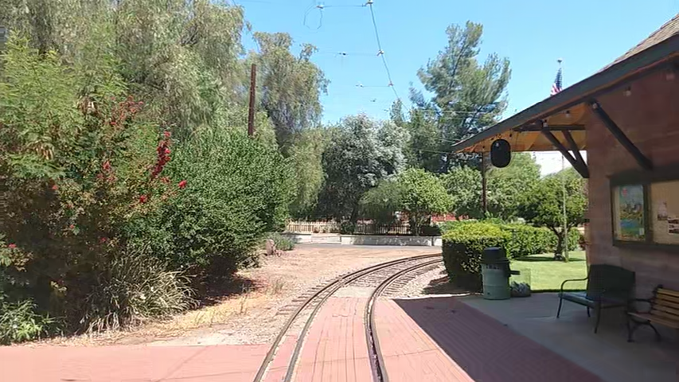
This is where you start and stop you run.

Broadway
Broadway is a stop where we let passengers on and off.
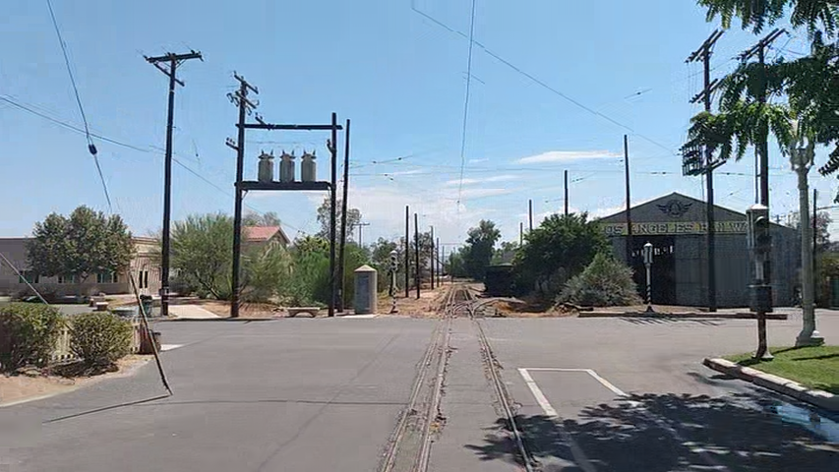
Sound one bell to indicate you’ve stopped.
Wait for passengers to get on and off.
Sound two bells then start moving.
Sound the as you proceed through Broadway.

Central
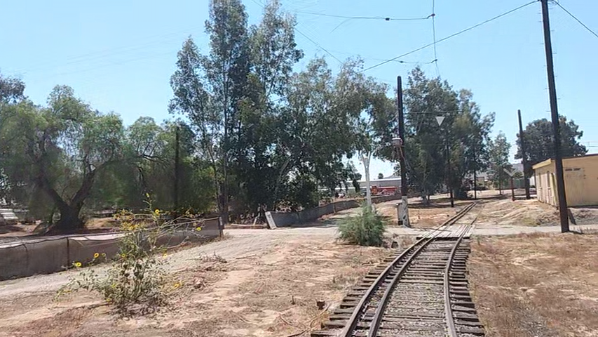
Sound the bell when crossing Central.

Carbarn 2 stop
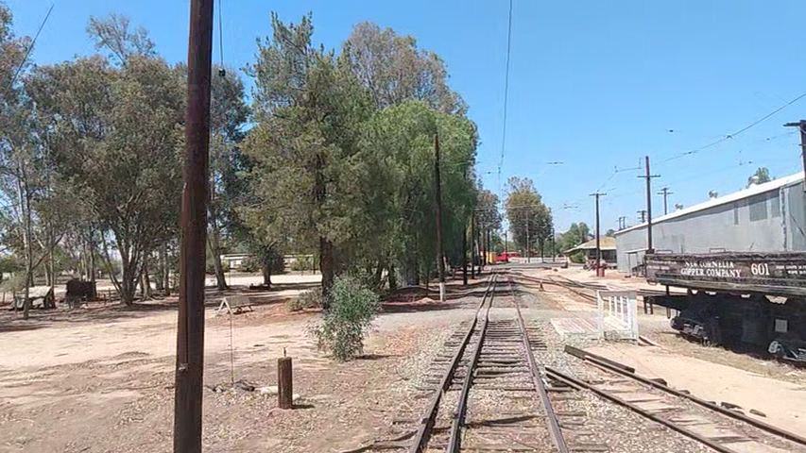
Stop here to let passengers on and off for Carbarn 2.
Sound the bell once when stopped.
Sound the bell twice before proceeding.

Carbarn 2 Zorch Point
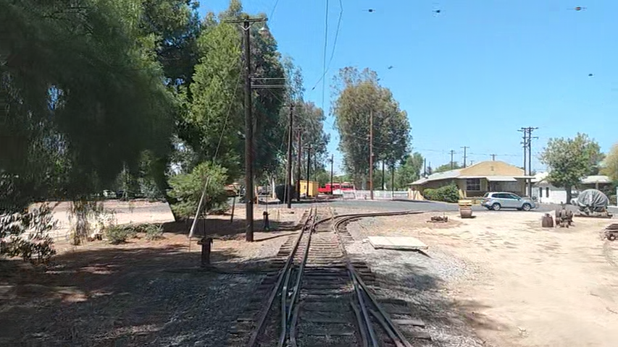
As you approach Broadway again you will pass the carbarn 4 switch. Above the trolley you’ll notice that the wires from the Carbarn 2 lead and the Loop Line merge in a frog. If the trolley is under power when the pole goes over this frog it will cause sparks to fly, thus zorching the end of the pole.
This is not a good thing as it wears out the shoe on the top of the pole. There is a yellow pipe (hard to see in the video) in the ground indicating where you should turn off power to prevent zorching.

Broadway
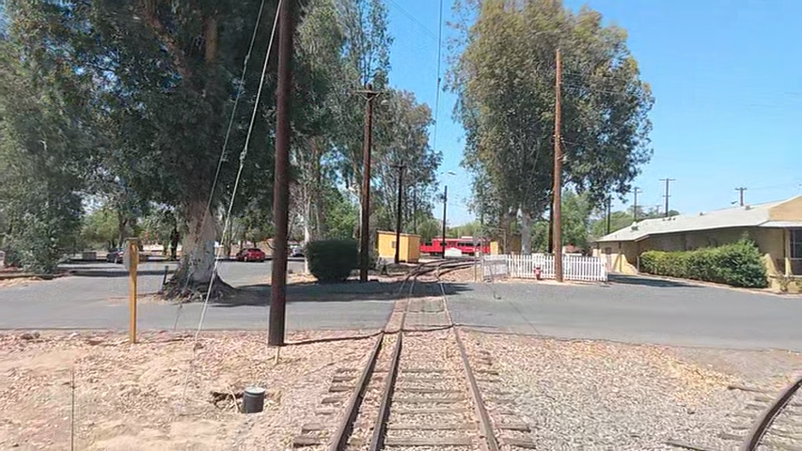
Sound the bell when crossing the south end of Broadway.

Main Line Zorch Point
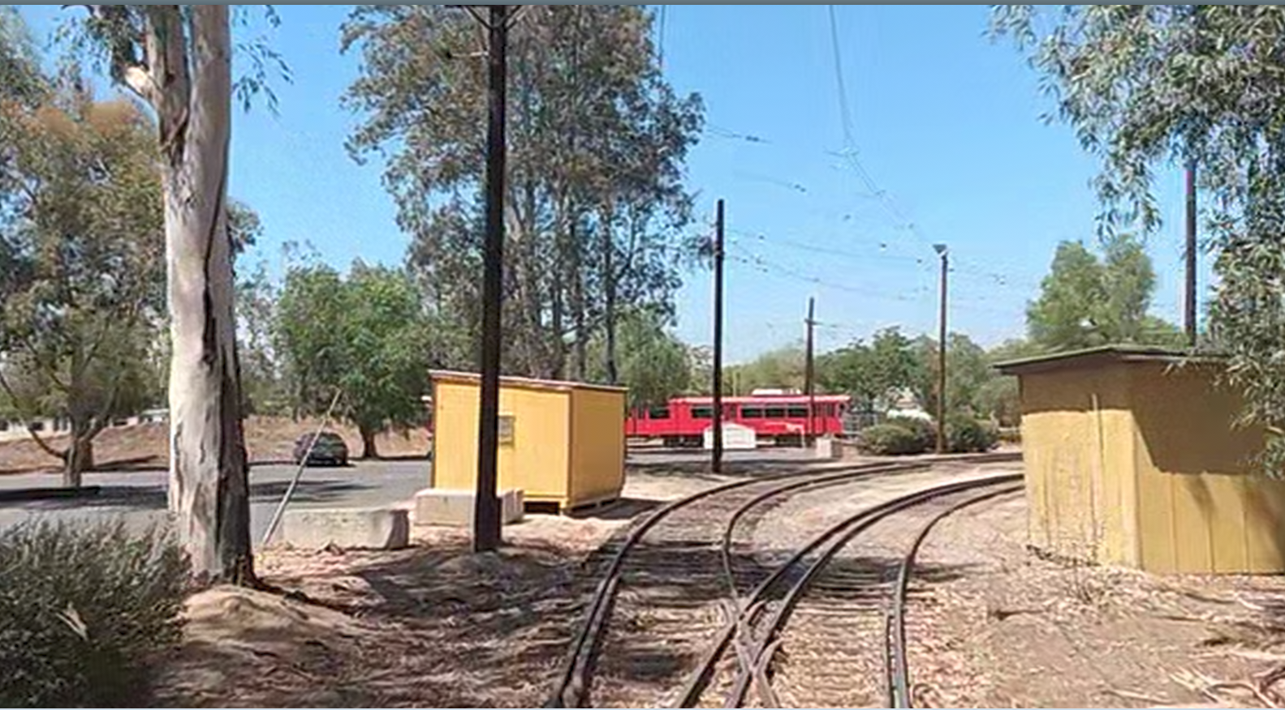
The main line lead goes off to the left. Here we have another frog in the overhead line. And another yellow pipe. (Which doesn’t show up in the picture.) Make sure to have power turned off when passing the pipe.

Thomas Stop
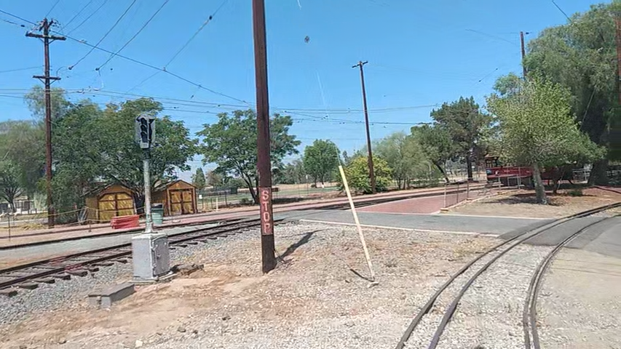
There is a mandatory stop at the Thomas Crossing. That’s because because for two weekends a year more people cross the track at this point in one day that visit the museum the rest of the year combined. So for the other 50 weeks we practice stopping.
Stop at the Thomas Crossing.
Sound the bell once to indicate that you’ve stopped.
Sound the bell twice before you start.
Move past the Thomas crossing.

Back at the Station
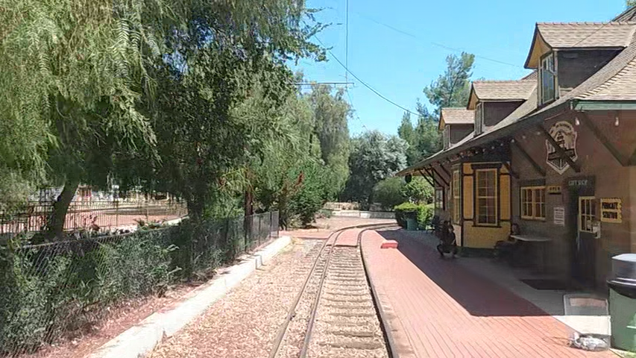
Stop at the station.
Ding the bell once to indicate you’ve stopped.

What you must do in full mode to complete a loop line run
- Two dings on the bell – tell people we are moving.
- Drive the trolley to Broadway and stop.
- One ding to indicate you’ve stopped.
- Ring the bell twice. Let people you know are moving.
- Ring the bell through the crossing.
- When you reach the Central crossing, ring the bell as you go through.
- Stop at the Carbarn 2 platform.
- Ring the bell once to indicate that you’ve stopped.
- Ring the bell twice to indicate that trolley is moving.
- Look for the yellow pole that indicates the Broadway spur. Make sure you are not under power when you pass it.
- Ring the bell crossing Broadway.
- Look for the yellow pole that indicates the Main Line Lead. Make sure you are not under power when you pass it.
- Stop at the Thomas crossing.
- Ring the bell once to indicate that you’ve stopped.
- Ring the bell twice to indicate the trolley is moving.
- Pull in front of the store and stop.
- Ring the bell once to indicate you’ve stopped.

Glossary
Apply (Air brake) – When the brake is in the “Apply” position, air is being added to the brake pipe and the trolley will stop. There may be a delay as the brake cylinder has to extend before it starts to slow down the trolley.
Controller – The controller is the control that determines how much power is sent to the traction motors which move the wheels.
Deadman – A control that must always be pressed in order to move the trolley. If the deadman is released, all power to the wheels is shutoff and the trolley performs an emergency stop.
Emergency (Air brake) – When the brake handle is in the “Emergency” position, the brake system dumps as much air as possible into the brakes to stop as quickly as possible.
Frog – A location where two tracks join each other. This means that two overhead wires must join each other as well.
Lap (Air brake) – The brake position where air is neither added or removed from the brake system.
Release (Air brake) – Release the air from the air brakes. Similar to taking you foot off the brake of an automobile.
Resister Pack – A bunch of iron bars mounted under the trolley designed to use up power so only a portion of the power reaches the traction motors.
Reverser – Controls what direction you are moving. This simulator only works in the forward direction.
Zorch – To burn or damage with an electric arc. This happens when a energized pole goes over a frog.

Controls
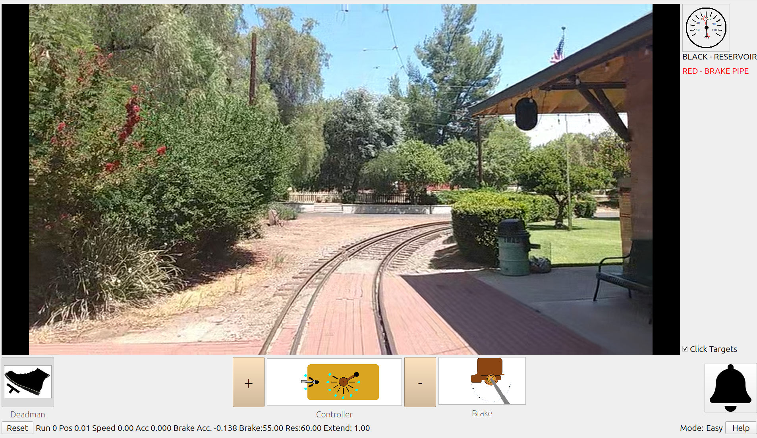
Bell
Motorman’s View
Air
Pressure
Deadman
Throttle
Reverser
Brake
Slower
Faster
Reset
Game
Debug
infomation
Current
mode
Get
Help

