Trolley Simulator
Deadman
Mode
Controller
Click to
change mode
Quick Start Guide

Warning: This is Alpha software. Improvements will follow.
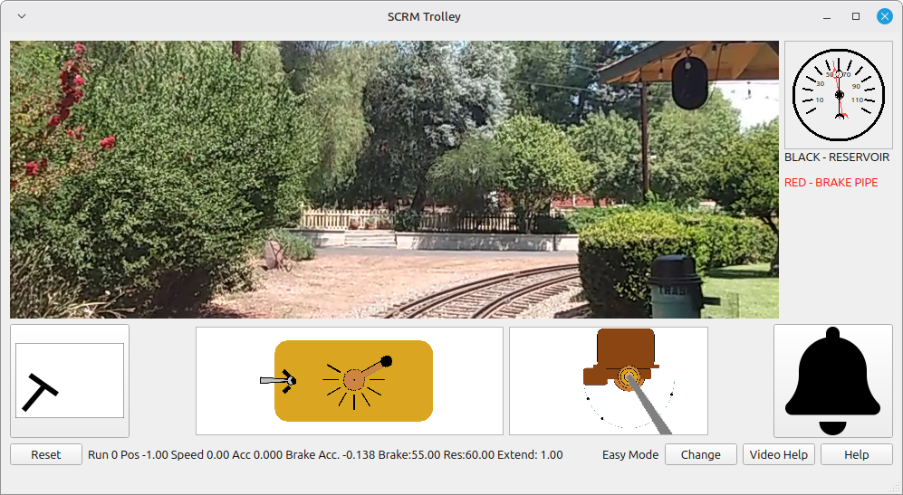

1. Make sure you are in easy mode.
Check the mode in the lower right of the screen. If it’s not in “Easy Mode”, change it using the “Change” button to “Easy Mode”.

2. Put your foot on the deadman switch.
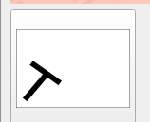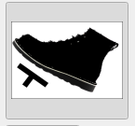

3. To move the trolley put the controller in Run-1, Run-2, or Run-3.
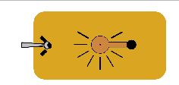  Run-1 Go |   Run-2 Go faster |   Run-3 Go really fast

4. To slow down, put the controller in Run-0.
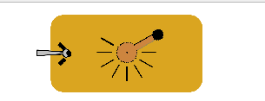

5. Run-4 – too fast – Trolley will jump the rails and the game ends.



