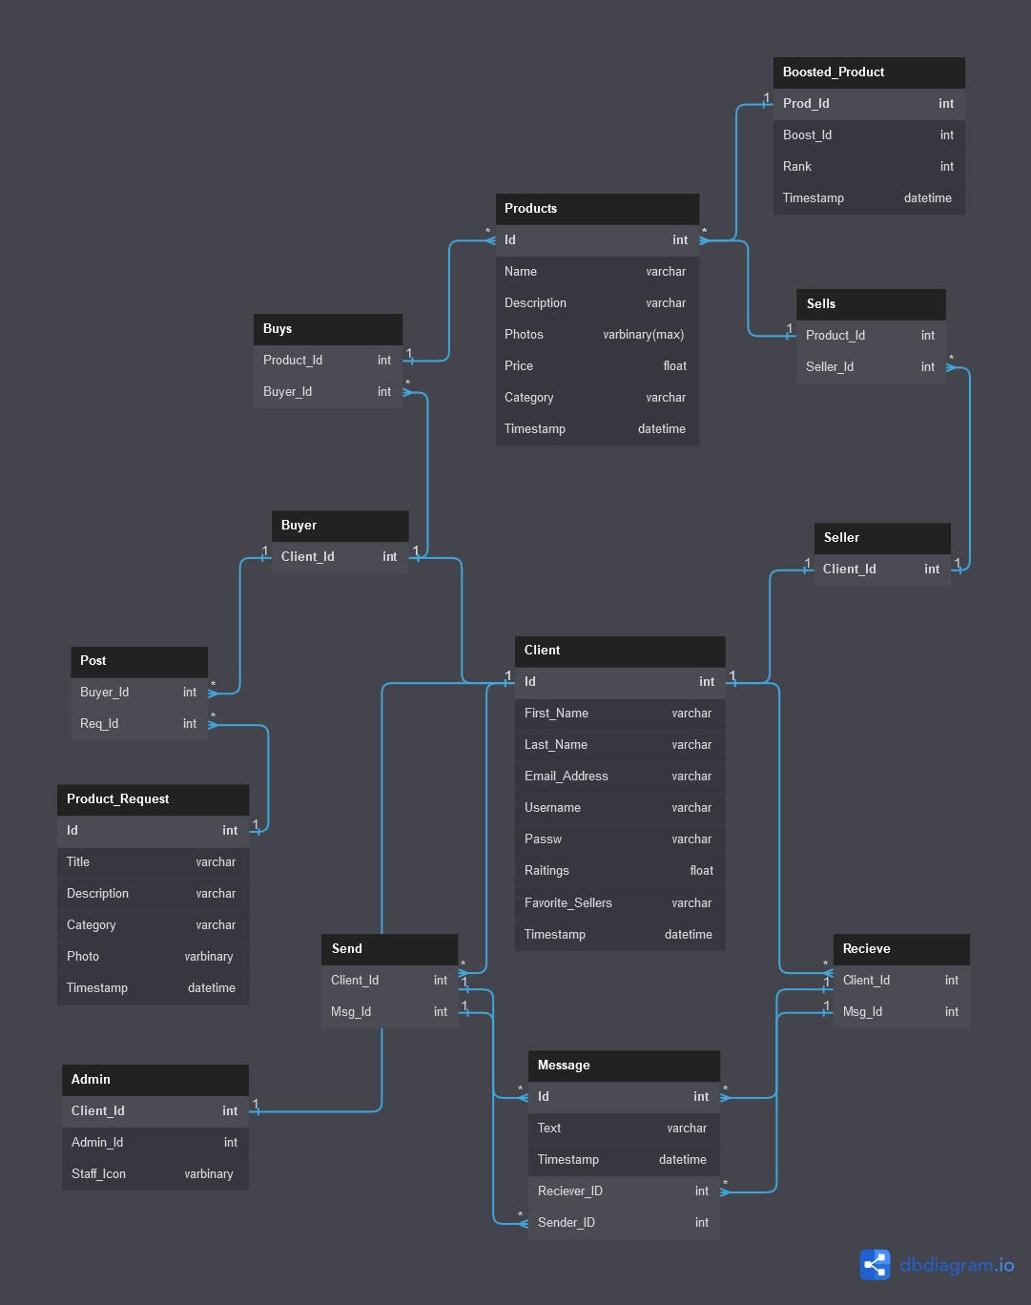

We have a Client entity which has Id as a primary key and all other necessary attributes, there is a Message entity with primary key Id and other attributes, which is connected to the client with two different relationships Send and Receive. Both relationships inherit the Client Id and the Message Id to connect the two entities. We also connect the relationships to the Receiver_ID and Sender_ID in Message entity respectively. We create three additional entities Buyer, Seller and Admin which inherit the Client entity’s Id, because the entities have an ISA relationship with the Client. But Admin also has a Staff icon and an Admin Id. We add a Products entity with Id as a primary key and all other attributes, which is connected to the Buyer and Seller entities using the Buys and Sells relationships respectively. Both relationships inherit the Id from Products and Buyer/Seller entities. Also, there is a Boosted Product entity which inherits its Id from the Products entity because of the ISA relationship and it has other attributes added to it. We add a Product Request entity with Id as a primary key with other attributes and connect it to the Buyer entity using a Post relationship which inherits the Id from the Buyer and the Id from the Product Request.

