CopterSonde Simulator
Setup and user manual for the CopterSonde, Skycharge and LAAIRS digital twin
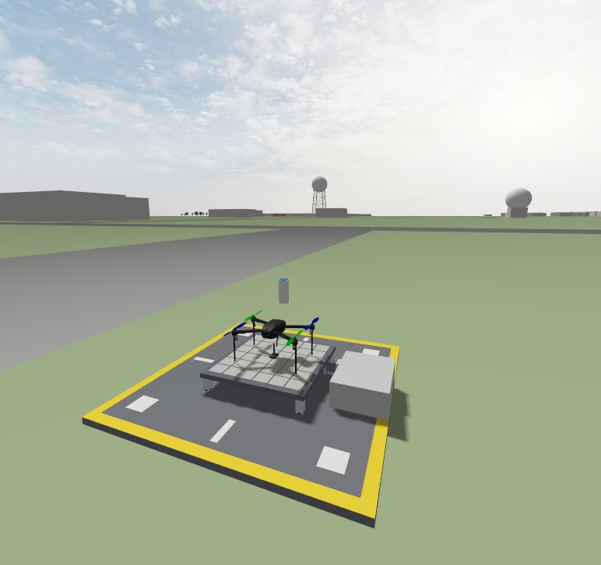
The CopterSonde resting on the Skycharge BOLOGNINI S1 pad in the Gazebo world of Norman, Oklahoma
For the capstone teams and BLISS contributors
Prepared by Dr. Antonio (Tony) Segales, University of Oklahoma
Version 1.0, November 2026

Contents
1. Welcome aboard! 4
How to read this manual 4
2. The CopterSonde ecosystem 4
2.1 The CopterSonde 4
2.2 LAAIRS: the drone-in-a-box 5
2.3 Why a simulator? 5
2.4 The code repositories 7
3. What you need 8
4. Installing WSL and Ubuntu on Windows 8
4.1 Before you start 9
4.2 Install Ubuntu 24.04 9
4.3 Good habits with WSL 9
5. Setting up Ubuntu for coding and simulation 10
5.1 Basic tools and your Git identity 10
5.2 Get the CopterSonde code from oubliss 10
5.3 ArduPilot development tools 10
5.4 Gazebo Jetty 11
5.5 Libraries for the CopterSonde Gazebo plugins 11
5.6 Check that Gazebo uses your graphics card 11
5.7 First build of the firmware 12
6. Setting up LAAIRS on Windows 12
6.1 Install Git, Python and Hatch 12
6.2 Get the LAAIRS code 13
6.3 First run 13
7. Running the simulation 13
7.1 Start the simulator 13
7.2 The Gazebo window 14
7.3 Connect LAAIRS 14
7.4 A tour of the LAAIRS main window 15
7.5 Charging on the Skycharge pad 16
7.6 RTK corrections 18
7.7 Fly a vertical profile 19
7.8 Stop the simulation 21
7.9 Keep your code up to date 21
7.10 When things don't work 21
8. Cheat sheet 22

If the page numbers look off after editing, right-click the list and choose Update Field.

1. Welcome aboard!
Welcome to the CopterSonde team! Whether you are here to automate the LAAIRS flight cycle, to build the launch hatch, or simply to learn how a weather drone thinks, this manual will take you from a fresh Windows laptop to a CopterSonde flying a vertical profile over Norman, Oklahoma, landing back on its charging pad and recharging, all without leaving your desk.
Don't worry if you have never used Linux, ArduPilot or Gazebo before. We wrote this manual for that situation, and we tried to keep the technical jargon to a minimum. Each step is short, and we tell you what you should see when it works. If something does not behave as described, take a screenshot and let us know: that is how this manual gets better.

How to read this manual
Commands go in grey boxes. The coloured label on top of each box tells you where to type them:
Ubuntu terminal
# commands for Linux go here

Windows PowerShell
# commands for Windows go here

- Type or paste one line at a time and press Enter. A line that ends with \ continues on the next line: paste those lines together. Lines starting with # are only comments.
- To paste in the Ubuntu terminal use Ctrl+Shift+V or a right-click (plain Ctrl+V does not work there).
- When Ubuntu asks for your password (after sudo), nothing appears while you type. That's normal: type it and press Enter.
- Words in bold are buttons, menus or fields you will see on the screen.

2. The CopterSonde ecosystem

2.1 The CopterSonde
The CopterSonde is a weather-sensing uncrewed aerial system (WxUAS) designed and built in-house at the University of Oklahoma. Its mission is to fill the observational gap in the lowest few kilometers of the atmosphere, the atmospheric boundary layer, where towers are too short and weather balloons are too sparse. It flies automatic vertical profiles of temperature, humidity and wind, and sends the data to the ground in real time.
- Sensors: iMet bead thermistors and HYT271 humidity sensors sit in a scoop at the front of the aircraft, with a small fan that keeps fresh air flowing over them.
- Wind vane mode: our custom autopilot algorithm turns the CopterSonde into the wind, so the sensors always face clean air. The tilt the wind forces on the aircraft also tells us the wind speed and direction.
- AutoVP: the autopilot builds its own vertical profile mission (take-off, climb to the target altitude, return to launch) with a single command.
- Firmware: BLISS-ArduCopter, our own version of the open-source ArduPilot autopilot (version 4.6), with the sensor drivers, the wind vane, the battery monitor and AutoVP built in.

2.2 LAAIRS: the drone-in-a-box
The CopterSonde does not fly alone. The Laboratory for Advanced Atmospheric Investigation using Robotic Sondes (LAAIRS) is a NOAA-funded collaboration between OU CIWRO and the NOAA National Severe Storms Laboratory. Its goal is a portable "drone-in-a-box" station where the CopterSonde takes off, profiles, lands, recharges and repeats, without a person on site, feeding real-time boundary-layer observations to forecasters. The station has three main parts:
- Skycharge charging pad: a BOLOGNINI S1 contact-charging pad. Metal tiles under the landing gear charge the battery as soon as the CopterSonde lands, controlled by a small Linux computer, the charge source.
- RTK precision landing: a u-blox ZED-F9P GNSS base station on the ground sends RTK corrections to the CopterSonde. With them, the CopterSonde knows its position within a couple of centimeters and lands right back on the pad.
- The LAAIRS app: the ground control station software. It runs the checklists, generates the mission, monitors the telemetry and the weather data, drives the charging pad and the RTK base, and exports the data in netCDF.

2.3 Why a simulator?
Flight tests are fun, but they are also expensive, weather-dependent and, let's be honest, a bit stressful when the code is new. So we built a digital twin of the whole system. Everything you use in the simulator is the real thing, except the physical world: the real autopilot code, the real LAAIRS app, and the same commands and messages the real pad and base station understand.
- Gazebo world: the Norman radar site around KCRI at Max Westheimer Airport, with buildings, trees, roads and radars at their true positions. The CopterSonde starts on the launch deck, resting on the S1 pad (Figures 1 and 2).
- Atmosphere: a repeating day of the boundary layer from the ground to 3.5 km, fitted to the 32 CSWX profiles we flew in 2026: a cool inversion and a low-level jet at night, a growing mixed layer in the morning and a deep, hot, turbulent afternoon.
- SITL (software in the loop): the BLISS-ArduCopter firmware compiled for your PC. The iMet and HYT271 sensors are simulated with their real lags and errors, the wind vane works from the real tilt, and the battery drains like the real 6S pack.
- Skycharge twin: behaves like the pad's computer, with the same skycharge-cli commands, states and errors.
- RTK base twin: behaves like a u-blox ZED-F9P base station. It surveys in and sends RTCM corrections, and the drone's GPS turns RTK FIXED only while the corrections arrive.
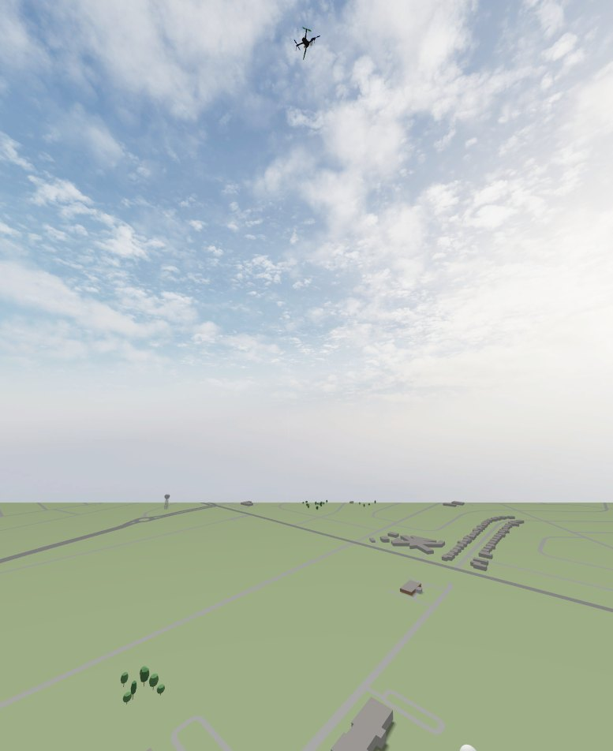
Figure 1. Left: the CopterSonde on the Skycharge S1 pad, on the launch deck at the take-off point; the box next to the pad is the charge source. Right: the CopterSonde climbing through 200 m above the Norman world.
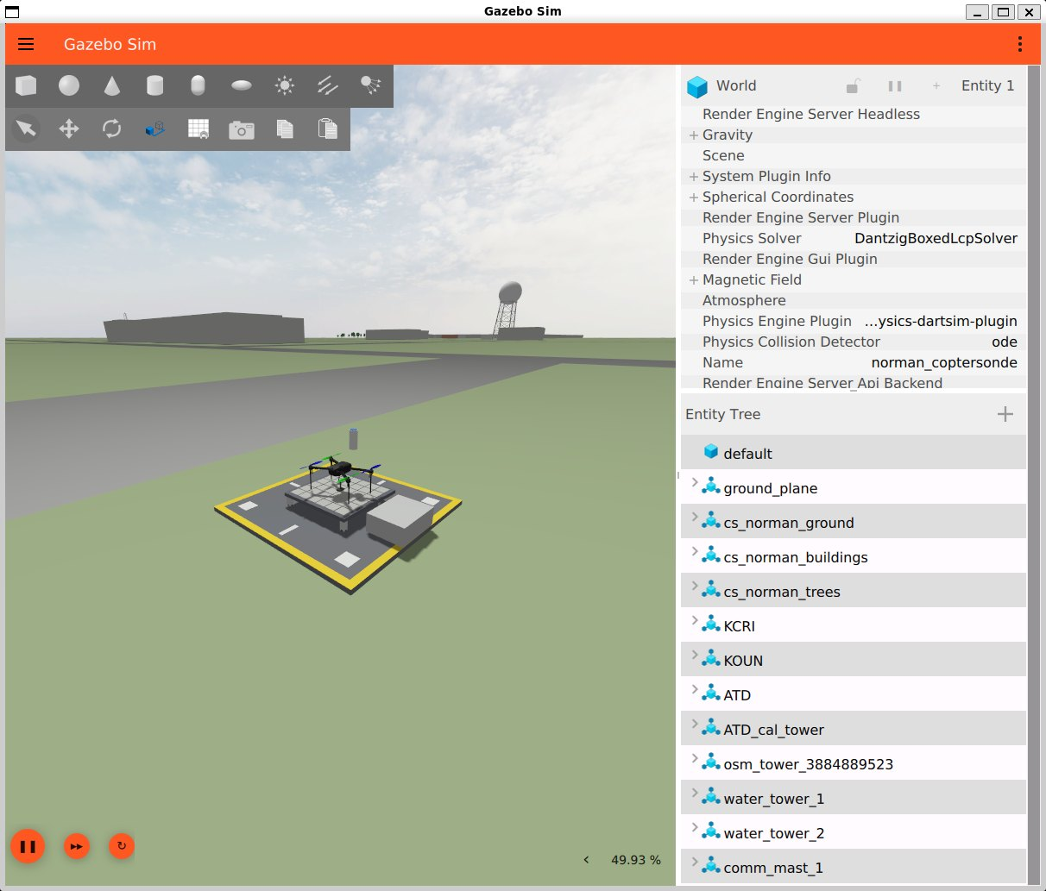
Figure 2. The Gazebo window. The 3D view is on the left, and the world and its models are listed on the right.
Figure 3 shows how the pieces talk to each other. The simulator runs inside Ubuntu (WSL), and LAAIRS runs on Windows exactly as it does in the field. Because LAAIRS cannot tell the difference, whatever you develop and test here should behave the same way on the real station. That is a big deal for the capstone projects!
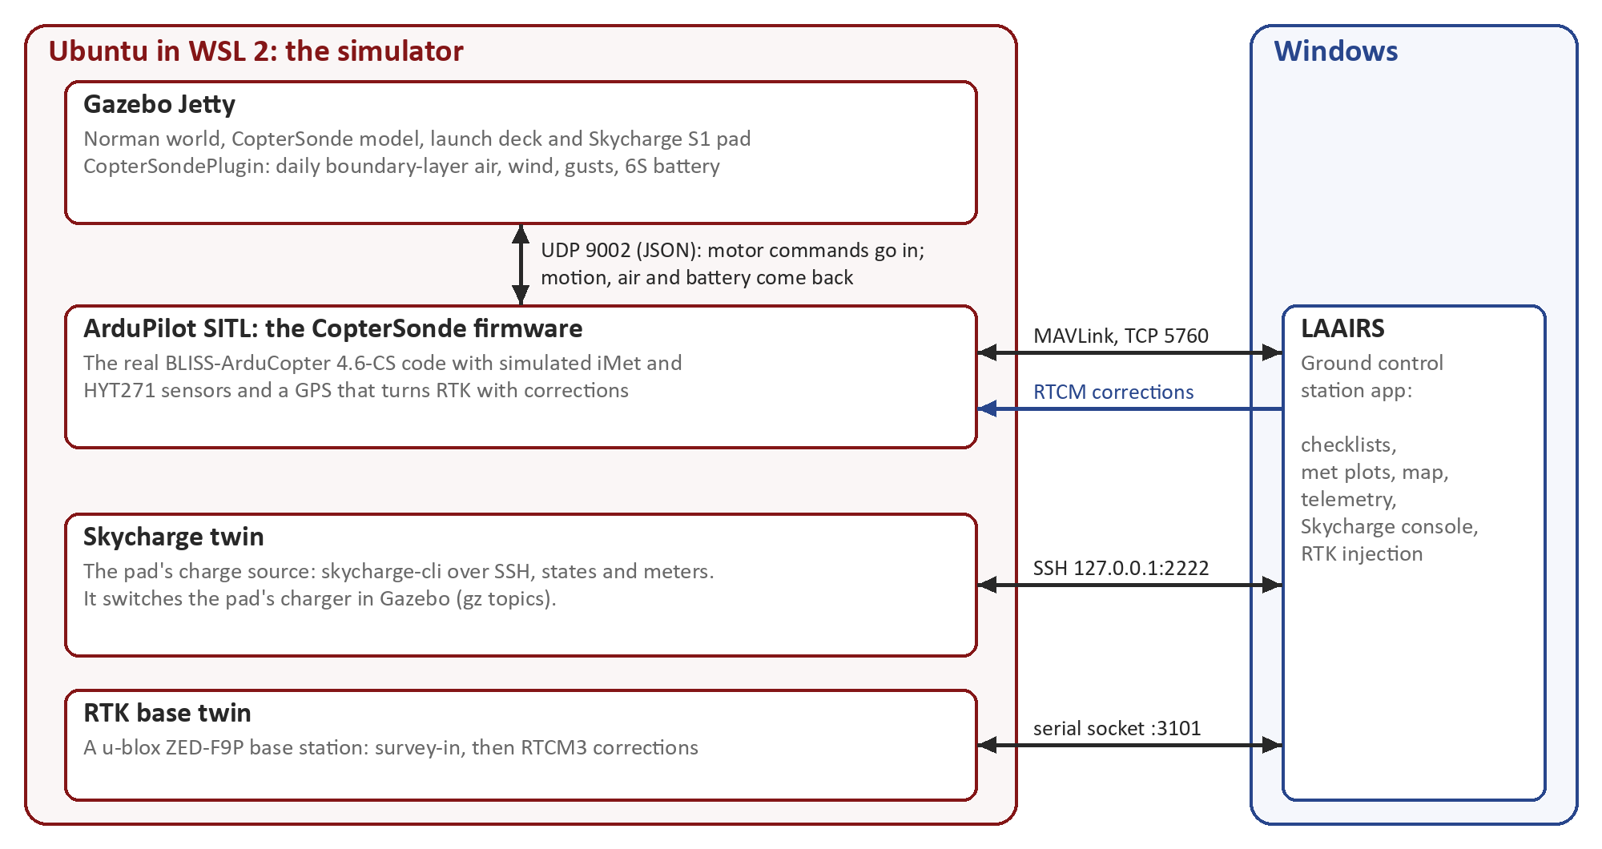
Figure 3. The CopterSonde simulator. One command starts everything inside the red box; LAAIRS connects to it from Windows.

2.4 The code repositories
All the code lives in the BLISS GitHub organization, oubliss. You need four repositories, but you only clone three of them yourself:
Repository (github.com/oubliss/...) | Branch | Where it goes | What it is
BLISS-ardupilot | ArduPilot-4.6-CS-gazebo | Ubuntu: ~/Github/BLISS-ardupilot | The CopterSonde firmware and the simulator (folder CopterSonde-sim)
ardupilot_gazebo | main-CopterSonde | Ubuntu: ~/Github/ardupilot_gazebo | The Gazebo plugins, including the CopterSonde plugin (air, wind, battery, charging)
BLISS-GCS | feature/skycharge-console | Windows: C:\Users\<you>\Github\BLISS-GCS | The LAAIRS app
mavlink | ArduPilot-4.6-CS | Downloaded automatically | The CopterSonde MAVLink messages. Nothing to do here.

Heads-up: BLISS-GCS is a private repository. Send your GitHub username to Dr. Segales so we can add you to the oubliss organization before you start Section 6.

3. What you need
The simulator runs a full 3D world, the autopilot and the ground station at the same time, so a reasonably modern computer helps. Here is what we recommend:
Item | Minimum | Recommended
Operating system | Windows 10 (21H2 or newer) or Windows 11, 64-bit | Windows 11, up to date
Processor | 4 cores (8 threads), with virtualization enabled | 8 cores (16 threads) or more
Memory (RAM) | 16 GB | 32 GB
Free disk space | 40 GB on an SSD | 60 GB or more on an SSD
Graphics | Any GPU with an up-to-date Windows driver | A dedicated NVIDIA or AMD GPU
Internet | About 6 GB of downloads during the installation
Accounts | A GitHub account with access to oubliss
Permissions | Administrator rights on the computer (to install WSL)

And this is the software you will install. All of it is free:
Software | Runs on | What it is for
WSL 2 with Ubuntu 24.04 LTS | Windows | A real Linux inside Windows, where the simulator runs
ArduPilot development tools | Ubuntu | Compilers, Python tools (pymavlink, MAVProxy) to build and run SITL
Gazebo Jetty | Ubuntu | The 3D robotics simulator
Git for Windows | Windows | Downloads the LAAIRS code
Python 3.13 and Hatch | Windows | Run LAAIRS and install its libraries
Visual Studio Code with the WSL extension (optional) | Windows | A friendly code editor for both sides

Tip: Why Ubuntu 24.04? The ArduPilot 4.6 installer script supports it, and it is the main platform of Gazebo Jetty. Our development computer runs Ubuntu 26.04, but there the ArduPilot script needs some manual work, so please stick to 24.04.

4. Installing WSL and Ubuntu on Windows
The Windows Subsystem for Linux (WSL) lets you run a real Ubuntu Linux inside Windows, without dual-booting or a virtual machine. Its graphics part, WSLg, shows Linux windows such as Gazebo right on your Windows desktop, and it uses your Windows graphics driver.

4.1 Before you start
1. Run Windows Update until nothing is left, and update your graphics driver from NVIDIA, AMD or Intel.
2. Check that virtualization is on: open Task Manager > Performance > CPU and look for Virtualization: Enabled. If it says Disabled, turn on Intel VT-x or AMD SVM in your computer's BIOS (ask us if you are not sure how).
Heads-up: Never install a Linux graphics driver inside Ubuntu. WSL uses the Windows driver, and a Linux driver would break it.

4.2 Install Ubuntu 24.04
1. Open PowerShell as administrator: Start menu, type PowerShell, right-click it and choose Run as administrator. Then run:
Windows PowerShell (administrator)
wsl --install -d Ubuntu-24.04

2. Restart the computer when it asks you to.
3. After the restart, Ubuntu opens by itself (or open Ubuntu 24.04 from the Start menu). It asks for a UNIX username and a password. Use a short lowercase name, and a password you will remember: you will type it every time you install something.
4. Back in PowerShell (a normal one is fine), make sure WSL is up to date and that Ubuntu runs on WSL version 2:
Windows PowerShell
wsl --update
wsl -l -v

You should see Ubuntu-24.04 with VERSION 2. Finally, update Ubuntu itself:
Ubuntu terminal
sudo apt update && sudo apt upgrade -y

4.3 Good habits with WSL
- Keep the code inside Ubuntu (your home folder ~), not under /mnt/c. Builds are many times faster on the Linux side.
- See your Linux files from Windows: in File Explorer look for Linux > Ubuntu-24.04 > home > <you>, or type explorer.exe . in the Ubuntu terminal to open the current folder.
- Windows Terminal (installed with Windows 11) shows Ubuntu and PowerShell side by side in tabs.
- VS Code: install Visual Studio Code on Windows with the WSL extension. Then code . in the Ubuntu terminal opens that folder in VS Code.
- Restart WSL when things get weird: wsl --shutdown in PowerShell, then open Ubuntu again.
Tip: By default WSL may use up to half of your RAM. With 16 GB, you can give it a little more: create the file C:\Users\<you>\.wslconfig with the two lines [wsl2] and memory=12GB, then run wsl --shutdown.

5. Setting up Ubuntu for coding and simulation
Now we prepare Ubuntu: the basic tools, the CopterSonde code, the ArduPilot tools, Gazebo and a few libraries. Do the steps in this order. All the commands in this section go in the Ubuntu terminal.

5.1 Basic tools and your Git identity
Ubuntu terminal
sudo apt install -y git curl lsb-release gnupg mesa-utils
git config --global user.name "Your Name"
git config --global user.email "your.email@ou.edu"

5.2 Get the CopterSonde code from oubliss
The firmware and the Gazebo plugins must sit side by side in the same folder: the simulator looks for ardupilot_gazebo next to BLISS-ardupilot. We use ~/Github:
Ubuntu terminal
mkdir -p ~/Github
cd ~/Github
git clone --recurse-submodules -b ArduPilot-4.6-CS-gazebo \
https://github.com/oubliss/BLISS-ardupilot.git
git clone -b main-CopterSonde https://github.com/oubliss/ardupilot_gazebo.git

The first clone is big (2 to 3 GB with its submodules) and can take 10 to 30 minutes. These two repositories are public, so Git won't ask you to log in. Check that you are on the right branches:
Ubuntu terminal
git -C ~/Github/BLISS-ardupilot branch --show-current # ArduPilot-4.6-CS-gazebo
git -C ~/Github/ardupilot_gazebo branch --show-current # main-CopterSonde

5.3 ArduPilot development tools
ArduPilot comes with a script that installs everything needed to build and run the firmware: compilers, Python libraries (pymavlink, MAVProxy and friends) and a Python virtual environment, ~/venv-ardupilot, that turns on by itself in every new terminal.
Ubuntu terminal
cd ~/Github/BLISS-ardupilot
Tools/environment_install/install-prereqs-ubuntu.sh -y

It takes 10 to 20 minutes. When it finishes, close the Ubuntu window and open a new one, so the new settings load. Then check that the virtual environment is active:
Ubuntu terminal
which python3 # should print /home/<you>/venv-ardupilot/bin/python3

5.4 Gazebo Jetty
Gazebo comes from its own package repository (the Open Robotics one). These are the official install commands:
Ubuntu terminal
sudo curl https://packages.osrfoundation.org/gazebo.gpg \
--output /usr/share/keyrings/pkgs-osrf-archive-keyring.gpg
echo "deb [arch=$(dpkg --print-architecture) \
signed-by=/usr/share/keyrings/pkgs-osrf-archive-keyring.gpg] \
https://packages.osrfoundation.org/gazebo/ubuntu-stable $(lsb_release -cs) main" \
| sudo tee /etc/apt/sources.list.d/gazebo-stable.list > /dev/null
sudo apt update
sudo apt install -y gz-jetty

Try it! This opens a small test world with a few shapes. Close the window when you have seen it:
Ubuntu terminal
gz sim shapes.sdf

5.5 Libraries for the CopterSonde Gazebo plugins
Ubuntu terminal
sudo apt install -y rapidjson-dev libopencv-dev \
libgstreamer1.0-dev libgstreamer-plugins-base1.0-dev \
gstreamer1.0-plugins-bad gstreamer1.0-libav gstreamer1.0-gl

You don't need to build the plugins by hand: the simulator's start script builds them the first time it runs (Section 7.1).

5.6 Check that Gazebo uses your graphics card
Ubuntu terminal
glxinfo -B | grep "OpenGL renderer"

If the answer mentions D3D12 and your graphics card, you are all set. If it says llvmpipe, Linux is drawing with the processor instead, and Gazebo will be slow. Tell it to use the graphics card, then open a new terminal and check again:
Ubuntu terminal
echo 'export GALLIUM_DRIVER=d3d12' >> ~/.bashrc
# only on laptops with two graphics cards (Intel + NVIDIA):
echo 'export MESA_D3D12_DEFAULT_ADAPTER_NAME=NVIDIA' >> ~/.bashrc

5.7 First build of the firmware
The start script also builds the firmware, but we like to do the first build by hand, so any problem shows up clearly:
Ubuntu terminal
cd ~/Github/BLISS-ardupilot
./waf configure --board sitl
./waf copter

The first build takes 5 to 10 minutes and ends with 'build' finished successfully. Later builds only recompile what changed.

6. Setting up LAAIRS on Windows
LAAIRS runs on Windows, exactly like on the field laptop where the radio and the RTK base station plug in by USB. WSL forwards the simulator's network ports to Windows, so LAAIRS reaches the simulator at 127.0.0.1 as if it were a drone on the other end of a cable.

6.1 Install Git, Python and Hatch
1. Install Git for Windows from git-scm.com (the default options are fine). It includes the Git Credential Manager, which handles the GitHub login for you.
2. Install Python 3.13 from python.org. On the first screen of the installer, tick Add python.exe to PATH.
3. Open a new PowerShell (a normal one, not administrator) and install Hatch, the tool that prepares LAAIRS's Python environment:
Windows PowerShell
python -m pip install --upgrade pip
python -m pip install hatch
hatch --version

Tip: If you like the command line, winget install --id Git.Git -e and winget install --id Python.Python.3.13 -e install the first two in one go.

6.2 Get the LAAIRS code
Windows PowerShell
mkdir $HOME\Github -Force
cd $HOME\Github
git clone -b feature/skycharge-console https://github.com/oubliss/BLISS-GCS.git

The first time, Git opens your browser to sign in to GitHub. Use the account that has access to oubliss. The feature/skycharge-console branch has the new Skycharge console and the simulator connections; it will be merged into main soon.

6.3 First run
Windows PowerShell
cd $HOME\Github\BLISS-GCS
hatch run laairs

The first time, Hatch downloads all of LAAIRS's libraries, which takes a few minutes. After that, LAAIRS starts in seconds. It opens with the Site Arrival Checklist. Press Skip for now and close LAAIRS: we will connect it to the simulator in the next section.

7. Running the simulation
This is the fun part. The order is always the same: first the simulator in Ubuntu, then LAAIRS on Windows.

7.1 Start the simulator
Ubuntu terminal
cd ~/Github/BLISS-ardupilot
CopterSonde-sim/tools/coptersonde_sim.sh

This single command starts four programs: Gazebo, the autopilot (SITL), the Skycharge twin and the RTK base twin. The very first time, it also builds the Gazebo plugins and generates the Norman world, so give it 10 to 15 minutes. Later starts take less than a minute. When everything is up, the terminal shows a summary like this:
Ubuntu terminal
CopterSonde simulator, instance 0
firmware ArduPilot-4.6-CS-gazebo, /home/<you>/Github/BLISS-ardupilot
gazebo main-CopterSonde, plugins up to date, /home/<you>/Github/ardupilot_gazebo
connect LAAIRS "WSL SITL" (tcp 127.0.0.1:5760); SITL waits for it, then tcp 5762 is free for MAVProxy
skycharge digital twin on ssh 127.0.0.1:2222; LAAIRS Skycharge console: "Digital twin (simulator)"
rtk base u-blox F9P twin on socket://127.0.0.1:3101; LAAIRS RTK Injection: "Digital twin (simulator)", then Survey-In
logs /home/<you>/.cache/coptersonde/run/I0
Ctrl-C stops everything this script started.

Keep this terminal open: it shows the autopilot's messages and the pad's state changes. Notice the line "SITL waits for it": the autopilot doesn't boot until a ground station connects. That's on purpose, so LAAIRS sees everything from the very first message.

7.2 The Gazebo window
The Gazebo window (Figure 2) shows the CopterSonde on its pad. A few things to know:
- Moving around: drag with the left mouse button to pan, scroll to zoom, and drag with the middle button (or Shift + left button) to rotate the view.
- Find the drone: in the entity tree on the right, right-click coptersonde and choose Move to. The camera jumps next to it, wherever it is flying.
- Real time factor (bottom right): how fast the simulation runs compared with real time. Below 100 % simply means everything happens in slow motion; it is normal on laptops.
- Don't press pause: the autopilot waits for Gazebo, so a paused world freezes the drone too.
- Closing the Gazebo window stops the whole simulator, the same as Ctrl-C in the terminal.

7.3 Connect LAAIRS
1. Start LAAIRS from PowerShell: cd $HOME\Github\BLISS-GCS and then hatch run laairs.
2. In the Site Arrival Checklist (Figure 4), pick any Tail Number, choose WSL SITL as the Connection Type and press Connect. After a few seconds it says Connected (heartbeat confirmed), and the Ubuntu terminal starts printing the autopilot's boot messages.
3. Only the first time: leave Use Skycharge charging pad unticked and press Skip. Open View > Toggle Skycharge Console, choose Digital twin (simulator) as the Pad and press Connect. LAAIRS remembers this choice.
4. From then on: tick Use Skycharge charging pad in the Site Arrival Checklist and LAAIRS connects to the pad twin by itself. Go through the checklist items and press Proceed.
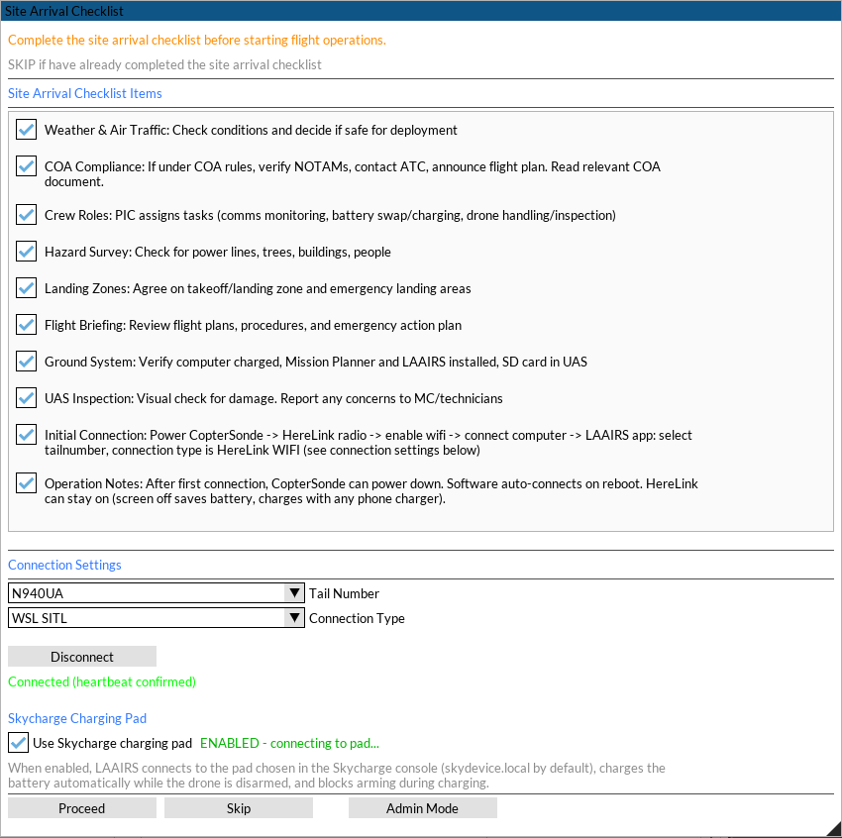
Figure 4. The Site Arrival Checklist, connected to the simulator through "WSL SITL", with the Skycharge pad enabled.

7.4 A tour of the LAAIRS main window
LAAIRS is made of several windows that you can move, dock into tabs or hide from the View menu. Our screenshots use a docked layout, so yours may look a bit different at first. Arrange the windows the way you like by dragging their tabs, then save it with View > Save Layout.
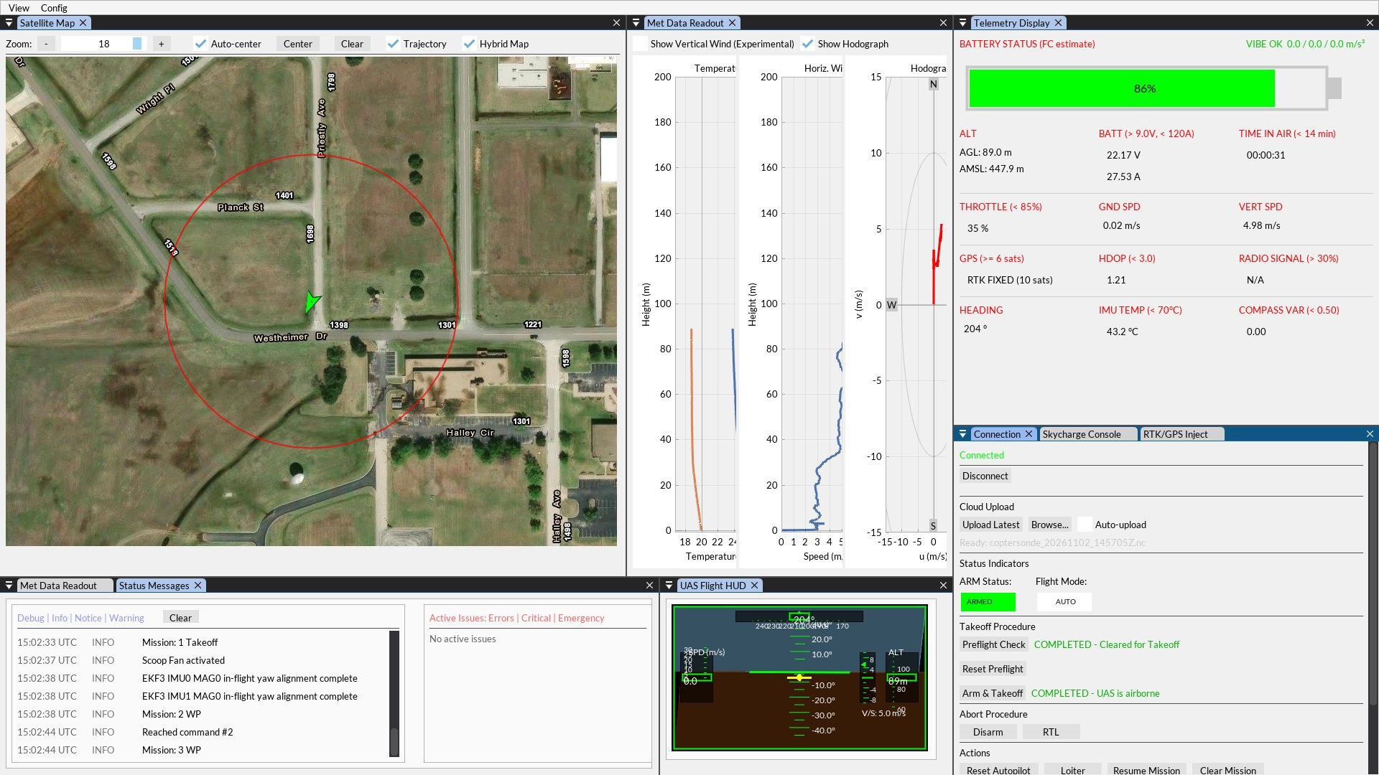
Figure 5. LAAIRS during a vertical profile in the simulator. The CopterSonde is climbing through 89 m in AUTO mode with an RTK FIXED GPS.
Window | What it shows | What to look for
Satellite Map | The CopterSonde (green arrow), its track and air traffic on a satellite image | Is the drone where you expect it? Any traffic nearby?
Met Data Readout | Temperature and humidity against height, horizontal wind speed and the hodograph | The profiles grow as the CopterSonde climbs. This is the science!
Telemetry Display | Battery, altitude, throttle, speeds, GPS fix, HDOP, heading, IMU temperature, compass variance and vibration | Each item shows its limit next to its name, and LAAIRS flashes and beeps when a value crosses it
Status Messages | Every message from the autopilot, and the active errors on the right | Read it whenever something is refused, for example a "PreArm" message
UAS Flight HUD | Attitude, heading, altitude and vertical speed, like a cockpit display | Steady attitude and about 5 m/s up or down during a profile
Connection tab | Connect and disconnect, ARM status, flight mode and the flight buttons | Preflight Check, Arm & Takeoff, RTL, Loiter, Disarm
Skycharge Console tab | The pad connection, its state machine and the charging data | Section 7.5
RTK/GPS Inject tab | The RTK base station: connection, survey-in and correction stream | Section 7.6

7.5 Charging on the Skycharge pad
As soon as LAAIRS sees the CopterSonde disarmed on the pad, it asks the pad to charge, and the Battery Charging window pops up (Figure 6). It shows how much energy went into the pack, the pad's state, its voltage, current and power, and the messages from the charger.
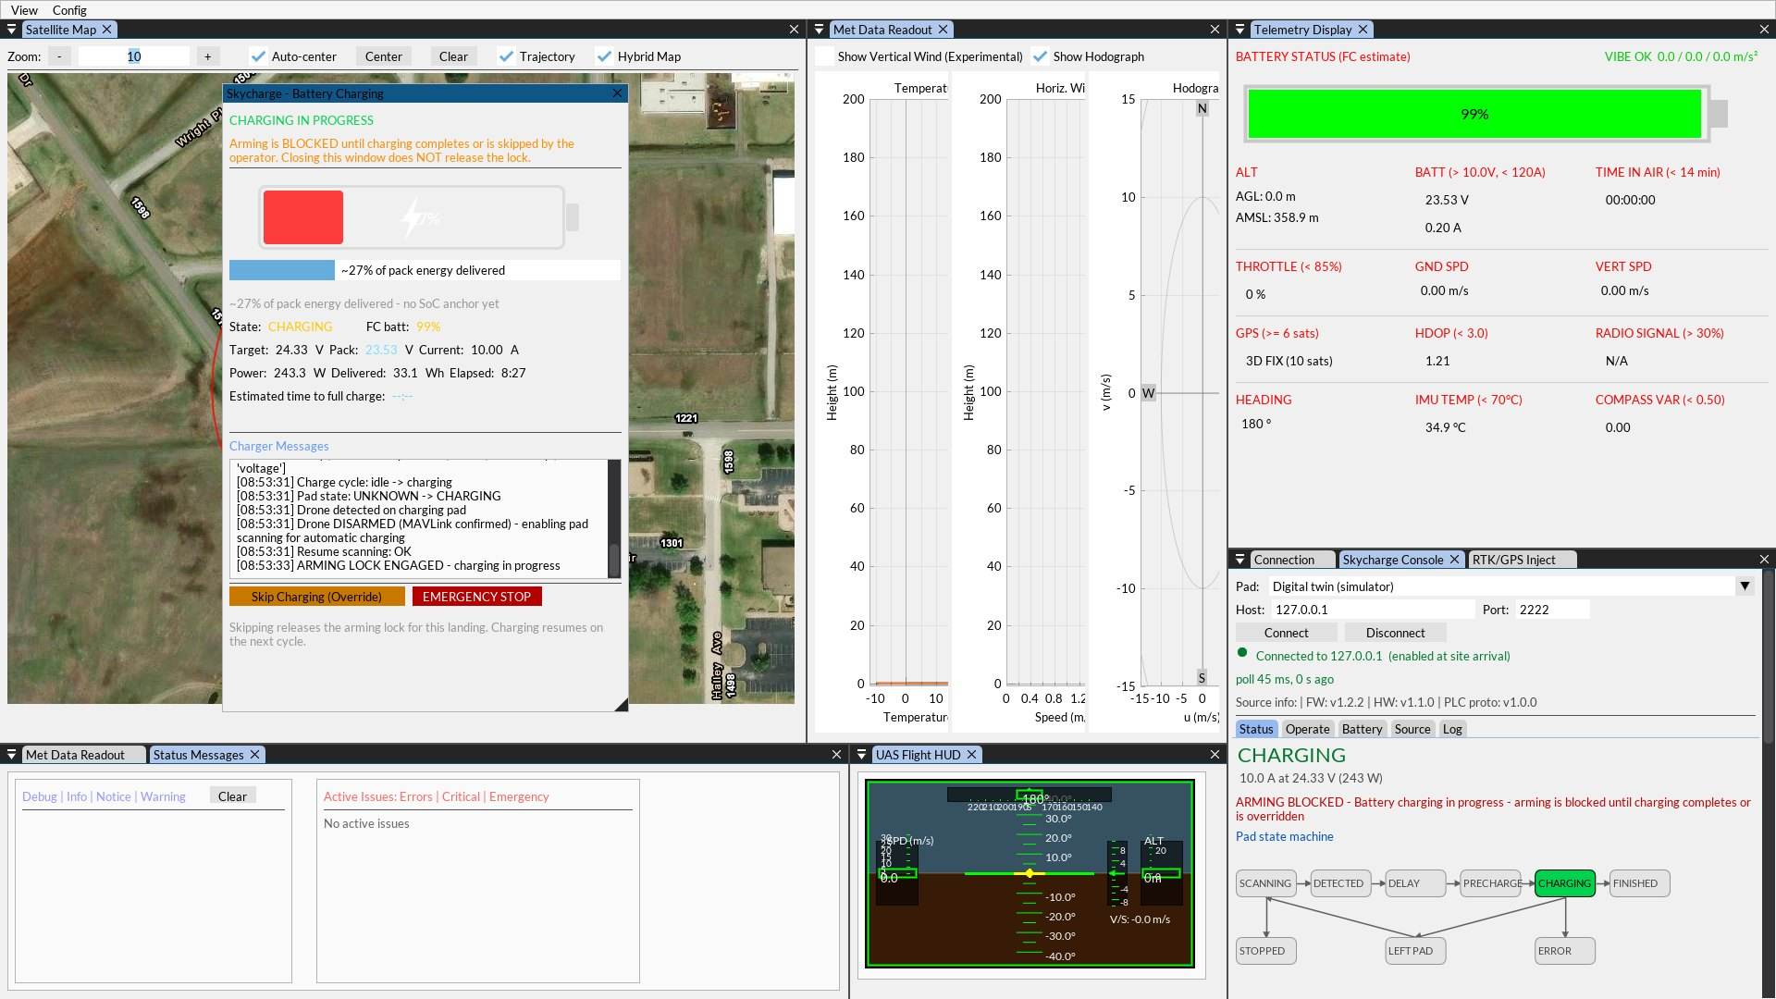
Figure 6. Charging on the pad. The Battery Charging window is on the left, and the Skycharge console is in the bottom-right tab.
- Arming is blocked while charging, and so is the Pre-Flight Checklist. That's a safety feature.
- Wait until the pad reports the battery full (state FINISHED), or press Skip Charging (Override) to fly now. EMERGENCY STOP stops the charging and the pad's scanning at once.
- The Skycharge console (Figure 7) follows the pad's own state machine: SCANNING, DETECTED, DELAY, PRECHARGE, CHARGING and FINISHED, plus STOPPED, LEFT PAD and ERROR. Its Operate, Battery, Source and Log tabs give you the pad commands, the battery settings and everything exchanged with the pad.
- The battery percentage in the Telemetry Display is the autopilot's own estimate. It counts the energy used since the autopilot started, so it doesn't see what the pad puts back. After a full charge, the Reset Autopilot & Confirm Full button in the charging window restarts the autopilot so the count starts again from a full pack.
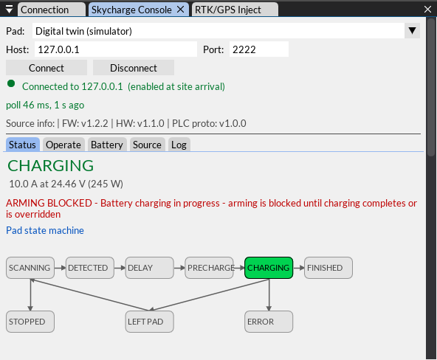
Figure 7. The Skycharge console connected to the pad twin while charging. The live state is lit in green.
Tip: The simulated pack starts full, so the first charge finishes quickly. To watch a whole charge, start the simulator with a smaller, half-empty pack: coptersonde_sim.sh --battery-ah 1 --battery-soc 0.5.

7.6 RTK corrections
Without corrections, the simulated GPS behaves like any GPS: a 3D fix that wanders about a meter. With the base station's RTCM corrections it turns RTK FIXED and becomes accurate to a centimeter or two, just like the real CopterSonde. With both Skycharge and RTK active, LAAIRS asks for RTK FIXED before take-off, so the CopterSonde can land back on the pad.
1. Open the RTK/GPS Inject window (View > Toggle RTK/GPS Inject).
2. Choose the COM port socket://127.0.0.1:3101 - Digital twin (simulator) (press Refresh if you don't see it) and press Connect.
3. Select Survey-In Mode, keep 60 s and 2.00 m, and press Start Survey-In.
4. About a minute later the survey shows Valid: Yes and the status changes to Streaming RTCM. About 10 seconds after that, the Telemetry Display shows GPS: RTK FIXED (Figure 8).
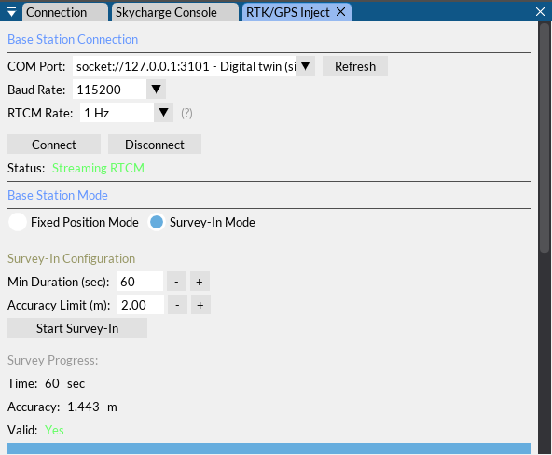
Figure 8. The RTK base twin after a 60-second survey-in, streaming corrections to the CopterSonde.

7.7 Fly a vertical profile
Now let's fly! The steps are the same ones we follow in the field.
1. In the Connection tab, press Preflight Check. The Pre-Flight Checklist opens (Figure 9).
2. Go through the items. LAAIRS checks some of them for you: the battery voltage, the GPS fix and the flight mode (press Loiter to set it). Type a battery ID.
3. Type the profile altitude in meters above ground (20 to 3000 m; try 200 m for a quick first flight) and press Generate Mission. The CopterSonde builds its AutoVP mission and LAAIRS shows Mission loaded. The Status Messages window says AutoVP mission received and Target alt: 200 m.
4. Tick the remaining items and press Confirm Checklist Complete.
5. Press Arm & Takeoff. The CopterSonde arms, takes off and climbs at about 5 m/s, and the In-Flight Checklist pops up as a reminder: read it and press Acknowledge & Close.
6. Watch the profile grow in the Met Data Readout, and follow the CopterSonde in Gazebo (Figure 1, right). Don't be surprised to see it turn on the way up: that's the wind vane pointing the sensors into the wind.
7. At the top, the CopterSonde comes home by itself (RTL), descends, lands on the pad and disarms. The Post-Flight Checklist pops up (Figure 10). When you press Acknowledge & Close, the pad starts charging again, and the cycle is complete.
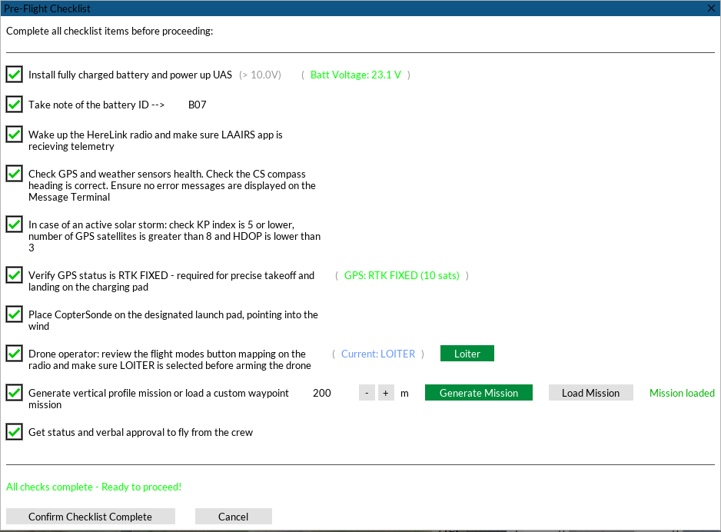
Figure 9. The Pre-Flight Checklist, completed. The mission for a 200 m profile has been generated, the GPS is RTK FIXED and the CopterSonde is in LOITER.
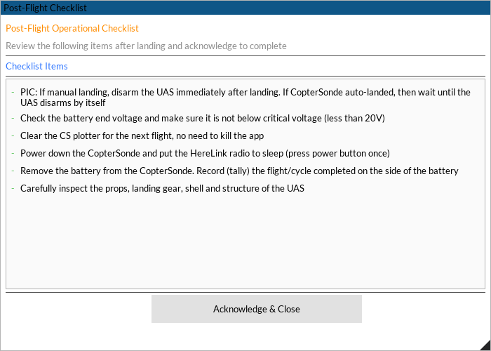
Figure 10. The Post-Flight Checklist appears after the landing. Acknowledging it lets the pad charge the battery again.
If something goes wrong during the flight, use RTL to bring the CopterSonde back to the pad, or Loiter to hold it where it is. Use Disarm only on the ground.
Heads-up: If the autopilot refuses to arm with PreArm: Battery 1 below minimum, the pack is below 23.3 V. Let the pad charge it for a while, exactly as you would in the field.

7.8 Stop the simulation
1. In LAAIRS, press Disconnect (Connection tab) and close it.
2. In the Ubuntu terminal, press Ctrl+C. The script stops Gazebo, SITL and both twins. The flight logs stay in ~/Github/BLISS-ardupilot/logs.

7.9 Keep your code up to date
Ubuntu terminal
cd ~/Github/BLISS-ardupilot
git pull
git submodule update --init --recursive
cd ~/Github/ardupilot_gazebo
git pull

Windows PowerShell
cd $HOME\Github\BLISS-GCS
git pull

The start script notices the changes and rebuilds what is needed the next time you run it.

7.10 When things don't work
What you see | What to do
Gazebo is very slow, or its window is black | Check the graphics card (Section 5.6). You can also run without the 3D window: coptersonde_sim.sh --headless.
"no display for the Gazebo window" | Run wsl --update in PowerShell, then wsl --shutdown, and open Ubuntu again.
"TCP 5760 is in use: SITL instance 0 is already running" | Another simulator is still running. Stop it with Ctrl+C in its terminal, or run wsl --shutdown.
LAAIRS never says Connected | Start the simulator first and wait for its summary. Choose WSL SITL, not another connection type.
The Skycharge console keeps trying to connect | The Pad must be Digital twin (simulator), and the simulator must not run with --no-skycharge.
Arm & Takeoff says arming is blocked | The pad is charging. Wait for FINISHED or press Skip Charging (Override).
A warning says the GPS is not RTK FIXED | Start the survey-in (Section 7.6) and wait for RTK FIXED.
The first build fails | Open a new Ubuntu terminal so ~/venv-ardupilot is active (Section 5.3), and run the build again. If it still fails, send us the last 20 lines.
"Repository not found" when cloning BLISS-GCS | Your GitHub account doesn't have access to oubliss yet. Send us your username.

8. Cheat sheet
Keep this page handy. Unless it says otherwise, run the Ubuntu commands from ~/Github/BLISS-ardupilot.

Windows PowerShell
Command | What it does
wsl --install -d Ubuntu-24.04 | Installs WSL with Ubuntu 24.04 (administrator, once)
wsl -l -v | Lists your Linux installations and their WSL version
wsl --update | Updates WSL and WSLg
wsl --shutdown | Stops all of WSL; the next Ubuntu window starts fresh
cd $HOME\Github\BLISS-GCS  hatch run laairs | Starts LAAIRS
hatch shell | Opens a PowerShell inside LAAIRS's Python environment (then type laairs)
hatch run test | Runs the LAAIRS tests
hatch env prune | Deletes LAAIRS's environment; the next run rebuilds it (useful after big updates)
git pull | Downloads the latest LAAIRS code

Getting around in Ubuntu
Command | What it does
cd ~/Github/BLISS-ardupilot | Goes to the firmware and simulator folder
ls | Lists the files in the current folder
explorer.exe . | Opens the current folder in Windows File Explorer
code . | Opens the current folder in VS Code
sudo apt update && sudo apt upgrade -y | Updates all Ubuntu packages
glxinfo -B | grep "OpenGL renderer" | Shows which graphics card draws Gazebo
Ctrl+C | Stops the program running in the terminal
Ctrl+Shift+C / Ctrl+Shift+V | Copy and paste in the Ubuntu terminal

Code and builds
Command | What it does
git status | Shows the branch and the files you changed
git branch --show-current | Shows the current branch (should be ArduPilot-4.6-CS-gazebo)
git pull  git submodule update --init --recursive | Downloads the latest code and its submodules
./waf configure --board sitl | Prepares a build for the simulator (once, or after big updates)
./waf copter | Builds the CopterSonde firmware for the simulator
./waf clean | Deletes the build, for a fresh start
python3 -m pytest CopterSonde-sim/tests | Runs the simulator's own tests

Running the simulator
In this table, ... stands for CopterSonde-sim/tools/coptersonde_sim.sh. You can combine the options.
Command | What it does
CopterSonde-sim/tools/coptersonde_sim.sh | Starts everything: Gazebo, SITL, Skycharge twin and RTK twin
... --headless | Same, without the Gazebo window (lighter on slow computers)
... --start-hour 15 | Starts the day at 3 pm local time (default 9 am), with a deep afternoon mixed layer
... --cycle-hours 2 | Runs a whole day of weather in 2 hours instead of 24
... --battery-soc 0.5 --battery-ah 1 | Starts with a half-empty 1 Ah pack, so a full charge takes minutes
... --no-skycharge  ... --no-rtk-base | Without the pad twin, or without the RTK base twin
... --no-build | Skips the rebuild checks and uses what is already built
... --mavproxy --mavproxy-args "--console --map" | Uses MAVProxy in the terminal instead of LAAIRS
... -h | Lists all the options

Flying, logs and other tools
Command | What it does
python3 CopterSonde-sim/tools/vp_flight_test.py --alt 500 | Flies an AutoVP profile to 500 m from a script (with LAAIRS connected)
mavproxy.py --master tcp:127.0.0.1:5762 --console | Connects MAVProxy next to LAAIRS, for typing autopilot commands
ls logs/ | Lists the autopilot flight logs (.BIN), one per flight
ls ~/.cache/coptersonde/run/I0/ | Lists the simulator logs: gazebo, sitl, skycharge and rtk-base
tail -f ~/.cache/coptersonde/run/I0/sitl.log | Follows the autopilot log live (Ctrl+C to stop)
gz sim --versions | Shows the installed Gazebo version (10.x is Jetty)

Words you will hear
Word | Meaning
SITL | Software in the loop: the real autopilot code running on your PC instead of the flight controller
Gazebo | The 3D simulator that plays the physical world: gravity, motors, wind, sensors
WSL / WSLg | Windows Subsystem for Linux, and its part that shows Linux windows on Windows
MAVLink | The language the autopilot and the ground station speak
GCS | Ground control station; for us, LAAIRS
RTK / RTCM | Real-time kinematic GPS, accurate to centimeters, and the format of its correction messages
AutoVP | The CopterSonde's automatic vertical profile mission
RTL | Return to launch: the CopterSonde flies home and lands by itself
Digital twin | A software copy of a real device that answers exactly like it
Boundary layer | The lowest 1 to 3 km of the atmosphere, in touch with the ground, where the CopterSonde flies

Where to learn more
- CopterSonde-sim/README.md: how the simulator works inside (atmosphere, sensors, pad, RTK), and how we verified it.
- The LAAIRS README.md in BLISS-GCS: every LAAIRS feature in detail.
- ArduPilot developer docs: ardupilot.org/dev. Gazebo docs: gazebosim.org/docs/jetty.
Happy flying, and welcome to the team!

