Notes on Accounting Analysis
and NetSuite ERP, HubSpot CRM, Excel

Anthony Rondini
(11/17/24)
Table of Contents
GAAP “Generally Accepted Accounting Principles” 4
Accrual 4
Consistency 4
Conservatism 4
Matching 4
Financial Statements 5
Balance Sheet (Statement of Financial Position) 5
Income Statement (Statement of Profit & Loss or "P&L") 5
Statement of Cash Flows 6
The Accounting Equation: 7
Assets 7
Liabilities (Debts / Obligations) 7
Equity 7
Revenue 7
Double-Entry System 9
Journal Entries 11
T-Account 11
Profit Margin 12
Excel Functions for Accounting / Finance 13
IF 13
IFS 13
SUMIFS 13
AVERAGEIF 13
XLOOKUP 13
COUNTIF 13
INDEX / MATCH 13
PMT 14
NPV (Net Present Value) 14
RANK.EQ 14
IRR (Internal Rate of Return) 14
KPIs (Key Performance Indicators) for Finance 15
Liquidity 15
Profitability 15
Leverage 16
Efficiency 16
Growth 17
Type of Financial Analysis 18
Variance Analysis 18
HubSpot CRM 19
HubSpot and Excel 20
Export Data 20
Custom Reporting 20
Data Cleanup and Preparation 20
Bulk Updates 20
How to Integrate 20
HubSpot and Power BI Use Cases 21
Pipeline Visualization 21
Combining Sales and Financial Data 21
Customer Lifetime Value (CLV) Analysis 21
Revenue Breakdown by Product or Service 21
Salesperson or Team Metrics 21
NetSuite ERP 22
Customization & Navigation 22
Dashboard Personalization 22
Centers 22
Global Search 22
Reporting Tools 23
Built-in Financial Reports 23
Saved Searches 23
SuiteAnalytics 23
Sources (Generalized) 27

GAAP “Generally Accepted Accounting Principles”

Accrual
- Revenue is recognized when it is earned. Expenses are recorded when incurred. Such as a bill, even if the payment is going to be made late, it must be recorded as soon as it is incurred.

EXAMPLE: If you provide a service in January but get paid in February, you would still record the revenue for January. Even if no invoice is received for the service, you must still accrue for the invoices not yet received.

Consistency
- Use a single method to record expenses. This causes forecasts to be more reliable.

Conservatism
- Record revenue when it is 100% earned, but record expenses and liabilities (debts / “contingent liabilities”) as soon as they’re likely. This way, you avoid overestimating income or underestimating costs.

EXAMPLE: If you are facing potential legal expenses, you need to put money aside despite not knowing what the amount is to avoid boosting profits and then dropping them drastically.

Matching
- Match related expenses and revenue to the same time period.

EXAMPLE: If you make a sale in March, record the cost of producing the item in March too. This helps show the true profit for the month.

Financial Statements
When creating a financial report, there are three statements that are required by the GAAP:

Balance Sheet (Statement of Financial Position)
- An overview of assets, liabilities, and shareholders' equity at a specific point in time.
  - Can see what you owe and what you own at the end of a your financial year. This is the financial health of the company.
EXAMPLES OF CURRENT ASSETS AND OTHER ASSETS:
Type | Current Asset? | Why/Why Not?
Cash | ✅ Yes | Always liquid.
Accounts Receivable | ✅ Yes | Collected within the operating cycle.
Inventory | ✅ Yes | Sold within the operating cycle.
Property, Plant & Equipment (PPE) | ❌ No | Long-term usage, not for sale soon.
Long-term Investments | ❌ No | Held beyond 12 months.

Income Statement (Statement of Profit & Loss or "P&L")
- Reports a company's revenues and expenses.

Statement of Cash Flows
- Tracks how a company uses its cash to pay its debts / obligations and fund its operating expenses and investments. Cash at the end of the Cash Flow Statement will be the Cash that is shown on the Balance Sheet under your Assets for the same year.
EXAMPLE ON HOW THESE CONNECT
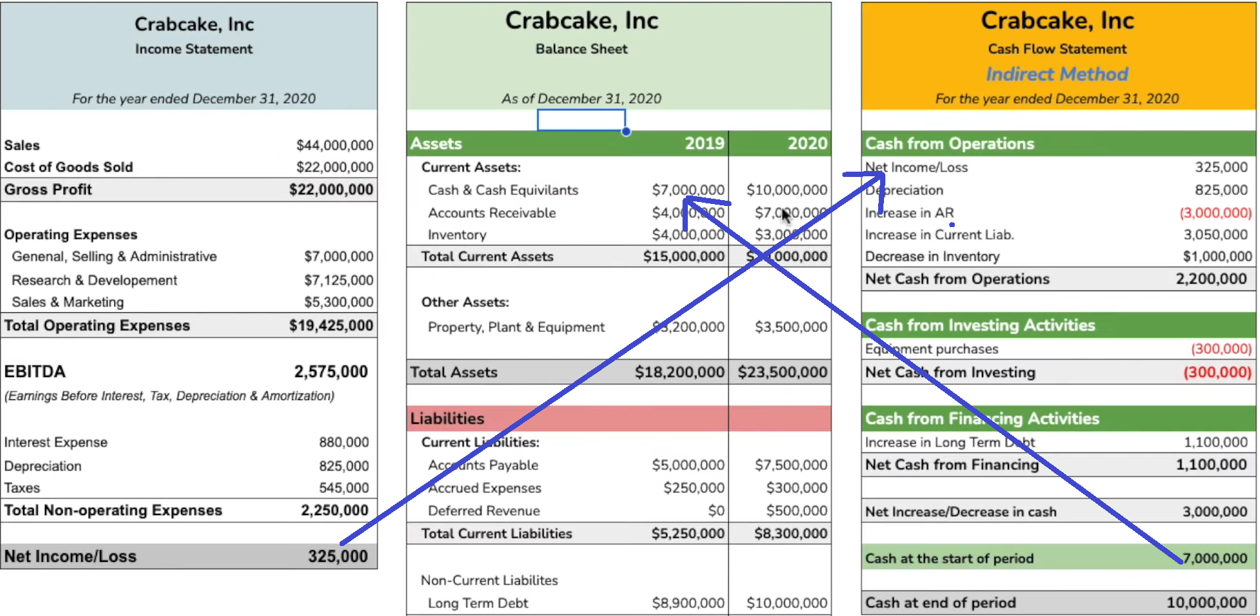

The Accounting Equation:
Assets = Liabilities + Equity
The accounting equation shows that a company’s assets are funded by either liabilities or equity. Every financial transaction impacts this equation, keeping it balanced.

Assets
- Things a company owns that have value. They help the business run and can be used to make money. Cash, equipment, buildings, inventory (products that are ready to be sold).

Liabilities (Debts / Obligations)
- How much the company has borrowed or promised to pay. Loans, bills to suppliers, and any unpaid expenses.

Equity
- The owner’s share of the company’s assets after paying off liabilities. The net worth of the business from the owner’s perspective. Initial investment by owners and any profits not paid out as dividends. This is what would be left for the owners if the company sold everything and paid off all debts.

Revenue
- Money the company earns from selling goods or services.

Differences Between Revenue and Income
Aspect | Revenue | Income
What it Measures | Total earnings from core operations. | Profit after all expenses and costs.
Focus | Sales and operational performance. | Overall financial performance (profit).
Location on Statement | Top of the income statement (also called "sales"). | Bottom of the income statement (also called "net income").
Includes Expenses? | No, it’s the total earnings before deducting expenses. | Yes, income is what’s left after deducting expenses, taxes, etc.
TL; DR
- Assets = What the company has – Cash, equipment, buildings, inventory
- Liabilities = What the company owes – Loans, bills to suppliers, unpaid expenses
- Equity = The owner’s share in the company
- Revenue = Money the company earns

Equity = Owner’s Equity – Dividends + Revenue – Expenses
rearranged as…
DEALER
Dividends + Expenses + Assets | Liabilities + Owner’s Equity + Revenue
These are Debits | These are Credits
Increase when debited | Increase when credited
Decrease when credited | Decrease when debited

EXAMPLE: If a company takes a loan, both its liabilities and assets increase by the loan amount.
When a company takes out a loan, it receives cash (asset) and also takes on an obligation to pay back the loan (liability).
- Assets Increase: The company receives cash from the loan which increases its assets.
If the loan is $10,000, the company’s cash (asset) goes up by $10,000.
- Liabilities Increase: Since the loan must be repaid, the company records it as a liability. The loan amount of $10,000 is added to the company’s liabilities.
The accounting equation remains balanced due to the Double-Entry System.

Double-Entry System
- Every transaction in accounting has two equal sides: if something goes up, something else must also go up, or another item must go down by the same amount.
- This system ensures that every transaction affects at least two accounts, keeping the overall equation balanced.
  - Debit = Increases an asset or expense account (what you received or what you paid for). The destination.
    - Assets, Expenses, Dividends
  - Credit = Increases a liability, equity, or revenue account (how you are financing the transaction or where the funds came from). The source.
    - Owner’s Equity, Liabilities, Revenue
Debits and Credits are NOT the same as adding and subtracting. They are neither good nor bad.
EXAMPLE
Transaction: You buy office supplies worth $500 in cash.
  - Debit: Office Supplies (Asset) increases by $500.
  - Credit: Cash (Asset) decreases by $500.
EXAMPLE #2
Transaction: A company repays $8,000 of a loan principle and $500 of interest in cash.
  - Debit: Loan Payable (Liability) decreases by $8,000.
  - Debit: Interest (Expense) increases by $500.
  - Credit: Cash (Asset) decreases by $8,500 because the company has paid the interest and loan principle with the company’s money (cash asset).
EXAMPLE #3
Transaction: A customer pays $5,000 in advance for services to be provided next month.
  - Debit: Cash (Asset) increases by $5,000.
  - Credit: Unearned Revenue (Liability) increases by $5,000.
NOTE: Revenue has not been earned yet as the services have not been provided yet so it is deemed as “Unearned Revenue” which is a liability.

OTHER EXAMPLES:
- Buying Equipment with Cash: If a company buys equipment worth $5,000 using its cash, its cash (asset) decreases by $5,000, but its equipment (asset) increases by $5,000. So, the total assets don’t change—they’re just reallocated.
- Revenue and Equity: If the company earns $1,000 from a sale, it gains cash (asset) and increases its revenue. This revenue eventually flows into equity, keeping the balance.
- Paying Off a Liability: When the company pays off part of a loan, both cash (asset) and the loan balance (liability) decrease equally, so the equation remains balanced.

Journal Entries
Records of purchases and other transactions to better visualize which accounts the money came from and went to. These involve two parts, debit and credit.
These are written in the below format:
- Date: When the transaction occurred.
- Accounts: Accounts involved in the transaction (Cash, Accounts Payable, Revenue, etc).
- Debit and Credit Amounts: Amounts for each account. Total debits must always equal total credits.

T-Account
Ways to visualize the flow of money through each account. Helps illustrate how debits and credits affect each account balance.
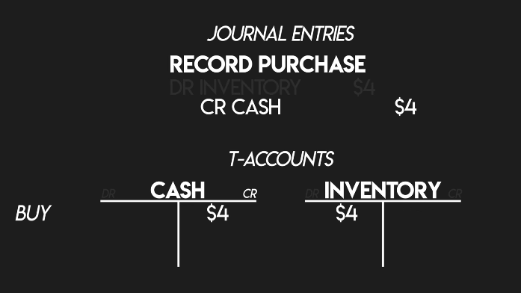

Profit Margin
A ratio that shows how much profit a company makes for every dollar of revenue. It tells you how efficiently the company is generating profit from its sales.
- The higher the profit margin, the more profit a company is making from its revenues.
There are different types of profit margins, but the most common are: Gross Profit Margin, Operating Profit Margin and Net Profit Margin.

EXAMPLE: A company sells $1,000 worth of goods and the cost of goods sold (COGS) is $600.
- Gross Profit = $1,000 - $600 = $400
- Gross Profit Margin = (Gross Profit ÷ Revenue) × 100 = ($400 ÷ $1,000) × 100 = 40%
This means that for every $1 of sales, the company keeps 40 cents as gross profit before accounting for other costs like operating expenses, taxes, etc.
Net Profit Margin includes all expenses (operation, taxes, interest), so it’s gives a more complete picture of the company’s overall profitability.

Excel Functions for Accounting / Finance

IF
- “If this condition is true, then do this; if not, do something else."

IFS
- "If this first condition is true, then do this. If the second condition is true, then do something else. If a third condition is true, do something else."

SUMIFS
- "Add up all the values in this range, but only if they meet a specific requirement."

AVERAGEIF
- Like SUMIF but calculates an average instead of a total. "What’s the average revenue per transaction for orders over $100?"
VLOOKUP
- "Look up this item in the first column and give me the value from another column in the same row."

XLOOKUP
- Can look up values in any direction based on specific conditions. "Find me this item anywhere in this range and give me the matching info from another column."

COUNTIF
- Count things that meet a certain condition. "Count all transactions over $500"

INDEX / MATCH
- INDEX: "Here’s a value from a specific spot in a range," MATCH: "Tell me the position of this item within a range."

PMT
- Calculates loan payments. “How much will my monthly payment be if I borrow this amount, for this time, at this interest rate?"

NPV (Net Present Value)
- Helps evaluate the worth of an investment by taking into account the time value of money. “What’s the total value of future cash flows in today’s dollars?”

RANK.EQ
- Ranks values in a dataset. Determines the position of a number in a list relative to other numbers. It ranks the values in order, with the highest (or lowest, depending on your choice) receiving a rank of 1.
EXAMPLE: Rank products by total sales or employees by performance.

IRR (Internal Rate of Return)
- Measures the profitability of an investment. It calculates the rate of return at which the net present value (NPV) of a series of cash flows (both incoming and outgoing) equals zero. The percentage return you can expect on an investment over time.

KPIs (Key Performance Indicators) for Finance

Liquidity
How well a company can meet its short-term obligations.
- Current Ratio: Measures the company’s ability to pay off its short-term liabilities with its short-term assets. A value greater than 1 suggests good liquidity.
Current Ratio = Current Assets / Current Liabilities

- Quick Ratio (Acid-Test Ratio): Similar to the Current Ratio but excludes inventory, as inventory can take time to sell. A ratio above 1 means good liquidity, while below 1 might indicate trouble paying off debts / bills.
Quick Ratio = (Current Assets - Inventory) / Current Liabilities

- Cash Ratio: This stricter measure only uses cash and cash equivalents. It’s helpful for assessing the company’s most immediate liquidity.
Cash Ratio = Cash / Current Liabilities

Profitability
How efficiently the company generates profit from its operations.
- Gross Profit Margin: Measures the percentage of revenue remaining after covering the cost of goods sold (COGS). This is useful for understanding product profitability.
GPM = (Revenue - Cost of Goods Sold) / Revenue * 100

- Net Profit Margin: Shows the percentage of revenue that becomes net profit, after all expenses, interest, and taxes. This indicates overall profitability.
NPM = Net Income / Revenue * 100

- Return on Assets (ROA): How efficiently the company uses its assets to generate profit. A higher ROA means better efficiency.
ROA = Net Income / Total Assets
- Return on Equity (ROE): Profitability relative to shareholders’ equity. This helps gauge how effectively equity is being used to generate profit.
ROE = Net Income / Total Equity

Leverage
The company's debt and how it finances its assets.
- Debt-to-Equity (DTE) Ratio: This shows how much a company is using debt compared to its own money (equity) to run the business.
  - High DTE: The company is borrowing a lot, which can be risky but might lead to higher growth if the borrowed money is used wisely.
  - Balanced DTE: Debt is used, but not too much, meaning the company is leveraging it to grow without taking on too much risk.
DTE Ratio = Total Liabilities / Total Equity

- Debt Ratio: Shows the percentage of assets financed by debt, providing a broad measure of leverage.
Debt Ratio = Total Liabilities / Total Assets

- Interest Coverage Ratio: Measures how easily the company can pay interest expenses with its earnings. A high value suggests the company has sufficient earnings to cover its interest obligations.

Efficiency
These measure how effectively the company uses its assets and manages liabilities.
- Asset Turnover Ratio: Shows how effectively the company generates sales from its assets. A higher ratio indicates efficient use of assets.
- Inventory Turnover: Measures how quickly inventory is sold and replaced over a period. A higher ratio suggests efficient inventory management.
- Accounts Receivable Turnover: Measures how effectively the company collects revenue from credit sales. A higher value suggests good credit control.

Growth
These show how the company is growing over time.
- Revenue Growth Rate: Measures the increase in revenue over a period, giving an indicator of business expansion.
- Net Income Growth Rate: Similar to revenue growth but focuses on net income. This shows whether profits are growing in line with revenue.
- Earnings Per Share (EPS) Growth: If the company is publicly traded, EPS growth is critical. It shows how earnings attributable to each share are increasing over time, an essential indicator for investors.

Example of a KPI Explanation to Stakeholders
Explaining the Debt-to-Equity (DTE) Ratio to a stakeholder:
"Our Debt-to-Equity ratio is 1.2, meaning we have $1.20 in liabilities for every $1 in equity—a balanced approach to financing. While leveraging debt to fund growth, we remain cautious to avoid over-reliance, which could increase financial risk. We’ll monitor this closely to maintain stability during expansion.”
“This ratio reflects our financial health, balancing growth potential with risk management. A moderate DTE reassures stakeholders of responsible growth while supporting sound financial planning and strategic decisions.“

These provide comprehensive insights into liquidity, profitability, leverage, efficiency, and growth, making them valuable metrics for assessing overall company performance. They can be used individually or collectively to help guide financial decision-making and strategic planning.

Type of Financial Analysis

Variance Analysis
Involves comparing actual financial data (revenue, expenses, etc.) to budgeted or forecasted values and understanding the reasons behind the variance / difference.
- Identify key metrics (revenue, cogs, operating expenses, net profit, gross margin, etc.)
- Budgeted figures are the expected values. This is typically based on historical data, industry standards or the goals of the business.
- Actual figures are the values from the financial statements or sales performance data.
EXAMPLE:
  - Budgeted revenue for Q1 = $500,000
  - Actual revenue for Q1 = $480,000
  - Variance = $480,000 - $500,000 = - $20,000

HubSpot CRM
Organizes and tracks customer information, communication, and interactions, to make it easier to sell, provide support, and market to customers. Designed to help businesses manage customer relationships, sales pipelines, and marketing efforts.
- Storing customer details (names, emails, companies).
- Tracking sales pipelines (deals, stages, values).
- Automating tasks (such as follow-up emails).
- Generating reports on sales and customer behavior.

HubSpot and Excel

Export Data
- Export HubSpot data like contacts, deals, companies, or sales pipelines to Excel.

Custom Reporting
- Use Excel's formulas, charts, and pivot tables to create custom reports or analyze trends not covered in HubSpot's built-in reporting.

Data Cleanup and Preparation
- Clean and structure your data (e.g., removing duplicates or reformatting dates) in Excel before importing it back into HubSpot or sharing it with others.

Bulk Updates
- Prepare updates in Excel (e.g., adjusting deal stages or adding new properties) and upload the file back to HubSpot for a bulk update.

How to Integrate
- Export data directly from HubSpot as a CSV file.
Tools like Zapier can be used for automated syncing between HubSpot and Excel.

HubSpot and Power BI Use Cases

Pipeline Visualization
- Use Case: Create a live dashboard showing deal progress through the pipeline, with metrics like total deal value in each stage or win/loss rates.
  - Helps leadership prioritize efforts to move deals through the pipeline.

Combining Sales and Financial Data
- Use Case: Import HubSpot deals into Power BI, then blend it with financial data from accounting software to compare revenue with costs.
  - Gives a complete picture of financial performance, aiding in decision-making.

Customer Lifetime Value (CLV) Analysis
- Use Case: Use HubSpot data on repeat purchases and deal values to calculate CLV and visualize it in Power BI.
  - Identifies the most profitable customers to focus retention strategies.

Revenue Breakdown by Product or Service
- Use Case: Build a Power BI report that categorizes revenue from HubSpot deals by product or service.
  - Highlights top-performing offerings and areas for growth.

Salesperson or Team Metrics
- Use Case: Display KPIs in Power BI for individual salespeople, like closed deals, total revenue generated, or average deal size.
  - Encourages healthy competition and performance tracking.

EXAMPLE:
A cleaning company expanding nationwide uses Power BI to:
- Pull deal data from HubSpot showing contracts won by city.
- Combine it with operational costs from their financial system.
- Visualize which cities are the most profitable to guide expansion efforts.

NetSuite ERP
Cloud-based ERP system that is used for streamlining and automating financial processes while integrating with other business functions such as inventory, CRM, and sales.

Customization & Navigation

Dashboard Personalization
- Use the "Personalize" option to add or remove portlets (dashboard widgets) based on your role.

Centers
- The blue ribbon at the top of the page tailored to your role.
- Key sections: Customers, Vendors, Billing, Reports, etc.

Global Search
Search across records with filters such as prefixes and wildcards:
  - Use prefixes (such as “cus: 123”) to limit searches to specific tables.
  - Add wildcards (%) for partial matches.

Reporting Tools

Built-in Financial Reports
- Found under the "Reports" tab in the Center ribbon.
- Contains reports such as Balance Sheets and Income Statements.
- Select time periods, subsidiary context, and columns (such as, show income statements by quarters).

Saved Searches
- Save and reuse filters for specific search types like Transactions. Like filtering transactions with amounts greater than X.
- Quickly access frequently used record searches.
- “Main Line” filter in a saved search determines whether to include only summary-level records or individual line-level details from transactions.
  - Yes: The search will return only the main summary record of a transaction, such as the invoice header. Line-level details like specific items or amounts will be excluded.
  - No: The search will return the detailed line items of transactions. For example, each product on an invoice will appear as a separate result.
- Can be added to your dashboard as a portlet.

SuiteAnalytics
Analyze data across the platform, create custom reports, and visualize trends.
- Dataset: Collection of raw data pulled from NetSuite records (transactions, customers, inventory, etc.). These are the basis of reports, pivot tables and charts / graphs.
  - Define and organize fields you need (like date, amount, department) and filter data to include only what is relevant (such as transactions over $1,000).

There are three different visualization types to use with your dataset.
- Table: A customizable organized table view.
- Pivot Table: Summarizes and segments the dataset.
- Chart: Create different charts (X-Axis, Series, Measures, Chart Type, etc) and change their properties to view your data graphically.

SALARY NEGOTIATION
Proposal:
After doing some research and taking into account the cost-of-living between Long Island and California, $77K - $80K feels appropriate for the current economic realities in both areas.
Counter (lower):
Counter (higher):

TO ASK
- Can you give examples of key metrics or KPIs that I would be focusing on?
  - Helps clarify which skills to focus on if you are selected for the role.
- How is the workflow between HubSpot CRM, NetSuite ERP and Power BI?

MAY BE ASKED

ANSWERED
- What training or support is available for new hires to become proficient with Power BI and HubSpot?
  - Demonstrates your proactive approach to learning new tools, especially since you’re eager to learn Power BI.
Memphis from iNX will provide the training for HubSpot and Power BI.
- How does the team collaborate with other departments? Are there any cross-team requests that might come through?
  - Shows you’re thinking about effective teamwork and how to support multiple areas within the company.
Zoom, Slack

Sources (Generalized)

Accounting Stuff YouTube Channel
Accounting Stuff. (n.d.). Accounting basics and tutorials
From https://www.youtube.com/c/AccountingStuff

SEC.gov
U.S. Securities and Exchange Commission. (n.d.). Resources on financial reporting and financial statement samples / examples.
From https://www.sec.gov

Investopedia
Investopedia. (n.d.). General finance and accounting guides.
From https://www.investopedia.com

Oracle NetSuite Documentation
Oracle NetSuite Application Suite. (n.d.) NetSuite Features, Basics, Connectors.
From https://docs.oracle.com/en/cloud/saas/netsuite/ns-online-help/chapter_N473387.html

ChatGPT
ChatGPT by OpenAI. (n.d.) Used to provide quick examples, and use cases.
From https://chatgpt.com

SuperTraining YouTube Channel
SuperTraining (n.d.) Various guides on NetSuite
From https://www.youtube.com/@SuiteCris

The Financial Controller YouTube Channel
The Financial Controller (n.d.) Principles of the Balance Sheet
From https://www.youtube.com/watch?v=7sx5nyY0cxc

