Traffic Sign Classifier

# Problem Statement:

Coming up with a model that can predict validation data set with 93% or more accuracy. Training a model of German traffic signs and training, validation, and test data are provided. The model is trained on set of 7 traffic signs and show the top 5 predictions.

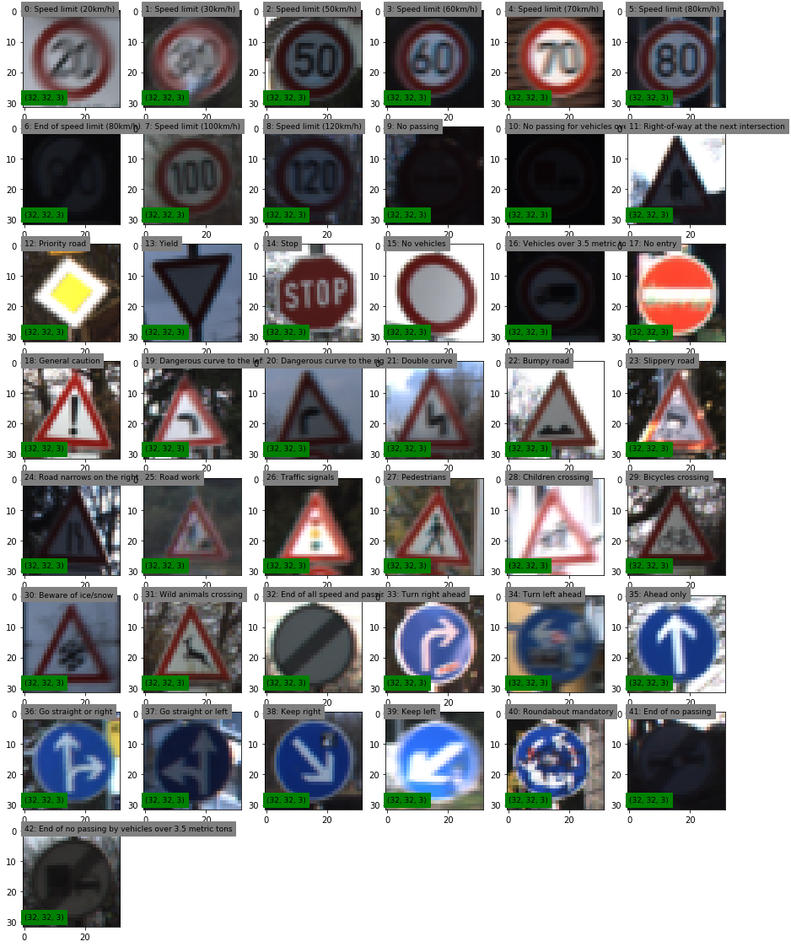

Figure1: 43 Unique German Traffic Signs

# Visualization of Traffic Signs:

There are 43 unique signs and randomly selected signs shown above in Figure1.

# LeNet Model Modification:

Alteration to the provided original LeNet model was to increase depth, multiply by 4, and adding additional two fully connected layers. Table1, LeNet Enhanced Model specifications given as follow

Table1: Enhanced LeNet Model

|  |  |  |  |  |  |
| --- | --- | --- | --- | --- | --- |
| **Layer** | **Filter** | **Strides** | **Padding** | **Kernel** | **Shape** |
| Input |  |  |  |  | 32x32x3 |
| Convolution | 5,5,1,24 | 1,1,1,1 | Valid |  | 28x28x3 |
| Pooling |  | 1,2,2,1 |  | 1,2,2,1 | 14x14x24 |
| Convolution | 5,5,24,64 | 1,1,1,1 | Valid |  | 10x10x64 |
| Pooling |  | 1,2,2,1 |  | 1,2,2,1 | 5x5x64 |
| Fully Connected |  |  |  |  | 1600 |
| Fully Connected |  |  |  |  | 480 |
| Fully Connected |  |  |  |  | 168 |
| Fully Connected |  |  |  |  | 84 |
| Fully Connected |  |  |  |  | 43 |

# Image Modifications:

## Color Space:

Number of color spaces has been trained with but Gray and YUV are the best accuracy among all the color spaces. YUV space gave a slightly better accuracy.

## Image Normalization

Normalization has a huge impact on the accuracy. For instance, validation data training accuracy jumped from 85% to 91% after normalizing the image data.

## Image Rotation

To make the model more robust and avoid over fitting rotation images up to +/- 15 degree but it had a negative impact on the validation accuracy so rotation or any other augmentation was avoided during training.

# Generic Improvements:

## Learning Rate:

Dividing learning rate by 10 it made the model more stable but it took longer to train over 95% validation accuracy.

## Epochs:

With small numbers such as 20 and 50 didn’t satisfy for a stable model because it was indicated in learning curves that there was still room to improve. When epochs set to 350 it was seen that training accuracy reached to the limit and validation accuracy was stable enough to stop at 350.