Lombok Barat birth outcomes
  - Data flow and matching guide
Workflow edition • actual SQL object names • no population totals or dashboard results

Simple summary
The data move from source tables into cleaning views, then into stored pregnancy and delivery tables. Reporting views read those tables and supply Looker. The following pages show the actual objects along that path.
All objects belong to project spheres-lombok-barat. Unless another dataset is shown, views and tables are in kohort_bumil_v3. A view runs a query when read; a table stores the result of a build script.

Where SIGIZI enters
Source table in raw_data | Cleaning view in kohort_bumil_v3
sigizi_kesga_bumil_anc | vs_sigizi_anc
sigizi_daftar_ibu | vs_sigizi_daftar_ibu
sigizi_daftar_ibu_hamil | vs_sigizi_daftar_ibu_hamil
sigizi_kohort_ibu | vs_sigizi_kohort_ibu
sigizi_ibu_nifas | vs_sigizi_kohort_nifas
These cleaning views feed t_sigizi_source_records. The geography correction updates the facility, village and Posyandu fields in that same table before pregnancy episodes are built.

Where EPUS enters
Source table in raw_data | Cleaning view in kohort_bumil_v3
epus_anc | vs_epus_anc
epus_inc | vs_epus_inc
epus_pnc | vs_epus_pnc
epus_kunjungan_ibu_hamil | vs_kohort_epus_kunjungan_ibu_hamil
These cleaning views feed t_epus_source_records. EPUS preparation then assigns mother and pregnancy identities and combines duplicate ANC visits before producing the pregnancy master.
Builders: 01_source_adapter_views.sql, 03_sigizi_source.sql, 03a_sigizi_geography.sql and 04_epus_source.sql.

From source records to the pregnancy table
Read each branch downward. The branches meet when matching concludes that a SIGIZI episode and an EPUS episode describe the same pregnancy. Unmatched episodes remain in the final pregnancy spine.
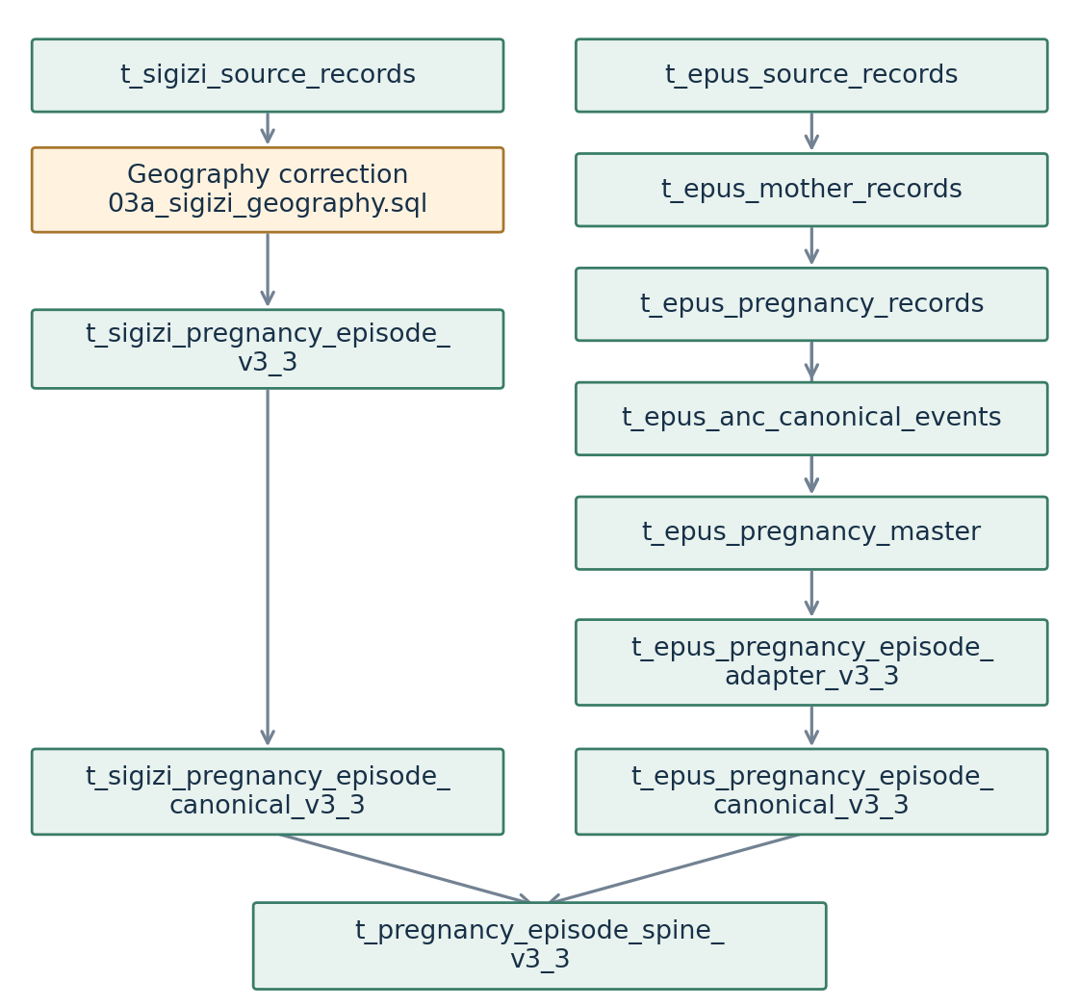
The geography step rewrites t_sigizi_source_records; it does not create a second production source table. The EPUS master reads both pregnancy records and canonical ANC events, and also uses vs_epus_inc for delivery evidence.
The final table, t_pregnancy_episode_spine_v3_3, holds the shared pregnancy identity. Canonical maps retain which original episodes contributed to it. It supplies the pregnancy context used by both outcome tracking and delivery-to-ANC matching.

How delivery evidence reaches the dashboard
Additional input | Entry view
raw_data.simrs_patut_patuh_inc | vs_simrs_patut_patuh_inc
data_kobo_form.e-form_pencatatan_pelayanan_intranatal_care | vs_kobo_inc_submission_clean → vs_kobo_inc_case_master
data_adjudication.adj_final | Also feeds vs_kobo_inc_case_master
data_kobo_form.neonatus_outcome_v2 | vs_kobo_neonatus_outcome_v2_baby
Facility birth reporting | birth_report_faskes.v_inc_report_tracker (external reporting view)
These inputs are combined with SIGIZI source records and the EPUS pregnancy master in t_pregnancy_outcome_events_v3_3. This is the common collection of outcome evidence.
The pregnancy spine, matched USG evidence and matched outcome evidence produce t_pregnancy_outcome_tracking_v3_3. Separately, dated birth evidence becomes t_delivery_source_records, then t_delivery_dedup_base, then t_delivery_event_master_unlinked. After matching those events to the pregnancy spine and checking competing links, the final result is t_delivery_event_master_v3.
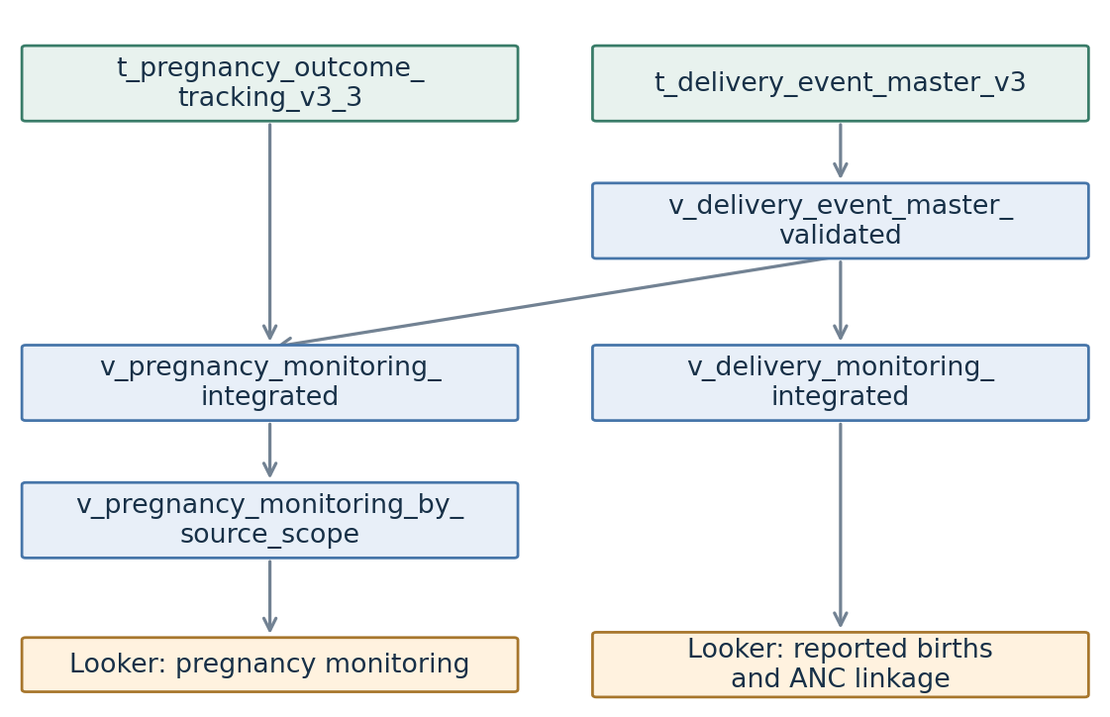
The diagram shows the actual main reporting dependencies. The facility tracker is consumed as an existing upstream view; its internal build is outside the supplied independent-core package.

Detailed logic

What cleaning does before matching
Cleaning makes equivalent representations comparable. It does not mean that every filled field is accepted as correct. The SQL retains raw identifiers and source evidence so a selected value can be traced back.
Field or record | Implemented treatment
Source identity | Keep a source identifier from UUID/hash fields or a row fingerprint. Retain source family and raw JSON where the stage provides them.
Repeated exports | The EPUS ANC adapter separates a full-row hash from a clinical-content hash that excludes ingestion metadata. This distinguishes a clinical row from the file that carried it.
Names | Uppercase and standardize punctuation and whitespace. Core-name normalization removes configured title words; compact-name comparison also removes spaces and punctuation.
NIK | Clean according to the source adapter, then evaluate reliability in core matching. Scientific notation, malformed values and known rounded/placeholder values are weaker clues, not trusted contradictory identities.
Dates | Parse source formats and retain usable pregnancy dates. Derive an anchor from HPHT or an HPL-based estimate where supported.
Phone | Outcome tracking validates normalized Indonesian mobile values. A valid pregnancy-source phone is preferred; otherwise a valid matched outcome-source phone can be selected.

How the Puskesmas/village correction works
For ANC, DAFTAR_IBU_HAMIL and KOHORT_IBU, the recovered resolver uses direct source-specific assignments. For DAFTAR_IBU and KOHORT_NIFAS, it considers metadata facility + raw village, metadata facility + shifted village, direct raw fields, and a shifted village with a uniquely known parent facility.
Candidates gain support from agreement with t_sigizi_location_reference and source metadata. The highest-scoring candidate is selected. Tied candidates receive AMBIGUOUS confidence and a deterministic method-name tie-break. The recovered application accepts every confidence except UNRESOLVED; unresolved fields become null. Thus an ambiguity flag is an audit warning, not an automatic rejection in this geography stage.
t_sigizi_location_resolved_v1 stores original values and the decision. The corrected source table feeds episode grouping, so geography must be repaired before deduplication. Simply renaming labels inside Looker would leave the upstream matching affected.
Source: adapter/preparation SQL, geography patch and 40_outcome_tracking.sql. Matching checks and final contact validation are distinct stages.

How records become pregnancies and ANC visits

Mother identity in EPUS
t_epus_mother_records first uses a valid NIK. If that is unavailable, exact normalized name + date of birth can attach the row to a uniquely identified NIK already present in the source; exact normalized name + phone is another route. Conflicting fallback identities are flagged. Without a known NIK anchor, name + date of birth or name + phone can form a fallback identity; weak or conflicting records remain source-specific.

Pregnancy episodes within a mother
EPUS derives reference dates from HPHT, HPL or delivery evidence, groups compatible reference dates within each mother, and assigns other records by their timing and event type. Records that cannot be assigned retain fallback/source-specific episode handling rather than being silently attached to an arbitrary pregnancy.
SIGIZI uses cleaned NIK when available. Where it is missing, a pregnancy signature can link to a unique NIK; name, date of birth and geography provide fallback identities. Its signature includes the core name, Puskesmas, village and pregnancy anchor. The initial anchor uses HPHT, otherwise HPL minus the assumed pregnancy duration. Rows without an anchor do not enter the anchored episode grouping, although they remain available in source/evidence processing.
For each source, records are ordered by their pregnancy anchor and separated when the gap exceeds that source’s grouping tolerance. This is an initial episode-building step; canonicalization later compares the episodes again with stronger combinations of evidence.

Deduplicating EPUS ANC visits
Within the same assigned pregnancy and ANC date, records from the ANC and pregnancy-visit extracts are combined when there is no conflict between known Puskesmas. If known facilities differ, the visits remain separated by facility. A record with missing facility cannot be assigned to a specific facility when that date has conflicting facilities, so it stays separate. Missing ANC dates also stay source-specific.

Example: repeated visits versus repeated pregnancies
An ANC export and a pregnancy-visit export may describe the same encounter. The visit stage can combine them when pregnancy, date and facility conditions agree. A later pregnancy for the same mother must receive a separate episode even when her name, NIK and phone are unchanged.
Source: 05_epus_mother.sql, 06_epus_pregnancy_records.sql, 07_epus_anc_events.sql and 10_sigizi_episodes.sql. These rules describe different grains: mother, pregnancy and visit.

Matching SIGIZI pregnancies with EPUS pregnancies
The script first canonicalizes episodes within SIGIZI and within EPUS. It then compares the canonical episodes across sources. The cross-source candidate rules below appear in priority order. “Anchor” means a date representing the pregnancy’s timing; DOB means the mother’s date of birth.
Match family | Required agreement
Exact NIK + anchor | Same non-null cleaned NIK and pregnancy anchors within ninety days. Within-source canonicalization uses a thirty-day anchor tolerance for this rule.
Strong name + DOB + HPHT | Exact core or compact name, exact DOB, HPHT within fourteen days, plus another supporting date, location or phone condition.
Strong name + DOB + HPL | Exact core or compact name, exact DOB, HPL within fourteen days, plus another supporting delivery, location or phone condition.
Strong name + DOB + delivery | Exact core or compact name, exact DOB, delivery dates within three days, plus a supporting HPL, location or phone condition.
Name + DOB + HPHT | Exact core name and DOB with exact HPHT, or HPHT within seven days under the fallback rule.
Name + DOB + facility + anchor | Exact core name, DOB and Puskesmas; cross-source anchors within ninety days.
Name + HPHT + facility | Exact core name and Puskesmas with exact HPHT, or HPHT within seven days.
Name + delivery + facility | Exact core name and Puskesmas, with delivery dates within three days.
Name + DOB + HPL | Exact core name and DOB, with HPL within seven days.
Name + phone + facility + anchor | Exact core name, accepted comparison phone and Puskesmas, with anchors within thirty days.
The strong name/DOB rules can permit NIK disagreement when their additional evidence is satisfied. The weaker fallback rules block conflicting trusted NIKs. A trusted NIK is an ordinary identifier of the expected length that is not classified as a placeholder or rounded value; this is a data-quality definition, not verification against a national registry.
If several methods propose the same episode pair, the best method is retained. Across sources, candidate pairs are ranked by rule priority, matching-date difference, anchor difference and deterministic identifiers. A pair is selected when each side ranks the other first among the remaining candidates; assigned episodes are removed from subsequent rounds.
Source: 20_pregnancy_canonicalization.sql. This is deterministic rule-based linkage; the SQL does not train a probabilistic matching model. Time tolerances above are rule definitions, not result totals.

Final pregnancy merges and controlled rescue rules
After the initial cross-source join, the final guard compares remaining pregnancy rows again. It can merge rows that the earlier rules left apart, including controlled corrections for imperfect identity data. These decisions are recorded in t_pregnancy_final_canonical_map_v3_3.
Rescue or final rule | Conditions beyond a similar name
Exact NIK | Same cleaned NIK with anchors within thirty days.
Strong exact/compact identity | Exact DOB plus nearby HPHT, HPL or delivery date, and an additional supporting field.
Fuzzy name | Exact DOB, HPHT within fourteen days and at least two corroborators. The name must also pass the edit-distance and minimum-length tests.
Phone-based identity | Exact phone and DOB, with both HPHT and HPL within their fourteen-day tolerances. Can recover name/NIK errors.
DOB missing on a side | Exact/compact name, exact HPHT and HPL, and agreement in at least two location components.
Strong pregnancy fingerprint | Exact/compact name, exact HPHT and HPL, and at least two corroborators. NIK/DOB conflict can be retained as QA while the rows merge.
Unique high-conflict fingerprint | Same compact-name/facility/HPHT/HPL fingerprint containing only a pair of episodes; permits controlled identity disagreement.
Conservative fallback | Exact core name and DOB, HPHT within seven days, and no trusted-NIK conflict.

What “fuzzy” and “corroborator” mean here
Compact matching handles formatting differences, such as “SITI AMINAH” versus “SITIAMINAH”. Fuzzy matching allows a small character edit distance: shorter eligible names permit a single edit, while longer names permit two. Names shorter than the configured minimum are excluded. This is character similarity, not a claim that different names refer to the same person.
In the final guard, corroborators are matching Puskesmas, village, Posyandu, comparison phone, or a close source delivery date. The SQL counts these signals; it does not prove that they are statistically independent. The special fingerprint routes retain identity-conflict flags for review.
Candidate merges point toward the higher-quality episode, with a stable identifier tie-break. Representative fields and source arrays are rebuilt for the final group. A changed canonical ID therefore needs source-map tracing before it is interpreted as missing data.
Source: final pair features and final guard in 20_pregnancy_canonicalization.sql. There is no general “one-digit NIK difference means match” rule in this reviewed core.

Deduplicating delivery reports
This stage asks: do these source reports describe the same delivery? It runs before linking a delivery to a pregnancy. The input is t_delivery_dedup_base; the initial outputs are t_delivery_event_master_unlinked and t_delivery_event_member_map.
Delivery deduplication rule | Required evidence
Trusted NIK | Exact trusted NIK and delivery dates within three days.
Untrusted NIK | Exact untrusted NIK and close delivery dates, supported by exact/compact name, DOB or phone.
Name + DOB | Exact or compact name, exact DOB and delivery dates within three days.
Phone + DOB + name | Exact comparison phone and DOB, plus exact/compact/fuzzy name and close delivery dates.
DOB missing: phone route | Exact/compact name and phone, with delivery dates within three days.
DOB missing: location route | Exact/compact name, exact delivery date, and matching Puskesmas or village.
Fuzzy-name route | Fuzzy name, exact DOB, delivery dates within a day, and an additional corroborator.
Weak delivery rules block conflicting trusted NIKs. Candidate links are then grouped into connected components: a report can be connected to others through shared reports. A further guard stops a whole component from collapsing if it contains different trusted NIKs, even when a missing-NIK record connected them indirectly.

Choosing the final fields
The event is not simply the newest source row. Fields are selected separately. For example, trusted NIK is preferred when choosing the identifier; name and DOB use record quality, source priority and stable source identifiers; geography uses its field-selection priority. Source membership and disagreements remain available alongside the selected values.

Example: same event versus conflicting identity
A hospital report and a SIGIZI report with the same trusted NIK and compatible delivery dates can describe the same event. If a third report with missing NIK also resembles another mother, the component guard prevents that indirect bridge from automatically joining conflicting trusted identities.
Source: deduplication, connected-component guard and unlinked master selection in 50_delivery_canonicalization.sql. These rules are stricter about trusted-NIK conflict than some final pregnancy rescue rules.

Matching a delivery event to an ANC pregnancy
Now the question changes: which pregnancy in t_pregnancy_episode_spine_v3_3 belongs to this deduplicated delivery? The ordinary candidate methods are listed in their implemented priority order.
Candidate method | Condition
DIRECT_EPUS_EPISODE_SOURCE_KEY | Delivery and pregnancy share the original EPUS episode key. An implausible direct candidate is retained for audit but is not automatically linked.
NIK+PREGNANCY_WINDOW | Exact non-null cleaned NIK and delivery within the permitted interval after the pregnancy anchor.
NAMA+DOB+PREGNANCY_WINDOW | Exact normalized name and maternal DOB, no conflicting trusted NIK, and the pregnancy interval passes.
COMPACT_NAME+DOB+PREGNANCY_WINDOW | Exact compact name and maternal DOB, no conflicting trusted NIK, and the interval passes.
PHONE+DOB+PREGNANCY_WINDOW | Exact comparison phone and maternal DOB, no conflicting trusted NIK, and the interval passes.
For the non-direct candidates, the implemented interval is from one hundred and twenty-six to three hundred and twenty-two days after the pregnancy anchor. The script ranks plausible candidates ahead of implausible direct-key candidates, then uses method priority and distance from expected delivery. If distinct pregnancies tie for the best score, the event remains ambiguous; an identifier tie-break does not turn that ambiguity into an accepted link.

SIGIZI direct-source rescue
This is tried only when the delivery has no existing ordinary candidate. It follows the delivery member map to the original SIGIZI record and follows pregnancy source membership to that same record. Shared source identity alone is insufficient: a contributing record must support a plausible source HPL or HPHT relationship.
With source HPL, delivery must be within six weeks of that HPL. Without HPL, source HPHT must meet the anchor-to-delivery interval above. A delivery before its source HPHT is not plausible evidence. Only a unique plausible pregnancy qualifies; borderline timing remains QA evidence.

Competing delivery clusters
After provisional linkage, reports linked to the same pregnancy are consolidated into date-based clusters. Competing clusters are ranked by independent source-system support, source records, linkage priority and date proximity. Only the winning cluster retains the pregnancy link; rejected clusters remain identifiable as collision rejections.
Source: strict ANC candidates, direct SIGIZI rescue, candidate ranking and post-ANC consolidation in 50_delivery_canonicalization.sql. Fuzzy names are used in delivery deduplication, but are not a separate ordinary delivery-to-ANC candidate method here.

USG matching, outcome matching and monitoring status

Attaching ultrasound evidence
vs_epus_anc supplies ultrasound records. They are compared with the pregnancy spine by exact NIK and a visit window around the pregnancy anchor. The fallback requires exact normalized name and maternal DOB, and is allowed only when NIK is missing on at least one side. It is not an override for two different non-null NIKs.
The visit window starts thirty days before the anchor and ends three hundred days afterward. Selection orders match method before dating quality, then ultrasound date and record ID. The result is t_pregnancy_usg_dating_v3_3. Consequently, this implementation does not simply choose the earliest scan across all possible identity methods.

Attaching outcome evidence
Outcome tracking matches t_pregnancy_outcome_events_v3_3 to the spine using direct EPUS episode key; otherwise exact NIK with an event-date window; otherwise exact name and DOB with that window when a NIK is missing. An undated outcome can use a matching NIK only if that NIK has a unique pregnancy episode and the outcome is present.
The dated-outcome window starts thirty days before the anchor and ends three hundred and fifty days afterward. The best pregnancy for each source event is selected by method priority, expected-delivery distance and stable pregnancy ID. This broader evidence matching is different from the stricter final delivery-to-ANC acceptance step.

Selecting HPL and the displayed status
In t_pregnancy_outcome_tracking_v3_3, expected delivery date prioritizes eligible early USG gestational-age dating, then recorded HPL, then HPHT-derived HPL, then a later USG fallback. The selected source is retained. The integrated reporting view also derives its own best-dating fields for gestational-age analysis; these should not be treated as interchangeable with operational HPL.
v_pregnancy_monitoring_integrated joins tracking with validated deliveries. Its status prioritizes an accepted delivery, then abortus and known delivery without a date, then the missing-date/overdue/active rules. “Missing birth” means that required birth evidence has not been found for an overdue episode. “Active pregnancy” is a status derived from the available dates and evidence.
v_pregnancy_monitoring_by_source_scope expands that integrated view into source scopes. Use the intended scope, eligibility field and date dimension in Looker so an episode repeated across scopes is not counted as a different pregnancy.
Source: 30_usg_and_outcome_evidence.sql, 40_outcome_tracking.sql and the integrated reporting definitions in 70_reporting_views.sql.

Appendix

Which script builds which table?
Run source preparation, geography correction and core builders in dependency order. Names in this table identify files and objects, not independent clock schedules.
Builder | Reads | Writes
03_sigizi_source.sql | SIGIZI cleaning views | t_sigizi_source_records
03a_sigizi_geography.sql | t_sigizi_source_records + t_sigizi_location_reference | Corrected t_sigizi_source_records; t_sigizi_location_resolved_v1
04_epus_source.sql | EPUS cleaning views | t_epus_source_records
05_epus_mother.sql | t_epus_source_records | t_epus_mother_records
06_epus_pregnancy_records.sql | t_epus_mother_records | t_epus_pregnancy_records
07_epus_anc_events.sql | t_epus_pregnancy_records | t_epus_anc_canonical_events
08_epus_master.sql | Pregnancy records + ANC events + vs_epus_inc | t_epus_pregnancy_master
10_sigizi_episodes.sql | Corrected t_sigizi_source_records | t_sigizi_pregnancy_episode_v3_3
11_epus_adapter.sql | t_epus_pregnancy_master | t_epus_pregnancy_episode_adapter_v3_3
20_pregnancy_canonicalization.sql | SIGIZI episodes + EPUS adapter | Source-canonical episode tables and maps; t_pregnancy_episode_spine_v3_3; final canonical map
30_usg_and_outcome_evidence.sql | Spine + EPUS ANC + SIGIZI/EPUS/SIMRS/Kobo/facility evidence | t_pregnancy_usg_dating_v3_3; t_pregnancy_outcome_events_v3_3
40_outcome_tracking.sql | Spine + USG dating + outcome events | t_pregnancy_outcome_tracking_v3_3
50_delivery_canonicalization.sql | Outcome events + spine + SIGIZI source lineage | Delivery source/base/master/member maps and rescue table
60_source_first_report.sql | Delivery master/maps + source records and upstream evidence | t_delivery_source_first_report_native
Create adapter and reporting views when their definitions change. Seed the geography reference before first use and maintain it deliberately. Run integrity and schema checks after builds. Older adapter builders targeting the same output should not also be scheduled.

Appendix: exact core outputs and lineage
Stage | Persistent outputs
Pregnancy canonicalization | t_sigizi_episode_canonical_map_v3_3  t_sigizi_pregnancy_episode_canonical_v3_3  t_epus_episode_canonical_map_v3_3  t_epus_pregnancy_episode_canonical_v3_3  t_pregnancy_episode_spine_v3_3  t_pregnancy_final_canonical_map_v3_3
Delivery canonicalization | t_delivery_source_records  t_delivery_dedup_base  t_delivery_event_member_map  t_delivery_event_master_unlinked  t_delivery_sigizi_direct_rescue_v3  t_delivery_event_member_map_v3  t_delivery_event_master_v3

How to trace a pregnancy
Start with the pregnancy_episode_id exposed by the reporting view. Read its spine row, then use the final canonical map and source-canonical maps to locate the contributing source episodes. SIGIZI episode membership links back to t_sigizi_source_records; EPUS source keys lead back through the pregnancy master and assigned pregnancy records to the source records.

How to trace a delivery
Start with delivery_event_id from the delivery reporting view. Use t_delivery_event_member_map_v3 to recover source_event_id values, then read those records from t_delivery_dedup_base and the relevant upstream evidence. The initial member map belongs to the pre-ANC event IDs; the final member map belongs to the post-consolidation IDs.

How to trace geography
Find the original SIGIZI row by source_table and source_record_id. Read t_sigizi_location_resolved_v1 to compare original geography, selected geography and resolution method. Its output must agree with the corrected source table used by the downstream episode build.

Why identifiers can change
New or corrected evidence can change episode membership or the chosen representative. Generated pregnancy or delivery IDs can therefore change even when their original source records still exist. Compare source membership and selected fields to distinguish regrouping from actual missing evidence.

Appendix: reporting views and their direct inputs
These dependencies are extracted from the supplied deployment SQL. This table shows direct reads, so follow another listed view to continue upstream. Unqualified objects are in kohort_bumil_v3.
Reporting view | Direct inputs in its SELECT
v_delivery_event_master_validated | t_delivery_event_master_v3
v_delivery_monitoring_integrated | v_delivery_event_master_validated
v_pregnancy_monitoring_integrated | t_pregnancy_outcome_tracking_v3_3  v_delivery_event_master_validated
v_pregnancy_monitoring_by_source_scope | v_pregnancy_monitoring_integrated
v_pregnancy_source_crosswalk_v3_3 | t_pregnancy_episode_spine_v3_3
v_pregnancy_delivery_source_long | v_pregnancy_monitoring_integrated
v_pregnancy_delivery_source_overlap_v3_3 | t_pregnancy_outcome_tracking_v3_3
v_pregnancy_dating_accuracy_v3_3 | t_pregnancy_outcome_tracking_v3_3
v_pregnancy_outcome_tracking_dashboard_v3_3 | t_pregnancy_outcome_tracking_v3_3
v_pregnancy_outcome_trend_monthly_v3_3 | t_pregnancy_outcome_tracking_v3_3
v_delivery_timing_analysis_v1 | t_delivery_event_master_v3  t_pregnancy_outcome_tracking_v3_3
v_birth_outcome_event_dashboard | t_delivery_event_master_v3  v_pregnancy_monitoring_integrated
v_birth_outcome_period_comparison | v_delivery_monitoring_integrated  v_pregnancy_monitoring_integrated
v_birth_capture_step_wedge_daily | ref_step_wedge_lombok_barat  v_pregnancy_monitoring_integrated
v_birth_capture_step_wedge_wide | v_birth_capture_step_wedge_daily
A chart connected to a reporting view reads the view’s dependencies at query time. Rebuilding a stored source/core table can change the chart values without changing the view definition. Preserve field names, types, grain and filter behavior when changing the reporting layer.

Appendix: dating, timing and weight dependencies
Reporting view | Direct inputs in its SELECT
v_edd_usg_hpht_paired | v_birth_outcome_event_dashboard
v_edd_usg_hpht_paired_distribution | v_edd_usg_hpht_paired
v_ga_usg_hpht_paired | v_birth_outcome_event_dashboard
v_ga_usg_hpht_paired_distribution | v_ga_usg_hpht_paired
v_birth_source_delay_category_long | t_delivery_source_first_report_native
v_birth_source_performance_daily_long | t_delivery_event_master_v3  t_delivery_source_first_report_native
v_birth_source_performance_wide | v_birth_source_performance_daily_long
v_birth_source_export_observations | raw_data.epus_inc  raw_data.sigizi_daftar_ibu  raw_data.sigizi_ibu_nifas  raw_data.sigizi_kohort_ibu
v_birth_reporting_timeliness | v_pregnancy_monitoring_integrated  raw_data.epus_inc  raw_data.sigizi_daftar_ibu  raw_data.sigizi_ibu_nifas  raw_data.sigizi_kohort_ibu
v_birth_reporting_timeliness_dashboard | v_birth_reporting_timeliness
v_birth_reporting_timeliness_evidence | v_birth_reporting_timeliness  v_birth_source_export_observations
v_simrs_birth_weight_normalized | vs_simrs_patut_patuh_inc
The timeliness branches use different evidence paths. Export-observation views read upstream raw exports; the source-performance branch reads the materialized first-report table. Choose the reporting view according to the analysis being performed.

Appendix: source audit views and maintenance
Reporting view | Direct inputs in its SELECT
v_delivery_source_first_report_native | birth_report_faskes.v_inc_report_tracker  data_kobo_form.e-form_pencatatan_pelayanan_intranatal_care  t_delivery_dedup_base  t_delivery_event_master_v3  t_delivery_event_member_map_v3  t_epus_mother_records  t_epus_pregnancy_master  t_sigizi_source_records  vs_kobo_inc_case_master  vs_kobo_neonatus_outcome_v2_baby  vs_simrs_patut_patuh_inc
v_birth_weight_observations | birth_report_faskes.birth_fu_faskes  t_delivery_dedup_base  t_delivery_event_member_map_v3  t_epus_pregnancy_master  vs_kobo_inc_case_master  vs_simrs_patut_patuh_inc
v_birth_weight_source_audit | birth_report_faskes.birth_fu_faskes  t_delivery_dedup_base  t_delivery_event_master_v3  t_delivery_event_member_map_v3  t_epus_pregnancy_master  vs_kobo_inc_case_master  vs_simrs_patut_patuh_inc
v_delivery_source_first_report_native has its own multi-source SELECT. It is not a simple alias of t_delivery_source_first_report_native. Birth-weight observation/audit views also read source evidence and the final delivery member map, so their row grain needs to be checked before using them as delivery totals.

Refresh and rule maintenance
Finish each dependency before starting its consumers and stop the chain on failure. Source preparation and geography correction must complete together before SIGIZI episodes are refreshed. Keep the SQL, reference data and reporting contracts under version control, with the reason for each rule change.
Validate unique canonical IDs, source membership, accepted-link conflicts, geography exceptions and reporting schemas. For a changed rule, compare the affected rows and their source evidence; a deterministic selection is repeatable, but is not by itself proof of a correct match.

Implementation boundary
This guide describes the SQL in the Source Preparation, Independent Core and Geography Patch packages available for this review. The raw ingestion schedules and the internal definition of the external facility tracker are outside those packages. No live BigQuery execution or clinical adjudication was performed for this documentation revision.
The first section explains the named data path. The detailed section explains why records join, merge or remain separate. This appendix supplies the object-to-object references for maintenance.

